Figure 1
Receiver Operating Characteristic (ROC) Curve of the Multivariate Predictive Model
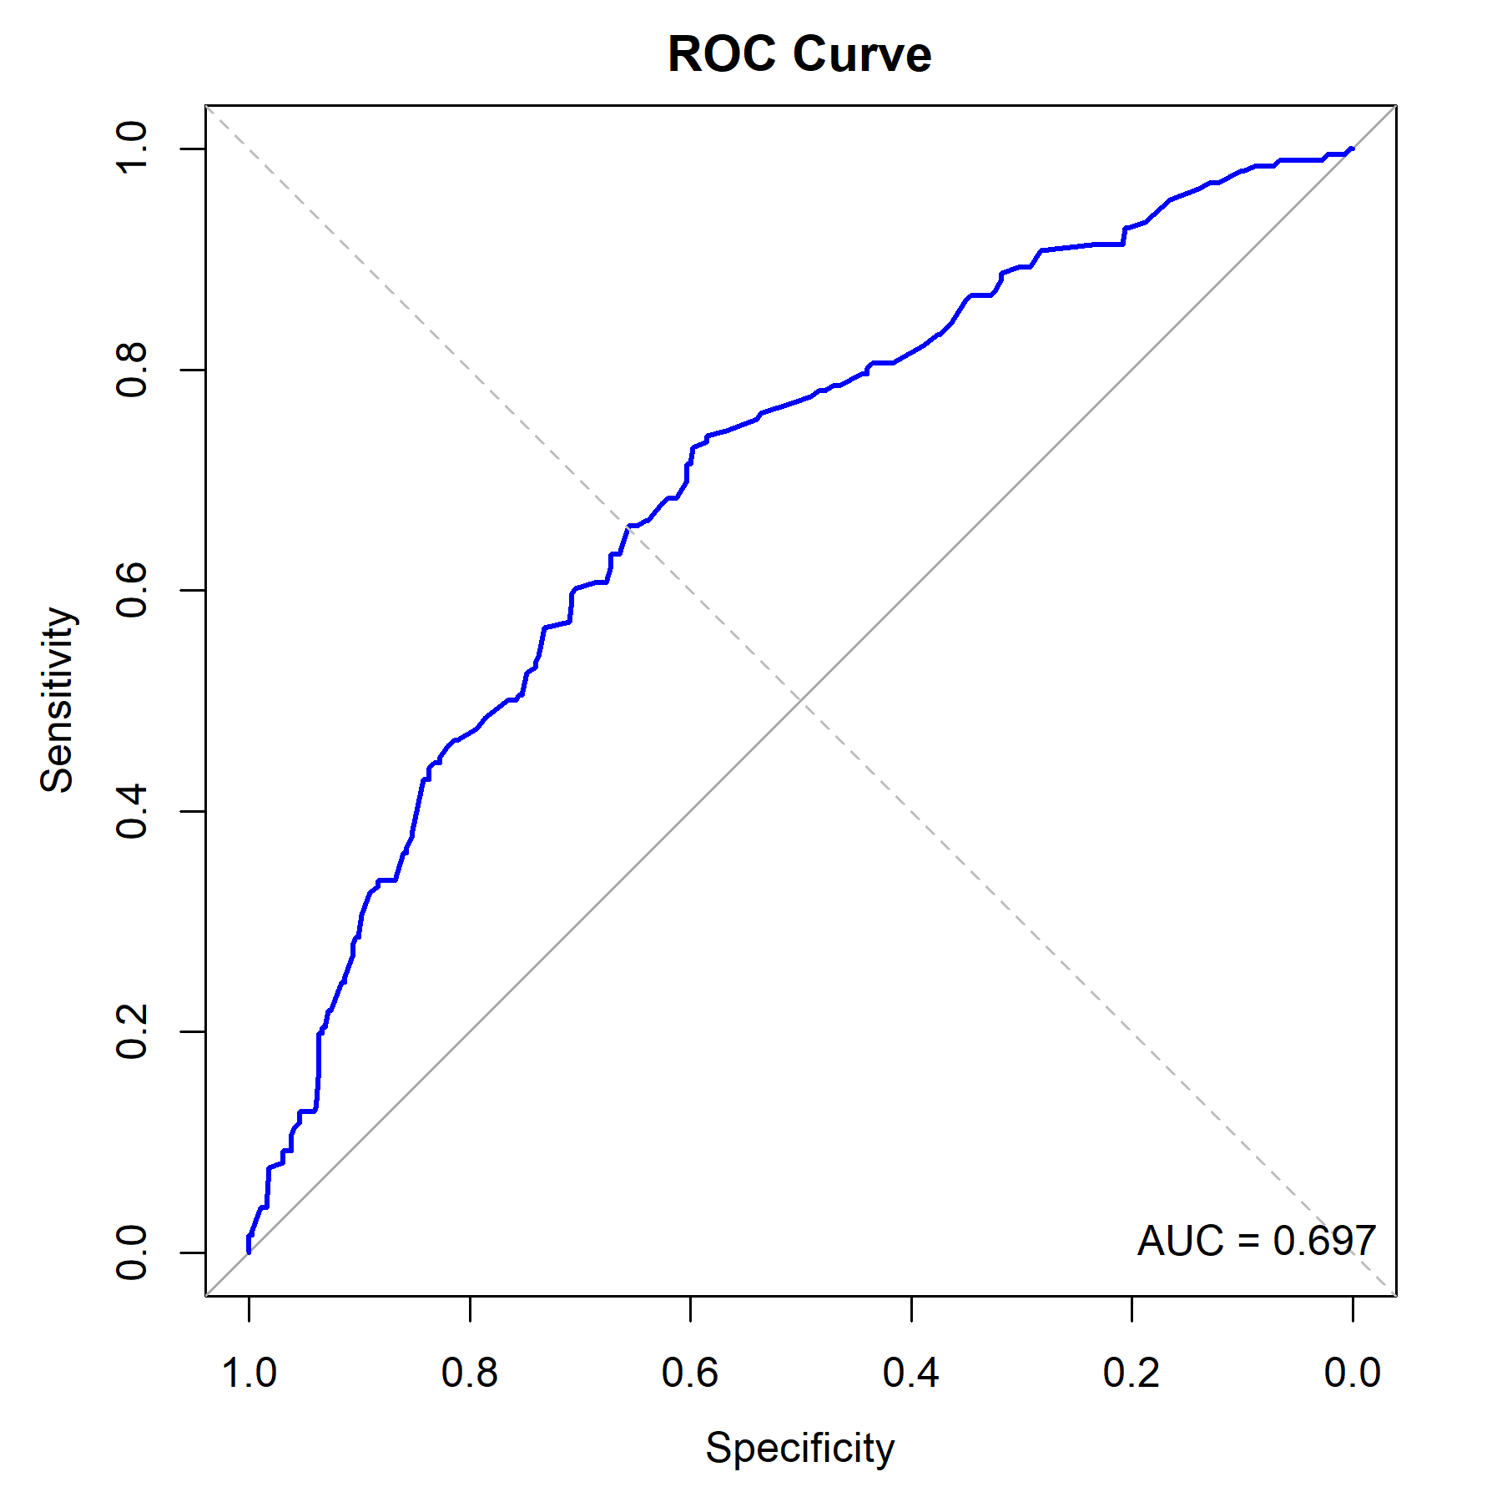
Note: The blue solid line represents model performance (AUC = 0.697). The gray dashed line represents the reference line of chance (AUC = 0.50).

