Fig. 1 Receiver Operating Characteristic (ROC) curve of the multivariable predictive model
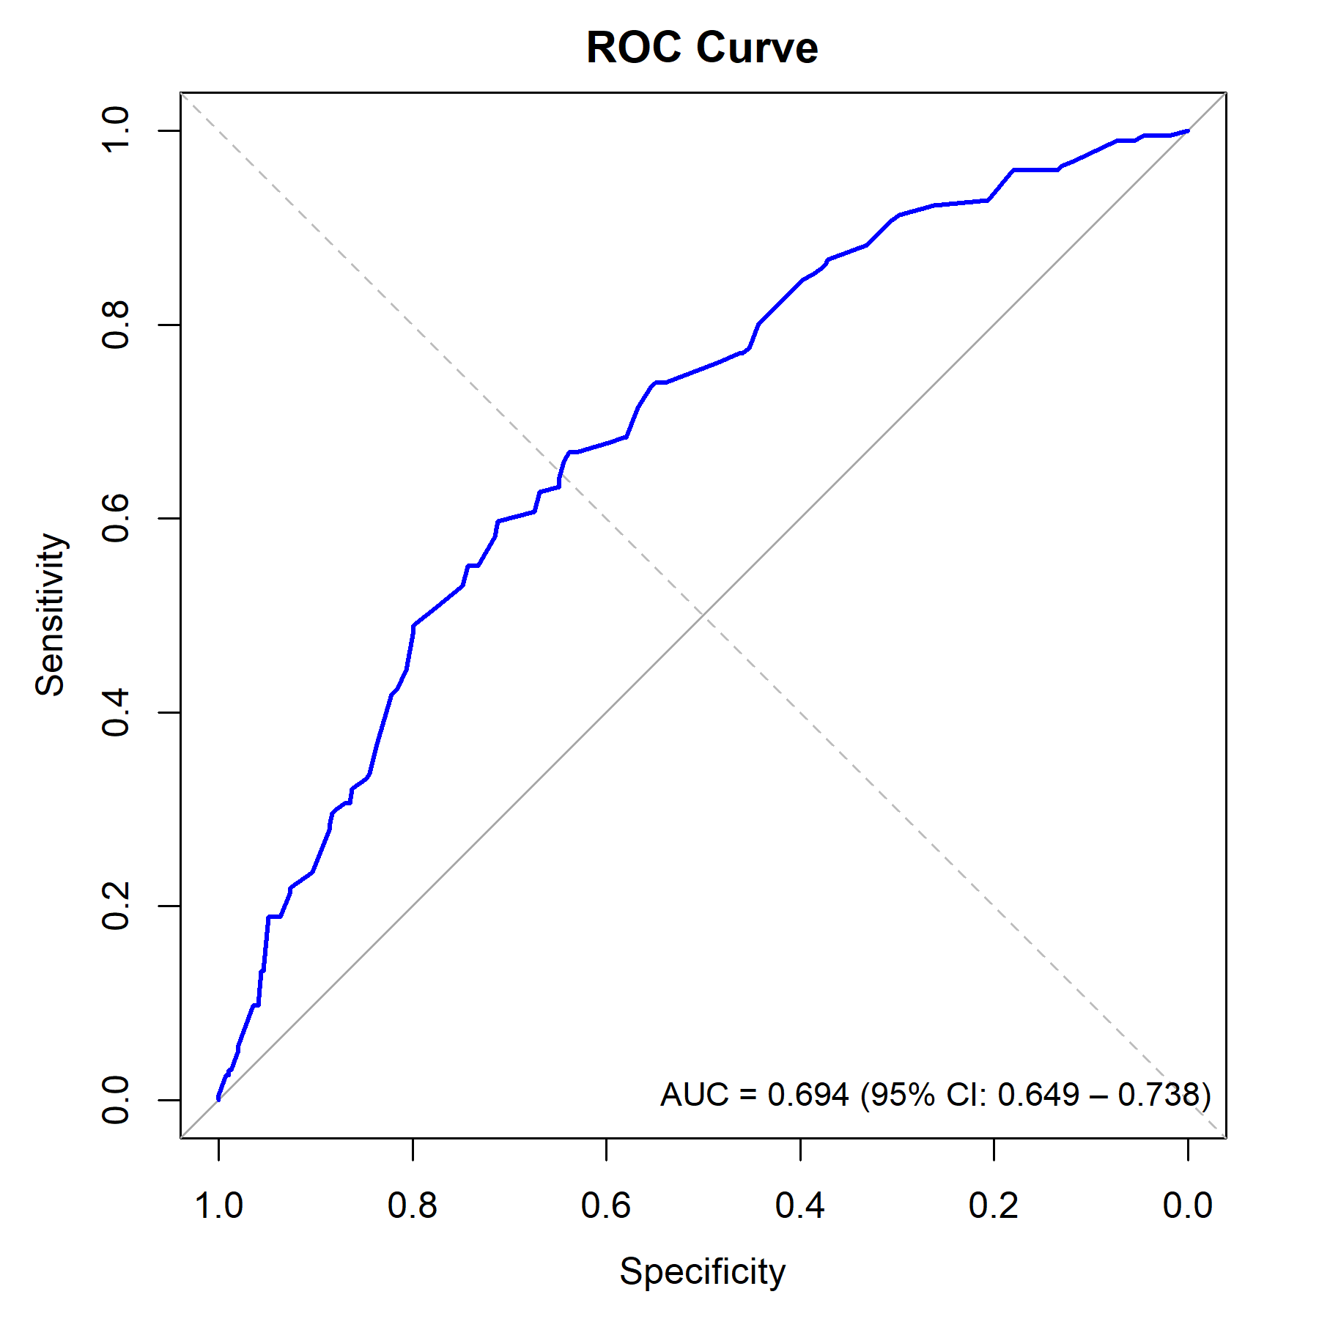
Note: The blue solid line represents overall model performance (AUC = 0.694 (95% CI: 0.649 – 0.738)). The gray dashed line represents the non-discrimination reference line (AUC = 0.500).

