https://stackoverflow.com/questions/34522732/changing-fonts-in-ggplot2

You can see what fonts you have available with the command windowsFonts(). For example mine looks like this when I started looking at this:

> windowsFonts()

$serif

[1] "TT Times New Roman"

$sans

[1] "TT Arial"

$mono

[1] "TT Courier New"

After intalling the package extraFont and running font_import like this (it took like 5 minutes):

library(extrafont)

font_import()

loadfonts(device = "win")

I had many more available - arguable too many, certainly too many to list here.

Then I tried your code:

library(ggplot2)

library(extrafont)

loadfonts(device = "win")

a <- ggplot(mtcars, aes(x=wt, y=mpg)) + geom_point() +

ggtitle("Fuel Efficiency of 32 Cars") +

xlab("Weight (x1000 lb)") + ylab("Miles per Gallon") +

theme(text=element_text(size=16, family="Comic Sans MS"))

print(a)

yielding this:

[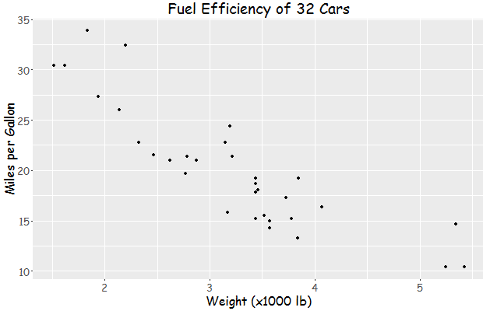](https://i.stack.imgur.com/n0B2H.png)

**Update:**

You can find the name of a font you need for the family parameter of element_text with the following code snippet:

> names(wf[wf=="TT Times New Roman"])

[1] "serif"

And then:

library(ggplot2)

library(extrafont)

loadfonts(device = "win")

a <- ggplot(mtcars, aes(x=wt, y=mpg)) + geom_point() +

ggtitle("Fuel Efficiency of 32 Cars") +

xlab("Weight (x1000 lb)") + ylab("Miles per Gallon") +

theme(text=element_text(size=16, family="serif"))

print(a)