LAPORAN PERANCANGAN SISTEM
Sistem Digital Wakrun

Mata Kuliah: Perancangan Berbasis Objek (PBO)
Sistem: Digital Wakrun - Digitalisasi Warung Kopi/Kedai
Tanggal: 12 Desember 2025
Versi: 1.0

• [Pendahuluan](#1-pendahuluan)
• [Overview Sistem](#2-overview-sistem)
• [Diagram Behavioral](#3-diagram-behavioral)
• [Diagram Structural](#4-diagram-structural)
• [Kesimpulan](#5-kesimpulan)
• [Appendix](#6-appendix)

BAB I
PENDAHULUAN

1.1 Latar Belakang
Sistem Digital Wakrun dirancang untuk digitalisasi proses operasional warung kopi/kedai makanan tradisional. Sistem ini bertujuan meningkatkan efisiensi layanan, mengurangi kesalahan pemesanan, dan memberikan pengalaman yang lebih baik bagi pelanggan.
1.2 Tujuan Perancangan
• Mendokumentasikan arsitektur sistem secara komprehensif
• Menyediakan blueprint untuk implementasi
• Memfasilitasi komunikasi antar tim development
• Menjadi acuan untuk maintenance dan pengembangan
1.3 Ruang Lingkup
Perancangan mencakup 14 jenis diagram UML yang menggambarkan:
• Behavioral Aspects: Interaksi dan alur proses sistem
• Structural Aspects: Arsitektur dan organisasi komponen

BAB II
OVERVIEW SISTEM

2.1 Deskripsi Sistem
Digital Wakrun adalah aplikasi web-based untuk manajemen pesanan makanan/minuman dengan fitur:
• Pemesanan digital oleh customer
• Manajemen menu oleh admin
• Notifikasi real-time ke dapur
• Tracking status pesanan
• Integrasi payment gateway
• Laporan penjualan
2.2 Aktor Sistem
Aktor | Deskripsi | Fungsi Utama
**Customer** | Pelanggan yang memesan | Browse menu, order, payment
**Admin** | Pengelola sistem | Manage menu, konfirmasi payment, reports
**Dapur** | Staff kitchen | Terima notifikasi, update status masakan
**Payment Gateway** | Sistem eksternal | Proses pembayaran digital

2.3 Teknologi Stack
• Frontend: HTML, CSS, Vanilla JavaScript
• Storage: LocalStorage (prototype), PostgreSQL (production plan)
• Payment: Midtrans integration (planned)
• Real-time: WebSocket untuk notifikasi

BAB III
DIAGRAM BEHAVIORAL

Diagram behavioral menggambarkan perilaku dinamis sistem, interaksi antar komponen, dan alur proses bisnis.

3.1 USE CASE DIAGRAM
Penanggung Jawab:
• Desainer: Ana Kusuma
• Reviewer: Budi Santoso
• Tanggal: 12 Desember 2025
Deskripsi
Use Case Diagram menggambarkan fungsionalitas sistem dari perspektif pengguna, menunjukkan aktor dan use case beserta relasinya.
Diagram

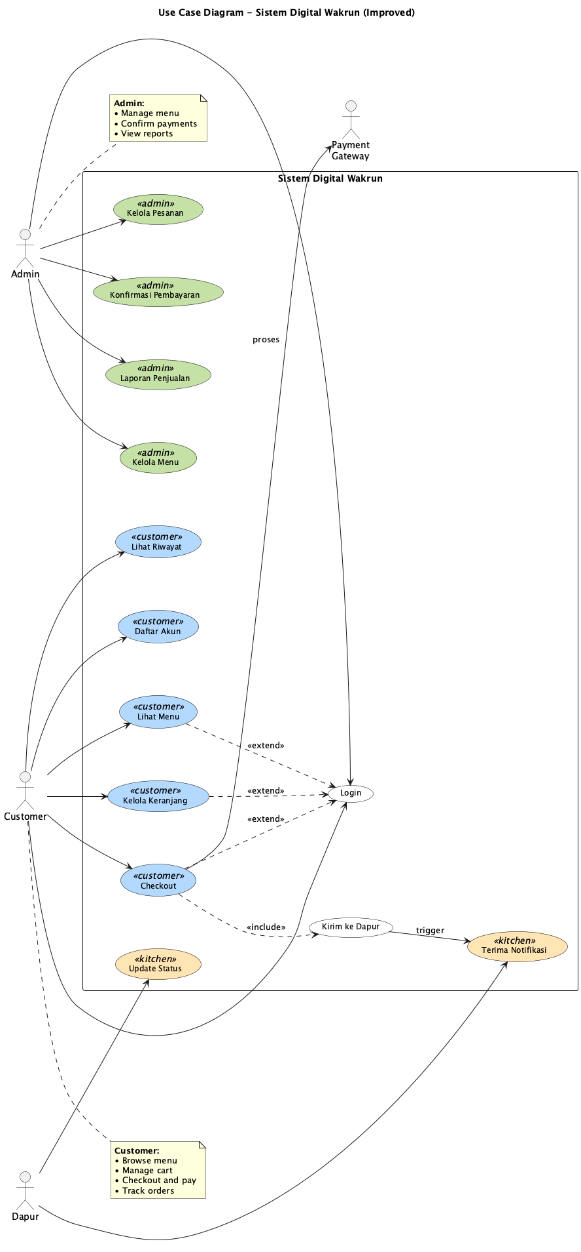
Gambar: Use Case Diagram

Komponen Utama
Aktor:
• Customer - Pengguna yang memesan makanan
• Admin - Pengelola sistem dan menu
• Dapur - Staff yang memproses pesanan
• Payment Gateway - Sistem pembayaran eksternal
Use Cases Customer:
• Login/Daftar Akun
• Lihat Menu
• Kelola Keranjang
• Checkout & Payment
• Lihat Riwayat Pesanan
Use Cases Admin:
• Kelola Menu (CRUD)
• Kelola Pesanan
• Konfirmasi Pembayaran
• Generate Laporan Penjualan
Use Cases Dapur:
• Terima Notifikasi Pesanan
• Update Status Masakan
Relasi Penting
• <<extend>> Login extends ViewMenu, Cart, Checkout
• <<include>> Checkout includes SendToKitchen
• Payment Gateway diakses saat Checkout

3.2 ACTIVITY DIAGRAM
Penanggung Jawab:
• Desainer: Citra Dewi
• Reviewer: Dewi Lestari
• Tanggal: 12 Desember 2025
Deskripsi Overall
Activity Diagram menggambarkan alur proses bisnis dari awal hingga akhir, menunjukkan decision points, parallel processes, dan swimlanes untuk setiap aktor.
Diagram Overall

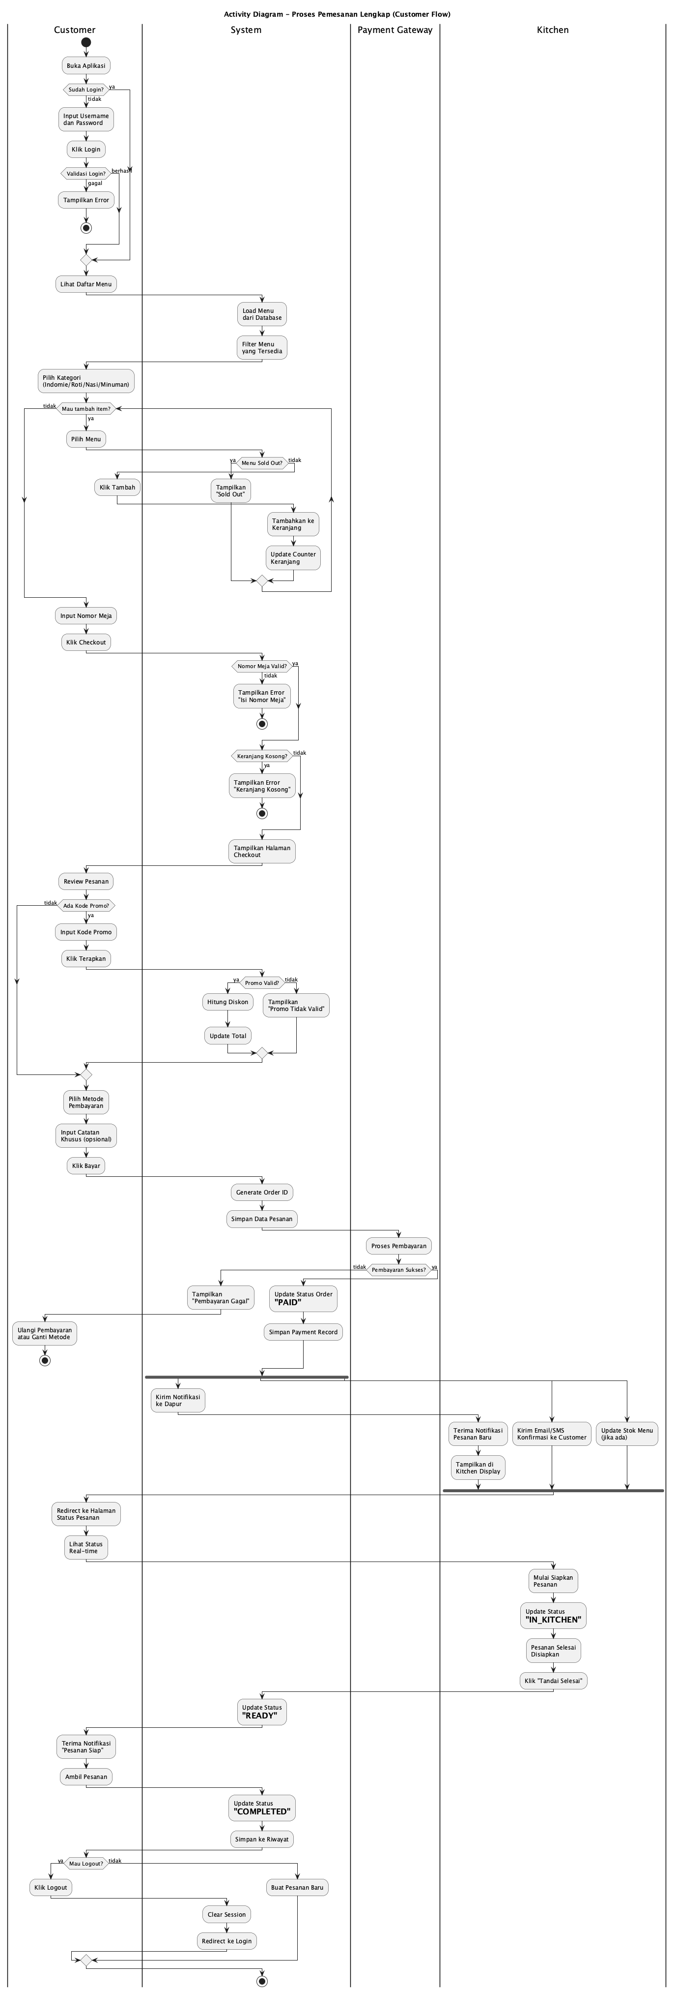
Gambar: Activity Overall

Keterangan: Diagram complete menunjukkan seluruh flow dari login hingga order completed. Untuk clarity, diagram dipecah menjadi 3 bagian fokus.

3.2.1 Customer Ordering Flow

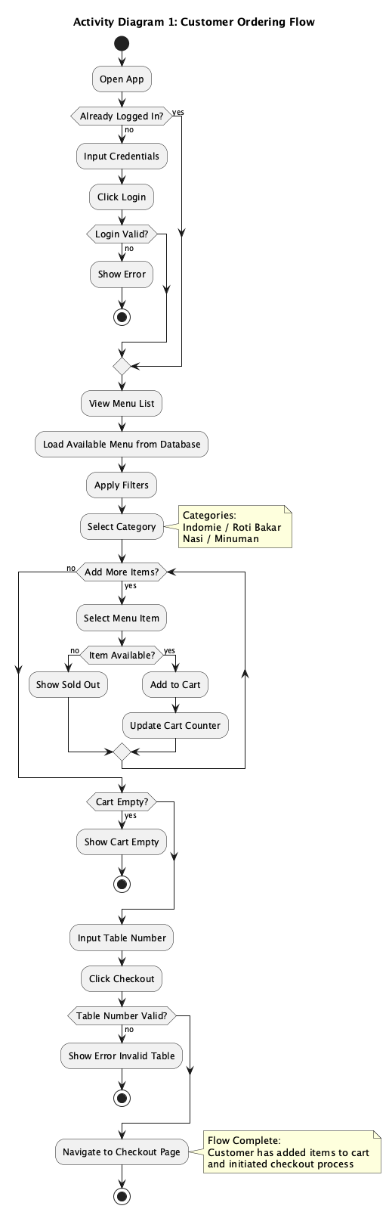
Gambar: Activity Ordering

Fokus: Proses pemesanan dari customer perspective
Alur Utama:
• Customer membuka aplikasi
• Login (jika belum)
• Browse menu dan pilih kategori
• Add items ke cart (loop)
• Input nomor meja
• Checkout
Decision Points:
• Already logged in? → Skip login
• Login valid? → Proceed atau show error
• Item available? → Add to cart atau show sold out
• Cart empty? → Cannot checkout
• Table valid? → Proceed to payment
Output: Customer siap untuk payment di checkout page

3.2.2 Payment Processing Flow

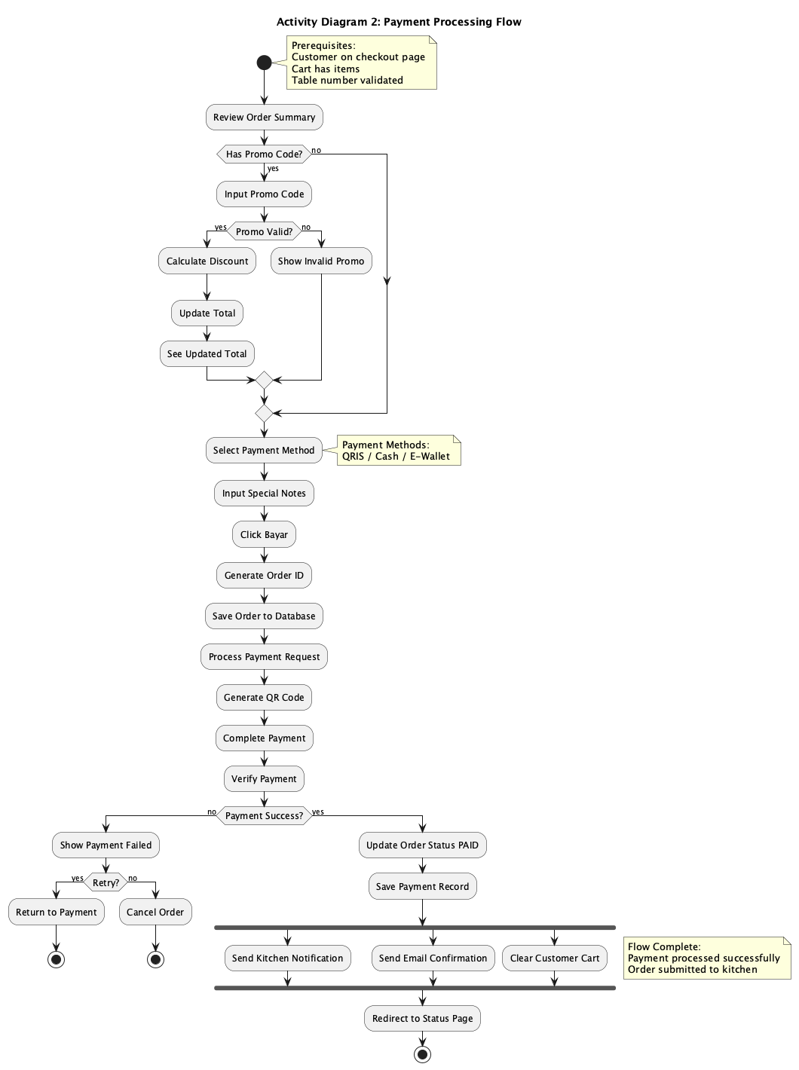
Gambar: Activity Payment

Fokus: Proses pembayaran dan order creation
Alur Utama:
• Review order summary
• Apply promo code (optional)
• Select payment method
• Generate order ID
• Process payment via gateway
• Verify payment
• Send notifications (parallel: kitchen, email, cart clear)
Decision Points:
• Has promo? → Validate dan apply discount
• Promo valid? → Calculate new total
• Payment success? → Complete order atau retry/cancel
• Retry payment? → Back to payment atau cancel
Output: Order confirmed, kitchen notified, customer redirected

3.2.3 Kitchen Processing Flow

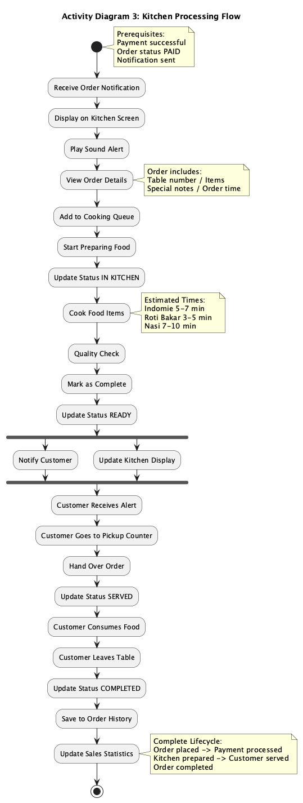
Gambar: Activity Kitchen

Fokus: Proses di dapur hingga order selesai
Alur Utama:
• Dapur terima notifikasi
• Display order di kitchen screen
• Add to cooking queue
• Prepare dan cook food
• Quality check
• Mark ready (parallel: notify customer, update display)
• Customer pickup
• Update status served → completed
Paralel Actions:
• Notify customer via push notification
• Update kitchen display status
Final Actions:
• Save to order history
• Update sales statistics

3.3 STATE MACHINE DIAGRAM
Penanggung Jawab:
• Desainer: Eko Prasetyo
• Reviewer: Fitri Handayani
• Tanggal: 12 Desember 2025
Deskripsi
State Machine Diagram menggambarkan lifecycle sebuah Order dari dibuat hingga completed/cancelled, termasuk semua state transitions dan conditions.
Diagram

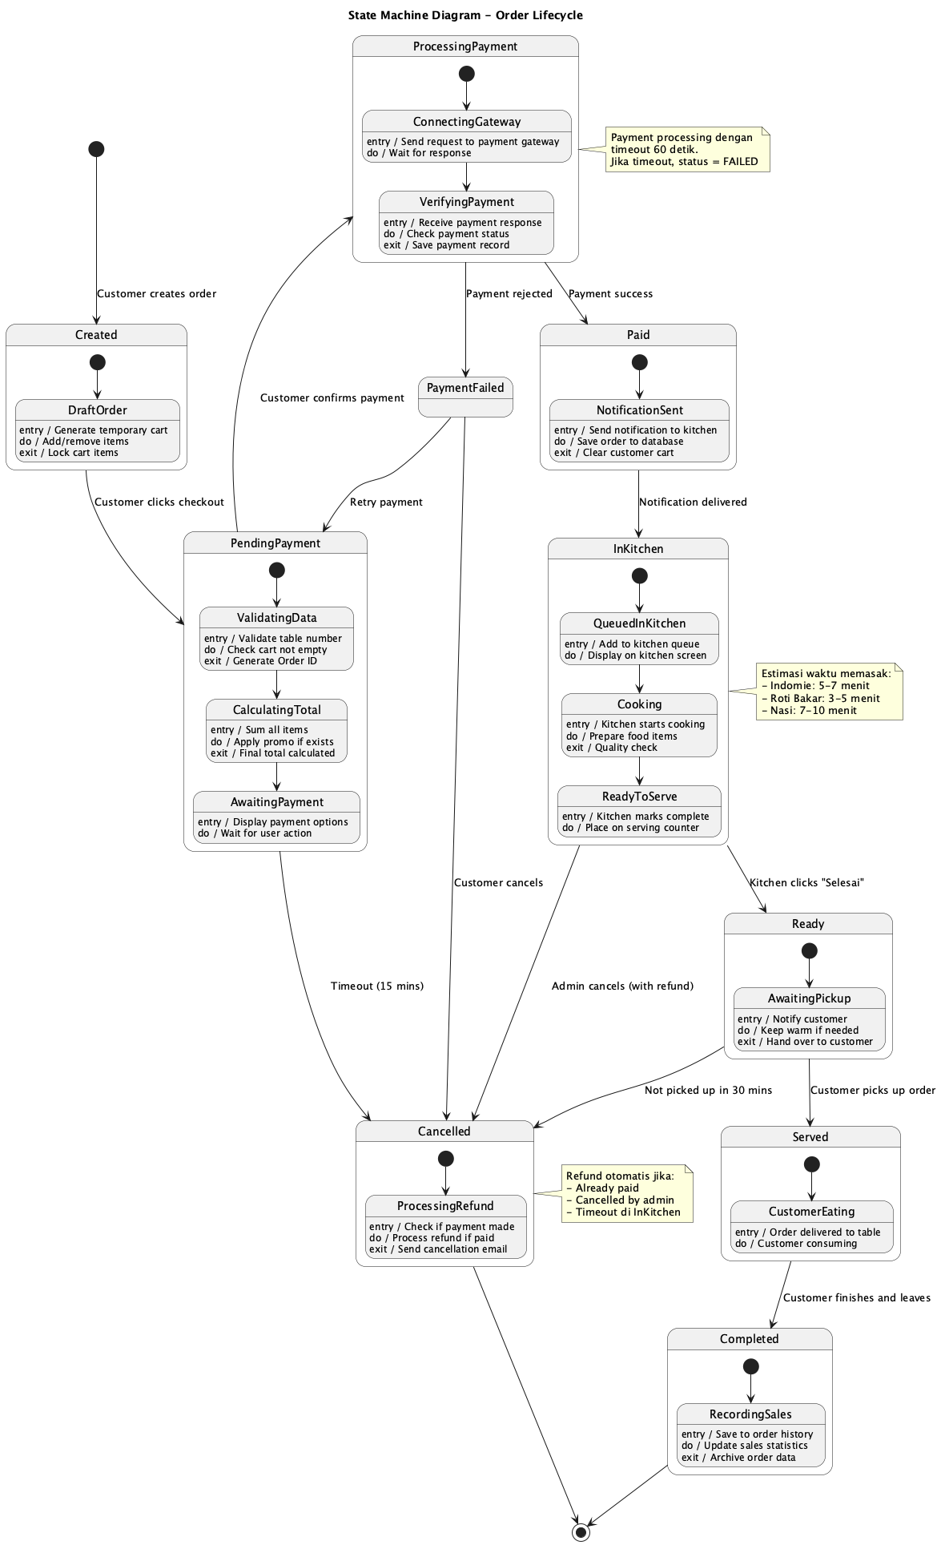
Gambar: State Machine

States Utama
State | Description | Activities
**Created** | Order baru dibuat | entry: generateOrderId
**PendingPayment** | Menunggu pembayaran | do: displayPaymentQR, timeout: 15 min
**ProcessingPayment** | Payment sedang diproses | do: verifyWithGateway
**Paid** | Pembayaran berhasil | entry: sendKitchenNotif
**InKitchen** | Sedang dimasak | do: cookFood, estimatedTime: 5-10 min
**Ready** | Siap diambil | entry: notifyCustomer
**Served** | Sudah diberikan ke customer | do: customerEating
**Completed** | Order selesai | entry: recordSales
**Cancelled** | Order dibatalkan | entry: releaseTable
**Refunded** | Pembayaran dikembalikan | do: processRefund

Transisi Important
• Created → PendingPayment: Customer confirms order
• PendingPayment → ProcessingPayment: Payment initiated
• ProcessingPayment → Paid [paymentSuccess]: Payment verified
• ProcessingPayment → PaymentFailed [!paymentSuccess]: Payment failed
• Paid → InKitchen: Kitchen starts cooking
• InKitchen → Ready: Cooking done
• Ready → Served: Customer picks up
• Served → Completed: Customer finishes & leaves
Alternative Paths
• Payment timeout → Cancelled
• Payment failed & no retry → Cancelled
• Payment failed after Paid → Refunded

3.4 SEQUENCE DIAGRAM
Penanggung Jawab:
• Desainer: Gita Maharani
• Reviewer: Hendra Wijaya
• Tanggal: 12 Desember 2025
Deskripsi Overall
Sequence Diagram menggambarkan interaksi antar objek secara kronologis selama proses checkout dan pembayaran, menunjukkan message passing dan object lifetimes.
Diagram Overall

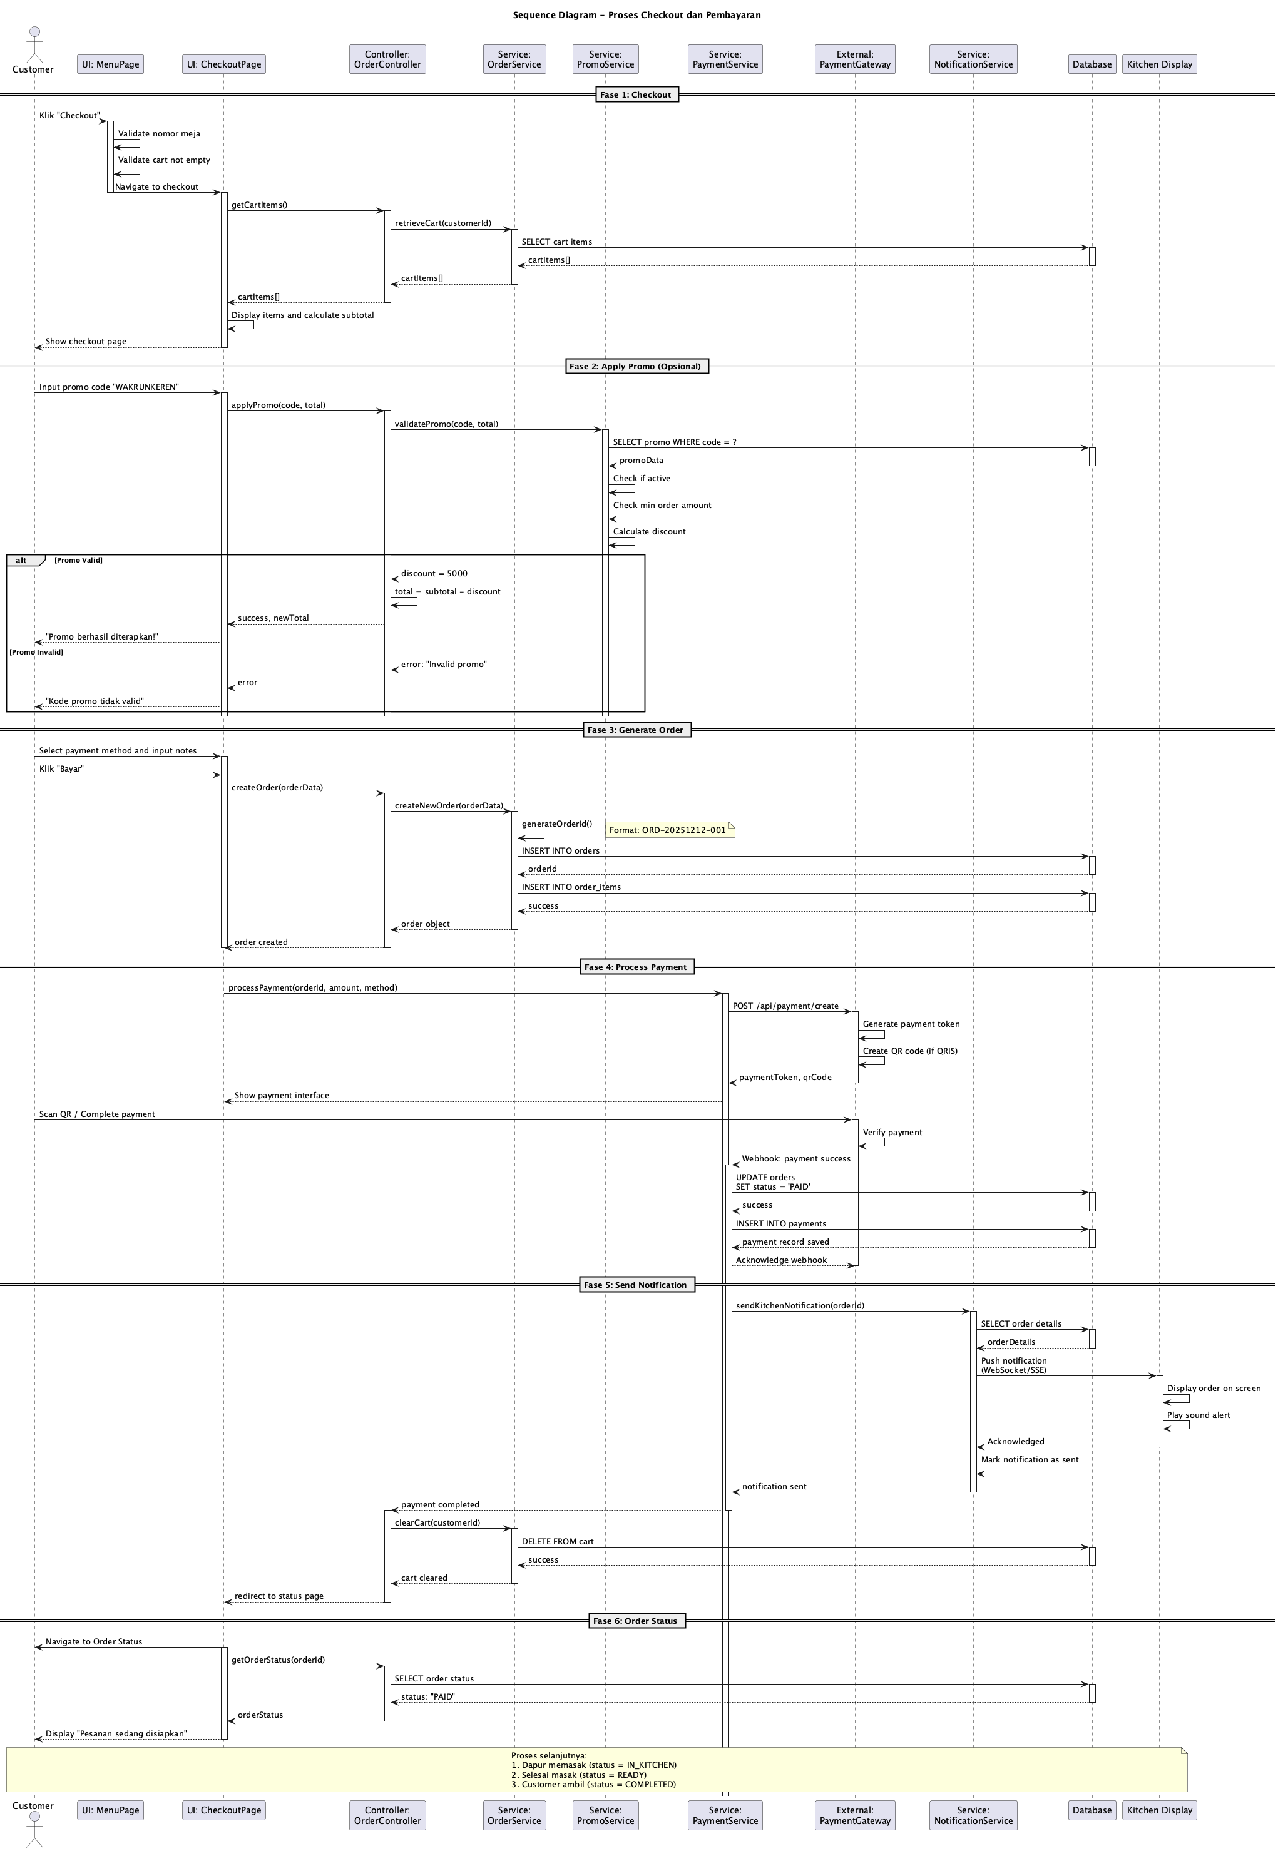
Gambar: Sequence Overall

Keterangan: Complete sequence dari checkout hingga kitchen notification. Dipecah menjadi 5 fase untuk detail.

3.4.1 Checkout & Cart Retrieval

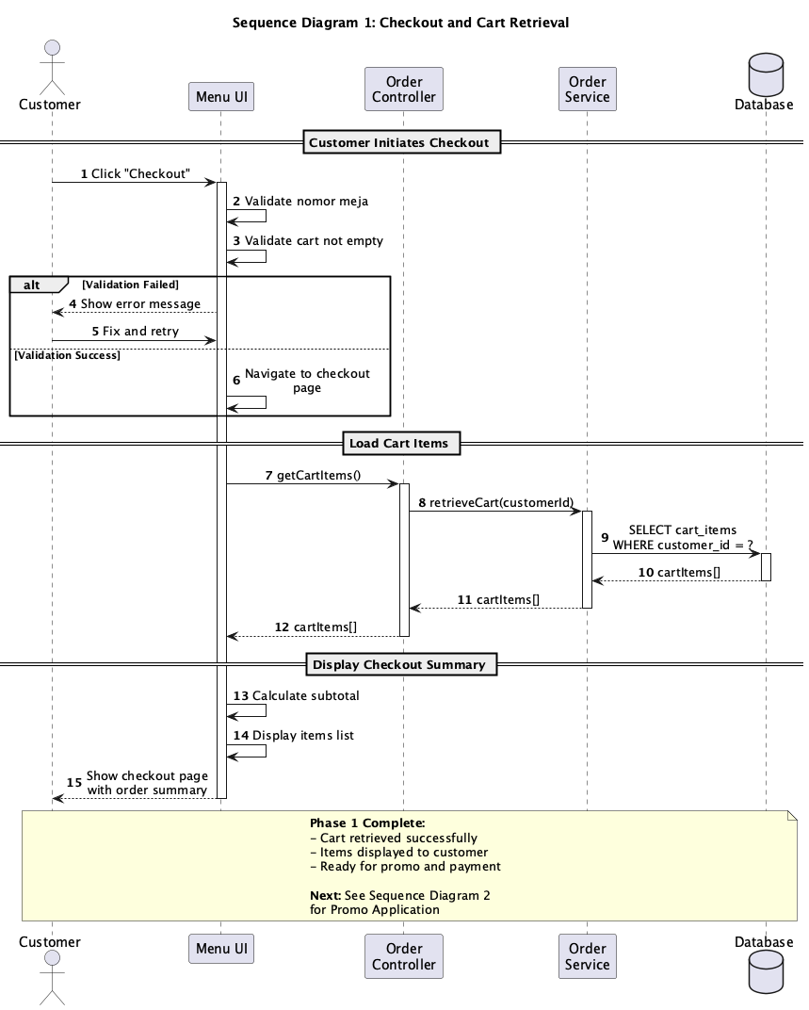
Gambar: Sequence Checkout

Participants: Customer, UI, OrderController, OrderService, Database
Flow:
• Customer clicks Checkout
• UI validates (table number, cart not empty)
• Navigate to checkout page
• Retrieve cart items from database
• Calculate subtotal
• Display checkout summary
Messages: 8 synchronous , 2 validation checks

3.4.2 Promo Application

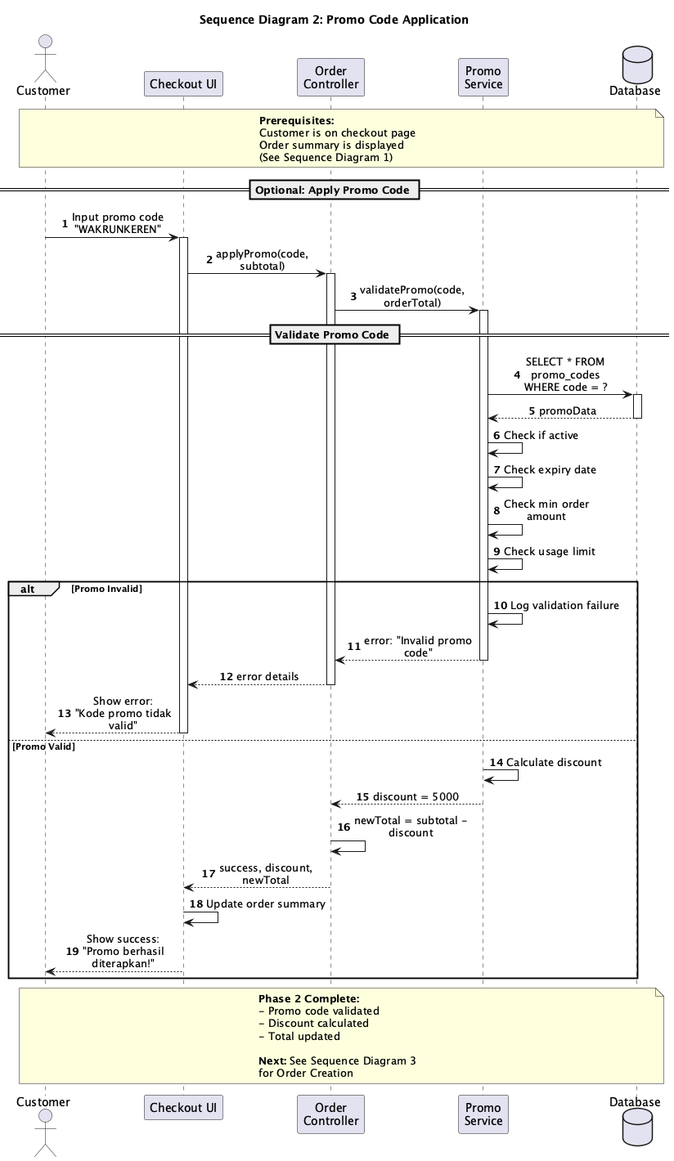
Gambar: Sequence Promo

Participants: Customer, UI, OrderController, PromoService, Database
Flow:
• Customer inputs promo code
• Validate promo (active, not expired, min amount)
• alt: Valid → calculate discount, update total
• alt: Invalid → show error message
Validation Checks:
• Promo active status
• Expiry date
• Minimum order amount
• Usage limit

3.4.3 Order Creation

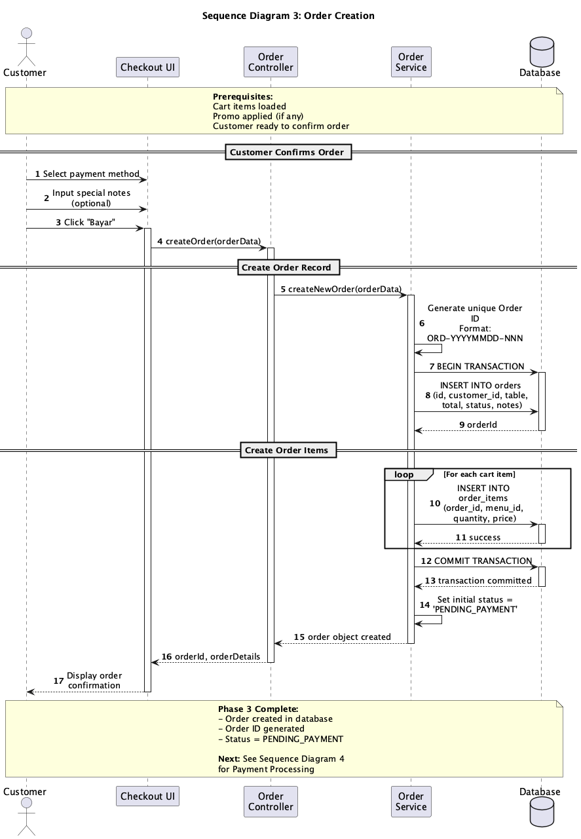
Gambar: Sequence Order Creation

Participants: Customer, UI, OrderController, OrderService, Database
Flow:
• Customer selects payment method & adds notes
• Generate unique Order ID
• Database transaction BEGIN
• INSERT order record
• INSERT order items (loop)
• COMMIT transaction
• Set status = PENDING_PAYMENT
Transaction Safety: All-or-nothing dengan database transaction

3.4.4 Payment Processing

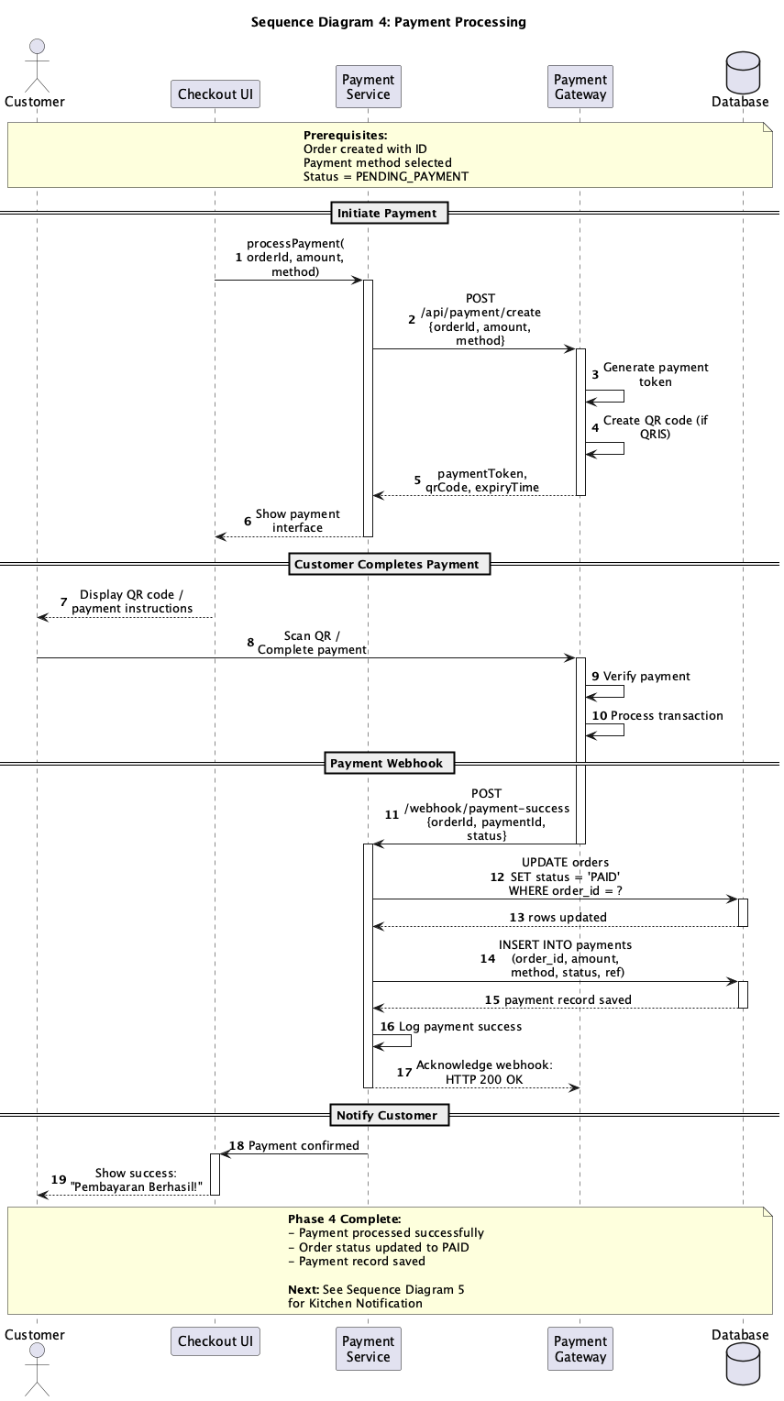
Gambar: Sequence Payment

Participants: Customer, UI, PaymentService, PaymentGateway, Database
Flow:
• Initiate payment request
• Gateway generates payment token & QR
• Customer completes payment
• Gateway verifies & sends webhook
• Update order status = PAID
• Save payment record
Async: Webhook dari payment gateway handled asynchronously

3.4.5 Kitchen Notification

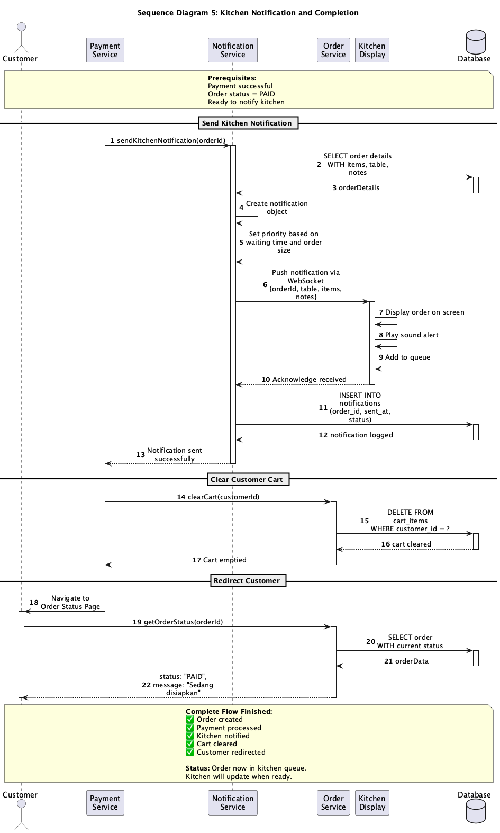
Gambar: Sequence Notification

Participants: PaymentService, NotificationService, Database, Kitchen Display, OrderService, Customer
Flow:
• Send kitchen notification with order details
• Push via WebSocket to kitchen display
• Kitchen acknowledges
• Clear customer cart
• Redirect customer to status page
Parallel: Notification, cart clear, dan redirect happen concurrently

3.5 COMMUNICATION DIAGRAM
Penanggung Jawab:
• Desainer: Indra Gunawan
• Reviewer: Joko Widodo
• Tanggal: 12 Desember 2025
Deskripsi
Communication Diagram menunjukkan hubungan struktural antar objek dan urutan message passing menggunakan numbering 1, 2, 2.1, 2.2, dst.
Diagram

Gambar: Communication

Object Collaboration
• Customer ↔ CheckoutUI
• CheckoutUI ↔ OrderController
• OrderController ↔ OrderService, PromoService, PaymentService
• Services ↔ Database
• PaymentService ↔ Payment Gateway
Message Numbering
• Customer initiates checkout
• UI validates and retrieves cart
2.1 Get cart items
2.2 Display summary
• Customer applies promo
3.1 Validate promo
3.2 Calculate discount
• Customer confirms order
4.1 Create order
4.2 Process payment
4.2.1 Generate QR
4.2.2 Verify payment
4.3 Send notifications

3.6 TIMING DIAGRAM
Penanggung Jawab:
• Desainer: Kartika Sari
• Reviewer: Lukman Hakim
• Tanggal: 12 Desember 2025
Deskripsi
Timing Diagram menggambarkan perubahan state sistem terhadap waktu, menunjukkan sinkronisasi dan duration setiap proses.
Diagram

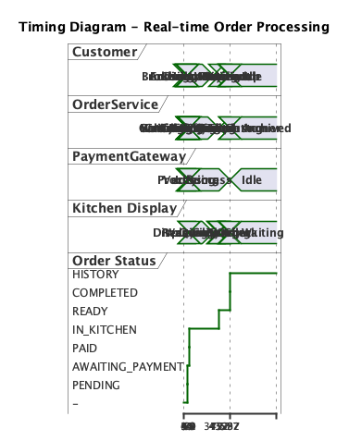
Gambar: Timing

Timeline Analysis
Time | Customer | OrderService | PaymentGateway | Kitchen | OrderStatus
T+0s | Checkout | Ready | Ready | Idle | -
T+5s | Waiting | Processing | Idle | Idle | PENDING
T+10s | Paying | Waiting | Processing | Idle | PENDING
T+30s | Paid | Completed | Completed | Notified | PAID
T+35s | Waiting | Idle | Idle | Cooking | IN_KITCHEN
T+6m | Waiting | Idle | Idle | Cooking | IN_KITCHEN
T+8m | Notified | Idle | Idle | Ready | READY
T+9m | Picking | Idle | Idle | Serving | READY
T+10m | Done | Idle | Idle | Idle | COMPLETED

Total Duration: ~10 minutes dari checkout sampai completed
Critical Paths:
• Payment: 25 seconds (checkout → paid)
• Cooking: 6 minutes (paid → ready)
• Pickup: 2 minutes (ready → completed)

3.13 INTERACTION OVERVIEW DIAGRAM
Penanggung Jawab:
• Desainer: Maya Puspita
• Reviewer: Nanda Permana
• Tanggal: 12 Desember 2025
Deskripsi
Interaction Overview Diagram menggabungkan activity diagram dengan sequence diagram references, menunjukkan high-level flow dengan detail interactions.
Diagram

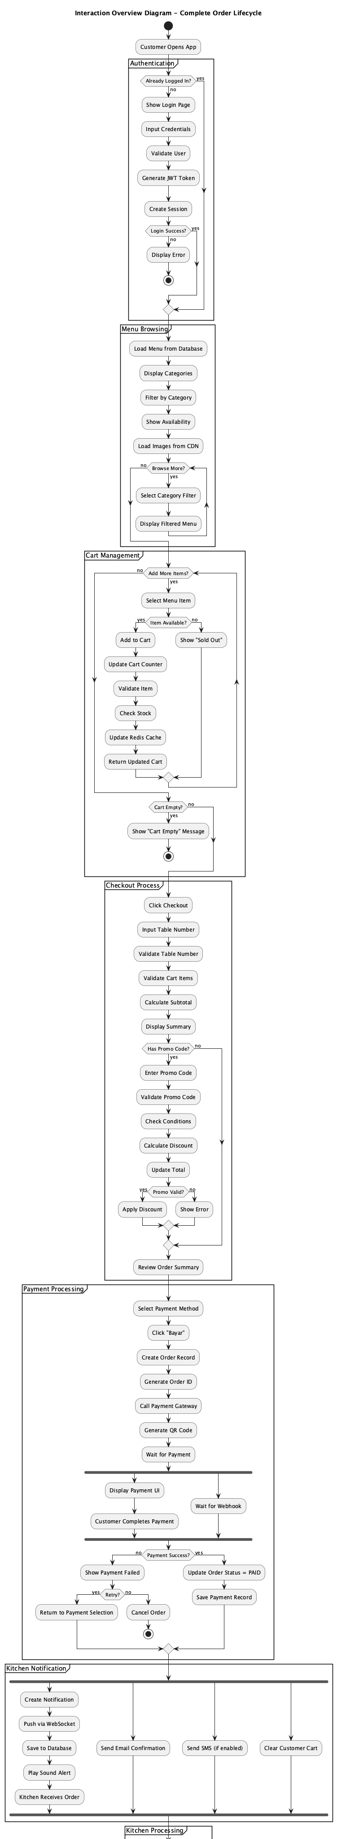
Gambar: Interaction Overview

Flow Partitions
• Authentication: Login/register
• Menu Browsing: View dan select items
• Cart Management: Add/update cart
• Checkout: Review dan confirm
• Payment: Process payment (ref: Sequence 04d)
• Kitchen Notification: Send to kitchen (ref: Sequence 04e)
• Kitchen Processing: Cook food
• Completion: Serve dan complete
Referenced Diagrams
• Sequence Diagram 04d for payment detail
• Sequence Diagram 04e for notification detail
• Activity Diagram 02c for kitchen processing

BAB IV
DIAGRAM STRUCTURAL

Diagram structural menggambarkan arsitektur statis sistem, organisasi komponen, dan relationships.

4.1 CLASS DIAGRAM
Penanggung Jawab:
• Desainer: Omar Faruq
• Reviewer: Prima Rahardja
• Tanggal: 12 Desember 2025
Deskripsi Overall
Class Diagram menggambarkan struktur logis sistem dengan classes, attributes, methods, dan relationships (association, aggregation, composition, inheritance).
Diagram Overall

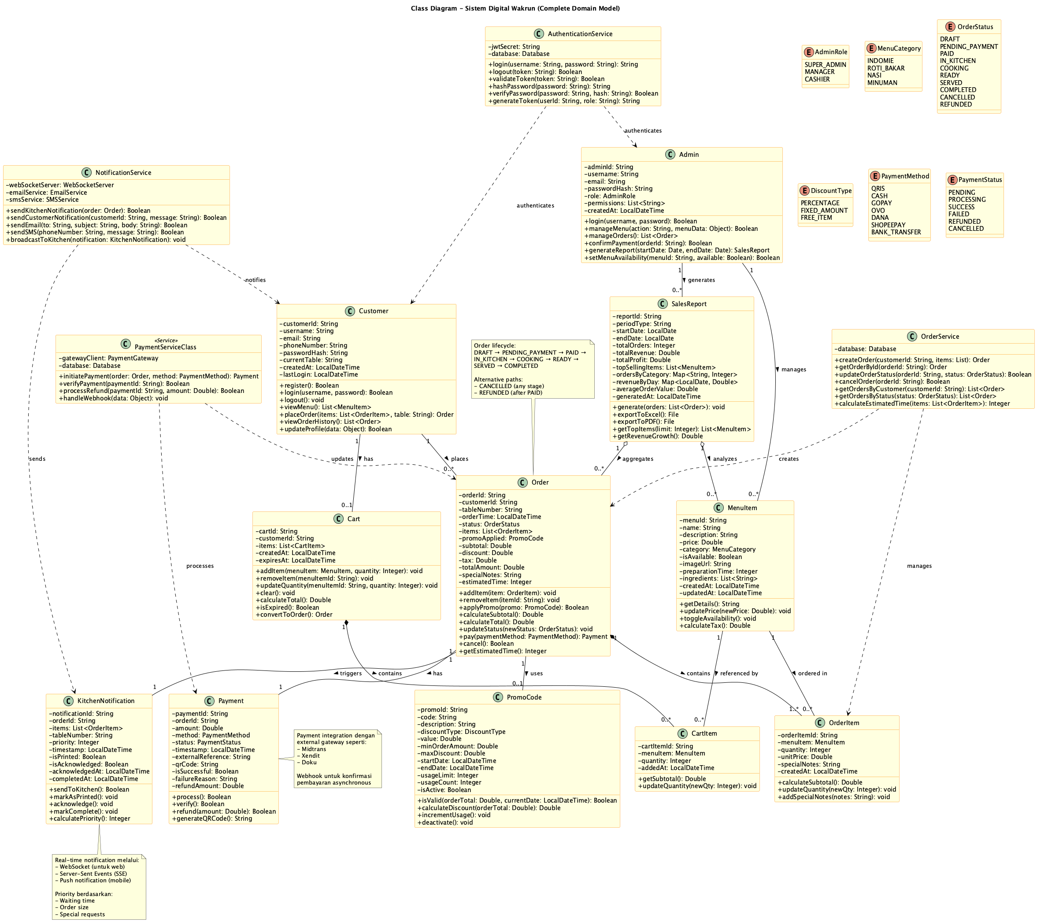
Gambar: Class Overall

Keterangan: Complete domain model dengan 15+ classes. Dipecah per domain untuk clarity.

4.1.1 Core Domain Model

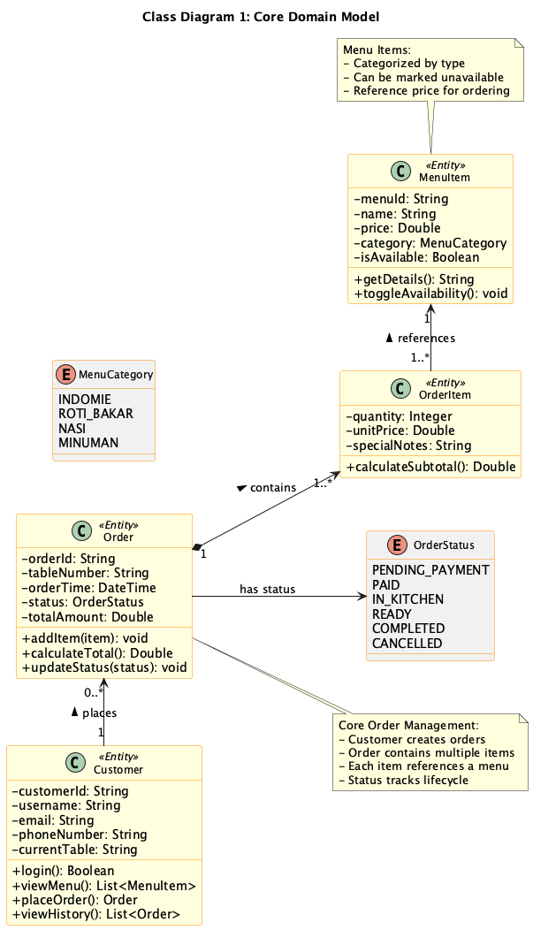
Gambar: Class Core

Entities:
Customer
Order
OrderItem
MenuItem
Relationships:
• Customer 1 → 0..* Order
• Order 1 → 1.. OrderItem (composition)
• OrderItem 1..* → 1 MenuItem

4.1.2 Payment & Promo Domain

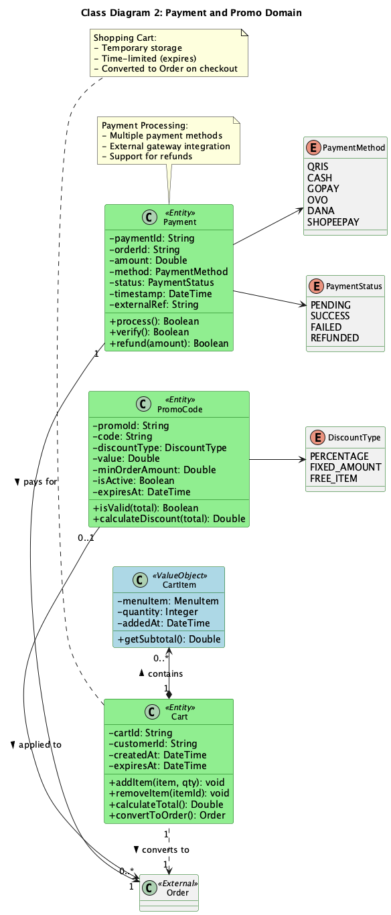
Gambar: Class Payment

Entities:
Payment
PromoCode
Cart
Enums:
• PaymentMethod: QRIS, CASH, GOPAY, OVO, DANA
• PaymentStatus: PENDING, SUCCESS, FAILED, REFUNDED
• DiscountType: PERCENTAGE, FIXED_AMOUNT, FREE_ITEM

4.1.3 Kitchen & Notification

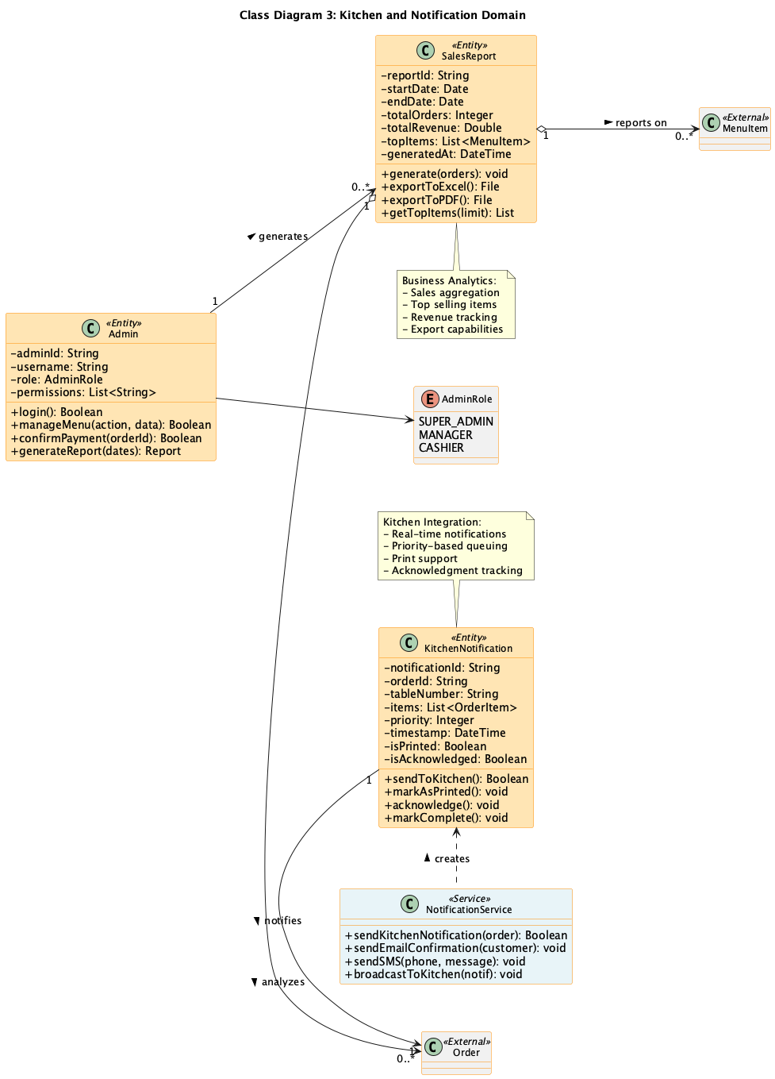
Gambar: Class Kitchen

Entities:
KitchenNotification
SalesReport
Admin

4.1.4 Service Layer

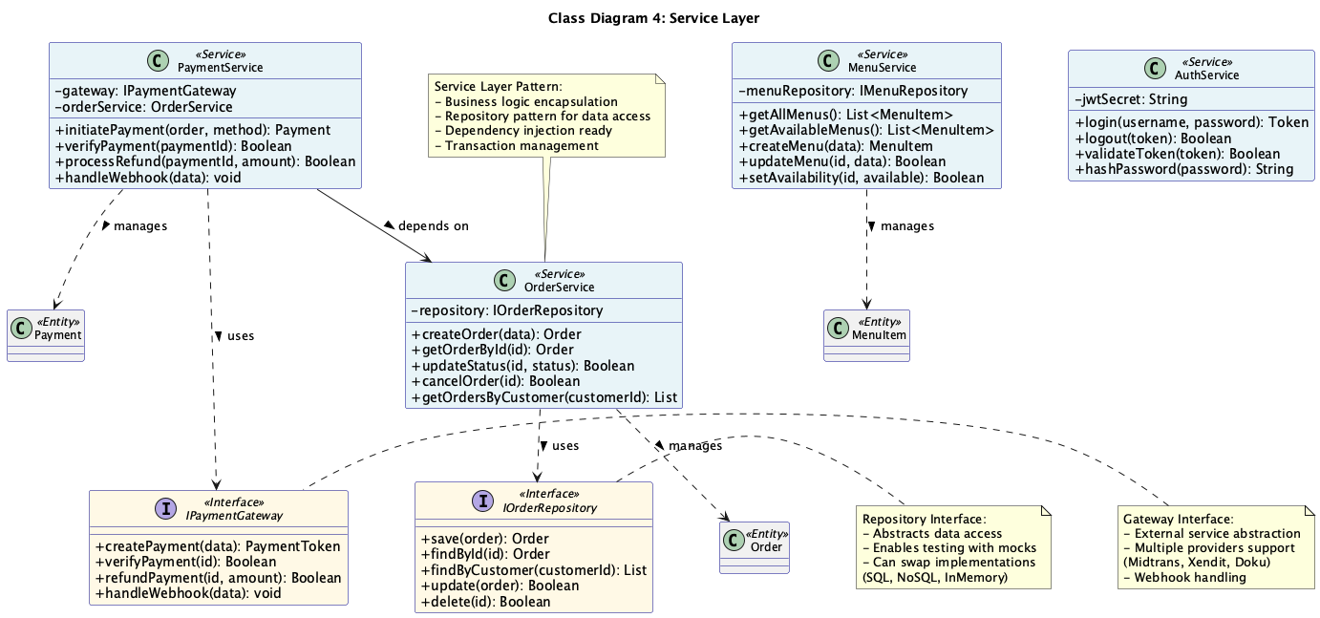
Gambar: Class Services

Interfaces:
• IOrderRepository
• IPaymentGateway
• IMenuRepository
Services:
OrderService
PaymentService
AuthService
Pattern: Repository and Gateway patterns untuk data access abstraction

4.2 OBJECT DIAGRAM
Penanggung Jawab:
• Desainer: Qori Ananda
• Reviewer: Rina Marlina
• Tanggal: 12 Desember 2025
Deskripsi
Object Diagram menunjukkan concrete instances dari classes pada waktu tertentu, dengan actual data values.
Diagram

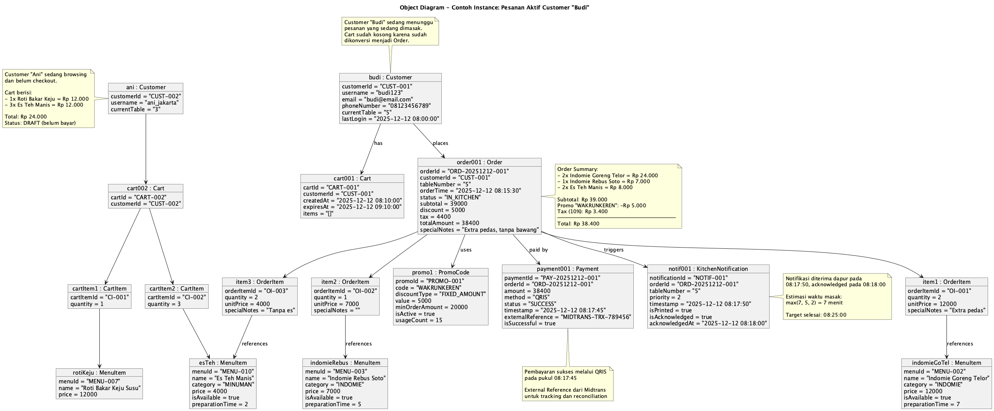
Gambar: Object

Scenarios
Scenario 1: Active Order (Budi)
Scenario 2: Browsing (Ani)

4.3 COMPONENT DIAGRAM
Penanggung Jawab:
• Desainer: Satria Buana
• Reviewer: Taufik Rahman
• Tanggal: 12 Desember 2025
Diagram Overall

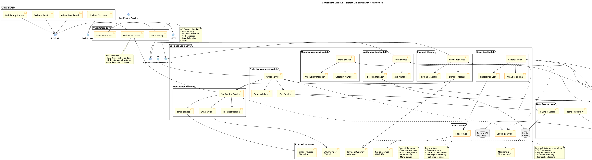
Gambar: Component Overall

4.3.1 High-Level Architecture

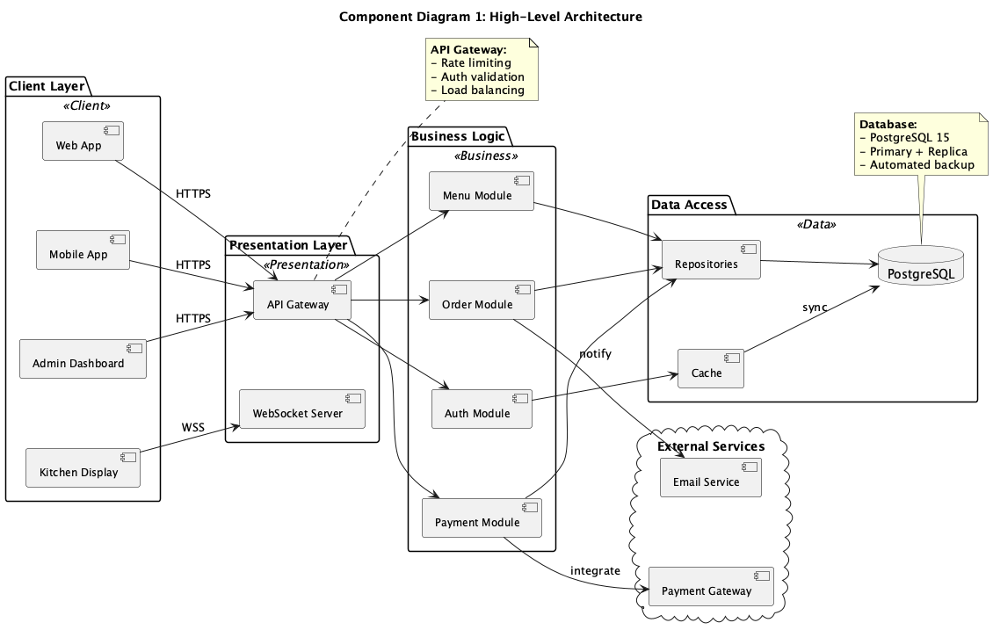
Gambar: Component High-Level

Layers:
• Client Layer: Web App, Mobile App, Admin Dashboard
• Presentation: API Gateway, WebSocket Server
• Business Logic: Order, Payment, Menu, Auth modules
• Data Access: Repositories, ORM, Cache
• External Services: Payment Gateway, Email
4-Tier Architecture dengan clear separation of concerns

4.3.2 Business Logic Detail

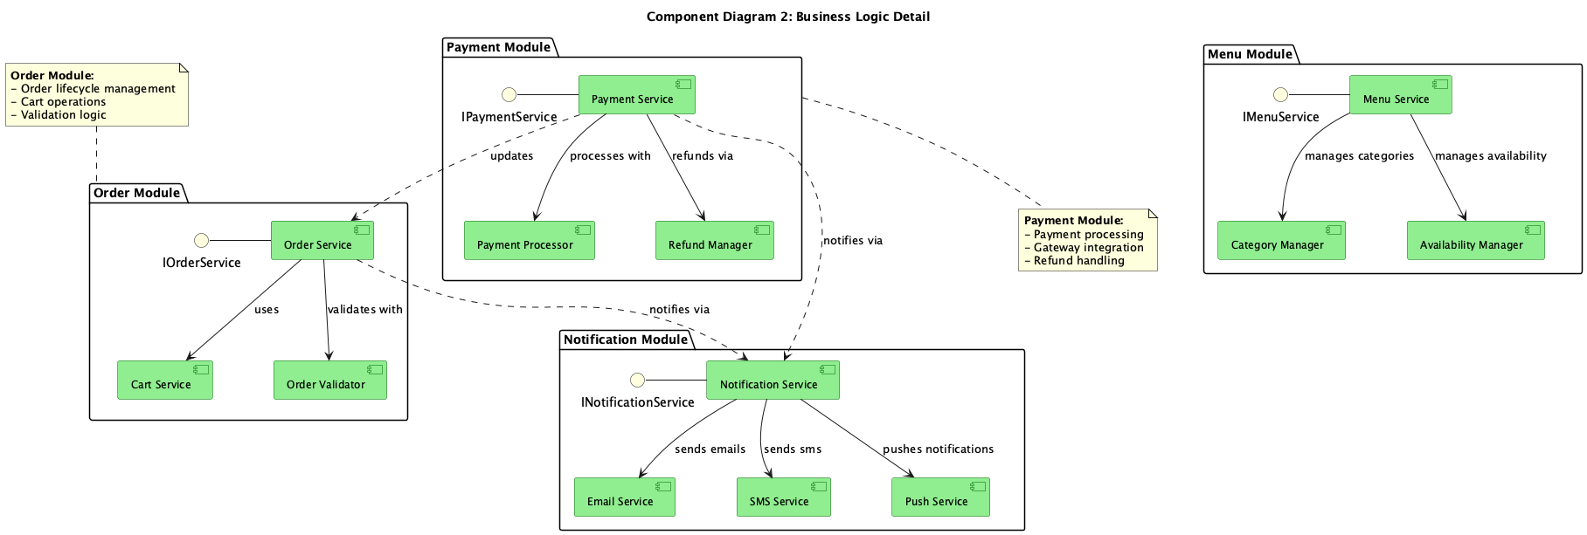
Gambar: Component Business

Modules:
Order Module:
• OrderService, CartService, OrderValidator
Payment Module:
• PaymentService, PaymentProcessor, RefundManager
Menu Module:
• MenuService, CategoryManager, AvailabilityManager
Notification Module:
• NotificationService, EmailService, SMSService, PushService
Inter-module: Service dependencies via interfaces

4.4 COMPOSITE STRUCTURE DIAGRAM
Penanggung Jawab:
• Desainer: Umar Bakri
• Reviewer: Vina Wati
• Tanggal: 12 Desember 2025
Deskripsi
Composite Structure menunjukkan internal architecture dari OrderService component, dengan ports, parts, dan connectors.
Diagram

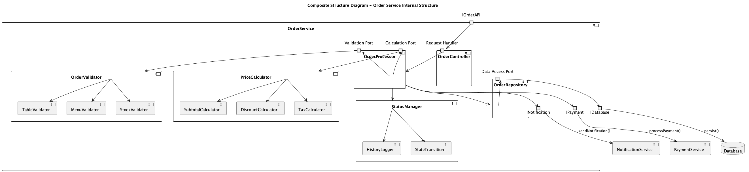
Gambar: Composite

Internal Parts
• OrderController: Entry point, routing
• OrderProcessor: Business logic orchestration
• OrderValidator: Validation rules
• PriceCalculator: Price calculations
• StatusManager: State management
• OrderRepository: Data persistence
Ports
• portin API: Receives requests
• portout Database: Data access
• portout Notification: Send notifications
• portout Payment: Payment integration

4.5 PACKAGE DIAGRAM
Penanggung Jawab:
• Desainer: Wahyu Nugroho
• Reviewer: Xena Kartika
• Tanggal: 12 Desember 2025
Diagram Overall

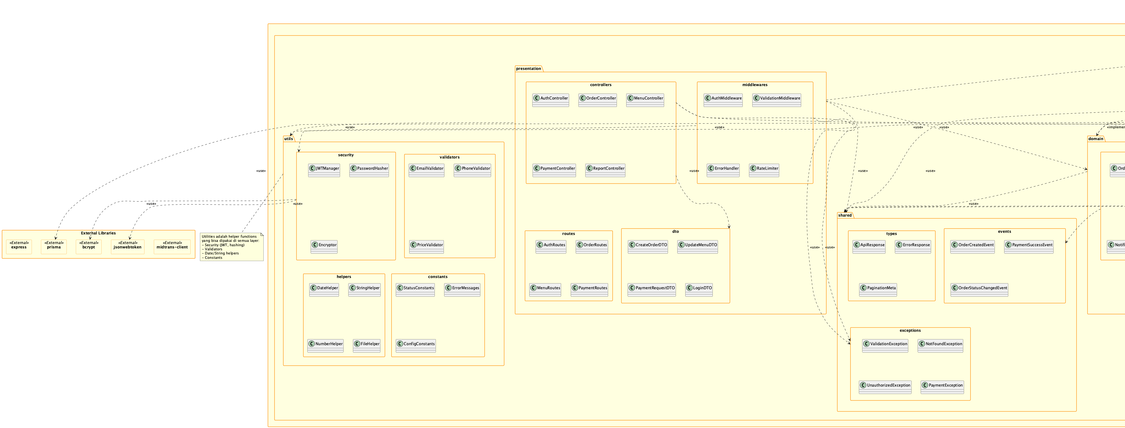
Gambar: Package Overall

4.5.1 Top-Level Organization

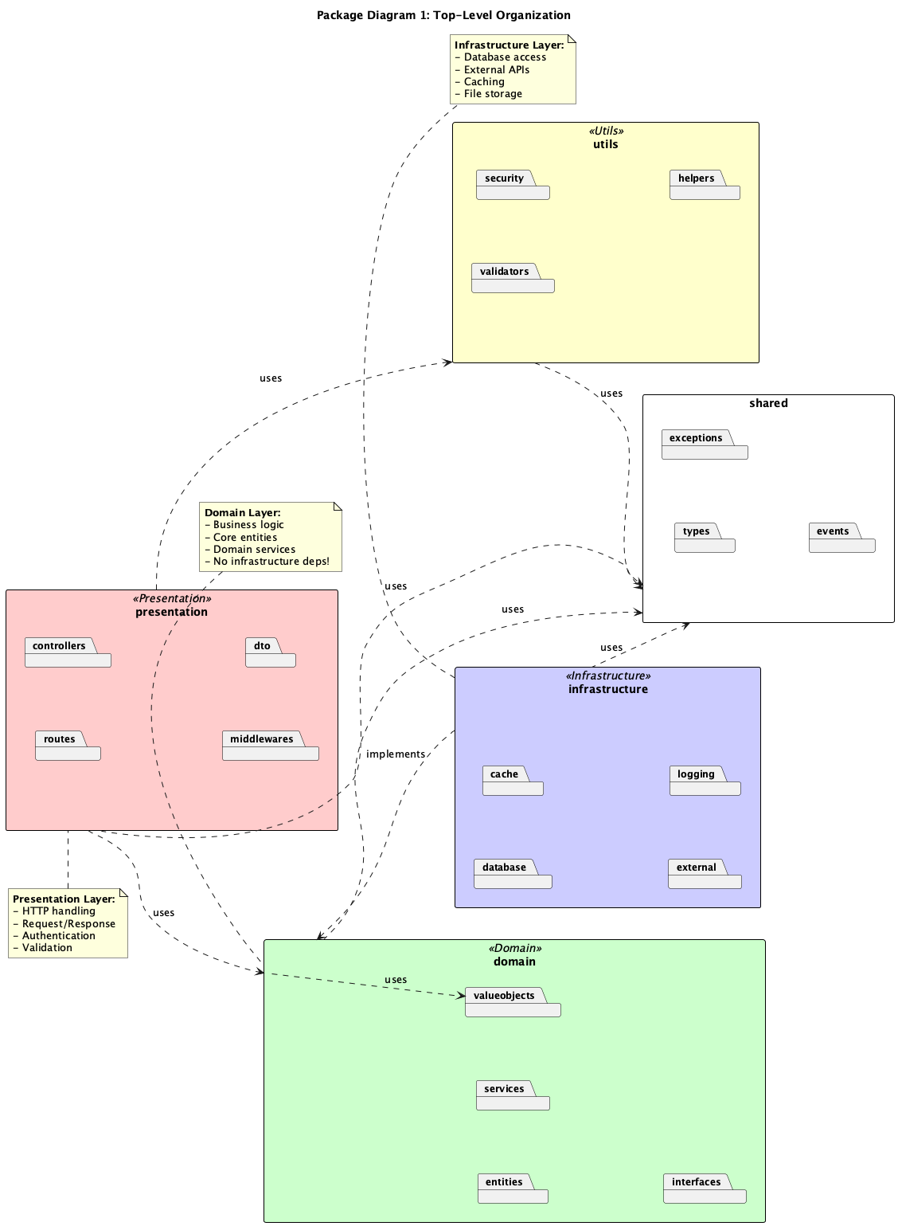
Gambar: Package Top

Packages:
• presentation: Controllers, routes, DTO
• domain: Entities, services, interfaces
• infrastructure: Database, cache, external
• utils: Security, validators, helpers
• shared: Types, exceptions, events
Dependencies: Presentation → Domain ← Infrastructure

4.5.2 Domain Detail

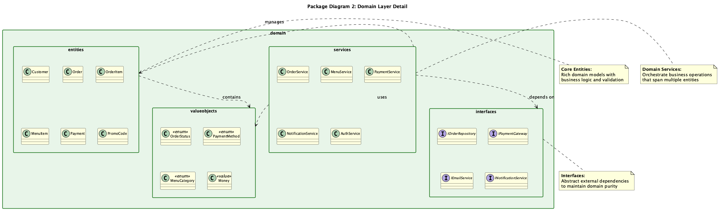
Gambar: Package Domain

Sub-packages:
• entities: Customer, Order, MenuItem, Payment
• services: OrderService, PaymentService, MenuService
• interfaces: IOrderRepo, IPaymentGateway
• valueobjects: Money, OrderStatus, etc.

4.6 DEPLOYMENT DIAGRAM
Penanggung Jawab:
• Desainer: Yudi Hartono
• Reviewer: Zahra Amelia
• Tanggal: 12 Desember 2025
Deskripsi
Deployment Diagram menggambarkan infrastructure fisik production environment.
Diagram

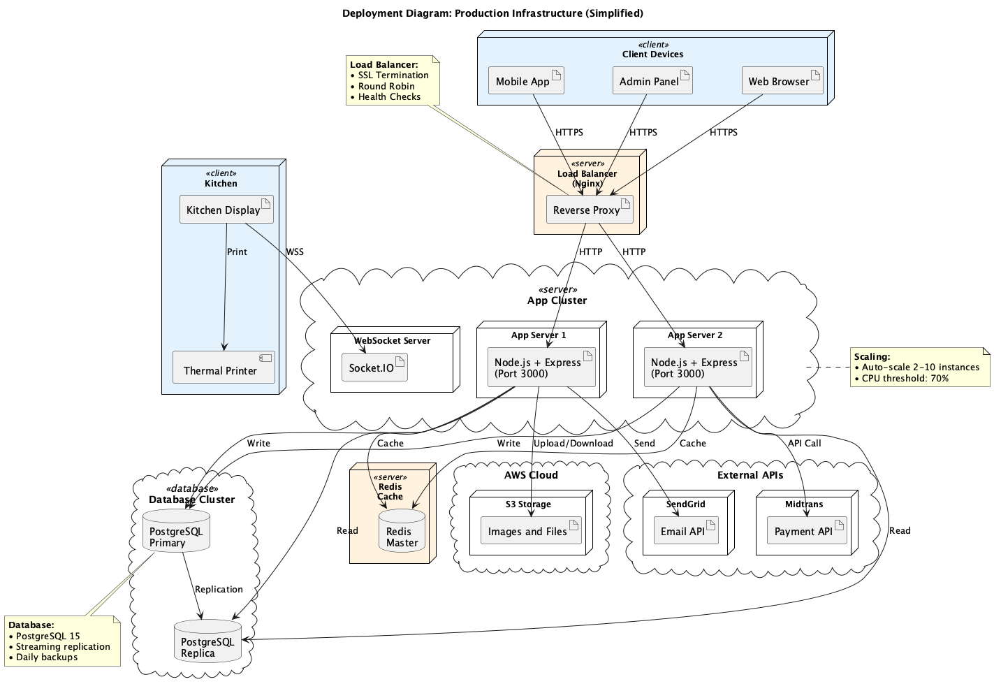
Gambar: Deployment

Infrastructure
Client Tier:
• Web Browser, Mobile App, Admin Panel, Kitchen Display
Load Balancer:
• Nginx (SSL termination, round-robin)
Application Tier:
• 2+ Node.js servers (auto-scale)
• WebSocket server (Socket.IO)
Database Tier:
• PostgreSQL Primary + Replica (streaming replication)
Cache Tier:
• Redis Master + Replica
Storage:
• AWS S3 (images, reports)
• CloudFront CDN
External:
• Midtrans Payment Gateway
• SendGrid Email Service
Monitoring:
• Prometheus, Grafana, ELK Stack

4.7 PROFILE DIAGRAM
Penanggung Jawab:
• Desainer: Adinda Putri
• Reviewer: Bagus Setiawan
• Tanggal: 12 Desember 2025
Deskripsi
Profile Diagram mendefinisikan UML extensions untuk Food & Beverage domain.
Diagram

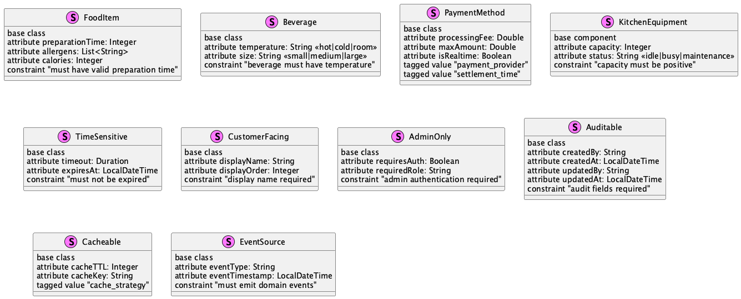
Gambar: Profile

Stereotypes Defined
<<FoodItem>>:
• preparationTime: Integer
• allergens: List
<<Beverage>>:
• temperature: Enum
• size: Enum
<<PaymentMethod>>:
• processingFee: Double
• maxAmount: Double
<<TimeSensitive>>:
• timeout: Duration
• expiresAt: DateTime
<<Cacheable>>:
• cacheTTL: Integer
<<EventSource>>:
• eventType: String
Applications:
• MenuItem <<FoodItem, CustomerFacing, Cacheable>>
• Order <<TimeSensitive, EventSource, Auditable>>
• Payment <<PaymentMethod, EventSource>>

BAB V
KESIMPULAN

5.1 Ringkasan
Perancangan Sistem Digital Wakrun telah didokumentasikan secara komprehensif menggunakan 14 jenis diagram UML yang mencakup aspek behavioral dan structural.
Diagram Behavioral (7): Use Case, Activity, State Machine, Sequence, Communication, Timing, Interaction Overview
Diagram Structural (7): Class, Object, Component, Composite Structure, Package, Deployment, Profile
5.2 Dokumentasi yang Dihasilkan
• 30 diagram files (.puml)
• 30 diagram images (PNG)
• Laporan perancangan lengkap
5.3 Next Steps
• Review & Validation: Tim review semua diagram
• Export Images: Generate PNG dari semua .puml
• Implementation: Mulai development berdasarkan design
• Testing: Unit, integration, system testing
• Deployment: Setup production infrastructure

BAB VI
APPENDIX

6.1 Daftar Diagram
Total: 30 diagram files, 14 types
No | Diagram Type | Files | Penanggung Jawab
1 | Use Case | 1 | Ana Kusuma
2 | Activity | 4 | Citra Dewi
3 | State Machine | 1 | Eko Prasetyo
4 | Sequence | 6 | Gita Maharani
5 | Communication | 1 | Indra Gunawan
6 | Timing | 1 | Kartika Sari
7 | Class | 5 | Omar Faruq
8 | Object | 1 | Qori Ananda
9 | Component | 3 | Satria Buana
10 | Composite | 1 | Umar Bakri
11 | Package | 3 | Wahyu Nugroho
12 | Deployment | 1 | Yudi Hartono
13 | Interaction | 1 | Maya Puspita
14 | Profile | 1 | Adinda Putri

6.2 Referensi
• UML 2.5 Specification - OMG
• PlantUML Documentation
• Clean Architecture - Robert C. Martin
• Domain-Driven Design - Eric Evans

Prepared by: Tim Perancang Sistem Digital Wakrun
Date: 12 Desember 2025
Version: 1.0
Status: Final

