**Competition leads to phylogenetic divergence in plant community of an unmanaged lawn recovering from herbicide spray**

**Introduction**

Herbicides shape plant community dynamics by differentially affecting species' survival, growth, and recovery, thereby altering taxonomic and functional composition. Some plant species demonstrate resilience and recover rapidly after herbicide exposure, while others fail to re-establish. Environmental conditions, resource availability, and species-specific phenotypic traits may influence these differential responses. However, the extent to which evolutionary history shapes these responses amidst other competing factors is still debated.

Phylogenetic conservatism, the tendency of closely related species to share similar ecological traits and niches due to their shared evolutionary history, is important to understanding species assembly and biodiversity patterns. Closely related plant species often share phenotypic traits, which could result in similar levels of resilience or susceptibility to disturbance. However, there is evidence to the contrary: Close relatives might not respond similarly to anthropic activities if competition between similar species takes a toll on the locally coexisting species. This is largely due to Darwin’s (1859) suggestion: species sharing close evolutionary relationships are more similar and compete more intensely with one another than with more distant species. This principle is referred to as the competition-relatedness hypothesis and is supported by the theory of limiting similarity (MacArthur & Levins 1967), which emphasizes that species must differ in their ecological niches to coexist locally. If species are too alike, the one with a competitive disadvantage will be driven towards depletion (or a worst case: extinction) due to competitive exclusion. This is more commonly referred to as the competitive exclusion principle. As a result, competition among closely related species may counteract phylogenetic conservatism. If related plant species experience stronger competition with one another than with more distantly related species, herbicide resilience within a closely knit clade could lead to intense intra-clade competition, ultimately favoring the persistence of more distantly related species. Thus, competition could promote phylogenetic divergence in herbicide resilience, counteracting expectations of strict phylogenetic conservatism.

Despite extensive research on plant-herbicide interactions, the role of phylogenetic relatedness in shaping plant species’ responses to disturbances from herbicide application remains understudied. Understanding whether plant responses to herbicide application—survival and/or recovery—are phylogenetically conserved (or not) can provide valuable insights into community assembly and species coexistence in disturbed environments. Identifying the balance between evolutionary constraints and competitive interactions in shaping plant community responses can provide valuable insights for ecological management and conservation in both natural and human-influenced landscapes.

This study aims to assess the phylogenetic conservatism of plant responses to herbicide application in an unmanaged lawn. Specifically, I will determine whether closely related species exhibit similar survival and recovery patterns, as reflected in changes in their percentage ground cover over time. For this study, ground cover would be regarded as the living (green) plants as seen from a vertical aerial observation. In a dense grass community, the (percentage) ground cover is a good way to learn how much competitive ground a plant species has (Anderson, 1986; Damgaard, 2011). In limited space, ground coverage is a zero-sum game; plants that take higher cover have more access to sunlight and also consequentially deprive other plants of space and sunlight. If phylogenetic conservatism influences herbicide resilience, I expect closely related plant species to exhibit similar responses immediately following herbicide application, leading to increased phylogenetic clustering among surviving species. However, as ground cover increases during post-spray (recovery), competitive interactions may disrupt this pattern, leading to greater phylogenetic divergence over time. If competition structures communities, then the co-existing plants should be less related than expected by chance. By examining how phylogenetic relatedness influences plant survival and recovery in response to herbicide disturbance, this study will contribute to a broader understanding of species persistence in dynamic environments.

**Materials and Methods**

**Study site**

The study was conducted within a 12-week period from January to April 2023 on an enclosed lawn behind Egborge Museum at the University of Benin, Benin City, Nigeria, located at a longitude of 6.392 N and a latitude of 5.613 E. The university is in southern Nigeria, which is characterized by a tropical rainforest environment. As shown in Figure 1, the site measures 23.77 m by 11.58 m. During the survey, mean ambient hourly temperatures ranged from 25 to 34 °C (Accuweather, 2023).

After a pre-spray sampling plant cover from the study site, the plot was treated with a non-selective systemic herbicide, Forceup™, containing glyphosate as the active ingredient. To assess the impact of glyphosate on the plant community, a recommended dose of 6L/ha was applied on ……… using a manually pressurized, two-liter, handheld sprayer to treat the entire study site with a 48 ml glyphosate solution per liter of water.

**Data collection and experimental plot**

The site would be divided into six plots (A-F; Figure 1) to allow for independent replication and to observe potential spatial autocorrelation in the data. Though each plot contained six subplots, data will be aggregated at the plot level to reduce random noise. Plant data would be collected over approximately 11 weeks, specifically at weeks 0 (pre-spray), 3, 6, 9, and 11.

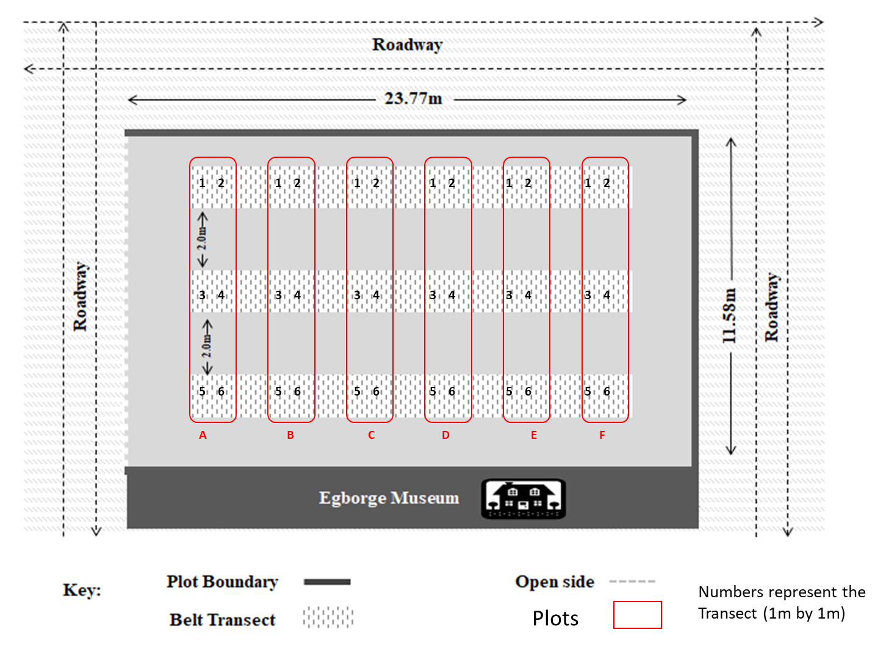

Figure 1: Experimental plot, adapted from Osawe N.E.'s undergraduate thesis (2023)

**Phylogenetic and statistical analysis**

Phylogenetic trees of lawn plants were assembled using the “V.PhyloMaker” R package. This package matches the taxonomic names of our study plant species to a backbone phylogeny derived from the Global Backbone of Tree for Biodiversity (GBOTB) with extended coverage (Jin & Qian, 2019). This approach allows for the inclusion of species that may not be present in the reference phylogeny by placing them within their most likely evolutionary position.

Phylogenetic distances were computed in R and matched with longitudinal percentage ground cover data. To estimate phylogenetic conservatism (or divergence), we will use Blomberg's K statistic. Blomberg’s K was used as a metric of phylogenetic signal, where K is calculated as the ratio of the observed phylogenetically correct mean-square error divided by the mean-square error of the data, standardized by the expectation under Brownian motion (Blomberg et al. 2003). K = 0 indicates no phylogenetic signal, 0 < K < 1 indicates that closely related species resemble each other less than expected under the BM model of trait evolution, K = 1 indicates phylogenetic signal as expected by BM evolution, and K > 1 indicates high phylogenetic signal, with closely related species resembling each other more than expected under BM (Blomberg et al., 2003).

We tested for significant phylogenetic signal, relative to a random distribution of the traits observed, given the topology and branch lengths of the ML phylogeny, with 999 replicates. Welch’s t-tests would be used to assess significant differences in the effect of spraying on [1] Blomberg's K values and [2] the plant ground cover (%) before and after spraying. Furthermore, an orthogonal polynomial mixed-effects model would be used to examine the relationship between the plant’s ground cover (%) and the strength of phylogenetic signal (measured using Blomberg’s K). Analyses were conducted in R (version 4.4.0.1).

**RESULTS**

The phylogenetic tree is represented in Figure 1.

All plant species from our study belong to 12 distinct species. Their evolutionary tree is shown in Figure 1.

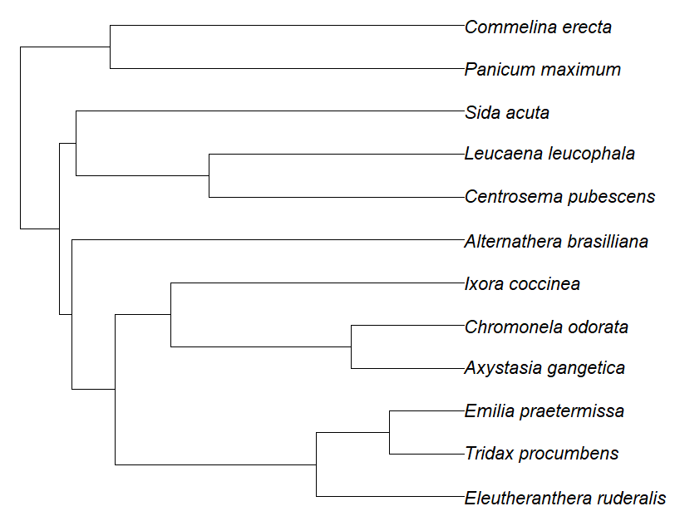

**Figure 1**: Phylogenetic tree showing the evolutionary relationships between the plants in the study.

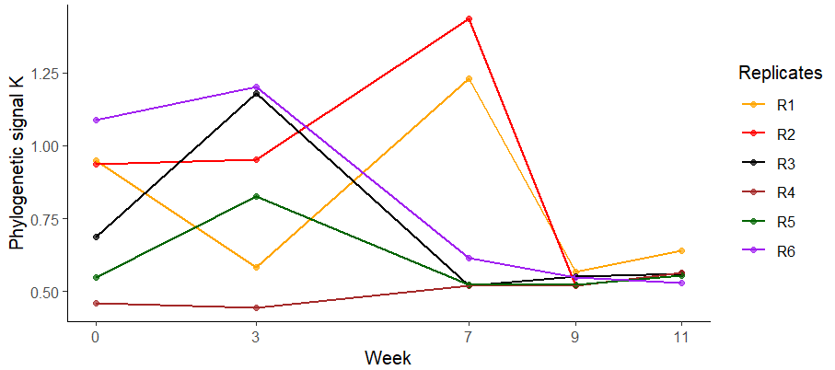

**Figure 2**: Phylogenetic signal (Bloomberg K values) of plants at each survey week. Week 0 is a pre-spray, while weeks 3-11 are post-sprays.

Though plant cover was significantly reduced (t= 3.54, p<0.05) when compared to the immediate survey post-spray (week 3), there was no significant difference (t= -0.52, p>0.1) in the phylogenetic signal between week 0 and 3. This indicates that the spray of herbicide had no significant implication on the plant community structure, despite the high reduction (92.1%) in plant cover following the herbicide spray.

An orthogonal polynomial mixed-effects model was used to assess the relationship between phylogenetic signal and plant ground cover, incorporating a quadratic term to account for potential nonlinear effects. Replicates were included as a random effect to control for variation across experimental units. Random effects analysis indicated that variability among replicates was relatively small. The linear term for ground cover was significantly negative (β = -0.596, SE = 0.225, p = 0.015), suggesting that the phylogenetic signal decreased as plant ground cover increased. However, the quadratic term was marginally significant (β = 0.461, SE = 0.230, p = 0.057), indicating a possible nonlinear relationship, where the phylogenetic signal may initially decline but later stabilize or increase at higher ground cover levels.

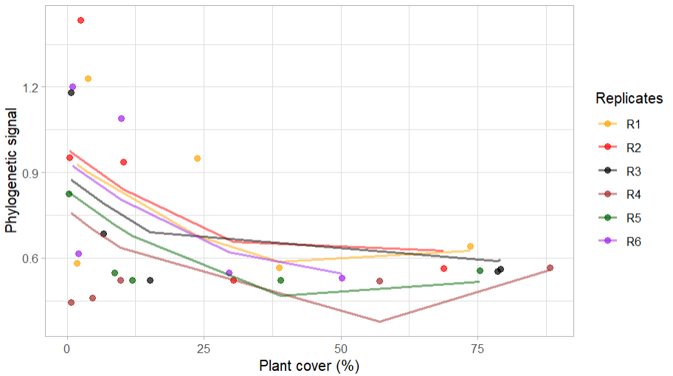

Figure _: Relationship between (strength of) phylogenetic signal and plant cover (%). Each line indicates a different replicate.

**REFERENCES**

Jin, Y., & Qian, H. (2019). V. PhyloMaker: an R package that can generate very large phylogenies for vascular plants. *Ecography*, *42*(8), 1353-1359.

Lovette, I. J., & Hochachka, W. M. (2006). Simultaneous effects of phylogenetic niche conservatism and competition on avian community structure. *Ecology*, *87*(sp7), S14-S28.

Damgaard, C. (2011). Measuring competition in plant communities where it is difficult to distinguish individual plants. *Computational Ecology and Software*, *1*(3), 125-137.

Anderson, E. W. (1986). A guide for estimating cover.