3. Results

3.1 Data Verification and Baseline Reproduction
Prior to analysis, all six spectral data files were verified against sample sizes reported in the figure captions of Ibrahim et al. (2026). Row counts for each file matched the published values exactly: DGRPFTIR.dat (n = 1,772 spectra), SexGenoFTIR.dat (n = 1,684), Diet2FTIR.dat (n = 1,187), AgeFTIR.dat (n = 2,046), Diet-AgeFTIR.dat (n = 1,870), and Diet1FTIR.dat (n = 177). All six files shared an identical wavenumber axis spanning 3,900 to 456 cm⁻¹ at 2 cm⁻¹ intervals (1,723 features per spectrum), confirmed by the data loading pipeline (scripts/ftir_loader.py).
The published classification pipeline was reproduced to confirm computational reproducibility before any new analyses were conducted. Ibrahim et al. (2026) trained a support vector machine (SVM) classifier to distinguish starvation-resistant from starvation-sensitive DGRP lines using their FTIR spectra, reporting reclassification rates of approximately 88% for resistant flies and 84% for sensitive flies. Three compatibility issues were identified in the original notebook arising from library version differences (matplotlib 3.7, numpy 2.x) and resolved in a corrected runner script (scripts/run_dgrp_baseline.py); the statistical logic of the pipeline was not modified. The corrected pipeline reproduced the published result: resistant reclassification 88.5% ± 4.5% (mean ± SD across 20 cross-validation splits), sensitive reclassification 83.9% ± 4.0%, consistent with Ibrahim et al. (2026) to within rounding error.
Starvation resistance scores for all 108 DGRP lines were generated by fitting a parametric survival model to the raw starvation survival data using the published R analysis pipeline (Ibrahim et al., 2026). The model (psm(Surv(time, censor) ~ DGRP, dist = "logistic")) estimated one log-scale estimated marginal mean (EMMean) per DGRP line, with higher values indicating greater starvation resistance. These EMMeans served as the continuous phenotype target for all subsequent regression analyses. External validity of the EMMeans was assessed by comparison against independently measured starvation resistance data from Morgante et al. (2015), retrieved from the DGRPool database (Roux et al., 2024). After correcting a line-identifier normalisation error in the initial overlap calculation (IDs of the form DGRP_021 were not matched to DGRP21 without round-tripping through integer conversion), 104 of the 108 DGRP lines with spectral data were found in the Morgante et al. (2015) dataset. EMMeans and Morgante et al. (2015) female starvation means were positively and significantly correlated across the 104 overlapping lines (Pearson r = 0.428, p = 5.88 × 10⁻⁶), confirming that the EMMeans captured genuine between-line genetic variation in starvation resistance rather than assay-specific noise (Figure 1).
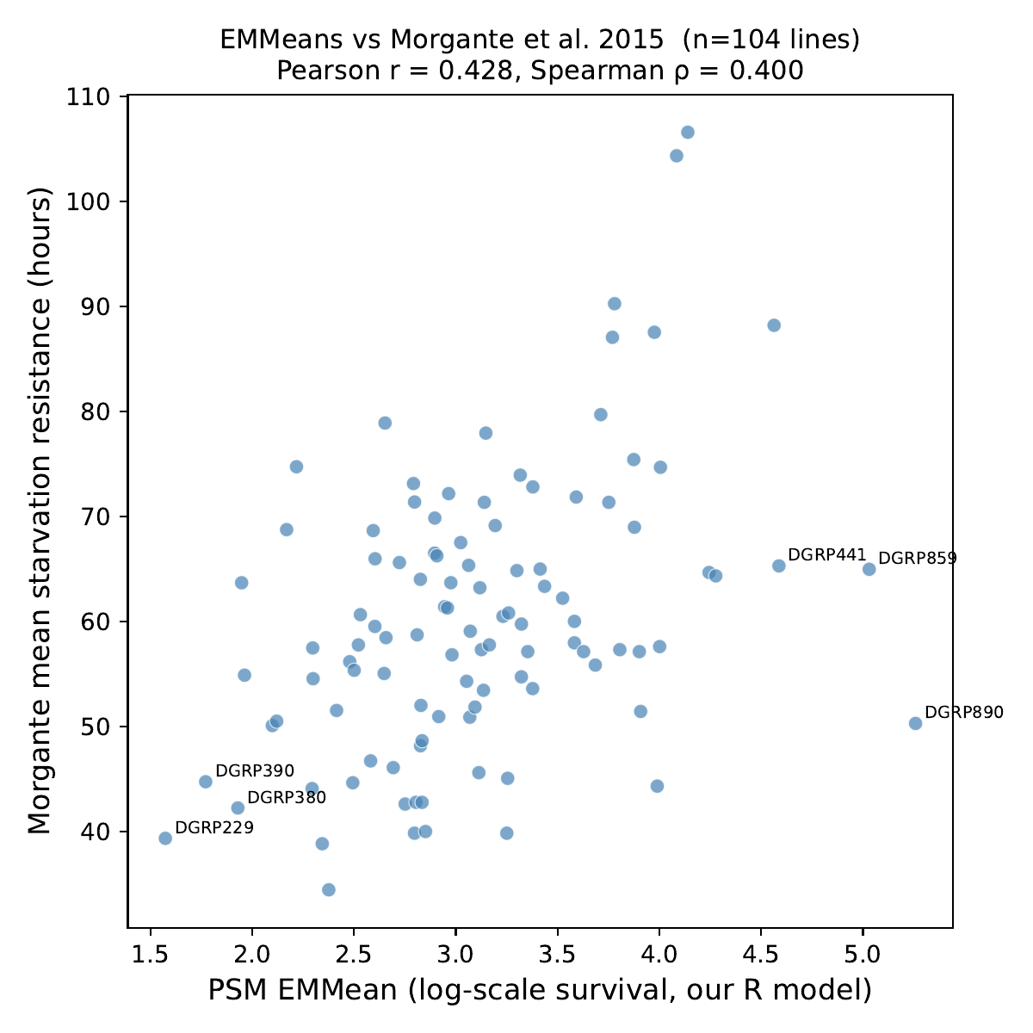
Figure 1. Internally derived starvation resistance EMMeans plotted against independently measured starvation resistance from Morgante et al. (2015), across 104 overlapping DGRP lines (Pearson r = 0.428, p = 5.88 × 10⁻⁶; Spearman ρ = 0.400). Six lines with the largest residuals are labelled.

3.2 Spectral Structure and the Effect of Within-Line Averaging
Before examining the relationship between spectral structure and phenotype, the effective dimensionality of the spectral data was assessed by running PCA on all 1,772 individual fly spectra. Only four principal components were required to capture 95.3% of total spectral variance (Figure 2), despite each spectrum containing 1,723 measured wavenumbers, indicating substantial redundancy between adjacent, correlated wavenumbers.
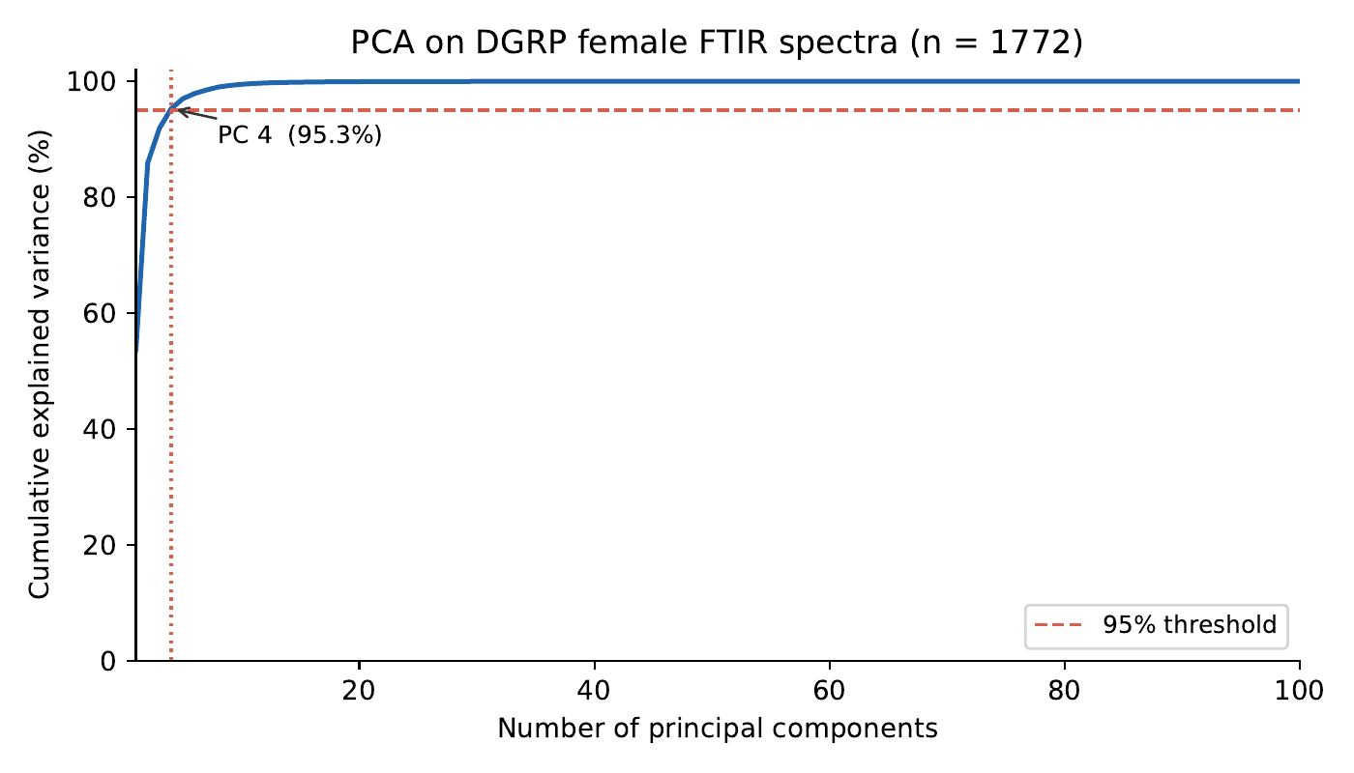
Figure 2. Cumulative explained variance as a function of the number of principal components, for PCA applied to all 1,772 individual fly spectra. The 95% variance threshold is reached at four components.
Two approaches to combining individual fly spectra with line-level phenotype data were compared, as the order of operations was not predetermined. In Order A, PCA was applied to all 1,772 individual female fly spectra, and the resulting PC scores were subsequently averaged within each DGRP line to produce one score per line. In Order B, the raw spectra were averaged within each DGRP line first to produce 108 line-mean spectra, and PCA was then applied to the 108-line matrix.
The two approaches produced strikingly different results. Under Order A, PC1 (which captured 53.6% of total spectral variance) showed no correlation with starvation EMMeans across the 108 lines (Pearson r = -0.050, p = 0.606). Under Order B, PC1 (which captured 65.4% of total spectral variance in the line-mean matrix) showed a strong positive correlation with starvation EMMeans (Pearson r = +0.685, p = 2.92 × 10⁻¹⁶). The contrast is illustrated in Figure 3, which shows PC1 vs PC2 scatter plots for both approaches, with each point coloured by its line's EMMean. Under Order A, no colour gradient is visible along any axis. Under Order B, a clear gradient runs left to right along PC1, with sensitive lines (low EMMean) clustering on the left and resistant lines (high EMMean) on the right.
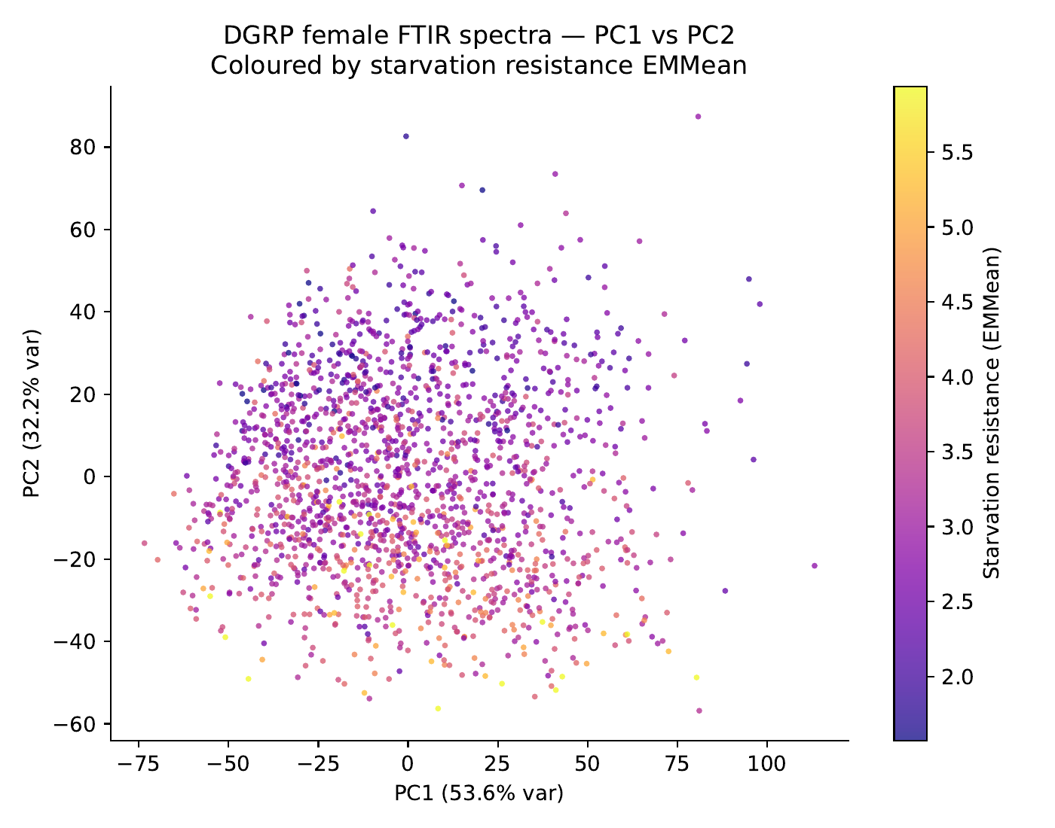
Figure 3a. PC1 vs PC2 for 1,772 individual fly spectra (Order A), coloured by each line's starvation resistance EMMean. No colour gradient is apparent along either axis (Pearson r = -0.050, p = 0.606).
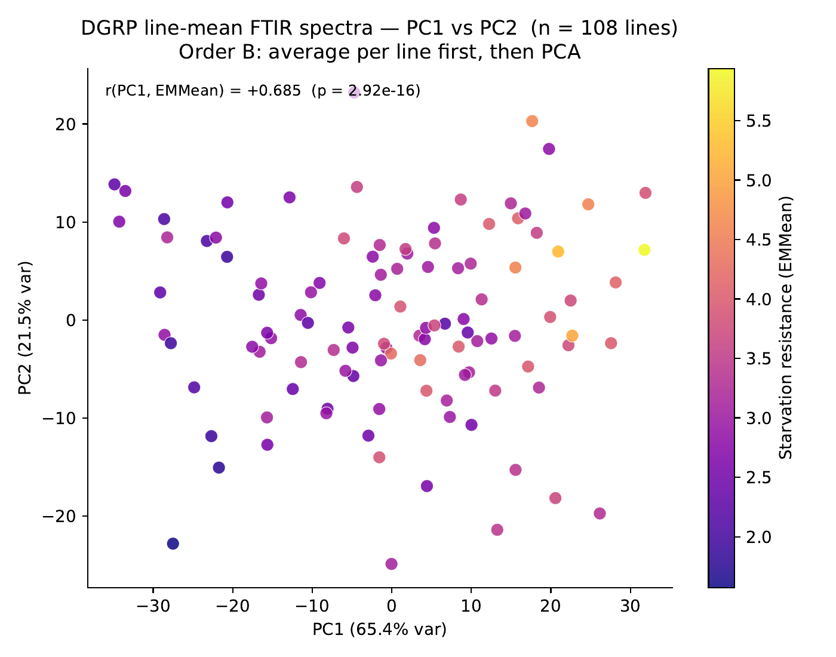
Figure 3b. PC1 vs PC2 for 108 DGRP line-mean spectra (Order B), coloured by starvation resistance EMMean. A clear gradient runs along PC1, with sensitive lines (low EMMean, dark purple) on the left and resistant lines (high EMMean, yellow) on the right (Pearson r = +0.685, p = 2.92 × 10⁻¹⁶).
The difference between the two approaches reflects the structure of within-line versus between-line variation in the spectral data. Under Order A, PCA is applied to all 1,772 individual fly spectra simultaneously. The dominant source of variation at this level is within-line fly-to-fly measurement noise, random differences between sibling flies from the same inbred line arising from biological stochasticity and measurement conditions. Because this within-line noise is large relative to the between-line genetic signal, PC1 captures noise rather than genotypic variation, and shows no relationship with starvation resistance. Under Order B, averaging approximately 16 spectra per line before applying PCA cancels within-line noise through averaging, leaving predominantly between-line genetic variation. PCA applied to this averaged matrix identifies spectral directions that distinguish genotypes from one another, and the first of these directions aligns strongly with starvation resistance.
This finding has two implications for the analysis. First, the starvation resistance signal in the FTIR spectra is a property of the DGRP genotype rather than something reliably readable from a single individual fly. Second, Order B (average spectra within lines before compression) is the correct approach for subsequent analyses using line-mean spectra. As shown above, the spectral data are of low effective dimensionality overall, with only four components needed to capture 95.3% of variance in the individual-fly PCA; this redundancy is consistent with the strong correlations expected between adjacent, chemically related wavenumbers.

3.3 Method Comparison on Line-Mean Spectra
Six multivariate regression methods were evaluated for their ability to predict starvation resistance EMMeans from DGRP line-mean FTIR spectra. All methods were assessed using leave-one-line-out cross-validation (LOO-CV), in which each of the 108 lines was held out in turn, the model was trained on the remaining 107 lines, and a prediction was made for the held-out line. This process was repeated 108 times so that every line received exactly one out-of-sample prediction. Performance was quantified using the coefficient of determination (R²), root mean square error (RMSE), and Spearman rank correlation (ρ). Spectral data were standardised (mean-centred and scaled to unit variance per wavenumber) within each training fold using only the 107 training lines, ensuring that the held-out test line did not influence scaling.
The six methods tested were: PCA followed by Ridge regression (PCA+Ridge), partial least squares regression (PLS), random forest regression, Ridge regression on the raw spectra, LASSO regression, and elastic net regression. PCA+Ridge used four principal components, matching the number found sufficient to capture 95.3% of variance in the individual-fly PCA reported in Section 3.2; a formal check of the variance threshold on the line-mean matrix specifically was not conducted, and this component count should be understood as a reasonable default informed by that earlier result rather than a value re-derived from the line-mean data. For PLS, the number of latent components was selected empirically by running LOO-CV across five candidate values (1, 2, 3, 5, 10, 15, 20). Performance peaked at 10 components (CV R² = 0.623) and declined at 15 (CV R² = 0.550) and 20 (CV R² = 0.515), consistent with overfitting when more than 10 latent dimensions were used with n = 108 lines. Ridge, LASSO, and elastic net were applied directly to all 1,723 raw wavenumbers without prior dimensionality reduction, with regularisation strength selected automatically by inner cross-validation within each training fold. For elastic net, the L1/L2 mixing ratio was also selected automatically from three candidate values (0.5, 0.9, 1.0); the median selected mixing ratio across the 108 outer folds was 0.90, indicating a predominantly sparse solution with some L2 stabilisation. For random forest, the number of trees and the number of features considered at each split were selected by inner three-fold cross-validation within each training fold.
Results for all six methods are presented in Table 1. Elastic net achieved the highest cross-validated performance (CV R² = 0.673, RMSE = 0.424, ρ = +0.816), followed by LASSO (CV R² = 0.669, ρ = +0.813) and Ridge regression on raw spectra (CV R² = 0.635, ρ = +0.809). All three regularised regression methods applied directly to the raw 1,723 wavenumbers outperformed both PLS (CV R² = 0.623) and PCA+Ridge (CV R² = 0.553). Random forest performed the least well of the non-baseline methods (CV R² = 0.540, ρ = +0.729), performing no better than PCA+Ridge despite being a substantially more complex model.
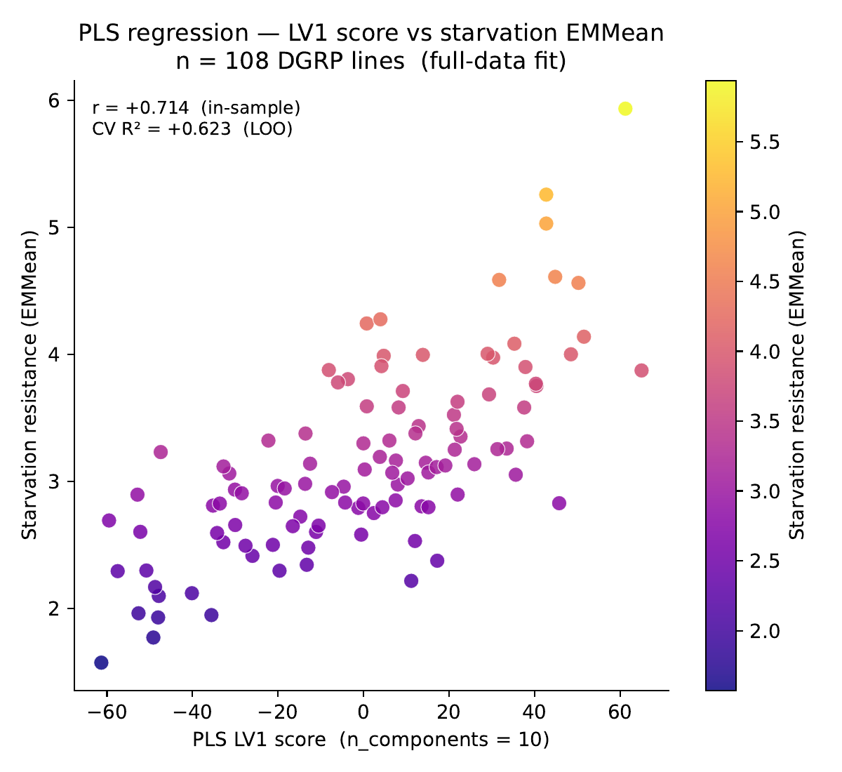
Figure 4. PLS latent variable 1 (LV1) score plotted against starvation resistance EMMean for all 108 DGRP lines (full-data fit; in-sample r = +0.714). The cross-validated R² for this model, obtained via leave-one-line-out cross-validation, was 0.623.
Method | CV R² | RMSE | Spearman ρ
PCA + Ridge (4 PCs) | 0.553 | 0.493 | +0.743
Random forest | 0.540 | 0.500 | +0.729
PLS (10 components) | 0.623 | 0.452 | +0.801
Ridge (raw spectra) | 0.635 | 0.445 | +0.809
LASSO | 0.669 | 0.427 | +0.813
Elastic net | 0.673 | 0.424 | +0.816
Table 1. Cross-validated prediction performance for six methods applied to 108 DGRP line-mean FTIR spectra. LOO-CV throughout; StandardScaler fitted on training lines only inside each fold.
The finding that direct sparse regression on the raw 1,723 wavenumbers outperformed the conventional chemometrics approach of compressing to a small number of latent variables before prediction is notable. PLS is specifically designed to find directions of maximum covariance between the spectra and the phenotype, which in principle should make it more efficient than unsupervised compression (PCA) or direct regression with penalty terms. The observed advantage of elastic net and LASSO over PLS suggests that, at the scale of n = 108 lines, the L1 penalty was a more effective approach to the high-dimensional regression problem than PLS latent variable compression. The poor performance of random forest relative to the linear methods is consistent with the spectral signal being primarily a smooth, broad feature (lipid content, as discussed in Section 3.3.1 below) rather than a complex nonlinear interaction between wavenumbers.

3.3.1 Spectral drivers of starvation resistance prediction
The PLS weight vector for latent variable 1, which represents the direction of maximum covariance between the spectra and starvation resistance, showed a dominant positive peak in the C-H stretching region at approximately 2,900 to 3,000 cm⁻¹ (Figure 5). This region corresponds to the infrared absorption of alkyl C-H bonds in lipids and fatty acids. Secondary features were present at approximately 1,650 cm⁻¹ (Amide I, protein carbonyl stretching, negative weight) and 1,550 cm⁻¹ (Amide II, protein N-H bending, positive weight). The elastic net coefficient vector showed a qualitatively similar pattern, with the strongest non-zero coefficients also concentrated in the C-H stretching region (Figure 6). The random forest feature importance profile, by contrast, was more diffusely distributed across the spectrum (Figure 7), consistent with random forest's weaker overall performance in Table 1 and with the interpretation that the signal is a smooth, broad spectral feature rather than one requiring a nonlinear model to detect.
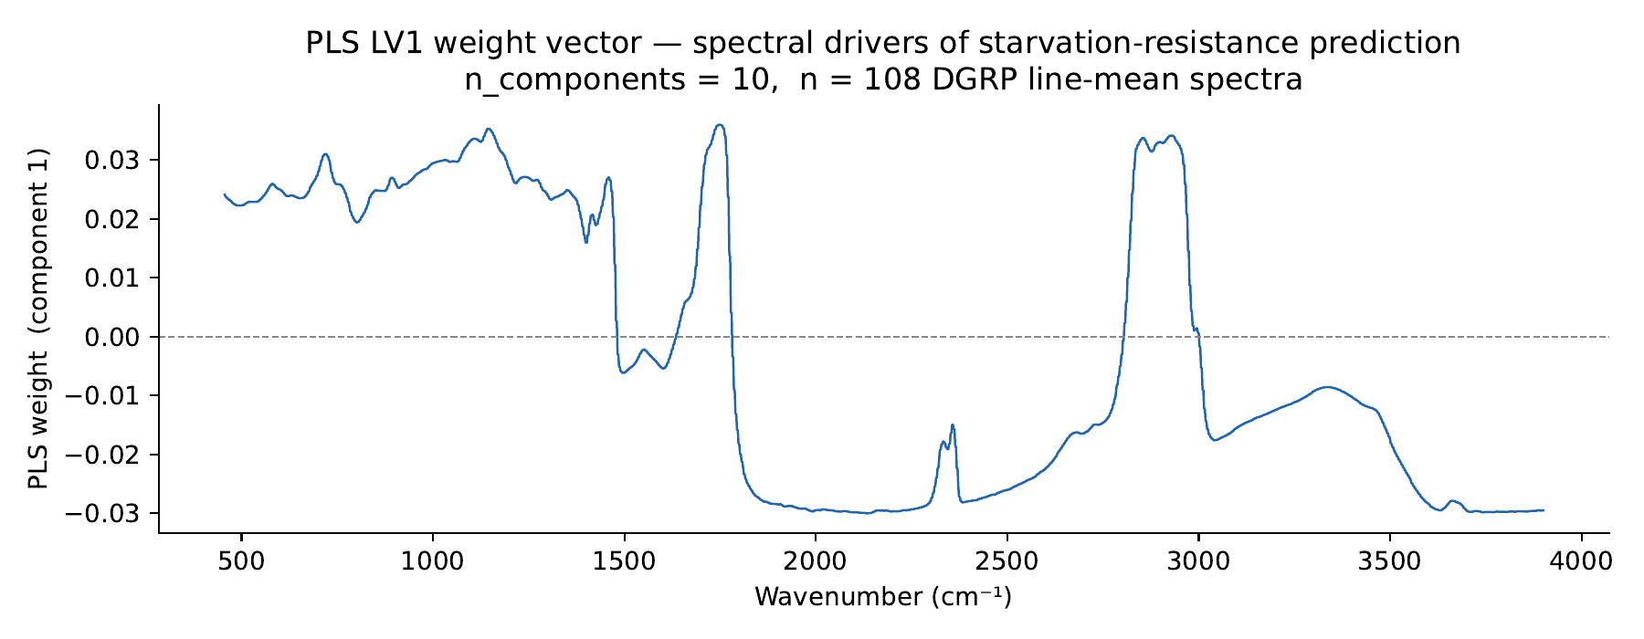
Figure 5. PLS latent variable 1 (LV1) weight vector plotted against wavenumber. The dominant positive peak in the C-H stretching region (~2,900-3,000 cm⁻¹) indicates that lipid content is the primary spectral feature driving the starvation resistance prediction.
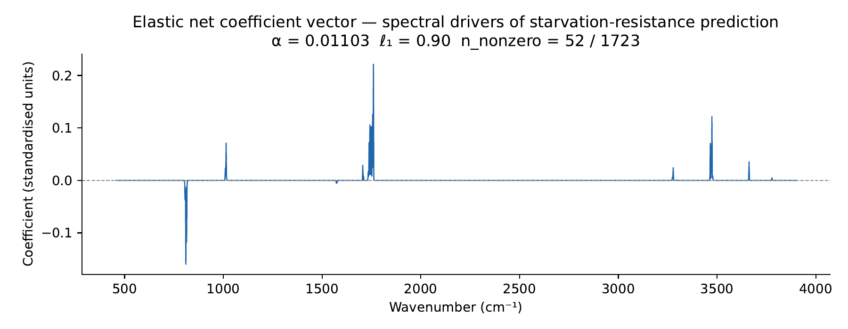
Figure 6. Elastic net coefficient vector (standardised units) plotted against wavenumber, from the model fitted on all 108 DGRP line-mean spectra (α = 0.011, ℓ₁ = 0.90, 52 of 1,723 coefficients non-zero). The pattern of non-zero coefficients closely matches the PLS LV1 weight vector shown in Figure 5, with the largest coefficients concentrated in the C-H stretching region.
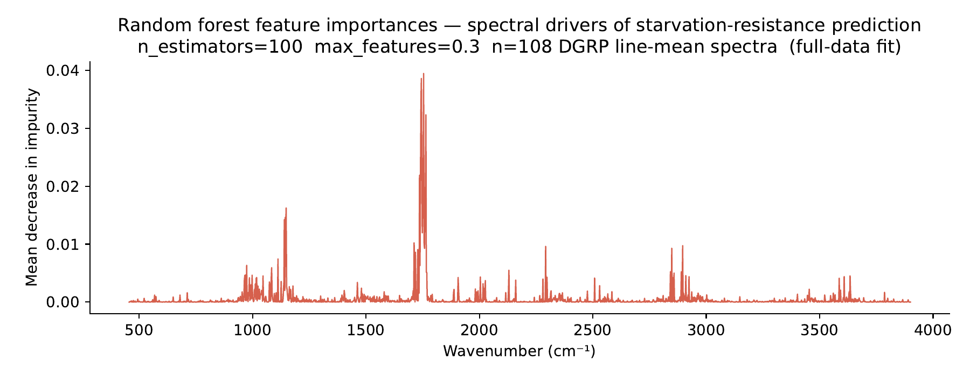
Figure 7. Random forest feature importances (mean decrease in impurity) plotted against wavenumber, from the model fitted on all 108 DGRP line-mean spectra (n_estimators = 100, max_features = 0.3). Importance is more diffusely distributed across the spectrum than the PLS or elastic net weight vectors.
These spectral features indicate that lines with higher starvation resistance have greater lipid content in their cuticular chemical profile as measured by FTIR, relative to lines with lower resistance. This is consistent with the known biology of starvation resistance in Drosophila melanogaster, in which triglyceride fat reserves are the primary energy substrate mobilised during food deprivation, and genetic variation in fat storage capacity is a major determinant of starvation survival time (Chippindale et al., 1996; Schwasinger-Schmidt et al., 2012). The loading vector was smooth and interpretable across the wavenumber axis, with no indication of the irregular or noisy pattern that would suggest the model was fitting measurement artefacts rather than biological signal.

3.4 Per-Fly Evaluation with Line-Stratified Cross-Validation
The analyses in Section 3.3 used line-mean spectra as the training unit, meaning each of the 108 DGRP lines was represented by a single averaged spectrum before model fitting. This approach removes within-line measurement noise before training, which, as demonstrated in Section 3.2, is necessary to reveal the between-line genetic signal. However, it also means the model is trained on 108 data points rather than on the 1,772 individual fly spectra available. A more demanding evaluation, and one that more closely reflects a practical deployment scenario in which individual fly spectra would be collected without prior averaging, was therefore conducted using individual fly spectra as the training unit.
Four methods were evaluated in this setting: PLS, Ridge, LASSO, and elastic net. Models were trained on individual fly spectra using group-stratified cross-validation (GroupKFold, n_splits = 10), with DGRP line as the grouping variable. This design ensured that all flies from a given DGRP line were always assigned to the same fold, so no fly's line appeared in both training and test folds simultaneously. This constraint was essential for two reasons. First, all flies from the same inbred line share the same starvation EMMean label, so splitting flies from a line across folds would allow the model to infer test labels from training flies of the same genotype. Second, flies from the same inbred line have more similar spectra to each other than to flies from other lines, so including them on both sides of a train-test split would inflate apparent accuracy. The grouping variable ensured neither of these forms of data leakage occurred.
For each outer fold, a StandardScaler was fitted on the training flies only and applied to the test flies. Each fly's training target was the EMMean of its DGRP line, repeated for all flies from that line. After predicting all test flies in each fold, predictions were averaged within each test-fold DGRP line to produce one line-level prediction per line. All performance metrics were computed at the line level by comparing these averaged predictions to the true EMMeans. For PLS, the number of latent components was selected by an inner group-stratified five-fold cross-validation on the outer training flies, using the same grouping variable to prevent secondary leakage at the inner level.
Results are shown in Table 2. In the per-fly setting, PLS achieved the highest line-level performance (R² = 0.534, RMSE = 0.503, ρ = +0.794), while Ridge, LASSO, and elastic net produced similar results to each other (line R² = 0.515 to 0.518). This represents a reversal of the ranking observed in the line-mean setting, where elastic net outperformed PLS.
Method | Line R² | RMSE | Spearman ρ | Per-fly R²
PLS | 0.534 | 0.503 | +0.794 | 0.360
Elastic net | 0.518 | 0.511 | +0.783 | 0.332
LASSO | 0.517 | 0.512 | +0.781 | 0.327
Ridge | 0.515 | 0.513 | +0.767 | 0.309
Table 2. Per-fly GroupKFold(10) evaluation results. Line-level metrics are computed after averaging per-fly predictions within each test-fold DGRP line. Per-fly R² is computed before line-level averaging and is shown for reference.
The reversal in ranking between the line-mean and per-fly settings reflects the different demands placed on each method when within-line noise is present during training. In the line-mean setting, models are trained on clean averaged spectra and the only variation is between-line genetic signal. Sparse methods such as elastic net and LASSO are well suited to this setting because they concentrate predictive weight on the small number of spectral regions that carry the between-line signal, specifically the lipid C-H stretching bands identified in Section 3.3.1. When individual fly spectra are used for training, within-line noise is present alongside the genetic signal. Sparse methods in this setting tend to select wavenumbers that reflect individual-fly variation which does not carry over to the line-level prediction. PLS, which finds latent directions of maximum covariance with the phenotype across all training flies simultaneously, is more robust to this noise because its latent variables are influenced by the consistent between-line signal shared by all flies of the same genotype rather than by individual-fly spectral quirks.
All four methods showed a decrease in line-level R² in the per-fly setting compared to the line-mean LOO-CV setting (Table 3). The magnitude of this decrease differed between methods. PLS showed the smallest reduction (0.623 to 0.534, a drop of 0.089), while elastic net and LASSO showed the largest reductions (drops of 0.155 and 0.152 respectively). This pattern is consistent with PLS being more robust to within-line noise during training.
Method | Line-mean R² | Per-fly line R² | Change
PLS | 0.623 | 0.534 | -0.089
Ridge | 0.635 | 0.515 | -0.120
LASSO | 0.669 | 0.517 | -0.152
Elastic net | 0.673 | 0.518 | -0.155
Table 3. Comparison of line-mean LOO-CV R² and per-fly GroupKFold line-level R² for the four methods evaluated in both settings.
The per-fly line-level R² values (0.515 to 0.534) represent a conservative lower bound on model performance, as the GroupKFold design holds out entire DGRP lines rather than individual flies, and training is conducted on noisy individual spectra without prior averaging. The line-mean LOO-CV R² values (0.623 to 0.673) represent an upper bound achievable when within-line noise has been removed before training. Both settings confirm that FTIR spectra contain a robust and replicable signal for predicting starvation resistance across DGRP genotypes.

3.5 Cross-Phenotype Specificity of the FTIR Signal
To assess whether the predictive signal identified in Sections 3.3 and 3.4 was specific to starvation resistance or reflected a more general readout of physiological variation across DGRP genotypes, the elastic net pipeline was applied to five additional phenotype targets retrieved from the DGRPool database (Roux et al., 2024). A general-purpose pipeline script (scripts/run_dgrpool_phenotype.py) was developed to accept any DGRPool-format phenotype file and apply the same elastic net LOO-CV pipeline used in Section 3.3. The pipeline was validated by confirming that it reproduced the known starvation resistance result (CV R² = 0.673) when run against the internally derived EMMeans.
The five additional phenotypes tested were: starvation resistance measured independently by Morgante et al. (2015), lifetime fecundity measured by Durham et al. (2014), lifespan measured by Ivanov et al. (2015), chill coma recovery time measured by Morgante et al. (2015), and the proportion of n-C25 cuticular hydrocarbon from total cuticular hydrocarbons measured by Dembeck et al. (2015). For each phenotype, DGRP line identifiers were normalised to match the spectral dataset format before joining, and the analysis was restricted to lines with valid phenotype values present in both datasets. Results are presented in Table 4.
Phenotype | Study | n lines | CV R²
Starvation resistance (EMMeans) | Internal (PSM model) | 108 | +0.673
Starvation resistance | Morgante et al. (2015) | 104 | +0.041
Lifetime fecundity | Durham et al. (2014) | 96 | -0.109
Lifespan | Ivanov et al. (2015) | 104 | -0.052
Chill coma recovery | Morgante et al. (2015) | 95 | -0.060
Cuticular hydrocarbon n-C25 | Dembeck et al. (2015) | 91 | -0.052
Table 4. Cross-phenotype elastic net LOO-CV results. All analyses used line-mean FTIR spectra (Order B from Section 3.2) and the same hyperparameters as Section 3.3.
Of the five external phenotypes, none showed a positive cross-validated R². All four non-starvation phenotypes produced negative R² values, meaning predictions were no better than simply predicting the mean phenotype value for every line. In each case, the standard deviation of LOO-CV predictions was a small fraction of the true phenotype standard deviation (ratios of 0.06 to 0.14), confirming that the elastic net selected near-maximal regularisation and effectively predicted the training mean for every test line.
The independent starvation resistance data from Morgante et al. (2015) produced a small but positive CV R² of +0.041. This result is substantially weaker than the R² = 0.673 obtained from the internally derived EMMeans and reflects the fact that the two starvation measurements are imperfectly correlated with each other across lines (Pearson r = 0.428). A model trained to predict one starvation measure from FTIR spectra cannot be expected to predict an independent, noisier replicate of the same trait substantially better than the two measures agree with each other directly.
For lifetime fecundity, chill coma recovery, and lifespan, the null results are biologically interpretable. The FTIR signal identified in Section 3.3.1 is primarily carried by the C-H stretching region, reflecting bulk lipid content. Starvation resistance in Drosophila melanogaster is directly determined by triglyceride fat reserves, creating a shared biochemical basis between the spectral signal and the phenotype. Lifetime fecundity depends on reproductive resource allocation, driven principally by protein synthesis and carbohydrate metabolism rather than bulk lipid storage. Lifespan is influenced by a broad range of biological processes including oxidative stress resistance, immune function, and proteostasis. Chill coma recovery reflects the capacity to maintain ion gradients across muscle and nerve cell membranes at low temperatures, a process mediated by ion transporter activity rather than energy reserve status. None of these mechanisms would be expected to produce systematic variation in bulk cuticular lipid content across genotypes, and the FTIR signal accordingly shows no predictive value for these traits.
The null result for cuticular hydrocarbon n-C25 proportion requires separate consideration. Cuticular hydrocarbons are surface-layer lipid molecules measured directly on the cuticle, the same surface sampled by ATR-FTIR spectroscopy, and were therefore the phenotype category most directly expected to show a relationship with the spectral data. However, the DGRPool phenotype used here measures the relative proportion of n-C25 among all cuticular hydrocarbons, expressed as a ratio. ATR-FTIR spectroscopy at the C-H stretching region detects total alkyl bond content, which reflects the aggregate abundance of all lipid species rather than the relative composition of individual hydrocarbon species. A DGRP line with high total cuticle lipid content (and correspondingly high FTIR absorption) may have any proportion of n-C25 depending on the relative abundance of other hydrocarbon species. The null result for n-C25 proportion therefore does not rule out a relationship between FTIR spectra and absolute cuticular hydrocarbon abundance, and a phenotype measuring total CHC content rather than a single species proportion would provide a more appropriate test of this relationship.
Taken together, the cross-phenotype results indicate that the predictive signal in the DGRP FTIR spectra is highly specific to starvation resistance within the set of phenotypes tested. The pattern of results is consistent with the interpretation that the signal reflects bulk lipid energy reserve content, which is directly relevant to starvation survival but not to the other traits examined. These findings align with the proposal by Adam Dobson (personal communication, June 2026) that FTIR-based chemotyping may be most informative for traits in which lipid metabolism plays a primary role, and suggest that the approach would benefit from validation against phenotypes with a more direct connection to lipid storage, such as directly measured triglyceride content, rather than broader life-history traits.

3.6 Extension to Independently Measured Metabolic Phenotypes
Section 3.5 established that the FTIR-based predictive signal was specific to starvation resistance among five phenotypes drawn from the DGRPool database, with no evidence of predictive power for fecundity, lifespan, chill coma recovery, or cuticular hydrocarbon composition. However, none of these five phenotypes constituted a direct biochemical measurement of the lipid or metabolic status hypothesised to underlie the spectral signal identified in Section 3.3.1. To test this hypothesis more directly, the elastic net pipeline was extended to a sixth external dataset: nutritional indices measured by Unckless et al. (2015) in males from 152 DGRP lines reared on either a low-glucose or high-glucose diet.
Unckless et al. (2015) quantified six metabolic measures directly relevant to energy storage and metabolism: free glucose, glycogen, free glycerol, triglycerides, total soluble protein, and wet body weight, each expressed as a line mean under three conditions (pooled across diets, high-glucose diet only, and low-glucose diet only), giving eighteen distinct phenotype targets. This dataset was assayed exclusively in males, whereas the FTIR spectra used throughout this dissertation were collected exclusively from females (Ibrahim et al., 2026). Because both traits were treated as properties of the DGRP genotype rather than of any specific individual, this comparison could still be conducted at the level of the line, matching each line's male metabolic measurements to its female FTIR spectrum by DGRP identifier. This is a stricter test than the same-sex comparisons in Sections 3.3 to 3.5, since any relationship detected would need to hold across sex as well as across laboratory and assay.
Supporting this general-purpose pipeline for a cross-sex comparison required one modification to the analysis script (run_dgrpool_phenotype.py). The script's sex-filtering argument had originally been used to filter both the phenotype file and the FTIR spectral file to the same value; because the FTIR dataset used here contains only female spectra, applying it with a male phenotype file would have filtered the spectral data to zero rows before any lines could be matched, an error that would have been caught immediately rather than producing an incorrect result. The script was modified to filter the phenotype file and the spectral file independently (--sex and --spectral-sex respectively, the latter defaulting to F), with an explicit warning printed whenever the two differ. Following this change, a targeted audit confirmed that (i) no non-female rows had been silently included in any of the five prior DGRPool analyses, three of which contained both sexes at the raw file level and were correctly filtered to females only before fitting; (ii) DGRP line-identifier normalisation was consistent across all data-preparation scripts; and (iii) the StandardScaler was correctly fitted on training-fold data only in every cross-validated script in the pipeline. No further issues were identified.
Eighteen elastic net LOO-CV analyses were run, one for each combination of the six metabolic measures and three diet conditions, using the same hyperparameter configuration and evaluation design as Section 3.3. Between 77 and 80 DGRP lines overlapped between the FTIR spectral dataset and each Unckless phenotype file, depending on diet condition. Results are shown in Table 5, alongside the phenotypic correlation each measure showed with an independent starvation resistance dataset (Mackay et al., 2012) as reported in Unckless et al. (2015), included here because it provides prior, independent evidence of which metabolic measures are and are not associated with starvation resistance in the DGRP.
Measure | Diet | n | CV R² | Published r
Glucose | Pooled | 77 | -0.026 | 0.246
Glucose | High-glucose | 77 | -0.026
Glucose | Low-glucose | 80 | -0.048
Glycerol | Pooled | 77 | +0.012 | 0.079
Glycerol | High-glucose | 77 | +0.012
Glycerol | Low-glucose | 80 | +0.007
Glycogen | Pooled | 77 | -0.070 | 0.307
Glycogen | High-glucose | 77 | -0.045
Glycogen | Low-glucose | 80 | -0.025
Triglyceride | Pooled | 77 | -0.051 | -0.071
Triglyceride | High-glucose | 77 | -0.006
Triglyceride | Low-glucose | 80 | -0.030
Protein | Pooled | 77 | -0.074 | -0.113
Protein | High-glucose | 77 | -0.026
Protein | Low-glucose | 80 | +0.066
Wet weight | Pooled | 77 | -0.026 | 0.241
Wet weight | High-glucose | 77 | -0.026
Wet weight | Low-glucose | 80 | -0.032
Table 5. Cross-sex elastic net LOO-CV results for six metabolic measures under three diet conditions, tested against female FTIR spectra. Published correlation is the phenotypic correlation coefficient between each measure and starvation stress resistance (Mackay et al., 2012), as reported in Table 1 of Unckless et al. (2015).
Seventeen of the eighteen tests showed no evidence of a spectral signal, with cross-validated R² values close to or below zero and, in most cases, a prediction standard deviation below 20% of the true phenotype standard deviation, indicating that the fitted model had converged to predicting close to the training mean for every held-out line. This pattern held regardless of each measure's independently published relationship with starvation resistance. Notably, glycogen showed the strongest published phenotypic correlation with starvation resistance of any measure tested (r = 0.307; Unckless et al., 2015), yet produced no detectable FTIR signal under any of the three diet conditions (CV R² of -0.070, -0.045, and -0.025). This indicates that the absence of signal for the other metabolic measures cannot be attributed simply to those measures being unrelated to starvation resistance; even the measure most strongly linked to starvation resistance in an independent dataset showed no relationship with the FTIR spectra collected in this study.
One result departed from this pattern. Protein measured under the low-glucose diet condition produced a small positive cross-validated R² of 0.066. Unlike the majority of null results in this dataset and in Section 3.5, the ratio of prediction standard deviation to true standard deviation for this analysis was 0.388, well above the 0.2 threshold used elsewhere to identify predictions that have collapsed to the training mean, confirming that the model was producing genuine variation in its predictions rather than a degenerate, near-constant output. This result is therefore not an artefact of the kind observed in the other null results. However, its magnitude is modest, it was not observed for protein under the pooled or high-glucose conditions (CV R² of -0.074 and -0.026 respectively), and it emerged from one comparison among eighteen conducted in this section without correction for multiple testing. Taken together, this result is best characterised as a candidate for further investigation rather than as evidence of a reliable relationship between FTIR spectra and protein content under this specific dietary condition.
Considered together with the results of Section 3.5, the FTIR-based predictive signal identified in this dissertation has now been tested against eleven independently measured phenotypes beyond the original starvation resistance target: an independent replicate of starvation resistance itself, four DGRPool life-history and stress-resistance traits, and six metabolic measures under three dietary conditions each. Of these eleven external phenotypes, only the independent starvation resistance replicate showed a positive association, and this association was substantially weaker than the association with the internally derived starvation resistance measure from which the spectral model was originally trained. No metabolic measure directly relevant to lipid or energy storage, including those independently linked to starvation resistance in prior work, showed a reliable spectral signal. This pattern indicates that the predictive value of the FTIR spectra in this system is narrower than a general readout of lipid or metabolic status, and is more precisely characterised as specific to the particular starvation resistance assay used to generate the original training data.

References
Chippindale, A. K., Chu, T. J. F., & Rose, M. R. (1996). Complex trade-offs and the evolution of starvation resistance in Drosophila melanogaster. Evolution, 50(2), 753-766.
Dembeck, L. M., Böröczky, K., Huang, W., Schal, C., Anholt, R. R. H., & Mackay, T. F. C. (2015). Genetic architecture of natural variation in cuticular hydrocarbon composition in Drosophila melanogaster. eLife, 4, e09861. https://doi.org/10.7554/eLife.09861
Durham, M. F., Magwire, M. M., Stone, E. A., & Mackay, T. F. C. (2014). Genome-wide analysis in Drosophila reveals age-specific effects of SNPs on fitness traits. Nature Communications, 5, 4338. https://doi.org/10.1038/ncomms5338
Ibrahim, R., González-Jiménez, M., … Wynne, K., & Dobson, A. J. (2026). Barcoding biology: Chemotype predicts variation in genotype, physiology, and stress response. bioRxiv. https://doi.org/10.64898/2026.03.22.713522
Ivanov, D. K., Escott-Price, V., Ziehm, M., Magwire, M. M., Mackay, T. F. C., Partridge, L., & Thornton, J. M. (2015). Longevity GWAS using the Drosophila Genetic Reference Panel. Journals of Gerontology: Series A, 70(12), 1470-1478. https://doi.org/10.1093/gerona/glv047
Mackay, T. F. C., Richards, S., Stone, E. A., Barbadilla, A., Ayroles, J. F., Zhu, D., Casillas, S., Han, Y., Magwire, M. M., Cridland, J. M., Richardson, M. F., Anholt, R. R. H., Barrón, M., Bess, C., Blankenburg, K. P., Carbone, M. A., Castellano, D., Chaboub, L., Duncan, L., ... Gibbs, R. A. (2012). The Drosophila melanogaster Genetic Reference Panel. Nature, 482(7384), 173-178. https://doi.org/10.1038/nature10811
Morgante, F., Sørensen, P., Sorensen, D. A., Maltecca, C., & Mackay, T. F. C. (2015). Genetic architecture of micro-environmental plasticity in Drosophila melanogaster. Scientific Reports, 5, 9785. https://doi.org/10.1038/srep09785
Roux, J., Vonesch, S. C., Branciamore, S., Bhatt, D. L., & Deplancke, B. (2024). DGRPool, a web tool leveraging harmonized Drosophila Genetic Reference Panel phenotyping data for the study of complex traits. eLife, 13, e88981. https://doi.org/10.7554/eLife.88981
Schwasinger-Schmidt, T. E., Kachman, S. D., & Harshman, L. G. (2012). Evolution of starvation resistance in Drosophila melanogaster: measurement of direct and correlated responses to artificial selection. Journal of Evolutionary Biology, 25(2), 378-387.
Tibshirani, R. (1996). Regression shrinkage and selection via the lasso. Journal of the Royal Statistical Society: Series B (Methodological), 58(1), 267-288. https://doi.org/10.1111/j.2517-6161.1996.tb02080.x
Unckless, R. L., Rottschaefer, S. M., & Lazzaro, B. P. (2015). A genome-wide association study for nutritional indices in Drosophila. G3: Genes|Genomes|Genetics, 5(3), 417-425. https://doi.org/10.1534/g3.114.016477
Zou, H., & Hastie, T. (2005). Regularization and variable selection via the elastic net. Journal of the Royal Statistical Society: Series B (Statistical Methodology), 67(2), 301-320. https://doi.org/10.1111/j.1467-9868.2005.00503.x
Mendez, K. M., Reinke, S. N., & Broadhurst, D. I. (2019). A comparative evaluation of the generalised predictive ability of eight machine learning algorithms across ten clinical metabolomics data sets for binary classification. Metabolomics, 15(12), 150. https://doi.org/10.1007/s11306-019-1612-4
Breiman, L. (2001). Random forests. Machine Learning, 45(1), 5-32. https://doi.org/10.1023/A:1010933404324
Huang, W., Massouras, A., Inoue, Y., Peiffer, J., Ràmia, M., Tarone, A. M., Turlapati, L., Zichner, T., Zhu, D., Lyman, R. F., Magwire, M. M., Blankenburg, K., Carbone, M. A., Chang, K., Ellis, L. L., Fernandez, S., Han, Y., Highnam, G., Hjelmen, C. E., ... Mackay, T. F. C. (2014). Natural variation in genome architecture among 205 Drosophila melanogaster Genetic Reference Panel lines. Genome Research, 24(7), 1193-1208. https://doi.org/10.1101/gr.171546.113

