**The following is a bio for Dean Fay; Founder, Executive Director, and Head Coach of Central City Boxing & Barbell Inc.**

Central City Boxing & Barbell Inc. was founded by Dean Fay, who at the time was an 18 year veteran of the Springfield Police Department. The following is brief history of how Central City Boxing & Barbell came to existence.  
  
Dean is a native of Holyoke, MA spending most of his childhood and being educated in Chicopee, MA. He grew up involved in athletics and competed in Football, Hockey, Baseball and Boxing. Being from Holyoke and the son and grandson of Holyoke Firefighters, Golden Gloves Boxing, which was a staple in Holyoke since 1957, was a large part of his life. In addition to being a yearly tradition and being a source of civic pride, this tournament was the source of much needed funding that supported several area youth programs.  
   
After high school, Dean followed in the family tradition of enlisting in the Military to serve his country and give back to the nation that has given so much to him. While in the military Dean continued to compete in various athletics and was eventually introduced to powerlifting. Dean found power lifting similar to boxing in that it is an act that is solely based on only your efforts. You will get out of it only what you put into it. There is no one to bail you out or no one to blame for your own inadequacies. These are two sports that are 60% mental and 40% physical. The values associated with these two sports are closely related to life.  
  
After ending his military enlistment while assigned as a weapons instructor at the United States Military Academy at West Point, Dean chose to return to Western Mass and again follow in his family's tradition of serving the community. Dean chose to serve his community as a Police Officer. Upon being appointed as a Police Officer, Dean returned to school attending Springfield Technical Community College and later Westfield State College where he obtained a degree in Criminal Justice. Dean felt that the discipline needed to work a full time job as a police officer while being a husband, father to an infant son and a full time student was largely obtained through his experiences with athletics and the military.  
  
Upon completing school, Dean began coaching youth athletics in the area and even returned to playing football, playing for various Semi-Professional Football Teams being named as an All-Star in the Eastern Football League at the age of 37. Through coaching, Dean attempted to teach these values to the youth that he believed would be essential to their success in life. In 2003, Nick Cosmos, who was the Director of the Golden Gloves as well as a football coach at Cathedral High School, sadly passed away leaving a void in not only the Golden Gloves but Amateur boxing in the area. Without the leadership of Nick Cosmos or anyone with the knowledge or desire to take on the monumental task of the Golden Gloves, the Golden Gloves Tournament was relocated to Connecticut.  
  
While serving as a Springfield Police Officer and dealing with the at-risk youth, Dean began to see a strong deterioration in the community that he believed was due in part to the lack of structured programs for the youth. One of those programs was the Golden Gloves, which Western Mass had enjoyed for nearly 50 years. This yearly event not only provided excitement for the patrons as well as a sense of civic pride for the fans who would follow their boxers through the nationally advancing process all the way to the nationals and onto the Olympics and professional status, but also the much needed funding that sustained several of these programs that provided an alternative for at risk youth. While dealing with these youth it became apparent that their behavior was cyclic and they often followed in the footsteps of the people who had the most influence in their lives. Unfortunately, due to the lack of structured programs and the unwillingness of others to influence these youths, they fell prey to the streets succumbing to the only way of life that they know. Dean often found himself, both as a police officer and as a coach, counseling these young men and woman who often thought that they were relegated to dealing drugs and living the life of crime because the "American Dream" was not for them. These youth expected not to graduate from high school; they expected to be in a gang, they expected to sell drugs and they expected to go to jail at some point in their life and even acknowledged it as a rite of passage. Dean would often explain to these youths that their destiny is only predetermined by their will to succeed, that with hard work and determination they can achieve great heights as long as they are willing to put in the work. These are values that are taught in boxing and weight training. Believing that more programs were needed, that are character-based, teaching the youth the value of hard work, Dean began his quest.  
  
In 2009 Dean met with several of the former Golden Gloves staff and enthusiasts who agreed to assist in bringing the Golden Gloves back where it spent nearly 50 years and where it was needed the most to bring back the much needed programs to assist the at-risk youth. After a long and difficult process, in 2013 Dean was awarded the Western New England Golden Gloves franchise on a provisional basis for two years as a trial period to determine if the franchise could be sustained in the area. Along with the overwhelming support of the community and corporate sponsors, the Western New England Golden Gloves was a great success being held at the Log Cabin Inn, Holyoke, MA before capacity crowds in excess of 1,200. In 2015 Dean was awarded the permanent Western New England Golden Gloves franchise which was held at the MassMutual Center in Springfield, MA playing host to more than 200 amateur boxers who competed for the title in front of more than 6,000 spectators over the four week tournament.  
  
At that time, Dean had approached the Police Commissioner and had submitted various requests to start a Nationally Recognized Police Athletic League that would integrate the Police Department's newest C-3 Policing Model with these programs targeting the at-risk youth in an attempt to foster the relationship between the city youth and law enforcement. After repeated attempts that were promptly denied, Dean had established a business plan and incorporated Central City Boxing & Barbell. In July, 2015 Central City Boxing and Barbell Inc. was awarded 501(c)3 non-profit status by the Internal Revenue Service. In September, while working as a Police Officer, Dean responded for a call for service at the intersection of Belmont and Locust Streets in Springfield's Forest Park Section which has some of the highest crime rates of the City. While dealing with several juveniles who were causing a disturbance on that corner, Dean noticed that the bottom floor of 1 Belmont Avenue, which housed Atlas Auto Body, appeared vacant. The following morning, Dean ended his shift and proceeded to 1 Belmont Avenue and spoke with Peter and Sandra Mutti, who together had successfully ran Atlas Auto Body for more than 50 years. After several meetings, Peter & Sandra agreed to assist Dean by renting the bottom floor for a boxing gym to enact programs for the neighborhood youth. A short time later, Peter and Sandra Mutti decided to close Atlas Auto Body which gave Dean the opportunity to move the program upstairs.

This provided a unique opportunity but had a few hurdles. Due to this space formerly being a fully functioning auto body shop coupled with the building owners requiring rent, it would take an unbelievable amount of hard work and dedication not to mention money. While attempting to raise the much-needed funds to renovate the space, Dean answered a call for service where a young neighborhood teen was shot and killed. This drove Dean over the edge while solidifying how much this program was needed. Dean then talked this over with his wife of 22 years who gave her blessing. Dean then sought the assistance from his best friend, Stan Zimowski, who he knew would be up for the task. Dean then sold is pontoon boat that he and his family had enjoyed for several summers and along with his entire savings, the two then went to work using renovating the space. Dean was forced to separate the building maintaining half while moving all the tools and equipment to the opposite side. Dean was then able to secure a tenant for the opposite side which continued as an auto body shop which assisted the building owners with additional rental income. After running out of money and believing that the program would make a difference, Dean decided to sell his most prized possession, his Harley Davidson Motorcycle. Using this money, the two completed the renovation of the former Atlas Auto Body. Below is the before and after photos from February, 2017 to May 2017.

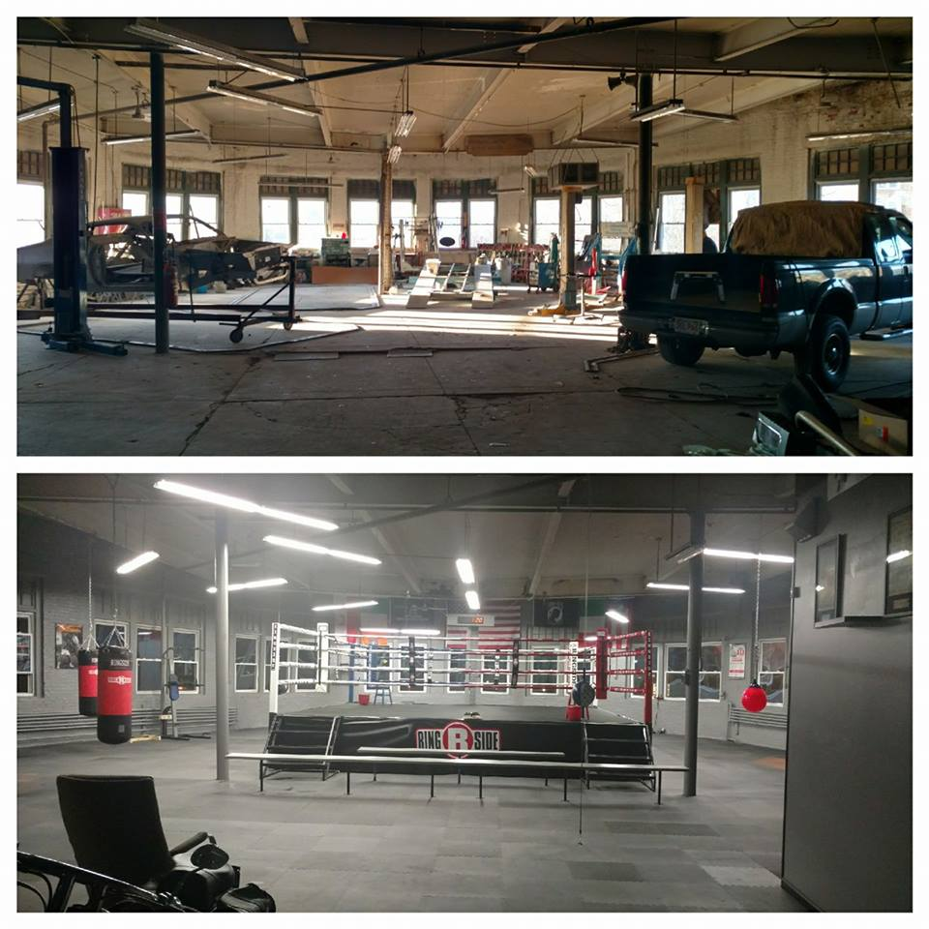

While preparing to open the facility, Dean spent countless hours creating a Youth Development Program which is character based explaining how life values relate to boxing. Almost immediately upon opening the doors, the space was filled with neighborhood youth as well as young adults who found an outlet for their energy while learning the value of hard work. In its first year of existence, this program gained local and national attention prompting an appearance on the Steve Harvey Show. Dean and three of his students were flown to Hollywood, California where they appeared on national television to talk about the intentions and success of the program. This national television appearance has facilitated several relationships with national organizations who commend the work that is being done by Central City Boxing & Barbell. Several of these organizations have showed interest in partnering with Central City Boxing & Barbell due to its strong, character-based curriculum and its desire to positively impact at risk youth.

In 2019, Central City Boxing & Barbell was met with a large dilemma when the building its program was located in was sold and Central City was told to vacate the building. Through community contacts and large support from the media Central City Boxing & Barbell launched a capital fundraiser. With the help of grants and donations along with the proceeds from Dean selling his house which he and his family enjoyed for nearly 20 years, Central City Boxing & Barbell was able to secure a new facility located at 22 Tyler Street. Central City spend the summer of 2019 relocating and remodeling its new location which opened in late August to correlate with the start of the school year. Central City is now running strong in its new training facility.

**22 Tyler Street**

Currently, Central City Boxing & Barbell is at its peek with more than 100 youth members, both male and female, between the ages of 8 and 18. Central City also runs an adult program which has more then 50 young adults, many of which use this program as support and as a safe haven where they know they can train while relying on their teammates keeping with Central City’s motto; One Team… One Fight!

Due to reaching its physical capacity, Dean aggressively sought grants and donations which facilitated the purchase of a new facility located 355 Berkshire Avenue where Central City Boxing & Barbell can expand their programs to an even broader range of youth who can use this location while being provided purpose, motivation and direction while developing into productive members of our community.

Currently, 355 Berkshire Avenue is in the process of being renovated with a target opening date of mid-September.