**Grade:** 100%

**Scrum Ceremonies**

Scrum ceremonies are essentially meetings. The scrum framework has 5 ceremonies. Scrum ceremonies are very specific meetings with clearly defined goals, participants, and time constraints.

Without those scrum ceremonies, scrum simply doesn’t work. These ceremonies are specific to the scrum framework, an agile process that teams use around the world to build things that work. Scrum is intentionally lightweight and simple, but it can be difficult to master. It is intended to provide a framework for cross-functional teams to solve complex problems. Simply put: scrum is a way to implement agile.

**✓**

**Product Backlog Refinement:**

Backlog refinement is the only ceremony in scrum that doesn’t have a defined time box or even a frequency. It is, however, a critical responsibility of the product owner with the help of their team to add new items to the list and order them based on their priority. At the same time, outdated, redundant or non-valuable items should be removed from the backlog to keep it clean, valuable and actionable. Sometimes teams make a meeting devoted to product backlog grooming to purposefully focus on this activity, but this is something every team decides for themselves.

**✓**

**Sprint Planning:**

Sprint Planning is the scrum ceremony designed to make sure the team is prepared to get the right things done every sprint. It is attended by the whole scrum team, so the product owner, development team and scrum master. The length of most scrum ceremonies is related to the length of the sprint. In terms of Sprint Planning, it should last 2 times the length of the sprint (in hours). So for a 2 week sprint, the Sprint Planning ceremony should be 4 hours maximum.

This scrum meeting happens at the beginning of a new sprint and is designed for the Product Owner and Development Team to meet and review the prioritized Product Backlog. Through a series of discussions and negotiations, the team should ultimately create a sprint backlog that contains all items they are committing to complete at the end of the sprint. This is called the sprint goal. The sprint goal should be a shippable increment of work, meaning it can be demonstrated at the end of a sprint. It needs to be agreed upon by the entire team.

The Product Owner is responsible for having the Product Backlog ready for review before Sprint Planning begins. This means adding acceptance criteria, requirements, and necessary details for the development team to accurately estimate the level of effort. The Product Owner also needs to be able to clarify any questions or assumptions that the Development Team has about the work. Only then can the development team accurately forecast the amount of work they can accomplish during the sprint.

**✓**

**Daily Scrum:**

The Daily Scrum is the team’s chance to get together, define a plan for the day’s work, and identify any blockers. It should last no more than 15 minutes. It is attended by the Scrum Master and the Development Team. The Product Owner is an optional attendee.

This scrum ceremony provides a frequent opportunity for the team to get together and communicate individual progress toward the sprint goal. The Daily Scrum is more than just a status update; it’s a pulse check that should illuminate any impediments that are slowing the team’s progress. The Scrum Master is responsible for clearing these roadblocks for the Development Team so they can focus on delivering the work identified in Sprint Planning.

During the daily scrum, each member of the Development Team should briefly answer the following questions:

* What did you do yesterday?
* What will you do today?
* Are there any impediments in the way?

Often times, members of the Development Team will identify opportunities to work together during the day based on commentary during the Daily Scrum.

**✓,** Brilliant and all on-point

**Sprint Review:**

The Sprint Review is the scrum ceremony where all work completed during the sprint can be showcased the stakeholders. It’s attended by the scrum team (product owner, development team & scrum master), and typically a mixture of management, outside stakeholders, customers, and even developers from other projects. It should last one hour per week of the sprint. So, a two hour Sprint Review should be scheduled for a two-week sprint.

At the conclusion of each sprint, the Sprint Review provides a platform for the Development Team to showcase all of the work that has been completed. This allows stakeholders to see things sooner than later and inspect or adapt the product as it emerges. All of the work showcased during this time should be fully demonstrable and meet the definition of done that the team is operating off of. The team should feel empowered to show off the work they’ve been able to complete over the course of the sprint. It should focus on the business value being delivered through product development.

**✓**

**Sprint Retrospective:**

The Sprint Retrospective is the final scrum ceremony in the sequence that allows the team to look back on the work that was just completed and identify items that could be improved. It’s attended by the Scrum Master and the Development Team. The Product Owner is an optional attendee. There should be no outside stakeholders involved in the retro. Typically, retrospectives should last no more than 1.5 hours for a two-week sprint.

After a Sprint Review has been conducted, the scrum team needs to have the opportunity to reflect on the work that was just showcased and discuss ways in which to improve. The sprint retrospective is that meeting. It gives the scrum team a platform to discuss things that are going well, things that could go better, and some suggestions for changes. Some common questions asked are:

* What went well over the last sprint?
* What didn’t go so well?
* What could we do differently to improve?

Ultimately, this scrum ceremony should provide a blameless space for members of the team to provide their honest feedback and recommendations for improvements. It should drive change. All actionable feedback should be collected and assigned so that members of the scrum team understand who is responsible for what.

Agile is all about constant improvement, and this ceremony is specifically designed to help the scrum team better.

**✓** Fantastic!

**Scrum Team Roles**

**Scrum Master:**

This person is responsible for ensuring the team has everything they need to deliver value. They are a coach, counsellor, advocate, impediment-remover, facilitator and mediator all rolled into one. They set up meetings and communicate progress and blockers. They’re essentially the project manager, just through the lens of scrum.

**✓**

**Product Owner:**

This role represents the client and the business in general for the product on which they’re working. They own the backlog and strive to prioritize items to be worked on before every sprint. They make executive product decisions on a daily basis. Ultimately, they’re translating customer needs into actionable work items for the Development team.

**Development Team:**

This is a group of cross-functional team members all focused on the delivery of working software. It is the singular noun for any developers, designers, QA and other technical roles that must collaborate on the actual development of a product. Ideally, this group of 5-9 people is fully dedicated to one scrum team. In reality, and especially at agencies, it might look a little bit different. The development team should to be self-organizing and motivated to provide value, and with proper facilitation by the Scrum Master and Product Owner, they can be.

**✓**

**Question 2**

You are leading a development team that was given a task to create a new yoga booking system.

High level description of the system is as follows:

* It has a very simple interface to accept user input (bookings) and display classes information
* All bookings, appointments, schedule etc should be stored in a SQL database.
* There is ‘backend’ system that should be written in Python to handle the logic and manage the data flow.

Your team has two weeks to build a simple prototype that will be shown to the client to seek their feedback and discuss further enhancements.

TASK

* Break this task into smaller stories (chunks of work) for the team to work on.
* Assume that one person works on one task.
* Mark tasks that can be worked on in parallel and perhaps those that need to be worked on in particular order.

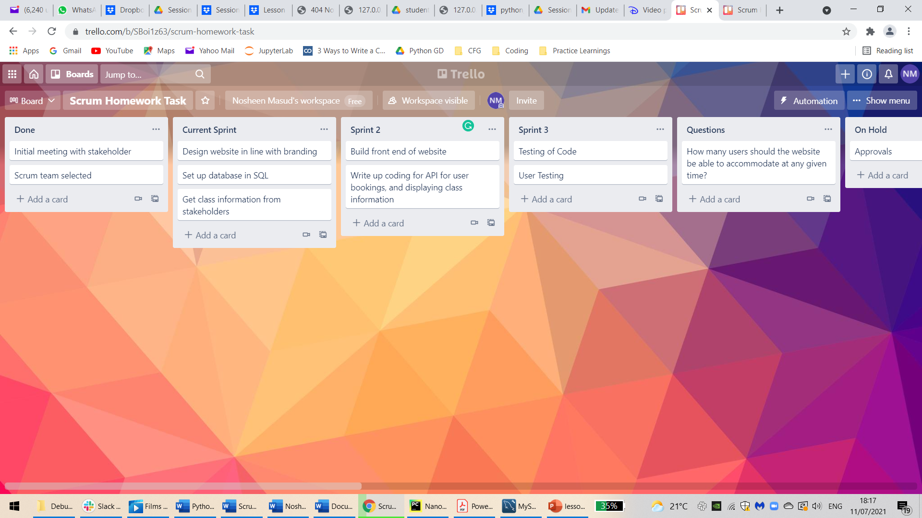

**✓** Amazing work, I really like the use of Trello for this submission (commonly used for real sprints as well in many teams!!). I think to take it further – which of these tasks are parallel-lisable and which are not? Think of using Trello’s ‘Label’ feature potentially for this

Try ‘assigning’ people to tasks as well – make it clear how much would each task need in terms of number of peoples