NLP-Based Techniques for IoT Security
Integrating N-gram Models, Word2Vec Embeddings, and Intelligent Threat Detection
A Comprehensive Review Paper
Khyrul Islam Akash
Student ID: 2028

ABSTRACT
The Internet of Things (IoT) has changed the way we interact with the world around us. Billions of everyday devices — from smart thermostats to industrial sensors — are now connected to the internet, collecting and sharing data around the clock. While this connectivity brings enormous benefits, it also opens the door to a wide range of cyber threats. Traditional security tools like encryption and authentication help protect data, but they often struggle to detect new or evolving attacks. This review paper explores how Natural Language Processing (NLP) can be used to strengthen IoT security across its three architectural layers: the Physical Layer, Network Layer, and Application Layer. In particular, we focus on two key NLP techniques — N-gram models, which identify suspicious word patterns in logs and messages, and Word2Vec, which helps systems understand the meaning behind words. We walk through the full process of building an NLP-based security system, from collecting data to automatically responding to threats. We also compare these methods with traditional approaches and discuss the road ahead for smarter, lighter, and more effective IoT security.
Keywords: Internet of Things, NLP, N-gram, Word2Vec, Cyber Threat Detection, IoT Layers, Anomaly Detection, Machine Learning

1. Introduction
We live in a world where our refrigerators send us notifications, our cars communicate with traffic systems, and factory machines diagnose their own faults. This world is made possible by the Internet of Things (IoT) — a vast network of physical devices that collect, share, and act on data continuously. As of 2024, there are estimated to be over 15 billion active IoT devices globally, and that number is expected to nearly double within the next five years.
But this explosive growth comes with a serious downside: security. IoT devices are often small, cheap, and designed with convenience in mind rather than security. Many run on stripped-down operating systems with no built-in protection, and because they are always connected and often left unattended, they make attractive targets for cybercriminals.
The old tools — firewalls, encryption, passwords — still matter, but they are no longer enough on their own. Modern threats are subtle, fast-moving, and often disguised as normal behavior. What we need are systems that can analyze the text-based data flowing through IoT networks — logs, alerts, commands, messages — and spot the warning signs of an attack before it causes damage.
This is where Natural Language Processing (NLP) steps in. NLP teaches machines to read, understand, and interpret human language. In the security world, NLP can analyze the textual footprints that cyberattacks leave behind — unusual log entries, strange command sequences, suspicious messages — and flag them before a human analyst would even notice.
This paper takes a comprehensive look at how NLP techniques — particularly N-gram models and Word2Vec embeddings — can be used to build smarter security systems for IoT environments. We also introduce a dedicated discussion of IoT's three-layer architecture and how threats and NLP-based defenses apply at each layer.

2. IoT Architecture: Three Layers and Their Security Challenges
To understand how NLP can protect IoT systems, we first need to understand how those systems are structured. IoT networks are typically organized into three distinct layers, each with its own role, its own components, and unfortunately, its own set of security vulnerabilities.
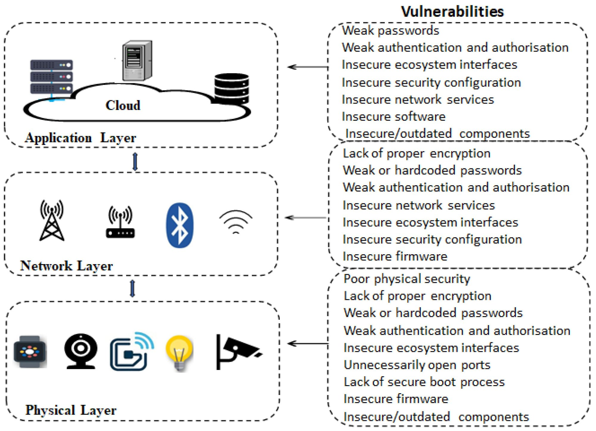
Figure 1: IoT Vulnerabilities Across the Three Architectural Layers (Physical, Network, Application)

2.1 Physical Layer
The Physical Layer is the foundation of any IoT system. It consists of the actual hardware devices that interact with the real world: temperature sensors, smart cameras, wearable health monitors, connected light bulbs, industrial actuators, and more. These devices collect raw data and send it upward through the system.
Security at this layer is particularly challenging because devices are often physically accessible to attackers, run outdated firmware, use hardcoded default passwords, and have open network ports that were never meant to be exposed. A compromised physical device can become a gateway into the entire network.
NLP contributes to physical layer security by analyzing the command logs and activity records these devices generate. Unusual sequences — such as a door sensor receiving a remote unlock command at 3am — can be flagged by N-gram-based anomaly detection.

2.2 Network Layer
The Network Layer handles all communication between IoT devices and between devices and the broader internet. This includes Wi-Fi routers, Bluetooth connections, cellular networks, and the protocols that govern how data moves around — such as MQTT, CoAP, and Zigbee.
This layer is a prime target for attackers because all data must pass through it. Man-in-the-middle attacks, packet injection, and denial-of-service floods all happen here. Insecure or unencrypted communications at this layer can expose the contents of every message passing through the network.
NLP-based tools can process the text-based logs and error messages produced by routers and gateways, identifying unusual patterns — such as repeated authentication failures from a single source — that indicate an ongoing attack.

2.3 Application Layer
The Application Layer is where users interact with IoT systems — through smartphone apps, web dashboards, cloud platforms, and voice assistants. It is also where the most complex processing happens: data aggregation, analytics, and control interfaces.
Vulnerabilities at this layer include poorly secured APIs, weak session management, and susceptibility to injection attacks and phishing. Because this layer handles user-generated text directly, it is particularly well-suited to NLP-based protection. NLP models can scan incoming messages, API calls, and user inputs for signs of social engineering or malicious commands.

2.4 Layer-by-Layer Summary
The table below summarizes how threats appear at each layer and how NLP can be specifically applied to counter them.

IoT Layer | Components | Key Vulnerabilities | How NLP Helps
Application Layer | Cloud platforms, web/mobile apps, user dashboards, APIs | Weak passwords, insecure interfaces, outdated software components, insecure configuration | NLP scans API logs and user-input data for injection patterns and phishing attempts
Network Layer | Wi-Fi, Bluetooth, cellular (4G/5G), routing infrastructure | Lack of encryption, weak authentication, insecure firmware, rogue access points | NLP analyzes network traffic messages and alerts to detect anomalous communication sequences
Physical Layer | Sensors, cameras, actuators, smart appliances, wearables | Poor physical security, open ports, insecure firmware, hardcoded passwords | NLP processes device logs and command sequences to detect unauthorized access attempts
Table 1: IoT Layers, Vulnerabilities, and NLP-Based Defenses

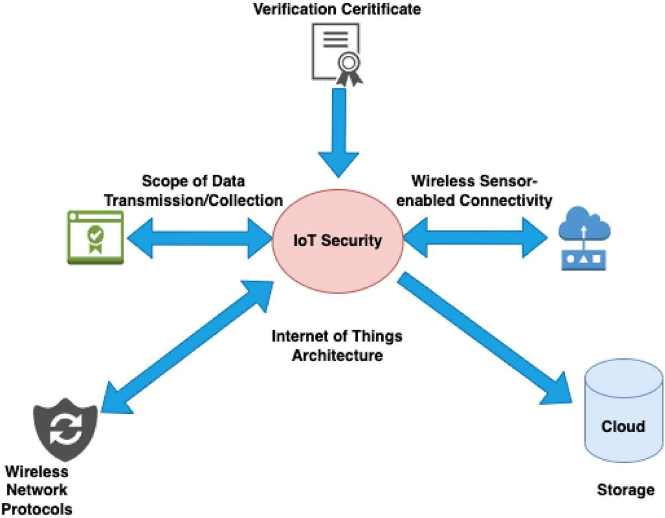
Figure 2: IoT Security Architecture — Key Dimensions Including Wireless Protocols, Data Transmission, and Cloud Storage

3. What is NLP and Why Does it Matter for IoT Security?
Natural Language Processing (NLP) is the branch of artificial intelligence concerned with giving computers the ability to read, understand, and work with human language. If you have ever asked Siri a question or used Google Translate, you have experienced NLP firsthand.
In the context of cybersecurity, NLP offers something very valuable: the ability to read and interpret the text-based data that systems constantly generate — logs, alerts, network messages, and user commands — at a scale and speed that no human team could match.

3.1 Textual Data in IoT Systems
IoT systems produce enormous quantities of text every day. System logs record every action a device takes. Security alerts fire when something unusual is detected. Network traffic messages carry the commands and responses devices exchange. User commands instruct smart home assistants and similar interfaces.
Each of these sources contains clues about what is happening inside the system. A series of failed login attempts, an unusual file access pattern, or a command the system has never seen before are all signals that something may be wrong. NLP gives us the tools to read these signals automatically.

3.2 How IoT Data Flows into NLP Security Systems
Figure 3 below shows how IoT device data moves from raw collection through machine learning classification and ultimately into a security evaluation result. This is the backbone of any NLP-powered IoT security system.

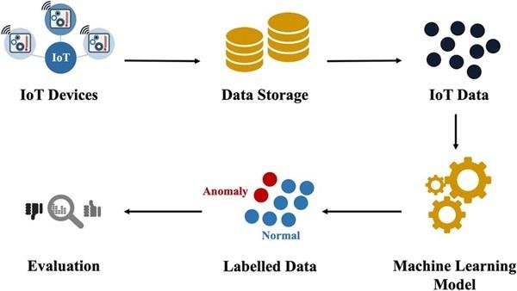

Figure 3: IoT Data Flow — From Device Collection Through Machine Learning to Security Evaluation

3.3 Core NLP Tasks Used in Security
- Text Classification — sorting incoming text into categories such as 'normal', 'suspicious', or 'attack'
- Tokenization — breaking text into individual words or tokens that can be analyzed
- Named Entity Recognition (NER) — identifying specific items like IP addresses, usernames, or file names
- Semantic Analysis — understanding what a piece of text actually means, not just what words it contains
- Anomaly Detection — flagging text patterns that deviate significantly from the established norm

4. N-gram Models: Spotting Patterns in Text
One of the oldest and most practical tools in the NLP toolbox is the N-gram model. Despite its simplicity, it is remarkably effective for detecting suspicious patterns in system logs and network messages.

4.1 The Basic Concept
An N-gram is simply a sequence of N consecutive words or tokens. Think of it like taking a sentence and sliding a window of a fixed size across it, capturing what falls inside the window each time.
For example, the sentence "multiple login failed attempts detected" contains the following N-grams:
- Unigrams (N=1): "multiple", "login", "failed", "attempts", "detected"
- Bigrams (N=2): "multiple login", "login failed", "failed attempts", "attempts detected"
- Trigrams (N=3): "multiple login failed", "login failed attempts", "failed attempts detected"
On their own, individual words may seem harmless — the word "login" appears in perfectly normal logs all the time. But when we look at sequences, patterns start to emerge. "Login failed" is mildly concerning. "Multiple login failed" looks like a brute-force attack in progress.

4.2 How N-gram Models Detect Threats
An N-gram based security system works in two phases. First, it learns what "normal" looks like by analyzing large volumes of legitimate system logs. It builds a statistical model of which sequences of words commonly appear together in normal operation. Then, when it encounters a new log entry, it checks whether the word sequences in that entry match the learned patterns. If they do not — if the system encounters an unusual or never-before-seen sequence — it raises an alert.
Table-2 below illustrates how the N value affects security interpretation. Notice how using longer sequences (trigrams) provides a much clearer threat signal than single words alone.

N Value | Token Sequence | Security Interpretation
1 (Unigram) | "login" | Single word — alone it tells us very little
2 (Bigram) | "login failed" | A pair that starts to look suspicious
3 (Trigram) | "multiple login failed" | A clear pattern that signals a brute-force attack
Table 2: N-gram Examples and Their Security Interpretation

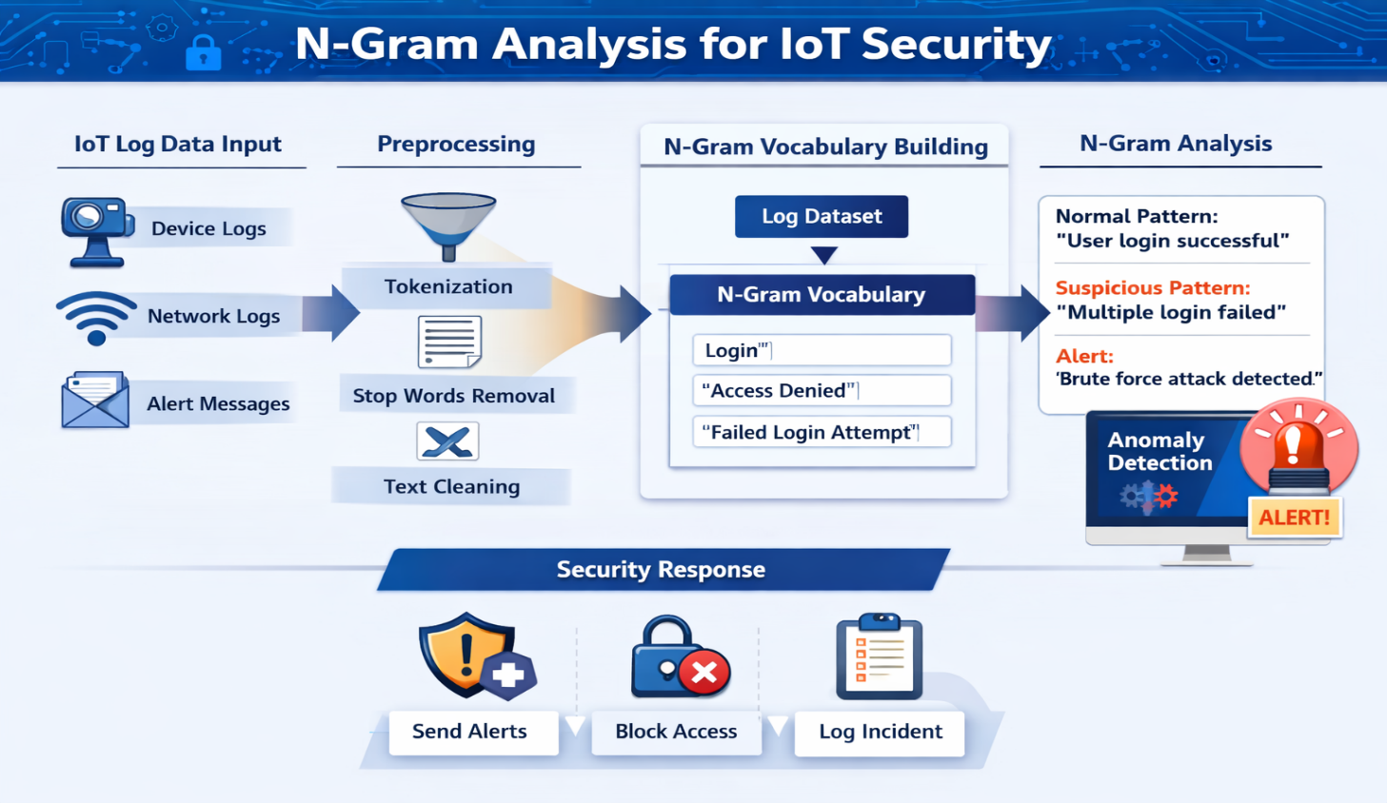
Figure 4: N-gram-based IoT Security Workflow — From Log Collection to Threat Detection

4.3 Advantages and Limitations
N-gram models have several appealing qualities for IoT security. They are computationally cheap, meaning they can run on devices with limited processing power. They are fast, capable of analyzing thousands of log entries per second. And they are easy to explain — an analyst can always see exactly which word sequence triggered an alert and why.
However, N-gram models have a fundamental weakness: they deal only in patterns, not meaning. They cannot understand that "unauthorized entry" and "illegal access" mean the same thing if those exact n-grams were not present in the training data. For deeper semantic understanding, we need Word2Vec.

5. Word2Vec: Teaching Machines to Understand Meaning in IoT Logs
While N-gram models are great at spotting known patterns, they struggle with meaning. A system trained on 'unauthorized access' might completely miss 'illegal entry' even though any human reader would recognize them as identical threats. Word2Vec was developed to solve exactly this problem.

5.1 How Word2Vec Works
Word2Vec is a neural network technique that transforms words into numerical vectors — each word gets a unique position in a multi-dimensional space. Words with similar meanings end up positioned close to each other in this space, while unrelated words are far apart.
After training on security-specific text, a Word2Vec model understands that 'attack' is close to 'intrusion', 'breach', and 'compromise'; that 'login' is close to 'authentication' and 'credential'; and that 'block' is close to 'deny' and 'reject'. These relationships emerge naturally from the data.

5.2 Applying Word2Vec to IoT Threat Detection
In an IoT security context, Word2Vec allows a detection system to recognize threats even when described in slightly different words. Consider these two log entries: 'Unauthorized access attempt from external IP address' and 'Illegal login request detected from foreign source'. A pattern-matching system treats these as unrelated. A Word2Vec-powered system recognizes the semantic equivalence and correctly classifies both as threats.
This is especially powerful for detecting phishing attacks, where attackers deliberately vary their language to evade detection, and for identifying new variants of known attack types that have never been seen before.
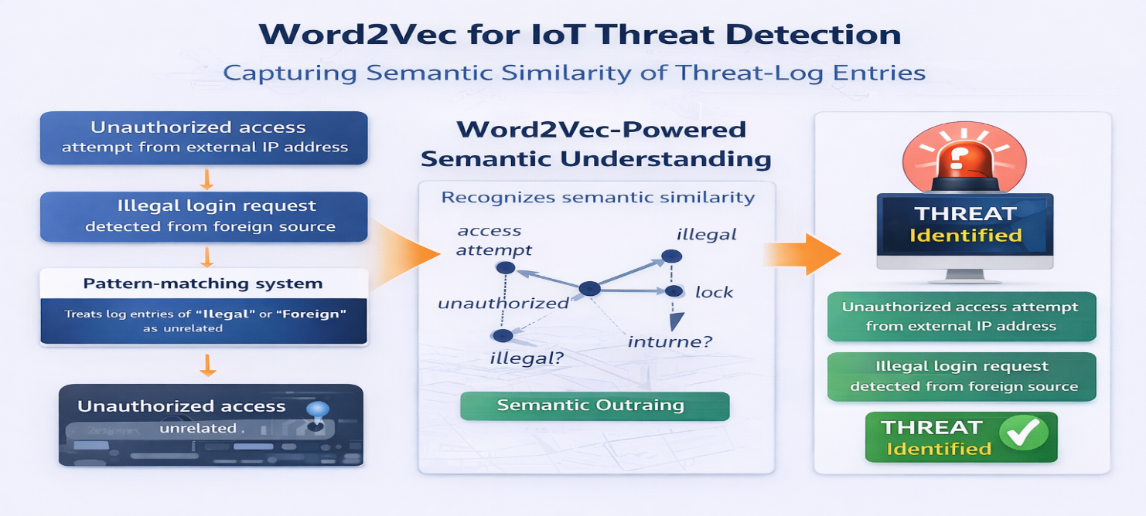
Figure 5: Word2Vec-Based Semantic Threat Detection in IoT Log Analysis

5.3 NLP Text Classification Pipeline
The diagram below shows the complete text classification pipeline that combines preprocessing, feature creation (using methods like Word2Vec and Bag-of-Words), and modelling stages with evaluation feedback — exactly how a real IoT security system would be built.

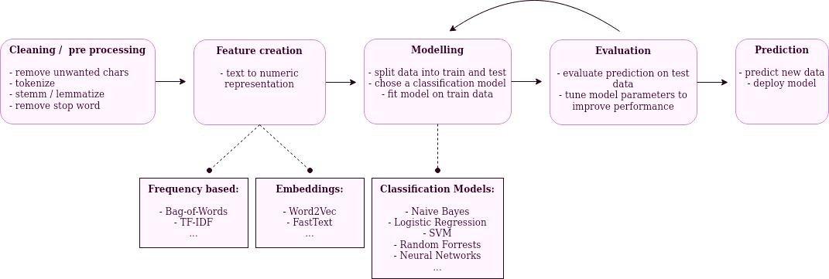
Figure 6: NLP Text Classification Pipeline — Preprocessing, Word2Vec Embeddings, Classification Models, and Evaluation

6. An End-to-End NLP Security Framework for IoT
Understanding individual NLP techniques is valuable, but the real power comes from combining them into a complete, working security pipeline. The NLP pipeline shown in Figure 7 below illustrates how data acquisition, preprocessing, feature engineering, modelling, and deployment all connect into a unified system.

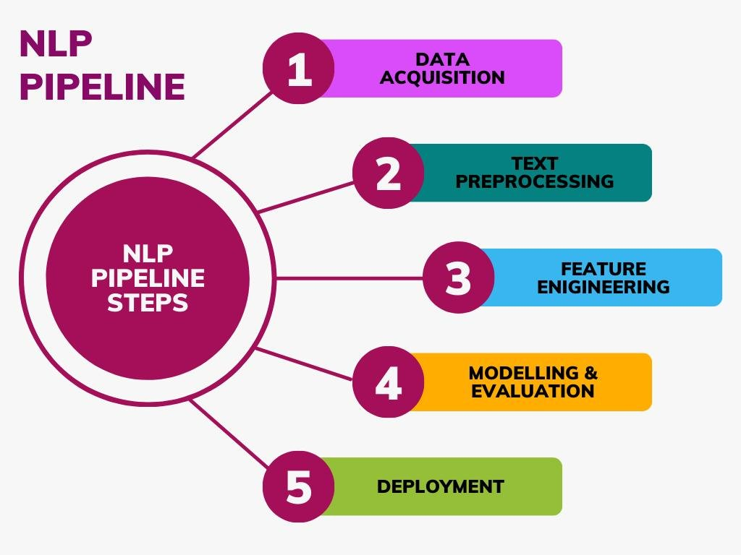
Figure 7: NLP Pipeline Steps — From Data Acquisition to Deployment

Table-3 below maps out the full end-to-end process in a tabular form, making it easy to see what happens at each stage and how each step feeds into the next.

# | Stage | What Happens
Step 1 | Data Collection | IoT logs, network traffic, alerts, user commands
Step 2 | Preprocessing | Tokenization, stop-word removal, stemming/lemmatization
Step 3 | Feature Extraction | N-gram patterns + Word2Vec semantic vectors
Step 4 | Model Training | Naïve Bayes, SVM, LSTM classifiers
Step 5 | Threat Detection | Normal vs. suspicious activity classification
Step 6 | Response System | Alert generation, auto-blocking, incident logging
Table 3: End-to-End NLP Security Pipeline for IoT Systems

Step 1 — Data Collection
The first challenge is gathering the right data. In an IoT environment, data comes from device logs that record every action taken by every device, network traffic logs that capture messages between devices and servers, user interaction records for voice-controlled or app-connected devices, and security alerts from existing monitoring tools. The quality and diversity of this collection phase directly determines how well the downstream NLP models will perform.

Step 2 — Data Preprocessing
Raw logs are messy. They contain timestamps, error codes, redundant phrases, and plenty of noise that is irrelevant to security. This stage involves tokenization (splitting text into individual words), stop-word removal (eliminating words like 'the' and 'is'), stemming and lemmatization (reducing words to their base forms), and noise removal (stripping irrelevant formatting and boilerplate).

Step 3 — Feature Extraction
With clean text in hand, the next step is converting it into numbers that machine learning models can work with. N-gram features capture statistical patterns of word sequences, while Word2Vec features encode the semantic meaning of words as dense numerical vectors. The best systems use both together, giving the model both pattern-recognition capability and semantic understanding.

Step 4 — Model Training
The extracted features are fed into a machine learning classifier. Naïve Bayes is fast and effective for text classification, well-suited to lightweight IoT deployments. Support Vector Machines (SVM) perform excellently on high-dimensional text data. Long Short-Term Memory (LSTM) networks model the sequential nature of log entries and are particularly good at detecting attack sequences that unfold over time.

Step 5 — Threat Detection
Once trained, the model evaluates each incoming log entry or network message and assigns it to a category: normal activity, potentially suspicious, or confirmed threat. The classification can be binary or fine-grained, distinguishing between phishing, brute-force, malware, and other attack types.

Step 6 — Automated Response
Detection is only useful if something happens as a result. The response system generates real-time alerts for security analysts, automatically blocks suspicious IP addresses or connections, isolates compromised devices from the rest of the network, and logs all detected incidents for forensic analysis and model retraining.

7. Comparative Analysis of Security Approaches
No single security technique is a silver bullet. The table below compares key approaches — including both NLP-based and traditional methods — across their strengths, weaknesses, and computational demands. The clear takeaway is that the most robust systems combine NLP-based intelligent detection with traditional security foundations.

Approach | Strengths | Weaknesses | Complexity
N-gram Models | Simple, fast, low memory | No semantic understanding | Low
Word2Vec | Understands word meaning & context | Needs large training corpus | Medium
BERT/Transformers | Deep contextual understanding | Very heavy on resources | High
Traditional Encrypt. | Strong data protection | Cannot detect threats | Low
Rule-Based IDS | Predictable, easy to audit | Misses novel attacks | Low
Hybrid NLP+Security | Detection + protection combined | Requires careful integration | High
Table 4: Comparative Analysis of IoT Security Approaches

8. Challenges and Honest Limitations
While the potential of NLP-based IoT security is genuinely exciting, it is important to be clear-eyed about the obstacles that remain.

8.1 Computational Demands
NLP models — especially Word2Vec and BERT — require real processing muscle to train and run. Many IoT devices simply do not have this capacity. A battery-powered environmental sensor cannot run a neural network. This pushes much of the NLP computation to edge servers or the cloud, introducing latency that can be unacceptable for real-time threat response.

8.2 Data Quality and Availability
Machine learning models are only as good as the data they are trained on. In the IoT security domain, high-quality labeled datasets — particularly those containing real examples of attacks in IoT-specific environments — are rare. There is also the challenge of concept drift: attack patterns evolve over time, and models need continuous updates to stay relevant.

8.3 Real-Time Processing
A security system that takes five seconds to classify a log entry is not useful when an attack can compromise a device in milliseconds. Building NLP pipelines that can keep pace with high-throughput IoT data streams in real time requires careful engineering and significant hardware investment.

8.4 Privacy Concerns
The logs and messages that NLP systems analyze may contain sensitive personal information — medical readings from health devices, location data from smart vehicles, or conversation snippets from voice assistants. Analyzing this data must respect user privacy and comply with data protection regulations such as GDPR.

8.5 Adversarial Attacks
Sophisticated attackers, knowing that an NLP-based detection system is in place, may deliberately craft their attack messages to evade it — using unusual phrasings, substituting words, or injecting noise. NLP-based security systems must therefore evolve continuously rather than being treated as static solutions.

9. Future Research Directions
The field of NLP-based IoT security is young and moving fast. The table below outlines the most promising directions for future research and development.

Future Direction | What It Means for IoT Security
Lightweight NLP Models | Compact models designed to run directly on resource-limited IoT hardware without cloud dependency
Edge-Based Processing | Moving threat detection to edge nodes (routers, gateways) to reduce latency and protect privacy
Blockchain Integration | Using tamper-proof blockchain logs alongside NLP to ensure detected threats cannot be altered
BERT & Transformers | Applying transformer models for far richer contextual understanding of complex attack patterns
Federated Learning | Training models across many devices without sharing raw data — preserving privacy while improving accuracy
Multilingual & Protocol NLP | Extending NLP to non-English logs and IoT protocols like MQTT and CoAP
Table 5: Future Research Directions in NLP-Based IoT Security

Perhaps the most important future direction is the development of truly lightweight NLP models — compact enough to run directly on IoT hardware without needing to send data to a remote server. Research into model compression techniques such as knowledge distillation and quantization shows real promise here.
Federated learning — a technique where models are trained across many devices without centralizing the raw data — could help address both the data scarcity problem and privacy concerns simultaneously. Each IoT device contributes to improving the shared model without ever sharing its raw log data with a central server.
The integration of NLP with blockchain technology is another exciting frontier. Blockchain's immutable ledger could be used to store threat detection records in a way that cannot be tampered with, providing a trustworthy audit trail for forensic investigations.

10. Conclusion
The Internet of Things has transformed our world, connecting billions of devices and enabling applications that would have seemed like science fiction just a decade ago. But this connectivity has also created serious security challenges that traditional tools alone cannot meet.
This paper has shown that IoT security must be understood at three levels: the Physical Layer, where devices collect data; the Network Layer, where data travels; and the Application Layer, where users interact with systems. Each layer has its own unique vulnerabilities, and each can benefit from NLP-based threat detection tailored to the text data it produces.
N-gram models provide fast, efficient pattern detection — identifying suspicious sequences of words in real time with minimal computational overhead. Word2Vec goes deeper, enabling systems to understand the meaning behind words and recognize threats even when they are phrased in unfamiliar ways. Together, these techniques form an intelligent, adaptive security layer that complements — rather than replaces — traditional mechanisms like encryption and authentication.
The road ahead is not without challenges. Computational constraints, data quality, real-time processing demands, and adversarial threats all present genuine obstacles. But emerging techniques like lightweight transformers, federated learning, and edge-based processing are steadily bringing the promise of NLP-powered IoT security closer to reality.
In a world where the number of connected devices continues to grow exponentially, building smarter, more adaptive security systems is not just a technical goal — it is an urgent necessity. NLP-based approaches are a critical part of that solution.

References
[1] Mikolov, T., Chen, K., Corrado, G., & Dean, J. (2013). Efficient estimation of word representations in vector space. arXiv:1301.3781.
[2] Kolias, C., Kambourakis, G., Stavrou, A., & Voas, J. (2017). DDoS in the IoT: Mirai and other botnets. Computer, 50(7), 80–84.
[3] Hatcher, W. G., & Yu, W. (2018). A survey of deep learning: Platforms, applications and emerging research trends. IEEE Access, 6, 24411–24432.
[4] Devlin, J., Chang, M. W., Lee, K., & Toutanova, J. (2019). BERT: Pre-training of deep bidirectional transformers for language understanding. NAACL-HLT 2019.
[5] Javed, A., et al. (2022). Towards a universal NLP-based IoT attack detection framework. IEEE Internet of Things Journal.
[6] Scarfone, K., & Mell, P. (2007). Guide to intrusion detection and prevention systems (IDPS). NIST Special Publication 800-94.
[7] Buczak, A. L., & Guven, E. (2016). A survey of data mining and machine learning methods for cybersecurity intrusion detection. IEEE Comms. Surveys & Tutorials, 18(2), 1153–1176.
[8] Xu, K., Yao, D. D., Ma, Q., & Crowell, A. (2017). Automatically detecting anomalous program behaviors using N-gram analysis. IEEE ICDCS.
[9] Apthorpe, N., Reisman, D., & Feamster, N. (2017). A smart home is no castle: Privacy vulnerabilities of encrypted IoT traffic. Workshop on Data and Algorithmic Transparency.
[10] Conti, M., et al. (2018). Internet of Things security and forensics: Challenges and opportunities. Future Generation Computer Systems, 78, 544–546.
[11] OWASP Foundation. (2023). OWASP Top 10 IoT Security Vulnerabilities. owasp.org/www-project-internet-of-things.
[12] Al-Garadi, M. A., et al. (2020). A survey of machine and deep learning methods for internet of things security. IEEE Communications Surveys & Tutorials, 22(3).

