**A Project Report on**

**RESUME(PROFILE)**

**USING HTML & CSS**

submitted by

**V NOSHITHA NAVYA RENUKA - GQT-S0156**

under the mentorship of

**KESHAV MURTHY**



**GLOBAL QUEST TECHNOLOGIES**

[info@gqtech.in](mailto:info@gqtech.in)

Yelahanka Satellite Town,

Bangalore, Karnataka - 560064.

[2023]

**Signature of the mentor Signature**

**Keshav Murthy G.R.Narendra Reddy**

**INTRODUCTION**

**HISTORY OF HTML:**

**HTML** stands for **Hyper Text Markup Language**.

* It is used to share the information over the internet.
* HTML id developed by Tim Berner’s Lee in 1991.But officially in 1993.
* The First version of HTML consists of “18 tags”
* HTML follows certain rules and regulations setup by “**ISO**”.
* International Organization for standardization is set of rules and regulation are present in ‘**SGML**’ document.

**Versions of HTML**

* **HTML-1** version in the year 1993.
* **Html-2** version in the year 1995.
* **HTML-3.02** version in the year 1997.
* **HTML-4.1** version in the year 1999.
* **HTML-5** version in the year 2014.

**Features of HTML**

* It is easy to Learn.
* It is a tag based language.
* HTML is supported by multiple browsers.
* First web browser is Netscape navigation which was developed by the “Mosiac”.
* It is a portable language.
* **WORA** stands for ‘write once run anywhere’

**Limitation of HTML**

* HTML has less designing capabilities.
* It is dependent on other technology such as CSS in order to develop well designed Webpages.
* HTML has no programming capabilities.
* Using HTML and CSS we can develop only static Web page.
* In order to write the HTML code required an editor such as VS Code, Notepad, Eclipse.
* In order to execute the HTML code we required Web browsers.Like Chrome, Firefox, edge, Opera Safari .

**CSS**

* **CSS** stands for **Cascading Style Sheets**.
* It was developed by W3C to add stylings to the HTML elements.
* W3C stands for World Wide Web.com

**Versions of CSS:**

* CSS-1 (level-1) in the year 1996.
* CSS-2 (level-2) in the year 1998.
* CSS-3 (level-3) in the year 1999.

**Why do we required CSS ?**

* Since HTML has less designing capabilities we cannot create well designed or most appealing Websites.
* Using HTML we cannot add style, animation and transitions to the Webpage.
* Therefore we require CSS to create well designed Webpages.

**Advantages of CSS**

* It allows to add styles, animation and variouses effects to the Webpage.
* It allows us to develop the Webpage rapidly. It is also know as RAD ( rapid application Developer).
* It allows us to separate from formatting develop page to the presentation of Webpage.
* It allows to create well designed Websites.

**Limitations of CSS**

* Using CSS we can perform static styles for the Webpages.
* In order to create dynamic styling for the Websites. We must make use of scripting language such as JavaScript and Libraries of JavaScript.

**Types of CSS:**

1. Inline CSS
2. Internal CSS
3. External CSS
4. Default Browser CSS

**Inline CSS:**

Defining all the CSS properties within the style attribute inside the opening of the tag is referred to as Inline CSS.

**Internal CSS:**

Defining all the CSS properties within <style> inside the HTML document is referred to as Internal CSS.

**External CSS:**

Defining all the CSS properties within as external Script or File with an extension CSS is referred to as External CSS.

* In order to link external CSS file within the HTML document we must use of <link>.
* The value for the ‘ref’ attribute should be ‘stylesheet’.

**RESUME(PROFILE)**

**Scope of the document**

I was created Resume using HTML & CSS.The Scope of the document is:

**Personal Information:** It includes my name, contact information, and a professional summary or objective statement.

**Education:**I have Listed my educational background, including institutions attended, degrees earned, and relevant dates.

**Skills:** I have mentioned technical and soft skills in a clear and organized manner.

**Projects:** I have done two projects in my college, that is also mentioned in this resume.

**Achievements and Awards:** I have completed some courses in online platform i.e Hackerrank.

**Certifications:** I achieved few cirtificates during my college and internships thoes are mentioned in this resume.

**Design and Styling:** Implemented my resume using HTML and CSS skills to design a visually appealing and well-structured resume.

**Technologies Used**

* HTML5
* CSS3

**Our Project**

**Root Structure:**

**RESUME**

→**CODES**

→**HTML_Files**

→Resume.html

→**CSS_Files**

→Resume.css

**PROJECT REPORT**

→FRONT END PROJECT 1 RESUME.DOC

**SCREENSHOTS**

→ALL THE CORRESPONDING SCREENSHOTS OF PAGES.

**Source Code:-**

**Resume.html:**

<!DOCTYPE html>

<html lang="en">

<head>

<meta charset="UTF-8">

<meta name="viewport" content="width=device-width, initial-scale=1.0">

<title>Document</title>

<link rel="stylesheet" href="style.css">

</head>

<body>

<div class="main">

<div class="header">

<div

style="height: 16px; width: 75%; background-color: #365B6D;margin-left: 260px;border-radius: 40px 90px 0px 40px;margin-top: 30px;">

</div>

<div id="c3"></div>

<div id="c4"></div>

<div id="c5"></div>

<h1 id="s">NOSHITHA NAVYA RENUKA V</h1>

<div style="width:35%;height: 0px;border: 1px solid #365B6D;margin-left: 450px;margin-top: 20px;"></div>

<div id="c24"></div>

<div id="c23"></div>

<div id="body-info1">

<p

style="color:#EAF2F6;font-size: 20px;margin-top: -1px;margin-left: -5px;font-family: sans-serif;width:80%;height:20px">

CAREER

OBJECTIVE</p>

</div>

<div id="c11">

<ul type="disk" style="color:#365B6D">

<li>As a Technical aspirant, I find my way to fullfill my dreams by exploring my skills with

confidence.</li>

<li>To Grow propessionally and make wonderful career with better opportunities.</li>

<li>I am excited to learn new things and seeking for an opportunity in a platform where i

can improve myself and develop software applications.</li>

</ul>

</div>

<img

src="Noshitha.jpg"><!--alt="" width="250px"height="240px" style="margin-left: 65px; margin-top: 30px;">-->

</div>

<div class="body2">

<div style="height: 2px; width: 100%; background-color: #365B6D;margin-left: 266;margin-top: -20px;"></div>

<div class="body-info">

<h1 class="cnt1"> INTERNSHIPS </h1>

<div class="cls">

<p style="margin-left: 21px;"><b>CCNA | Cisco Network Academy</b></p>

<ul class="info1">

<li>I have achieved student level credential for completing CCNAv7: Switching,Routing, and

Wireless

Essentials.</li>

</ul>

</div>

</div>

<div class="body-info">

<h1 class="cnt1"> CERTIFICATIONS</h1>

<div class="cls">

<ul class="info1">

<li>Currently I am pursuing additional certification course on java full stack

development in GQT.</li>

<li>Course Completion Certificate on CCNAv7 Network Essentials, Switching,

Routing.</li>

<li>Courses Completed in CodeTantra (C,Java,Python)</li>

<li>Certificate on TCS ion Career Edge - Young Professionals</li>

</ul>

</div>

</div>

<div class="body-info">

<h1 class="cnt1"> PROJECTS</h1>

<p style="margin-left: 21px;"><b>Designing a game playing bot using Artificial Intelligence.</b></p>

<div style="width:85%;height: 200px;margin-left: 35px;">

<ul type="disc" style="margin-left: -35px;margin-top: 15px;line-height: 23px;">

<li>In this Project the game of Chess has beenimplemented using two algorithms, Min-Max

algorithm and Min-Max with alpha beta pruning.</li>

<li>In this project I created UI(User Interface) for Playing automatic chess playing bot.</li>

<li>To implement this algorithm using <b>Python.</b></li>

</ul>

</div>

</div>

<div class="body-info">

<h1 id="cnt11">STRENTHS</h1>

<ul class="info1" style="line-height: 23px;">

<li>Hard working</li>

<li>Positive Thinking</li>

<li>Self Motivated</li>

</ul>

</div>

<div class="body-info">

<h1 id="cnt12">LANGUAGES</h1>

<ul class="info1" style="line-height: 23px;">

<li>English</li>

<li>Telugu</li>

</ul>

</div>

</div>

<div class="side">

<h1 class="cnt9">EDUCATION</h1>

<div class="edu">

<ul type="disc"></ul>

<li>2020-2023 - Bachelor Of

Technology In

CSE<br>&nbsp;&nbsp;&nbsp;&nbsp;&nbsp;&nbsp;&nbsp;&nbsp;&nbsp;&nbsp;&nbsp;&nbsp;&nbsp;&nbsp;&nbsp;&nbsp;&nbsp;&nbsp;&nbsp;&nbsp;&nbsp;&nbsp;&nbsp;&nbsp;&nbsp;&nbsp;S

V College Of Engineering,

Tirupati.<br>&nbsp;&nbsp;&nbsp;&nbsp;&nbsp;&nbsp;&nbsp;&nbsp;&nbsp;&nbsp;&nbsp;&nbsp;&nbsp;&nbsp;&nbsp;&nbsp;&nbsp;&nbsp;&nbsp;&nbsp;&nbsp;&nbsp;&nbsp;&nbsp;&nbsp;&nbsp;CGPA

- 81.37</li><br>

<li> 2017-2020 - Diploma In

CSE<br>&nbsp;&nbsp;&nbsp;&nbsp;&nbsp;&nbsp;&nbsp;&nbsp;&nbsp;&nbsp;&nbsp;&nbsp;&nbsp;&nbsp;&nbsp;&nbsp;&nbsp;&nbsp;&nbsp;&nbsp;&nbsp;&nbsp;&nbsp;&nbsp;&nbsp;&nbsp;S

V Govt. Polytechnic College, Tirupati.

&nbsp;&nbsp;&nbsp;&nbsp;&nbsp;&nbsp;&nbsp;&nbsp;&nbsp;&nbsp;&nbsp;&nbsp;&nbsp;&nbsp;&nbsp;&nbsp;&nbsp;&nbsp;&nbsp;&nbsp;&nbsp;&nbsp;&nbsp;&nbsp;&nbsp;&nbsp;CGPA

- 85.78</li>

</div>

<h1 class="cnt2">TECHNICAL SKILLS</h1>

<ul class="list-time1">

<li>C, Python</li>

<li>Core Java/ Advanced Java</li>

<li>HTML, CSS, Bootstrap, JavaScript,ES6</li>

<li>SQL,MySQL</li>

<li>Manual Testing</li>

<li>Automation Testing</li>

</ul>

<h1 class="cnt2">SKILLS</h1>

<ul class="list-time1">

<li>Communication</li>

<li>Problem Solving</li>

<li>Creativity</li>

<li>Designing</li>

<li>Team work and Multitasking</li>

<li>Good Organization Skills</li>

</ul>

<h1 class="cnt2">ACHIEVEMENTS</h1>

<ul class="list-time1">

<li> Java In Hackerrank ⭐⭐⭐⭐⭐</li>

<li> MySQL In Hackerrank ⭐⭐⭐</li>

</ul>

<div class="class-info">

<h1 class="cnt">CONTACT</h1>

<ul class="list-time">

<li id="im1">Email - vnoshitha@gmail.com</li>

<li id="p1">Phone - 8179705629</li>

<li id="l1">Location - Tirupati, andhra Pradesh</li>

<li id="l2">Linkedin -<a

href="linkedin.com/in/vithanala-noshitha-navya-renuka-b76b08236">linkedin.com/in/vithanala-noshitha-navya-<br>renuka-b76b08236</a>

</li>

</ul>

</div>

</div>

</div>

</body>

</html>

**Resume.css:**

#c1{

width:95%;

height: 400px;

background-color:#EAF2F6;

margin-left: 10px;

margin-top: 10px;

border-bottom: 2px solid #365B6D;

}

img{

width: 20%;

height: 300px;

margin-left: 85px;

margin-top: 50px;

border-radius: 40px 0px;

}

#c3{

width:89%;

height: 15px;

background-color:#365B6D;

margin-left: 125px;

margin-top: -352px;

border-radius: 40px 0px 0px 40px;

}

#c4{

width:15px;

height: 15px;

background-color:#365B6D;

border-radius: 90px 90px 90px 90px;

margin-left: 100px;

margin-top: -14px;

}

#c5{

width:15px;

height: 15px;

background-color:#365B6D;

border-radius: 90px 90px 90px 90px;

margin-left: 80px;

margin-top: -15px;

}

#c6{

width:15px;

height: 15px;

background-color:#365B6D;

border-radius: 90px 90px 90px 90px;

margin-left: 60px;

margin-top: -15px;

}

#c8{

width:40%;

height: 50px;

margin-left: 520px;

margin-top: 20px;

color: #365B6D;

text-align: left;

font-size: xx-large;

border:2px solid #365B6D;

}

#c24{

width:10px;

height: 10px;

background-color:#365B6D;

border-radius: 90px 90px 90px 90px;

margin-left: 900px;

margin-top: -5px;

border:2px solid red;

}

#c25{

width:5px;

height: 5px;

background-color:#365B6D;

border-radius:50% ;

margin-left: 913px;

margin-top: -7px;

border:2px solid #365B6D;

}

#c26{

width:5px;

height: 5px;

background-color:#365B6D;

border-radius:50% ;

border:2px solid #365B6D;

margin-left: 540px;

margin-top: -7px;

}

#c23{

width:10px;

height: 10px;

background-color:#365B6D;

border-radius: 90px 90px 90px 90px;

margin-left: 550px;

margin-top: -6px;

border: 2px solid red;

}

#c9{

width:50%;

height: 50px;

margin-left: 510px;

margin-top: -10px;

color: #365B6D;

text-align: center;

font-size: xx-large;

}

#c10{

width:49%;

height: 35px;

background-color:#365B6D;

border-radius: 0px 90px 90px 0px;

margin-left: -60px;

margin-top: 60px;

color: #EAF2F6;

text-align: left;

}

#c11{

color:#365B6D;

margin-top: 30px;

width: 95%;

height: 250px;

text-align: left;

font-size: 15px;

line-height: 40px;

margin-left: -80px;

font-family: serif;

}

#c2{

width:35%;

height: 1300px;

background-color:#365B6D;

border-radius: 20px 20px 0px 0px;

}

#c7{

width:65%;

height: 1190px;

background-color:#EAF2F6;

margin-left: 400px;

margin-top: -1183px;

}

#c12{

width:60%;

height: 50px;

margin-left: 500px;

margin-top: 20px;

color: #365B6D;

text-align: center;

}

#c13{

width:15%;

height: 40px;

border: 2px solid red;

margin-left: 30px;

margin-top: -1000px;

color: #365B6D;

text-align: left;

font-size: 25px;

font-family: sans-serif;

}

p{

color:#365B6D;

font-size: x-large;

}

#c14{

margin-left: 120px;

margin-top: -1px;

line-height: 20px;

border: 2px solid darkorchid;

width:20%;

border: 2px solid peru;

}

.c{

color:#EAF2F6;

font-size: 18px;

font-family: serif;

line-height: 20px;

border: 2px solid violet;

}

#c15{

width:1%;

height: 320px;

background-color:#365B6D;

margin-left: 250px;

margin-top: -300px;

}

#c16{

width:2%;

height: 20px;

background-color:#365B6D;

border-radius: 150px 150px 150px 150px;

margin-left: 247px;

margin-top: -5px;

}

#c17{

border: 2px solid green;

width:10%;

margin-left: 20px;

margin-top: -150px;

}

#c20{

width:24%;

height: 35px;

background-color:#365B6D;

border-radius: 0px 90px 90px 0px;

margin-left: 450px;

margin-top: -420px;

color: #EAF2F6;

text-align: left;

font-size: xx-large;

}

#c21{

border: 2px solid yellow;

margin-left: 40px;

margin-top: 130px;

color: #EAF2F6;

text-align: left;

font-size: 25px;

font-family: sans-serif;

}

#c22{

width:30%;

height: 40px;

background-color:#365B6D;

border-radius: 0px 90px 90px 0px;

margin-left: 530px;

margin-top: 50px;

color: #EAF2F6;

text-align: left;

font-size: xx-large;

}

#c27{

width:42%;

height: 15px;

background-color:#365B6D;

margin-left: 630px;

margin-top: 7px;

border-radius: 0px 40px 40px 0px;

}

#c28{

width:1%;

height: 15px;

background-color:#365B6D;

border-radius: 90px 90px 90px 90px;

margin-left: 1270px;

margin-top: -15px;

}

#c29{

width:1%;

height: 15px;

background-color:#365B6D;

border-radius: 90px 90px 90px 90px;

margin-left: 1290px;

margin-top: -15px;

}

#c30{

width:1%;

height: 15px;

background-color:#365B6D;

border-radius: 90px 90px 90px 90px;

margin-left: 1310px;

margin-top: -15px;

}

#c31{

width:2%;

height: 1100px;

background-color:#365B6D;

margin-left: 1320px;

margin-top: -1150px;

border-radius: 40px 0px 0px 40px;

}

#c09{

width:19%;

height: 35px;

background-color:#365B6D;

border-radius: 0px 90px 90px 0px;

margin-left: 630px;

margin-top: -890px;

color: #EAF2F6;

}

#c08{

width:19%;

height: 35px;

background-color:#365B6D;

border-radius: 0px 90px 90px 0px;

margin-left: 680px;

margin-top: -200px;

color: #EAF2F6;

text-align: left;

font-size: xx-large;

}

#c07{

width:19%;

height: 35px;

background-color:#365B6D;

border-radius: 0px 90px 90px 0px;

margin-left: 630px;

margin-top: -1130px;

color: #EAF2F6;

}

#x1{

color:#365B6D;

margin-top: -10px;

width: 90%;

height: 60px;

text-align: left;

font-size: 18px;

margin-left: 440px;

font-family: serif;

border: 2px solid red;

}

#d1{

margin-top: -90px;

margin-left: 100px;

border-radius: 0px 40px 40px 0px;

border: 2px solid blue;

width:20%;

}

**Output:**

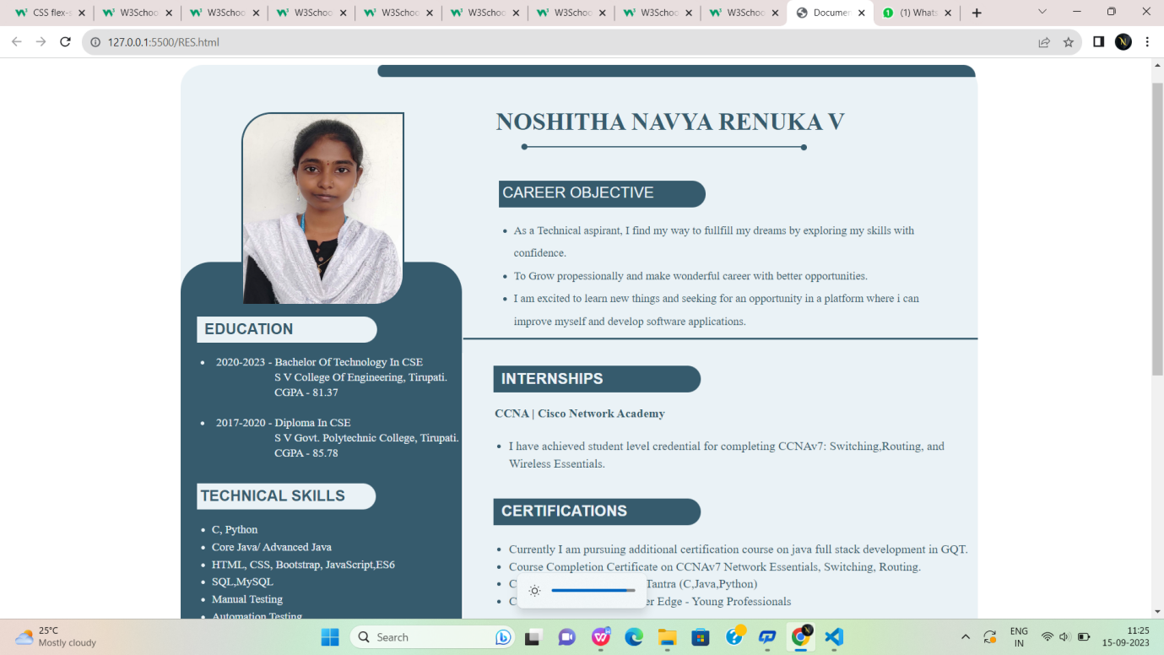

Fig:1

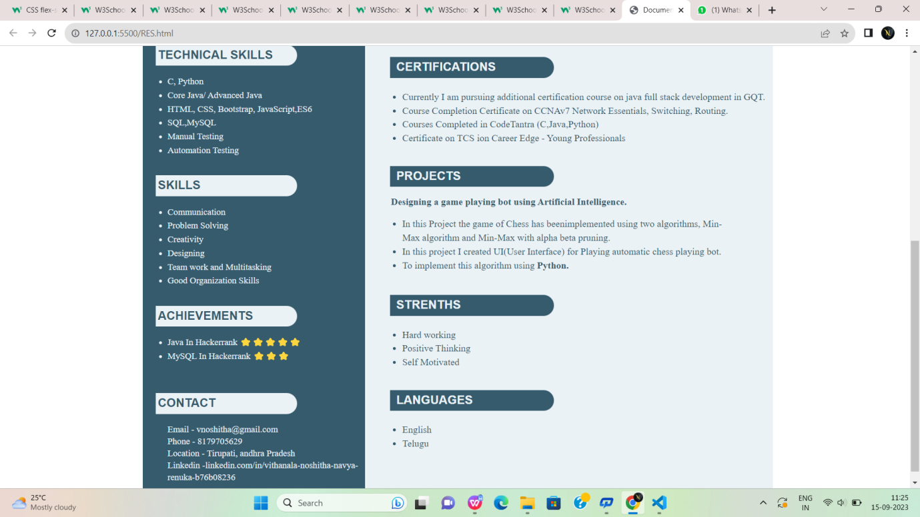

Fig:1.2

**Conclusion**

"In crafting this resume using HTML and CSS, I aimed to create a professional and visually engaging representation of my qualifications and experiences. With a strong educational background, a proven track record in [Computer science and Engineering], and a diverse skill set that includes [Java fullstack Development, HTML,CSS,Java Script,MySql].

This resume serves as a snapshot of my journey and abilities, and I am ready to provide more detailed information and discuss how I can add value to your organization.