Delivery Email Notifications via Zoho Flow
How Zoho Flow polls AfterShip and sends delivery confirmation emails automatically
Overview: This flow completes the automation loop. Flow 1 (Send Tracking to AfterShip) pushes tracking numbers from Zoho Books into AfterShip. Flow 2 (described here) monitors AfterShip for delivery updates and sends a confirmation email to the customer when a shipment is delivered — all from within Zoho.
Flow Architecture
URL Trigger  Polls AfterShip API  at regular intervals | → | Decision  Is tag =  "Delivered"? | → | Send Email  Delivery confirmation  to customer

How It Was Built
1. URL Trigger configured. A new Zoho Flow was created with a URL trigger pointed at the AfterShip API (https://api.aftership.com/v4/trackings). Authentication uses an API key passed as a token header. The trigger polls the endpoint at regular intervals and fires when shipment data changes. The unique key is set to last_updated_at so the flow re-triggers whenever a shipment status updates.
2. Decision logic added. A Decision step checks whether the shipment’s tag field equals "Delivered." Only delivered shipments proceed to the email step. All other statuses are ignored.
3. Send Email action configured. Under the "Delivered" condition, a Send Email action sends a confirmation to the customer with the tracking number and carrier name pulled from the AfterShip data. The email is sent from Zoho (noreply@zohoflow.com) and signed with the Global Promo name.
Result
The flow executed successfully on March 10, 2026 at 4:57 PM. When AfterShip reported a UPS shipment (1Z791A3E0398398309) as delivered, Zoho Flow detected the update and sent the confirmation email shown below. No manual intervention was required.
Zoho Flow — Execution History
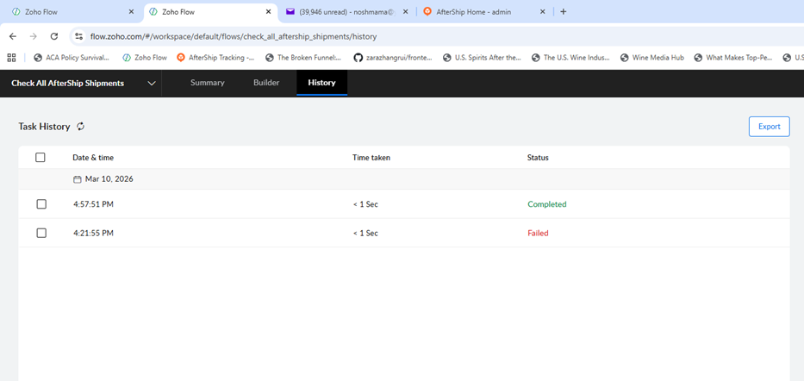
Flow completed successfully at 4:57 PM on March 10, 2026
https://flow.zoho.com/#/workspace/default/flows/check_all_aftership_shipments/history

Customer Delivery Email
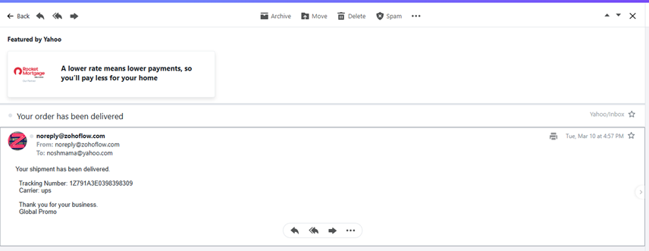
Delivery confirmation email received by customer at 4:57 PM
Note: This prototype demonstrates the complete data flow: Zoho Books → AfterShip → Zoho Flow → customer email. All flows would need further testing before deployment in a production environment. Trial subscriptions end Wednesday, March 12.

