How the Zoho Flow → AfterShip Automation Was Built
This walkthrough describes the process used to connect Zoho Books invoices to AfterShip tracking via Zoho Flow. The goal: when a tracking number is added to an invoice in Zoho Books, it is automatically registered in AfterShip for real-time shipment monitoring and customer email notifications.
Phase 1 — Prepare Zoho Books
Step 1: Create invoices from order data.
Each of the five sample orders was entered as an invoice in Zoho Books. The key fields were: Customer Name, Order/PO Number, Item, Quantity, and Rate.
Step 2: Add custom fields for tracking data.
Zoho Books does not include tracking fields by default. Two custom fields were created under Settings → Invoices → Custom Fields:
- Tracking Number (text field)
- Carrier (dropdown: UPS, FedEx, USPS, DHL)
Once created, these fields appear on every invoice and can be filled in when a shipment is dispatched.
Phase 2 — Build the Zoho Flow Automation
Step 3: Create a new flow and set the trigger.
In Zoho Flow (flow.zoho.com), a new flow was created called Send Tracking to AfterShip. The trigger was set to App → Zoho Books → Invoice updated. This means the flow fires every time any invoice is saved.
Step 4: Add the AfterShip action.
Below the trigger, an action was added by searching for AfterShip in Zoho Flow's app library and selecting Create tracking. This action registers a new shipment in AfterShip each time the flow runs.
Step 5: Connect AfterShip using the API key.
When the AfterShip action is first added, Zoho Flow prompts for a connection. Clicking Connect opens a dialog where the AfterShip API key is entered. This key authorizes Zoho Flow to send tracking data to AfterShip on your behalf.
Step 6: Map the invoice fields to AfterShip.
The Create Tracking form has several fields. The critical mappings are:
- Tracking number → mapped to the Zoho Books Tracking Number custom field (inserted as a variable)
- Country of origin → USA
- Destination country → USA
- Title → Invoice Number (from Zoho Books)
- Customer name → Customer Name (from Zoho Books)
- Email addresses → Customer Email (from Zoho Books)
Important: AfterShip requires ISO Alpha-3 country codes (e.g., "USA" not "United States"). Using the full country name will cause the action to fail.
Phase 3 — Configure AfterShip Notifications
Step 7: Set up email notification flows in AfterShip.
Inside AfterShip, under Notifications → Flows, there are pre-built notification templates for each shipment event. For this prototype, two flows were enabled:
- When shipment updates to delivered → sends a confirmation email
- When shipment updates to exception → sends an alert email
Each flow uses a simple Trigger → Send Email structure. The email templates are customizable and automatically insert the order number and tracking details. Note: these notifications are configured and enabled, but the email templates are currently under review by AfterShip before they can send. Additionally, notifications only fire on future status changes. All flows in this project would need further testing to verify that they work as expected in a production environment.
Phase 4 — Test and Verify
Step 8: Enter tracking numbers on the invoices.
With the flow turned on, tracking numbers and carriers were entered into the custom fields on each of the five Zoho Books invoices and saved. Each save triggered the flow.
Step 9: Confirm execution in Zoho Flow History.
The History tab in Zoho Flow shows every execution. Early runs failed due to the country code issue (step 6), but after correcting to "USA," all five tracking numbers were sent successfully.
Final Dashboards
The two dashboards below confirm the end-to-end integration is working.
Zoho Flow — Summary Dashboard
Shows the Send Tracking to AfterShip flow with 28 total executions: 5 successful (one per invoice) and 23 failures from early testing before the country code fix. Task usage confirms 5 completed task executions.
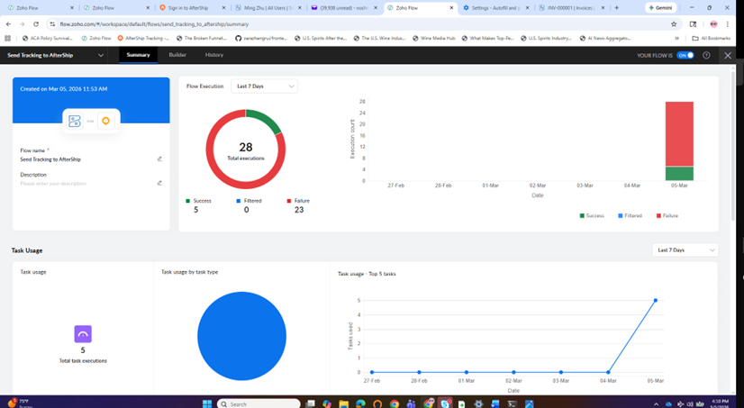
AfterShip Tracking Dashboard — Shipments List
Shows all 5 shipments registered automatically from Zoho Flow in the AfterShip tracking dashboard. Each entry displays the tracking number, carrier (UPS/FedEx), service type, delivery status, origin/destination, transit time, and on-time status. Four shipments show as Delivered and one as In Transit — all pulled in real time from the carriers with no manual entry in AfterShip.
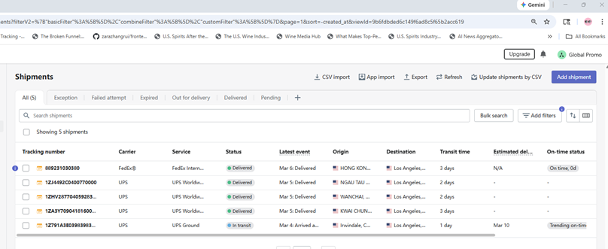
Result: Five invoices in Zoho Books → five tracked shipments in AfterShip, with delivery and exception email notifications configured. No manual data entry in AfterShip was required. The entire data flow is: Zoho Books invoice saved → Zoho Flow fires → AfterShip registers tracking → carrier status monitored → email sent on delivery or exception. All flows would need further testing before deployment in a production environment.

