Tests Backend
=================================================

http://localhost:3001/
{"message":"API RéservSalle fonctionne"}
=================================================

GET /api/salles

http://localhost:3001/api/salles

[{"id":"B204","nom":"Salle B204","batiment":"B","capacite":30,"equipements":["projecteur","tableau blanc"],"accessible":true},{"id":"B301","nom":"Salle B301","batiment":"B","capacite":50,"equipements":["projecteur","visioconference"],"accessible":true},{"id":"L120","nom":"Laboratoire L120","batiment":"L","capacite":25,"equipements":["ordinateurs","projecteur"],"accessible":true},{"id":"C110","nom":"Salle C110","batiment":"C","capacite":15,"equipements":["tableau blanc"],"accessible":false},{"id":"D205","nom":"Salle D205","batiment":"D","capacite":40,"equipements":["projecteur","microphone"],"accessible":true}]

Réussi
=============================================================================

GET /api/salles/B204

http://localhost:3001/api/salles/B204

{"id":"B204","nom":"Salle B204","batiment":"B","capacite":30,"equipements":["projecteur","tableau blanc"],"accessible":true}

Réussi

===============================================================================
---

GET /api/reservations
http://localhost:3001/api/reservations

[{"id":1,"salleId":"B204","date":"2026-11-02","debut":"09:00","fin":"11:00","nom":"Nike Djateng","motif":"Réunion de projet"},{"id":2,"salleId":"L120","date":"2026-11-02","debut":"13:00","fin":"15:00","nom":"Yann","motif":"Présentation"}]

Réussi
==================================================================================
---

GET /api/reservations/1
http://localhost:3001/api/reservations/1

{"id":1,"salleId":"B204","date":"2026-11-02","debut":"09:00","fin":"11:00","nom":"Nike Djateng","motif":"Réunion de projet"}
Réussi

===============================================================

POST /api/reservations
http://localhost:3001/api/reservations/
201 Created
Confere image
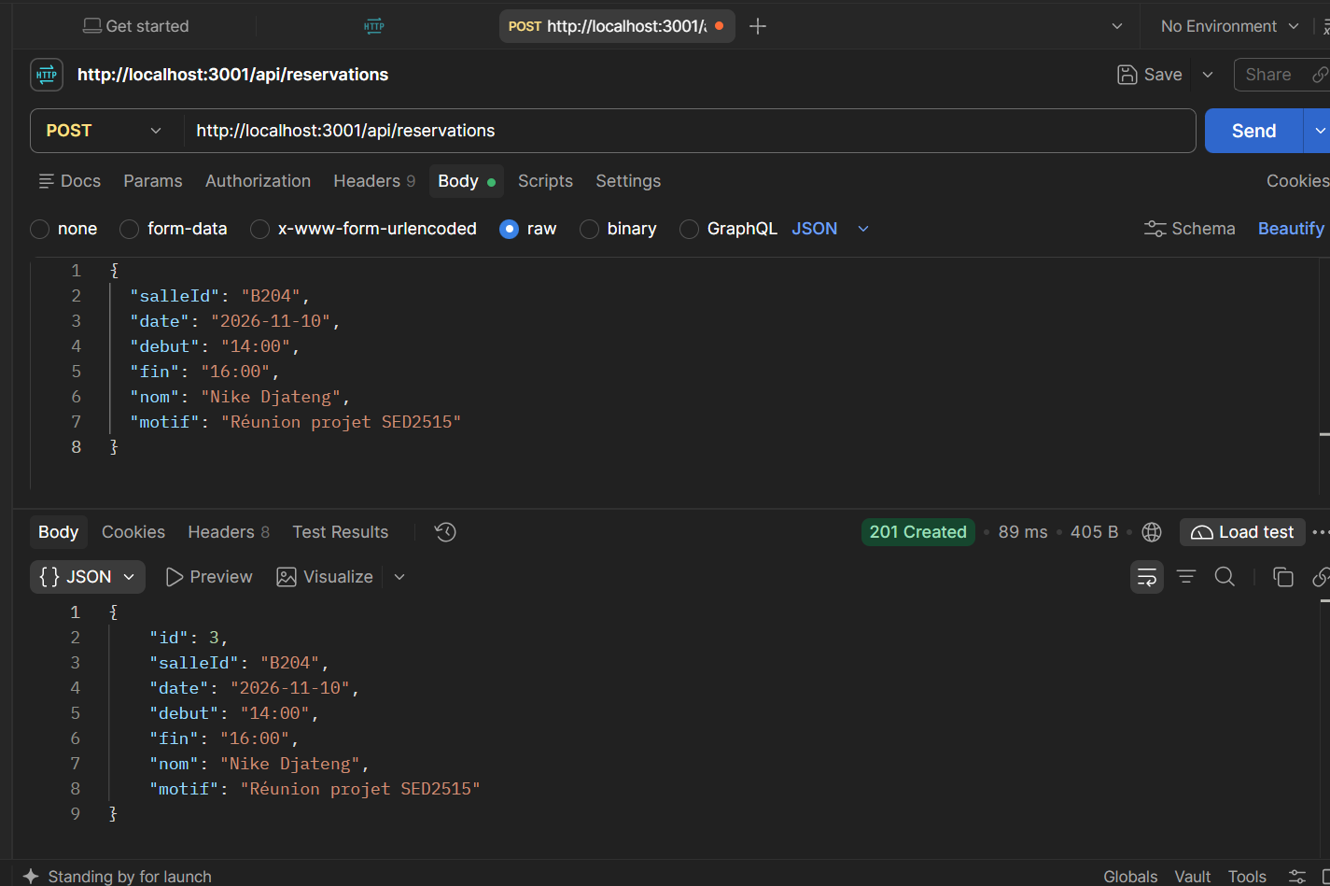

============================================
POST Conflict Error
http://localhost:3001/api/reservations

Body :

{
"salleId": "B204",
"date": "2026-11-10",
"debut": "15:00",
"fin": "17:00",
"nom": "Test",
"motif": "Conflit"
}

Resultat : 409 Conflict
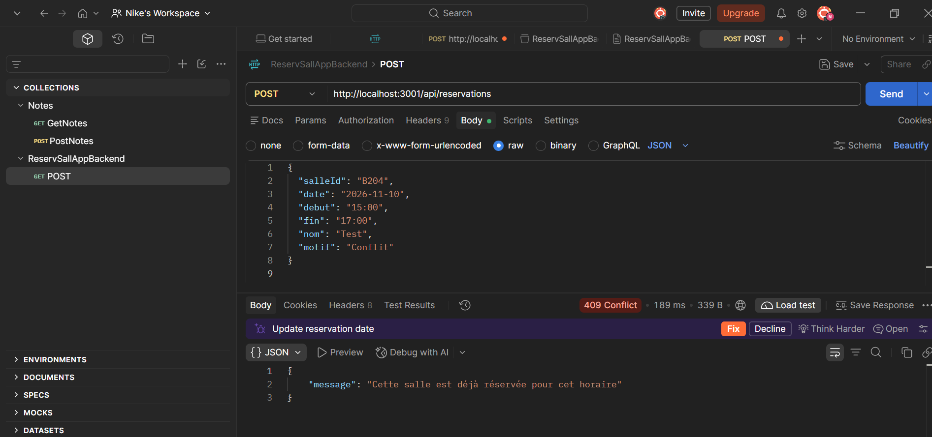
================================================================

POST Validation Error
POST
http://localhost:3001/api/reservations

Body :

{
"salleId": "B204"
}

Attendu :

400 Bad Request
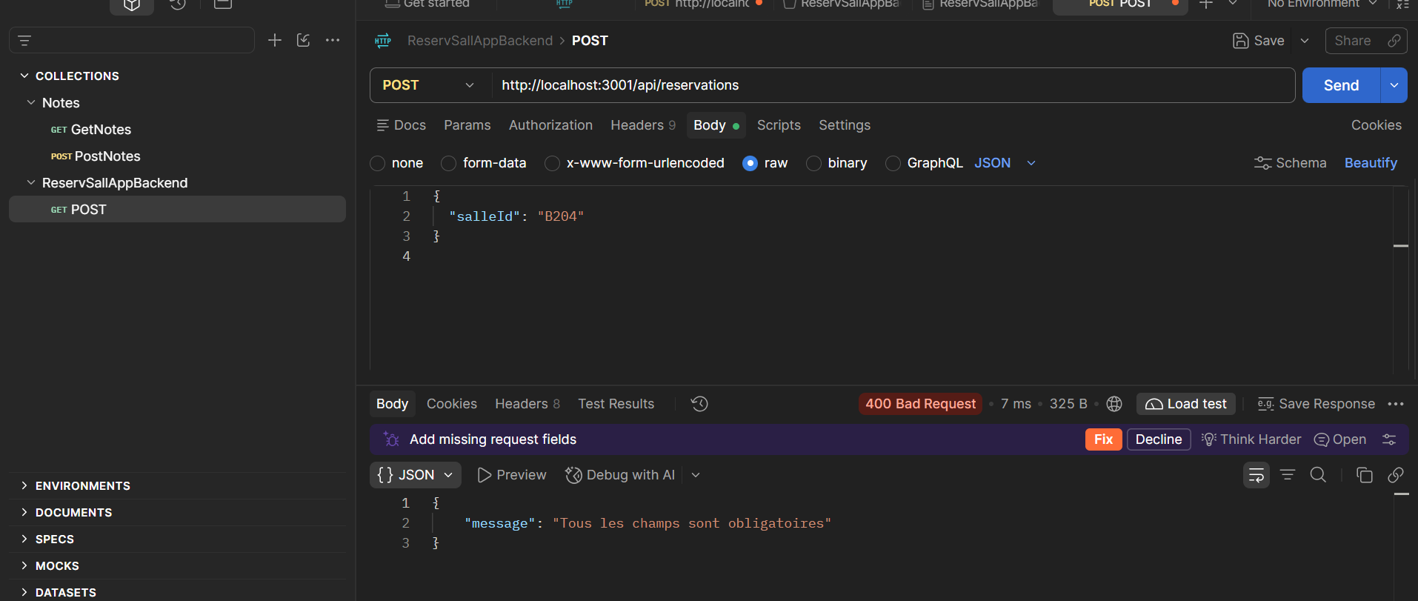
=============================================================
Vérifier que PUT modifie réellement :

PUT /api/reservations/1

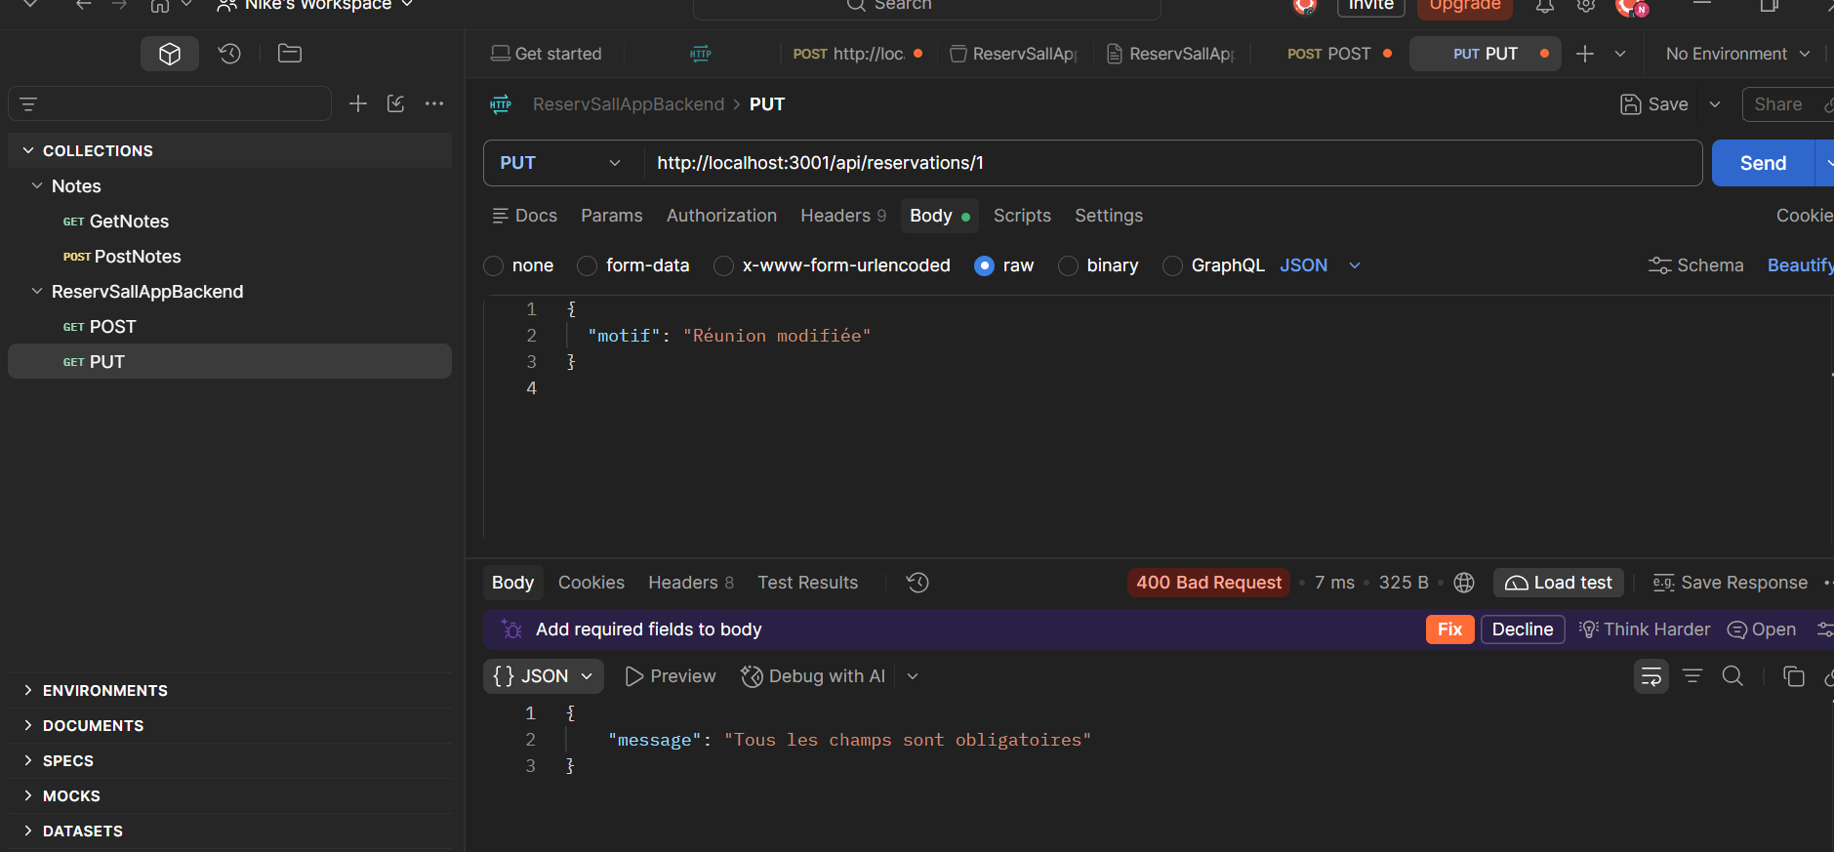

=============================================================

==============================================================
DELETE supprime réellement :

DELETE /api/reservations/1
http://localhost:3001/api/reservations/1
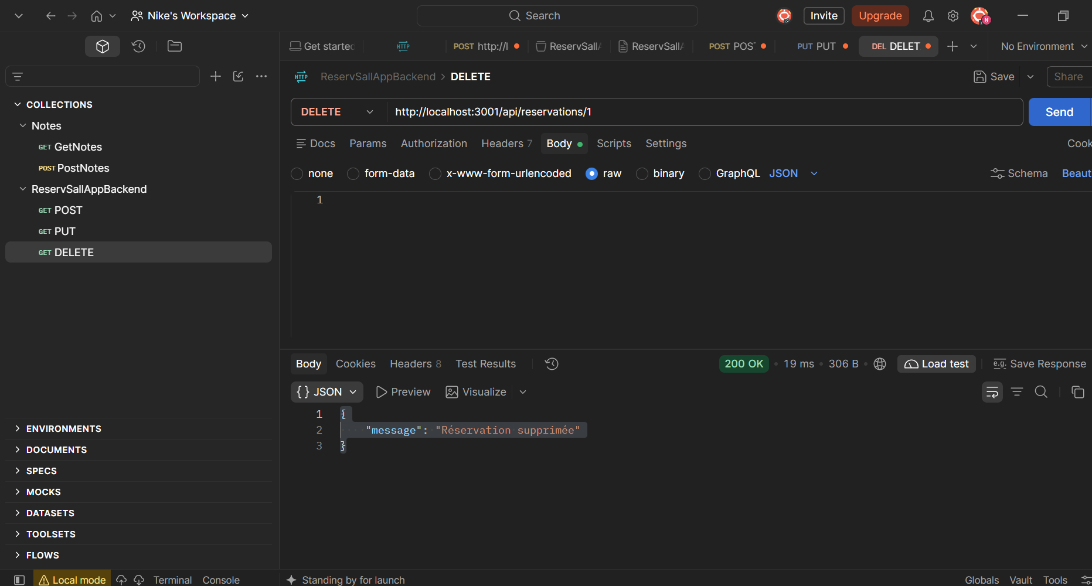

================================================

GET api/reservations/
http://localhost:3001/api/reservations/
Reservations 1 a disparu.\
Voici le resultat :
[
{
"id": 2,
"salleId": "L120",
"date": "2026-11-02",
"debut": "13:00",
"fin": "15:00",
"nom": "Yann",
"motif": "Présentation"
},
{
"id": 3,
"salleId": "B204",
"date": "2026-11-10",
"debut": "14:00",
"fin": "16:00",
"nom": "Nike Djateng",
"motif": "Réunion projet SED2515"
}
]

