# Pre-processing Techniques Applied

### Filter Examples

Filter out rows with missing data.

### Select Attribute

Selects only the required attributes.

### Normalize

Normalizes all the required attributes to a range of 0-1

### Set Role

Sets the role of the output attribute as the label

# ROC Curve

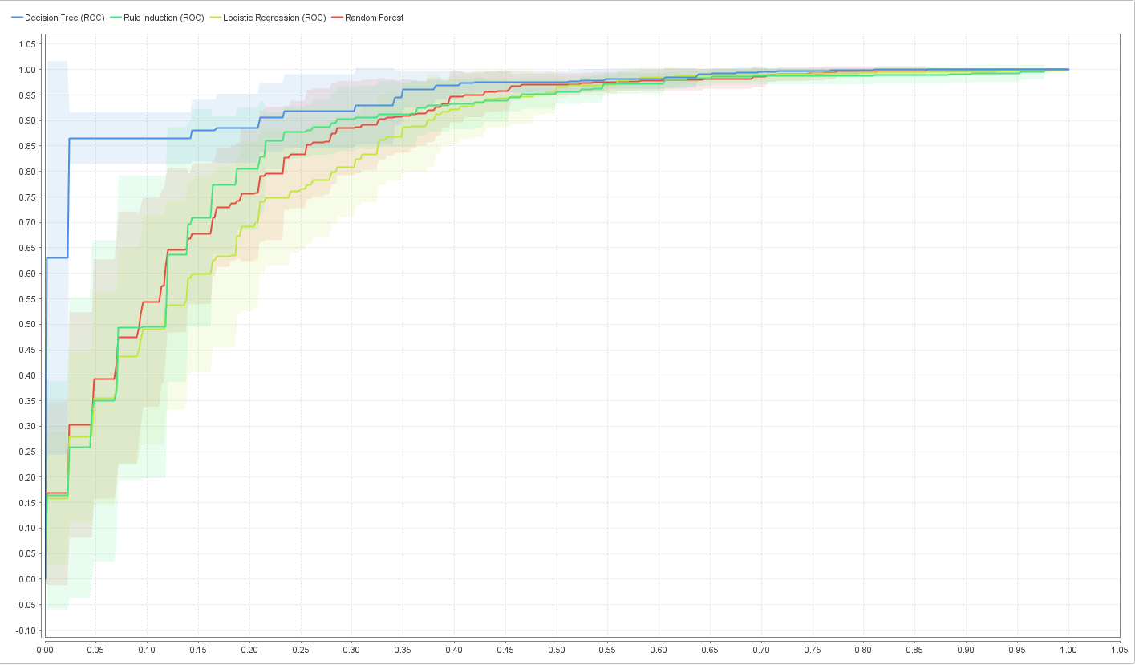

*(fig 1: ROC curve)*

# Technique 1: Decision Tree

### Motivation

* Dataset has binomial output/ class i.e., discrete data. So, classification algorithms are best for the dataset and decision tree is a classification technique.
* Best Area under the ROC Curve (fig 1)

### Snapshot

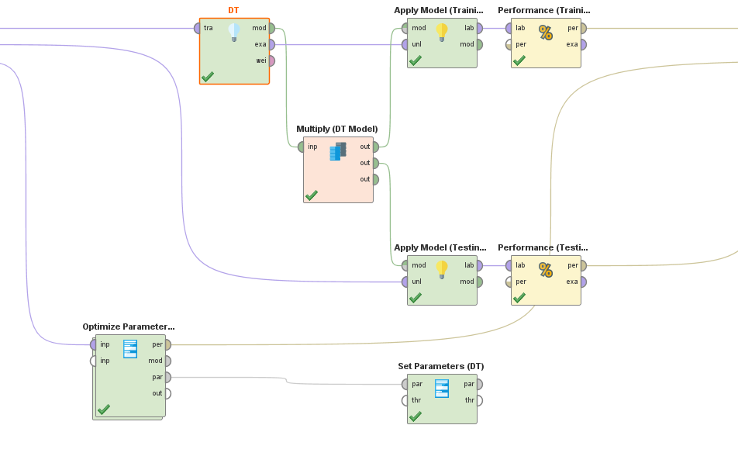

### Parameter Settings

* Criterion: gini_index
* Maximal depth: 4
* Apply pruning: false
* Apply prepruning: false

|  |  |
| --- | --- |
| accuracy | 81.69% |
| precision | 82.43% (positive class: No) |
| recall | 87.76% (positive class: No) |
| f-measure | 85.01% (positive class: No) |

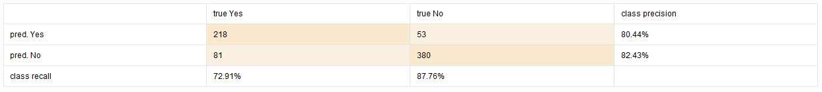

# Technique 2: Logistic Regression

### Motivation

* Dataset has binomial output/ class i.e., discrete data. So, classification algorithms are best for the dataset and Logistic Regression is a classification technique.
* Complex algorithm/ model (requirement)

### Snapshot

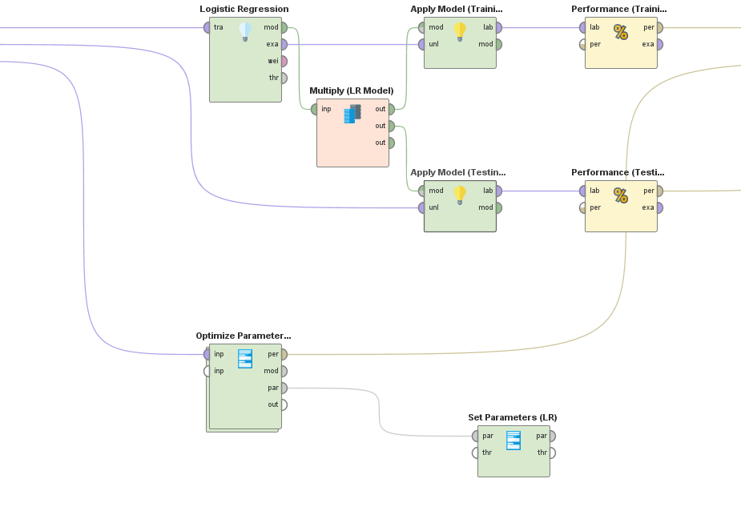

### Parameter Settings

* Solver: auto
* Reproducible: false
* User regularization: false
* Standardize: true
* Non-negative coefficients: false
* Add intercept: true
* Compute p-values: true
* Remove collinear column: true

**Optimize Parameters** operator used for the best result.

|  |  |
| --- | --- |
| accuracy | 78.01% |
| precision | 80.09% (positive class: No) |
| recall | 83.60% (positive class: No) |
| f-measure | 81.81% (positive class: No) |



# Comparison of Testing Performance

### Testing Performance Report

### Cross-validation Performance Report

# Final Recommendation of Best Modal