5. OVERALL SUMMARY

5.1 OVERALL RESULT

Medium Macro Fouling Was Observed, with No Major Visible Structural Damage
The underwater hull and appendages were visually inspected across the active Excel work scope. The highest biofouling condition was Rating 3 (Medium Macro Fouling), mainly associated with NICHE Boss Cap, MID-AFT Vertical Side Shell, FWD-MID Vertical Side Shell, and other recorded areas. Observed condition reached Rating 3 (Notable Observation), and SCRATCH, PEELING, PEELING, SCRATCH was noted where entered. No major visible structural damage was identified in the recorded observations.

5.2 BIOFOULING CONDITION OVERVIEW

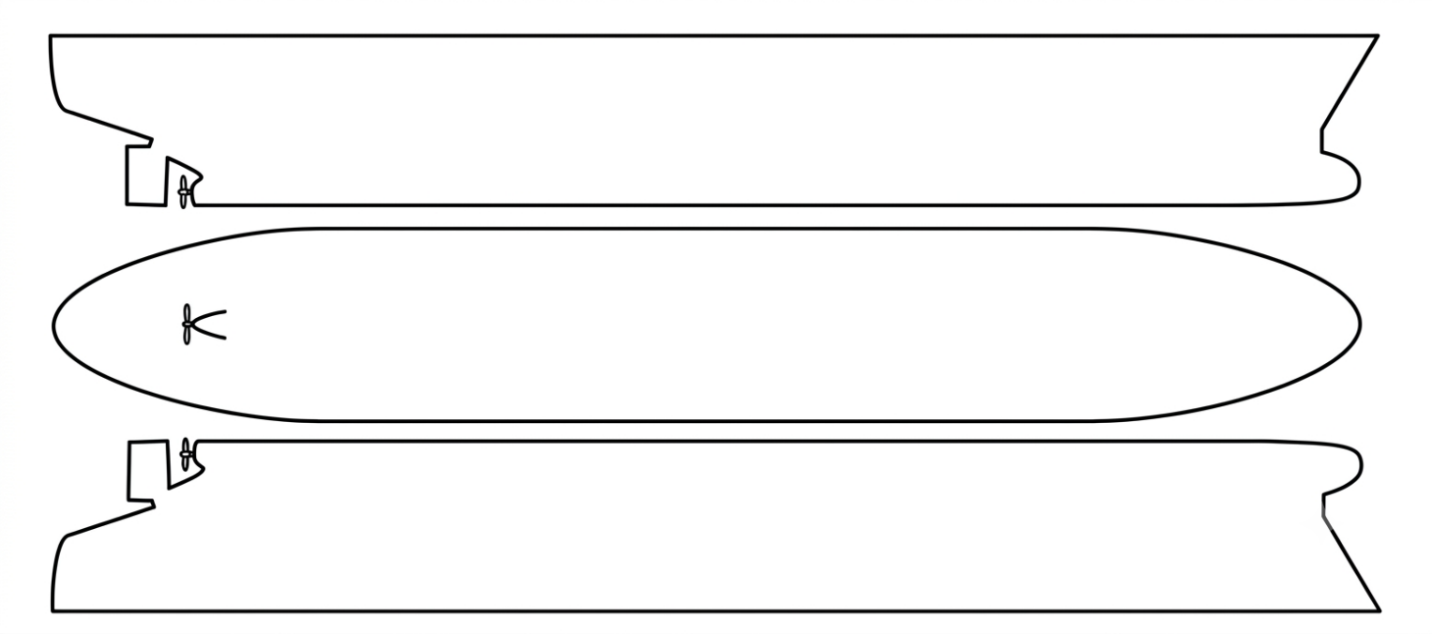
FWD
Rating 2
MID-FWD
Rating 3
MID
Rating 3
AFT-MID
Rating 3
AFT
Rating 2
AFT
Rating 2
AFT-MID
Rating 1
MID
Rating 1
MID-FWD
Rating 1
FWD
Rating 1
FWD
Rating 2
MID-FWD
Rating 3
MID
Rating 3
AFT-MID
Rating 3
AFT
Rating 2

0 / Clean | 1 / Micro Fouling | 2 / Light  Macro Fouling | 3 / Medium  Macro Fouling | 4 / Heavy  Macro Fouling | 5 / Severe  Macro Fouling

Component | Rating | Type | Coverage | Component | Rating | Type | Coverage
Bulbous Bow | 2 | Light Macro Fouling | 10% | Transducer | 1 | Micro Fouling | 20%
Bow Thruster | 2 | Light Macro Fouling | 5% | Stern Frame | 1 | Micro Fouling | 10%
Bilge Keel | 2 | Light Macro Fouling | 5% | Rope Guard | 2 | Light Macro Fouling | 5%
Sea Chest | 3 | Medium Macro Fouling | 10% | Propeller | 2 | Light Macro Fouling | 5%
Discharge Pipe | 1 | Micro fouling | 10% | Boss Cap | 3 | Medium Macro Fouling | 10%
Anode / ICCP | 2 | Light Macro Fouling | 5% | Rudder & Pintle | 3 | Medium Macro Fouling | 10%

5. OVERALL SUMMARY

5.3 OVERALL FINDINGS MATRIX

FWD | FWD-MID | MID | MID-AFT | AFT

MAIN HULL SURFACES / FWD
 |  | FOULING CONDITION |  |  | OBSERVED CONDITION
COMPONENT | SIDE | RATING | TYPE | COVERAGE | RATING | LEVEL | TYPE | PAGE
VERTICAL SIDE SHELL | PORT | 2 | Light Macro Fouling | 5% | 1 | Normal / Trace
 | STBD | 2 | Light Macro Fouling | 5% | 1 | Normal / Trace
BOTTOM |  | 1 | Micro Fouling | 10% | 1 | Normal / Trace

MAIN HULL SURFACES / FWD-MID
 |  | FOULING CONDITION |  |  | OBSERVED CONDITION
COMPONENT | SIDE | RATING | TYPE | COVERAGE | RATING | LEVEL | TYPE | PAGE
VERTICAL SIDE SHELL | PORT | 3 | Medium Macro Fouling | 10% | 1 | Normal / Trace
 | STBD | 3 | Medium Macro Fouling | 10% | 1 | Normal / Trace
BOTTOM |  | 1 | Micro Fouling | 30% | 1 | Normal / Trace

MAIN HULL SURFACES / MID
 |  | FOULING CONDITION |  |  | OBSERVED CONDITION
COMPONENT | SIDE | RATING | TYPE | COVERAGE | RATING | LEVEL | TYPE | PAGE
VERTICAL SIDE SHELL | PORT | 3 | Medium Macro Fouling | 10% | 1 | Normal / Trace
 | STBD | 3 | Medium Macro Fouling | 10% | 1 | Normal / Trace
BOTTOM |  | 1 | Micro Fouling | 20% | 1 | Normal / Trace

5. OVERALL SUMMARY

5.3 OVERALL FINDINGS MATRIX

FWD | FWD-MID | MID | MID-AFT | AFT

MAIN HULL SURFACES / MID-AFT
 |  | FOULING CONDITION |  |  | OBSERVED CONDITION
COMPONENT | SIDE | RATING | TYPE | COVERAGE | RATING | LEVEL | TYPE | PAGE
VERTICAL SIDE SHELL | PORT | 3 | Medium Macro Fouling | 15% | 1 | Normal / Trace
 | STBD | 3 | Medium Macro Fouling | 15% | 1 | Normal / Trace
BOTTOM |  | 1 | Micro Fouling | 10% | 1 | Normal / Trace

MAIN HULL SURFACES / AFT
 |  | FOULING CONDITION |  |  | OBSERVED CONDITION
COMPONENT | SIDE | RATING | TYPE | COVERAGE | RATING | LEVEL | TYPE | PAGE
VERTICAL SIDE SHELL | PORT | 2 | Light Macro Fouling | 5% | 1 | Normal / Trace
 | STBD | 2 | Light Macro Fouling | 5% | 1 | Normal / Trace
BOTTOM |  | 2 | Light Macro Fouling | 2% | 1 | Normal / Trace

5. OVERALL SUMMARY

5.3 OVERALL FINDINGS MATRIX(CONTINUED)

NICHE AREAS & COMPONENTS
 |  | FOULING CONDITION |  |  | OBSERVED CONDITION
COMPONENT | SIDE | RATING | TYPE | COVERAGE | RATING | LEVEL | TYPE | PAGE
Bulbous Bow | PORT | 2 | Light Macro Fouling | 10% | 3 | Notable Observation | SCRATCH | P.40
 | STBD | 2 | Light Macro Fouling | 10% | 1 | Normal / Trace
Bow Thruster | PORT | 2 | Light Macro Fouling | 5% | 1 | Normal / Trace
 | STBD | 2 | Light Macro Fouling | 5% | 1 | Normal / Trace
Bilge Keel | PORT | 2 | Light Macro Fouling | 5% | 1 | Normal / Trace
 | STBD | 2 | Light Macro Fouling | 5% | 1 | Normal / Trace
Sea Chest | PORT | 3 | Medium Macro Fouling | 10% | 1 | Normal / Trace
 | STBD | 3 | Medium Macro Fouling | 10% | 1 | Normal / Trace
Discharge Pipe |  | 1 | Micro Fouling | 10% | 2 | Minor Observation | PEELING | P.75
Anode / ICCP | PORT | 2 | Light Macro Fouling | 5% | 2 | Minor Observation | PEELING | P.79
 | STBD | 2 | Light Macro Fouling | 5% | 2 | Minor Observation | PEELING | P.81
Transducer |  | 1 | Micro Fouling | 20% | 1 | Normal / Trace
Stern Frame |  | 1 | Micro fouling | 10% | 1 | Normal / Trace
Rope Guard |  | 2 | Light Macro Fouling | 5% | 2 | Minor Observation | PEELING SCRATCH
Propeller |  | 2 | Light Macro Fouling | 5% | 1 | Normal / Trace
Boss Cap |  | 3 | Medium Macro Fouling | 25% | 1 | Normal / Trace
Rudder & Pintle | PORT | 3 | Medium Macro Fouling | 10% | 1 | Normal / Trace
 | STBD | 3 | Medium Macro Fouling | 10% | 1 | Normal / Trace

