TABLE OF CONTENTS

1. GENERAL INFORMATION 2
2. OPERATIONAL INFORMATION 2
3. SERVICE ITEMS 2
4. PRE-OPERATION SAFETY & READINESS RECORD 3
5. OVERALL SUMMARY 4
5.1 OVERALL RESULT 4
5.2 BIOFOULING CONDITION OVERVIEW 4
5.3 OVERALL FINDINGS MATRIX 5
6. ASSESSMENT GUIDELINES 8
6.1 FOULING CLASSIFICATION 8
6.2 OBSERVED CONDITION ASSESSMENT 9
7. DETAILED SERVICE RECORD 10
8. QUALIFICATION & CERTIFICATION RECORDS 17

1. GENERAL INFORMATION

VESSEL NAME |  |  |  | IMO NUMBER |  |  | CALL SIGN
STAR KVARVEN |  |  |  | 9396153 |  |  | LAJK7
VESSEL TYPE | LOA(m) | BREADTH(m) |  |  | GT | DWT |  | YEAR BUILT
Cargo ship | 208 | 32 |  |  | 37,158 | 49,924 |  | 2010
OWNER / CLIENT |  |  | JOB NO.
HMM |  |  | US-HMM-2603001

2. OPERATIONAL INFORMATION

VESSEL SCHEDULE | ETA | ETD |  | WORK WINDOW |  | LOCATION
 | 14 Jul 2026,  10:00 | 15 Jul 2026,  13:00 |  | 27 Hours ± 1 Hrs |  | Ulsan Yongyeon Pier
OPERATION RECORD | START | END |  | WORKING TIME |  | POSITION
 | 22 March 2026,  05:55 | 22 March 2026,  10:50 |  | 4Hrs |  | STBD SIDE
VESSEL & SITE | DRAUGHT (m) |  |  |  |  |  | BERTHING SIDE
 | FWD / 11.4 |  | MID / 11.9 |  | AFT / 12.6 |  | STBD
 | WEATHER |  | KNOTS |  | CURRENT (m) |  | VISIBILITY (m)
 | Sunny |  | 0.2 |  | 0.2 |  | 0.8
PERSONNEL  DEPLOYED | SITE SUPERVISOR : Ryu K.H / DIVER : 4

3. SERVICE ITEMS

SERVICES PERFORMED

SERVICE CATEGORY | SERVICE DESCRIPTION | SCOPE BASIS
Cleaning | Full Cleaning(MPI) | Planed

4. PRE-OPERATION SAFETY & READINESS RECORD

TOOLBOX MEETING & LOTO |  | 06:00 ~ 06:30 Hrs
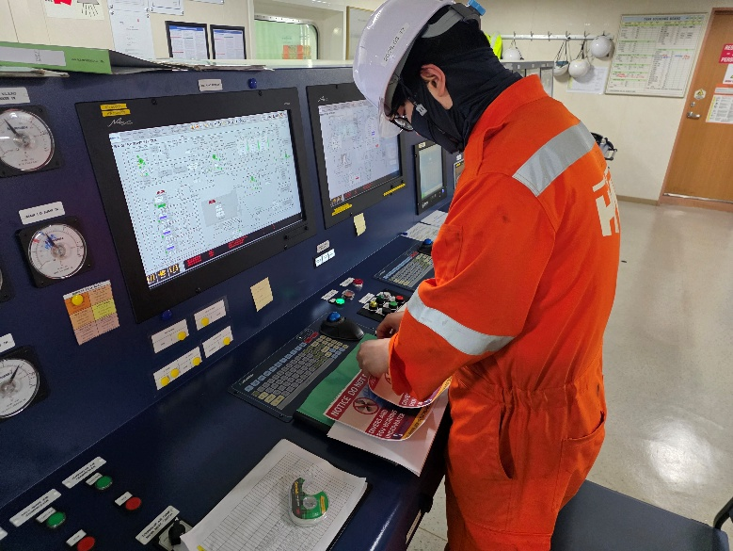 |  | 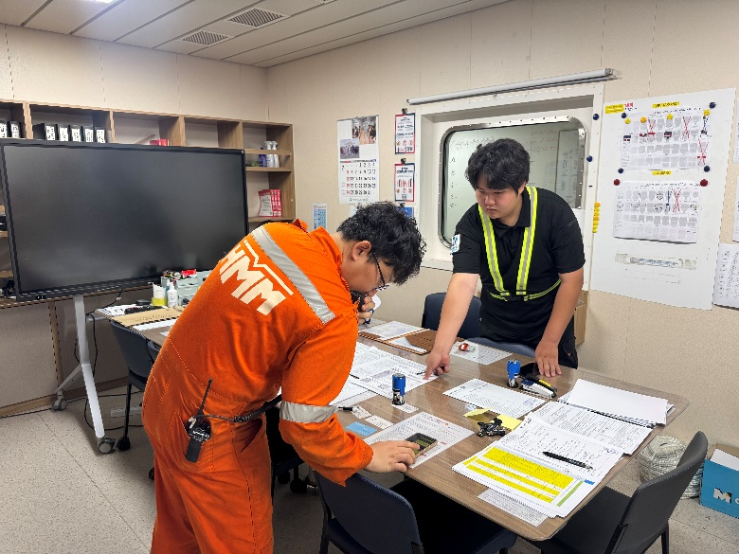
NOTES | No safety concerns noted before operation.

PREPARATION ON SITE |  | 07:00 ~ 07:30 Hrs
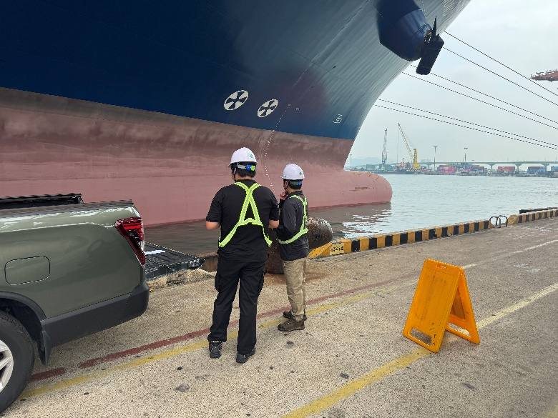 |  | 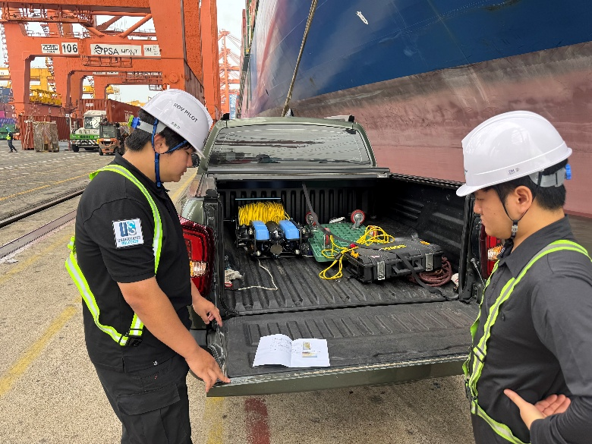
NOTES | No abnormal conditions observed at site.

