7. DETAILED SERVICE RECORD

{{BC}} | {{SIDE_LABEL}}

{{TITLE}} | WORK PERFORM {{WORK}}
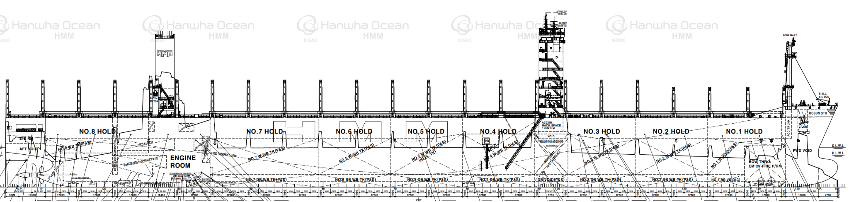

FOULING CONDITION  RATING TYPE COVERAGE  @FR {{FT}} {{FC}} |  | OBSERVED CONDITION  RATING LEVEL TYPE  @OR {{OL}} {{OT}}

{{P1}} |  | {{P2}}
{{P3}} |  | {{P4}}

7. DETAILED SERVICE RECORD

{{BC}} | {{SIDE_LABEL}}

{{P5}} |  | {{P6}}
{{P7}} |  | {{P8}}
{{P9}} |  | {{P10}}

