
REPORT NO : US-CLS-2609003
DATE OF ISSUE : 5 Sep 2026
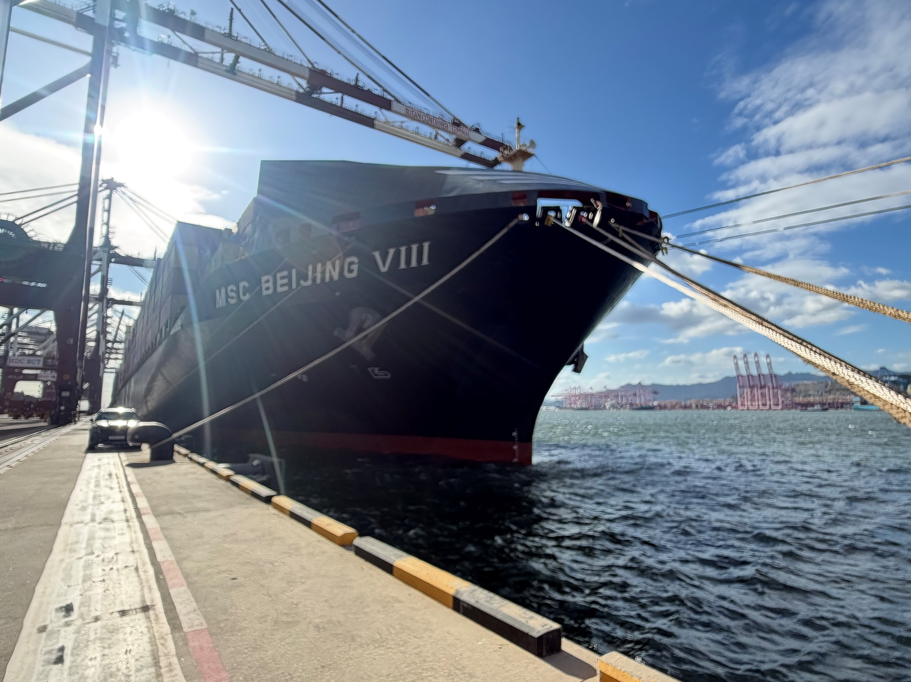

 | ㅤSERVICE REPORT
ㅤUNDERWATER
ㅤPHOTO REPORT
VESSEL NAME
MSC BEIJING VIII
IMO NUMBER |  | CALL SIGN |  | SCOPE OF WORK
9289099 |  | CQEG5 |  | 1. Removal of Entanglement Rope & Fishing net  - Removal of entangled rope and fishing net from the Sea Chest was carried out by the diver team.
OWNER/CLIENT
MSC
OPERATION DATE & LOCATION
4 Sep 2026 ,
Busan Newport Pier 6

 |  |  |  |  | 

