

University of Caloocan City – North Campus
Computer Studies Department

Bubblelicious Online Ordering Management System

A Project Presented to
the Faculty of the Computer Studies Department of
University of Caloocan City – North Campus

In Partial Fulfillment
of the Requirements for the Degree of
Bachelor of Science in Computer Science

by

Tiu, Michael Aaron I.
Cabreros, James Vincient
Granadozo, Khen Hurryson
Lorezo, John
Rocabo, Ralph Michael
Suarez, Audric

Prof. Joemen G. Barrios
Adviser

December 2024

A P P R O V A L S H E E T

This Project entitled “BUBBLELICIOUS ONLINE ORDERING MANAGEMENT SYSTEM prepared and submitted by Michael Aaron I. Tiu, Cabreros, James Cabreros, Khen Hurryson Granadozo, John Lorezo, Ralph Michael Rocabo, Audric Suarez in partial fulfillment of the requirements for the Degree BACHELOR OF SCIENCE IN COMPUTER SCIENCE has been examined and is recommended for acceptance and approval for FINAL ORAL DEFENSE.

PROF. Joemen G. barrios
Adviser

This Project was approved by the Committee on Oral Defense with a grade of __________.

_____________ _____________
Panelist Panelist

_____________
Panelist
_____________
Panelist

Accepted and approved in partial fulfillment of the requirements for the Degree of Bachelor of Science in Computer Science.

DR. TED A. MACARAEG, JR.
Head, Computer Studies Dept.
Date: _________________

C E R T I F I C A T I O N

This is to certify that the documentation of Project entitled “BUBBLELICIOUS ONLINE ORDERING MANAGEMENT SYSTEM” prepared by Michael Aaron I. Tiu, Cabreros, James Cabreros, Khen Hurryson Granadozo, John Lorezo, Ralph Michael Rocabo, Audric Suarez, BS in Computer Science students, has been examined and proof read by the undersigned.

______________________
Grammarian
Date: _________________

A C K N O W L E D G E M E N T

We sincerely thank Prof. Joemen G. Barrios, our adviser, for her direction, criticism, and unwavering support during the project's study and progress. Her knowledge and dedication have greatly influenced our research.
The University of Caloocan City and its committed teachers and staff deserve special recognition for their knowledge and assistance, which have been essential to this endeavor. We are especially grateful to the Department of Computer Studies for offering the necessary tools, direction, and educational opportunities that have greatly aided in our academic and professional growth.

Additionally, we would like to thank the management and employees of Bubblelicious, our project's client, for their collaboration and insightful suggestions. Their observations have improved our comprehension of the difficulties and specifications involved in creating a productive point-of-sale and inventory management system.

A B S T R A C T

T A B L E O F C O N T E N T S

CHAPTER 1 – Introduction
- Introduction
1.1 Background of the Study
1.2 Statement of the Problem……………………………………………………………………….
1.2.1………………………………………………………………………………………………………..
1.2.2………………………………………………………………………………………………………..
1.2.3………………………………………………………………………………………………………..
1.3 Statement of the Objectives
1.3.1 General Objectives
1.3.2 Specific Objectives
1.4 Scope and Limitation
1.4.1 Project Scope………………………………………………………………………………
1.4.2 Limitation……………………………………………………………………………………….
1.5 Software Features………………………………………………………………………………..

CHAPTER 2 – REVIEW OF RELATED LITERATURE AND COMPARISON OF SYSTEMS
- Review of Related Literature and Comparison of System
2.1 Review of Related Literature……………………………………………………………………
2.1.1 Foreign Literature……………………………………………..…………………………
2.1.2 Local Literature……………………………………………………………………………….
2.2 Review of Related Studies………………………………………………………………………..
2.2.1 Foreign Studies…………………………………………………………………………….
2.2.2 Local Studies…………………………………………………………………………………..
2.3 Methodology……………………………………..……………………………………………………

2.3.1 System Development Life Cycle (SDLC)………………………………………..
2.3.2 Agile Development Approach………………………………………………………….

Chapter 3 The Client

- The Client
3.1 Local of the Study…………………………………………………………………………………
3.2 Description of the Existing System
3.3 Context Diagram / Data Flow Diagram

Chapter 4 The Project

- The Project
4.1 Description of the Project…………………………..…………………………………………..
4.2 Context Diagram / Data Flow Diagram
4.3 Data Dictionary………………………………………………………………………………..
4.4 Entity Relationship Diagram
4.5 Program Flow Chart
4.6 Form Specifications/UI/VTOC
4.7 Report Specifications

Chapter 5
- Chapter 5
5.1 Cost of Benefit Analysis…………………………………………………………………………
5.1.1 Executive Summary………………………………………………………………………
5.1.2 Objectives……………………………………………………………………………….
5.1.3 Cost Analysis…………………………………………………………………………………
5.1.4 Initial Costs (One-Time) ……………………………………………………………….
5.1.5 Ongoing Costs (Recurring) ……………………………………………………………
5.1.6 Benefit Analysis…………………………………………………………………………….
5.1.7 Tangible Benefits………………………………………………………………………….
5.1.8 Intangible Benefits……………………………………………………………………….

5.1.9 Cost-Benefit Comparison…………………………………………………………
5.1.10 Sensitivity Analysis…………………………………………………………………
5.1.11 Recommendation……………………………………………………………………….
5.1.12 Approval…………………………………………………………………………………….
5.2 Screenshots………………………………………………………………………………………………
5.3 Program Listing
5.4 User Manual
5.5 Gantt Chart

CHAPTER I

- INTRODUCTION
  - Background of the Study

The manual processes that are carried out to take orders, process payments, and maintain the records of inventory hampered the Bubblelicious-Milk Tea House's smooth operations. Thus, the “Bubblelicious Online Ordering Management System” using MERN technology stack, was proposed to automate the very crucial operations of placing the order, controlling the stock, getting connected with payments, and reporting. For such an extremely competitive marketplace, the proposed method helps to bring more customer satisfaction, high operational efficiency, and also helps to centralize the systems of the business.

  - Statement of the Problem or Opportunity
    - The present manual system at the Bubblelicious-Milk Tea House is inefficient regarding processing orders, tracking inventories, and processing payments.
    - Mistakes and delays, the lack of automatic reporting, and limited types of payments affect customer satisfaction and the efficiency of operation.
    - Thus, a necessity for an integrated system that will increase customer satisfaction, ensure accuracy, and accelerate procedures exists.

  - Statement of Objectives
    - General Objective
Within three months, to be able to develop the Bubblelicious Ordering System with MERN Technology stack, MongoDB, Express.js, React, and Node.js, emphasizing effective order administration, payment connection, inventory monitoring, and user-friendly interfaces for administrators and customers.

    - Specific Objectives
- To select, view, and place customer’s orders. A customer can search, view product description, and order hardware products they want to buy.)
- To view Order Tracking. Can view Real-time updates for each stage of order progress
- To Include Shipping & Delivery. Includes detailed shipping and delivery information.
- Validate Payment Processing & Inventory Management. Calculates total costs and processes payments (Gcash or cash). Updates inventory and triggers reorder
- To Generates Reporting & Notifications. Confirmations and real-time inventory updates. Provides comprehensive stock and sales reports

  - Scope and Limitations
    - Project Scope
- Management of Products and Inventory
- Owner: Create and modify g.0oods, control inventory, initiate reorders, and access reports.
- View items and stock levels, customer.
- Placing and Managing Orders
- Purchases, product browsing, and status tracking (such as "Shipped" or "Delivered") are all done by the customer.
- Owner: Keep track of and modify order statuses.
- Billing and Payment
- Client: View receipts and safely send payments.
- Owner: Create sales reports and oversee payments.
- Analytics & Reporting
- Owner: Produce financial, inventory, and sales data.
- Customer: Track orders and view order receipts.
- Account Management & Security
- Owner: Control user permissions and guarantee data security.
- Client: Safely view and control account information.

    - Limitations
- Order Volume Handling
- May have trouble handling a large number of orders at once.
- Payment Method Support
- Limited to simple payment methods (cash, Gcash, etc.).
- Marketing Features
- Lacks sophisticated instruments for customer interaction or promotions.

1.4.3 Software Features
Customer Information Management
- Customers input personal details (name, contact, shipping address).
- System validates data for accurate order processing and delivery.
Product & Inventory Management
- Owner: Add/update/remove products, manage stock, trigger reorders.
- Customer: Browse products and view stock availability.
Order Placement & Tracking
- Customer: Place orders, make payments, and track status.
- Owner: Manage orders and update statuses (e.g., "Shipped", "Delivered").
Payment & Billing Integration
- Customer: Secure payments via Gcash, Cash, and view receipts.
- Owner: Process payments and generate sales reports.
Shipping & Delivery Information
- Include delivery address, expected date, and status updates.

Order Confirmation & Notifications
- Customer: Receive email/SMS confirmation and track orders.
- Owner: Send order confirmation and update delivery status.
Inventory Monitoring & Alerts
- Owner: Monitor stock levels and receive low stock alerts, set reorder thresholds.
Reporting & Analytics
- Owner: Generate sales, inventory, and financial reports.
- Customer: View order receipts and track current orders.
Data Security & User Access Management
- Owner: Manage secure access with role-based permissions.
- Customer: Secure login for personal account management.
Order Management Dashboard
- Owner: Centralized dashboard for managing orders and stock levels.

CHAPTER 2

- REVIEW OF RELATED LITERATURE AND COMPARISON OF SYSTEMS
This chapter presents the review of related literature and studies. The
researchers have gone through profound readings of the materials, both printed
and published from the internet, which have a great significance to the problem
during the research process

  - Review of Related Literature

    - Foreign Literature
Hidayati, I. (2023) stated that "The POS system can help inventory management, predict customer demand, and avoid excess or shortage of merchandise stock. It can also speed up the customer payment process, improve customer experience, and generate accurate sales reports." emphasizes that POS and inventory management systems streamline workflows. The ability to track inventory in real time ensures businesses avoid overstocking and understocking issues, which can save on costs and improve profitability.
Source: https://journalstkippgrisitubondo.ac.id/index.php/PKWU/article/view/881

Modern POS systems go beyond processing transactions by providing businesses with insights into sales trends, employee productivity, inventory levels, and customer preferences. POS systems integrate seamlessly with other business tools like ERP and CRM systems to improve operations, increase profitability, and enhance customer satisfaction.

Source: “Point-of-Sale (POS) Systems Overview,” Business Insights Report, 2023.

    - Local Literature
POS in Small Businesses
In the Philippines, small-to-medium enterprises (SMEs) benefit significantly from modern POS systems. Features such as inventory tracking, sales reporting, and loyalty program management enable SMEs to streamline operations and make informed business decisions. Businesses using integrated POS systems report fewer errors and improved operational efficiency.
Source: "Technology Adaptation in SMEs," Philippine Business Insights, 2022.

Inventory Challenges in Local Stores
Many local businesses struggle with manual inventory tracking, resulting in inefficiencies like stockouts and delays. Implementing automated POS systems reduces human error, ensures real-time inventory updates, and provides sales trend data to improve purchasing decisions.
Source: "POS Systems for Local Businesses," Manila Tech Magazine, 2021.

  - Review of Related Studies

    - Foreign Studies
Study Title: The Effects of Implementing Advanced POS Systems in Restaurants
Description:
This study examines the effects of implementing advanced POS systems in various types of restaurants, including buffets. The research highlights significant improvements such as a 25% increase in order accuracy, a 30% reduction in wait times, and a 20% improvement in overall customer satisfaction. The advanced POS systems incorporate integrated features such as order management, inventory tracking, and customer relationship management (CRM), which contribute to operational efficiency and enhanced dining experiences. The study gathered data over a two-year period from a diverse range of restaurants, demonstrating the versatility and benefits of POS systems in modern food service operations.
• Source: https://alexandriacomputers.com/impact-of-restaurant-pos-systems/

Developer: Block, Inc.
Description: Square POS allows small businesses to process payments, manage inventory, and generate detailed sales reports. The system's mobile capabilities make it particularly useful for small businesses that operate in various locations.

    - Local Studies
Thesis Title: “Inventory Management Automation for Small Restaurants”
Author: Santos, R. (2022)
Description: The study developed a POS system with features like real-time inventory tracking, sales analysis, and customer data management, enabling restaurant owners to minimize stock shortages and improve service efficiency.

App Name: QPOS

Developer: Queue Technologies, PH
Description: QPOS is a locally developed POS system designed for small retailers. It integrates inventory management, sales tracking, and employee monitoring, providing a one-stop solution for SMEs.

2.3 Methodology
2.3.1 System Development Life Cycle (SDLC)
The System Development Life Cycle (SDLC) will guide the creation of the CMS, providing a structured approach to its design, development, and implementation. The phases include:

1. Requirement Analysis: Identifying the needs of the maparamen’s operations, from order processing to inventory management.
2. System Design: Designing the system’s user interface and procedure to ensure its efficient.
3. Development: Building the POS and Inventory management system using Vue for the frontend, Laravel for the backend.
4. Testing: Conducting tests to ensure the system works as expected and fixing any bugs.
5. Deployment: Launching the POS and inventory management system in tablet that will be use in the maparamen.
6. Maintenance: Providing ongoing support and updates to the system to ensure smooth operation.
2.3.2 Agile Development Approach
The development process will follow the Agile methodology, which allows flexibility and regular feedback from maparamen staff during the development stages. Short development cycles (sprints) for faster progress, Regular feedback loops with the branch manager and staff to refine the system, Continuous testing and improvement to ensure the system meets user needs.

CHAPTER 3
- The Client

3.1 Locale of the Study
The local Milktea House establishment Bubblelicious, which serves a variety of beverages, meal and snack, will be the subject of the study. Bubblelicious, which is located in Ph8a Bagong Silang Caloocan City, mostly serves local families and students.
Customers put their orders directly at the counter, and staff members prepare them while manually entering transactions under the shop's present manual ordering method.
This method of tracking sales, payments, and inventories is inefficient, time-consuming, and prone to mistakes. Due to Bubblelicious' expanding customer and the growing need for faster and simpler ordering processes, particularly during busy times, an Online Ordering Management System is essential.
The company hopes to enhance operations, offer a smooth client experience, and maximize inventory and payment management by putting this technology into place. In order to exceed consumer expectations while reducing errors and delays, the study will assess how the suggested system might improve Bubblelicious' daily operations, namely in automating order placement, payment processing, and inventory tracking.
3.2 Description of the Existing System
Bubblelicious currently uses a manual, partially digital method to handle customer orders, inventories, and payments. Although this configuration enables the organization to function, it has a number of issues that limit productivity and progress. A thorough explanation of the current system may be found below:

1. Placing and Processing Orders Procedure: Orders are placed by customers in person at the counter, over the phone, or via text messaging apps like Facebook Messenger. Orders are manually recorded by the personnel, who also record customer information, product specifics, and quantity. Problems: *Orders may be misplaced or reported incorrectly. * Processing delays result from the lack of a centralized mechanism for tracking orders. * Limited order status transparency for customers.
2. Management of Inventory Procedure: Staff members manually record inventory levels, usually with spreadsheets or handwritten logs. Instead of using real-time data, restocking is done using approximate choices. Problems: *Lack of precise inventory tracking could lead to overstocking or product shortages. *After each transaction, additional manual updates are made. *No automated stock output, which could cause restocking delays.
3. Processing Payments Procedure: Either cash or manual GCash transfers are used to collect payments. Unless asked, receipts are either handwritten or not sent at all. Problems: *Some clients may be put off by the lack of secure interaction for online payments. *Payment verification done by hand is prone to mistakes. *No automatically billing records or receipts.
4. Analytics and Reporting Procedure: Logs or simple spreadsheets are used to manually record sales and inventory data. Data is manually compiled at the end of each day, week, or month to create reports. Problems: *Human mistake can result in reports that are mistaken or incomplete. *It is challenging to track sales patterns and make prompt business decisions when there is a lack of real-time data.
5. Experience of the Customer Procedure: Consumers must personally check the store or get in touch with employees to find out if a product is available. They are unable to track their orders, browse the menu, or check stock levels.

Problems: *Longer wait times are the result of ineffective communication. *Customers become uncertain when order tracking is unavailable. *It is difficult for customers to obtain previous purchases or receipts.

3.3 Context Diagram
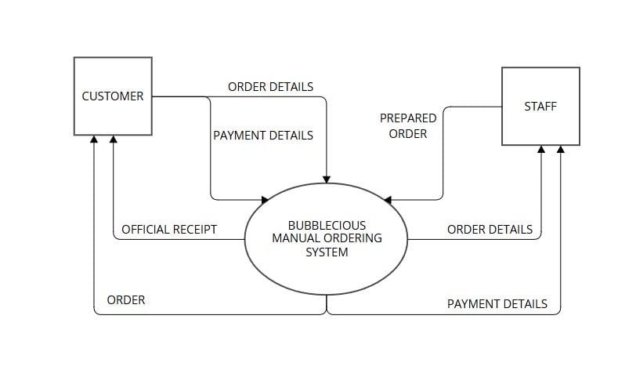

3.4 Data Flow Diagram
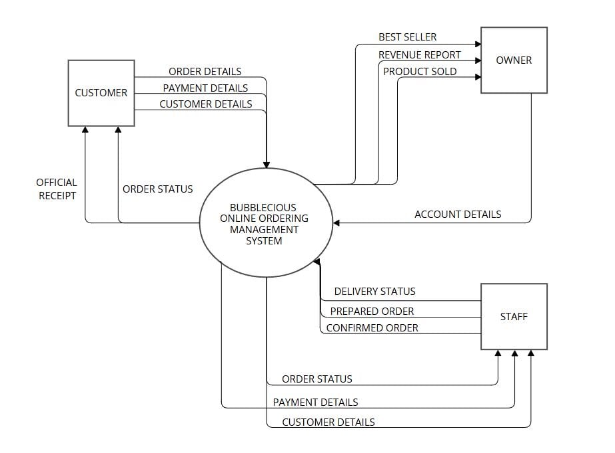

CHAPTER 4
- The Project
4.1 Description of the Project
This project aims to design and develop an innovative online ordering management system for Bubblelicious, a milk tea house, as part of the System Fundamentals course at the University of Caloocan City. This system will be built using the Laravel framework, with a development timeline of three months, showcasing both theoretical knowledge and practical application of computer science principles.
The system is designed to streamline and automate various aspects of Bubblelicious's operations, enhancing efficiency and improving the customer experience. It will feature capabilities such as product and inventory management, order tracking, payment processing, and reporting. Customers will be able to browse available products, place orders, and make secure payments through multiple methods, including GCash. The system will also enable the store owner to manage stock levels, process payments, and generate insightful sales and inventory reports.

4.2 Context Diagram / Data Flow Diagram

Existing
The context diagram for the Bubblelicious Manual Ordering System illustrates the interaction between the system and its two main external entities: Customers and Staff.
The system serves as the central hub for managing orders and payments. Customers interact with the system by providing order details and payment details when placing an order. In return, the system generates an official receipt and ensures that the completed order is delivered back to the customer.

On the other hand, staff are responsible for receiving order details from the system, preparing the order, and then returning the prepared order to the system.

Additionally, staff may provide payment details to finalize transactions. This diagram effectively outlines the flow of data between the customers, staff, and the system, showing how orders and payments are processed seamlessly within the manual ordering workflow.



Proposed
This context diagram illustrates the interactions of the Bubblelicious Online Ordering System with three main external entities: the customer, the owner, and the staff.

At the center, the system processes and manages data related to orders, payments, and account details.

Customers provide order details, payment information, and personal details to the system. In return, they receive updates on their order status and official receipts.

The owner interacts with the system by accessing insights such as best-selling products, total revenue, and sales data, while also managing account details. Staff members play a crucial role in operational tasks, sending confirmed orders, prepared orders, and delivery status updates to the system, which in turn provides them with necessary information such as order status, payment details, and customer details.

This diagram provides a high-level overview of the data flow within the Bubblelicious Online Ordering System, ensuring a clear understanding of its structure and processes.

4.3 Data Dictionary
Entity/Table | Attribute | Data Type | Description
Customer | customer_id | INT | Unique identifier for each customer.
 | name | VARCHAR | Full name of the customer/
 | email | VARCHAR | Customer’s email address.
 | username | VARCHAR | Customer’s account username.
 | address | VARCHAR | Customer’s shipping address.
Order | order_id | INT | Unique identifier for each order
 | customer_id | INT | Links the order to a specific customer
 | order_date | DATE | The date the order was placed.
 | order_amount | DECIMAL | Total amount of the order.
 | order_status | VARCHAR | Current status of the order *e.g., Shipped, Delivered).
Product | product_id | INT | Unique Identifier for each product
 | name | VARCHAR | Name of the product
 | price | DECIMAL | Price of the product
 | category | VARCHAR | Category or type of the product
 | stock_level | INT | Number of items available in inventory.
Payment | payment_id | INT | Unique identifier for each payment.
 | order_id | INT | Links the payment to a specific order.
 | method | VARCHAR | Payment method (e.g., Gcash, Cash).
 | amount | DECIMAL | Payment amount.
 | transaction_id | VARCHAR | Transaction identifier from payment systems.
Cart | cart_id | INT | Unique identifier for the shopping cart.
 | customer_id | INT | Links the cart to a specific customer.
 | product_id | INT | Link products added to the cart
Tracking Details | tracking_id | INT | Unique identifier for order tracing.
 | order_id | INT | Links the tracking detail to a specific order.
 | status | VARCHAR | Status of delivery (e.g., In Transit, Delivered).
 | transaction_id | VARCHAR | Identifier for tracking payments or delivery details.

4.4 Entity Relationship Diagram
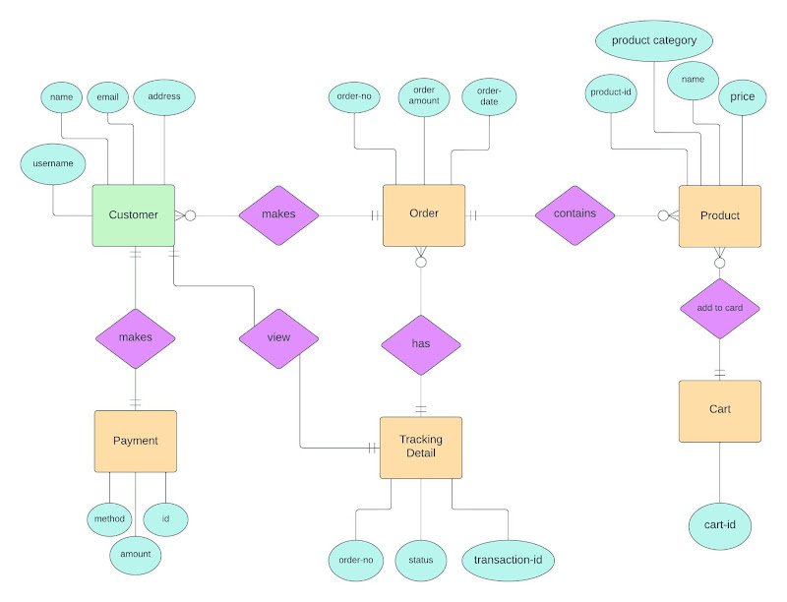
This ERD outlines the structure of an e-commerce system, detailing the relationships between customers, orders, products, payments, and tracking information. The Customer entity captures essential details such as name, email, username, and address. Customers can place Orders, which include attributes like order number, order amount, and order date. Each order can consist of multiple Products, which are defined by properties such as product ID, name, price, and category. Customers also have the option to make Payments, with payment details including an ID, method, and amount.

In addition, the system allows customers to view their orders and payment details. Each order is associated with Tracking Details that monitor its progress using attributes like order number, status, and transaction ID. On the product side, customers can add items to a Cart, identified by a cart ID. The relationships between these entities are mapped out clearly, showing how one customer can place multiple orders, make

payments, and interact with products. This structure reflects how data flows seamlessly through an online shopping system.

4.5 Program Flow Chart
The flowchart for the Bubblelicious Online Ordering Management System outlines the step-by-step process of how a user interacts with the system, starting from registration to order completion. The process begins with a decision point to determine if the user is registered. If not, the user proceeds to User Registration; otherwise, they move to User Authentication. After successful authentication, the system directs the user to the Menu, where several options are available: View/Search Items, View Account Status, View/Edit Account Information, or Logout.
From the View/Search Items option, the user can explore products and add items to their cart. The system then Displays Cart Contents, allowing the user to Preview Products or Change Cart Items as needed. Once satisfied, the user confirms the items and proceeds to Place Order. At this stage, the user selects a payment method, choosing between GCash or Cash on Delivery.
After completing the payment, the user can perform additional actions such as View Receipt, Track Order, and Rate/Add Comment to provide feedback. The process concludes with the End step, marking the completion of the order workflow. Overall, the flowchart demonstrates a structured and user-friendly process, ensuring smooth navigation for customers from product selection to order fulfillment.

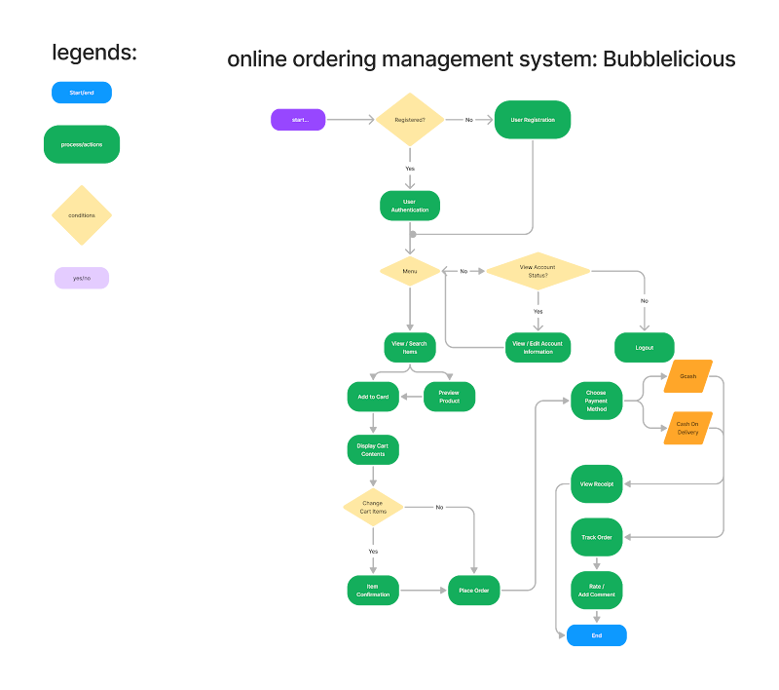

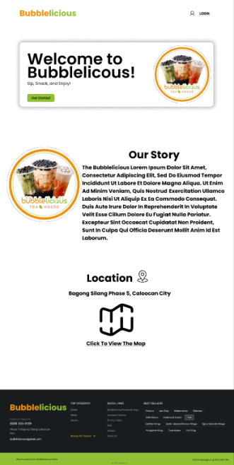

Welcome Page: Serves as the entry point, showcasing the Bubblelicious brand with a warm greeting and inviting users to explore the menu, learn about the story, and navigate to other sections of the website.

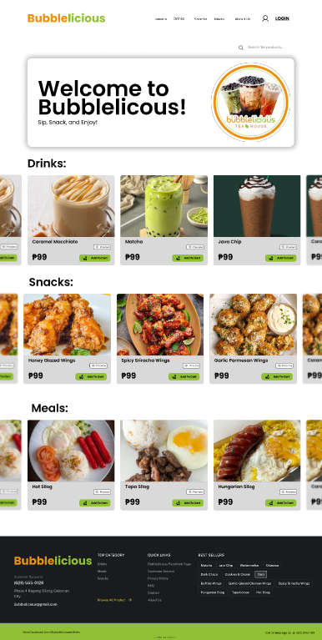

Menu Page: Allows users to browse, select, and customize their orders seamlessly. Allow users to visualize the categorized list of available drinks, snacks, and meals with pricing and an option to add items to the cart.

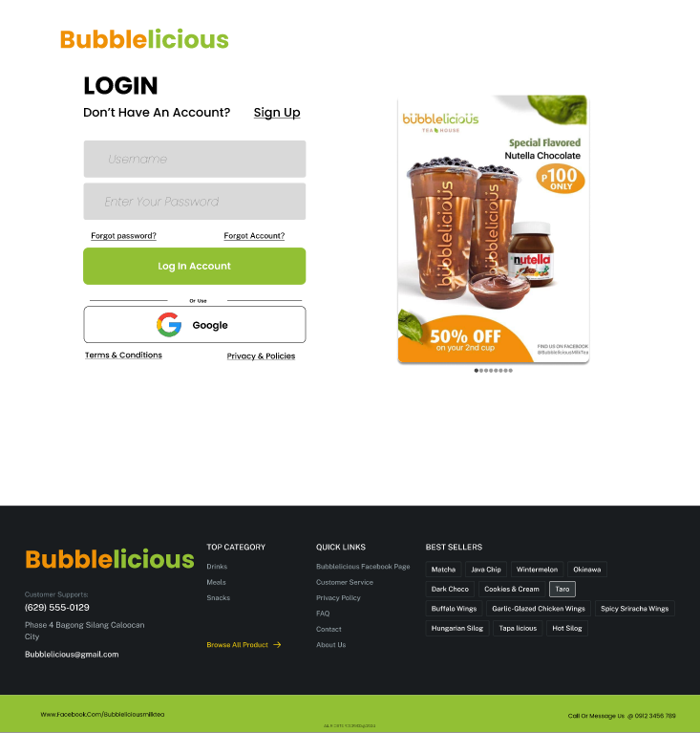
Login Page: Allows users to securely log in to their accounts by entering their credentials.

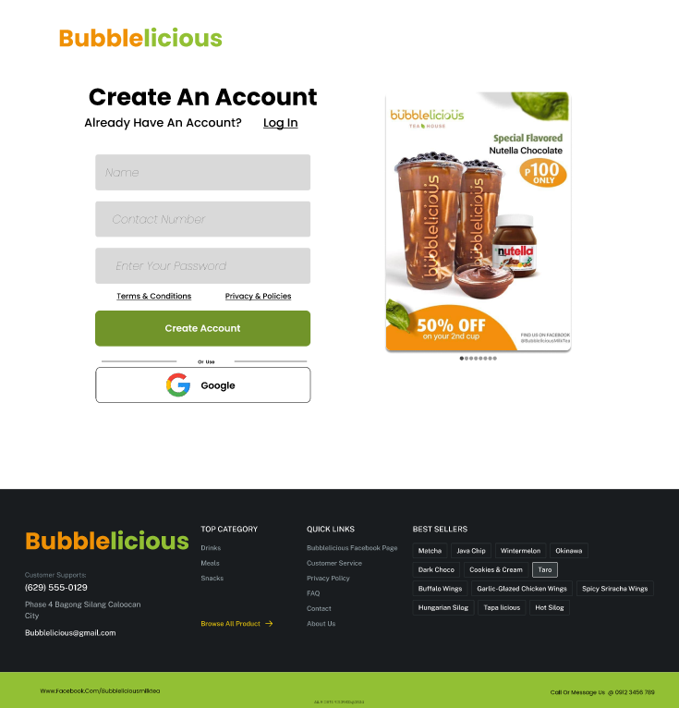

Sign-Up Page: Enables new users to create an account by providing required details such as name, contact number, and password.

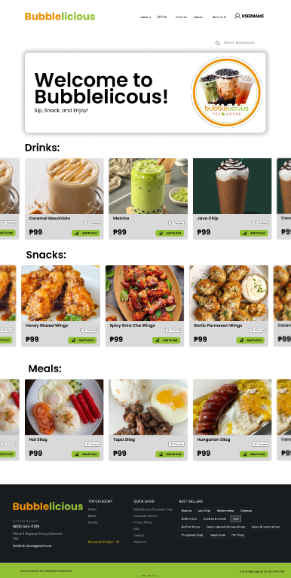

Menu Page: Displays a categorized list of available drinks, snacks, and meals with pricing and an option to add items to the cart. Allows users to browse, select, and customize their orders seamlessly.
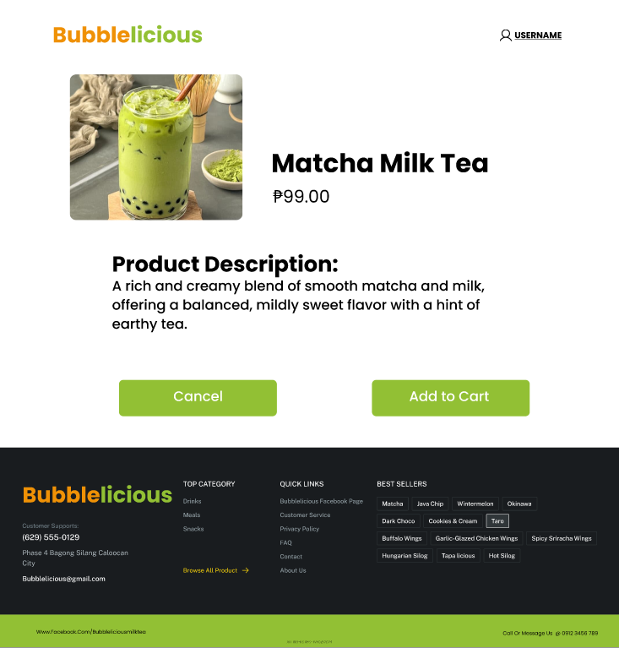
Order Preview Page: Displays a summary of the selected items, including product description and prize.

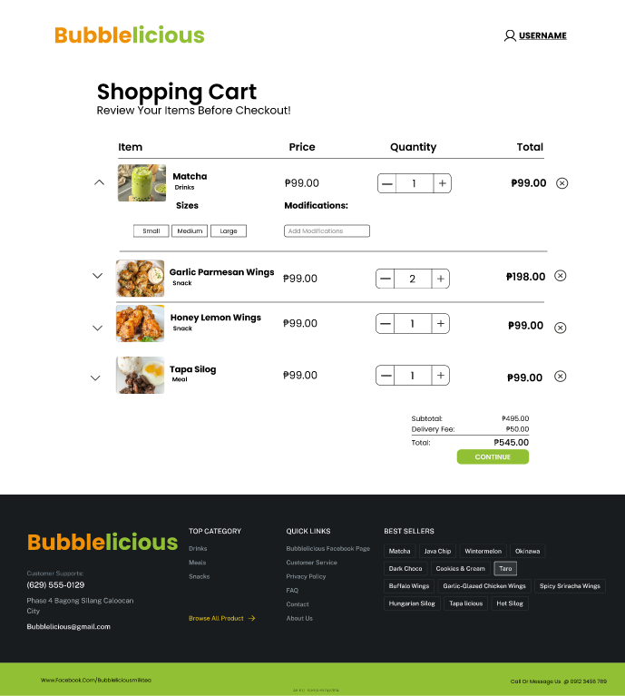

Shopping Cart Page: Displays all selected items, quantities, and the total price. Users can customize the items, remove items, or proceed to checkout. The page also notifies if the items are not available and calculates final costs before payment.

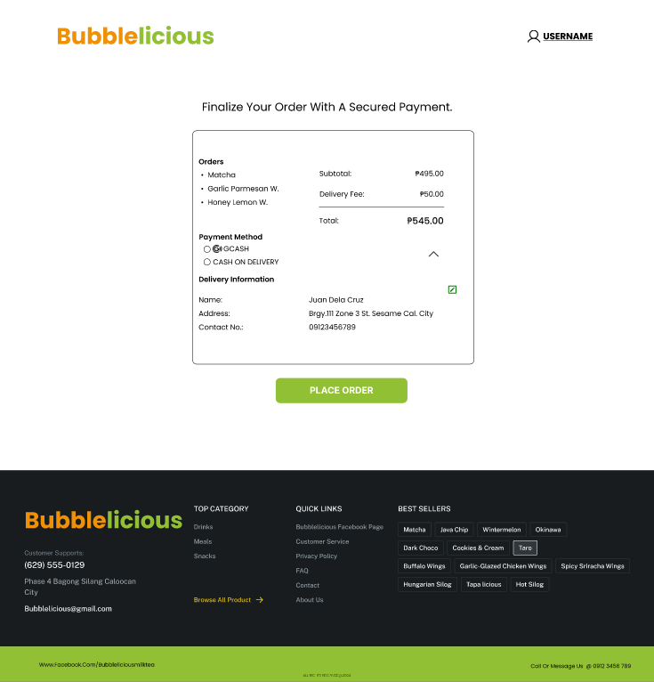

Payment Method Page: Allows users to select their preferred payment option (e.g., GCash, Cash, or COD). View the items and the total costs to place an order.

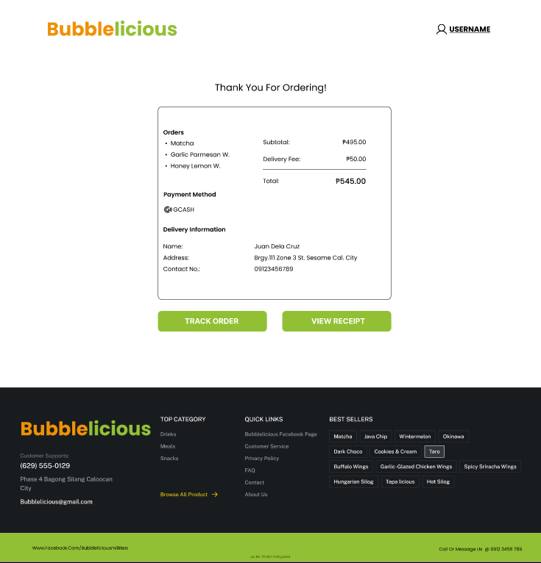
Receipt Page: Displays a detailed order confirmation with a summary of purchased items, payment method, total cost.

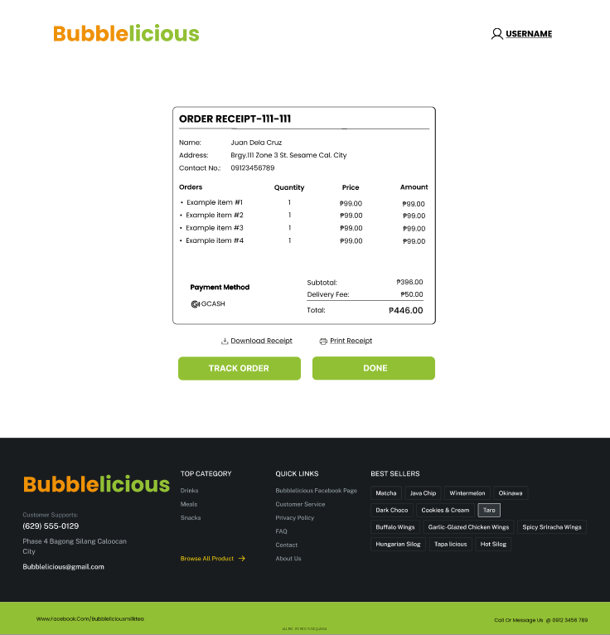

Official Receipt Page Flow: Generates a formal, itemized receipt for the completed transaction. Includes customer details, order summary, payment method, transaction number. Users can view, download, or print the receipt for record-keeping and track the order.

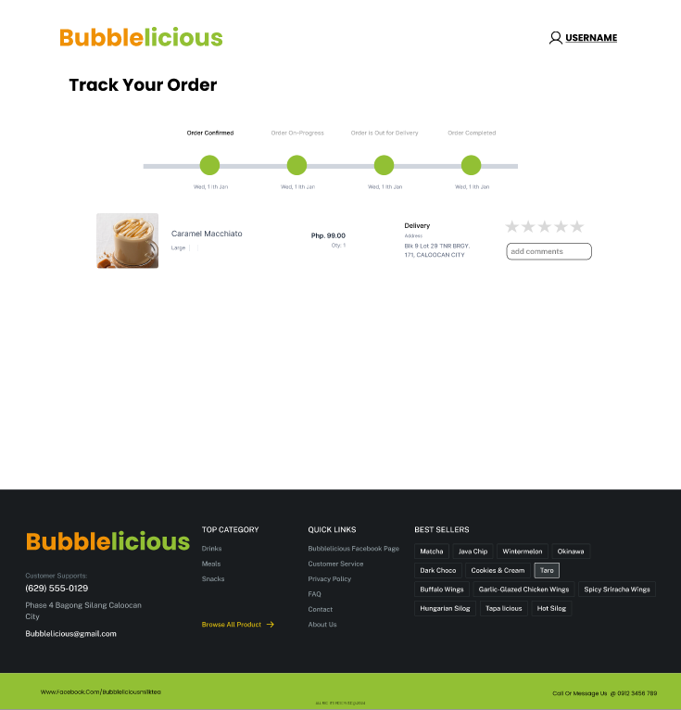

Track Order Page: Allows users to view the current status and progress of their order (e.g., order confirmed, order on-progress, order is out of delivery, order completed). Provides real-time updates on shipping and delivery details also the user can rate the product and add a comment.

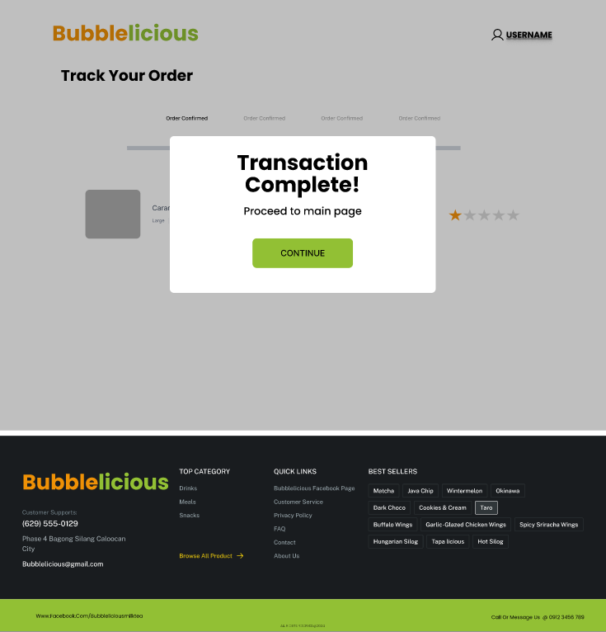

Transaction Complete Page: After rating the product, the user can proceed to the main page.

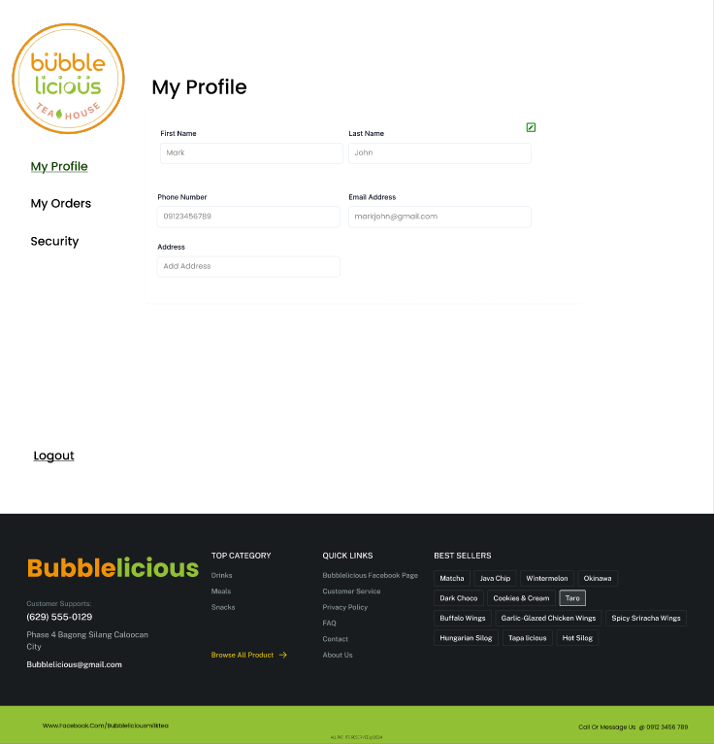

Profile Page: Displays the user's personal information. Allows users to update their details and change their password.

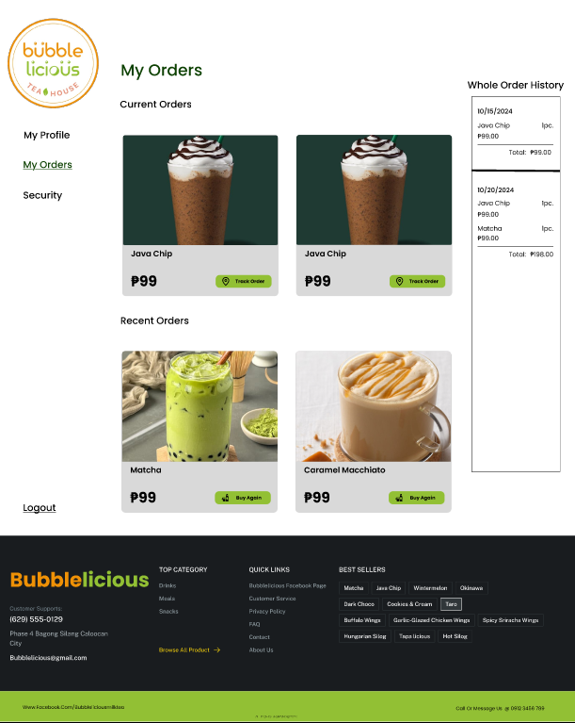

Page: Shows a detailed list of the user's past and current orders, including order status, items purchased, and payment details. Users can view, track on their orders.

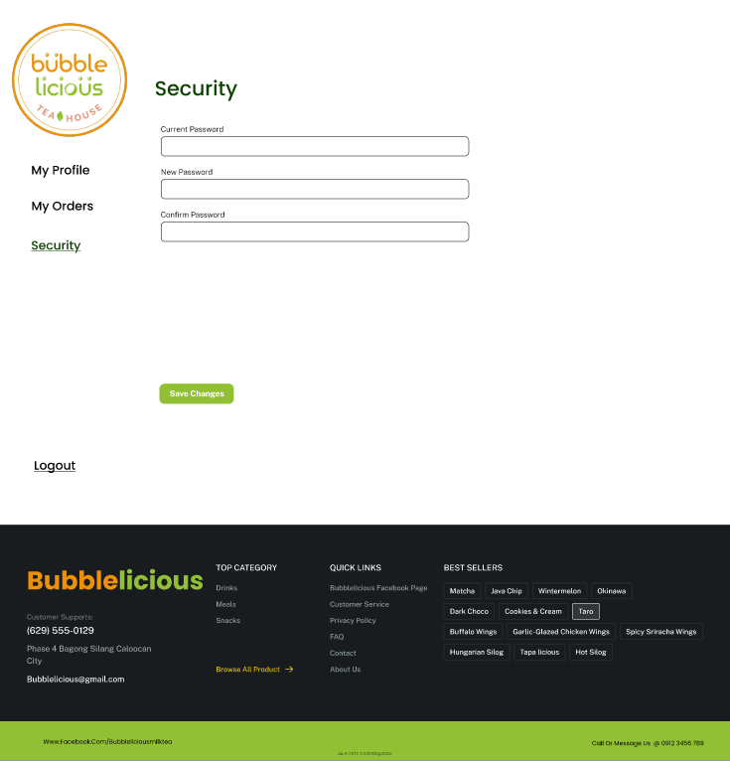

Security Page: The user can manage their account by updating the password.

4.6 Report Specification

Report Name | Report Purpose | Generated By | Data Sources | Fields/Contents
Sales Report | To analyze the total sales over a period of time. | Owner/Admin | Order, Payment | - Date range  - Order ID  - Customer Name  - Total Order Amount  - Payment Method
Inventory Report | To monitor product stock levels and trigger restocks. | Owner/Admin | Product, Order | - Product ID  - Product Name  - Category  - Stock Level  - Reorder Alert Status
Order Status Report | To track the status of all orders for customers. | Customer/Owner | Order, Tracking Detail | - Order ID  - Customer Name  - Order Date  - Order Status  - Tracking Status
Payment Report | To view all payments made and pending refunds. | Owner/Admin | Payment, Order | - Payment ID  - Order ID  - Customer Name  - Payment Amount  - Payment Method  - Transaction ID
Customer Order History | To allow customers to view their past orders. | Customer | Order, Payment | - Order ID  - Order Date  - Product Name(s)  - Total Amount  - Payment Method  - Order Status
Financial Summary Report | To provide a summary of revenue, refunds, and payments. | Owner/Admin | Payment, Order | - Date Range  - Total Revenue  - Total Refunds  - Payment Breakdown (GCash, Cash)
Tracking Report | To display order tracking details for customers. | Customer/Owner | Tracking Detail, Order | - Order ID  - Tracking ID  - Status (In Transit, Delivered)  - Transaction ID

CHAPTER 5

5.1 Cost of Benefits Analysis

Project Name: BUBBLELICIOUS ONLINE ORDERING MANAGEMENT SYSTEM

Prepared By:
Tiu, Michael Aaron
Cabreros, James
Rocabo, Ralph Michael
Lorezo, John
Granadozo, Khen Hurryson
Suarez, Audric

Executive Summary
The purpose of this Cost-Benefit Analysis (CBA) is to evaluate the financial and operational implications of implementing an Online Ordering Management System for Bubblelicious, located in Bagong Silang, Caloocan City North. Bubblelicious operates with a suboptimal ordering process that leads to inefficiencies, order inaccuracies, and increased operational costs. This analysis examines the benefits of transitioning to a streamlined, automated system against the investment required for its development and deployment.

Our proposed system, developed using the MERN stack (mongo, express, node), is designed to enhance efficiency and improve the customer experience by integrating features such as real-time order tracking, inventory management, and payment processing.

2. Objectives
The objectives of the project or investment under analysis.
- Improve process efficiency by automating manual operations, including order processing, inventory management, and payment monitoring.
- Reduce operational costs by minimizing human errors, optimizing resource usage, and eliminating paper-based processes.
- Enhance customer satisfaction by decreasing order response time, increasing order accuracy, and providing real-time order status updates.
- Provide actionable insights through detailed analytics and reporting for the branch manager, including sales trends, inventory levels, and transaction records.
- Optimize inventory management with features such as real-time tracking, automated low-stock alerts, and intelligent reorder suggestions.

3. Cost of benefits
Identify and estimate all costs associated with the project. Divide costs into categories.

3.1 Initial Costs (One-Time)
Cost item | Description | Estimated Cost
Software Development
Software/Infrastructure
Training
Deployment/Installation

3.2 Ongoing Costs (Recurring)
Cost Item | Description | Annual Cost
Licensing Fees | Software licenses
Maintenance Support | Technical support and updates
Operational Costs | Additional staffing/resources
Total Costs Over [Time Period]: Php ₱

5.2 Screenshots

5.3 Program Listing

5.4 User Manual
Bubblelicious User Manual
Table of Contents
- System Overview
- User Roles
- System Features and Functionalities
- Admin Panel
- Inventory Management
- Order Management
- Report generation

- Customer Panel
- Product selection and purchase
- Add to cart
- Payment selection
- Track order
- System Limitations
- Getting Started
- Troubleshooting

1. System Overview
The Online Ordering Management System is a web-based platform built using the MERN stack (MongoDB, Express.js, React, and Node.js). It facilitates efficient management of customer orders, inventory tracking, and payment processing while offering customers an intuitive interface for placing and tracking orders. The system ensures a user-friendly experience for both Owner and customers, enhancing operational efficiency and customer satisfaction.

2. User Roles
The system supports three types of users.

Owner
The owner manages the backend operations, including inventory management, order processing, and report generation.

Employees
Employees monitor transactions, inventory levels, and customer details to ensure smooth day-to-day operations.

Customers
Customers interact with the frontend to search for products, place orders, and track their order statuses.

3. System Features and Functionalities
Owner Panel
The Owner Panel provides the following functionalities:
3.1. Inventory Management
Owners can:
- Add/Update/Delete Categories: Organize product categories efficiently.
- Manage Products: Add new products, update stock levels, and remove discontinued items.
- Update Product Availability: Adjust inventory status in real-time.
Steps to Add a Product:
- Navigate to Owner Panel > Inventory Management > Products.
- Click "Add Product."
- Enter product details (name, category, price, stock level).
- Save changes.

3.2. Order Management
Owners can:
- Approve/Decline Orders: Manage customer orders.
- Track Order Status: Monitor progress (e.g., Pending, Confirmed, Delivered).
- Manage User Data: View and update customer profiles.
Steps to Approve an Order:
- Navigate to Owner Panel > Order Management > Orders.

- Select an order.
- Review details and click "Approve."
- Update shipping status.

3.3. Report Generation
Owners can:
- Generate detailed reports (e.g., monthly sales, inventory data).
- Export reports for further analysis.
Steps to Generate a Report:
- Navigate to Owner Panel > Reports.
- Select the time range.
- Click "Generate Report."
- View, print, or download the report.

Employee Panel

3.4. Monitor Transactions
Employees can:
- View and verify ongoing transactions.
- Track order statuses.

3.5. Monitor Inventory
Employees can:
- View current stock levels.
- Report low stock items.

3.6. Monitor Customer Details
Employees can:
- Access customer information as needed.

Customer Panel

3.7. Product Search and Purchase
Customers can:
- Search for products using filters like categories and availability.
- Add items to their cart and complete the checkout process.

Steps to Purchase a Product:
- Browse products using search or filters.
- Add items to the cart.
- Proceed to checkout and provide payment details.
- Confirm the order.

3.8. Order Tracking
Customers can:
- View the status of their orders (Pending, Shipped, Delivered).
- Access order confirmations and download invoices.
Steps to View Order Status:
- Go to "My Orders" in the customer dashboard.
- Select an order to view its details.

4. System Limitations
- Requires an active internet connection.
- Limited to operational features (no marketing tools).

5. Getting Started

For Owners:
- Log in to the Owner Panel using your credentials.
- Set up categories, inventory, and user roles.
- Begin managing orders and reports.

For Customers:
- Create an account or log in.
- Browse the catalog, add items to the cart, and place orders.
- Track order status and download invoices.

End of Document
Thank you for choosing the Bubblelicious Online Ordering Management System! For assistance, contact the system administrator.

5.5 Gantt
