

========IEEE – Computer Arithmetic Workshop========
=======Assignment(1)=======
> 64-bit Carry Look ahead Adder <

Name: Ibrahim Mohamed Mohamed Hanafy

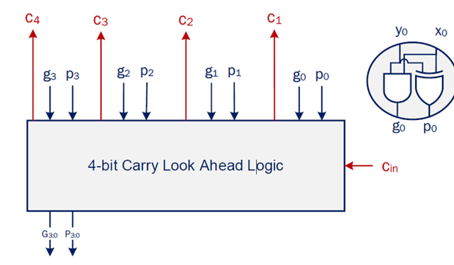
Step 1: 4bit CLA

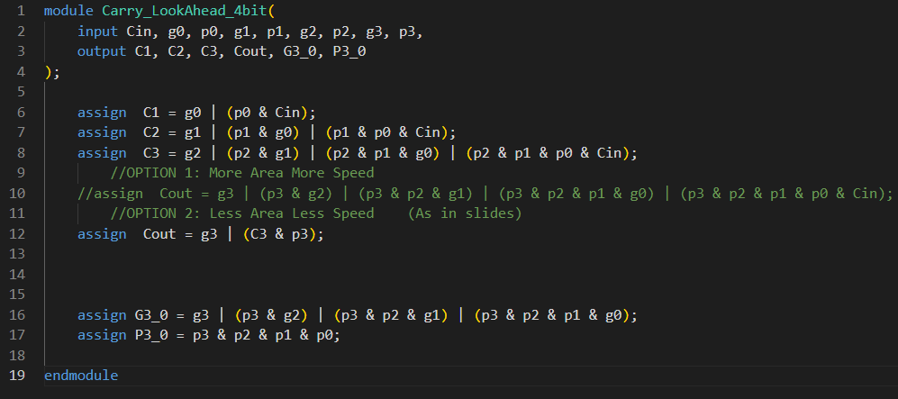
-RTL:

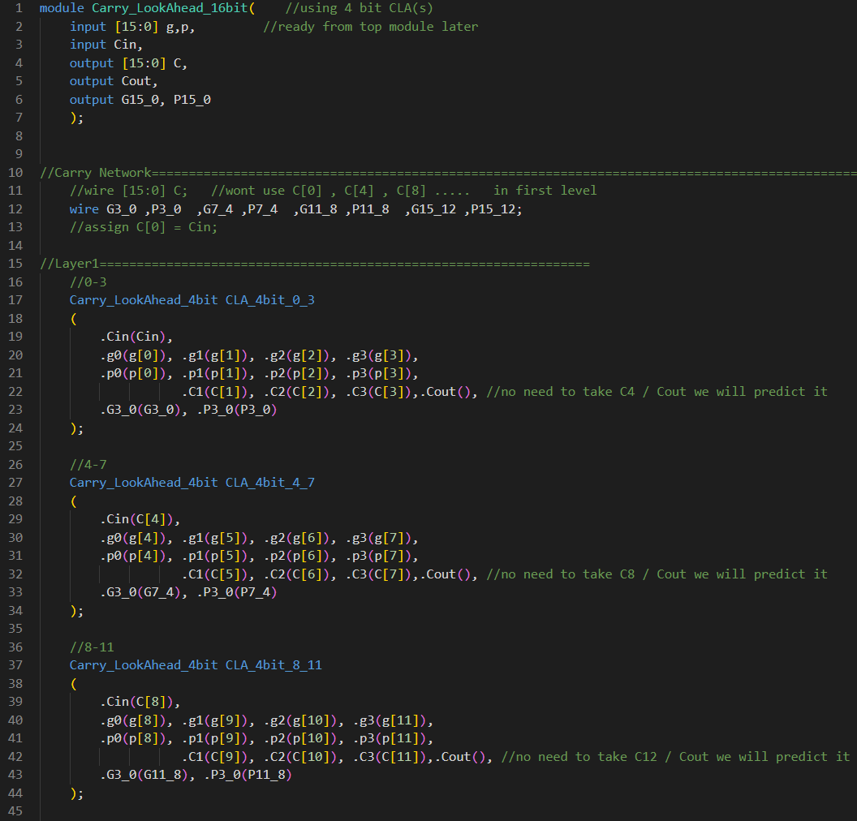
Step 2.1: 16 bit CLA -RTL:

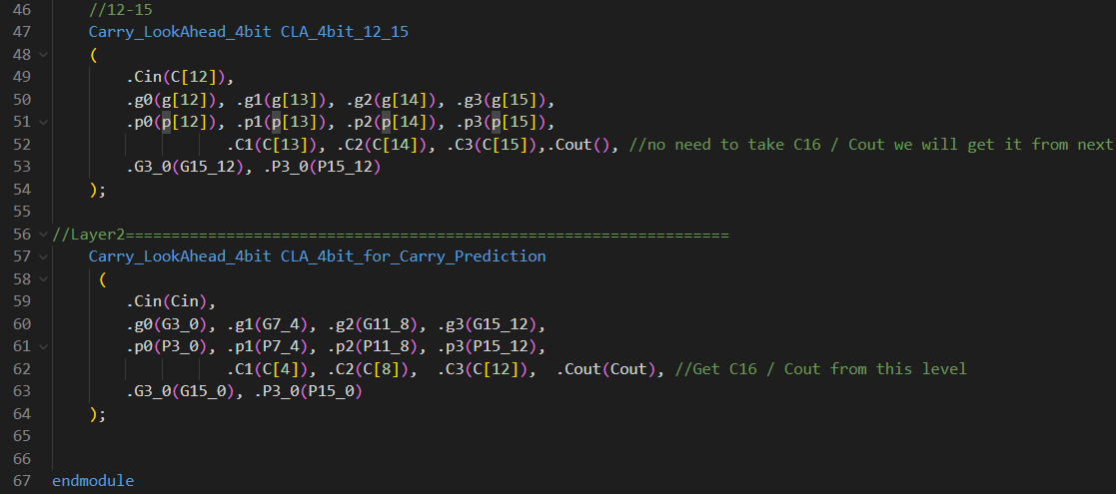

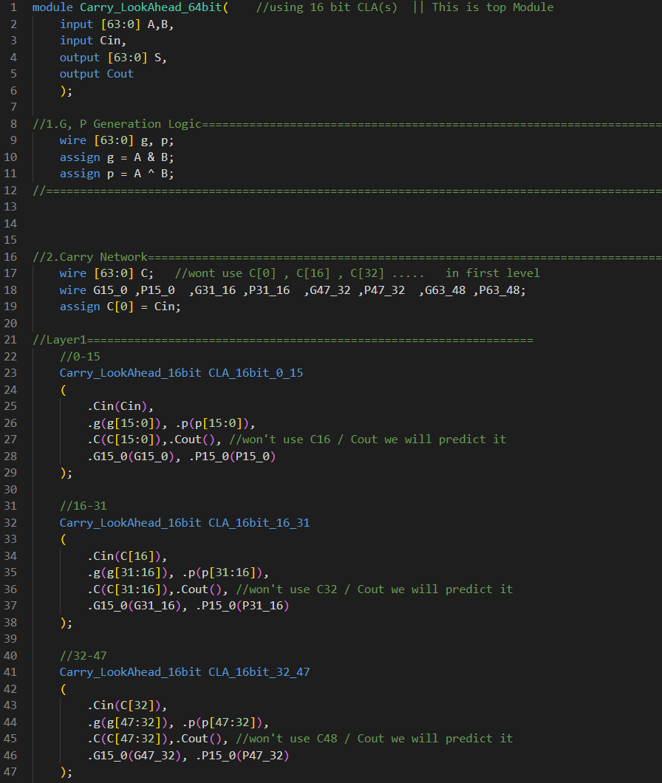
Step 2.2: 64 bit CLA -RTL:

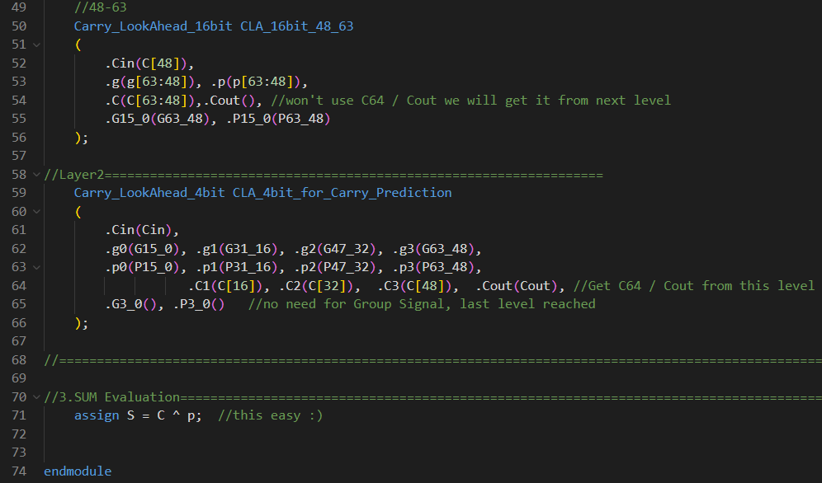

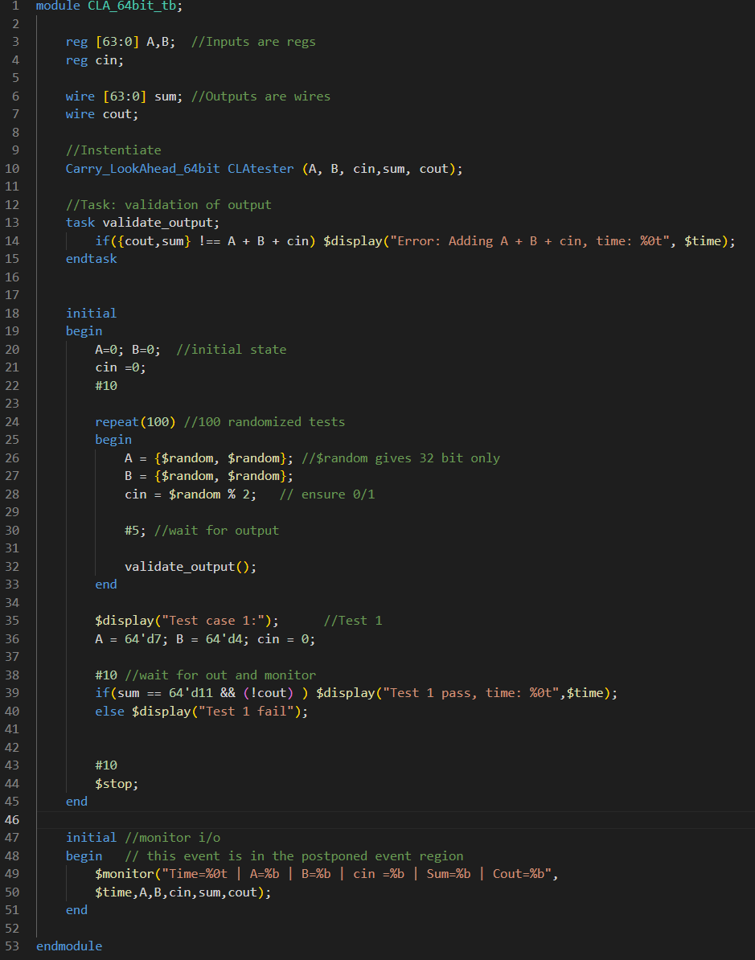
Testbench [100 Random Tests]

-Waveforms , Results

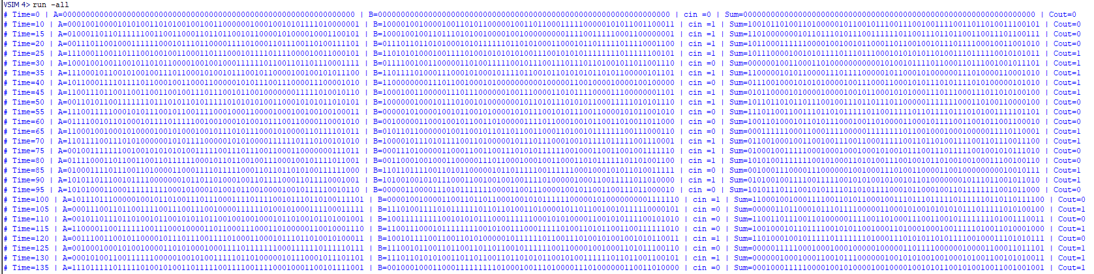

-No Errors
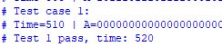

-Pass

FPGA Implementation [xc7a100tcsg324-1]
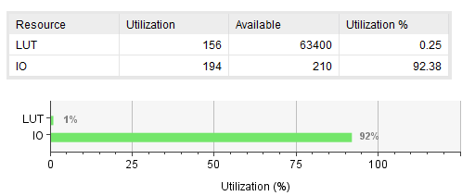
-Utilization Report

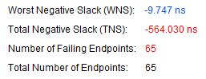
-Timing Report

Given: 5ns max delay $∴$Critical Delay = 14.747ns
Report on limitations
-This Architecture using 4 bit CLAs is limited to ($4^{n}$) bits addition

