

========IEEE – Computer Arithmetic Workshop========
=======Assignment(2)=======
> 64-bit Prefix Adder <
[Brent Kung Topology]

Name: Ibrahim Mohamed Mohamed Hanafy

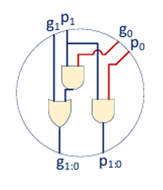
C Operation

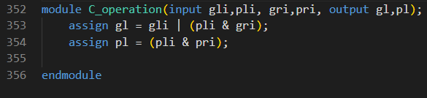
-RTL:

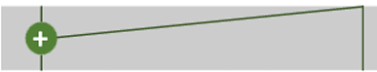
2-input net

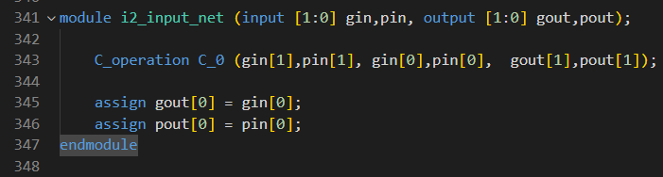
-RTL:

4-input net
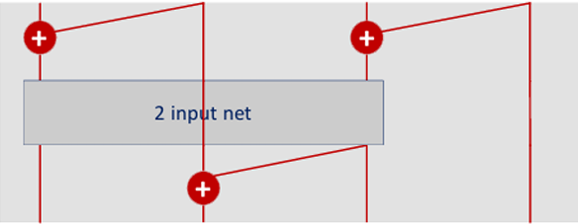

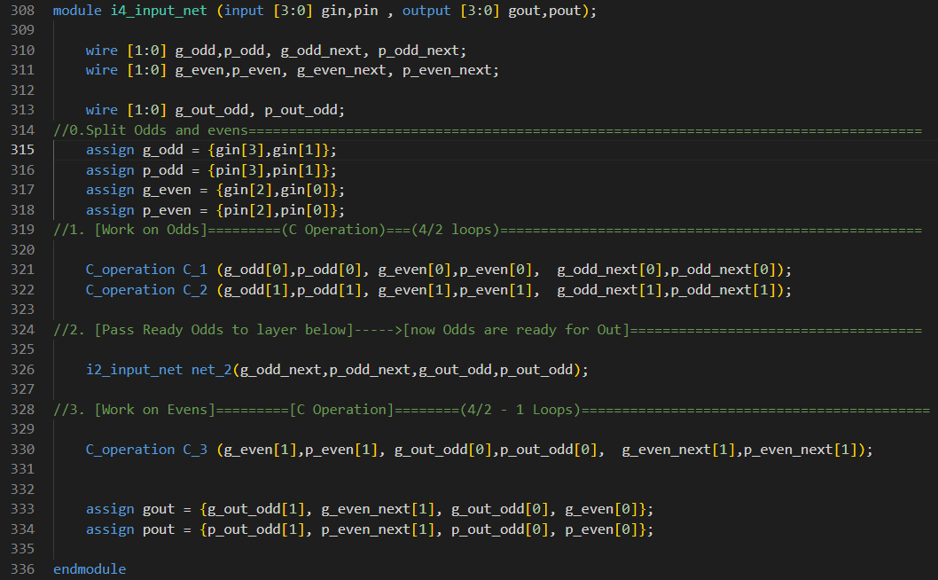
-RTL:

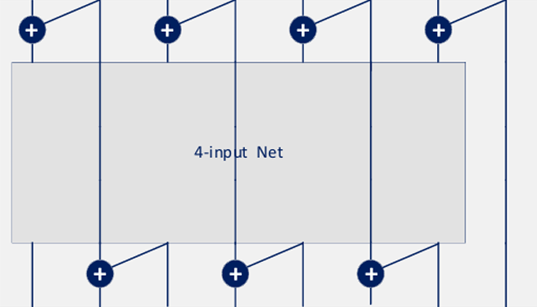
8-input net

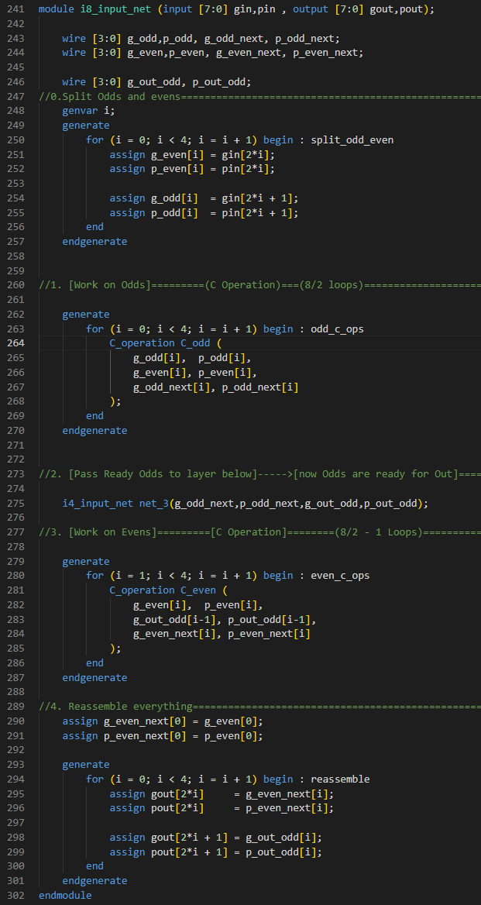
-RTL:

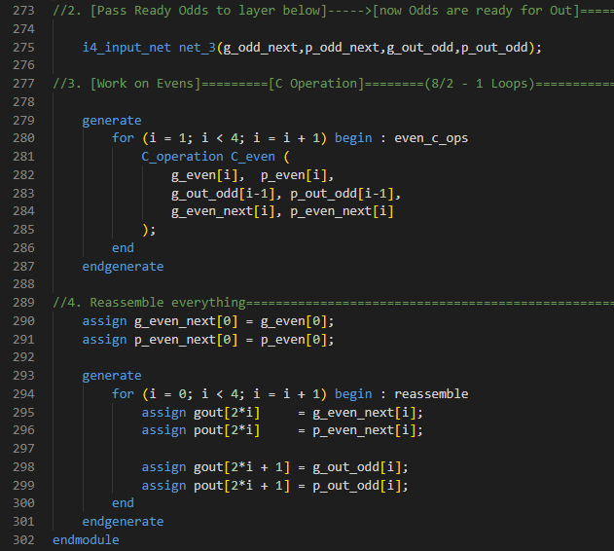

16-input net 32-input net 64-input net
Can be written as the 8-input net where each one instantiates the previous one.
Final 64 Adder
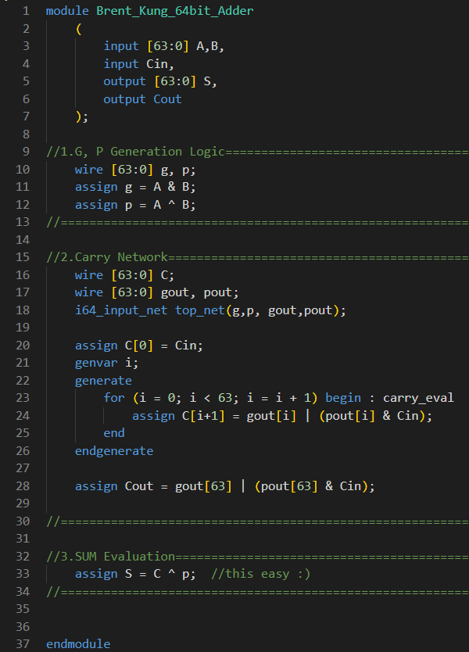
-RTL:

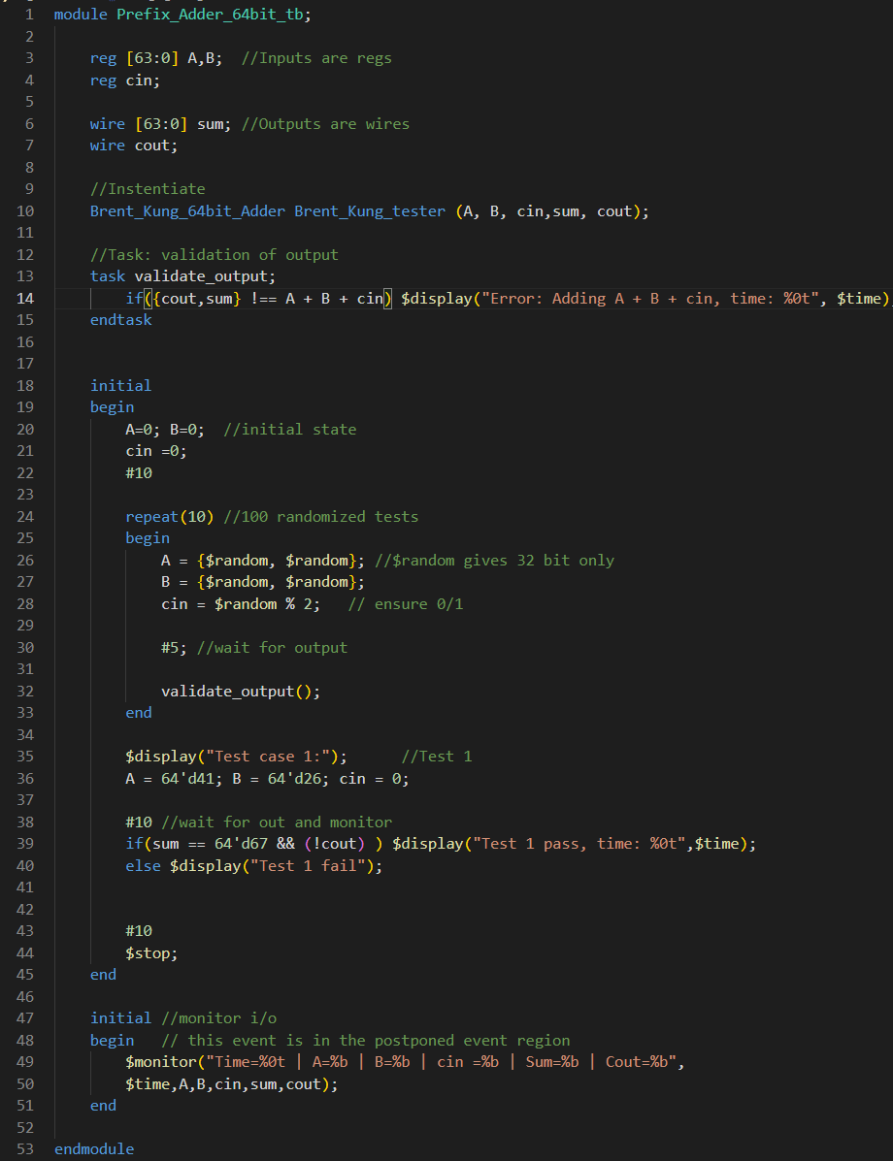
Testbench [100 Random Tests]

-Waveforms , Results

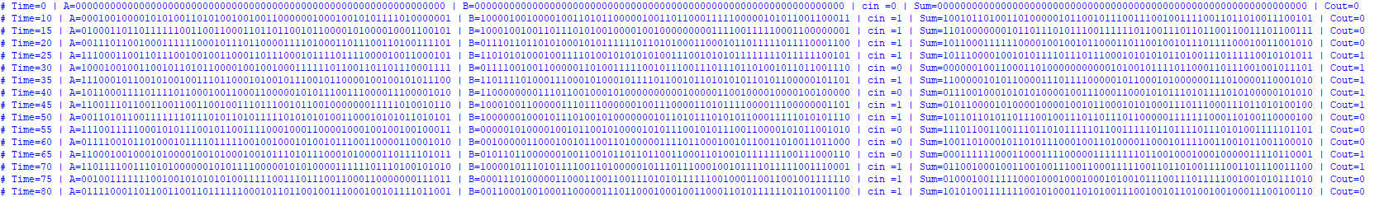

-No Errors
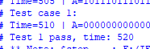

-Pass

FPGA Implementation [xc7a100tcsg324-1]
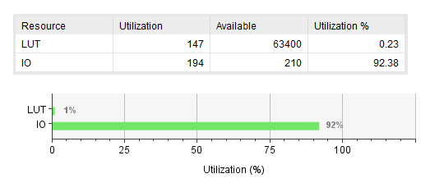
-Utilization Report

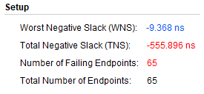
-Timing Report

Given: 5ns max delay $∴$Critical Delay = 14.368ns
Report on limitations
-This RTL Code can implement only 64,32,16,8,4,2 bit adders with a little work needed to implement them
-However for other $n$ bit adder more RTL tweaks would be needed

