SV9 - Digital Verification using SV & UVM
======Assignment(1)======

Name
Ibrahim Mohamed Mohamed Hanafy

Design 1: Adder
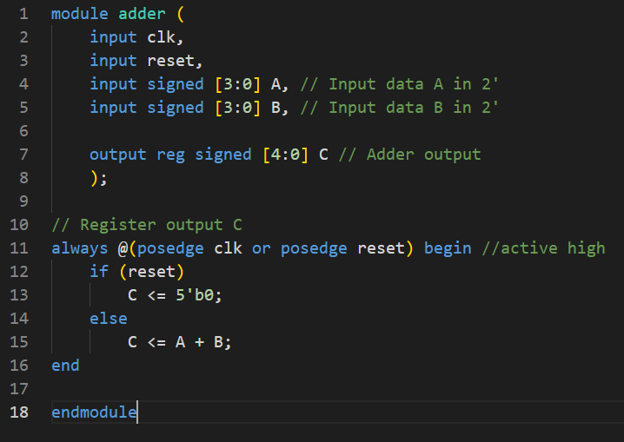
-Adder Design Code:

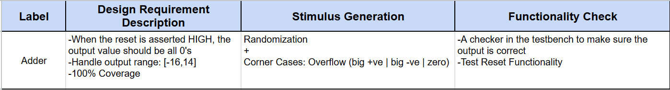
-Verification Plan:

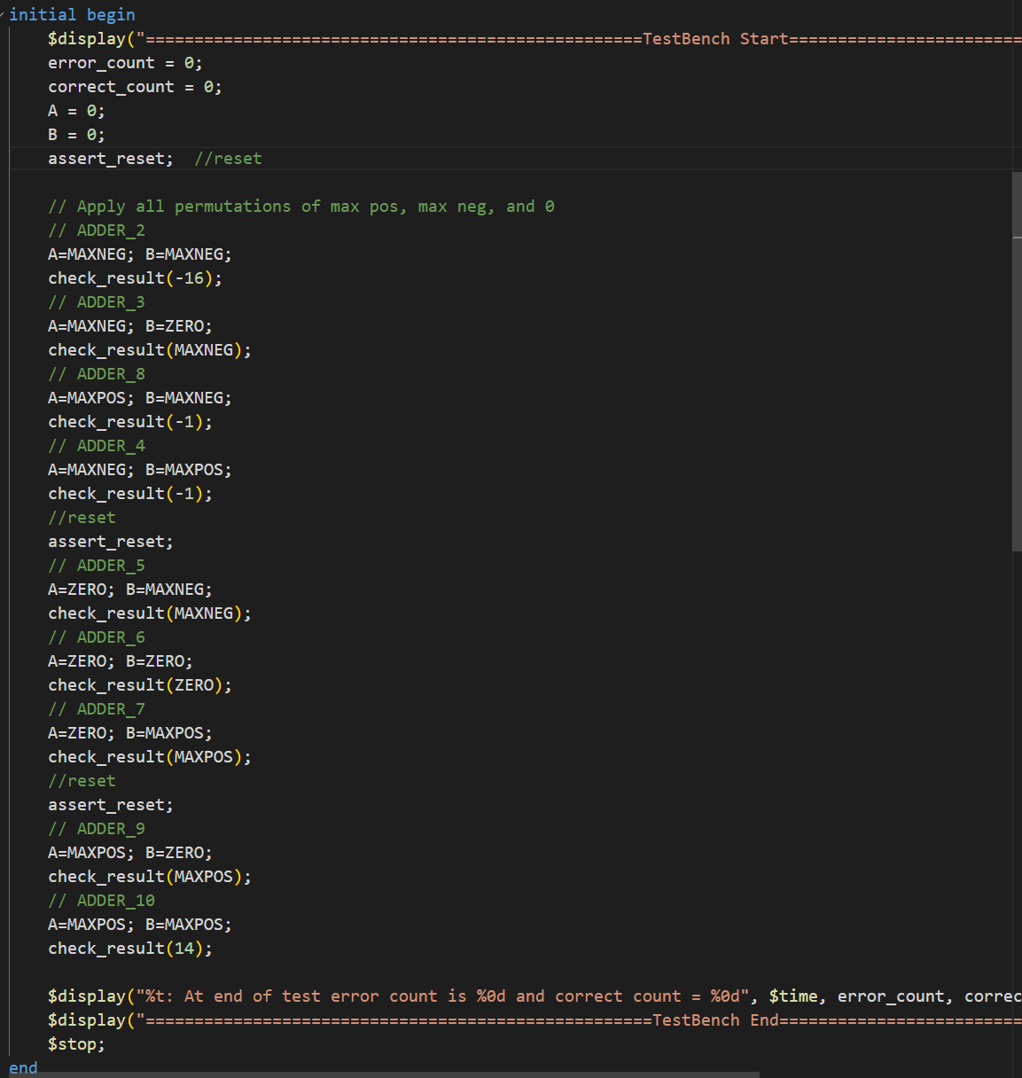
- Testbench:

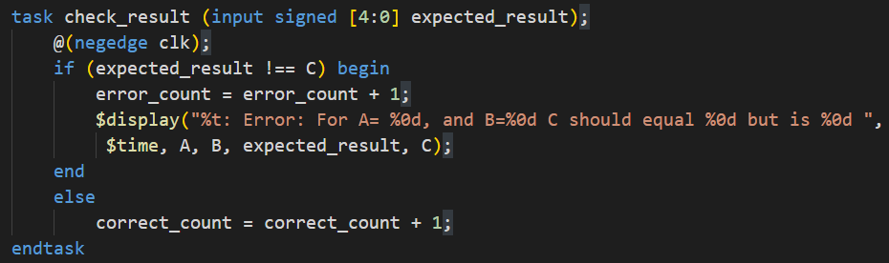

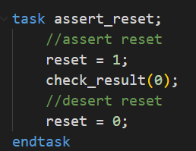

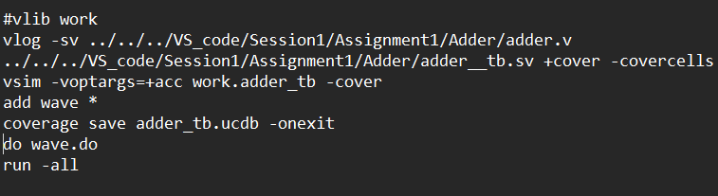
- Do file:

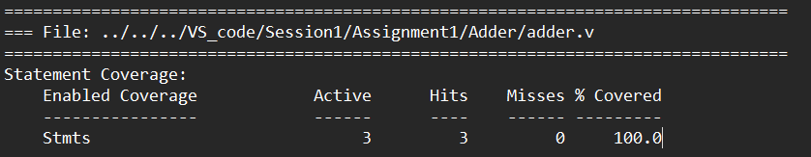
Coverage Report:

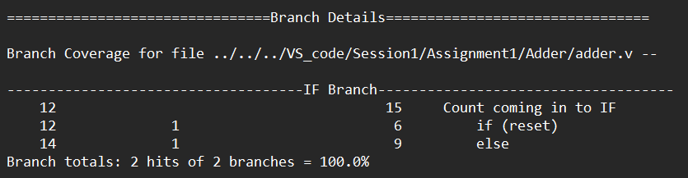

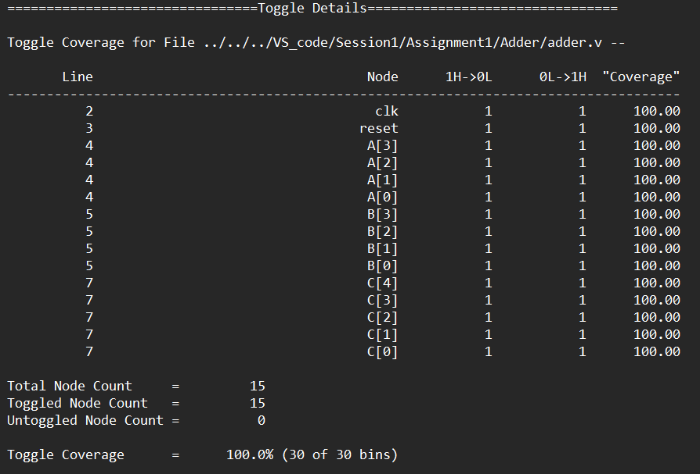

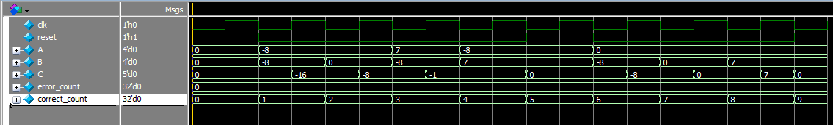
-Waveforms:

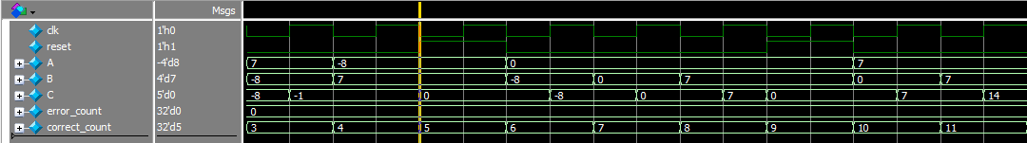

-Coverage Snippets:
Toggle Coverage Branch Coverage
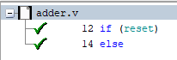
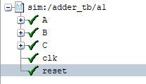

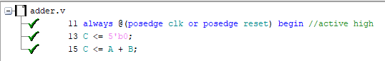
Statement Coverage

Design 2: 4-to-2 Priority encoder
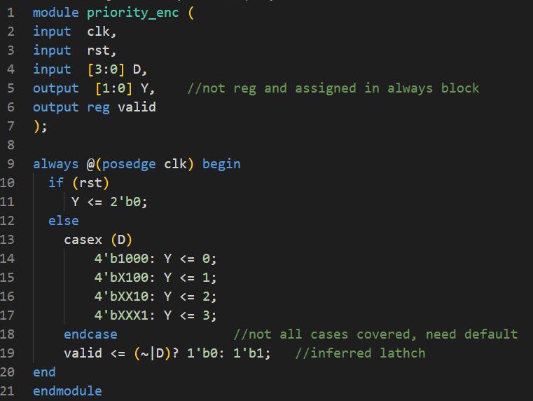
-Encoder Design Code:

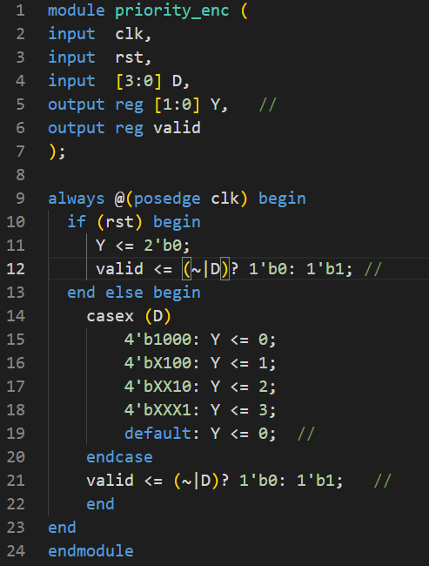
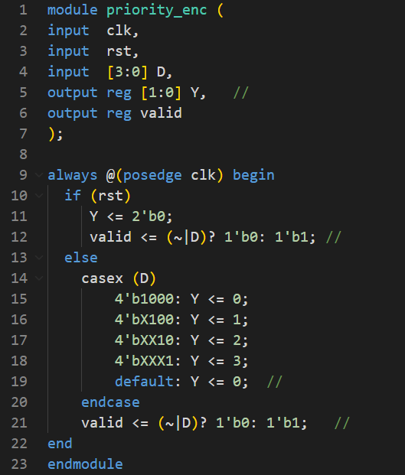
-Bugs & fixes:
-Y isn’t defined as reg, when its assigned in an always block
-A case where D is all 0’s isn’t covered in case statement, adding a default statement
-A latch is inferred for value as it’s not assigned in the if condition
-missing (begin, end) syntax for if and else

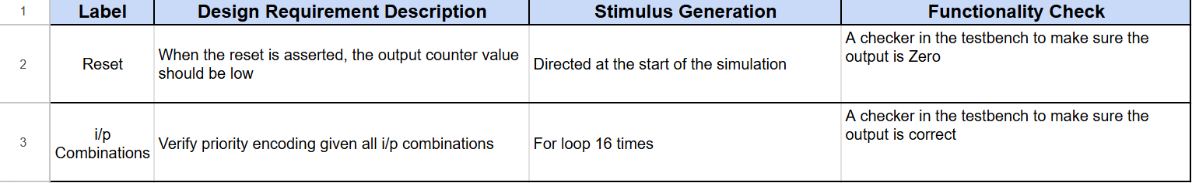
-Verification Plan:

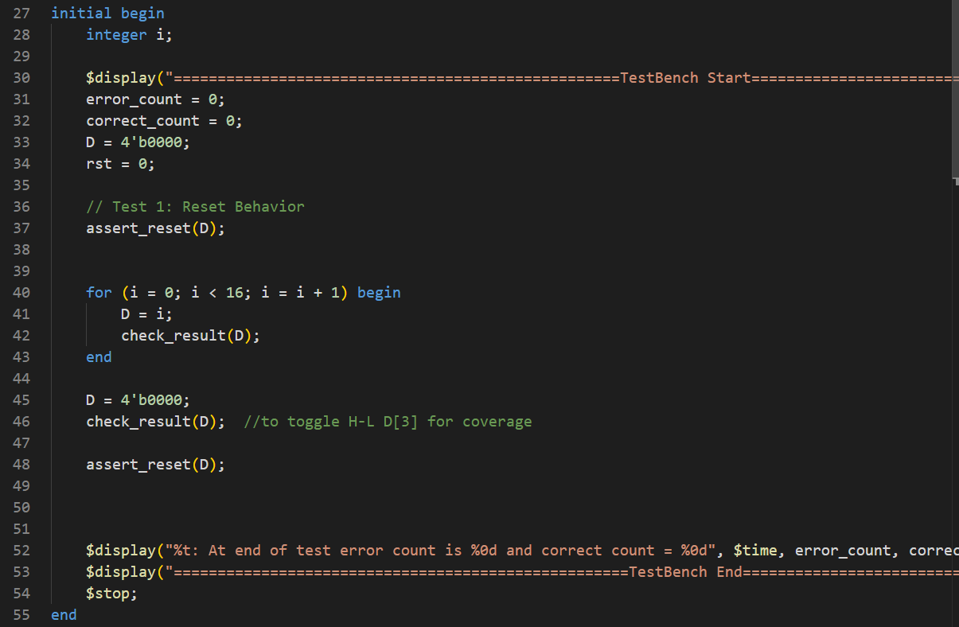
- Testbench:

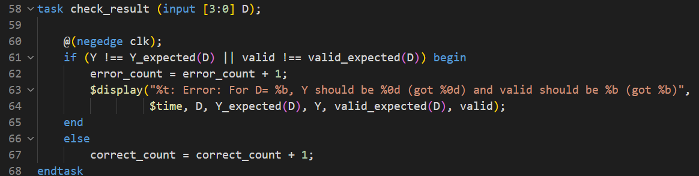

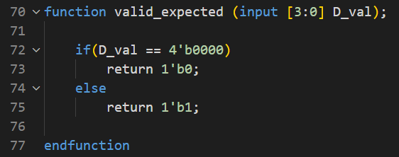

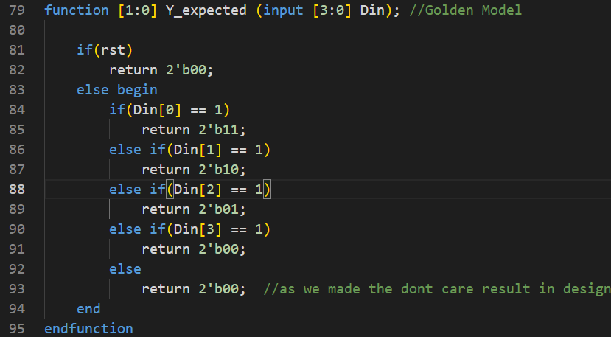

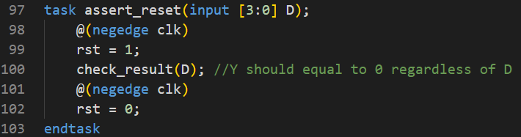

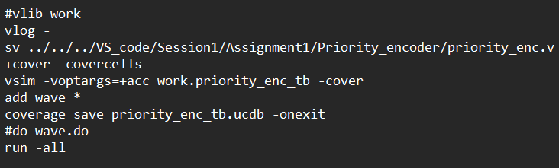
- Do file:

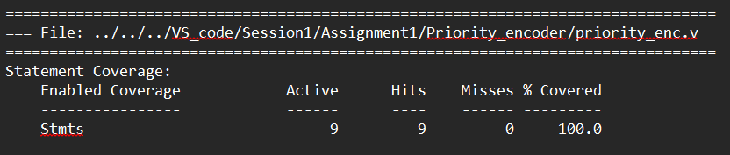
Coverage Report:

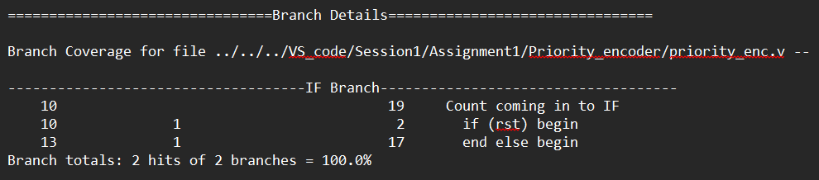

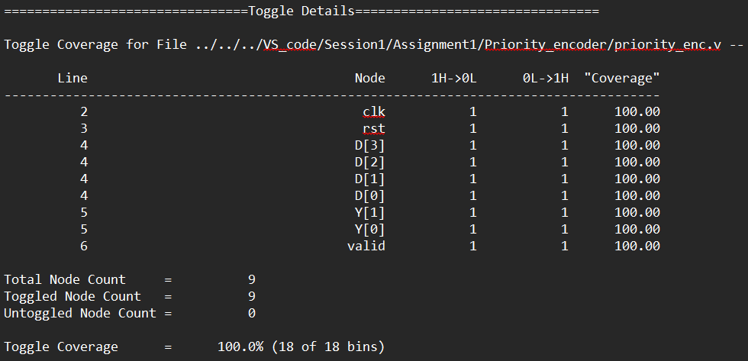

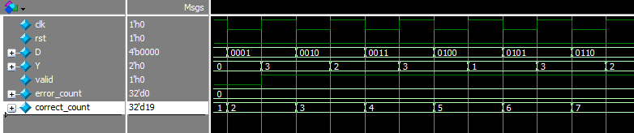
-Waveforms:

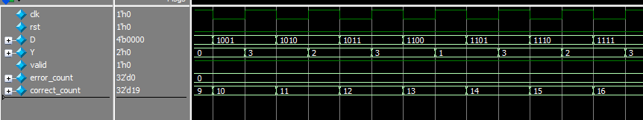

-Coverage Snippets:
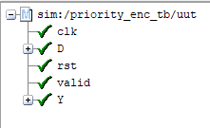
Toggle Coverage Branch Coverage
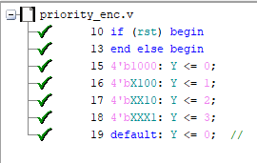

Statement Coverage
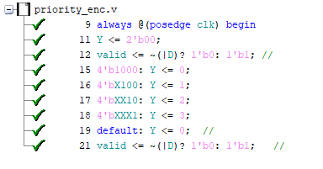

Design 3: ALU
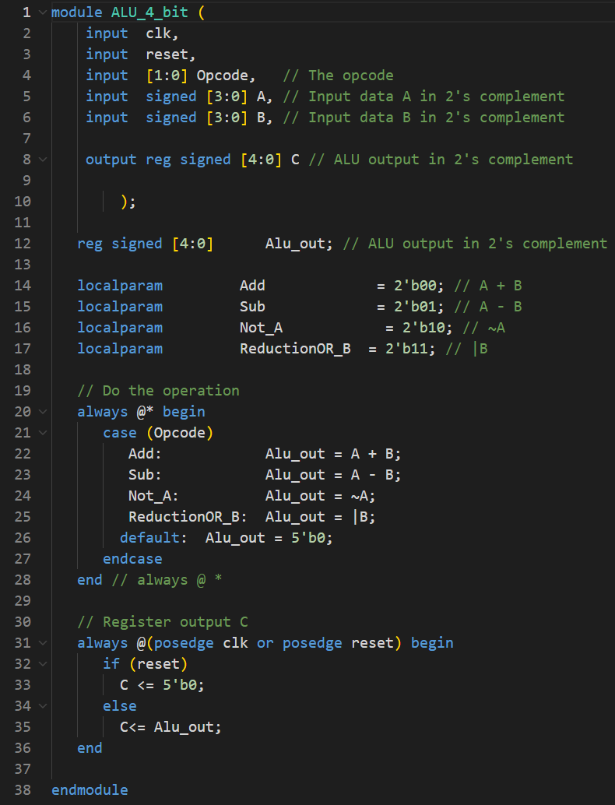
-ALU Design Code:

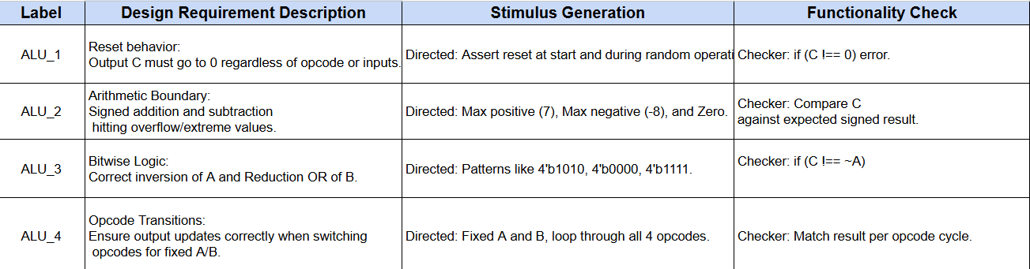
-Verification Plan:

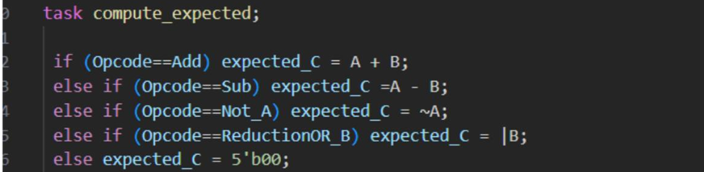
- Testbench:

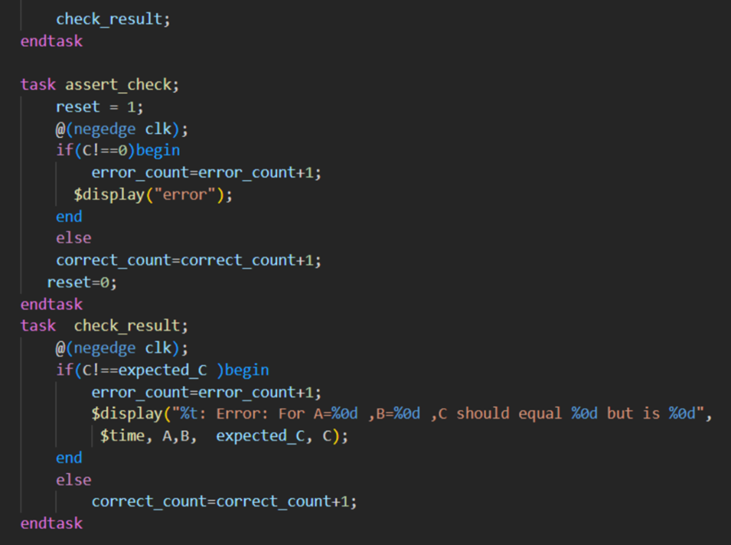

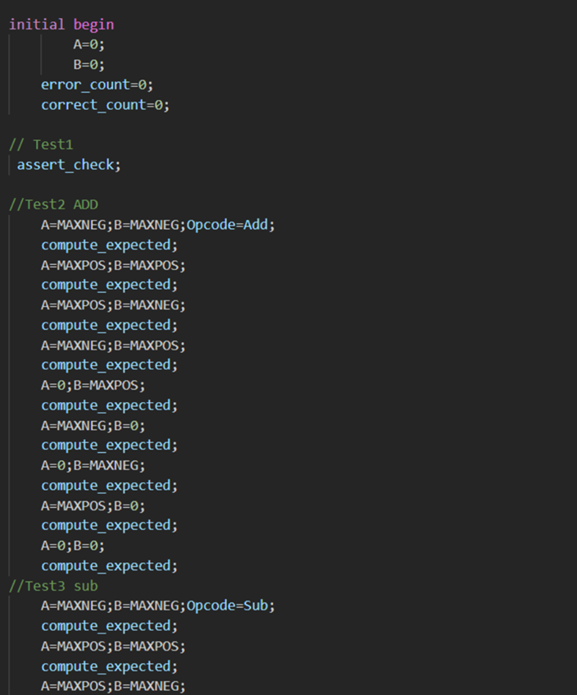

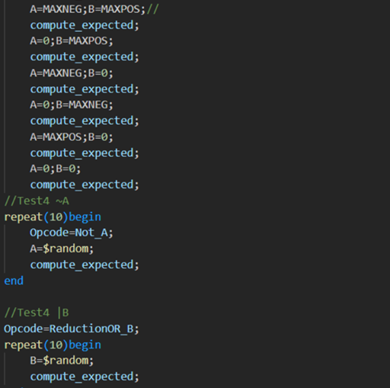
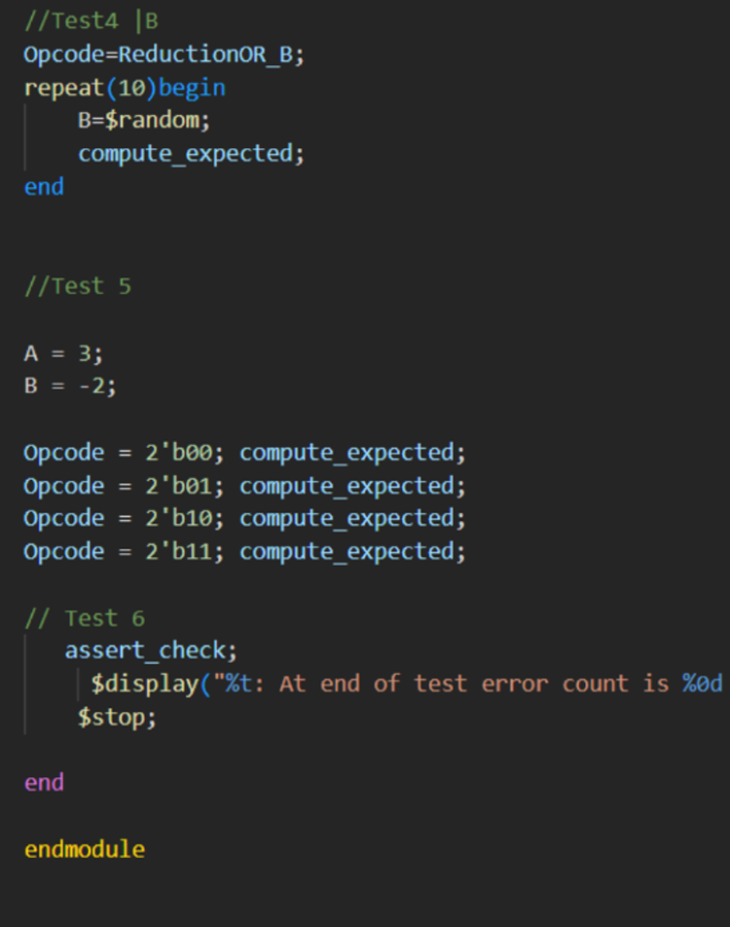

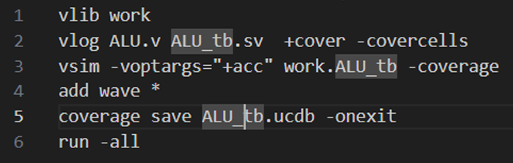
- Do file

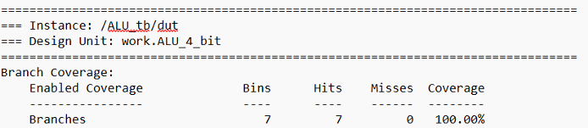
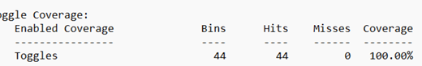
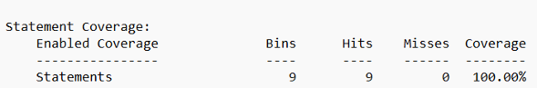
Coverage Report

-Waveforms:
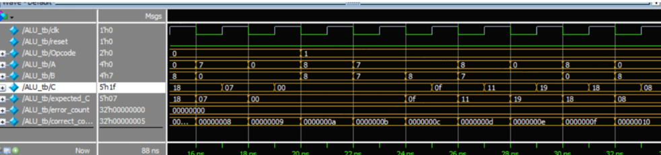

Design 4: DSP
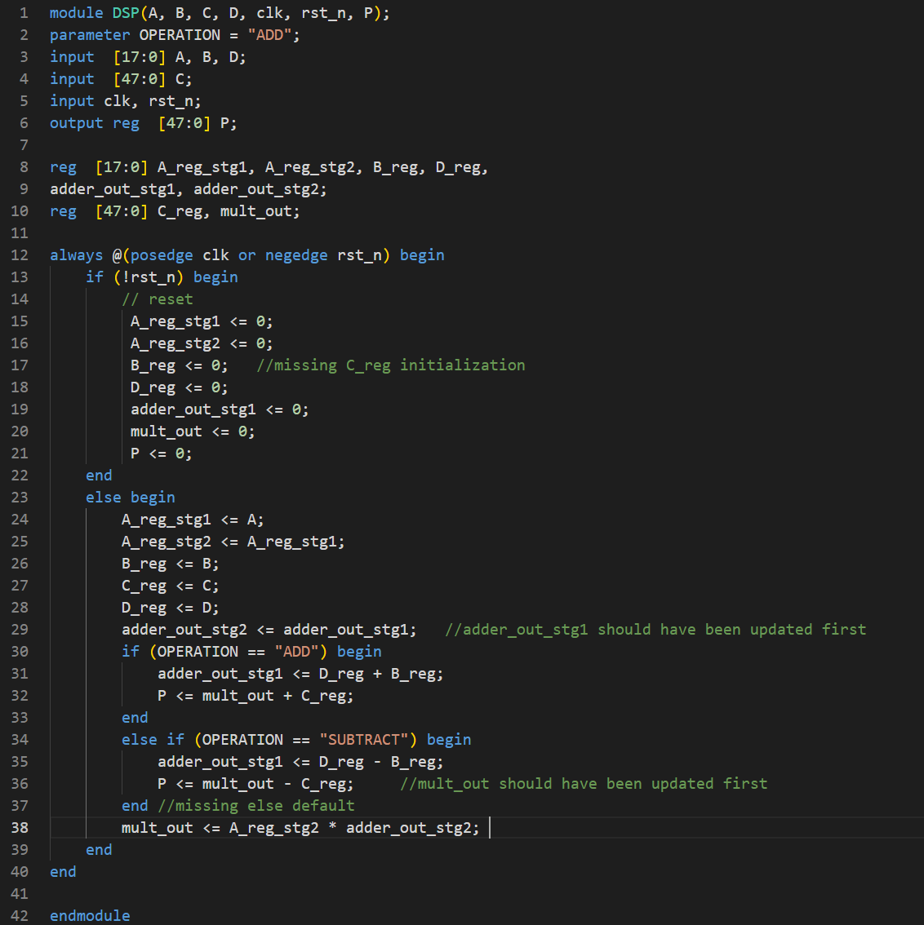
-DSP Design Code:

-Bugs & fixes:
-Y


-Verification Plan:


- Testbench:










- Do file:


Coverage Report:






-Waveforms:



-Coverage Snippets:

Toggle Coverage Branch Coverage


Statement Coverage


