SV9 - Digital Verification using SV & UVM

====== Project======
Synchronous FIFO verification using UVM

Name
Ibrahim Mohamed Mohamed Hanafy

-Verification Plan
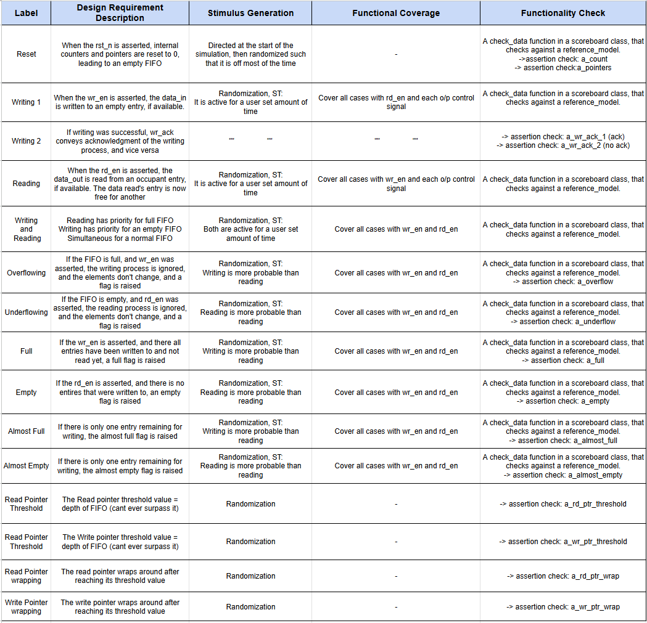

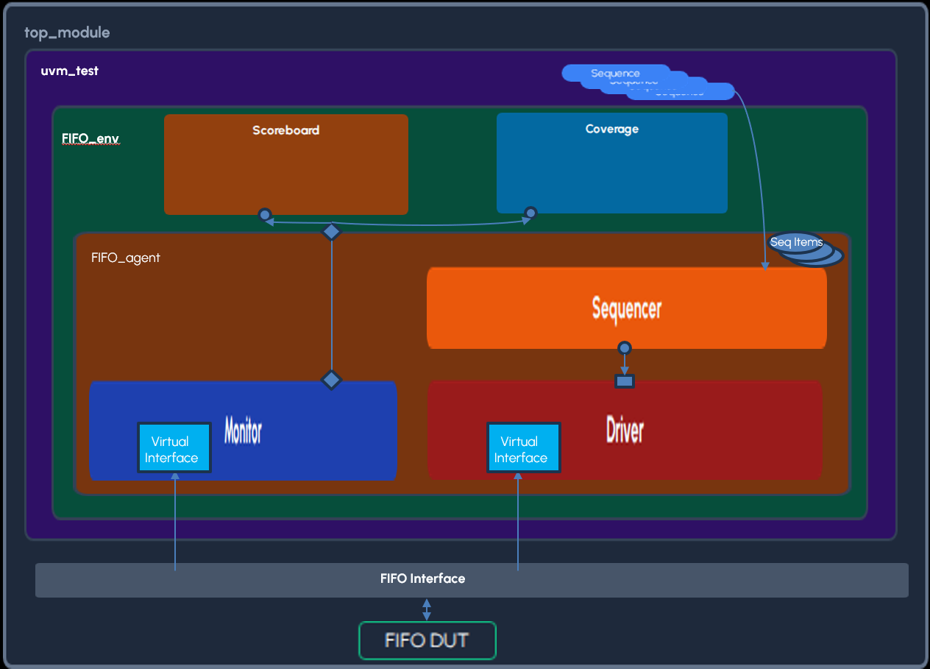
-UVM Testbench Diagram

Results
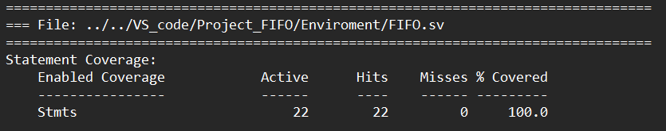
-Code Coverage

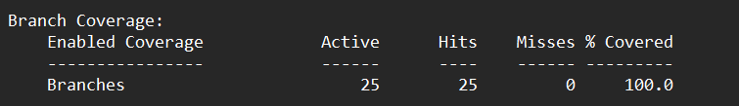

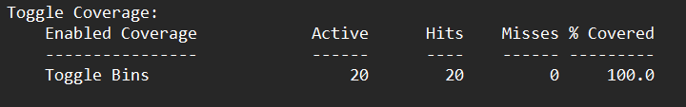

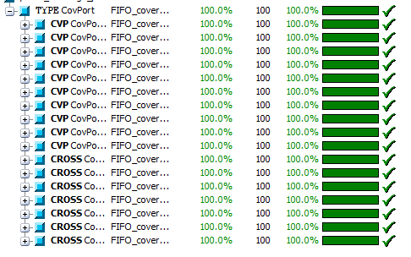
-Functional Coverage

-Assertions Coverage
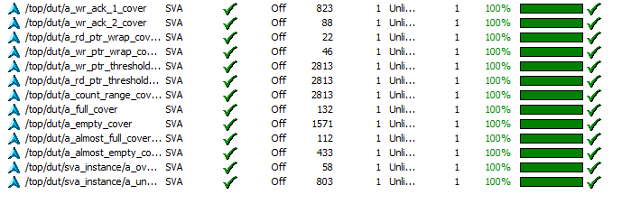

-Bug Report
Bug #1: Underflow signal not implanted sequentially

Bug #2: almost full implemented incorrectly

Bug #3: incorrect resetting behavior:
wr_ack, underflow, overflow, data_out

Bug #4: No handling of simultaneous read and writing
Bug #5:Incorrect conditions for overflow and underflow

-Sequences and Waveforms
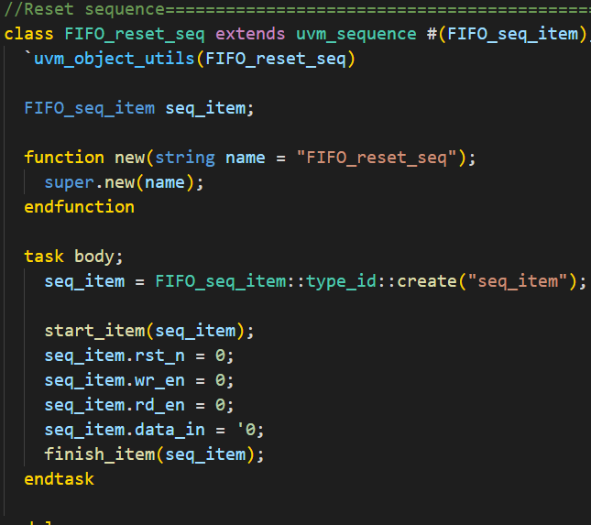
*Reset sequence

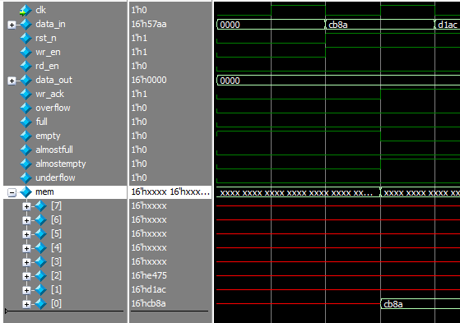

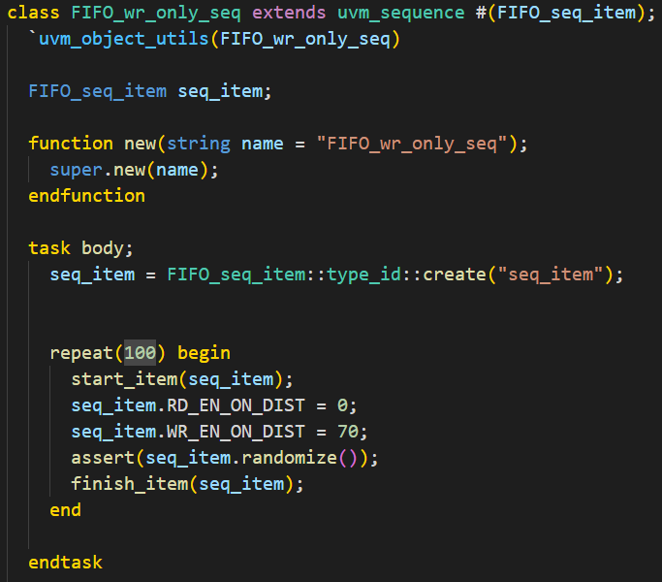
*Write only sequence

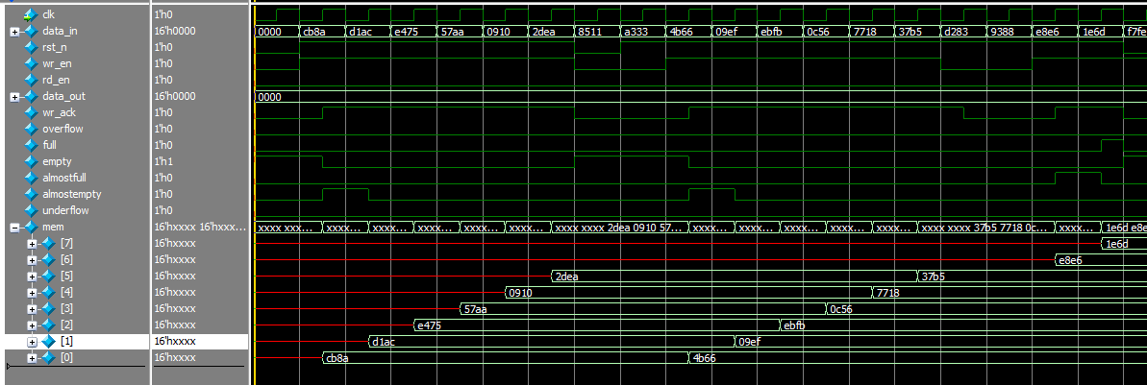
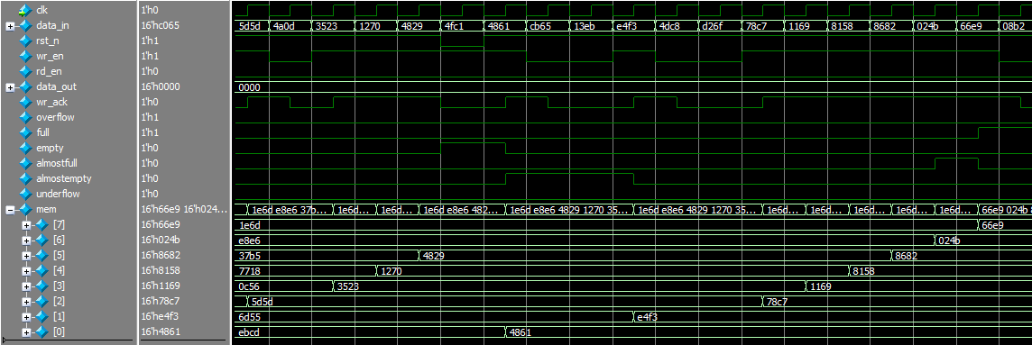

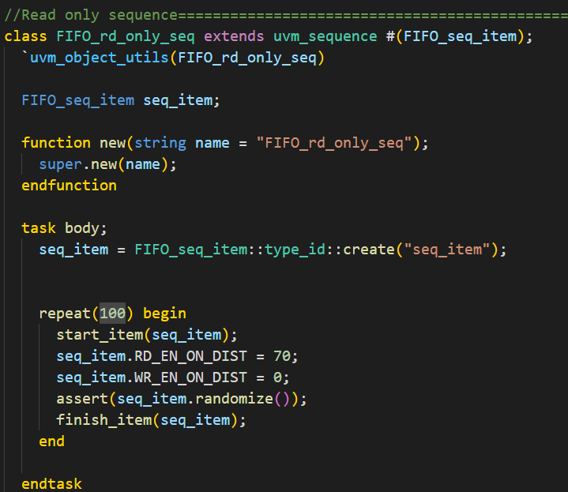
*Write only sequence

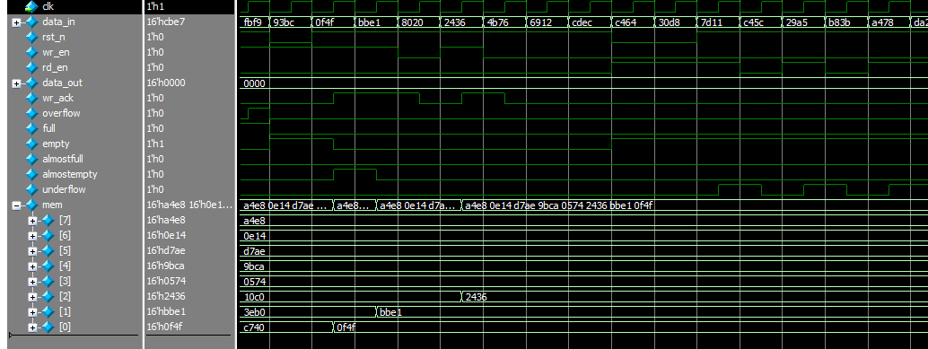

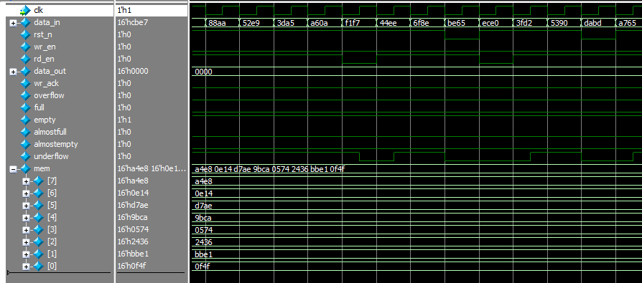

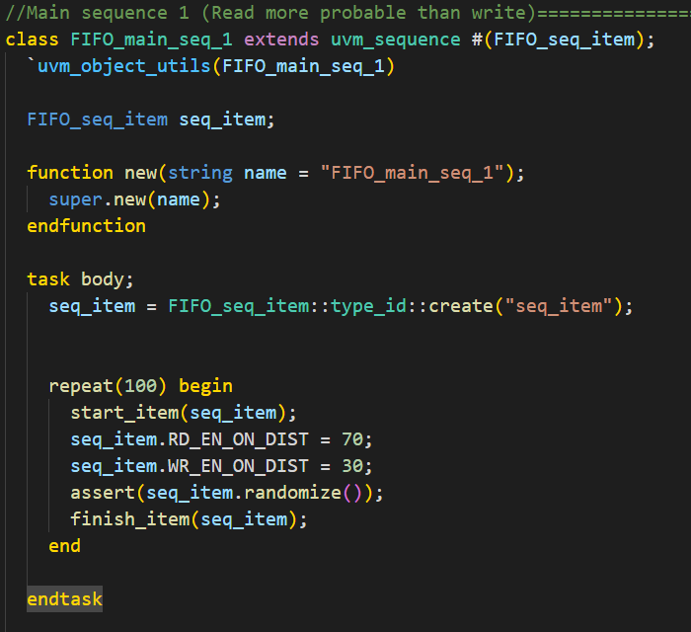
*Reading more than writing seq

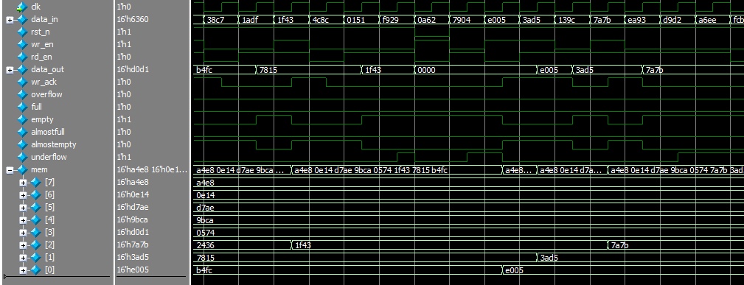

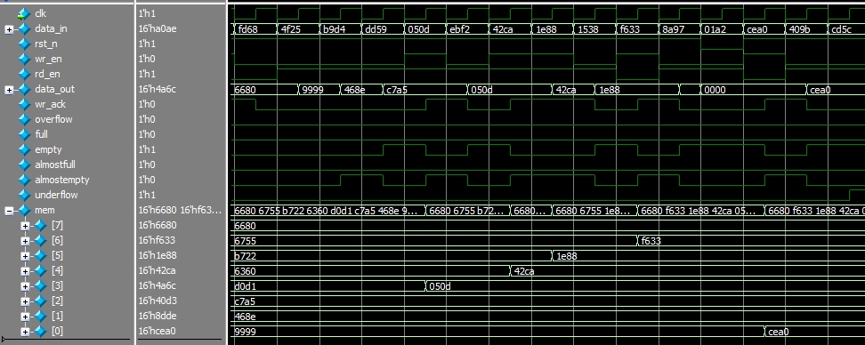

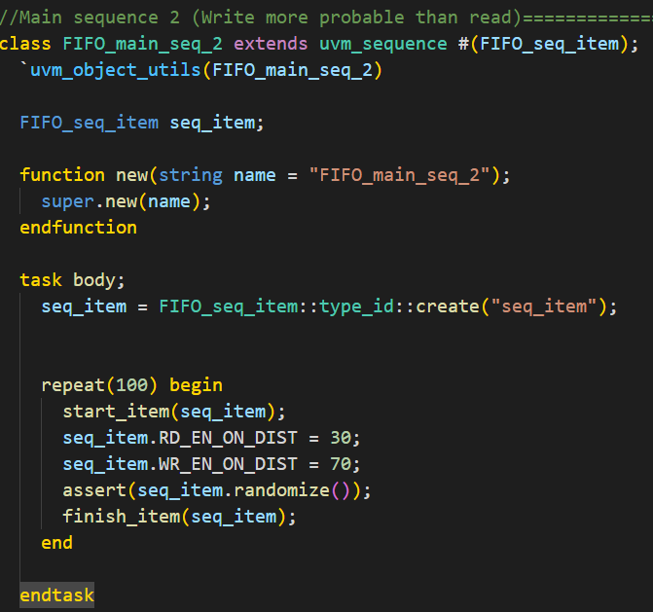
*Writing more than reading seq

