SV9 - Digital Verification using SV & UVM

======Assignment (5)======
Applying UVM

Name
Ibrahim Mohamed Mohamed Hanafy

Part #1: Setting up till Environment
-run phase of test results:
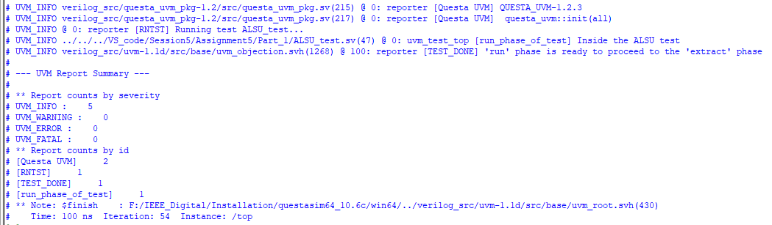

Part #2: Setting up till Driver

