SV9 - Digital Verification using SV & UVM

======Assignment (2)======
Data Types & Constrained Random Assignment

Name
Ibrahim Mohamed Mohamed Hanafy

Question1: Dynamic Arrays
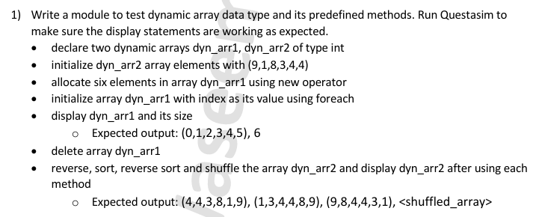
-Requirements:

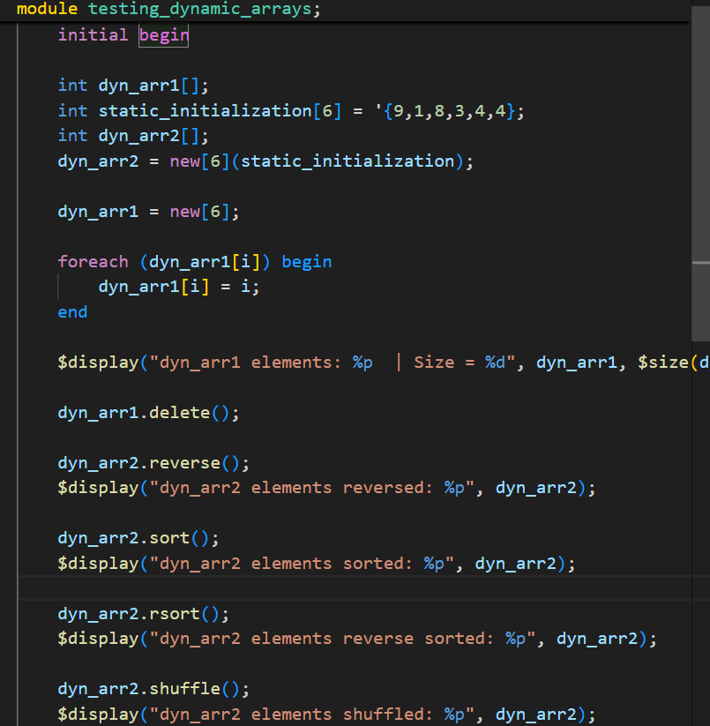
-Module:

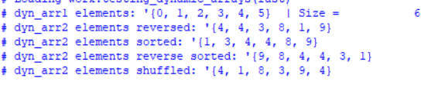
-Results:

Question 2: Counter
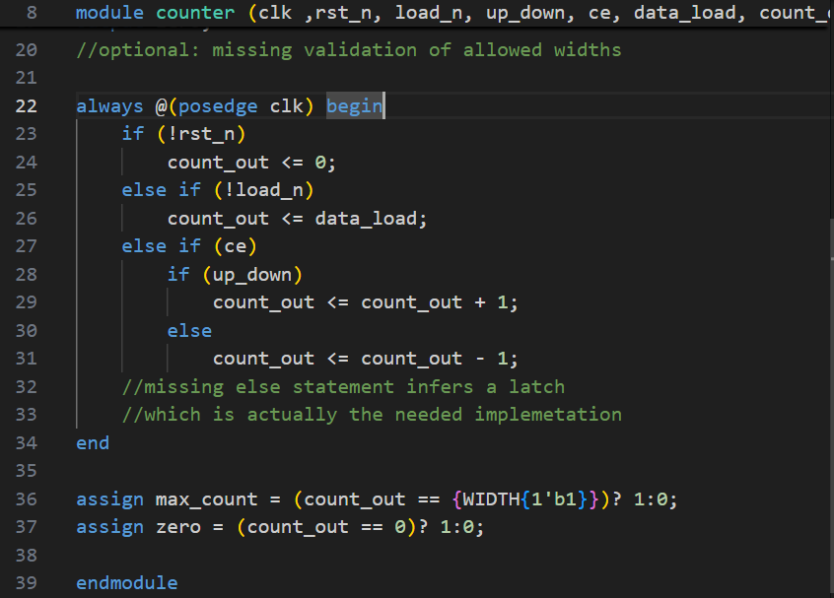
-Counter Design Code:

-Bugs & fixes:
-Added Validation check for width allowed values “4,6,8”
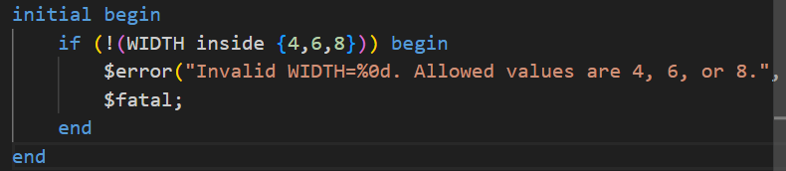

-Verification Plan:
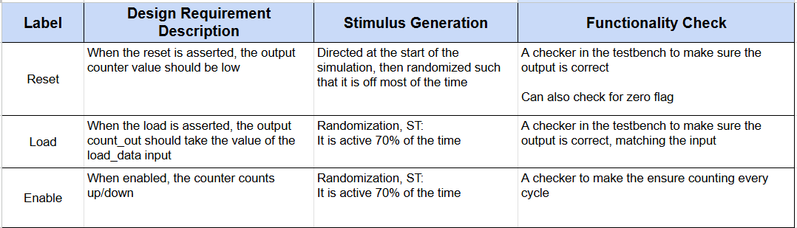

- Package:

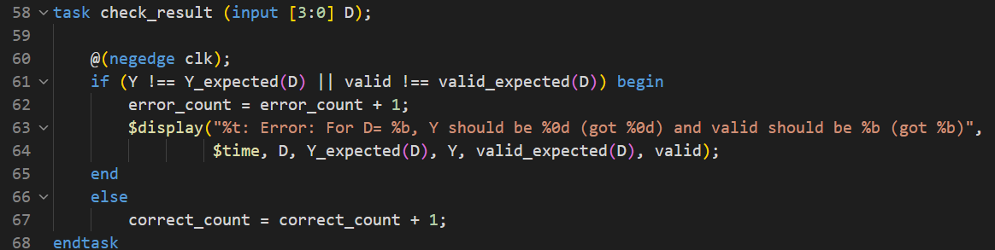

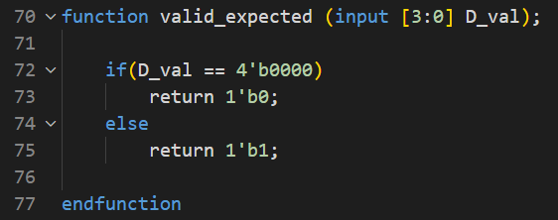

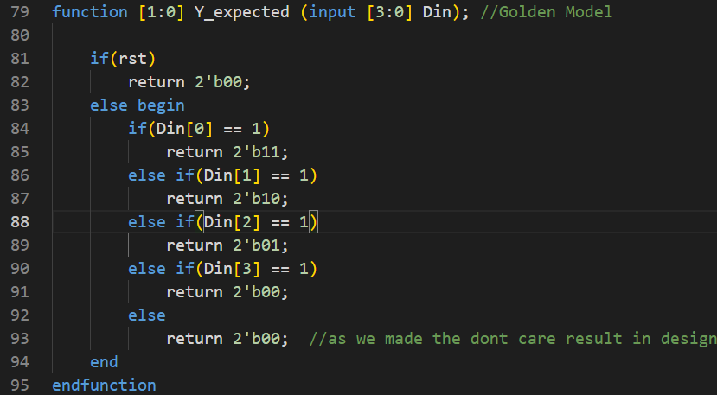

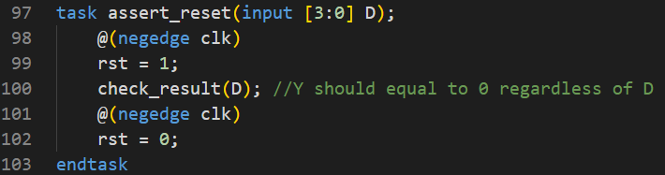

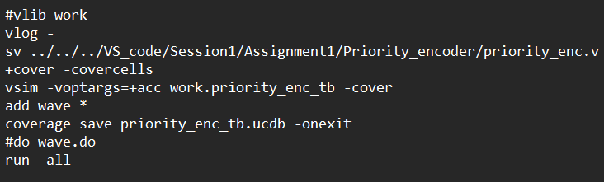
- Do file:

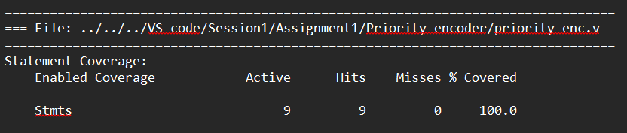
Coverage Report:

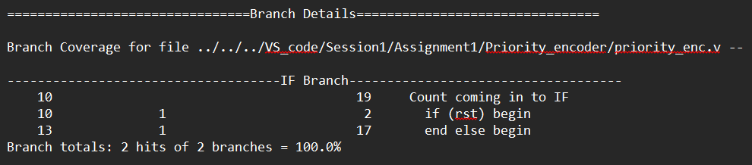

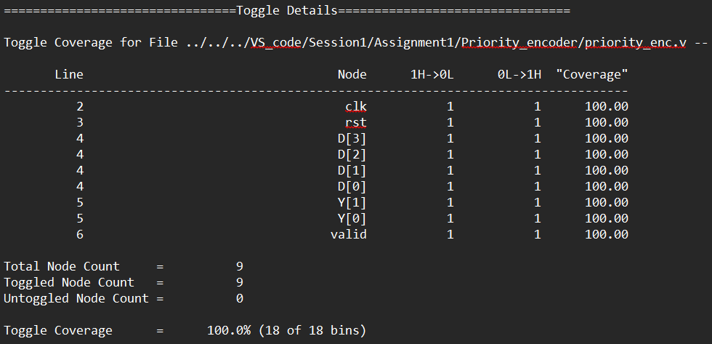

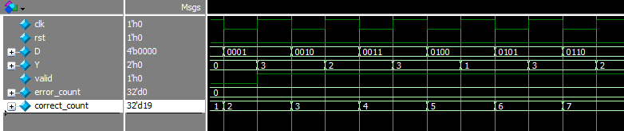
-Waveforms:

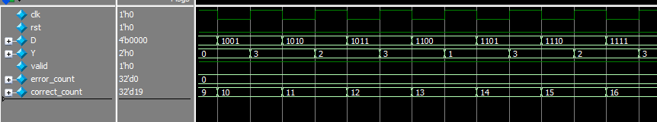

-Coverage Snippets:
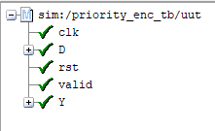
Toggle Coverage Branch Coverage
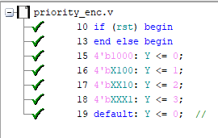

Statement Coverage
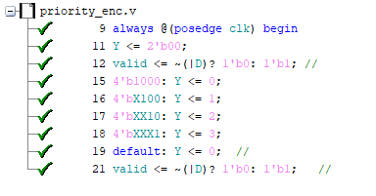

Design 3: ALU
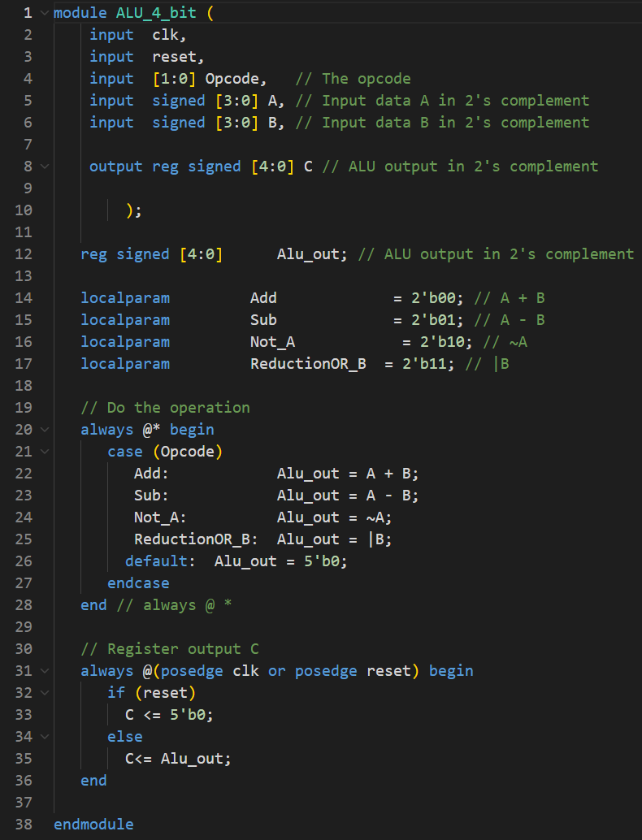
-ALU Design Code:

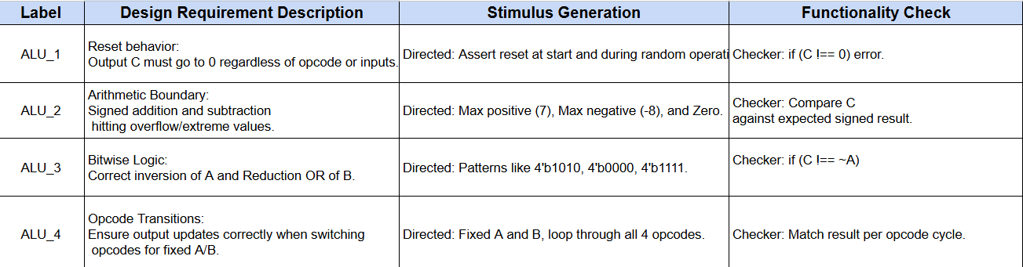
-Verification Plan:

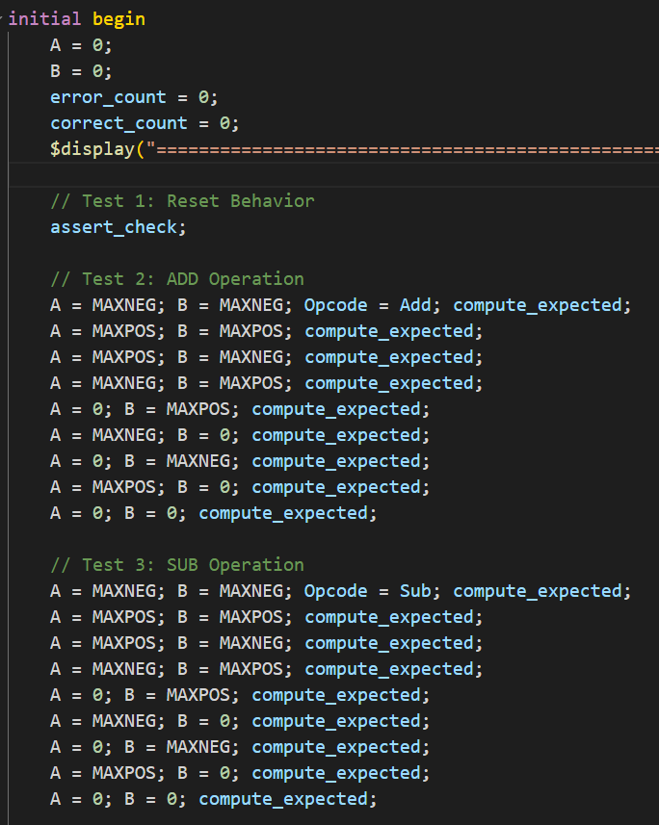
- Testbench:

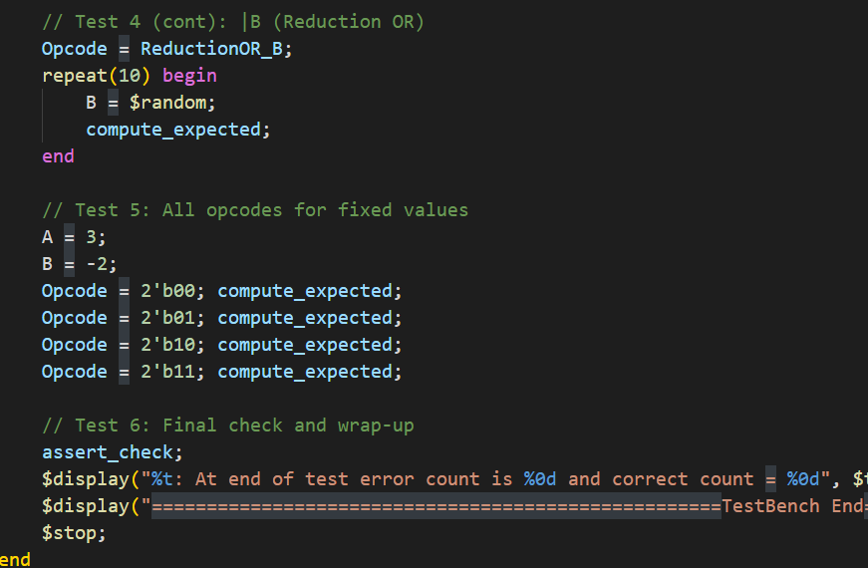

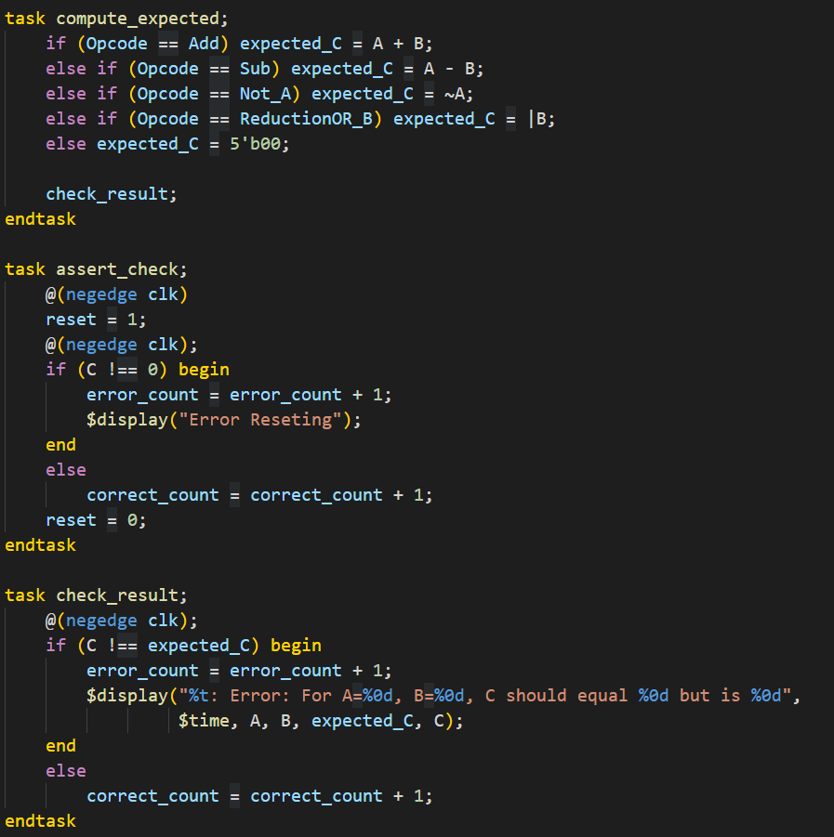

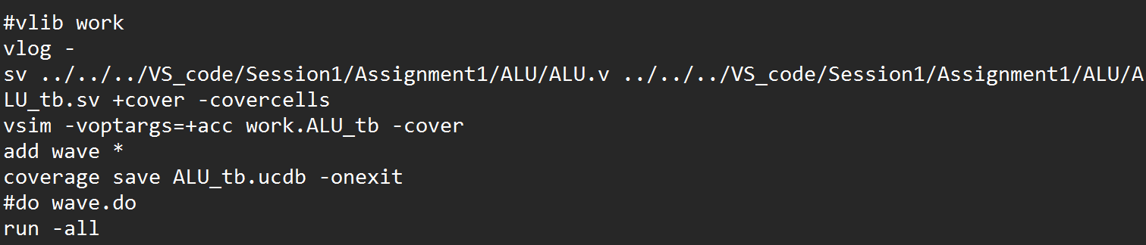
- Do file

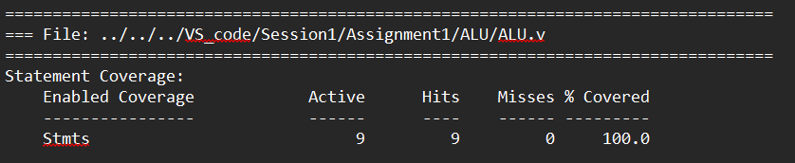
Coverage Report

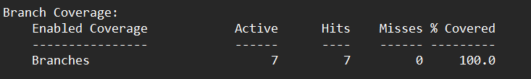

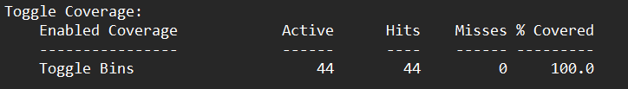

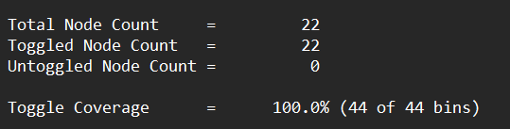

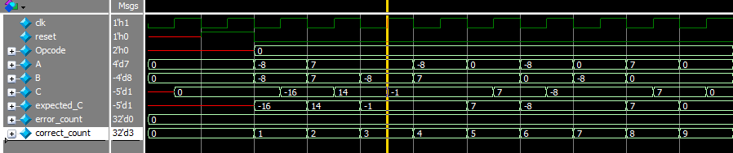
-Waveforms:

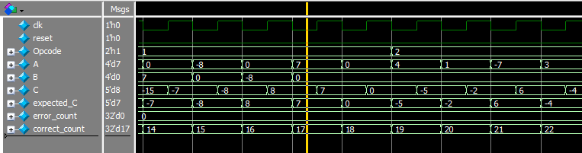

-Coverage Snippets:
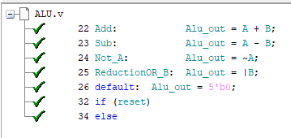
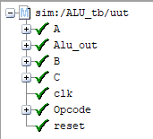
Toggle Coverage Branch Coverage

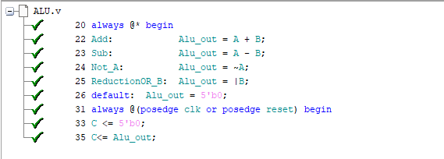
Statement Coverage

Design 4: DSP
-DSP Design Code:
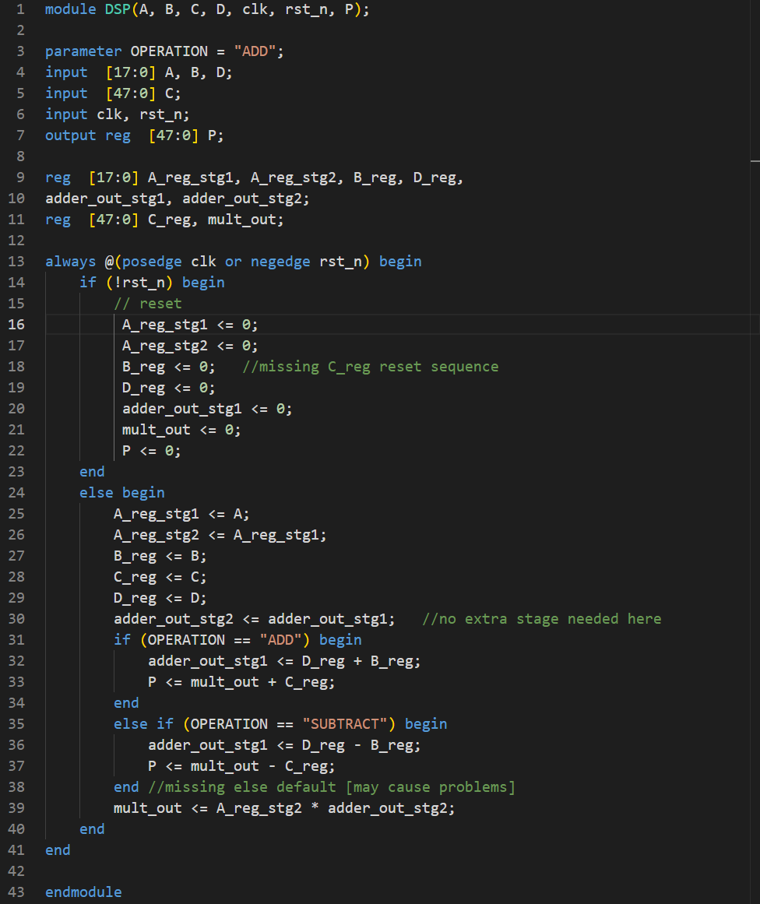

-Bugs & fixes:
-C_reg wasn’t included in the reset sequence
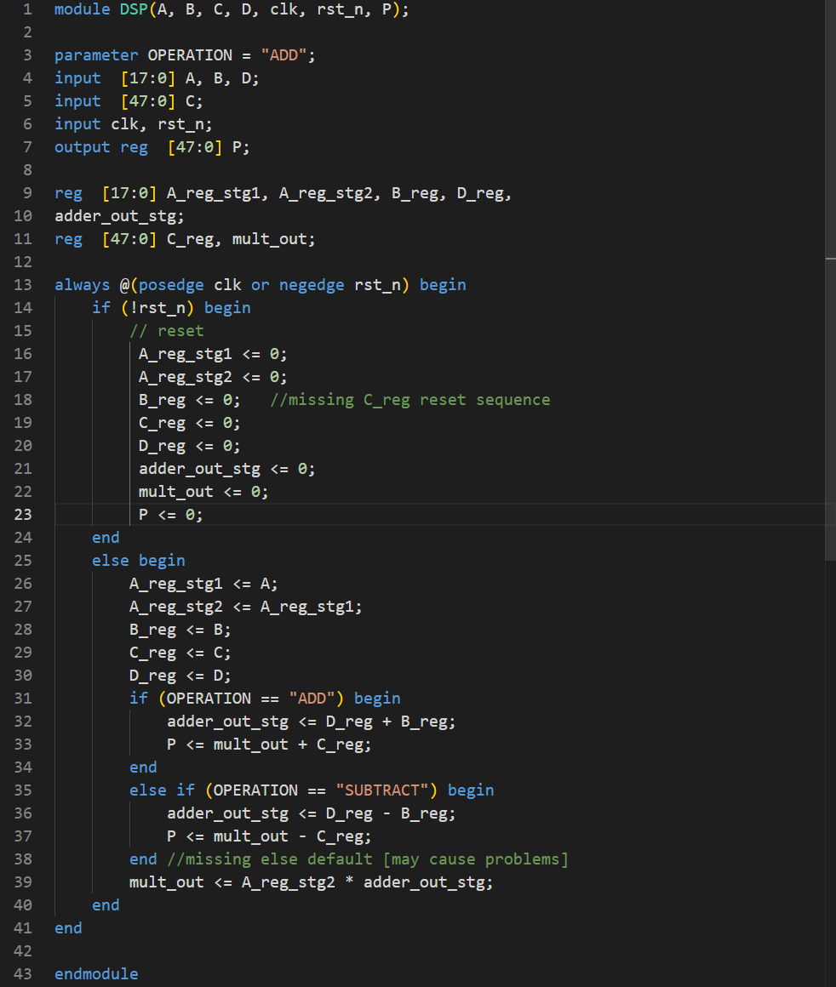
-An extra adder stage that was not needed and not included in the diagram

-Verification Plan:
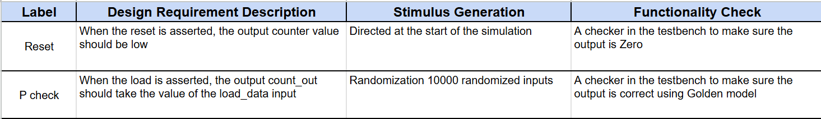

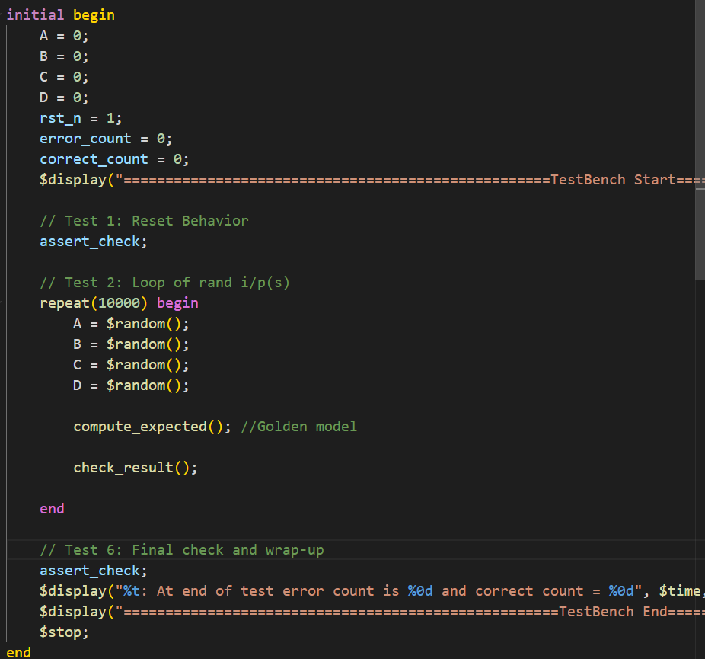
- Testbench:

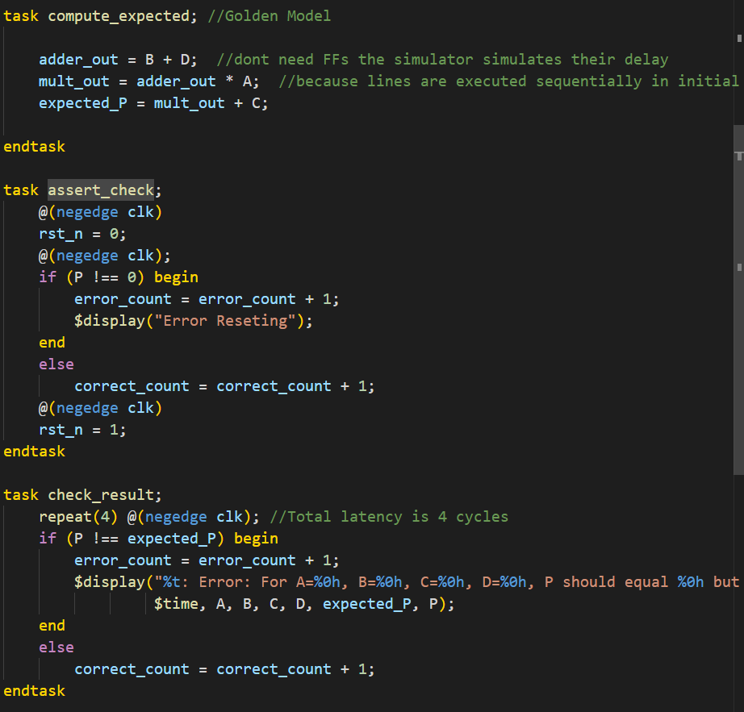

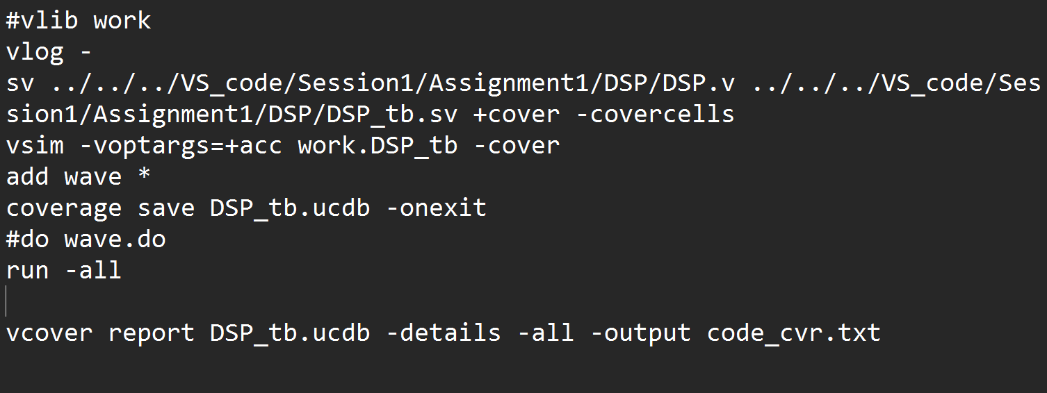
- Do file:

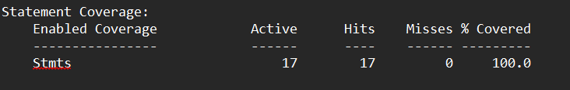
Coverage Report:

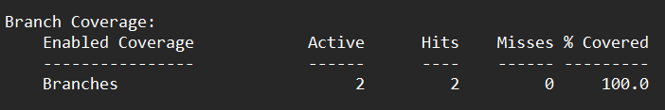

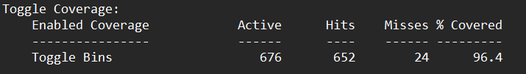

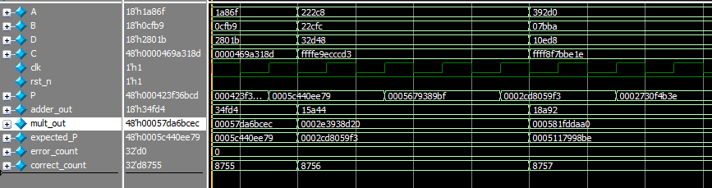
-Waveforms:

-Coverage Snippets:
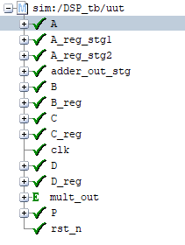
Toggle Coverage Branch Coverage
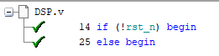

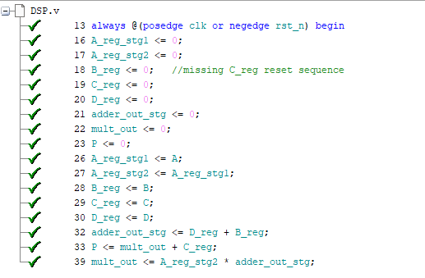

Statement Coverage

