

**Online Auction system**

**2202CSEPID26**

**by**

**1.Darshil kumar(2202900100071)**

**2.Devansh Singh (2202900100075)**

**3.Ishmeet singh sodhi(2202900100096)**

**Under the Supervision of**

**Prof.Monika Gaur**

**Asstt. Professor**



**DEPARTMENT OF COMPUTER SCIENCE AND ENGINEERING**

**ABES INSTITUTE OF TECHNOLOGY GHAZIABAD**

**Affiliated to**

**DR. APJ ABDUL KALAM TECHNICAL UNIVERSITY**

**(Formerly Uttar Pradesh Technical University, Lucknow)**

**06 November, 2023**

|  |  |  |
| --- | --- | --- |
| **Contents** | | |
| **Chapter no.** | **Contents** | **Page no** |
| 1 | Abstract | **3** |
| 2 | Motivation | **4** |
| 3. | Literature Survey | **5** |
| 4 | Literature Review | **6** |
| 5 | Problem formulation/Objectives | **7** |
| 6 | Methodology/ Planning of work | **8** |
| 7 | Facilities required for proposed work | **9** |
| 8 | Conclusion | **10** |
| 9 | Bibliography/References | **11** |

**Abstract**

The Online Auction System is a web-based application developed using Python Django and SQLite. The system is designed to provide a platform for online auctions that enables bidders and sellers to participate in the auction process with ease. The system is divided into three main modules: Admin, Bidder, and Seller.

The Admin module manages the overall functioning of the auction system. It is responsible for managing sellers, bidders, and products available for bidding. The module allows the administrator to view bidding products and manage the bidding product categories and subcategories. The module also provides features to view participants and bid winners.

The Seller module allows sellers to add new bids, view products available for bidding, and track participant and winner lists. The module enables sellers to view the status of their bids and manage their inventory effectively.

The Bidder module allows bidders to participate in auctions by placing bids on products available for bidding. The module also enables bidders to view products and the list of winners.

This Online Auction System provides an efficient platform for users to participate in auctions and place bids on a wide range of products. With its user-friendly interface and robust functionality, the application is an ideal solution for conducting online auctions. The system is expected to enhance the user experience, increase the number of bids, and provide a seamless bidding experience.

**Chapter: 2**

**Motivation**

The old manual system was suffering from a series of drawbacks. Since whole of the system was to be maintained with hands the process of keeping, maintaining and retrieving the information was very tedious and lengthy. The records were never used to be in a systematic order. there used to be lots of difficulties in associating any particular transaction with a particular context. If any information was to be found it was required to go through the different registers, documents there would never exist anything like report generation. There would always be unnecessary consumption of time while entering records and retrieving records. One more problem was that it was very difficult to find errors while entering the records. Once the records were entered it was very difficult to update these records.

The reason behind it is that there is lot of information to be maintained and have to be kept in mind while running the business .For this reason we have provided features Present system is partially automated (computerized), actually existing system is quite laborious as one has to enter same information at three different places.

**Chapter: 3**

**Literature survey**

|  |  |  |  |  |  |  |  |  |  |  |  |  |  |
| --- | --- | --- | --- | --- | --- | --- | --- | --- | --- | --- | --- | --- | --- |
| |  |  |  |  |  | | --- | --- | --- | --- | --- | | **SL No.** | **Paper Title** | **Authors** | **Year** | **Name of Publisher** | | 1 | An econometric analysis on the vehicle quota system (VQS) in Singapore. | Koh W.T.H,. et. al | 2007 | Koh W.T.H,. et. al | |  |  |  |

**Chapter: 4**

**Literature Review**

This paper is organized as follows. This literature review is taken from e-government research streams , publish research on reverse auctions and G2B reverse auctions adoption literature. The reverse auctions mechanism is introduced, global public sector reverse auctions, followed by a description of the Malaysian reverse auctions context. Theoretical and practical implications are offered and then close with recommendations for future research. The process of searching for related literature focused on articles from different scientific publishers on a timeframe from 2000s until mid 2012.

**Chapter: 5**

**Problem Formulation/ Objective**

The online auction system project aims to address the pressing challenges and opportunities in the e-commerce sector, specifically within the domain of online auctions. The primary problem revolves around the need for a robust, user-friendly, and secure platform that enables users to participate in, monitor, and manage online auctions seamlessly. Current online auction systems may lack essential features, have security vulnerabilities, or not provide a satisfactory user experience.

To tackle these issues, the project sets forth the following objectives:

* **Development of a Secure Platform**: The foremost objective is to build a secure online auction platform that ensures the integrity and confidentiality of user data and financial transactions. Implementing encryption, access control, and user authentication are key components of this objective.
* **User-Friendly Interface**: The project aims to deliver a user-friendly and intuitive interface for both bidders and sellers. This includes easy item listing, bid placement, and tracking of auction progress.
* **Real-Time Auction Updates**: Implement real-time updates and notifications for auction participants to enhance their engagement and overall experience. This objective involves the use of web sockets and asynchronous communication.
* **Comprehensive Features**: The system will encompass a wide range of features, such as multiple bidding options, auction item categorization, item search, and detailed item descriptions.
* **Efficient Database Management**: Ensuring efficient data storage, retrieval, and management through an appropriate database management system, which will contribute to the system's overall performance.
* **Scalability and Future Expansion**: The system should be designed with scalability in mind, enabling future expansion and adaptation to changing e-commerce trends.

By addressing these objectives, the online auction system project aims to provide a comprehensive, secure, and user-centric platform for online auctions, meeting the needs of both bidders and sellers while setting the stage for future growth and enhancements in the e-commerce industry.

**Chapter: 6**

**Methodology/ Planning of work**

Now let us know about the modules of our project. In our online auction system, We have three main modules.

1. Seller Module

2. Bidder Module

3. Admin Module

Seller Module

* Add Bid: The seller can add bids for their products, including the starting bid amount and bidding end time.
* View Products: The seller can view their products available for bidding, including the current highest bid amount.
* View Participants: The seller can view the participants who have placed bids on their products.
* View Winners: The seller can view the winners of their products' bidding process.
* Logout: The seller can log out of the system to end the current session.

Bidder Module

* Bid: The bidder can bid on products by entering their desired amount. The system will notify the bidder if their bid is outbid.
* View Products: The bidder can view the available products for bidding, including the current highest bid amount and bidding end time.
* View Winners: The bidder can view the winners of the products they have bid on.

Admin Module

* Manage Seller: The admin can manage and view the seller accounts, including deleting their accounts if necessary.
* Manage Bidder: The admin can manage and view the bidder accounts, including deleting their accounts if necessary.
* View Bidding Products: The admin can view all the products that are currently available for bidding.
* Manage Bidding Product Category and Subcategory: The admin can manage the categories and subcategories of the products available for bidding, including adding, viewing, updating, and deleting them.
* View Participants: The admin can view the details of all the participants involved in the bidding process.
* View Bid Winners: The admin can view the details of the winners of each product that was up for bidding.

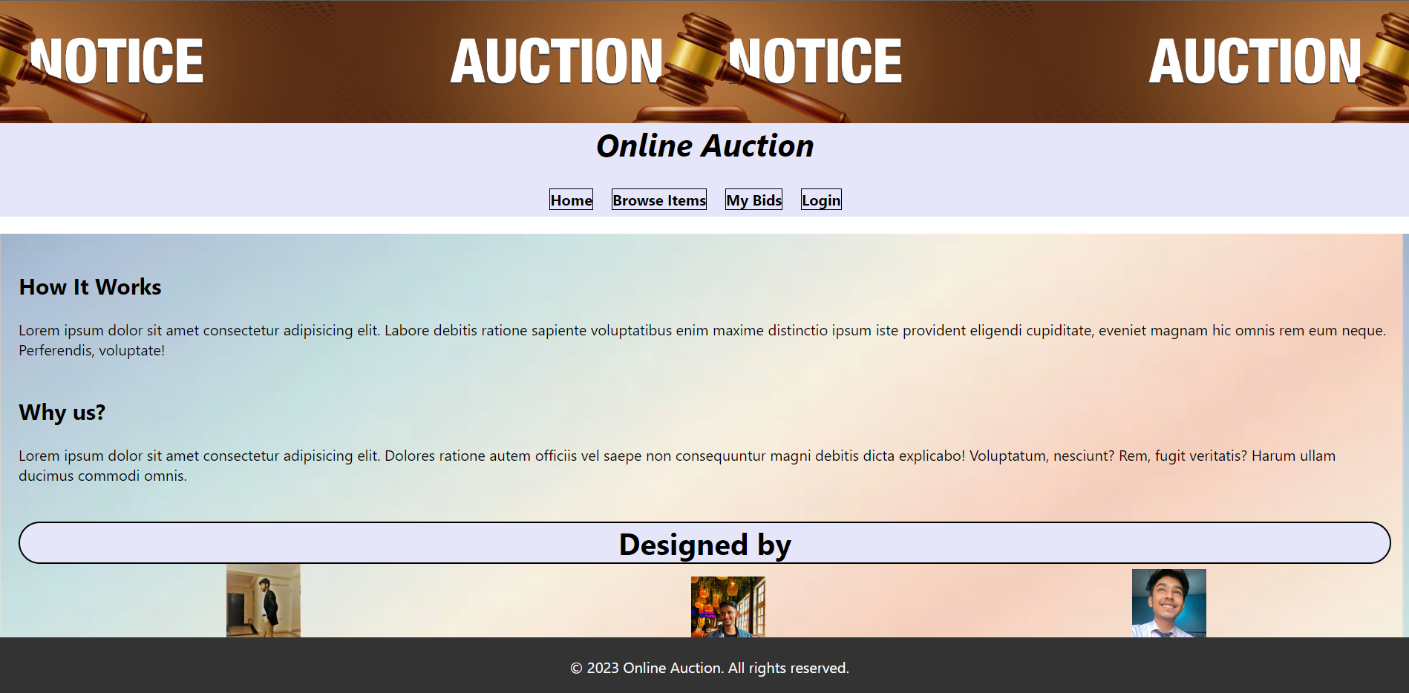



**Chapter: 7**

**Facilities required for online auction system**

1. Technology Stack for the Online Auction System Project: The online auction system leverages a robust technology stack to provide a secure and efficient platform for users. Here are the key technologies and software tools used in the project:

Backend Development:

* Backend Logic Language: Python is the chosen backend logic language, known for its versatility and ease of use.
* Framework: Django, a powerful and high-level web framework, is employed to facilitate rapid development, maintainability, and security.
* Backend Database: SQLite serves as the backend database, ensuring data integrity and efficiency.

Frontend Development:

* Languages: The frontend is constructed using a combination of HTML, CSS, JavaScript, and Bootstrap, providing a responsive and visually appealing user interface.

1. Software Tools:

Python Interpreter: Essential for executing Python scripts and Django applications.

Django Framework: The core framework that streamlines development tasks, including user authentication and database management.

Integrated Development Environment (IDE): Developers can choose between PyCharm and VSCode editors for coding and debugging.

Web Browsers: Users can access the online auction system from various browsers such as Chrome, Firefox, and others, ensuring broad compatibility.

This technology stack forms the foundation of the online auction system, offering a seamless user experience while maintaining data security and efficient backend processes.

**Chapter: 8**

**Conclusion**

An online auction system is a dynamic platform that

enables individuals to buy and sell products through virtual actions.

It offers a range of facilities such as user registration, comprehensive

product listings, a robust bidding system, secure payment

gateways, real time monitoring of auctions, auction management

features, user feedback and ratings, and reliable customer support.

These facilities contribute to seamless and trustworthy auction

experience, empowering users to engage in transactions with ease

and convenience.

Whether you are a seller looking to reach a wider audience or a buyer

searching for unique items, an online auction system provides the

necessary tools and facilities for a successful and enjoyable auction Process.

**Chapter: 9**

**References**

* Google for Problem Solving
* https://www.geeksforgeeks.org/python-django/
* https://www.javatpoint.com/django-tutorial
* https://www.python.org/
* https://www.freeprojectz.com/project-report/8771
* https://www.tutorialspoint.com/django/index.html
* Sandeep Kumar, “Pricing Algorithms in Online Auctions by” International Journal of Advanced Research in Computer Science and Software Engineering, Volume 3, Issue 6, June 2013 ISSN: 2277 128X, June - 2013, pp.148-153.
* https://www.academia.edu/9973247/Literature_review_on_online_auctions_research