                                                                                                                                      Assignment No.: _

 **Assignment Cover Sheet**

|  |  |  |
| --- | --- | --- |
| **Student Information (If for group assignment, please state names of all members)** | | **Grade/Marks** |
| **Name** | **ID** |  |
| Hridaya Manandhar |  |  |
| Abhinav Singh |  |  |
| Bishal Jung Basnet |  |  |
| **Module/Subject Information** | | **Office Acknowledgement** |
| **Module/Subject Code** | BIT102 |  |
| **Module/Subject Name** | Web Design And Development |  |
| **Lecturer/Tutor/Facilitator** | Mr. Niraj Shukla |  |
| **Due Date** | 10th January |  |
| **Assignment Title/Topic** | UniPortal |  |
| **Intake (where applicable)** |  |  |
| **Word Count** |  | **Date/Time** |

**Declaration**

. I/We have read and understood the Programme Handbook that explains on **plagiarism**, and I/we testify that, unless otherwise acknowledged, the work submitted herein is entirely my/our own.

. I/We declare that no part of this assignment has been written for me/us by any other person(s) except where such collaboration has been authorized by the lecturer concerned.

. I/We authorize the University to test any work submitted by me/us, using text comparison software, for instances of plagiarism. I/We understand this will involve the University or its contractors copying my/our work and storing it on a database to be used in future to test work submitted by others.

Note:1) The attachment of this statement on any electronically submitted assignments will be deemed to have the same authority as a signed statement.

 2) The Group Leader signs the declaration on behalf of all members, if for group assignment.

|  |  |
| --- | --- |
| Signature: | Date: |
| Mail. |  |
| **Feedback/Comments\*** | |
| **Main Strengths** | |
|  | |
|  | |
|  | |
|  | |
|  | |
|  | |
| **Main Weaknesses** | |
|  | |
|  | |
|  | |
|  | |
|  | |
|  | |
|  | |
| **Suggestions for improvement** | |
|  | |
|  | |
|  | |
|  | |
|  | |
|  | |
|  | **Student acknowledge feedback/comments** |
|  |
| Grader’s signature | Student’s signature: |
| Date: | Date: |

Note:

1) A soft and hard copy of the assignment shall be submitted.

2) The signed copy of the assignment cover sheet shall be retained by the marker.

3) If the Turnitin report is required, students have to submit it with the assignment. The assignment shall only be marked upon the submission of the Turnitin report.

*Use additional sheets if required.

# Acknowledgment

We would like to express our sincere gratitude to everyone who contributed to the completion of this website report. Special thanks to our team members for their hard work and dedication, and to our lecturer **Mr. Niraj Shukla** for his valuable insights and his full support throughout the completion of our project.

We would also like to acknowledge the guidance and encouragement provided by our advisors, whose guidance was invaluable in shaping the direction of this report. Furthermore, the constructive feedback from our peers has been significantly helpful in refining our approach and improving the final outcome.

# Abstract

This report presents the development and evaluation of our website **UNIportal**, coded to assist many students aiming to further continue their studies abroad, assisting them to lift geographical barriers. Our approach for the construction of this website includes assisting students through all the language proficiency tests, documentation and processing.

Our key purpose and motive behind the creation of our website is to provide a reliable cost-effective platform for students to further continue their studies without the fear of scams and fraud. There have been a lot of cases found where consultancy have committed many scams and frauds ruining many student's life and career and mental stress.

This report concludes with detailed information about our website and leaves room for further improvement and research as we intend to launch this website practically aiming to enhance the overall reliability for students for very less amount making abroad study affordable to all classes of students regardless of their background offering them a equal platform of opportunities and to further enhance the experience of the website.

Contents

Acknowledgment 3

Abstract 4

List of Tables 7

List of Figures 8

Chapter-I 9

Project Overview 9

Chapter-II 11

Industry Analysis 11

Characteristics of Industry 11

Target Audience 12

Table-1 13

Competitors Analysis 13

Strength & Weaknesses 14

Website 1 14

Website 2 16

Website 3 17

Chapter-III 18

Goals & Objective 18

Reliability 18

Affordability 18

Chapter-IV 19

Site map & Navigation 19

Site map 19

Navigation 19

Chapter-V 20

Content strategy 20

Chapter-VI 21

Design & Layout 21

Chapter-VII 24

Functional Requirements 24

Chapter-VIII 25

Justification and Evaluation 25

Justification of the Color Scheme 25

Justification of the Page Layout 25

Justification of the Font 26

Logo and Banner 26

Challenges and Risks associated with the Website Plan 27

Reference 28

Website Link 29

Annex-1 30

Rubik for Assessment 30

# List of Tables

Table 1 1: table of competitor website analysis 12

Table 1.1 1: table of strengths and weakness of website 1 14

Table 1.2 1: table of strength and weakness of website 2 15

Table 1.3 1: table of strength and weakness of website 3 16

Table 2 1- Design and Layout 22

Table 3 1- Functional requirements 23

# List of Figures

Fig 1 1- Home page of aecc 13

Fig 2 1 - Homepage of Aus Studies 15

Fig 3 1 – Homepage of Grace 16

Fig 4 1 - Site map 18

Fig 5 1 22

Fig 6 1- Logo 25

# Chapter-I

# Project Overview

UNIportal is an innovative online platform designed to revolutionize the education industry in Nepal by creating a reliable, transparent, and user-friendly interface for students and universities to connect directly, bypassing the need for third-party consultancy. With the increasing number of scams and fraud activities happening in the education sector in Nepal, our platform aims to eliminate these risks and provide a secure, trusted environment for students seeking educational opportunities.

The platform allows students to explore various universities and their programs and degrees, assisting them in making transparent decisions about their education. By providing detailed university profiles, course information, and direct application functionalities, UNIportal empowers students to make educated choices without relying on potentially unreliable consultants. The universities suggested by UNIportal are all thoroughly inquired and checked whether they are actually registered as a university in their respective native countries as history tells us these types of scams are often pulled off by consultancies for the sake of their high commission.

Upon visiting the homepage, users can easily search for countries, price ranges, and universities that match their academic interests and location preferences. Each university profile provides essential information such as courses offered, tuition fees, campus facilities, rankings, and faculty details. Students can read detailed descriptions, view images to gain a better understanding of their chosen institution.

To ensure a smooth and secure experience, we have implemented multiple layers of verification to validate university credentials, preventing scams and fraudulent listings. The platform also includes a comprehensive feedback system to address any concerns and foster a safe community of students and institutions.

In addition to its educational functions, UNIportal includes sections for student resources, such as scholarship opportunities, career advice, and visa information, to support users throughout their educational journey. The platform also offers reviews from students who already used this platform and their experience.

UNIportal is not only a platform for students and universities to connect but also a community that ensures transparency, trust, and a positive educational experience. With a focus on user comfort, the platform provides both light and dark modes for easy navigation.

UNIportal is also designed to assist students in taking their language proficiency tests and guide them through the documentation process as well as to assist them in processing to take off to abroad universities. It is the ideal solution for students seeking genuine educational opportunities and universities at affordable prices looking to connect with quality education.

# Chapter-II

# Industry Analysis

## Characteristics of Industry

The education industry in Nepal has witnessed rapid growth in recent years, mainly driven by the increasing number of students seeking to study abroad. Education consultancies in Nepal provide various services, such as career counseling, guidance for study abroad programs, and assistance with university admissions, visa processing, and more. However, like many others, this industry has been associated with several challenges, including fraud, scams, and a lack of transparency, leading to issues for students and their families. The concept of migration infrastructure illustrates that the migration process involves not only the students but also a network of various actors, rules, and technologies. Educational consultants, also known as brokers, play a vital role in this process.

The findings challenge the mixed perceptions of brokers, revealing that their work often blends profit motives with social considerations. Negative experiences reported by some clients led to the creation of a business association for these educational consultants. Examining the functioning of this association sheds light on how these agents work to enhance their professionalism and counter the complex reputation they often face. They actively redefine their position within the migration infrastructure to ensure their services are essential, allowing them to stay competitive in the market.

Young, well-educated Nepalese from the middle class can travel overseas thanks to consultancies who assist individuals in preparing official documents such as acceptance letters for courses from foreign universities or colleges help with bank statement Journal of Population and Development preparation, offer advice on how to prepare for interviews and visas, help with English language preparation, and prepare reports for police and charter accountants. The processing charge that an applicant must pay is approximately Rs.5, 000-15,000/-. Even if the applicant is denied a visa, this money will not be refunded. The applicant must pay an additional processing cost of approximately Rs.30, 000-50,000/-if they are granted a visa. The entire cost often varies between Rs. 4, 00,000 and Rs. 10, 00,000, depending on the fees that must be paid to the college/university. These consultancies assist youth in going outside and funnel money into their studies and take hefty amounts of commissions.

## Target Audience

Our website, UNIportal, is specifically designed to support students from middle-class families who aim to pursue higher education, both domestically and internationally. These students often face financial constraints, making it essential for them to access reliable, transparent, and affordable resources throughout their educational journey.

UNIportal provides a user-friendly platform where students can explore various universities, understand course offerings, and compare options without relying on costly third-party consultancies. By offering access to essential information, application forms, and direct communication with universities, we encourage these students to make informed decisions that align with their academic goals and financial capacities.

Our key concern for middle-class students is Affordability, and UNIportal addresses this by eliminating the need for expensive consulting services. Our platform ensures that students can access accurate and up-to-date information about scholarships, financial aid opportunities, and other resources to help ease their financial burden.

UNIportal serves as a comprehensive and cost-effective solution for students embarking on their higher education journey. We aim to bridge the gap between quality education and financial accessibility, ensuring that every student, regardless of background, can pursue their academic aspirations with confidence.

## Table-1

## Competitors Analysis

|  |  |  |  |
| --- | --- | --- | --- |
| **Competitors website** | **aecc** | **AusStudies** | **graceintlgroup** |
| **Color and Graphics**   * Consistency * Websites overview | * The color theme is consistent using white and purple. * Clean and modern design. | * The color theme is consistent using white, light green, and blue. * Bold design with informative content. | * Blue, green, and white color theme is consistent across all pages. * Informative content and an animated logo. |
| **Content Presentation**   * Fonts- Size, Color * Organized Content * Minimal clicks to find information | * Fonts are easy-to-read. * Clear section for different services. * 2 clicks | * Good contrast between the text and background. * Well-organized content. * 3 clicks | * Good readability and contrasting colors. * Organized layout but is a bit cluttered. * 4-5 clicks |
| **Functionality** | Fully responsive on mobile, tablet, and desktop. | Interactive elements (buttons, sliders) work smoothly. | Excellent interactive elements, such as pop-up chat and form submission. |
| **Browser Compatibility** | Works well on Chrome, Firefox, etc. | Works well on Chrome, Firefox, etc.  Compatible with all major browsers, including Chrome, Firefox, etc. | Works well on most browsers, slight issues with older versions of Internet Explore. |
| **Navigation** | Easy to navigate with clear menus and labels. | Extremely easy to use with a well-structured, drop-down menu for quick access. | Navigation is clear but sometimes confusing for new users. |

**Table 1 1: table of competitor website analysis**

## Strength & Weaknesses

### Website 1

**Link** - <https://www.aeccglobal.com.np/>

**Homepage** –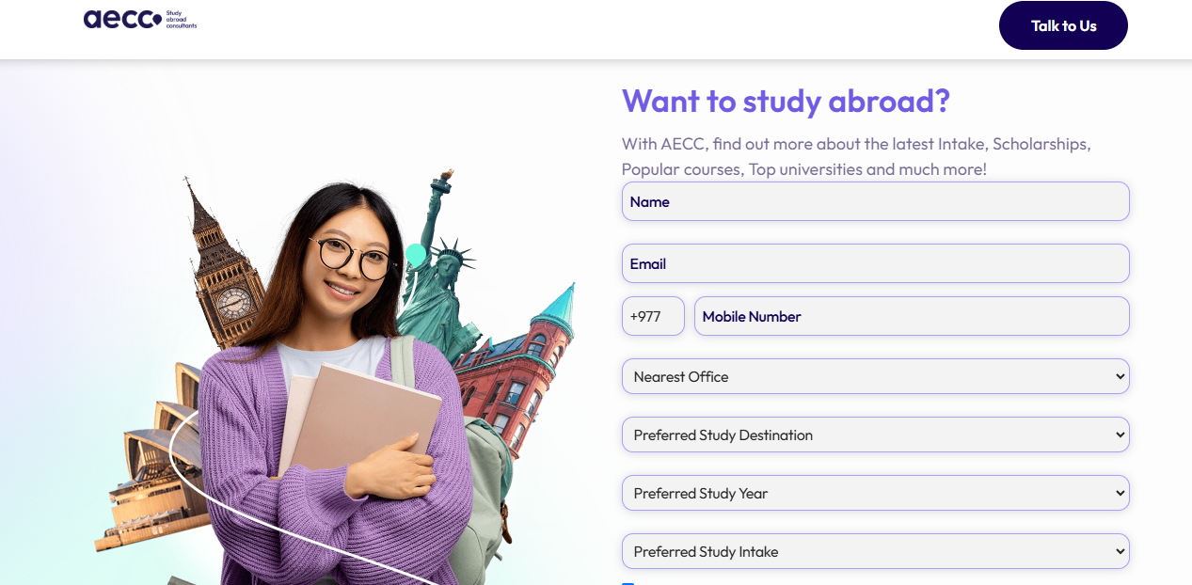

Fig 1 - Home page of aecc

**Purpose** – To assist students to fulfill their dreams of studying abroad. Our expert counselors provide personalized guidance, helping you choose the right course and university, navigate the application process, and secure a student visa.

**Table-1.1**

**Strength and weakness** –

|  |  |
| --- | --- |
| **Strength** | **Weakness** |
| Clean and modern design. | Very Expensive |
| Few clicks to obtain important information. | Limited universities. |
| Fully responsive on mobile, tablet, and desktop. | Limited Interactive Elements |

**Table 1.1 1: table of strengths and weakness of website 1**

### Website 2

**Link** - <https://ausstudies.com/>

**Homepage** –

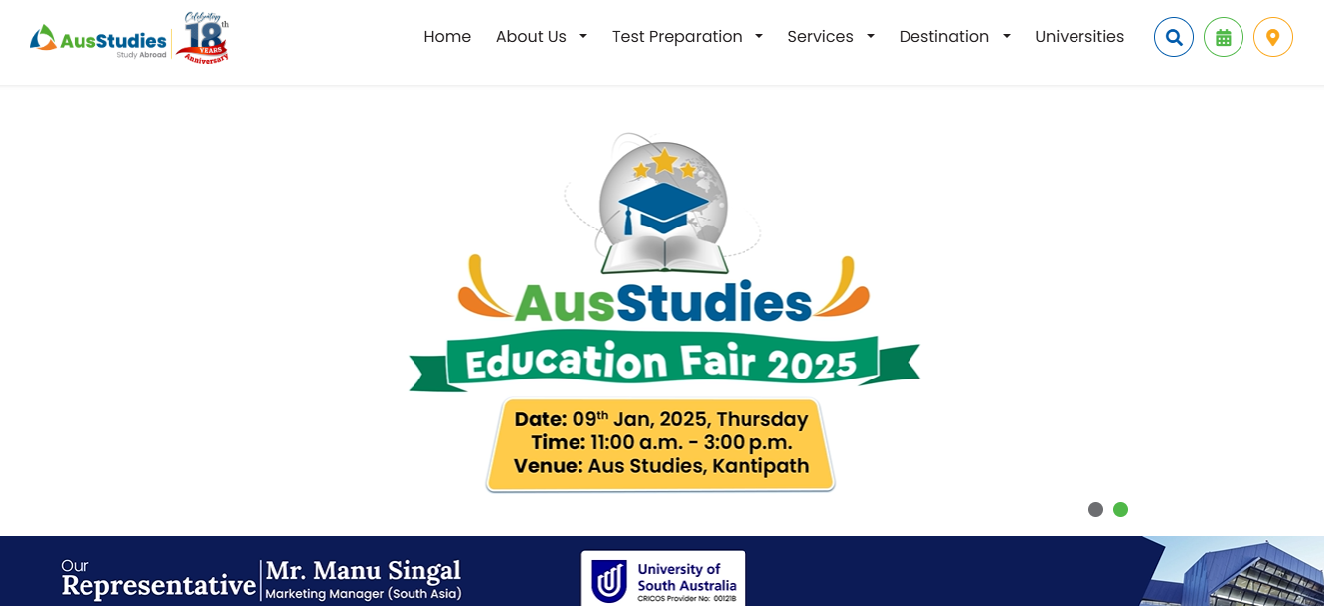

Fig 2 - Homepage of Aus Studies

**Purpose** – To make students study abroad DREAM a REALITY with their Trusted Study Abroad Consultants and offer personalized support to guide students through every step of the process, from choosing a destination to obtaining a visa.

**Table-1.2**

**Strength and weakness** –

|  |  |
| --- | --- |
| **Strength** | **Weakness** |
| Bold design with informative content. | Very expensive |
| Interactive elements (buttons, sliders) work smoothly | Cluttered Layout |
| Bold design with informative content. | No clear Call-To-Action |

**Table 1.2 1: table of strength and weakness of website 2**

### Website 3

**Link** - <https://graceintlgroup.com/>

**Homepage** –

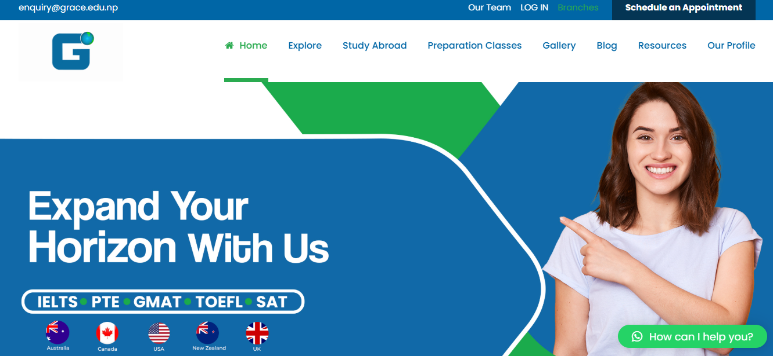

Fig 3 – Homepage of Grace

Purpose -To guide students to explore and help secure their career prospects through suitable education and pathways.

**Table-1.3**

**Strength and weakness** –

|  |  |
| --- | --- |
| **Strength** | **Weakness** |
| Informative content and an animated logo. | Navigation is clear but sometimes confusing for new users. |
| Good readability and contrasting colors | Very expensive |
| Excellent interactive elements, such as pop-up chat and form submission. | Limited content depth |

**Table 1.3 1: table of strength and weakness of website 3**

# Chapter-III

# Goals & Objective

Our main goals and objectives for generating this website are:

## Reliability

Our primary goal for establishing UNIportal is to place it as the most reliable platform for students aiming for higher education opportunities. We aim to ensure that all information on the website, including university details, course offerings, application processes, and financial aid options, is accurate, up-to-date, and thoroughly verified. By partnering with credible and accredited universities and implementing verification procedures, we aim to eliminate misunderstandings and provide students with trustworthy resources. Our objective is to achieve a 100% accuracy rate in university listings and program details within the upcoming 3 months, ensuring that students can rely on UNIportal for accurate and reliable information at all stages of their academic journey.

## Affordability

Our secondary goal is to make higher education accessible to middle-class students by ensuring the affordability of all services provided on UNIportal. We will keep all platform access low-cost for students, removing the financial burden of consultancy fees, and focus on providing cost-effective resources such as scholarship listings, financial aid opportunities, and affordable application management tools. Additionally, we aim to facilitate direct connections between students and universities, cutting out intermediaries and helping students avoid unnecessary additional costs. Our target is to increase the number of students using UNIportal by 25% within the next year, proving that affordability and quality can coexist in the education sector.

# Chapter-IV

# Site map & Navigation

## Site map

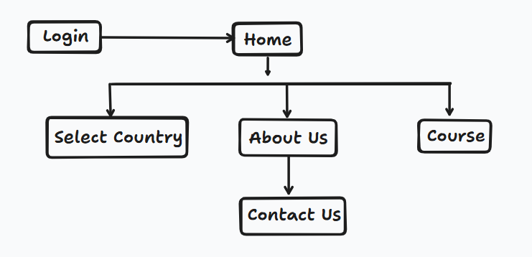

Fig 4 - Site map

## Navigation

Our website follows a user-friendly navigation structure, guiding users through various sections efficiently. The breakdown of our website is as follows:

* Login- Entry point of our website where users are required to log in.
* Home- This page serves as a central hub for navigating our website here users are given the option to choose countries then universities.
* Course- Users are presented with available language proficiency courses.
* About us- This section provides information about our website and creators also a contact us form.

# Chapter-V

# Content strategy

UNIportal will focus on providing valuable, relevant, and accessible information to students while utilizing social media platforms to increase student engagement and generate traffic. Our strategy is to create an approach that aligns with the needs of middle-class students seeking reliable and affordable higher abroad educational opportunities. Some of our strategies are listed below:

**Educational Blog** - We will publish weekly blog posts that offer expert insights on university selection, study abroad tips, scholarship opportunities, application guides, and student success stories. This content will be optimized for SEO to drive organic traffic to the website.

**Student testimonials & case study -** We will feature real student experiences and success stories through social media campaigns and website content. These stories will be shared across Social media platforms with a focus on authentic, relatable content that encourages interaction. We will create video interviews with students who have successfully used UNIportal to secure university placements, building trust and credibility.

**Social media campaigns -** To increase brand awareness and engagement, we will run targeted ad campaigns on Facebook, Instagram, and Google to promote UNIportal’s affordable services. We will use paid ads to reach prospective students, offering them valuable resources like university application tips or scholarship advice. Regular Q&A sessions, live webinars, and social media contests will further increase student interaction and platform visibility.

# Chapter-VI

# Design & Layout

**Table-2**

|  |  |
| --- | --- |
| Screenshot of the layout | Description on the layout |
| Fig 5.1- Login page | This layout presents a modern and user-friendly login page divided into two sections. The left side features a clean "Sign In" form with options for social media login, email/password input, a "Forgot password" link, and a "Sign In" button. The right side showcases a welcoming design with the UniPortal University Hub logo, a greeting message, and a "Sign Up" button for new users. The rounded edges and vibrant colors create a professional and inviting interface. |
| Fig 5.2- Home page | Our home page features a clean and user-friendly design. At the top, the header includes the UniPortal logo on the left, navigation links for Home, About Us, and Course, and a search bar with a "Search" button on the right. The main section displays a dropdown menu labeled "Choose a country," allowing users to select their region for localized content. |
| Fig 5.3-University selection | In this layout, we have utilized cards. Each card has an image section its description and its name and a button. When the user presses that button it opens a pop-up giving them more information about that university. |
| Fig 5.4- Pop-Out | This pop-up has 4 main components first being the price range, documentation that is required to go into this university, its global rating, and the button that helps the user to get the course for the skill and document. |
| Fig 5.5- Course | This layout presents a course section where students can learn about language proficiency tests and helps to improve them through online recorded teaching videos. |
| Fig 5.6- Course Videos | In this layout, students can get recourses and videos about the skills and education or guidelines they need to join their desired country. Students can access these resources freely without paying anything and just by logging in to the website. |
| Fig 5.7- About us | This layout features a clean and minimalistic design with a gradient background blending light green and blue hues. At the center, there is a prominent logo, accompanied by a graduation cap graphic above it. In the top-left corner, a small button labeled "Homepage" provides navigation. The layout is simple and visually appealing, emphasizing the logo and brand identity |
| Fig 5.8- About us description | The page layout features a clean and minimalist design with a central focus on the "About Us" section. At the top, there is a headline emphasizing this section's purpose. Below the headline is a concise description explaining the purpose of the service. The background includes an image of a graduate, symbolizing achievement and aspirations. |
| Fig 5.9- Our services | This layout highlights Our Services segment, arranged in a neat, three-column layout. At the top, the heading is prominently displayed in a purple font, with a minimal horizontal line beneath it for emphasis. Each column showcases a specific service with an icon, bolded title, and a brief description. |
| Fig 5.10- Our Specialities | This layout is a balanced mix of text, visuals, and interactive elements. The heading is bold and prominent, followed by a subheading, which adds a conversational tone. On the left side, two buttons are color-coded to encourage user interaction. On the right side, horizontal bar indicators labeled visually emphasize key attributes of their services |
| Fig 5.11- Our Students | This layout highlights diversity and inclusivity by showcasing a grid of student portraits. Styled in a purple font with a horizontal line beneath it. It consists of a 2x3 grid of images, each featuring individual students symbolizing learning and academic focus. Their smiling expressions vibes positivity and confidence, resonating with the message of support and success. |
| Fig 5.12- Contact us | This layout combines a Contact Us form and a Social Media footer for user interaction and connectivity. The form is clean and straightforward, featuring input fields for essential details and a larger text box for a message. At the bottom of the form, a bright green Send button invites users to submit their inquiries. The design is minimalistic, ensuring ease of use. |

Fig 5

**Table 2 1- Design and Layout**

# Chapter-VII

# Functional Requirements

**Table-3**

|  |  |  |
| --- | --- | --- |
| **Students Incharge** | **Functionalities** | **Description** |
| Abhinav Singh | 1. Homepage | Our home page consists of a clean and user-friendly design. At the top, the header includes the UniPortal logo on the left, navigation links for Home, About Us, and Course, and a search bar with a "Search" button on the right. The main section displays a dropdown menu labeled "Choose a country," allowing users to select their region for localized content. |
| 1. Country selection | On our home page students are to select their preferred country only then they are allowed to proceed further. |
| 1. University selection | After Country Selection students are provided with the options of universities and their details after that they can proceed to the course section. |
| Bishal Jung Basnet | 1. About Us | Here students are welcomed with our logo and a short introduction. |
| 1. Our services | Here we have beautifully and cleanly showcased the services that we offer to students. |
| 1. Our Specialities | This section focuses on showcasing what differentiates us from others. |
| 1. Our Students | This section shows our previous student's experiences and on hover their testimonies are shown. |
| 1. Contact us | In this form, users can contact us for further information. |
| Hridaya Manandhar | 1. Log in / Sign up | This section is a modern and user-friendly login page divided into two sections. The left side features a clean "Sign In" form. The right side showcases a welcoming design. The rounded edges and vibrant colors create a professional and inviting interface. |
| 1. Course | In this section, students can learn about language proficiency tests and get recourses and videos about the skills and education or guidelines they need to join their desired country. Students can access these resources freely without paying anything and just by logging in to the website. |
| 1. Documentation | Here we have generated a through report using various tables, and snapshots of the website following the Apa format. |

**Table 3 1- Functional requirements**

# Chapter-VIII

# Justification and Evaluation

## Justification of the Color Scheme

For our website #0067ac (a deep, vibrant blue) and white has been chosen to reflect our brand’s professionalism, trustworthiness, and clarity. The bold blue hue conveys confidence, stability, and reliability, making it an ideal choice for key elements like headers, buttons, and navigation links. It creates a strong visual impact while remaining approachable, which helps establish a sense of security for users interacting with the site.

White is used as a complementary background color, providing a clean and minimalist vibe that allows the blue accents to stand out. The contrast between the two colors ensures readability, enhances user focus and promotes a sense of openness and simplicity. This combination of #0067ac and white not only ensures aesthetic harmony but also reinforces a modern, professional look that is easy on the eyes and effective in guiding users through the site. Together, these colors create a balanced and inviting atmosphere that aligns with our brand’s values and enhances the overall user experience.

## Justification of the Page Layout

The layout of our website has been carefully crafted to ensure a user-friendly experience, with a focus on clarity and accessibility. We’ve prioritized a clean, minimalistic design for easy navigation, ensuring that users can quickly find what they need with a few clicks. Each page, from the login page to the contact form, is structured to create an inviting and professional atmosphere, using design elements that are both functional and visually appealing. The layout utilizes a consistent color scheme, with the primary color being #0067ac, which evokes trust, professionalism, and reliability while maintaining an engaging user experience.

## Justification of the Font

For our website, we have used the **Oswald** font as it is bold and readable across devices. Its distinctiveness draws eyes instantly while maintaining a professional and friendly appearance. Its balance of boldness makes it ideal for impactful messaging, from highlighting key ideas to user engagement. Great design keeps important content front and center, fitting today's modern branding and communication strategies perfectly. This design makes the important content stand out.

## Logo and Banner



Fig 6 - Logo

The logo used on our website reflects our website’s core values and mission, serving as a visual representation of our identity. Its design combines simplicity with modern elements to ensure recognition and memorability. The colors and shapes were carefully chosen to build trust and professionalism, aligning with the message we want to communicate to our users. By placing the logo prominently, we aim to strengthen our brand presence and create a cohesive, engaging experience for visitors as they navigate the site. We have included a hat to represent universities and students successfully graduating from there. And as our logo suggests our website is a portal for students to choose their preferred universities.

## Challenges and Risks associated with the Website Plan

For our website’s development and maintenance we faced several challenges and risks. One key challenge was to ensure the website’s functionality across different devices and browsers, which requires constant testing and optimization. Security is another significant concern, as websites are vulnerable to cyber-attacks such as hacking, data breaches, and malware. Furthermore, maintaining fast load times and scalability is crucial for user experience and handling traffic spikes. Additionally, ensuring the site complies with legal and regulatory standards, such as data privacy laws, adds complexity. Lastly, staying up-to-date with design trends and technological advancements is necessary to keep the site relevant and user-friendly. As well to meet our users mainly students standards.

# Reference

* Thieme, S. (2017). Educational consultants in Nepal: Professionalization of services for students who want to study abroad. *Mobilities*, *12*(2), 243-258.
* Khattri, S. Higher Education in Nepal: Exploring Current Student Services and Practices.
* AECC Nepal. (2024, June 13). AECC | Study Abroad Consultant in Nepal - Expert Guidance for International Education. Aecc NEPAL. <https://www.aeccglobal.com.np/>
* Ausstudies. (n.d.). Trusted Study Abroad Consultants in Nepal - Aus studies. <https://ausstudies.com/>
* Grace International. (2024, December 24). Best Educational Consultancy - Grace International. <https://graceintlgroup.com/>

# Website Link

Github link of the source code repository:

<https://github.com/Not-Donno/BIT102_WebDesignAndDevelopment_Assignment.git>

# Annex-1

# Rubik for Assessment

**Table-4**

**Project Marks (40%) -** **All marking criteria are to cover CLO3.**

|  |  |  |  |  |  |  |  |
| --- | --- | --- | --- | --- | --- | --- | --- |
| **Criteria** | **Weightage** | **Limited (1)** | **Developing (2)** | **Adequate (3)** | **Proficient (4)** | **Exceptional (5)** | **Marks** |
| Project Overview | 5 | The project overview is unclear, incomplete, or missing. | The project overview is basic but lacks detail or is somewhat unclear. | The project overview provides a basic understanding of the project but lacks depth or detail. | The project overview provides a clear understanding of the project with sufficient detail. | The project overview is comprehensive, well-written, and provides an excellent understanding of the project. |  |
| Web Functionalities | 10 | Screenshot and description are missing or incomplete. Assigned functionalities are not clear. Main web coding is missing or not relevant. | Screenshot and description are incomplete or lack detail. Assigned functionalities are somewhat clear. Main web coding is somewhat relevant but lacks detail. | Screenshot and description provide a basic understanding of the website functionalities. Assigned functionalities are clear. Main web coding is relevant but lacks some detail. | Screenshot and description provide a clear understanding of the website functionalities. Assigned functionalities are well-defined. Main web coding is relevant and includes important points corresponding to the web output. | Screenshot and description provide an excellent understanding of the website functionalities. Assigned functionalities are clearly defined. Main web coding is highly relevant and includes all important points corresponding to the web output. |  |
| Web Interface Design | 10 | Barely used required HTML elements, leading to poor functionality. Lacks proper use of semantic elements, affecting structure and meaning | Used limited HTML elements, and semantic elements need more focus. Needs significant improvement for proper functionality and structure. | Included enough HTML elements for functionalities. Some semantic elements used, but room for better organization and accessibility. | Used a good variety of HTML elements effectively for required functionalities. Included semantic elements to improve structure and meaning, supporting accessibility. | Appropriately used a wide range of HTML elements, boosting functionalities. Chose semantic elements thoughtfully for better structure and meaning, enhancing user experience. |  |
|  | 10 | Minimally applied CSS with limited selector use. Interface's visual appeal and consistency need more work. Use a wider array of selectors for better styling. | Minimally applied CSS with limited selector use. Interface's visual appeal and consistency need more work. Use a wider array of selectors for better styling. | Applied CSS styles acceptably with moderate selector variety. Interface is visually acceptable, but more cohesion and precision could be improved. | Applied CSS proficiently with diverse selectors, leading to a visually pleasing interface. Used different selector levels effectively for precision. | Meticulously applied CSS using various selectors, showcasing deep understanding. Resulted in cohesive, visually appealing interface with different selector levels. |  |
| PHP scripting | 20 | Used minimal PHP, lacking functions. Validation, cookies, and file handling missing or basic. Code comments insufficient, affecting clarity. | Applied PHP for essential functions. Validation maintains data integrity. Cookies used suitably. Managed files sufficiently. Code comments offer understanding. | Applied PHP for essential functions. Validation maintains data integrity. Cookies used suitably. Managed files sufficiently. Code comments offer understanding. | Used PHP for client-server app effectively. Solid validation ensures accuracy. Cookies manage user data well. Managed files competently. Code comments enhance clarity. | Mastered PHP to create a full client-server app with all functions needed. Validation is strong. Cookies used seamlessly for user data. Skilled file handling. Clear comments enrich the code. |  |
| Test Cases  (validation, w3c) | 10 | Test case is missing or incomplete. | Test case lacks detail or clarity. | Test case provides a basic understanding but lacks some detail. | Test cases provide a clear understanding of testing procedures. | Test case is comprehensive, well-documented, and effectively tests all aspects of the web application. |  |
| Database Structure & Properties | 10 | Database structure and properties are missing or unclear.    Weak relationships. Limited PHP use. Web server hosting has major problems. | Database structure and properties lack detail or are somewhat unclear.    Set up basic tables, refining needed. Basic relationships. Simple PHP for data. Web server hosts with some problems. | Database structure and properties provide a basic understanding but lack depth or detail.    Suitable tables with basic relationships. Used PHP for data. Web server hosts app, minor issues. | Database structure and properties provide a clear understanding with sufficient detail.    Structured tables well, with appropriate relationships. Managed data using PHP effectively. Web server hosts app without issues. | Database structure and properties are comprehensive, well-documented, and effectively describe the database used in the project.    set up complex database tables perfectly, with strong relationships. Used PHP effectively for data. Web server works flawlessly. |  |
| The Technologies, Frameworks and Libraries Used | 10 | Technologies, frameworks, and libraries used are missing or incomplete. Description of usage is unclear. | Technologies, frameworks, and libraries used lack detail or are somewhat unclear. Description of usage is basic. | Technologies, frameworks, and libraries used are listed but lack depth or detail. Description of usage provides a basic understanding. | Technologies, frameworks, and libraries used are listed with clear descriptions of usage. | Technologies, frameworks, and libraries used are comprehensive, well-documented, and effectively describe how they have been used throughout the project. |  |
| Reflection | 5 | Reflection is missing or incomplete. Opinions are unclear or unsupported. | Reflection lacks detail or depth. Opinions are somewhat unclear or unsupported. | Reflection provides a basic understanding but lacks depth or detail. Opinions are somewhat clear but lack support. | Reflection provides a clear understanding with sufficient detail. Opinions are clear and supported by evidence. | Reflection is comprehensive, well-written, and provides an excellent understanding. Opinions are clear, well-supported, and insightful. |  |
| Presentation | 10 | Comprehensive content with exceptional structure and seamless flow. Highly engaging with outstanding visual aids. Exceptionally clear and confident speech with perfect timing and pacing. | Strong understanding and thorough content. Clear structure with smooth transitions and good audience engagement. High-quality visual aids. Clear and articulate speech with minimal nervousness. Good pacing and timing. | Solid understanding and clear content with minor depth issues. Well-structured with reasonable engagement. Effective visual aids. Generally clear speech and confidence, with slight timing and pacing issues. | Basic understanding with some gaps. Weak structure and minimal engagement. Visual aids are basic and not very effective. Speech clarity is inconsistent, with noticeable nervousness and timing issues. | Content is unclear and off-topic. No structure, audience interaction, or effective use of visual aids. Speech is mumbled, with visible nervousness and poor timing. |  |
| **Total** | | | | | | |  |
| **Late Submission Penalty (-5 marks per day)** | | | | | | |  |
| **Submission without Source Code (-10 marks)** | | | | | | |  |
| **Submission does not adhere to the template (-5 marks)** | | | | | | |  |
| **Report with significant issues and writing quality are minimal (-5 marks)** | | | | | | |  |
| **TOTAL MARKS OUT OF 100** | | | | | | |  |

**Table 4- Table of Rubik of assessment**