                                                                                                                                      Assignment No.: _

 **Assignment Cover Sheet**

|  |  |  |
| --- | --- | --- |
| **Student Information (If for group assignment, please state names of all members)** | | **Grade/Marks** |
| **Name** | **ID** |  |
| Hridaya Manandhar |  |  |
| Abhinav Singh |  |  |
| Bishal Jung Basnet |  |  |
|  |  |  |
|  |  |  |
| **Module/Subject Information** | | **Office Acknowledgement** |
| **Module/Subject Code** | BIT_101 |  |
| **Module/Subject Name** |  |  |
| **Lecturer/Tutor/Facilitator** | Mr. Niraj Shukla |  |
| **Due Date** |  |  |
| **Assignment Title/Topic** |  |  |
| **Intake (where applicable)** |  |  |
| **Word Count** |  | **Date/Time** |

**Declaration**

. I/We have read and understood the Programme Handbook that explains on **plagiarism**, and I/we testify that, unless otherwise acknowledged, the work submitted herein is entirely my/our own.

. I/We declare that no part of this assignment has been written for me/us by any other person(s) except where such collaboration has been authorized by the lecturer concerned.

. I/We authorize the University to test any work submitted by me/us, using text comparison software, for instances of plagiarism. I/We understand this will involve the University or its contractors copying my/our work and storing it on a database to be used in future to test work submitted by others.

Note:1) The attachment of this statement on any electronically submitted assignments will be deemed to have the same authority as a signed statement.

 2) The Group Leader signs the declaration on behalf of all members, if for group assignment.

|  |  |
| --- | --- |
| Signature: | Date: |
| Mail. |  |
| **Feedback/Comments\*** | |
| **Main Strengths** | |
|  | |
|  | |
|  | |
|  | |
|  | |
|  | |
| **Main Weaknesses** | |
|  | |
|  | |
|  | |
|  | |
|  | |
|  | |
|  | |
| **Suggestions for improvement** | |
|  | |
|  | |
|  | |
|  | |
|  | |
|  | |
|  | **Student acknowledge feedback/comments** |
|  |
| Grader’s signature | Student’s signature: |
| Date: | Date: |

Note:

1)A soft and hard copy of the assignment shall be submitted.

2)The signed copy of the assignment cover sheet shall be retained by the marker.

3) If the Turnitin report is required, students have to submit it with the assignment. The assignment shall only be marked upon the submission of the Turnitin report.

*Use additional sheets if required.

# Acknowledgement

We would like to express our sincere gratitude to everyone who contributed to the completion of this website report. Special thanks to our team members for their hard work and dedication, and to our lecturer **Mr. Niraj Shukla** for his valuable insights and his full support throughout the completion of our project.

We would also like to acknowledge the guidance and encouragement provided by our advisors, whose guidance was invaluable in shaping the direction of this report. Furthermore, the constructive feedback from our peers has been significantly helpful in refining our approach and improving the final outcome.

# Abstract

This report presents the development and evaluation of our website **UNIportal**, coded to assist many students aiming to further continue their studies abroad, assisting them to lift geographical barriers. Our approach for the construction of this website includes assisting students through all the language proficiency tests, documentation and processing.

Our key purpose and motive behind the creation of our website is to provide a reliable cost-effective platform for students to further continue their studies without the fear of scams and fraud. There have been a lot of cases found where consultancy have committed many scams and frauds ruining many student's life and career and mental stress.

This report concludes with detailed information about our website and leaves room for further improvement and research as we intend to launch this website practically aiming to enhance the overall reliability for students for very less amount making abroad study affordable to all classes of students regardless of their background offering them a equal platform of opportunities and to further enhance the experience of the website.

Contents

Acknowledgement 3

Abstract 4

Project Overview 6

Industry Analysis 8

Characteristics of Industry 8

Target Audience 9

Competitors Analysis 10

Strength & Weaknesses 11

Website 1 11

Website 2 12

Website 3 13

Goals & Objective 14

Reliability 15

Affordability 15

Site map & Navigation 15

Content strategy 16

Design & Layout 18

Functional Requirements 19

# Project Overview

UNIportal is an innovative online platform designed to revolutionize the education industry in Nepal by creating a reliable, transparent, and user-friendly interface for students and universities to connect directly, bypassing the need for third-party consultancy. With the increasing number of scams and fraud activities happening in the education sector in Nepal, our platform aims to eliminate these risks and provide a secure, trusted environment for students seeking educational opportunities.

The platform allows students to explore various universities and their programs and degrees, assisting them in making transparent decisions about their education. By providing detailed university profiles, course information, and direct application functionalities, UNIportal empowers students to make educated choices without relying on potentially unreliable consultants. The universities suggested by UNIportal are all thoroughly inquired and checked whether they are actually registered as a university in their respective native countries as history tells us these types of scams are often pulled off by consultancies for the sake of their high commission.

Upon visiting the homepage, users can easily search for countries, price ranges, and universities that match their academic interests and location preferences. Each university profile provides essential information such as courses offered, tuition fees, campus facilities, rankings, and faculty details. Students can read detailed descriptions, view images to gain a better understanding of their chosen institution.

To ensure a smooth and secure experience, we have implemented multiple layers of verification to validate university credentials, preventing scams and fraudulent listings. The platform also includes a comprehensive feedback system to address any concerns and foster a safe community of students and institutions.

In addition to its educational functions, UNIportal includes sections for student resources, such as scholarship opportunities, career advice, and visa information, to support users throughout their educational journey. The platform also offers reviews from students who already used this platform and their experience.

UNIportal is not only a platform for students and universities to connect but also a community that ensures transparency, trust, and a positive educational experience. With a focus on user comfort, the platform provides both light and dark modes for easy navigation.

UNIportal is also designed to assist students in taking their language proficiency tests and guide them through the documentation process as well as to assist them in processing to take off to abroad universities. It is the ideal solution for students seeking genuine educational opportunities and universities at affordable prices looking to connect with quality education.

# Industry Analysis

## Characteristics of Industry

The education industry in Nepal has witnessed rapid growth in recent years, mainly driven by the increasing number of students seeking to study abroad. Education consultancies in Nepal provide various services, such as career counseling, guidance for study abroad programs, and assistance with university admissions, visa processing, and more. However, like many others, this industry has been associated with several challenges, including fraud, scams, and a lack of transparency, leading to issues for students and their families. The concept of migration infrastructure illustrates that the migration process involves not only the students but also a network of various actors, rules, and technologies. Educational consultants, also known as brokers, play a vital role in this process.

The findings challenge the mixed perceptions of brokers, revealing that their work often blends profit motives with social considerations. Negative experiences reported by some clients led to the creation of a business association for these educational consultants. Examining the functioning of this association sheds light on how these agents work to enhance their professionalism and counter the complex reputation they often face. They actively redefine their position within the migration infrastructure to ensure their services are essential, allowing them to stay competitive in the market.

Young, well-educated Nepalese from the middle class can travel overseas thanks to consultancies who assist individuals in preparing official documents such as acceptance letters for courses from foreign universities or colleges help with bank statement Journal of Population and Development preparation, offer advice on how to prepare for interviews and visas, help with English language preparation, and prepare reports for police and charter accountants. The processing charge that an applicant must pay is approximately Rs.5,000-15,000/-. Even if the applicant is denied a visa, this money will not be refunded. The applicant must pay an additional processing cost of approximately Rs.30,000-50,000/-if they are granted a visa. The entire cost often varies between Rs. 4,00,000 and Rs. 10,00,000, depending on the fees that must be paid to the college/university. These consultancies assist youth in going outside and funnel money into their studies and take hefty amounts of commissions.

## Target Audience

Our website, UNIportal, is specifically designed to support students from middle-class families who aim to pursue higher education, both domestically and internationally. These students often face financial constraints, making it essential for them to access reliable, transparent, and affordable resources throughout their educational journey.

UNIportal provides a user-friendly platform where students can explore various universities, understand course offerings, and compare options without relying on costly third-party consultancies. By offering access to essential information, application forms, and direct communication with universities, we encourage these students to make informed decisions that align with their academic goals and financial capacities.

Our key concern for middle-class students is Affordability, and UNIportal addresses this by eliminating the need for expensive consulting services. Our platform ensures that students can access accurate and up-to-date information about scholarships, financial aid opportunities, and other resources to help ease their financial burden.

UNIportal serves as a comprehensive and cost-effective solution for students embarking on their higher education journey. We aim to bridge the gap between quality education and financial accessibility, ensuring that every student, regardless of background, can pursue their academic aspirations with confidence.

## Competitors Analysis

|  |  |  |  |
| --- | --- | --- | --- |
| **Competitors website** | **Website 1** | **Website 2** | **Website 3** |
| **Color and Graphics**   * Consistency * Websites overview |  |  |  |
| **Content Presentation**   * Fonts- Size, Color * Organized Content * Minimal clicks to find information |  |  |  |
| **Functionality** |  |  |  |
| **Browser Compatibility** |  |  |  |
| **Navigation** |  |  |  |

Table1: table of competitor website analysis

## Strength & Weaknesses

### Website 1

Link -

Homepage –

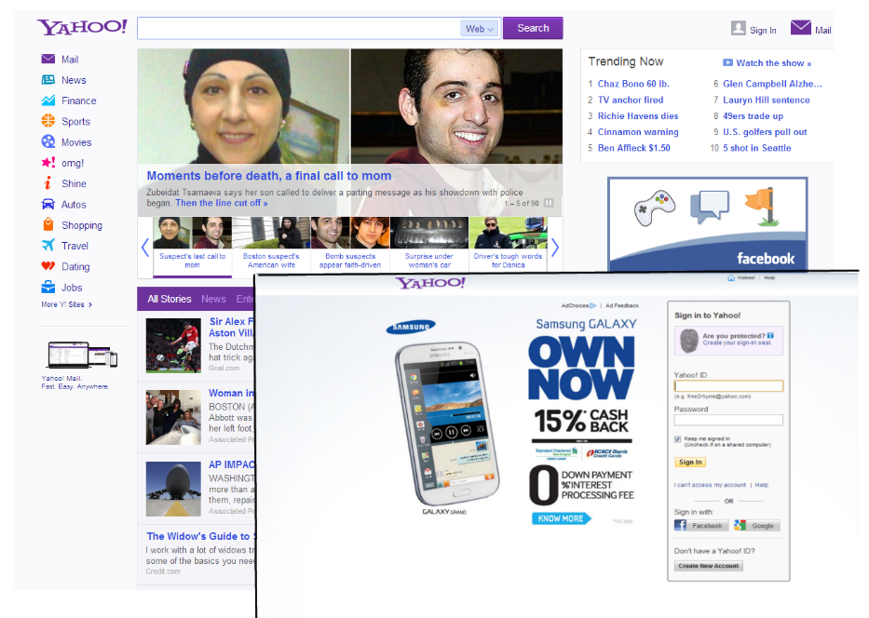

Purpose –

Strength and weakness –

|  |  |
| --- | --- |
| **Strength** | **Weakness** |
|  |  |
|  |  |
|  |  |

Table1.1: table of strength and weakness of website 1

### Website 2

Link -

Homepage –



Purpose –

Strength and weakness –

|  |  |
| --- | --- |
| **Strength** | **Weakness** |
|  |  |
|  |  |
|  |  |

Table1.2: table of strength and weakness of website 2

### Website 3

Link -

Homepage –



Purpose –

Strength and weakness –

|  |  |
| --- | --- |
| **Strength** | **Weakness** |
|  |  |
|  |  |
|  |  |

Table1.1: table of strength and weakness of website 3

# Goals & Objective

Our main goals and objectives for generating this website are:

## Reliability

Our primary goal for establishing UNIportal is to place it as the most reliable platform for students aiming for higher education opportunities. We aim to ensure that all information on the website, including university details, course offerings, application processes, and financial aid options, is accurate, up-to-date, and thoroughly verified. By partnering with credible and accredited universities and implementing verification procedures, we aim to eliminate misunderstandings and provide students with trustworthy resources. Our objective is to achieve a 100% accuracy rate in university listings and program details within the upcoming 3 months, ensuring that students can rely on UNIportal for accurate and reliable information at all stages of their academic journey.

## Affordability

Our secondary goal is to make higher education accessible to middle-class students by ensuring the affordability of all services provided on UNIportal. We will keep all platform access low-cost for students, removing the financial burden of consultancy fees, and focus on providing cost-effective resources such as scholarship listings, financial aid opportunities, and affordable application management tools. Additionally, we aim to facilitate direct connections between students and universities, cutting out intermediaries and helping students avoid unnecessary additional costs. Our target is to increase the number of students using UNIportal by 25% within the next year, proving that affordability and quality can coexist in the education sector.

# Site map & Navigation

# Content strategy

UNIportal will focus on providing valuable, relevant, and accessible information to students while utilizing social media platforms to increase student engagement and generate traffic. Our strategy is to create an approach that aligns with the needs of middle-class students seeking reliable and affordable higher abroad educational opportunities. Some of our strategies are listed below:

**Educational Blog** - We will publish weekly blog posts that offer expert insights on university selection, study abroad tips, scholarship opportunities, application guides, and student success stories. This content will be optimized for SEO to drive organic traffic to the website.

**Student testimonials & case study -** We will feature real student experiences and success stories through social media campaigns and website content. These stories will be shared across Social media platforms with a focus on authentic, relatable content that encourages interaction. We will create video interviews with students who have successfully used UNIportal to secure university placements, building trust and credibility.

**Social media campaigns -** To increase brand awareness and engagement, we will run targeted ad campaigns on Facebook, Instagram, and Google to promote UNIportal’s affordable services. We will use paid ads to reach prospective students, offering them valuable resources like university application tips or scholarship advice. Regular Q&A sessions, live webinars, and social media contests will further increase student interaction and platform visibility.

# Design & Layout

# Functional Requirements