ASSIGNMENT-6

**Q1)Simple XML Program with its syntax**

**<?xml version="1.0" encoding="UTF-8"?>**

**<note>**

**<to>bob</to>**

**<from>Rohan</from>**

**<heading>Reminder</heading>**

**<body>Don't forget me this weekend!</body>**

**</note>**

**OUTPUT:**

Note

To: bob

From: Rohan

Heading: **Reminder**

Don't forget me this weekend!

**Q2)**

**(a)XML PROGRAM WITH DTD’S(DOCUMENT TYPE DEFINITION)**

**CODE:**

**<?xml version="1.0" encoding="UTF-8"?>**

**<!DOCTYPE note SYSTEM "Note.dtd">**

**<note>**

**<to>Tove</to>**

**<from>Jani</from>**

**<heading>Reminder</heading>**

**<body>Don't forget me this weekend!</body>**

**</note>**

**Note.dtd**

**<!DOCTYPE note>**

**[**

**<!ELEMENT note (to,from,heading,body)>**

**<!ELEMENT to (#PCDATA)>**

**<!ELEMENT from (#PCDATA)>**

**<!ELEMENT heading (#PCDATA)>**

**<!ELEMENT body (#PCDATA)>**

**]>**

**(b)TV schedule –DTD**

**<!DOCTYPE TVSCHEDULE>**

**<!ELEMENT TVSCHEDULE (CHANNEL+)>**

**<!ELEMENT CHANNEL (BANNER,DAY+)>**

**<!ELEMENT BANNER (#PCDATA)>**

**<!ELEMENT DAY (DATE,(HOLIDAY|PROGRAMSLOT+)+)>**

**<!ELEMENT HOLIDAY (#PCDATA)>**

**<!ELEMENT DATE (#PCDATA)>**

**<!ELEMENT PROGRAMSLOT (TIME,TITLE,DESCRIPTION?)>**

**<!ELEMENT TIME (#PCDATA)>**

**<!ELEMENT TITLE (#PCDATA)>**

**<!ELEMENT DESCRIPTION (#PCDATA)>**

**<!ATTLIST TVSCHEDULE NAME CDATA #REQUIRED>**

**<!ATTLIST CHANNEL CHAN CDATA #REQUIRED>**

**<!ATTLIST PROGRAMSLOT VTR CDATA #IMPLIED>**

**<!ATTLIST TITLE RATING CDATA #IMPLIED>**

**<!ATTLIST TITLE LANGUAGE CDATA #IMPLIED>**

**]>**

**(c)Newspaper article DTD**

**<!DOCTYPE NEWSPAPER [**

**<!ELEMENT NEWSPAPER (ARTICLE+)>**

**<!ELEMENT ARTICLE (HEADLINE,BYLINE,LEAD,BODY,NOTES)>**

**<!ELEMENT HEADLINE (#PCDATA)>**

**<!ELEMENT BYLINE (#PCDATA)>**

**<!ELEMENT LEAD (#PCDATA)>**

**<!ELEMENT BODY (#PCDATA)>**

**<!ELEMENT NOTES (#PCDATA)>**

**<!ATTLIST ARTICLE AUTHOR CDATA #REQUIRED>**

**<!ATTLIST ARTICLE EDITOR CDATA #IMPLIED>**

**<!ATTLIST ARTICLE DATE CDATA #IMPLIED>**

**<!ATTLIST ARTICLE EDITION CDATA #IMPLIED>**

**<!ENTITY NEWSPAPER "Vervet Logic Times">**

**<!ENTITY PUBLISHER "Vervet Logic Press">**

**<!ENTITY COPYRIGHT "Copyright 1998 Vervet Logic Press">**

**]>**

**Q3) Write a program of XML with CSS.**

**(a)**

**<CATALOG>**

**<CD>**

**<TITLE>Empire Burlesque</TITLE>**

**<ARTIST>Bob Dylan</ARTIST>**

**<COUNTRY>USA</COUNTRY>**

**<COMPANY>Columbia</COMPANY>**

**<PRICE>10.90</PRICE>**

**<YEAR>1985</YEAR>**

**</CD>**

**<CD>**

**<TITLE>Hide your heart</TITLE>**

**<ARTIST>Bonnie Tyler</ARTIST>**

**<COUNTRY>UK</COUNTRY>**

**<COMPANY>CBS Records</COMPANY>**

**<PRICE>9.90</PRICE>**

**<YEAR>1988</YEAR>**

**</CD>**

**<CD>**

**<TITLE>Greatest Hits</TITLE>**

**<ARTIST>Dolly Parton</ARTIST>**

**<COUNTRY>USA</COUNTRY>**

**<COMPANY>RCA</COMPANY>**

**<PRICE>9.90</PRICE>**

**<YEAR>1982</YEAR>**

**</CD>**

**<CD>**

**<TITLE>Still got the blues</TITLE>**

**<ARTIST>Gary Moore</ARTIST>**

**<COUNTRY>UK</COUNTRY>**

**<COMPANY>Virgin records</COMPANY>**

**<PRICE>10.20</PRICE>**

**<YEAR>1990</YEAR>**

**</CD>**

**<CD>**

**<TITLE>Eros</TITLE>**

**<ARTIST>Eros Ramazzotti</ARTIST>**

**<COUNTRY>EU</COUNTRY>**

**<COMPANY>BMG</COMPANY>**

**<PRICE>9.90</PRICE>**

**<YEAR>1997</YEAR>**

**</CD>**

**<CD>**

**CSS CODE:**

**CATALOG {**

**background-color: #ffffff;**

**width: 100%;**

**}**

**CD {**

**display: block;**

**margin-bottom: 30pt;**

**margin-left: 0;**

**}**

**TITLE {**

**display: block;**

**color: #ff0000;**

**font-size: 20pt;**

**}**

**ARTIST {**

**display: block;**

**color: #0000ff;**

**font-size: 20pt;**

**}**

**COUNTRY, PRICE, YEAR, COMPANY {**

**display: block;**

**color: #000000;**

**margin-left: 20pt;**

**}**

**OUTPUT:**

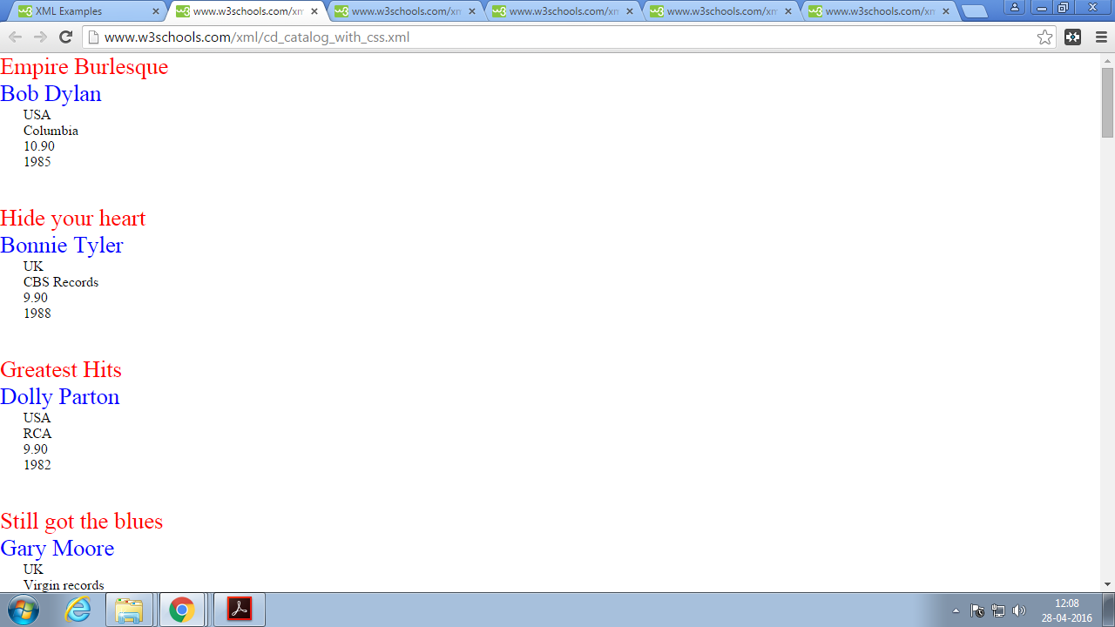

**Q4)Write aprogram of XML with HTML**

**<?xml version="1.0" encoding="UTF-8"?>**

**<?xml:stylesheet type=”text/xsl” href=”menu.xsl”?>**

**<breakfast_menu>**

**<food>**

**<name>Belgian Waffles</name>**

**<price>$5.95</price>**

**<description>Two of our famous Belgian Waffles with plenty of real maple syrup</description>**

**<calories>650</calories>**

**</food>**

**<food>**

**<name>Strawberry Belgian Waffles</name>**

**<price>$7.95</price>**

**<description>Light Belgian waffles covered with strawberries and whipped cream</description>**

**<calories>900</calories>**

**</food>**

**<food>**

**<name>Berry-Berry Belgian Waffles</name>**

**<price>$8.95</price>**

**<description>Light Belgian waffles covered with an assortment of fresh berries and whipped cream</description>**

**<calories>900</calories>**

**</food>**

**<food>**

**<name>French Toast</name>**

**<price>$4.50</price>**

**<description>Thick slices made from our homemade sourdough bread</description>**

**<calories>600</calories>**

**</food>**

**<food>**

**<name>Homestyle Breakfast</name>**

**<price>$6.95</price>**

**<description>Two eggs, bacon or sausage, toast, and our ever-popular hash browns</description>**

**<calories>950</calories>**

**</food>**

**</breakfast_menu>**

**Html code:**

**<?xml version="1.0" encoding="UTF-8"?>**

**<html xsl:version="1.0" xmlns:xsl="http://www.w3.org/1999/XSL/Transform">**

**<body style="font-family:Arial;font-size:12pt;background-color:#EEEEEE">**

**<xsl:for-each select="breakfast_menu/food">**

**<div style="background-color:teal;color:white;padding:4px">**

**<span style="font-weight:bold"><xsl:value-of select="name"/> - </span>**

**<xsl:value-of select="price"/>**

**</div>**

**<div style="margin-left:20px;margin-bottom:1em;font-size:10pt">**

**<p>**

**<xsl:value-of select="description"/>**

**<span style="font-style:italic"> (<xsl:value-of select="calories"/> calories per serving)</span>**

**</p>**

**</div>**

**</xsl:for-each>**

**</body>**

**</html>**

**OUTPUT:**

