Sprint 05/11/24: Styling and Section Development

Objectives:

Design and style the homepage sections, including “About Us,” “Mission,” and “Meet Our Trainers.”

Ensure responsive design compatibility for different screen sizes.

Tasks

1. About Section: Created an introductory section with a custom background and heading styles.
2. Mission Section: Added a mission statement with padding and colour adjustments to align with the brand.
3. Trainer Profiles: Designed individual trainer cards in a responsive grid layout.

Code Snippet

The following CSS styles are used to enhance the visual appeal of sections:

    body {

        background-color: #dddeee;

    }

    .about-section {

        background-color: #a6abf3;

        color: #1f25a5;

        padding: 40px;

        border-radius: 8px;

    }

    .mission-section {

        background-color: #f0f2ff;

        padding: 20px;

        border-radius: 8px;

    }

Website Screenshot

Sprint 06/11/24: Adding Trainer Profiles

Objectives

Create individual cards for each trainer, highlighting their expertise.

Implement consistent styling across trainer cards for a cohesive look.

Tasks

1. Profile Cards: Developed a template for each trainer card, including name, specialization, and description.
2. Styling: Added styles to enhance readability and visual hierarchy.

Code Snippet

Each trainer card is created using a Bootstrap-like grid for layout consistency.

experience, Al    <section class="trainer-cards mt-5">

        <h2 class="text-center">Meet Our Trainers</h2>

        <div class="row mt-4">

*<!-- Trainer Card 1 -->*

            <div class="col-md-4">

                <div class="card text-center">

                    <div class="card-body">

                        <h5 class="card-title">Alex Turner</h5>

                        <p class="card-text">

Specializes in weight training

</p>

                    </div>

                </div>

            </div>

Website Screenshot

Sprint 07/11/24: Final Content and Call-to-Action

Objectives

Add a call-to-action section encouraging users to view available sessions.

Finalize content and ensure consistent branding and colours across sections.

Tasks

1. Call-to-Action: Developed a prominent section at the bottom of the page, with a button linking to the sessions page.
2. Responsive Checks: Reviewed the layout and styling across devices to ensure compatibility.
3. Code Review and Cleanup: Ensured code clarity and minimized CSS duplication.

Code Snippet

The call-to-action button is designed for visual emphasis and includes a link to the sessions page.

    <section class="mt-5 text-center">

        <h2>Join Us Today!</h2>

        <p>

            No matter where you are...

            Sign up for one of our...

        </p>

        <a href="/sessions" class="btn btn-primary">View Our Sessions</a>

    </section>

Website Screenshot

Future Improvements

User Testimonials: Consider adding a section to display client feedback.

Interactive Trainer Cards: Add hover effects or modals with additional trainer information.

Sprint 12/11/24

Objectives:

Add a modal to display more information about each trainer and then a button in the modal to book sessions for that trainer.  
  
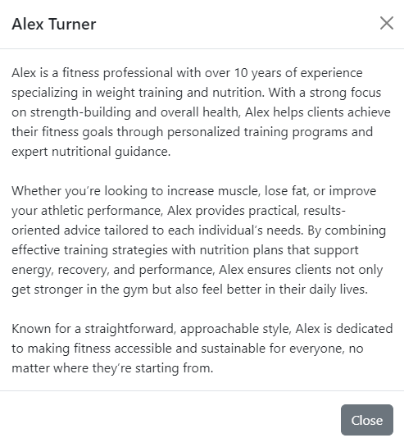

Sprint 19/11/2024

Today I intend to implement the admin pages so that sessions can be added from the web page