# Geminids: A punctual meteor shower

To sleep or not to sleep...

Every stargazer has had to ask this question at least once in their life. But this December 14th the answer must be the latter; for The Geminids are back.

They have already kicked off from December 5 and will continue till December 17, but their peak on December 14 is the event worth watching with >100 meteors per hour darting at medium speeds (very helpful for people with slower reflexes) and providing one of the grandest spectacles that have been consistent throughout the years.

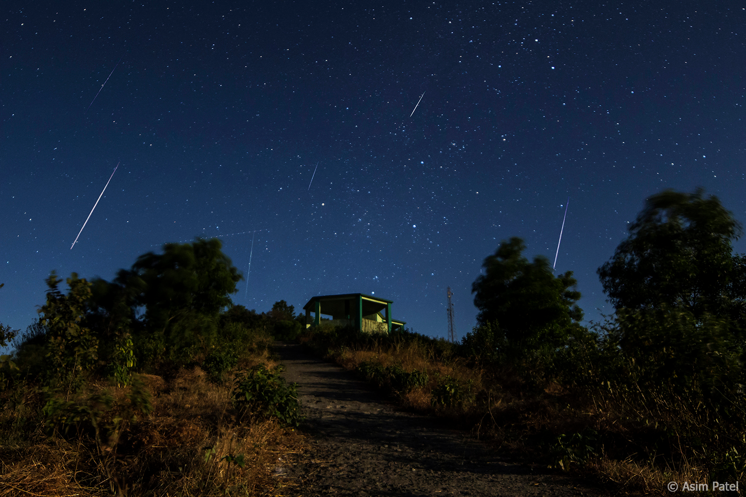

## Why are the Geminids special?

Meteor showers find their origin in the dust grains released from comets. When the Earth moves through this debris, we observe the meteor shower phenomenon.

But there is an exception[1], The Geminids which are not caused by any comet but an asteroid named **Phaeton**.

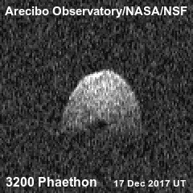

In studies performed by NASA in 2012, it was theorized that Phaeton's extremely close perihelion (point in an orbit that is closest to the sun) causes fractures to grow on the surface of the asteroid. These fractures can sometimes result in loosely held pieces being dislodged from the surface upon getting hit by solar radiation.

But a recent spectroscopic study suggests that as Phaeton approaches the sun, the sodium in it heats up and fizzes out of the asteroid but not before sending out a lot of rocky debris from the asteroid which the very weak gravity of Phaeton can't stop.[2]

Phaeton is an interesting entity itself with it being the first asteroid that we ever discovered using images from a spacecraft.

But the characteristic that makes it very interesting is its "comet" like nature. Since its orbit resembles a comet more than an asteroid, it has been referred to as a **Rock Comet**. Also unlike most other asteroids that tend to be gray or red, phaeton is one of the rarer blue-colored asteroids that we have discovered.

The high-speed flyby mission by the JAXA (Japan Aerospace Exploration Agency) named DESTINY+ will be helpful to understand the nature and origin of these cosmic specs from Phaeton.[3]

## Ending Note

While our astronomy club plans to host great sky-gazing events to watch the Geminids in their full glory, humanity must look past their faithful appearance every year and try to get a feel for their mysterious origin which ultimately makes us question about complexity of comets and asteroids especially when the differences between them seem to blur.[4]

Image credits: Wikipedia

1. Quadrantids also have a non-comet parent body with theirs being a minor planet.
2. <https://www.sciencedirect.com/science/article/abs/pii/S0032063319304969>
3. <https://www.isas.jaxa.jp/en/missions/spacecraft/developing/destiny_plus.html>
4. <https://answersresearchjournal.org/distinction-between-asteroids-comets/>