## S: Space Research and Developments

1. [Death Screams of a Dying Star](https://astronomyclubiiserm.blogspot.com/2022/12/death-scream-of-dying-star.html) – By Sanskar (MS21234)
2. [Geminids: A Punctual Meteor Shower](https://astronomyclubiiserm.blogspot.com/2022/12/geminids-punctual-meteor-showe.html) – By Kshitish (MS22174)
3. [A TITAN-ic Success: Lakes on Another Planetary Body](https://astronomyclubiiserm.blogspot.com/2022/12/a-titan-ic-sucess-lakes-on-another.html) – By Namitha (MS22118)

## K: Know Your Mission

### SLV: A Sea Loving Vehicle

This week we are up with the launch of India's first satellite launch vehicle, SLV-3.

But before dwelling on the story, let's rewind to November 21, 1963. India has just launched its first sounding rocket, Rohini-1. The world was astounded, and the Indian scientists were ecstatic. But in the midst of these emotions, there was a man who was planning ideas that were way beyond his time. Someone whose audacious dreams were going to change the course of Indian Space Research forever. Dr. Vikram Sarabhai wanted India's space program to be self-reliant and indigenous. He wanted India to build its Satellite launch vehicle, and for the same, he devised the mission SLV-3.

[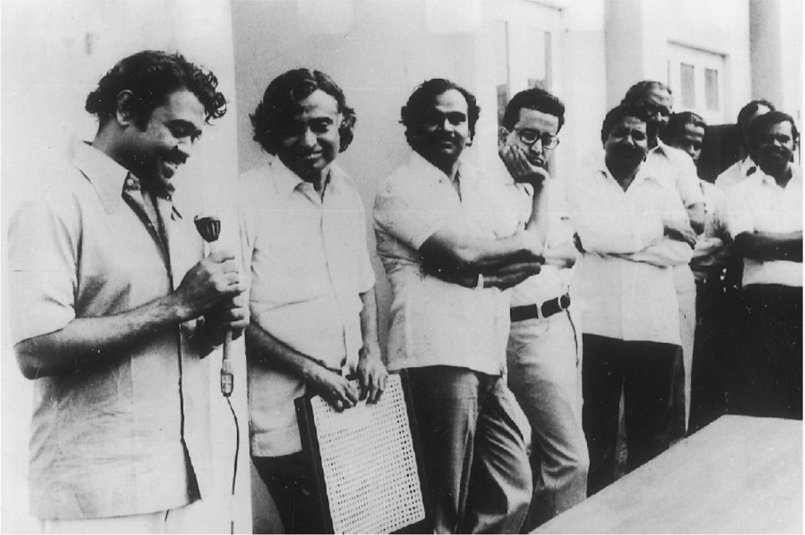](https://draft.blogger.com/u/1/#)Kalam with his team

Later on, after the untimely demise of Dr. Sarabhai, Dr. Satish Dhawan took charge of ISRO. The SLV-3 mission was redesigned and commissioned. Dr. A.P.J Abdul Kalam was appointed as the project director. Although Kalam had minimal experience and wasn't the most brilliant mind in the ISRO then, he was given full responsibility for the project. The dream and hard work of numerous engineers and scientists were in his hands. SLV was set to launch on August 10, 1979, at Sriharikota. Everyone was anxious and on edge.

It was finally D-day. The vehicle was set to launch, and everyone was hopeful. The countdown started...

T-7

T-6

T-5

But alas, at T-4 minutes, the computer put the launch on hold. There was a leak in the control system of the second stage. Dr. Kalam was assured by his team that there were no errors in their calculations, and he decided to launch the vehicle overriding the warning.

The rocket rose, along with everyone's hopes, and plunged into the Bay of Bengal five minutes and 15 seconds into the flight. The press swarmed over the news, called the mission overly ambitious, and nicknamed SLV the Sea Loving vehicle.

Dr. Kalam was dejected. As the project director, he was upset about his failure to launch the vehicle. During the press meeting, Dr. Satish Dhawan, the Chairman of ISRO, took complete responsibility for the failure and assured that the launch would take place the following year. They set up a review committee for the same. Kalam offered his resignation from ISRO, stating it was his decision to go ahead with the launch and that had it been any other country, the project director would have been fired. To which Dhawan famously said, "I am going to put Kalam in orbit."

[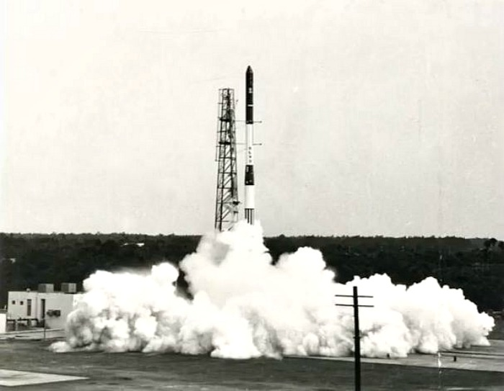](https://draft.blogger.com/u/1/#)Launch of SLV-3

The second launch went with its challenges too. The launch was set on July 18, 1980, at Sriharikota. It was held off initially due to heavy clouds, and then again, as one of the cables connecting the rocket with the ground wasn't reaching as expected. The fuels were all set, and it was a safety hazard for anyone to detach it manually.

A technician volunteered to do it. The team risked his safety to launch the rocket. He climbed up a height of 60 ft, kicked off the cable, and the system was finally ready. Dr. Kalam gave the launch control to Iris 55. All checks came positive, and the rocket was launched.

The launch was a success. Moreover, the rocket was launched into an orbit higher than expected. This was a historic moment in the Indian Space program. The dream of Dr. Sarabhai had finally become a reality. This launch set wings for India's space missions and Kalam's career.

And finally, we became one of the few nations with independent launch capability. Quite a story, isn't it?

## Y: Yield of the Fortnight

The Geminid meteor showers hit their peak on 14th December, and thus the Astronomy Club held a meteor watching session on the night of 14th December; a bunch of people showed up, and students report that a maximum of 42 meteors were seen.

[Pictures of the event](https://drive.google.com/drive/folders/1AR_rllccowczVs38jRD4CrOdhKrAwIn7?usp=sharing)

Talk-O-Tuesdays continue to happen, with the second talk being given by Abineet Parichha of MS18 on [‘an Introduction to Cosmology’](https://www.example.com/).

