Top

NSD NETWORK DAY01
- 案例1：eNSP软件与交换机命令行
- 案例2：访问及配置交换机
- 案例3：验证交换机工作原理

1 案例1：eNSP软件与交换机命令行

1.1 问题
- 熟悉eNSP软件的使用
- 熟悉交换机的命令行视图
- 熟悉交换机视图间的转换

1.2 方案
在eNSP程序主窗口中，添加一台s3700交换机，进入交换机，输入相关命令进行配置和查看交换机

1.3 步骤
实现此案例需要按照如下步骤进行
步骤一：改变命令行视图

- <Huawei>system-view //进入系统视图
- [Huawei]interface Ethernet0/0/1 //进入接口视图
- [Huawei-Ethernet0/0/1]quit //返回上一视图
- [Huawei]
- [Huawei]interface Ethernet0/0/1 //再次进入接口视图
- [Huawei-Ethernet0/0/1]return //返回用户视图
- <Huawei>

2 案例2：访问及配置交换机

2.1 问题
- 修改交换机主机名
- 查看交换机VRP版本
- 查看交换机配置
- 使用账户和密码登录终端
- 保存交换机的配置
- 恢复设备出厂默认值

2.2 方案
在eNSP程序主窗口中，添加一台s3700交换机，进入交换机，输入相关命令进行配置和查看交换机

2.3 步骤
实现此案例需要按照如下步骤进行
步骤一：修改交换机主机名
进入系统视图后，使用sysname指令可以为交换机设置主机名。例如，以下操作可以将主机名设置为SW1

- <Huawei>system-view
- [Huawei]sysname SW1
- [SW1]

步骤二：显示VRP版本

- [Huawei]display version
- Huawei Versatile Routing Platform Software
- VRP (R) software, Version 5.110 (S3700 V200R001C00)
- Copyright (c) 2000-2011 HUAWEI TECH CO., LTD

- Quidway S3700-26C-HI Routing Switch uptime is 0 week, 0 day, 0 hour, 17 minutes

步骤三：查看交换机配置
查看ios名称及版本信息

- [Huawei]display current-configuration
- #
- sysname Huawei
- #
- cluster enable
- ntdp enable
- ndp enable
- #
- drop illegal-mac alarm
- #
- diffserv domain default
- #
- drop-profile default
- #

步骤四：使用账户和密码登录终端

- <Huawei>system-view
- [Huawei]aaa //进入aaa认证
- [Huawei-aaa]local-user admin01 password cipher 123 //创建账户叫admin01,密码123
- [Huawei-aaa]quit
- [Huawei]user-interface console 0
- [Huawei-ui-console0]authentication-mode aaa //激活配置

步骤五：保存交换机的配置

- <Huawei>save
- The current configuration will be written to the device.
- Are you sure to continue?[Y/N]y //这里按y确认
- Info: Please input the file name ( *.cfg, *.zip ) [vrpcfg.zip]:
- Mar 12 2019 19:12:18-08:00 Huawei %%01CFM/4/SAVE(l)[0]:The user chose Y when dec
- iding whether to save the configuration to the device.
- Now saving the current configuration to the slot 0.
- Save the configuration successfully.

步骤六：恢复设备出厂默认值

- <Huawei>reset saved-configuration //重置配置文件
- Warning: The action will delete the saved configuration in the device.
- The configuration will be erased to reconfigure. Continue? [Y/N]:y //是否擦除，回答y
- Warning: Now clearing the configuration in the device.
- Mar 12 2019 19:13:50-08:00 Huawei %%01CFM/4/RST_CFG(l)[1]:The user chose Y when
- deciding whether to reset the saved configuration.
- Info: Succeeded in clearing the configuration in the device.

- <Huawei>reboot //重启设备
- Info: The system is now comparing the configuration, please wait.
- Warning: All the configuration will be saved to the configuration file for the n
- ext startup:, Continue?[Y/N]:n //提示是否再次保存，选择n
- Info: If want to reboot with saving diagnostic information, input 'N' and then e
- xecute 'reboot save diagnostic-information'.
- System will reboot! Continue?[Y/N]:y //是否重启，选择y

3 案例3：验证交换机工作原理

3.1 问题
通过2台交换机以及4台pc设备分析交换机工作原理

3.2 方案
实现此目的需要先搭建拓扑，如图-1所示
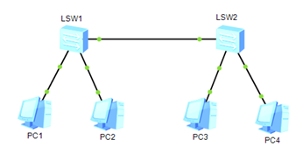
图-1

3.3 步骤
步骤一：pc设备配置
为不同pc设置ip地址与子网掩码，分别是192.168.0.1/24~192.168.0.4/24，配置完毕点击右下角应用，如图-2所示
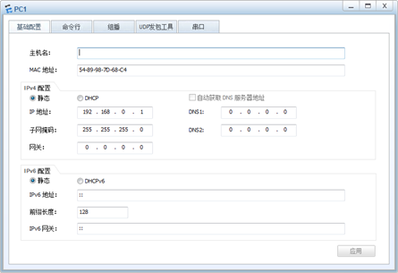
图-2
步骤二：通过pc设备的命令行界面使用ping命令对其他设备发起访问
如图-3所示
/
图-3
步骤三：在交换机中查看MAC地址表

- [Huawei]display mac-address
- MAC address table of slot 0:
- -------------------------------------------------------------------------------
- MAC Address VLAN/ PEVLAN CEVLAN Port Type LSP/LSR-ID
- VSI/SI MAC-Tunnel
- -------------------------------------------------------------------------------
- 5489-987d-68c4 1 - - Eth0/0/1 dynamic 0/-
- 5489-9806-61a2 1 - - Eth0/0/2 dynamic 0/-
- 5489-98d8-3d5d 1 - - Eth0/0/3 dynamic 0/-
- 5489-98d3-6953 1 - - Eth0/0/3 dynamic 0/-
- -------------------------------------------------------------------------------

Top

NSD NETWORK DAY02
- 案例1：划分VLAN
- 案例2：多交换机VLAN的划分
- 案例3：配置trunk中继链路
- 案例4：链路聚合配置
- 案例5：配置静态路由
- 案例6：三层交换机基本配置

1 案例1：划分VLAN

1.1 问题
在交换机上创建以下VLAN，按照拓扑图-1将端口加入到指定的VLAN并配置服务器IP地址，实现同VLAN主机的通信
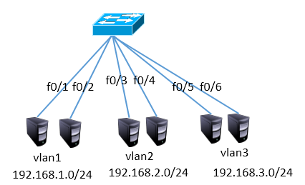
图-1

1.2 步骤
实现此案例需要按照如下步骤进行
步骤一：创建vlan，并将接口加入
由于默认情况下所有接口都在VLAN1中，且VLAN1默认就存在，所以只需要配置VLAN2和VLAN3即可

- <Huawei>system-view
- [Huawei]vlan batch 2 3 //创建VLAN2、3
- [Huawei]port-group 1
- [Huawei-port-group-1]group-member Ethernet0/0/3 Ethernet0/0/4
- [Huawei-port-group-1]port link-type access
- [Huawei-port-group-1]port default vlan 2
- [Huawei-port-group-1]quit
- [Huawei]port-group 2
- [Huawei-port-group-2]group-member Ethernet0/0/5 Ethernet0/0/6
- [Huawei-port-group-2]port link-type access
- [Huawei-port-group-2]port default vlan 3

2 案例2：多交换机VLAN的划分

2.1 问题
通过配置交换机实现图-2中的同VLAN主机互通
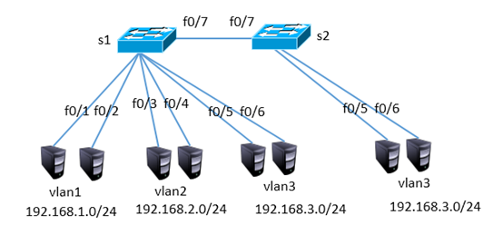
图-2

2.2 步骤
注：以下配置需要在案例1的基础上完成
步骤一：创建vlan，并将接口加入
1）S1配置

- [Huawei]interface Ethernet0/0/7
- [Huawei-Ethernet0/0/7] port link-type access
- [Huawei-Ethernet0/0/7] port default vlan 3

2）S2配置

- <Huawei>system-view
- [Huawei]vlan 3 //创建VLAN3
- [Huawei]port-group 1
- [Huawei-port-group-1]group-member Ethernet0/0/5 to Ethernet0/0/7
- [Huawei-port-group-1]port link-type access
- [Huawei-port-group-1]port default vlan 3

3 案例3：配置trunk中继链路

3.1 问题
通过配置实现跨交换机的同VLAN通信，如图-3所示
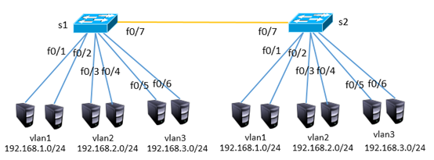
图-3

3.2 步骤
注：以下配置需要在案例2的基础上完成
步骤一：配置trunk，放行所有vlan
1）S1配置

- 如果接口被改动过，则需要恢复默认配置
- [Huawei] clear configuration interface Ethernet0/0/7
- [Huawei]interface Ethernet0/0/7
- [Huawei-Ethernet0/0/7]port default vlan 1
- [Huawei-Ethernet0/0/7]port link-type trunk
- [Huawei-Ethernet0/0/1]port trunk allow-pass vlan all

2）S2配置

- <Huawei>system-view
- [Huawei]vlan 2 //创建VLAN2
- [Huawei]port-group 1
- [Huawei-port-group-1]group-member Ethernet0/0/3 Ethernet0/0/4
- [Huawei-port-group-1]port link-type access
- [Huawei-port-group-1]port default vlan 2
- [Huawei]interface Ethernet0/0/7
- [Huawei-Ethernet0/0/7]port default vlan 1
- [Huawei-Ethernet0/0/7]port link-type trunk
- [Huawei-Ethernet0/0/1]port trunk allow-pass vlan all

4 案例4：链路聚合配置

4.1 问题
参照图-4将两台交换机的f0/1-f0/2接口互联，并实现高可用

图-4

4.2 步骤
步骤一：创建链路聚合接口，并捆绑物理接口
1）S1配置

- [Huawei]interface Eth-trunk 1
- [Huawei- Eth-trunk1]trunkport ethernet 0/0/1 0/0/2

- 如果接口被改动过，则需要恢复默认配置
- [Huawei] clear configuration interface Ethernet0/0/1

2）S2配置

- [Huawei]interface Eth-trunk 1
- [Huawei- Eth-trunk1]trunkport ethernet 0/0/1 0/0/2

5 案例5：配置静态路由

5.1 问题
按照图-5拓扑结构配置接口ip地址并通过静态路由实现全网互通
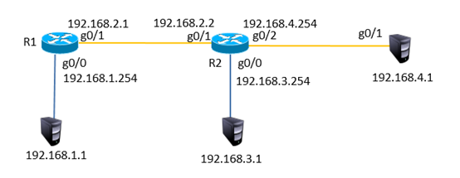
图-5

5.2 步骤
步骤一：配置ip地址，添加静态路由
1）R1配置

- <Huawei>system-view
- [Huawei]interface GigabitEthernet 0/0/0
- [Huawei-GigabitEthernet0/0/1]ip address 192.168.1.254 24
- [Huawei-GigabitEthernet0/0/1]quit
- [Huawei]interface GigabitEthernet 0/0/1
- [Huawei-GigabitEthernet0/0/1]ip address 192.168.2.1 24
- [Huawei]ip route-static 192.168.3.0 24 192.168.2.2
- [Huawei]ip route-static 192.168.4.0 24 192.168.2.2

2）R2配置

- <Huawei>system-view
- [Huawei]interface GigabitEthernet 0/0/0
- [Huawei-GigabitEthernet0/0/1]ip address 192.168.3.254 24
- [Huawei-GigabitEthernet0/0/1]quit
- [Huawei]interface GigabitEthernet 0/0/1
- [Huawei-GigabitEthernet0/0/1]ip address 192.168.2.2 24
- [Huawei-GigabitEthernet0/0/1]quit
- [Huawei]interface GigabitEthernet 0/0/2
- [Huawei-GigabitEthernet0/0/1]ip address 192.168.4.254 24
- [Huawei]ip route-static 192.168.1.0 24 192.168.2.1

6 案例6：三层交换机基本配置

6.1 问题
按照图-6的拓扑结构配置ip地址并通过三层交换实现VLAN间通信
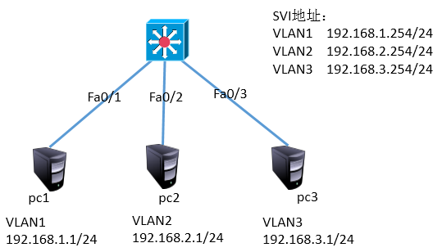
图-6

6.2 步骤
步骤一：创建vlan，并配置虚拟接口的ip
三层交换机配置

- [Huawei]vlan batch 2 3
- [Huawei]interface Vlanif 1
- [Huawei-Vlanif1]ip address 192.168.1.254 24
- [Huawei]interface Vlanif 2
- [Huawei-Vlanif1]ip address 192.168.2.254 24
- [Huawei]interface Vlanif 3
- [Huawei-Vlanif1]ip address 192.168.3.254 24
- [Huawei]interface G0/0/2
- [Huawei-GigabitEthernet0/0/2] port link-type access
- [Huawei-GigabitEthernet0/0/2] port default vlan 2
- [Huawei]interface G0/0/3
- [Huawei-GigabitEthernet0/0/2] port link-type access
- [Huawei-GigabitEthernet0/0/2] port default vlan 3

Top

NSD NETWORK DAY03
- 案例1：动态路由
- 案例2：基本ACL的配置（1）
- 案例3：基本ACL的配置（2）
- 案例4：高级ACL

1 案例1：动态路由

1.1 问题
通过配置静态路由协议ospf实现全网互通，按照图-1拓扑图所示
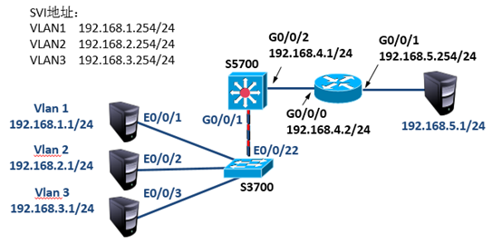
图-1

1.2 步骤
实现此案例需要按照如下步骤进行。
步骤一：配置交换机
1）S3700交换机配置

- [Huawei]vlan batch 2 3 //创建VLAN2、3
- [Huawei]interface Ethernet0/0/2
- [Huawei-Ethernet0/0/2]port default vlan 2
- [Huawei]interface Ethernet0/0/3
- [Huawei-Ethernet0/0/3]port default vlan 3
- [Huawei]interface Ethernet0/0/22
- [Huawei-Ethernet0/0/22]port link-type trunk
- [Huawei-Ethernet0/0/22]port trunk allow-pass vlan all

2）S5700交换机配置

- [Huawei]vlan batch 2 3 4 //创建VLAN2、3、4
- [Huawei]interface Vlanif 1
- [Huawei-Vlanif4]ip address 192.168.1.254 24
- [Huawei]interface Vlanif 2
- [Huawei-Vlanif4]ip address 192.168.2.254 24
- [Huawei]interface Vlanif 3
- [Huawei-Vlanif4]ip address 192.168.3.254 24
- [Huawei]interface Vlanif 4
- [Huawei-Vlanif4]ip address 192.168.4.1 24

- [Huawei]interface GigabitEthernet 0/0/1
- [Huawei-GigabitEthernet0/0/1] port link-type trunk
- [Huawei-GigabitEthernet0/0/1] port trunk allow-pass vlan all
- [Huawei]interface GigabitEthernet 0/0/2
- [Huawei-GigabitEthernet0/0/2] port link-type access
- [Huawei-GigabitEthernet0/0/2] port default vlan 4
- [Huawei]ospf 1
- [Huawei-ospf-1]area 0
- [Huawei-ospf-1-area-0.0.0.0]network 192.168.1.0 0.0.0.255
- [Huawei-ospf-1-area-0.0.0.0]network 192.168.2.0 0.0.0.255
- [Huawei-ospf-1-area-0.0.0.0]network 192.168.3.0 0.0.0.255
- [Huawei-ospf-1-area-0.0.0.0]network 192.168.4.0 0.0.0.255
- [Huawei]ip route-static 0.0.0.0 0.0.0.0 192.168.4.2

步骤二：配置路由器
AR2220路由器配置如下

- [Huawei]interface GigabitEthernet 0/0/0
- [Huawei-GigabitEthernet0/0/0] ip address 192.168.4.2 24
- [Huawei]interface GigabitEthernet 0/0/1
- [Huawei-GigabitEthernet0/0/0] ip address 192.168.5.254 24
- [Huawei]ospf 1
- [Huawei-ospf-1]area 0
- [Huawei-ospf-1-area-0.0.0.0]network 192.168.4.0 0.0.0.255

2 案例2：基本ACL的配置（1）

2.1 问题
按照图-2所示拓扑结构，禁止主机pc2与pc1通信，而允许所有其他流量
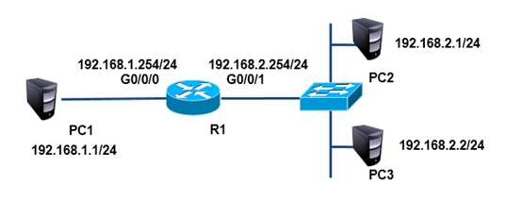
图-2

2.2 步骤
实现此案例需要按照如下步骤进行。
步骤一：配置IP
为路由器g0/0/0接口配置ip 192.168.1.254，为路由器g0/0/1接口配置ip 192.168.2.254

- [Huawei]interface GigabitEthernet 0/0/0
- [Huawei-GigabitEthernet0/0/0] ip address 192.168.1.254 24
- [Huawei]acl 2000
- [Huawei-acl-basic-2000]rule deny source 192.168.2.1 0
- [Huawei]interface GigabitEthernet 0/0/1
- [Huawei-GigabitEthernet0/0/1]ip address 192.168.2.254 24
- [Huawei-GigabitEthernet0/0/1]traffic-filter inbound acl 2000

3 案例3：基本ACL的配置（2）

3.1 问题
按照图-3所示拓扑结构，允许主机pc2与pc1互通，而禁止其他设备访问pc1
图-3

3.2 步骤
实现此案例需要按照如下步骤进行。
步骤一：放行192.168.2.1，拒绝其他设备
此步骤需要在上一实验基础上进行

- [Huawei]acl 2001
- [Huawei-acl-basic-2001]rule permit source 192.168.2.1 0
- [Huawei-acl-basic-2001]rule deny source any
- [Huawei]interface GigabitEthernet 0/0/1
- [Huawei-GigabitEthernet0/0/1]undo traffic-filter inbound acl 2000
- [Huawei-GigabitEthernet0/0/1] traffic-filter inbound acl 2001

4 案例4：高级ACL

4.1 问题
按照图-4所示拓扑结构，禁止pc2访问pc1的ftp服务，禁止pc3访问pc1的www服务，所有主机的其他服务不受限制
图-4

4.2 步骤
实现此案例需要按照如下步骤进行。
步骤一：根据协议所用端口进行封堵
此步骤需要在上一实验基础上进行

- [Huawei]acl 3000
- [Huawei-acl-adv-3000]rule deny tcp source 192.168.2.1 0 destination 192.168.1.1
- 0 destination-port eq 21
- [Huawei-acl-adv-3000]rule deny tcp source 192.168.2.2 0 destination 192.168.1.1
- 0 destination-port eq 80
- [Huawei]interface g0/0/1
- [Huawei-GigabitEthernet0/0/1]traffic-filter inbound acl 3000 //在接口中应用acl

Top

NSD NETWORK DAY04
- 案例1：配置静态NAT
- 案例2：Easy IP
- 案例3：三层交换配置VRRP
- 案例4：网络负载均衡

1 案例1：配置静态NAT

1.1 问题
按照图-1拓扑图所示，在R1上配置静态NAT使192.168.2.1转换为100.0.0.2,192.168.2.2转换为100.0.0.3，实现外部网络访问
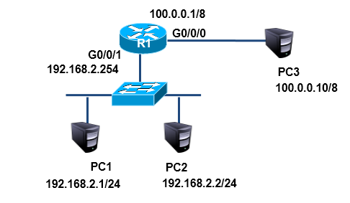
图-1

1.2 步骤
实现此案例需要按照如下步骤进行。
步骤一：配置静态NAT
pc3无需配置网关

- [Huawei]interface GigabitEthernet 0/0/0
- [Huawei-GigabitEthernet0/0/0] ip address 100.0.0.1 8
- [Huawei-GigabitEthernet0/0/0]nat static global 100.0.0.2 inside 192.168.2.1
- [Huawei-GigabitEthernet0/0/0]nat static global 100.0.0.3 inside 192.168.2.2

2 案例2：Easy IP

2.1 问题
按照图-2所示的拓扑结构，在R1上配置Easy IP使企业内网192.168.2.0/24利用g0/0/0端口的ip，实现外部网络的访问
图-2

2.2 步骤
实现此案例需要按照如下步骤进行
步骤一：配置静态NAT
注：以下命令需要在路由器配置好ip的基础上完成

- [Huawei]acl 2000
- [Huawei-acl-basic-2000]rule permit source any //使用acl定义任何内部地址
- [Huawei]interface g0/0/0
- [Huawei-GigabitEthernet0/0/0]nat outbound 2000 //可以利用g0/0/0的ip访问外网

3 案例3：三层交换配置VRRP

3.1 问题
按照图-3所示拓扑结构，在三层交换机配置热备份路由协议使组内两个出口设备共享一个虚拟ip地址192.168.1.254为内网主机的网关
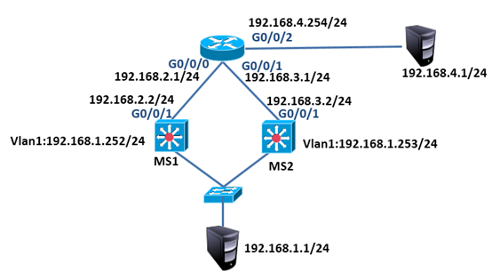
图-3

3.2 步骤
本实验暂不考虑NAT问题
步骤一：pc配置ip
pc设备配置ip与网关，192.168.1.1的网关为192.168.1.254
192.168.4.1的网关为192.168.4.254
步骤二：路由器配置
路由器配置

- <Huawei>system-view
- [Huawei]interface GigabitEthernet 0/0/0
- [Huawei-GigabitEthernet0/0/0]ip address 192.168.2.1 24
- [Huawei]interface GigabitEthernet 0/0/1
- [Huawei-GigabitEthernet0/0/1]ip address 192.168.3.1 24
- [Huawei]interface GigabitEthernet 0/0/2
- [Huawei-GigabitEthernet0/0/2]ip address 192.168.4.254 24

- [Huawei]ospf
- [Huawei-ospf-1]area 0
- [Huawei-ospf-1-area-0.0.0.0]network 192.168.2.0 0.0.0.255
- [Huawei-ospf-1-area-0.0.0.0]network 192.168.3.0 0.0.0.255
- [Huawei-ospf-1-area-0.0.0.0]network 192.168.4.0 0.0.0.255

步骤三：交换机配置
1）MS1

- <Huawei>system-view
- [Huawei]interface Vlanif 1
- [Huawei-Vlanif1]ip add 192.168.1.252 24
- [Huawei]vlan 2
- [Huawei-vlan2]quit
- [Huawei]interface Vlanif 2
- [Huawei-Vlanif2]ip address 192.168.2.2 24
- [Huawei-Vlanif2]quit
- [Huawei]interface GigabitEthernet 0/0/2
- [Huawei-GigabitEthernet0/0/2]port link-type access
- [Huawei-GigabitEthernet0/0/2]port default vlan 2

- [Huawei]ospf
- [Huawei-ospf-1]area 0
- [Huawei-ospf-1-area-0.0.0.0]network 192.168.1.0 0.0.0.255
- [Huawei-ospf-1-area-0.0.0.0]network 192.168.2.0 0.0.0.255

- [Huawei]interface Vlanif 1
- [Huawei-Vlanif1]vrrp vrid 1 virtual-ip 192.168.1.254

2）MS2

- <Huawei>system-view
- [Huawei]interface Vlanif 1
- [Huawei-Vlanif1]ip add 192.168.1.253 24
- [Huawei]vlan 3
- [Huawei-vlan3]quit
- [Huawei]interface Vlanif 3
- [Huawei-Vlanif3]ip address 192.168.3.2 24
- [Huawei-Vlanif3]quit
- [Huawei]interface GigabitEthernet 0/0/2
- [Huawei-GigabitEthernet0/0/2]port link-type access
- [Huawei-GigabitEthernet0/0/2]port default vlan 3

- [Huawei]ospf
- [Huawei-ospf-1]area 0
- [Huawei-ospf-1-area-0.0.0.0]network 192.168.1.0 0.0.0.255
- [Huawei-ospf-1-area-0.0.0.0]network 192.168.3.0 0.0.0.255

- [Huawei]interface Vlanif 1
- [Huawei-Vlanif1]vrrp vrid 1 virtual-ip 192.168.1.254

4 案例4：网络负载均衡

4.1 问题
按照图-4所示拓扑结构，配置MS1为vlan10的主路由器、vlan20的备份路由器，MS2为vlan10的备份路由器、vlan20的主路由器，实现负载均衡的效果
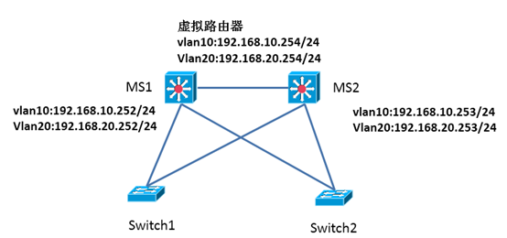
图-4

4.2 步骤
实现此案例需要按照如下步骤进行
步骤一：配置交换机
1）MS1

- [Huawei]interface Vlanif 10
- [Huawei-Vlanif10]ip address 192.168.10.252 24
- [Huawei-Vlanif10]vrrp vrid 1 virtual-ip 192.168.10.254
- [Huawei-Vlanif10]vrrp vrid 1 priority 110

- [Huawei]interface Vlanif 20
- [Huawei-Vlanif20]ip address 192.168.20.252 24
- [Huawei-Vlanif20]vrrp vrid 2 virtual-ip 192.168.20.254

1）MS2

- [Huawei]interface Vlanif 10
- [Huawei-Vlanif10]ip address 192.168.10.253 24
- [Huawei-Vlanif10]vrrp vrid 1 virtual-ip 192.168.10.254

- [Huawei]interface Vlanif 20
- [Huawei-Vlanif20]ip address 192.168.20.253 24
- [Huawei-Vlanif20]vrrp vrid 2 virtual-ip 192.168.20.254
- [Huawei-Vlanif20]vrrp vrid 2 priority 110

Top

NSD NETWORK DAY05
- 案例：综合网络搭建

1 案例：综合网络搭建

1.1 问题
现有网络问题分析：
- 接入层交换机只与同一个三层交换机相连，存在单点故障而影响网络通信。
- 互联网连接单一服务商
现有网络需求：
- 随着企业发展，为了保证网络的高可用性，需要使用很多的冗余技术
- 保证局域网络不会因为线路故障而导致的网络故障
- 保证客户端机器不会因为使用单一网关而出现的单点失败
- 保证到互联网的高可用接入使用冗余互联网连接

1.2 方案
基于项目的需求，需要用到如下技术：
- OSPF路由协议：实现网络路径的自动学习
- VRRP：实现网关冗余
重新规划后的网络拓扑如图-1：
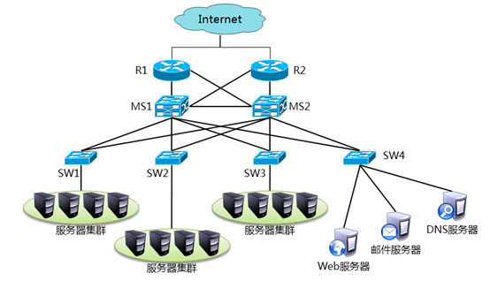
图-1

1.3 步骤
实现此案例需要按照如下步骤进行，为了配置过程中不被弹出信息干扰，可以关闭信息提示
步骤一：S3700交换机配置

- SW1配置
- <Huawei>system-view
- [Huawei]vlan batch 10 20 30 40
- [Huawei]port-group 1
- [Huawei-port-group-1]group-member Ethernet 0/0/1 to Ethernet 0/0/2
- [Huawei-port-group-1]port link-type trunk
- [Huawei-port-group-1]port trunk allow-pass vlan all
- [Huawei-port-group-1]quit

- [Huawei]interface Ethernet 0/0/5
- [Huawei-Ethernet0/0/5] port link-type access
- [Huawei-Ethernet0/0/5] port default vlan 10

- SW2配置
- <Huawei>system-view
- [Huawei]vlan batch 10 20 30 40
- [Huawei]port-group 1
- [Huawei-port-group-1]group-member Ethernet 0/0/1 to Ethernet 0/0/2
- [Huawei-port-group-1]port link-type trunk
- [Huawei-port-group-1]port trunk allow-pass vlan all
- [Huawei-port-group-1]quit

- [Huawei]interface Ethernet 0/0/5
- [Huawei-Ethernet0/0/5] port link-type access
- [Huawei-Ethernet0/0/5] port default vlan 20

- SW3配置
- <Huawei>system-view
- [Huawei]vlan batch 10 20 30 40
- [Huawei]port-group 1
- [Huawei-port-group-1]group-member Ethernet 0/0/1 to Ethernet 0/0/2
- [Huawei-port-group-1]port link-type trunk
- [Huawei-port-group-1]port trunk allow-pass vlan all
- [Huawei-port-group-1]quit

- [Huawei]interface Ethernet 0/0/5
- [Huawei-Ethernet0/0/5] port link-type access
- [Huawei-Ethernet0/0/5] port default vlan 30

- SW4配置
- <Huawei>system-view
- [Huawei]vlan batch 10 20 30 40
- [Huawei]port-group 1
- [Huawei-port-group-1]group-member Ethernet 0/0/1 to Ethernet 0/0/2
- [Huawei-port-group-1]port link-type trunk
- [Huawei-port-group-1]port trunk allow-pass vlan all
- [Huawei-port-group-1]quit

- [Huawei]interface Ethernet 0/0/5
- [Huawei-Ethernet0/0/5] port link-type access
- [Huawei-Ethernet0/0/5] port default vlan 40

步骤二：S5700交换机配置

- MS1配置

- <Huawei>system-view
- [Huawei]vlan batch 10 20 30 40 50 60
- [Huawei]port-group 1
- [Huawei-port-group-1]group-member GigabitEthernet 0/0/1 to GigabitEthernet 0/0/5
- [Huawei-port-group-1]port link-type trunk
- [Huawei-port-group-1]port trunk allow-pass vlan all
- [Huawei-port-group-1]quit

- [Huawei]interface Vlanif 10
- [Huawei-Vlanif10]ip address 192.168.10.252 24
- [Huawei-Vlanif10]vrrp vrid 1 virtual-ip 192.168.10.254
- [Huawei-Vlanif10]vrrp vrid 1 priority 110
- [Huawei]interface Vlanif 20
- [Huawei-Vlanif20]ip address 192.168.20.252 24
- [Huawei-Vlanif20]vrrp vrid 2 virtual-ip 192.168.20.254
- [Huawei-Vlanif20]vrrp vrid 2 priority 110

- [Huawei]interface Vlanif 30
- [Huawei-Vlanif30]ip address 192.168.30.252 24
- [Huawei-Vlanif30]vrrp vrid 3 virtual-ip 192.168.30.254
- [Huawei]interface Vlanif 40
- [Huawei-Vlanif40]ip address 192.168.40.252 24
- [Huawei-Vlanif40]vrrp vrid 4 virtual-ip 192.168.40.254

- [Huawei]interface Vlanif 50
- [Huawei-Vlanif50]ip address 192.168.50.2 24
- [Huawei]interface GigabitEthernet 0/0/23
- [Huawei-GigabitEthernet0/0/23]port link-type access
- [Huawei-GigabitEthernet0/0/23]port default vlan 50

- [Huawei]interface Vlanif 60
- [Huawei-Vlanif60]ip address 192.168.60.2 24
- [Huawei]interface GigabitEthernet 0/0/24
- [Huawei-GigabitEthernet0/0/24]port link-type access
- [Huawei-GigabitEthernet0/0/24]port default vlan 60

- [Huawei]ospf
- [Huawei-ospf-1]area 0
- [Huawei-ospf-1-area-0.0.0.0]network 192.168.10.0 0.0.0.255
- [Huawei-ospf-1-area-0.0.0.0]network 192.168.20.0 0.0.0.255
- [Huawei-ospf-1-area-0.0.0.0]network 192.168.30.0 0.0.0.255
- [Huawei-ospf-1-area-0.0.0.0]network 192.168.40.0 0.0.0.255
- [Huawei-ospf-1-area-0.0.0.0]network 192.168.50.0 0.0.0.255
- [Huawei-ospf-1-area-0.0.0.0]network 192.168.60.0 0.0.0.255

- MS2配置
- <Huawei>system-view
- [Huawei]vlan batch 10 20 30 40 70 80
- [Huawei]port-group 1
- [Huawei-port-group-1]group-member GigabitEthernet 0/0/1 to GigabitEthernet 0/0/5
- [Huawei-port-group-1]port link-type trunk
- [Huawei-port-group-1]port trunk allow-pass vlan all
- [Huawei-port-group-1]quit

- [Huawei]interface Vlanif 10
- [Huawei-Vlanif10]ip address 192.168.10.253 24
- [Huawei-Vlanif10]vrrp vrid 1 virtual-ip 192.168.10.254
- [Huawei]interface Vlanif 20
- [Huawei-Vlanif20]ip address 192.168.20.253 24
- [Huawei-Vlanif20]vrrp vrid 2 virtual-ip 192.168.20.254

- [Huawei]interface Vlanif 30
- [Huawei-Vlanif30]ip address 192.168.30.253 24
- [Huawei-Vlanif30]vrrp vrid 3 virtual-ip 192.168.30.254
- [Huawei-Vlanif20]vrrp vrid 3 priority 110
- [Huawei]interface Vlanif 40
- [Huawei-Vlanif40]ip address 192.168.40.253 24
- [Huawei-Vlanif40]vrrp vrid 4 virtual-ip 192.168.40.254
- [Huawei-Vlanif20]vrrp vrid 4 priority 110

- [Huawei]interface Vlanif 70
- [Huawei-Vlanif70]ip address 192.168.70.2 24
- [Huawei]interface GigabitEthernet 0/0/23
- [Huawei-GigabitEthernet0/0/23]port link-type access
- [Huawei-GigabitEthernet0/0/23]port default vlan 70

- [Huawei]interface Vlanif 80
- [Huawei-Vlanif80]ip address 192.168.80.2 24
- [Huawei]interface GigabitEthernet 0/0/24
- [Huawei-GigabitEthernet0/0/24]port link-type access
- [Huawei-GigabitEthernet0/0/24]port default vlan 80

- [Huawei]ospf
- [Huawei-ospf-1]area 0
- [Huawei-ospf-1-area-0.0.0.0]network 192.168.10.0 0.0.0.255
- [Huawei-ospf-1-area-0.0.0.0]network 192.168.20.0 0.0.0.255
- [Huawei-ospf-1-area-0.0.0.0]network 192.168.30.0 0.0.0.255
- [Huawei-ospf-1-area-0.0.0.0]network 192.168.40.0 0.0.0.255
- [Huawei-ospf-1-area-0.0.0.0]network 192.168.70.0 0.0.0.255
- [Huawei-ospf-1-area-0.0.0.0]network 192.168.80.0 0.0.0.255

然后测试目前网络是否可以达成全网互通
步骤三：路由器配置
按图-2为路由器与三层交换机相连的接口配置ip
注:50.1表示ip需要配置为192.168.50.1
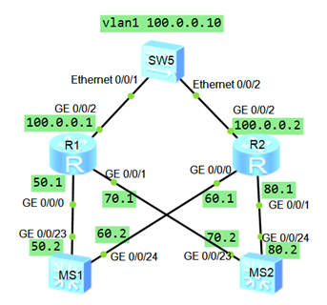
图-2

- R1
- <Huawei>system-view
- [Huawei]acl 2000
- [Huawei-acl-basic-2000]rule permit source any
- [Huawei]interface GigabitEthernet 0/0/0
- [Huawei-GigabitEthernet0/0/0]ip address 192.168.50.1 24
- [Huawei]interface GigabitEthernet 0/0/1
- [Huawei-GigabitEthernet0/0/1]ip address 192.168.70.1 24
- [Huawei]interface GigabitEthernet 0/0/2
- [Huawei-GigabitEthernet0/0/2]ip address 100.0.0.1 8
- [Huawei-GigabitEthernet0/0/0]nat outbound 2000
- [Huawei-GigabitEthernet0/0/2]quit
- [Huawei]ip route-static 0.0.0.0 0 100.0.0.10

- [Huawei]ospf
- [Huawei-ospf-1]default-route-advertise
- [Huawei-ospf-1]area 0
- [Huawei-ospf-1-area-0.0.0.0]network 192.168.50.0 0.0.0.255
- [Huawei-ospf-1-area-0.0.0.0]network 192.168.70.0 0.0.0.255

- R2
- <Huawei>system-view
- [Huawei]acl 2000
- [Huawei-acl-basic-2000]rule permit source any
- [Huawei]interface GigabitEthernet 0/0/0
- [Huawei-GigabitEthernet0/0/0]ip address 192.168.60.1 24
- [Huawei]interface GigabitEthernet 0/0/1
- [Huawei-GigabitEthernet0/0/1]ip address 192.168.80.1 24
- [Huawei]interface GigabitEthernet 0/0/2
- [Huawei-GigabitEthernet0/0/2]ip address 100.0.0.2 8
- [Huawei-GigabitEthernet0/0/0]nat outbound 2000
- [Huawei-GigabitEthernet0/0/2]quit
- [Huawei]ip route-static 0.0.0.0 0 100.0.0.10

- [Huawei]ospf
- [Huawei-ospf-1]default-route-advertise
- [Huawei-ospf-1]area 0
- [Huawei-ospf-1-area-0.0.0.0]network 192.168.60.0 0.0.0.255
- [Huawei-ospf-1-area-0.0.0.0]network 192.168.80.0 0.0.0.255

三层交换机如果看不到从路由器学习来的默认路由就去检查路由器G0/2地址是否配置，之后验证从内网可以访问外网设备，ping通证明项目升级成功

