**Evaluating HCI for a graphical user interface for regulating the bandwidth capacity and the priority between the information’s provider and consumer in a network system.**

Människa maskin kommunikation för ett grafiskt användarsnitt för att kunna reglera bandbredden och prioriteten mellan informationsproducenten och konsumenten i ett nätverk.

Jonas Ekman

**Degree project, in Electrical engineering**

**Ground level: 15 hp**

**Supervisor at KTH: Anders Cajander**

**Examiner: Thomas Lind**

**School of Technology and Health**

**TRITA-STH 20XX:XX**

**Royal Institute of Technology**

**School of Technology and Health**

**Häsovägen 11C**

**141 57 Huddinge**

**www.kth.se/sth**

**Abstract:**

**Keywords:**

**Sammanfattning:**

**Nyckelord:**

**Acknowledgements:**

**Abbreviations**

GUI – Graphic user interface

HCI – Human-computer Interaction

AI – Artificial intelligence

BFT – Blue Force Tracking

COP – Common Operational Picture

Voice – Streamed Voice

ISR – Intelligence, surveillance and reconnaissance

Video – Streamed Video

Msg – Command and control messages

Control – System Management traffic, e.g. authorities.

Table of contents

1. Introduction 8

1.1 Background: 8

1.2 Problem definition: 9

1.3 Goal: 9

1.4 Delimitations: 9

1.5 Related works 9

2. Theory and background: 10

2.1 Background information about the project: 10

2.1.1 Nodes 11

2.1.2 Reequipments for the GUI 12

2.2 Human-computer Interaction (HCI): 12

2.2.1 The different modes in HCI 12

2.2.1.1 Mode 1 Data Interaction 12

2.2.1.2 Mode 2 Image Interaction 12

2.2.1.3 Mode 3 Voice Interaction 13

2.2.1.4 Mode 4 Intelligent Interaction 13

2.3 The design process for a human computer interface 13

2.3.1 Structural Design / Seeheim model 13

2.3.2 Behavioural model 14

2.3.2.1 Goals Operators Method and Selection (GOMS) MODEL 14

2.3.2.2 Enhanced OAI Modelling 15

2.3.2.3 NGOMSL 16

2.3.2.4 Fitts’s Law 17

2.3.3 Important Design aspects 18

2.3.3.1 Determination of Design types of interaction 18

2.3.3.2 Ergonomics 18

2.3.3.3 Reducing the mistake of user 18

2.3.3.4 Identifiable and Operational design 19

2.3.3.5 Communicating between user and computer 19

2.3.3.6 Shortcuts 19

2.3.3.7 Feedback 19

2.3.3.8 Short term memory 19

2.3.3.9 Help function 19

2.3.4 Virtual Design 19

2.3.4.1 Light 20

2.3.5 Military Symbols 21

2.3.5.1 Colour 21

2.3.5.2 Identities and dimensions 21

2.3.5.3 Icon 22

2.3.5.4 Modifiers 22

3. Methods and Result 23

3.1 New HCI model 23

3.1.1 Task/Goal 23

3.1.2 Structure 23

3.1.3 Design 24

3.2 Prototype of the GUI 25

4. Analysis and discussion 25

5. Conclusion 25

6. Continuous work 25

7. Reference 25

1. **Introduction**

This thesis has been carried out on behalf of the C4I Solutions and Combat Systems at SAAB.

* 1. **Background:**

SAAB is one of the leading providers of military equipment and develops everything from air fighter to submarines. One of the most famous products for the public is their fighter jet JAS 39-gripen.

At SAAB, they have a department called C4I and Combat, one of their specialised in developing a communications system for the land forces.

One of the projects what are under development is a system witch nodes e.g. UAV, radar and military hospital. All the nodes are connected to a network and can communicate to each other. The nodes are both producer and consumer of different communications types e.g. video and tracing. The idea is that under some special situation some types of communication types will be more prioritized and have greater quality compare to other communications types. The system will be operated through a GUI there an operator will make these settings. A potential operator is a person at a leading position in the army.

* 1. **Problem definition:**

This thesis of this project is to investigate HCI models that can be used to create a new model that can be used to design a GUI, that will reduce the possibility of the user can configure the system wrong in a way. A potential user of the GUI is a person in a leading position e.g. army and will make inputs of the types e.g. occupy the hill or defend Gotland. The GUI must comply with standards for GUI and military equipment.

* 1. **Goal:**

The goal of this theses is to find a design based on scientific studies and standards about human-computer interaction to find a potential design of a GUI and to find a way for the user to configure the system easy and correct, i.e. as few errors from the operator.

* 1. **Delimitations:**

This thesis has been limited to investigate the human-computer interaction for a GUI for an operator with knowledge of the system but doesn't know the implications and the technical aspects for the system. It will only compare the Seeheim model as a structural model and GOMS and Enhanced OAI Modelling as the behavioural model.

* The prototyping GUI will be made in JavaFX
* No intervus whit potenilel users, because of the anlys of the HCI models.
* The prototype GUI will be created for an operator sitting at desktop with a mouse and keybord.
  1. **Related works**

There are no other similar products available on the market today, compare to the system SAAB has under development. But it’s many other who have dune recuse in how to make the complex system easy to use for the user. One study is about evaluating the GOMS model for human-robot interaction, without any participation from a potential user. There the goal was to create a GUI that would be easy to use(1). Another similar work is a study based on HCI for a smart home system. The goal was to find and an HCI model that could be used for designing the GUI for the system(2).

1. **Theory and background:**

This section is presenting the theory behind the project at SAAB and HCI.

* 1. **Background information about the project:**

The equipment what is used by the army is represented as nodes in this project, e.g. a node can be military hospital and UAV. At this state, it’s only 8 different nodes that are represented see table 1, but the system should be able to have more nodes. The idea is that under some situation in the army you need to be able to choose that kind of communication that are prioritised and which communication type e.g. video and BFT. A real situation is it needs to evacuate the wound soldiers, in that kind of situation it probably the video and voice communication between the medical and the soldier should have higher quality and priority in the network compared to the other nodes and interfaces. Because of the limitation of bandwidth of the backbone network all the different communication types which are in all the individual nodes cannot produce their service at the highest quality.

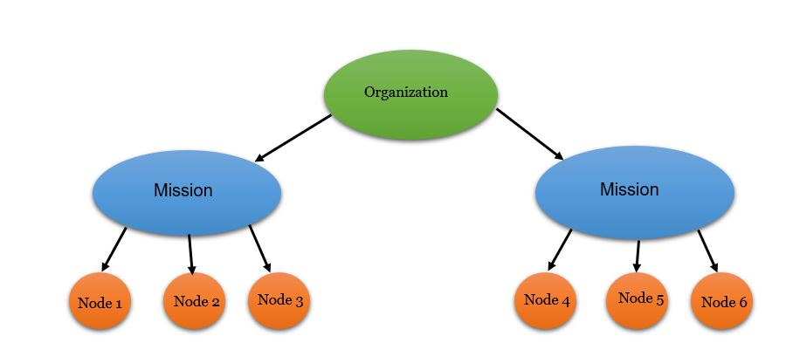The nodes will belong to an operation(mission) and is pre-defined from the order of combat. An operations is a mission to do something e.g. capture the hill and medical evacuate wound solders, and an operation

is belongs to an origination e.g. defend Gotland.

Figure 1 Tree of an orginasation

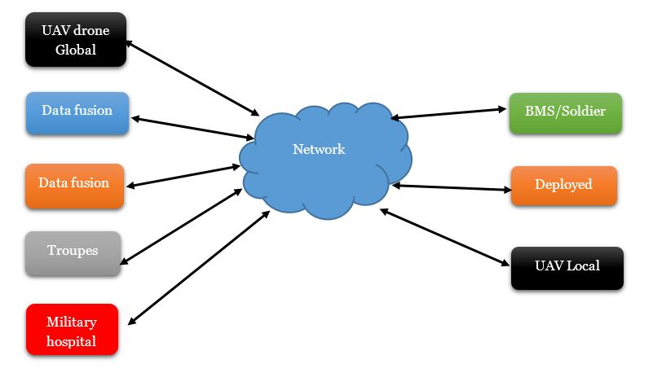

Figure 2 Potential network configuration

* + 1. **Nodes**

In this stage of the project, it only has 8 different nodes, and all of them are consumer and producer of different types of communication, e.g. Voice, Video and BFT. It will be more nodes in then the system is in use. The 8 nodes today are as follow:

|  |  |  |  |  |  |  |  |  |  |  |  |  |  |  |
| --- | --- | --- | --- | --- | --- | --- | --- | --- | --- | --- | --- | --- | --- | --- |
| Node/Interface | BFT | | COP | | Voice | | ISR | | Video | | Msg | | Control | |
| UAV Global | P | C | P | C | P | C | P | C | P | C | P | C | P | C |
| Data Fusion M | P | C | P | C | P | C | P | C | P | C | P | C | P | C |
| Data Fusion S | P | C | P | C | P | C | P | C | P | C | P | C | P | C |
| Troupes | P | C | P | C | P | C | P | C | P | C | P | C | P | C |
| Military Hospital | P | C | P | C | P | C | P | C | P | C | P | C | P | C |
| Soldier | P | C | P | C | P | C | P | C | P | C | P | C | P | C |
| Deployed | P | C | P | C | P | C | P | C | P | C | P | C | P | C |
| UAV Local | P | C | P | C | P | C | P | C | P | C | P | C | P | *C* |

Table 1 Table for the consumer (C) and producer (P) of the interface for the node

* + 1. **Reequipments for the GUI**

The requirements of the GUI are that the operator will be able to work at three different levels 1) Plan: the operator will be able to plan the operations, 2) Live: the operator will set setting that will be used in real-time and see at witch nodes and communications types the system don’t deliver the wished quality and priority. 3) Simulate: at this level, the operator will test set settings for the nodes and communication types and simulate if the network can deliver it, or if it needs more network equipment.

* Set priority and quality at one or a group of nodes at one operation.
* Set priority and quality at one or a group of communications types at one operation.
* Set priority and quality between two nodes in an operation.
  1. **Human-computer Interaction (HCI):**

An important part in creating a graphic user interface is the study about the relationship between the machine and human and calls human-computer interaction (HCI). The point of this is to find communications method that makes the input and output from the computer easy for the user. It also reduces the connectivity load of the user fundamentally and enhances the user to operate the system(3).

* + 1. **The different modes in HCI**

The implication of the GUI and HCI is to make the process of input and outputs information between the user and computer easy to use. Via the GUI the user sends instructions to the system, and the computer will respond to the user and will be different depended on the interaction mode. There are 4 different modes the user and the computer can interact with each other(3).

* + - 1. **Mode 1 Data Interaction**

Data interaction is an important role HCI, it is about put data to the computer and exchanges it. Most of the time the process between the human and computer: is that the computer asks the user to do a data input; then in respond the system generates feedback to the user which may be presented on the screen. Then the system receives data from the user if it’s any error. Depended on the different figures, graphs(4), menus is different ways of interactive data(3).

* + - 1. **Mode 2 Image Interaction**

Then human interacts whit a system, the message transmission is usually in three ways: language, words and image. From the information the human gets from the virtual system is 70% obtained from images(4).

* + - 1. **Mode 3 Voice Interaction**

Voice interaction is the interaction between the computer and the human, or other information facilities. It’s usually a tow way communication or interacts. The first one is when it is a system with voice recognition and understanding, which depends on it has a sender of the voice e.g. a human. The second one is the use of audio or voice to communicate to user e.g. it can be success or failure(3). From different studies, it has to be proven that the auditory signal detection is faster than the detection from virtual signals. Because of that, auditory signals are the most important information channel between the computer and the user.

* + - 1. **Mode 4 Intelligent Interaction**

The implementation of AI in GUI will be next generation in HCI. That could lead to the machine can communicate to the user by voice and data interaction and will learn from the behave of the user, and adapt to user’s needs(3).

* 1. **The design process for a human computer interface**

The design process of HCI for GUI can be developed from a different perspective. If the study in HCI is from the perspective of the structure of the system, it called structural model e.g. Seeheim model(2). The structural is most of the time divided into three categories e.g. specification, dialogue control and application interface(5). If the study is from by analysing the potential users’ reaction and characteristics, then are called behavioural model e.g. GOMS and Enhanced OAI –model. Behavioural model can be described in a variety of formats and models.

* + 1. **Structural Design / Seeheim model**

The Seeheim model is a structure based model and the perspective of the development is of the structure of the system and not the user. Developing process of the model is often divided into 3 steps(5).

* ***Presentation:***This state is to define the internal mapping of basic symbols. The input from the user is translated to numbers of basic symbols. For making a dialogue between the user and the system(5).
* ***Dialogue Control****:* This state is to define the structure of the dialogue between the user and the application program. It also has the responsibility for routeing the basic symbol to the appropriate part of the system/application.
* ***Application interface:*** This state is the repatriation is the view of the application semantics that is provided as the interface (6).

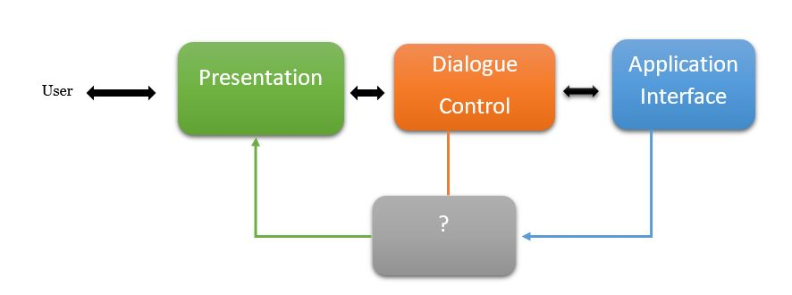

Figure 3 Seehiem model

The box mark “?” is there to allow rapid semantic feedback. An example of that can be freehand drawing and highlight the trash pin on Apple Macintosh when a file is over the symbol(6).

* + 1. **Behavioural model**

The behavioural model is by studying the potential users’ reaction and characteristics. It’s a lot of different models to use the analysing the user, this paper is only analysing few of them.

* + - 1. **Goals Operators Method and Selection (GOMS) MODEL**

The GOMS model is a method used for to analyse the user’s knowledge of how to use a special task, in terms of goals, operations, methods and selection(7). GOMS model analyse can also be done then a company want to buy new software program or creating a new, it many examples of companies who halved saved millions of dollars, e.g. NYNEX who used GOMS before buying new software, and the conclusion was the new software was inefficient compared to the program the used(6).

***Goals:*** This section is to analyse the goals of the system, in terms of what does he or she want to accomplish by using the software? Do the goal need to be accomplished in the next day, the next few mints, the next few seconds? (7).

***Operations:*** This section is to analyse the action user can is allowed to do by the software. In the begin of using computers, the operator controlled the software by typing in commands at the keyboard. Now is the operation with GUI the e.g. menu section, Butten presses and speaking the commands(7).

***Methods:*** This section is to analyse well-learned sequences. The well-learned sequence is then the user is using sub-goals and operations to accomplish a goal. The classic example of this is then you are deleting a text, you can place the cursor at the binding of the text, and holds the mouse button down and drag it to end of the text, and then hits the delete key. It can also be accomplished by placing the cursor at the end of the text and then hits the delete key(7).

***Selection:*** If it’s more than one method is available to use to accomplice a single goal. The user has more the one way to accomplice the goal and can choose it by himself(7).

* + - 1. **Enhanced OAI Modelling**

The original OAI model identifies the possible action in a system, by representing each action in the form of the interface object. The connection between the action and the object is (1 to 1) correspondent(8). Enhanced OAI model is the same as the original OAI but it adds interface response. The OAI model is a state machine and can only switch state then the condition is meet.

***Interface Object(O):***GUI is build up whit e.g. buttons and dialogue boxes. That can chance its state by specifying the action. Interface objects must have virtual affordance, and design constraints and with natural mapping. Virtual affordance is for the user to recognise the object to do a specific task, e.g. the handle on a teacup represent obvious affordance for holding. A design constrains it to limit the user’s action for an interface object. Natural mapping is for the user to understand the structure related to an object(8).

***Interface Action(A):*** Is the associated with an interface object, and is the user’s conceptual model of an interface object(8). Interface actions is also decomposable into lower-level actions, e.g. saving a file, there are many steps involved: set a file name and then write to memory(9)

***Interface Responded(R):*** Is the respond associated each interface object. The interface object is representing the behaviour of an interface action, and the representations of that action are interface respond(8).

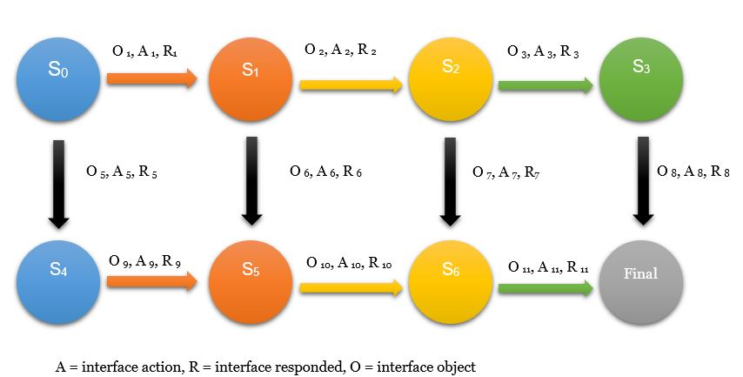

Figure 4 State machine for enhanced OAI model

This state machine works as following: the system is starting from state S0. A change of state is happening it's performing a type of action (Ax) on a specific type of object (Ox), and as a respond of the new state, it will respond with a type of respond Rx. If the design has natural mapping, virtually constraints and affordance will guide the user to perform right actions by choosing a right action which is associated with an object(8).

* + - 1. **NGOMSL**

Natural GOMS Language is a part of the GOMS family and is based on cognitive complexity theory (CCT). It’s suitable for application that is practical, and it contains the procedure for developing GOMS model. Because of the NGOMSL are in program form, it opens the possibility to make the method structuring very clear, and can represent general methods(10).

The technique for constructing NGMSL model is a top-down method. The top-level goals for the user are transformed into methods, and the methods can methods again until the methods only contain the operators e.g. button, moving the cursor(10). Every goal and sub-goals are constructed up by pseudocode.

Because of NGOMSL is based on CCT, it can constrain some the ability to estimate the time it takes for the user to learn the how to use it, and the estimated time it takes for execution(10).

In the NGOMSL model is it possible to estimate the time it requires to learn to use the GUI. The estimation Is based on the numbers of NGOMSL statements and a constant called *“Learning time parameter”* there the value is 30 sec for rigorous procedure training or the constant can be 17 sec for a typical learning situation.

$$Pure Method Learning Time=Learning Time Parameter* Number of NGOMSL statements to be learnd$$

Equation 1 NGOMSL formula to estimate learning time

By using NGOMSL it’s possible to estimate the time is requires memorizing the information in the long-term memory. It can be accomplished by using the Model Human Processor parameters, there the value is 10 sec/chunk is the time it takes to save LTM. There chunks are used to represented how complex a method is.

Execution time can be used to predict the time it takes to execute a method. The estimation can only be done on a specific task because only then it the number of steps and operates be determined.

$$Execution Time=NGOMSL statment time+Primitiv External Operator Time+Analyst-defined Mental Operator Time+Wating Time$$

* NGOMSL Statement Time: Number of statements executed * 0,1 sec.
* Primitive External Operator: Total of times for primitive external operators
* Analyst-Defined Mental Operator Time: Total of times for mental operators defined by the analyst
* Waiting Time = Total time when user idle while waiting for the system.
  + - 1. **Fitts’s Law**

Fitts’s Law is a model used to predict the time it requires to move to point at a target, based on the object’s size and the distance. The law was developed to find a model that could describe the relationship between the speed and accuracy moving towards a target on a display. It has shown that the Fitts’s law has been useful for deciding where to locate the digital objects on the screen, and what size it should be, also the distances between them(11).

Fitts’s Law equation is as follow:

$T=k*\log_{2}{(\frac{D}{S}+1)}$

Equation 2 Formula for Fitts’s Law

* T = average time to complete the movement
* k = Is a constant different dependent on the system, and most of the time approximately 200 ms/bit.
* S = Size of the object.
* D = the distance between the starting point and the centre of the object.

Fitts’s Law has been found useful to decide where to locate objects on the screen and the relations to other objects. The law also predicts that the 4 corners of the screen are the places that are quickest to access. Fitts’s law was used to help the designer predict the position and the sizes of the 12-keycell phone keypad(11).

* + 1. **Important Design aspects**

Any product is a connection between a human and a system, the goal of this connection is to make the dialogue between the user and computer harmonious. The problem is to make the several processes e.g. feedback of the information, mutual transmission, mutual understanding and mutual recognition. When using human- computer interface design, the core and its content is the interactive design(3).

* + - 1. **Determination of Design types of interaction**

By identifying the characteristics of the user and, the task and environment of the system. Including identifying the task of HCI and an estimating the support the interaction needs and the complexity of interaction, is a method to find the most suitable interaction(3).

* + - 1. **Ergonomics**

By creating an ergonomic GUI and HCI the workload of the user will be less. The more the system and computer can do, the less workload of the user it will be, and the design will be better. By using a combination of humans and computer will effectively ensure the life of the system is longer but also the reliability(3).

* + - 1. **Reducing the mistake of user**

To achieve a GUI where the user doesn’t make as much mistake, it’s important that the make it understandable. By using similar interface appearance, layout, a similar mode of interaction and similar information display, it will reduce the burden of the user. Because the user is already familiar with the design and the reaction, i.e. the user will not have to learn and memorise a new design(3).

* + - 1. **Identifiable and Operational design**

The design of the interface should be simple and understandable, and the using of colour is the best effect of showing. Other ways to conveying information are the use of icons, graphs, language e.g. menus, windows, recycle bin, documents, folders, tool box. It also needs to be designed without any culture and religious barriers, to make the interface universal(3).

* + - 1. **Communicating between user and computer**

If a user by mistake is manipulating the system, the system should inform the user. Or to prevent an incorrect input the can make confirmations from the user(3).

* + - 1. **Shortcuts**

For the user in an easy and fast way can find information in a large amount of data a search function, or by using a scroll bar window. Other shortcuts should be provided to the user, based on the user’s different experience or motive(3).

* + - 1. **Feedback**

Then the user is using the interface the user should have a respond to the operations. The feedback can be presented in different ways e.g. texts, graphics and sound(3).

* + - 1. **Short term memory**

Short term memory is a kind of memory that can be referred to as a scratch pad, to save temporarily information. The memory can be access to rapidly, at 70ms, but the saved information can only be kept in 200ms. Then remembering a phone number or a sequence of the number you usually remember it in parts, the average person can only remember 7+-2 digits. This aspect is imported in the designing of the system(6).

* + - 1. **Help function**

For the user to be able to find the GUI easy to understandable and effective, the interface should provide simple and standard help operation. All the operations based on HCI should have a help function. The help function and the content should be based on the knowledge of the user, and by using understandable terms and language to provide the content useful(3).

* + 1. **Virtual Design**

Virtual design is a purpose to make the design easy to use and understandable for the user. The design is based on the psychology of light and the sensory organ of the target group of users. Virtual design includes e.g. the choice of colour, a method to present graphics and image, front design, page layout. According to Gong Chao paper is based on fooling principles(3)

* With the clear and coherent interface, it allows users to customise the contents of the interface.
* To enhance computer’s function of memorising and reduce user’s burden of short-term memory.
* To provide more functions as default, undo and redo.
* To provide more interface shortcuts.
* Icon design should respect the past using the experience of the user.
* To enhance visual stimulate of graphics symbol through the application of colour. Different colours give us different feeling, check this on the following table.
* To improve the clarity of the visual symbol and make the picture, layout of words and metaphors easy to understand and identify.
* Make the whole colour of interface within five colour system and minimise the use of red and green. Similar colours should be used in icons on behalf of similar meanings.

|  |  |
| --- | --- |
| Colour | Psychological reaction |
| Red | Fervency, peril, spark… |
| Orange | Warm, joy, envy … |
| Yellow | Sunshine, hope, cheerfulness, commonness… |
| Green | Pace, safety, growth, greenness … |
| Blue | Equability, mind … |
| Purple | Elegance, dignity, weightiness, mystery |
| Black | Solemnity, vigorous, fear, death … |
| White | Immaculate, holiness, lustration, sunshine… |
| Grey | Commonness, chill, modesty… |

Table 2 Psychological reaction of colours (3)

* + - 1. **Light**

Brightness is the amount of the light reflected from an object, and the reflection is measured by the amount of luminance. The Brightness in displays that are used today is also measured in luminance. By using a display with high luminance will increase the visual activity of the user. The negative part is the by using higher luminance will also increase the amount of flicker. It will only appear if the screen is switched less the 50 Hz if it’s higher the eye will think it’s on(6).

* + 1. **Military Symbols**

The design of a symbol is the reprotection of an action in the system. There are today different types of standard that have a predefined different design to represent different actions. In the military are different standards for icons, there are NATO’s and USA’S have different designs. In the NATO, standard APP-6(C) is describing the symbols in these following states.

* + - 1. **Colour**

In military symbols, the colour the object has is inside or at the boundary has different meanings.

|  |  |  |  |
| --- | --- | --- | --- |
| Description | Hand-Drawn | Computer Generated  (ICON) | (FILL) |
| Friend | Blue | Cyan  RGB:(0,255,255) | Crystal Blue  RGB:(128,224,255) |
| Neutral | Green | Neon Green  RGB:(0,255,0) | Bamboo Green  RGB:(170,255,170) |
| Hostile | RED | RED  RGB: (255,0,0) | Salmon  RGB: (255,128,128) |

Table 3 Colour specification from APP-6(C)

* + - 1. **Identities and dimensions**

Dimensions and identities symbol is representing a mission area for the object within the operational environment. An object can have a mission area in air, land and sea or booth under and over the earth’s surface. To make it easy all the different objects with is representing a mission is represented with its own dimension, e.g. following objects

|  |  |  |
| --- | --- | --- |
|  | Sea Surface | Air |
| Friend |  |  |
| Hostile |  |  |
| Neutral |  |  |

Table 4 Examples of dimensions for some area and objects

* + - 1. **Icon**

The icon is the paces at the innermost part in a symbol, which represents a units, equipment, installations, activities and operations. An example of an icon is the representation of Medical:

* If you put the icon into dimensions:

|  |  |  |
| --- | --- | --- |
| Friendly | Hostile | Neutral |
|  |  |  |
| Medical | Medical | Medical |

Table 5 Example of full frame icon

* + - 1. **Modifiers**

A modifier provides additional information about the icon e.g. unit, installation or activity. The modifiers are placed either at the top or button inside the frame.

* + 1. **Standards**
    2. **Cogulator**

1. **Methods and Result**

In this chapter, the method and techniques that are used in design of the new HCI model and the prototype of the GUI is explained.

* 1. **New HCI model**

From the study of the difference HCI models in chapter 2, the result is that neither of them is taking care of that the user doesn’t configure the system in the right and the focus of the models was in different area e.g. Fitts’s law to estimate the time based on the distance and size of the object, the same functoriality to estimate the time is also in NGOMSL but there are the steps pre-defined and don’t take care of the distance.

The idea is to mix the OAI, NGOMSL model and Fitts’s Law. OAI model is based on a state machine and can’t move to the next state until the previses state is don. That can be used to be certain that the user has config the system or done the goal in the right way. NGOMSL is a god way to divide the goals for the system to higher level goal and sub-goals, the idea is what the higher-level goals is representing a state machine and the sub-goals is representing the states in the state machine, e.g. the high- level goal is that the user will set 2 settings, each of this setting is representing the one state in the state machine, the user as to config this two settings before the high- level goal is accomplished. The Fitts’s law can be useful to estimate the time it takes to for the user to move and the size of the object. Together with the NGOMSL and Fitts’s law can an estimation the time it takes to perform the states. The design process can be divided in to 3 steps: Task/Goal, Structure, Design time.

* + 1. **Task/Goal**

The task and goal step is to define that is the goals with the GUI and what the user will be available to do. To define the task/goals of a system a good way is to follow the NGOSML model to define the high level

To analyse the task of the system

* + 1. **Structure**

From higher-level goals and the sub goal is representing whit states machines. The higher-level goals are representing whit its own state machine and the sub goals is the states inside the state machine and need to be accomplished to reach the end goal.

From this type of structuring whit interface Object, interface action and interface respond the connection between all these steps Is accomplish. Then the system chance its state it will give the user feedback ether that is has changed its state or not.

* ***Interface Object(O****):* is the object that are on the GUI and is representing to a special action and the commands in NGOMSL language what represents the users action on the GUI e.g. click. The design of the object must have virtual affordance to provide looks and feel reequipments for a specific type and action, to reduce the possibility that the user will think the object dose another action. Placing of the object must be in natural mapping also to reduce the risk that the user think the object will be done on the wrong task e.g. wrong origination and mission.
* ***Interface action(A):*** is the operation done by the interface object applied by the operator. The action is applied to the system.
* 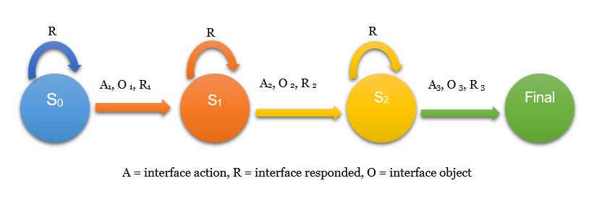***Interface Respond(R):*** is the response from the sate machine has chanced is state to a new state, and send the respond to the user.

Figure 5 Example of state machine from start to the goal of a task

* + 1. **Design**

The design is one of the most important aspects in the in the HCI, because it’s there the user will work and must be design so the work load of the user is so small as possible. Neither of the previous is taking account of how the design and where the different buttons and menus will be pleased and the size of that. Bu using the Fitts’s law the time it takes for the user to move the cursor from the previous position to the finish position, based on the calculation of size of the object and the distant from the start and finish position.

* 1. **Prototype of the GUI**

1. **Analysis and discussion**
2. **Conclusion**
3. **Continuous work**
4. **Reference**

1. Drury JL, Scholtz J, Kieras D, editors. Adapting GOMS to model human-robot interaction. 2007 2nd ACM/IEEE International Conference on Human-Robot Interaction (HRI); 2007 9-11 March 2007.

2. Zhao X, Zhou C, Huang W, editors. Smart home power management system design based on human-computer interaction model. Proceedings of 2013 3rd International Conference on Computer Science and Network Technology; 2013 12-13 Oct. 2013.

3. Chao G, editor Human-Computer Interaction: Process and Principles of Human-Computer Interface Design. 2009 International Conference on Computer and Automation Engineering; 2009 8-10 March 2009.

4. Yang X, Chen G, editors. Human-Computer Interaction Design in Product Design. 2009 First International Workshop on Education Technology and Computer Science; 2009 7-8 March 2009.

5. ten Hagen PJ. Critique of the Seeheim model. User Interface Management and Design: Springer; 1991. p. 3-6.

6. Dix A, Finlay JE, Abowd GD, Beale R. Human-Computer Interaction (3rd Edition): Prentice-Hall, Inc.; 2003.

7. John B. Why GOMS? interactions. 1995;2(4):80-9.

8. Rashid U, Niaz IA, Amin MW, Bhatti MA, editors. Designing interactions using OAI model: A new interface modeling paradigm. 2009 International Conference on Emerging Technologies; 2009 19-20 Oct. 2009.

9. Shneiderman B, Plaisant C, Cohen M, Jacobs S. Designing the User Interface: Strategies for Effective Human-Computer Interaction: Addison-Wesley Publishing Company; 2009. 624 p.

10. John BE, Kieras DE. The GOMS family of analysis techniques: Tools for design and evaluation. DTIC Document; 1994.

11. Preece J, Rogers Y, Sharp H. Interaction Design: Beyond human-computer interaction. John Wiley & Sons; 2015.