TITANIC
Survival Prediction
An interpretable Decision Tree classifier using Pandas and scikit-learn
Project detail | Description
Prepared by | [Your Name]
Objective | Predict passenger survival using Pclass, Sex, Age, and Fare.
Tools | Python, Pandas, scikit-learn, Matplotlib, pytest
Dataset | Titanic - Machine Learning from Disaster (labelled training set)

Executive summary
This project builds a supervised classification pipeline to predict the Titanic passenger survival label. After imputing missing values and encoding the categorical Sex feature, a shallow Decision Tree was trained on 712 passengers and evaluated on a separate set of 179 passengers. The model achieved 79.3% validation accuracy, compared with 61.5% for a simple majority-class baseline. The feature-importance analysis ranked Sex first, followed by Pclass.

Key results
Metric | Result | What it tells us
Validation accuracy | 79.3% | Share of held-out passengers classified correctly.
Balanced accuracy | 76.7% | Average recall across the two classes.
Precision (survived) | 77.6% | When predicting survival, how often the prediction was correct.
Recall (survived) | 65.2% | Share of actual survivors identified by the model.
Majority baseline | 61.5% | Accuracy from always predicting the more common class.

Note: these scores are from one stratified 80/20 holdout split with random seed 42. They are not a guarantee of performance on other data.

1. Dataset and preparation
Exploring the data, choosing features, and handling missing values
The project uses the labelled Titanic training table. It contains 891 passenger rows and a binary target, Survived. A value of 0 means the passenger did not survive; 1 means the passenger survived. The raw dataset is not bundled in the repository; the README explains how to download train.csv from Kaggle.

Selected inputs
Feature | Type | How it is used
Pclass | Numeric / ordinal | Passenger ticket class (1st, 2nd, or 3rd).
Sex | Categorical | Converted into one-hot encoded numeric indicator columns.
Age | Numeric | Missing values are replaced with the training-set median.
Fare | Numeric | Passenger fare; missing numeric values would be median-imputed.
Survived | Target label | 0 = did not survive; 1 = survived.

Initial data checks
- Rows loaded: 891; training split: 712; validation split: 179.
- Survival classes: 549 did not survive and 342 survived.
- Age has 177 missing values in the selected feature columns. Pclass, Sex, and Fare have no missing values in the included run.
- The split is stratified, so the class proportions stay broadly similar in the training and validation sets.
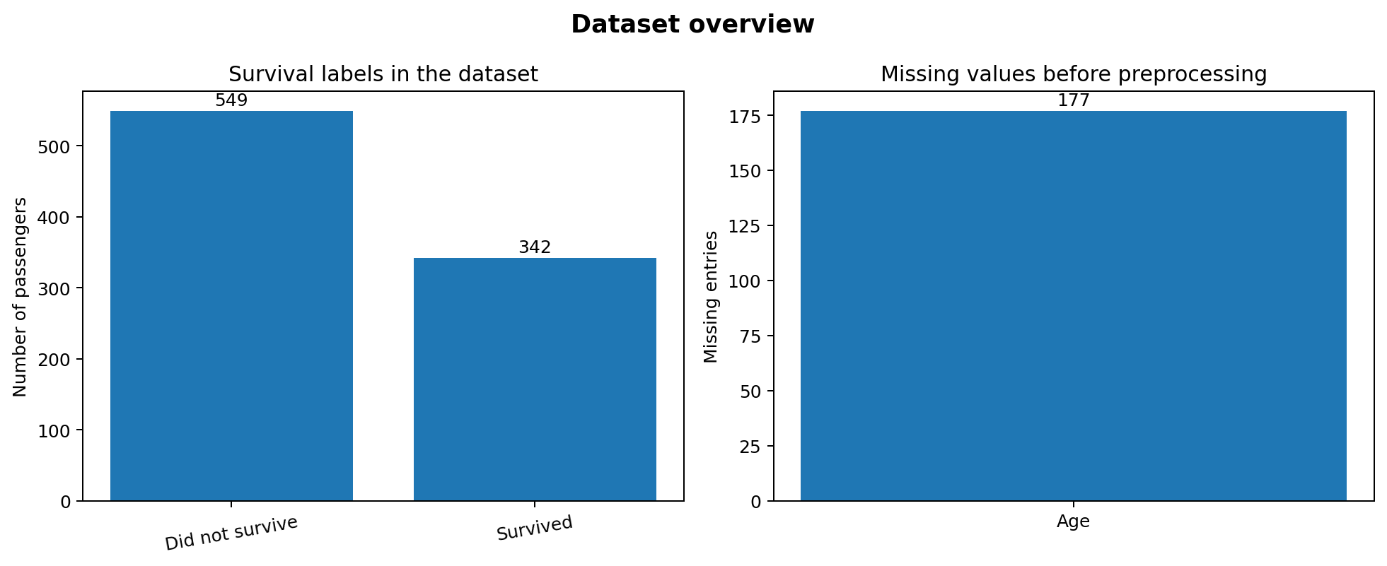
Figure 1. Target distribution and missing values before imputation.

Preprocessing
A scikit-learn Pipeline and ColumnTransformer keep the preprocessing steps attached to the classifier. Median and most-frequent values are learned from the training split only, reducing the risk of validation-data leakage. Sex is one-hot encoded; unknown categories are safely ignored by the encoder.

2. Training and evaluation
A held-out evaluation measures how the trained tree performs on unseen rows
The classifier is a DecisionTreeClassifier using Gini impurity, maximum depth 3, minimum 8 samples per leaf, and random_state=42. The shallow tree is intentionally chosen to make the learned rules easier to inspect and explain. The split uses 80% of the rows for training and 20% for validation.

Evaluation results
Metric | Value
Accuracy | 0.793 (79.3%)
Balanced accuracy | 0.767 (76.7%)
Precision for survival class | 0.776 (77.6%)
Recall for survival class | 0.652 (65.2%)
F1-score for survival class | 0.709 (70.9%)
Majority-class baseline accuracy | 0.615 (61.5%)

Confusion matrix
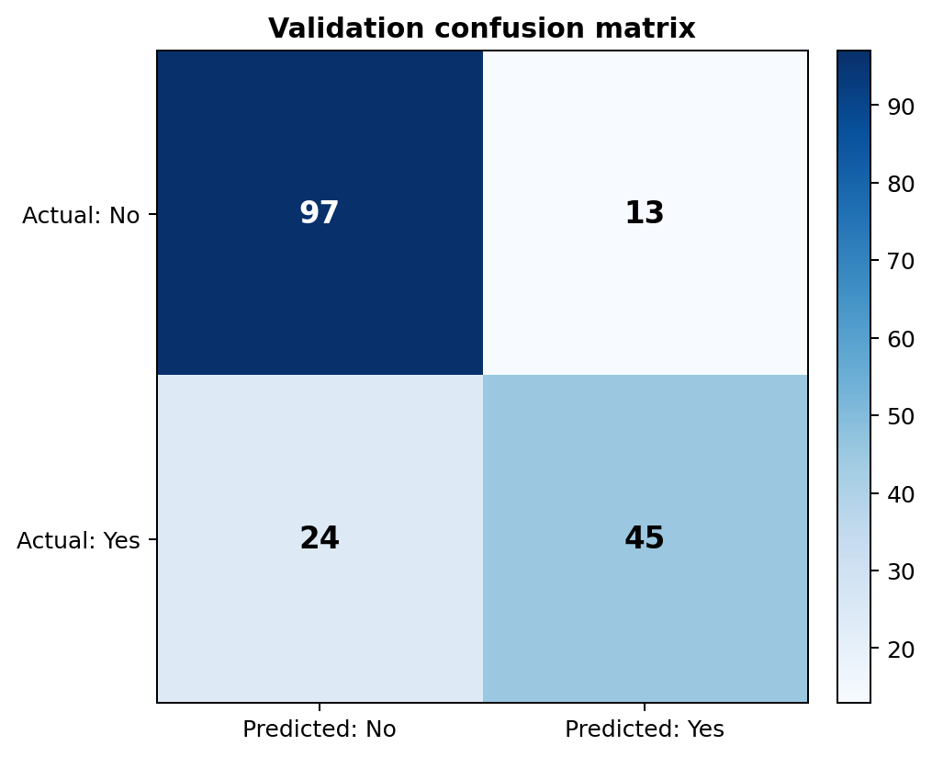
Figure 2. Correct and incorrect predictions on the 179-row validation set.
The matrix contains 97 true negatives (correctly predicted non-survivors), 13 false positives (predicted survivors who did not survive), 24 false negatives (survivors missed by the model), and 45 true positives (correctly identified survivors). The model identifies many non-survivors correctly, but it still misses some actual survivors; this is why accuracy should be read together with recall and F1-score.

3. Which features matter most?
Feature importance aggregates the encoded Sex columns back into one original input
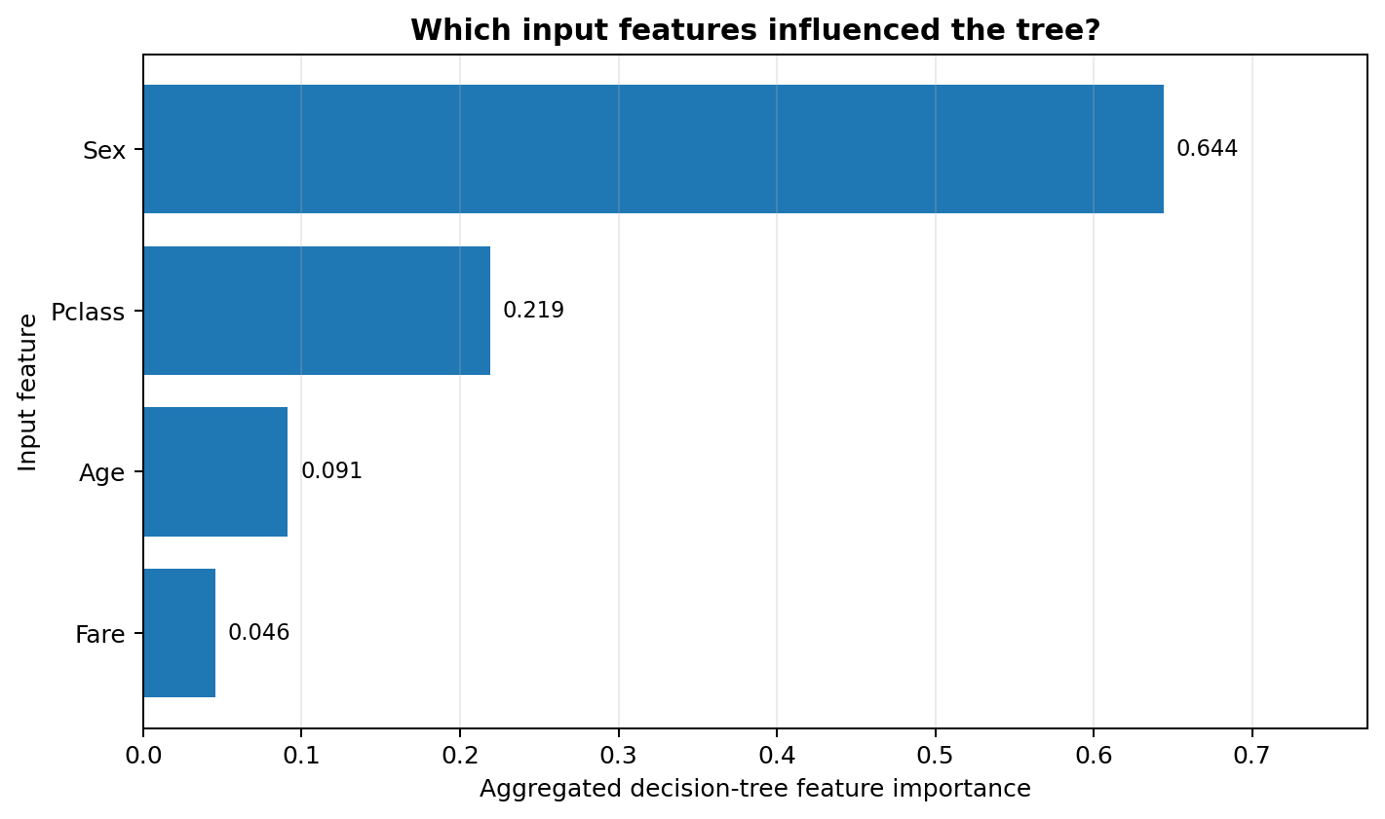
Figure 3. Aggregated decision-tree feature importance for the four selected inputs.
Rank | Feature | Importance | Interpretation
1 | Sex | 0.644 (64.4%) | Largest contribution to impurity reduction in this fitted tree.
2 | Pclass | 0.219 (21.9%) | Passenger class is the second strongest input in this run.
3 | Age | 0.091 (9.1%) | Adds some extra separation between passenger groups.
4 | Fare | 0.046 (4.6%) | Contributes less than the other selected features in this tree.

Finding
In this run, Sex is the most important feature, followed by Pclass. The model suggests that these variables help distinguish survival outcomes in this dataset. Importance scores are specific to the selected model and split; they do not prove that a feature caused an outcome or describe every passenger’s circumstances.

4. Inspecting the model and reproducing the work
The tree visualisation makes the learned threshold rules visible
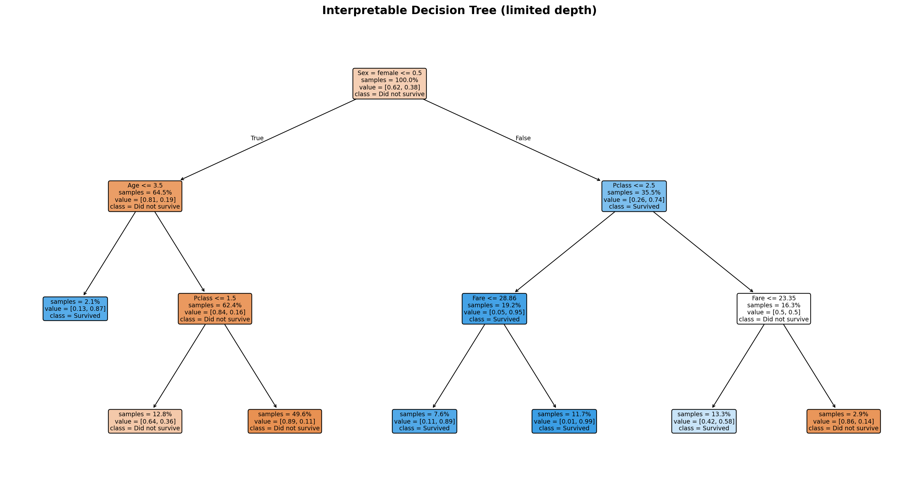
Figure 5. Learned Decision Tree. Each internal node represents a threshold test; each leaf gives a predicted class.

How to reproduce the project
- Download train.csv from https://www.kaggle.com/competitions/titanic/data and place it at data/train.csv.
- Install Python 3.10+ and run: python -m pip install -r requirements.txt
- Run from the project root: PYTHONPATH=src python -m titanic_tree.train (Windows PowerShell: set $env:PYTHONPATH = "src" first).
- Inspect reports/metrics.json, reports/SUMMARY.md, reports/figures/, and reports/classification_report.txt.
- Run tests with PYTHONPATH=src pytest -q. Use src/titanic_tree/predict.py to try a sample passenger after training.

Limitations
- The dataset is small and historical; this model is for learning, not for safety-critical use.
- A single holdout split gives one performance estimate. Cross-validation or repeated experiments would give a more stable picture.
- Only four selected features are used. Additional passenger or family information could change model performance.
- Feature importance is not causation, and the model can make incorrect predictions.

References
- Kaggle, Titanic - Machine Learning from Disaster: https://www.kaggle.com/competitions/titanic/data
- scikit-learn, DecisionTreeClassifier: https://scikit-learn.org/stable/modules/generated/sklearn.tree.DecisionTreeClassifier.html
- scikit-learn, Pipeline and composite estimators: https://scikit-learn.org/stable/modules/compose.html
Before final submission, replace [Your Name], rerun the program with your downloaded Kaggle file, and ensure the public GitHub repository and shareable Google Docs document are accessible to the reviewer.

