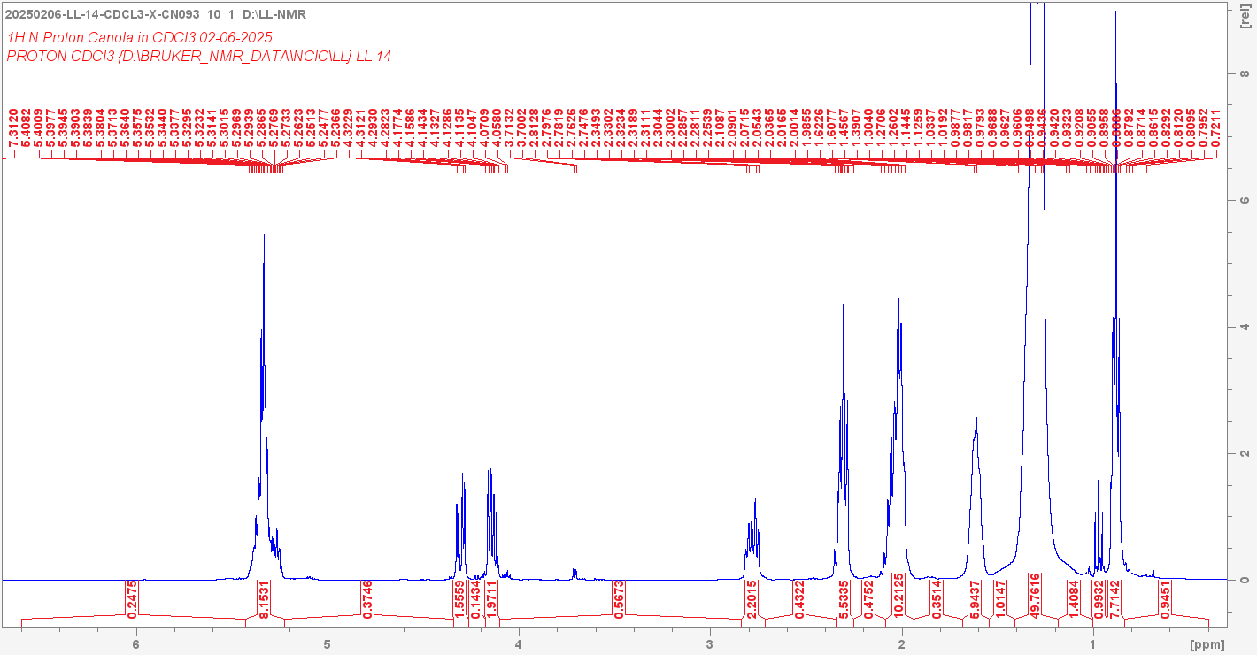

Current data set:

NAME =20250206-LL-14-CDCL3-X-CN093 EXPNO = 10 PROCNO = 1

DATPATH = D:/LL-NMR

Number Integrated Region Integral

1 6.600 5.428 0.247467

2 5.428 5.224 8.15314

3 5.224 4.341 0.374563

4 4.341 4.262 1.55591

5 4.262 4.175 0.143382

6 4.175 4.100 1.97106

7 4.100 2.837 0.567256

8 2.837 2.715 2.2015

9 2.715 2.344 0.432183

10 2.344 2.253 5.53345

11 2.253 2.088 0.475224

12 2.088 1.938 10.2125

13 1.938 1.685 0.351442

14 1.685 1.543 5.94368

15 1.543 1.409 1.01474

16 1.409 1.184 49.7616

17 1.184 1.002 1.40838

18 1.002 0.927 0.993186

19 0.927 0.837 7.71418

20 0.837 0.400 0.94514

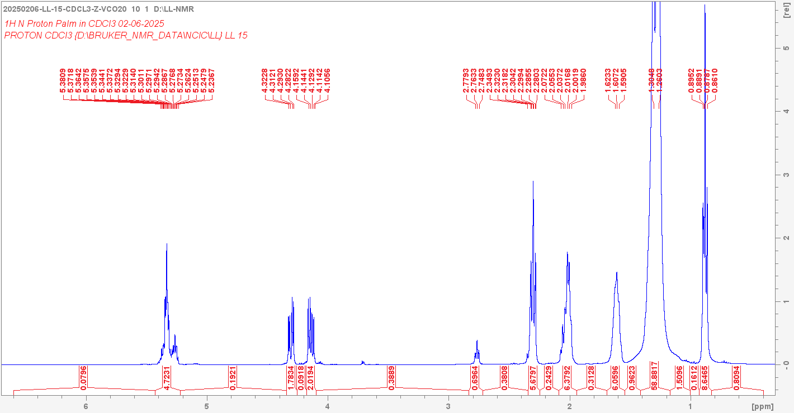

Current data set:

NAME =20250206-LL-15-CDCL3-Z-VCO20 EXPNO = 10 PROCNO = 1

DATPATH = D:/LL-NMR

Number Integrated Region Integral

1 6.600 5.428 0.0795995

2 5.428 5.222 4.72308

3 5.222 4.341 0.192053

4 4.341 4.253 1.78335

5 4.253 4.176 0.0917593

6 4.176 4.095 2.0194

7 4.095 2.835 0.388851

8 2.835 2.718 0.696374

9 2.718 2.346 0.380832

10 2.346 2.249 5.67971

11 2.249 2.092 0.242872

12 2.092 1.943 6.37919

13 1.943 1.692 0.312778

14 1.692 1.543 6.05955

15 1.543 1.413 0.962253

16 1.413 1.171 58.8817

17 1.171 1.002 1.50957

18 1.002 0.929 0.161217

19 0.929 0.828 8.64649

20 0.828 0.400 0.809376

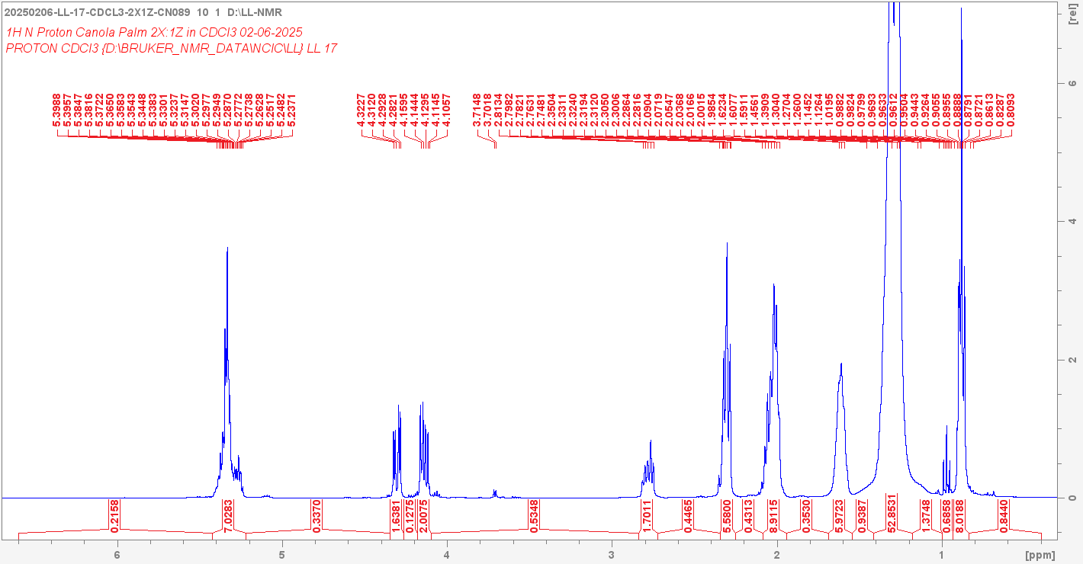

Current data set:

NAME =20250206-LL-17-CDCL3-2X1Z-CN089 EXPNO = 10 PROCNO = 1

DATPATH = D:/LL-NMR

Number Integrated Region Integral

1 6.600 5.426 0.215819

2 5.426 5.223 7.02834

3 5.223 4.345 0.337042

4 4.345 4.264 1.63807

5 4.264 4.178 0.127467

6 4.178 4.097 2.00752

7 4.097 2.841 0.53484

8 2.841 2.723 1.70113

9 2.723 2.345 0.446527

10 2.345 2.252 5.58

11 2.252 2.085 0.431288

12 2.085 1.943 8.91149

13 1.943 1.687 0.352989

14 1.687 1.544 5.97233

15 1.544 1.414 0.938678

16 1.414 1.179 52.8531

17 1.179 1.000 1.3748

18 1.000 0.935 0.685757

19 0.935 0.837 8.0188

20 0.837 0.400 0.84401

