System Requirements Specification

for

Low-Cost Laser Communications

Version 1.0.1

Prepared by:

Sean Huber

Dylan Koch

Cameron Martinez

Dominic Steiner

Matthew Simms

Jarod Siglin

October 4th, 2022

Table of Contents

Table of Contents ii

Revision History ii

1. Introduction 1

1.1 Purpose 1

1.2 Intended Audience and Reading Suggestions 1

1.3 Product Scope 1

2. Overall Description 1

2.1 Product Perspective 1

2.2 Product Functions 2

2.3 User Classes and Characteristics 2

2.4 Operating Environment 2

2.5 Design and Implementation Constraints 3

2.6 User Documentation 3

2.7 Assumptions and Dependencies 3

3. External Interface Requirements 3

3.1 User Interfaces 3

3.2 Hardware Interfaces 3

3.3 Software Interfaces 3

3.4 Communications Interfaces 4

4. System Features 4

4.1 Automatic Transmit and Recieve 4

5. Other Nonfunctional Requirements 4

5.1 Performance Requirements 4

5.2 Safety Requirements 4

5.3 Security Requirements 4

5.4 Software Quality Attributes 4

5.5 Business Rules 5

6. Other Requirements 5

Appendix A: Glossary 5

Revision History

|  |  |  |  |
| --- | --- | --- | --- |
| **Name** | **Date** | **Reason For Changes** | **Version** |
| Matthew Simms | 10/4/2022 | Initial Release | 1.0 |
| Sean Huber | 10/7/2022 | Minor updates to software aspect | 1.0.1 |

# Introduction

The product is designed to be a low-cost alternative for optical communication system (OCS) satellites. Previous endeavors in the field can be fully utilized in order to lessen the financial burden of creating a new OCS along with using as many commercial-off-the-shelf components (COTS). Additionally, the project is geared more towards an educational mindset, with the long-term goals of commercial viability.

## Purpose

This document is intended to cover all the design requirements for the project associated with low-cost OCS. The associated hardware to interact with the software and user is COTS.

## Intended Audience and Reading Suggestions

The intended users for this project are universities, communication, and aerospace companies.

## Product Scope

This project aims to deliver a system capable of transmitting data using an optical communication method. The product will be able to transmit live video stream over free space using an optical communication system, which consists of a laser and a laser receiver. Using COTS components, the intent is to deliver a system which is simple enough to provide a learning tool for educational scenarios, but also advanced enough that it challenges standard hobbyist projects. Ultimately, this project has the potential to be used as a base for small-scale satellite communication, such as in a CubeSat or similar satellite project.

# Overall Description

This section describes the system from a high-level view. This section describes the overall idea of the product, as well as functions, users, environments, and constraints and dependencies.

## Product Perspective

The OCS is a product designed to offset the high cost of satellite and communications development for transmission and receiving data through free space.

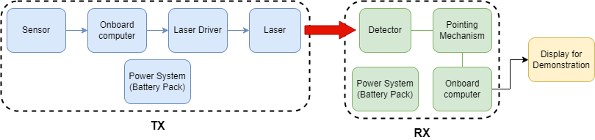**Figure 2.1.1 System Configuration.**

## Product Functions

2.2.1 The system shall use the onboard computers to process input signal data.

2.2.2 The system shall use a laser to transmit the data through free space.

2.2.3 The laser receiver shall receive the transmitted signal.

2.2.4 The system shall transcode the received signal back into usable data.

2.2.5 The system shall finally display the received data in a user-understandable format as a video stream on a hosted webpage.

## User Classes and Characteristics

### Ground Station Operator

The ground station operator maintains and controls the signals used for the OCS. Additionally monitors the satellites to confirm proper operation.

### Test Engineer:

The Test Engineer is a qualified individual who is proficient in all aspects of OCS. The test engineer shall be able to validate any part of the system as working using tests laid out in a test plan document. They shall also be able to diagnose and repair any faults found during testing.

## Operating Environment

### Data Transmission:

**Figure 2.4.1.1 Block diagram of passing of information throughout the system.**

The data input is collected through a Raspberry Pi camera, which is then transmitted to a Raspberry Pi for transformation into a serial signal via the mjpg-streamer library. This data is then sent directly to the laser driver via the serial transmit pin. The laser driver will then send the data as an on-off keyed serial signal over free space to the receiver. The receiver will then transmit the received signal to the receiving Raspberry Pi via the serial interface. The receiving Raspberry Pi will then transcode the data and send it to a display, the format will be an mjpeg stream.

2.4.1.1: The Raspberry Pi shall read in data from the Raspberry Pi Camera over the Camera Serial Interface (CSI). The incoming data shall then be converted to an MJPG stream by the mjpg-streamer utility, which then writes the raw binary data to the serial output of the Raspberry Pi.

2.4.1.2: The UART serial signal from the Raspberry Pi shall be connected to the enable/disable pin of the laser driver board, which will simply turn on or off the laser, based on the state of the serial signal.

2.4.1.3: The laser receiver shall receive the laser signal and transmit it to the receiver via a serial signal based on the received laser state.

2.4.1.4: The receiver Raspberry Pi shall reconstruct the serial bitstream into an mjpeg stream which can then be displayed on a connected display or webpage.

### Data Collection:

The data collected will depend on the specific needs of the project, however, the first implementation will use a video stream collected from a Raspberry Pi camera.

## Design and Implementation Constraints

### Design Constraints:

#### The transmitting system shall fit within 1U (10x10x10 in)

#### The system shall cost under $10000 USD

#### The transmitting system shall weigh less than 20 pounds

### Implementation Constraints:

#### The system shall use COTS components wherever possible

#### The transmitting laser shall use a 1500 nm wavelength driver (IR-B class)

#### All system code implementation shall be done in Python and shell scripting

## User Documentation

Currently no documents are required as the design is not finalized.

## Assumptions and Dependencies

2.7.1 The system shall be tested in an enclosed space with proper safety equipment in place.

2.7.2 The system shall maintain Line of Sight (LOS) between transmitter and receiver.

2.7.3 The system shall maintain power for an adequate amount of time, as yet to be determined.

2.7.4 The system shall be turned on by the user when ready to use, test or demonstrate.

2.7.5 The system shall not be left on when not in use.

# External Interface Requirements

## User Interfaces

The user shall interface with the system via the input camera, potentially by some sort of camera control system, which is outside of the scope of this project, and/or the output display, depending upon which side of the system the user is interfacing with. As the system is intended to be used over a long distance, it is unlikely that a user will be able to interface with both parts of the system at once.

## Hardware Interfaces

3.2.1 The system shall interface with the Raspberry Pi camera to receive video input.

3.2.2 The system shall use the Raspberry Pi to send the received video signal over serial interface to the laser driver and laser diode.

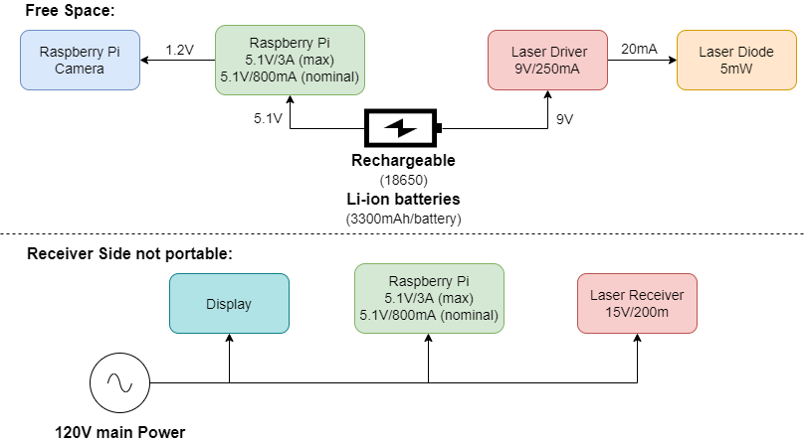3.2.3 The system shall use a physical display to show the received video feed to the user.

**Figure 3.2.1 Block diagram of power distribution to all system components.**

## Software Interfaces

3.3.1 The system shall use the mjpg-streamer software to transcode the video feed from the Raspberry Pi camera into a serial bitstream. This stream will be sent via OOK via the modulation of the laser diode using the UART standard. The incoming bitstream on the detector side will be to restream the received video to the desired output.

## Communications Interfaces

3.4.1 The system shall communicate between transmitter and receiver modules via an optical communication system.

3.4.2 The system shall communicate with the data display by either a serial interface or via a web interface, depending on desired output.

3.4.3 The system shall not communicate with any external systems, except if the external system contains data which is requested by the customer to be transmitted by this system.

3.4.4 The system shall record a copy of the restreamed incoming data.

# System Features

## Automatic TX and RX

4.1.1 Description and Priority

Upon selection of data to send, the onboard computer shall process and send the data via OOK to the receiver. Once received by the receiving module, the data will then be reconstructed back into its original form by use of the Raspberry Pi, where it will be displayed on either an onboard display or a web interface.

4.1.2 Stimulus/Response Sequences

After receiving data from the input sensor(s), the data will then be transmitted. Once the data is transmitted by the laser, the laser receiver will then send the received data to the receiving computer.

4.1.3 Functional Requirements

4.1.3.1 Software shall allow for TX and RX of the signal.

4.1.3.2 The signal shall be viewed via a sensor to verify data being sent through free space.

4.1.3.3 The signal shall be received, and the data decoded for use.

4.1.3.4 The decoded signal shall be recorded for future use and or analysis.

# Other Nonfunctional Requirements

## Performance Requirements

5.1.1 The hardware shall be able to transmit a signal via free space.

5.1.2 The hardware shall transmit a signal at a speed such that the transmitting and receiving computers are able to adequately transmit and decode all data, while also not becoming limited by any thermal or computation speed caps.

5.1.3 The hardware shall transmit data with an error rate of less than 5%, and such that data loss rate is not high enough to interfere with system goals.

5.1.4 The system shall transmit data with a one-way latency of less than 5s.

5.1.5 The system shall transmit data no less than 6 inches through free space.

## Safety Requirements

5.2.1 The carrier signal (laser) shall not be oriented at anything other than the receiver.

5.2.2 The laser shall not be operated without a member of the project team to verify its proper use.

5.2.3 The laser shall always be used in a fixed mount unless otherwise required, such as for testing or maintenance.

5.2.4 Any users in the vicinity of the laser shall wear proper protective equipment, meaning laser safety goggles.

## Security Requirements

5.3.1 Only authorized project members are allowed to use and test the product.

5.3.1.1 Authorized Members:

5.3.1.2 Project Owner, Eduardo Rojas.

5.3.1.3 Project Team Members.

5.3.1.4 Any other individual designated by the Project Owner or Team Members.

## Software Quality Attributes

5.4.1 The system software shall be written in a way that is readable by any user and shall be sufficiently commented so that any user can clearly understand the program.

## Business Rules

5.5.1 Only project members, owners and assistants shall be authorized to use and test the product.

Appendix A: Glossary

COTS – Commercial-off-the-shelf

LOS – Line of Sight

OBC – On-Board Computer

OCS – Optical Communications System

OOK – On-Off Key

RX – Receive

TX – Transmit