**System Requirements Specification**

**for**

**Optical (Laser) Communications Low-Cost Payload**

**Prepared by Cameron Martinez, Dominic Steiner, Sean Huber, Jarrod Siglin, Matthew Simms, Dylan Koch**

**Embry-Riddle Aeronautical University**

**12/3/2022**

Table of Contents

Table of Contents 2

Revision History 2

1. Introduction 4

1.1 Purpose 4

1.2 Intended Audience and Reading Suggestions 4

1.3 Product Scope 4

1.4 References 4

2. Overall Description 5

2.1 Product Perspective 5

2.2 Product Functions 5

2.3 User Classes and Characteristics 5

2.4 Operating Environment 6

2.5 Design and Implementation Constraints 7

2.6 User Documentation 7

2.7 Assumptions and Dependencies 7

3. External Interface Requirements 8

3.1 User Interfaces 8

3.2 Hardware Interfaces 8

3.3 Software Interfaces 8

3.4 Communications Interfaces 8

4. System Features 9

4.1 Automatic TX and RX 9

4.2 TX Power Distribution System 9

5. Other Nonfunctional Requirements 9

5.1 Performance Requirements 9

5.2 Safety Requirements 10

5.3 Security Requirements 10

5.4 Software Quality Attributes 10

5.5 Business Rules 10

Appendix A: Glossary 10

Revision History

|  |  |  |  |
| --- | --- | --- | --- |
| **Name** | **Date** | **Reason For Changes** | **Version** |
| Cameron Martinez | 10/7 | Initial setup | 1.0 |
| Sean Huber | 10/8 | Minor updates to software aspect | 1.0.1 |
| Matthew Simms and Sean Huber | 11/8 | Additional and more detailed requirements | 2.0 |
| Sean Huber, Cameron Martinez, Dylan Koch | 12/2 | Revision to software details and general revisions | 3.0 |

# Introduction

## Purpose

The product in which this document defines is the requirements relating to the development of a low-cost laser driven optical communications payload (OCSP). In which, the goal is to use commercially available off-the-shelf materials and components to reduce the financial requirements of an OCSP.

## Intended Audience and Reading Suggestions

This system is designed for educational institutions, aerospace companies, and prospective systems requiring an OCSP, or interested in the technology. Any organization or corporation that can benefit from high-bandwidth, rapid-speed communication can benefit from this product. The document contains the purpose of the product, how it should function, what it should accomplish while functioning, features it shall have, and some nonfunctional requirements in that order.

## Product Scope

This project is attempting to develop a low-cost OCSP that is capable of one-way video communications. This will provide the customer with a live video feed that is transmitted through free space while being simplistic enough to allow the customer to configure the OCSP to their application requirements. Ideally, the result of this project is to construct an OCSP that could be integrated into a smaller aerospace device and/or satellites, such as a CubeSat.

## References

Menlo Systems. (2021). *APD-Series High Sensitivity Avalanche Photodetector User Manual* [Photodiode receiver user’s manual]. <https://www.thorlabs.com/drawings/dbea16003904ede6-792C3D4D-E6CE-EC7F-4976A9400BD3E60B/APD310-Manual.pdf>.

ThorLabs. (2015). *1550 nm DFB Laser Diode, 5 mW* [Laser diode specifications sheet]. <https://www.thorlabs.com/drawings/dbea16003904ede6-792C3D4D-E6CE-EC7F-4976A9400BD3E60B/L1550P5DFB-SpecSheet.pdf>.

ThorLabs. (2018). *EK2000 OEM Laser Diode Driver Evaluation Kit User Guide* [Laser driver specifications and user's manual]. <https://www.thorlabs.com/drawings/dbea16003904ede6-792C3D4D-E6CE-EC7F-4976A9400BD3E60B/EK2000-Manual.pdf>.

ThorLabs. (2019). *PM400 Operating Manual* [Laser power and energy gauge user’s manual]. <https://www.thorlabs.com/drawings/dbea16003904ede6-792C3D4D-E6CE-EC7F-4976A9400BD3E60B/PM400-Manual.pdf>.

# Overall Description

## Product Perspective

The OCS is designed to bring a low-cost, simplistic product intended to allow educational or hobby level customers to implement an OCS in satellite communications through free space. It is a new, self-contained product focused on emerging studies and technologies. It is initially more based as a proof-of-concept, rather than a complete product.

## Product Functions

2.2.1 The system shall use the onboard computers to process input signal data.

2.2.2 The system shall use a laser to transmit the data through free space.

2.2.3 The laser receiver shall receive the transmitted signal.

2.2.4 The system shall transcode the received signal back into usable data.

2.2.5 The system shall finally display the received data in a user-understandable format as a video stream on a hosted webpage.

Figure 2.2.1 Top-View of System Architecture Demonstrating Product Functions

The blue arrows represent interactions between systems, while the red arrow represents transmission through free space.

## User Classes and Characteristics

### Ground Station Operator

The Ground Station Operator maintains and controls the signals used for the OCS. Additionally monitors the satellites to confirm proper operation. This is the user at the RX who monitors the video stream from the TX.

### Test Engineer

The Test Engineer is a qualified individual who is proficient in all aspects of OCS. The test engineer shall be able to validate any part of the system as working using tests laid out in a test plan document. They shall also be able to diagnose and repair any faults found during testing.

**2.3.3 Sensor Operator**

The Sensor Operator is at the TX of the system, in charge of the input sensing device. This may be a camera, microphone, etc. This user class is optional, because the sensor may not need any user operation.

## Operating Environment

2.4.1

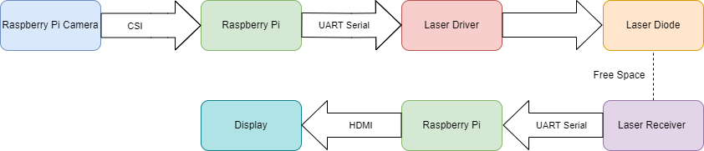

**Figure 2.4.1.1 Block diagram of passing of information throughout the system.**

The integrated Raspberry Pi systems will be running the following software along with their version:

2.4.1.1.1: Python ver. 3.10.7

2.4.1.1.2: Raspberry Pi OS Lite ver. September 22, 2022

2.4.1.1.3: PL011 SoC UART ver. Nov 1, 2005

2.4.1.1.4: NumPy ver. 1.23.4 Oct 12, 2022

2.4.1.1.5: OpenCV ver. 4.6.0.66 June 8, 2022

2.4.1.1.6: Flask ver. August 8, 2022

The data input is collected through a Raspberry Pi camera, which is then transmitted to a Raspberry Pi for transformation into a serial signal using OpenCV libraries. This data is then sent to the laser driver via the PL011 UART serial transmit pin. The laser driver will then send the data as an on-off keyed serial signal over free space to the receiver. The receiving Raspberry Pi will then decode, then transcode the data and send it to a Flask web display, the format will be an mjpeg stream.

**Figure 2.4.1.2 Test signal sent through UART being read by TX on oscilloscope.**

2.4.1.2.1: The Raspberry Pi shall read in data from the Raspberry Pi Camera over the Camera Serial Interface (CSI). The incoming data shall then be converted to an byte stream by the OpenCV library, then will write the byte data to the PL011 serial output of the Raspberry Pi.

2.4.1.2.2: The UART serial signal from the Raspberry Pi shall be connected to the analog modulation pin of the laser driver board, which will turn on or off the laser, based on the state of the serial signal.

2.4.1.2.3: The laser receiver shall receive the laser signal and transmit it to the receiver via a serial signal based on the received laser state.

2.4.1.2.4: The receiver Raspberry Pi shall reconstruct the serial bitstream into an mjpeg stream which can then be displayed on a connected display and/or webpage.

### Data Collection:

The data collected will depend on the specific needs of the project, however, the first implementation will use a video stream collected from a Raspberry Pi camera. This could be replaced by any other form of information sensor or collector. Anything that is used to transmit data could send information to the RX from the TX.

## Design and Implementation Constraints

### Design Constraints:

#### The transmitting system shall fit within 1U (10x10x10 in)

#### The system shall cost under $2000 USD

#### The transmitting system shall weigh less than 20 pounds

### Implementation Constraints:

#### The system shall use COTS components wherever possible

#### The transmitting laser shall use a 1500 nm wavelength driver (IR-B class)

#### All system code implementation shall be done in Python and shell scripting

## User Documentation

2.6.1 The system shall have a basic procedure manual on how to operate the device.

2.6.1.2 The system shall have operational/technical manual references to the off-the-shelf components used in the specification configuration.

## Assumptions and Dependencies

2.7.1 The system shall be tested in an enclosed space with proper safety equipment in place.

2.7.2 The system shall maintain Line of Sight (LOS) between transmitter and receiver.

2.7.3 The system shall maintain power for an adequate amount of time, yet to be determined.

2.7.4 The system shall be turned on by the user when ready to use, test or demonstrate.

2.7.5 The system shall not be left on when not in use.

# External Interface Requirements

## User Interfaces

The user will plug in the power sources and activate the laser using the laser driver. Then they will only need to provide input into the Raspberry Pi camera for an output on the display monitor and web stream at the receiver side. All activation of the system will be hardware based and software initialization will be performed via startup script or a secure shell.

## Hardware Interfaces

3.2.1 The system shall interface with the Raspberry Pi camera to receive video input.

3.2.2 The system shall use the Raspberry Pi to send the received video signal over serial interface to the laser driver and laser diode.

3.2.3 The system shall use a physical display to show the received video feed to the user.

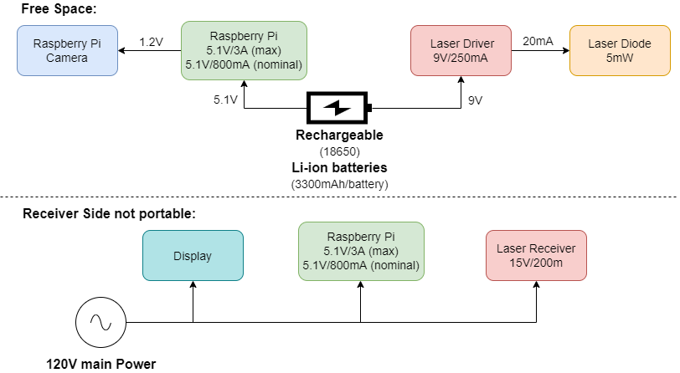

**Figure 3.2.1 Block diagram of power distribution to all system components.**

## Software Interfaces

3.3.1: The system shall use OpenCV, to transcode the video feed from the Raspberry Pi camera into a serial bitstream. Then receiver and decode into a mjpeg video stream.

3.3.2: The transmitter will use the PL011 driver to transport the serial bitstream through the GPIO pin 14.

3.3.3: The receiver will use the PL011 driver to receive the serial bitstream through GPIO pin 15.

3.3.4: The decoded mjepg video stream will be displayed on a Flask web server, accessible on the local network.

## Communications Interfaces

3.4.1 The system shall communicate between transmitter and receiver modules via an optical communication system.

3.4.2 The system shall communicate with the data display by either a serial interface or via a web interface, depending on desired output.

3.4.3 The system shall not communicate with any external systems, except if the external system contains data which is requested by the customer to be transmitted by this system.

3.4.4 The system shall record a copy of the restreamed incoming data.

# System Features

## Automatic TX and RX

4.1.1 Description and Priority

Upon selection of data to send, the onboard computer shall process and send the data via OOK to the receiver. Once received by the receiving module, the data will then be reconstructed back into its original form by use of the Raspberry Pi, where it will be displayed on either an onboard display or a web interface.

4.1.2 Stimulus/Response Sequences

After receiving data from the input sensor(s), the data will then be transmitted. Once the data is transmitted by the laser, the laser receiver will then send the received data to the receiving computer.

4.1.3 Functional Requirements

4.1.3.1 Software shall allow for TX and RX of the signal.

4.1.3.2 The signal shall be viewed via a sensor to verify data being sent through free space.

4.1.3.3 The signal shall be received, and the data decoded for use.

4.1.3.4 The decoded signal shall be recorded for future use and or analysis.

4.1.3.5 The TX shall transmit through free space.

## TX Power Distribution System

4.2.1 Description and Priority

The transmitter side of the system shall be portable, meaning an onboard power system is needed. For demonstration and initial design, this can be stationary, so priority is not high.

4.2.2 Stimulus/Response Sequences

When the TX system is turned on, power will be distributed to all parts using the power distribution system. This will lead to full operation of the TX.

4.2.3 Functional Requirements

4.2.3.1 All parts of the TX shall receive nominal voltages and currents.

4.2.3.2 The system shall use batteries for power.

# Other Nonfunctional Requirements

## Performance Requirements

5.1.1 The hardware shall be able to transmit a signal via free space.

5.1.2 The hardware shall transmit a signal at a speed such that the transmitting and receiving computers are able to adequately transmit and decode all data, while also not becoming limited by any thermal or computation speed caps.

5.1.3 The hardware shall transmit data with an error rate of less than 5%, and such that data loss rate is not high enough to interfere with system goals.

5.1.4 The system shall transmit data with a one-way latency of less than 5s.

5.1.5 The system shall transmit data no less than 6 inches through free space.

5.1.6 The system shall not have a data transmission rate requirement

## Safety Requirements

5.2.1 The carrier signal (laser) shall not be oriented at anything other than the receiver.

5.2.2 The laser shall not be operated without a member of the project team to verify its proper use.

5.2.3 The laser shall always be used in a fixed mount unless otherwise required, such as for testing or maintenance.

5.2.4 Any users in the vicinity of the laser shall wear proper protective equipment, meaning laser safety goggles.

5.2.5 The system should have no possible shorting hazards or exposed wiring.

## Security Requirements

5.3.1 Only authorized project members are allowed to use and test the product.

5.3.1.1 Authorized Members:

5.3.1.2 Project Owner, Eduardo Rojas.

5.3.1.3 Project Team Members.

5.3.1.4 Any other individual designated by the Project Owner or Team Members.

## Software Quality Attributes

5.4.1 The system software shall be written in a way that is readable by any user and shall be sufficiently commented on so that any user can clearly understand the program.

## Business Rules

5.5.1 Only project members, owners and assistants shall be authorized to use and test the product.

Appendix A: Glossary

COTS – Commercial-off-the-shelf

LOS – Line of Sight

OBC – On-Board Computer

OCS – Optical Communications System

OOK – On-Off Key

RX – Receive

TX – Transmit