Reproducibility Reanalysis of Clindamycin Resistance in Clostridioides difficile Using the EMBL-EBI AMR Portal
Marker-only baselines match the machine-learning classifier in a public phenotype-genotype cohort
Aditya Agrawal
School of Health Sciences and Technology, UPES, Dehradun, Uttarakhand, India | B.Tech. Bioinformatics | ORCID: 0009-0000-1843-3507

Abstract
Background: Public antimicrobial-resistance resources make it possible to reproduce genotype-to-phenotype analyses, but model performance should be compared against simple biological-marker rules. Methods: The EMBL-EBI AMR Portal 2026-07 combined phenotype-genotype release was filtered to Clostridioides difficile isolates with resistant or susceptible clindamycin phenotypes. AMRFinderPlus resistance determinants were encoded as binary isolate-level features. Logistic regression, random forest and Extra Trees were evaluated using repeated stratified five-fold cross-validation. Follow-up analyses compared the selected classifier with erm(B)-only, cfr(C)-only and erm(B)-OR-cfr(C) rules, stratified results by source database, and audited false negatives. Results: The cohort contained 102 isolates (35 resistant, 67 susceptible). Three non-singleton features remained: erm(B), cfr(C) and invariant cplR. Logistic-regression out-of-fold classification achieved 96.1% accuracy, 94.3% balanced accuracy, 88.6% sensitivity and 100% specificity. However, the erm(B)-only rule produced exactly the same 102 binary classifications. cfr(C) occurred only among erm(B)-positive isolates and therefore added no classification gain. Four resistant isolates lacked both erm(B) and cfr(C). Source composition was imbalanced: all 23 NCBI_antibiogram isolates were resistant, while the PATRIC subset contained 12 resistant and 67 susceptible isolates. Within PATRIC alone, the erm(B) rule retained 97.5% accuracy but 83.3% sensitivity. Conclusion: This reanalysis reproduces a strong genotype-phenotype association but does not demonstrate incremental classification benefit from machine learning over a single known marker. The result is best interpreted as a transparent reproducibility and baseline-audit study, not a novel clinical predictor.

1. Introduction
Clostridioides difficile is an anaerobic spore-forming pathogen associated with antibiotic-associated diarrhoea and healthcare-associated infection. Genomic resistance determinants can be compared with laboratory susceptibility phenotypes to evaluate whether genotype provides useful predictive information.
The central resistance signal studied here is not novel. Drouin et al. (2016) developed interpretable machine-learning models from whole-genome k-mers for multiple bacterial species and antibiotics, explicitly including C. difficile clindamycin resistance; their clindamycin model targeted ermB-associated sequence and a Tn6194-like element. More recently, Brouwer et al. (2024) reported 86% accuracy for genotype-based clindamycin resistance prediction in 99 Irish C. difficile isolates. U.S. genomic surveillance also found erm genes in 90.3% of isolates with clindamycin MIC >16 mg/L.
Accordingly, the contribution of the present work is narrower: to audit the reproducibility of a simple AMRFinderPlus-feature workflow on the 2026-07 EMBL-EBI AMR Portal release, compare machine learning against biologically obvious marker rules, expose source imbalance, and identify failure cases. No claim is made that erm(B), cfr(C), or genomic prediction of clindamycin resistance was discovered here.

2. Materials and methods

2.1 Data source and licensing
The analysis used the EMBL-EBI Antimicrobial Resistance Portal release 2026-07 combined phenotype-genotype dataset. The portal links experimentally determined AMR phenotypes with in-silico genotype annotations for matching samples/assemblies. The AMR Portal states that its data are available under CC BY 4.0. This study filtered and transformed those public records; it does not claim ownership of the source data.

2.2 Cohort and features
Rows were retained for organism = Clostridioides difficile, antibiotic = clindamycin, and resistance phenotype in {resistant, susceptible}. Duplicate genotype rows were collapsed to one isolate-level binary feature vector. Feature names used AMR element symbol, then gene symbol or reference name as fallbacks. Features observed in fewer than two isolates were removed. The binary target was resistant = 1 and susceptible = 0.

2.3 Models and validation
Class-weighted logistic regression (C=0.5; max_iter=5000), random forest (250 trees; min_samples_leaf=2; max_features=sqrt), and Extra Trees (250 trees; min_samples_leaf=2; max_features=sqrt) were evaluated with five-fold stratified cross-validation repeated five times. A separate shuffled five-fold out-of-fold prediction run (random_state=2026) generated per-isolate predictions and diagnostic figures. The decision threshold was 0.50.

2.4 Follow-up baseline and bias audit
The final out-of-fold machine-learning classifications were compared with three deterministic baselines: presence of erm(B), presence of cfr(C), and presence of either marker. The analysis also stratified the erm(B) rule by source database and inspected all resistant false-negative isolates. These follow-up tests were specified after observing that only two retained features varied with phenotype and therefore directly address whether machine learning adds classification value beyond known resistance markers.

2.5 Computational reproducibility and AI assistance
The complete executable Python pipeline, processed matrices, per-isolate predictions, serialized model, environment specification, checksums and follow-up scripts accompany the manuscript. Generative AI (OpenAI ChatGPT, GPT-5.6 Sol) was used to assist literature search, code development, statistical checking, document drafting and organization. The human author must review the code, rerun the final pipeline, verify references and results, and take responsibility for the submitted work. AI is not listed as an author.

3. Results

3.1 Cohort and retained features
The final cohort contained 102 isolates: 35 resistant and 67 susceptible. The retained non-singleton features were erm(B), cfr(C) and cplR. cplR was invariant (102/102) and therefore non-discriminatory. erm(B) occurred in 31/35 resistant and 0/67 susceptible isolates; cfr(C) occurred in 24/35 resistant and 0/67 susceptible isolates. Every cfr(C)-positive isolate was also erm(B)-positive.
Feature | Resistant | Susceptible | Interpretation
erm(B) | 31/35 (88.6%) | 0/67 (0%) | Strong discriminator
cfr(C) | 24/35 (68.6%) | 0/67 (0%) | Nested within erm(B)
cplR | 35/35 (100%) | 67/67 (100%) | Invariant

3.2 Machine-learning performance
Mean repeated-cross-validation AUROC for the three model families was approximately 0.943, with mean accuracy 0.961, balanced accuracy 0.943, sensitivity 0.886 and specificity 1.000. Logistic regression was retained for interpretability. The separate out-of-fold run yielded AUROC 0.904 and PR-AUC 0.926, with 67 true negatives, 31 true positives, 0 false positives and 4 false negatives.
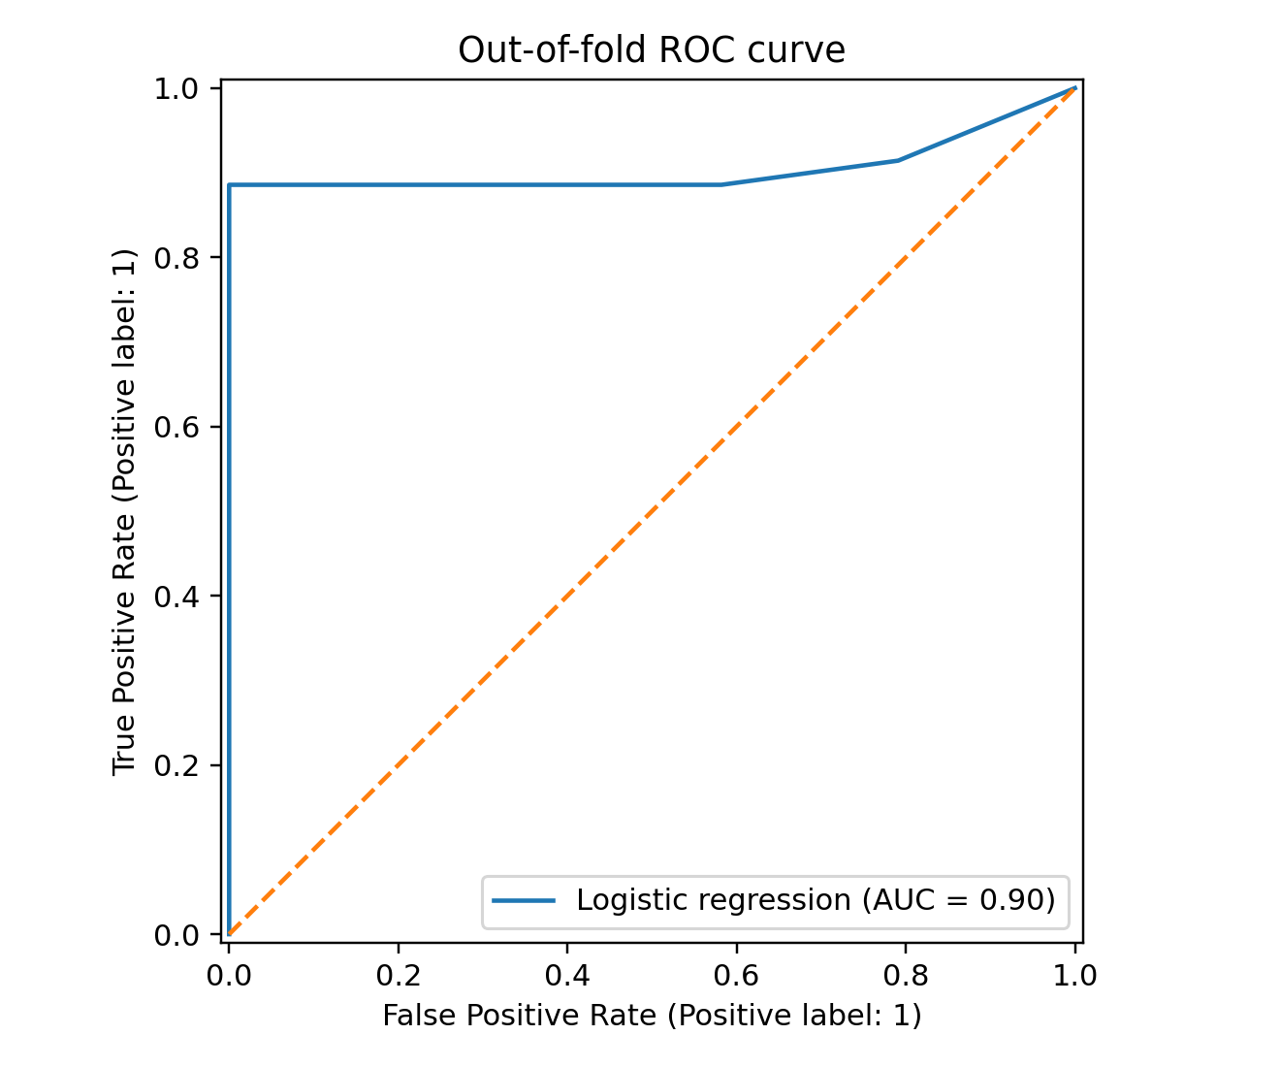
Figure 1. Out-of-fold ROC curve for the logistic-regression model.

3.3 Marker-only baselines
Method | Accuracy | Balanced acc. | Sensitivity | Specificity
erm(B) only | 0.961 | 0.943 | 0.886 | 1.000
cfr(C) only | 0.892 | 0.843 | 0.686 | 1.000
erm(B) OR cfr(C) | 0.961 | 0.943 | 0.886 | 1.000
Logistic regression OOF | 0.961 | 0.943 | 0.886 | 1.000
At the 0.50 decision threshold, logistic regression and the erm(B)-only rule produced identical classifications for all 102 isolates. Adding cfr(C) to the marker rule did not alter any classification because cfr(C) was completely nested within erm(B) in this cohort. Therefore the machine-learning model did not add binary classification benefit over the single-marker baseline.
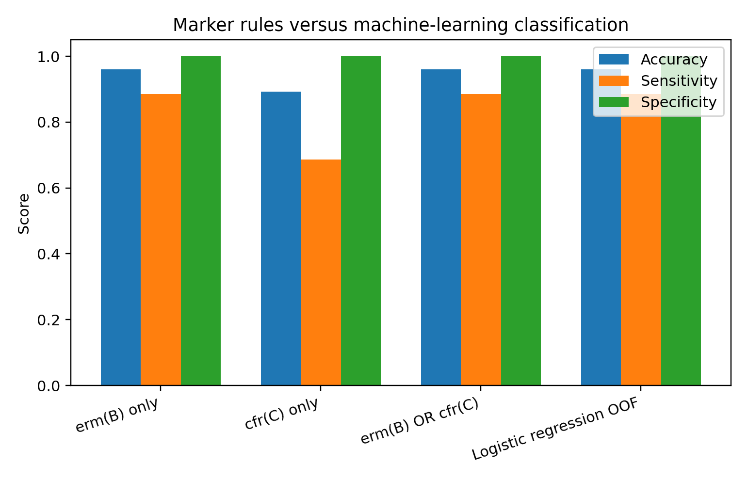
Figure 2. Marker-rule baselines compared with out-of-fold machine-learning classification.

3.4 Source-stratified analysis and false negatives
Source | n | R | S | erm(B) accuracy | Sensitivity | Specificity
NCBI_antibiogram | 23 | 23 | 0 | 0.913 | 0.913 | Not estimable
PATRIC | 79 | 12 | 67 | 0.975 | 0.833 | 1.000
Source composition was strongly imbalanced: all NCBI_antibiogram isolates were resistant. Consequently, source membership itself is associated with phenotype and a clean source-to-source external validation is impossible. Importantly, the erm(B) association remained strong within the PATRIC subset, although sensitivity fell to 83.3%.
BioSample | Source | Phenotype detail | erm(B) | cfr(C)
SAMN42552498 | NCBI_antibiogram | Resistant; MIC 8 mg/L | Absent | Absent
SAMN42552503 | NCBI_antibiogram | Resistant; MIC 256 mg/L | Absent | Absent
SAMEA3663998 | PATRIC | Resistant | Absent | Absent
SAMEA3664209 | PATRIC | Resistant | Absent | Absent
The same four isolates were false negatives for both logistic regression and the erm(B) rule. Their resistance therefore cannot be explained by the retained AMRFinderPlus marker set used here. Potential explanations include alternative resistance mechanisms, incomplete annotation, phenotype/breakpoint heterogeneity or other genomic variants not represented by these features.

4. Discussion
The main scientific conclusion is a negative incremental-value result: the machine-learning classifier reproduced a strong known erm(B)-phenotype association but did not improve binary classification over an erm(B)-only rule. This matters because high predictive accuracy can otherwise be mistaken for evidence that a complex model adds information. In this cohort, it does not.
The result is consistent with prior biology. Gargis et al. reported erm genes in 90.3% of C. difficile isolates with clindamycin MIC >16 mg/L, while cfr genes were also enriched. Candela et al. experimentally demonstrated that cfr(C) can confer a multi-class resistance phenotype including lincosamides. However, the present dataset cannot establish causality, discover a new mechanism, or support clinical use.
A key novelty limitation emerged during the final literature audit: the PATRIC records in this cohort point to PMID 27671088, the 2016 Drouin et al. machine-learning study. Thus part of the current portal cohort derives from data already used for C. difficile resistance prediction. This makes it inappropriate to present the analysis as a previously unstudied prediction problem. Its defensible value is reproducibility, updated resource integration, simple-baseline comparison, and transparent bias/error auditing.

5. Limitations
- Small cohort (n=102) and only 35 resistant isolates.
- Source imbalance prevents independent source-to-source validation.
- Part of the cohort is linked to a previously published machine-learning study, limiting novelty.
- Only AMRFinderPlus-derived determinant features were used; raw genome-wide variation was not modeled.
- Phenotype methods and breakpoint metadata are incomplete/heterogeneous in the aggregated public resource.
- Collection year is unavailable for the eligible cohort, preventing temporal validation.
- No independent external cohort was available in the supplied release.
- The work is not clinically validated and must not guide patient treatment.

6. Conclusion
In the EMBL-EBI AMR Portal 2026-07 C. difficile/clindamycin cohort, an interpretable logistic-regression model achieved high internal classification performance, but its binary predictions were exactly reproduced by an erm(B)-only rule. The study therefore supports the importance of simple biological baselines and transparent source auditing in genomic AMR prediction. The analysis is suitable as a reproducibility/reanalysis report and as a foundation for future work using genuinely independent isolates and richer genome-wide features; it should not be marketed as a novel clindamycin-resistance predictor.

Data availability
Source data: EMBL-EBI AMR Portal, release 2026-07, combined phenotype-genotype resource, licensed CC BY 4.0. The reproducibility package records the exact source-file SHA-256 and documents all transformations. A public repository/Zenodo DOI should be inserted here before submission.

Code availability
The accompanying reproducibility package contains the full analysis pipeline, follow-up baseline audit, processed matrices, per-isolate predictions, environment specification, checksums, figures and serialized model. A GitHub release archived to Zenodo should be cited here once the author publishes it.

Ethics statement
This secondary computational analysis used publicly available microbial isolate and antimicrobial-resistance records and did not involve recruitment of human participants or intervention by the author. Any journal-specific ethics wording should be confirmed during submission.

Competing interests
The author declares no competing interests, subject to final confirmation by the author before submission.

Declaration of generative AI and AI-assisted technologies
During preparation of this work, the author used OpenAI ChatGPT (GPT-5.6 Sol) to assist literature searching, code development, data-analysis checking, document organization and drafting. The author is responsible for independently reviewing and editing the final manuscript, verifying the analyses and references, rerunning the reproducibility pipeline, and taking full responsibility for the submitted content.

References
1. EMBL-EBI. Antimicrobial Resistance Portal: About, usage, developer access and licensing. Release 2026-07; accessed 20 September 2026.
2. Drouin A, Giguère S, Déraspe M, et al. Predictive computational phenotyping and biomarker discovery using reference-free genome comparisons. BMC Genomics. 2016;17:754. doi:10.1186/s12864-016-2889-6.
3. Brouwer L, Carroll A, McNamara E. Genotypic and phenotypic antimicrobial resistance of Irish Clostridioides difficile isolates, 2022. Anaerobe. 2024;88:102857. doi:10.1016/j.anaerobe.2024.102857.
4. Gargis AS, Karlsson M, Paulick AL, et al. Reference susceptibility testing and genomic surveillance of Clostridioides difficile, United States, 2012-17. Clin Infect Dis. 2023;76(5):890-896. doi:10.1093/cid/ciac817.
5. Candela T, Marvaud JC, Nguyen TK, Lambert T. A cfr-like gene cfr(C) conferring linezolid resistance is common in Clostridium difficile. Int J Antimicrob Agents. 2017;50(3):496-500. doi:10.1016/j.ijantimicag.2017.03.013.

