Annotated web research · 29 July 2026
A field guide to portfolios with a point of view.
Engineer portfolios that make the interface part of the work, and photographer portfolios that make looking feel deliberate.
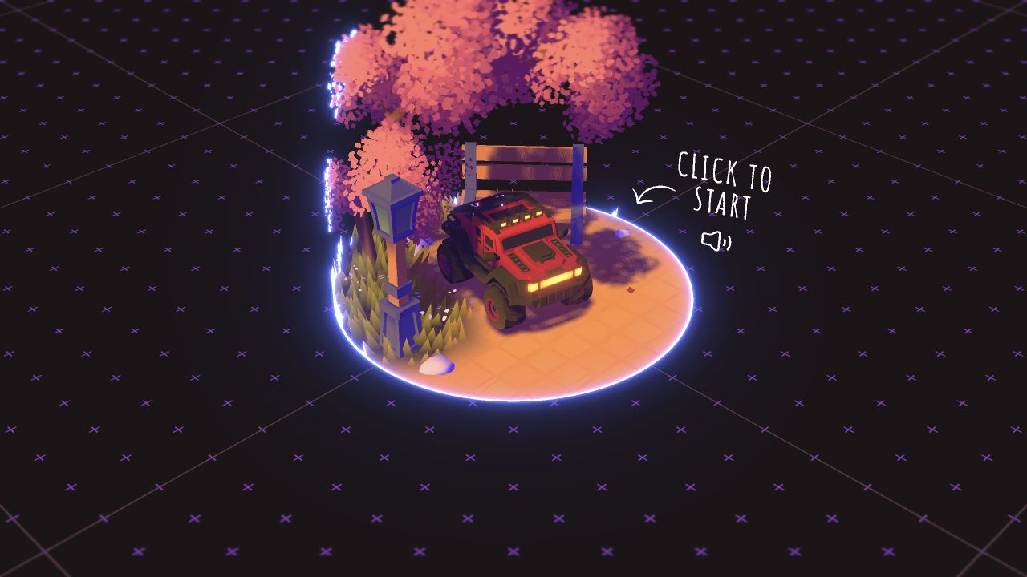  Bruno Simon · play | 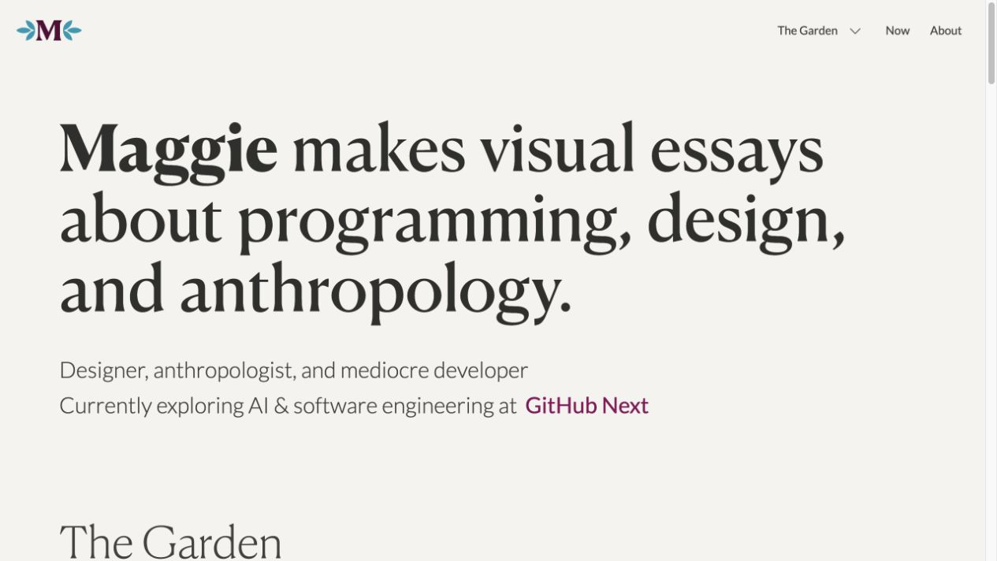  Maggie Appleton · garden
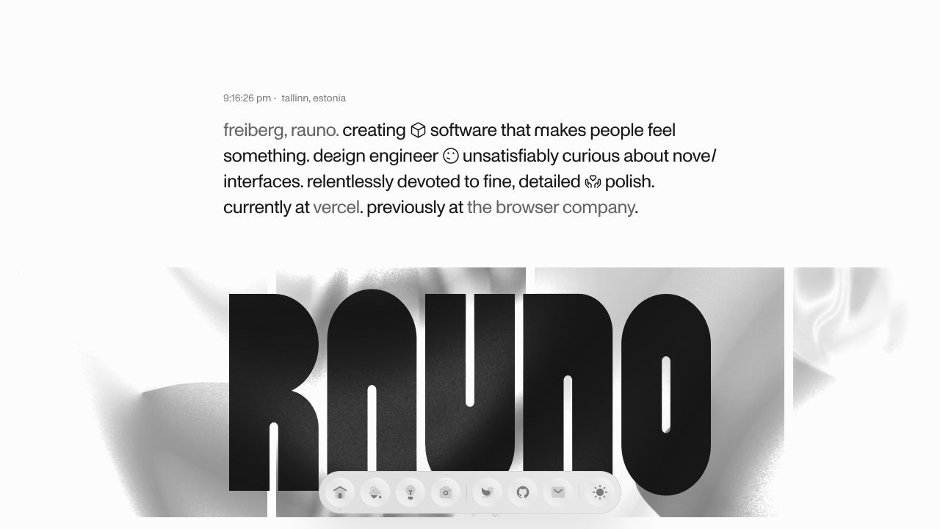  Rauno Freiberg · craft | 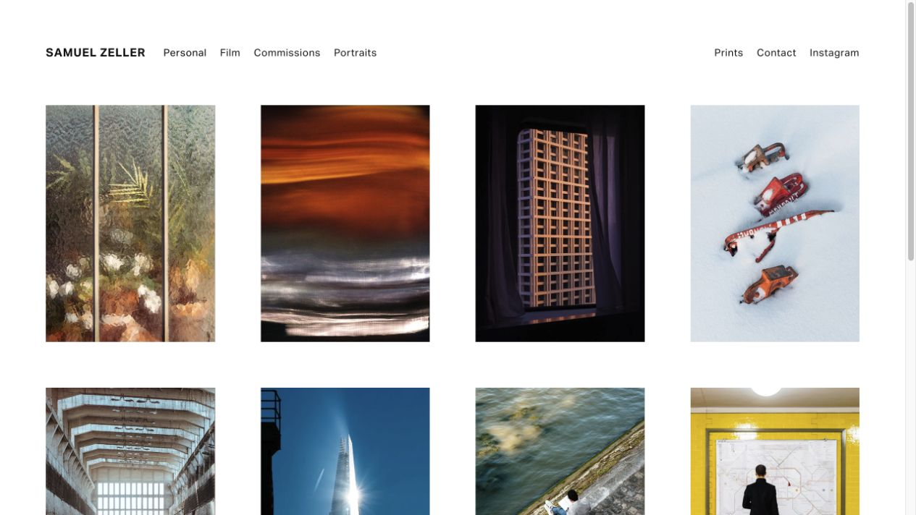  Samuel Zeller · series
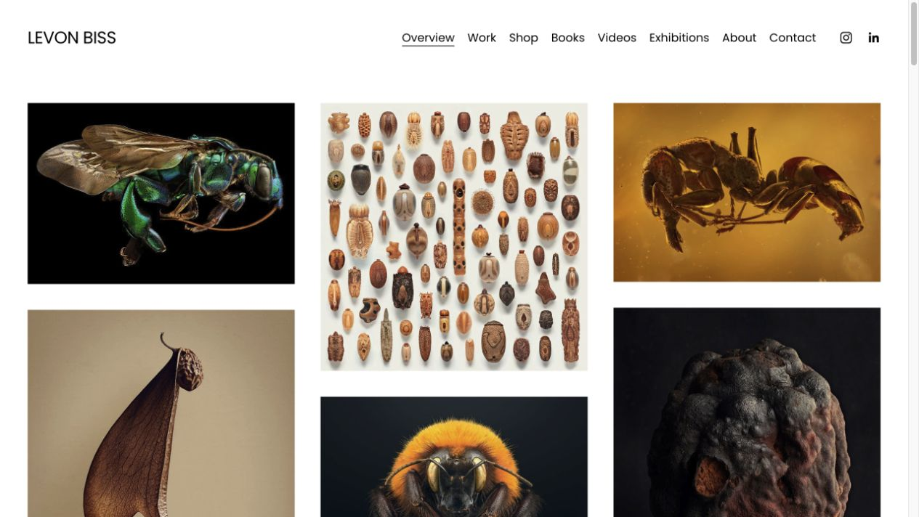  Levon Biss · overview | 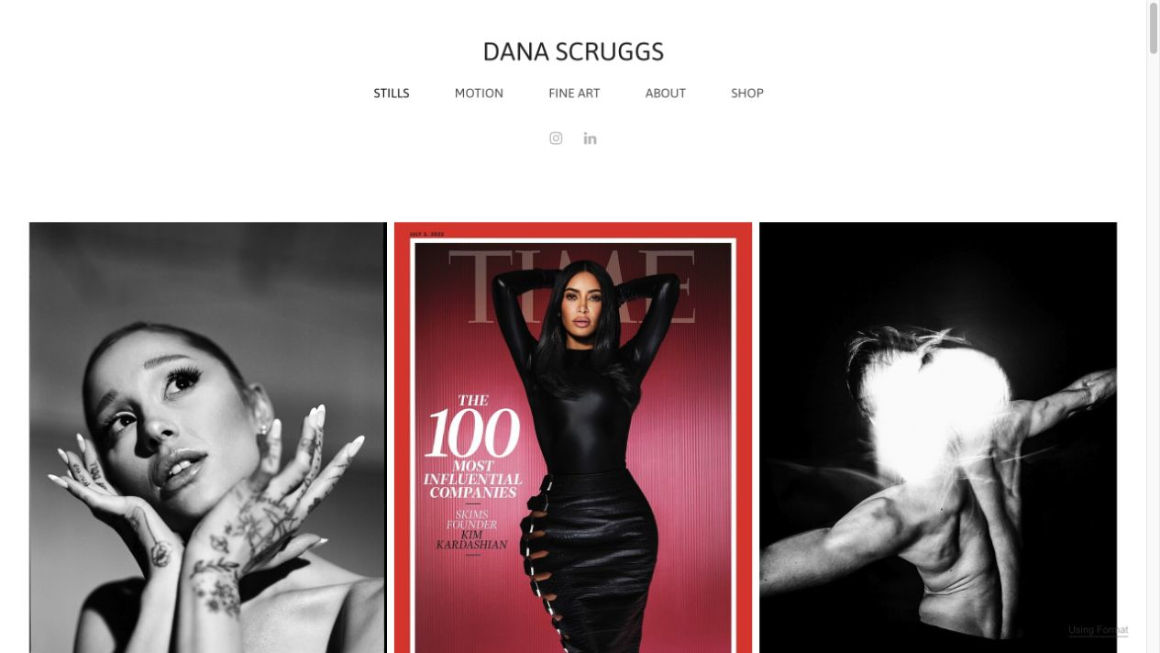  Dana Scruggs · editorial index
Screenshots are small reference captures from the linked sites, used here for private research. The photographs and interface designs remain the property of their respective creators.

The through-line
A portfolio can be a door, not a container.
The references that feel most alive do two things at once: they make a sharp first impression, then offer a more useful second layer. That layer might be a project archive, a digital garden, a set of visual essays, or simply a better way to move through images.
First impression  Can a visitor feel the point of view in the first 10 seconds? | Depth  Does the next layer reward curiosity with context, a series, or a body of work? | Friction  Is the interaction memorable without slowing everyday browsing?
Why this matters for Place Y Face
Your current direction already has the ingredients: a restrained photographic archive, short field notes, and an intentionally paced gallery. The opportunity is not to add spectacle. It is to make the archive feel more discoverable, more authored, and more legible as a record that will grow.
Read the references in two modes
- Look for the principle: what happens before, during, and after the first click?
- Ignore the visual surface when it is inseparable from somebody else’s voice. Borrow the information architecture, pacing, and generosity instead.
- Notice the quiet sites. An archive should be easy to return to, not a performance every time.
The rest of this packet is deliberately opinionated: each card names a useful move, plus the constraint that keeps it from turning into decoration.

Part one · Engineer portfolios
When the interface is evidence of the craft.
These sites are useful because their interaction model says something specific about the maker. The transferable lesson is rarely “add more animation.” It is “make the behavior reinforce the point of view.”
ENGINEER · 01
Bruno Simon
Visit: Open the site ↗
A portfolio as a tiny drivable 3D world. The visitor discovers work by navigating, with clear controls, a reset path, and a low-stakes sense of play. The site makes creative development tangible before any case study begins.
Borrow: Let the archive have one memorable spatial metaphor—an index, a route, a contact sheet—not a maze.
Watch out: A full game is a high-friction default for a photo archive. Keep the primary path usable in one click and on a slow connection.

ENGINEER · 02
Rauno Freiberg
Visit: Open the site ↗
A design engineer’s site that leads with a clear thesis, then lets craft experiments, prototypes, writing, and photographs coexist. Visual polish stays concentrated in the transitions and small interface details instead of overwhelming the whole surface.
Borrow: Treat experiments, writing, and photographs as adjacent evidence of one practice—not separate brands.
Watch out: Reserve the unusual treatment for a few high-value moments. His own writing frames the useful balance as familiar structure with a small dose of novelty.

ENGINEER · 03
Maggie Appleton
Visit: Open the site ↗
A living portfolio organized as a digital garden. Essays, notes, patterns, a library, and a “now” page create different depths of commitment, while the home page still tells one coherent story about the person behind the work.
Borrow: Give the journal distinct content types: field note, sequence note, location fragment, and longer essay can each signal a different promise.
Watch out: A garden works only if every label is understandable. Avoid taxonomy for its own sake.

Engineer portfolios · continued
ENGINEER · 04
Brittany Chiang
Visit: Open the site ↗
The opposite of maximalism: a fixed, readable index with in-page jump links, accessible structure, projects, writing, and an archive. It makes a convincing case through clarity and repeatable scanning rather than flourish.
Borrow: Make return paths obvious: Archive, Journal, About, and a durable way back after opening an image or entry.
Watch out: Minimal does not mean empty. The content needs a strong point of view and enough context to reward attention.

ENGINEER · 05
Dennis Snellenberg
Visit: Open the site ↗
A portfolio whose archive is a real working index: dozens of projects can be scanned by client, location, service, and year. The editorial presentation stays expressive; the archive makes the body of work actually navigable.
Borrow: Use modest metadata as a finding aid—year, place, series, and maybe image count—without turning the gallery into a dashboard.
Watch out: Metadata must serve the photograph. Show only the fields that change how someone finds or understands a frame.

ENGINEER · 06
Robby Leonardi
Visit: Open the site ↗
An interactive resume presented as an illustrated side-scrolling game. Sections of a conventional resume become scenes and mechanics, making the structure easier to remember because the metaphor is consistently applied.
Borrow: A sequence can be an interaction: individual photographs may feel like scenes in a walk, transit ride, or small act of noticing.
Watch out: The metaphor has to clarify the content. Never turn image viewing into a puzzle users must solve to see the work.

A compact principle from this group
Make the machine visible only where it strengthens the story. Everywhere else, let the visitor read, look, and move normally.
Visit: Rauno Freiberg, “Novelty” ↗

Part two · Photography portfolios
When looking becomes a structured activity.
The best photography sites are not just image grids. They decide whether a visitor should browse, compare, zoom, read, return, or commission. That small amount of choreography is what turns a collection into an authored archive.
PHOTOGRAPHER · 01
Samuel Zeller
Visit: Open the site ↗
A clear project index sits beside a separate archive and journal. The main portfolio is concise and visual; the archive is deeper, searchable, and contextual. This is the closest structural cousin to Place Y Face.
Borrow: Keep an edited “front room” and a deeper archive connected by a deliberate handoff. Let locations and series become more discoverable over time.
Watch out: Do not duplicate every image in both places. The front room should be an edit; the archive should be the record.

PHOTOGRAPHER · 02
Levon Biss
Visit: Open the site ↗
A visually rich masonry overview makes the first browse feel like discovery. Every image still acts as a project doorway, and clear navigation provides alternate ways to narrow by body of work.
Borrow: A mixed-aspect index can preserve the visual rhythm of your images while remaining a useful series browser.
Watch out: Masonry can lose sequence. Use it for overview pages, then give a series its own intentional order.

PHOTOGRAPHER · 03
Scott Snyder
Visit: Open the site ↗
Large photographs, generous negative space, and a deliberately quiet identity let the work do the selling. Projects open into specific client and process context rather than treating every image as an isolated hero.
Borrow: Use negative space and a restrained masthead when the image itself already carries a lot of visual information.
Watch out: The quieter the shell, the more exact the image selection and cropping need to be.

Photography portfolios · continued
PHOTOGRAPHER · 04
Dana Scruggs
Visit: Open the site ↗
A single visual index covers stills, motion, and fine art without erasing the photographer’s point of view. Direct categories make it easy for different audiences to find a relevant body of work.
Borrow: Use a small number of meaningful entry points. “Archive” and “Journal” are enough now; future modes should earn their place.
Watch out: Do not split the work by medium unless the viewer’s task meaningfully changes with the split.

PHOTOGRAPHER · 05
Luke Hayes
Visit: Open the site ↗
An architectural photographer whose site holds commissioned projects and longer, personal observations together. Individual entries gain weight from a little background, a recurring subject, and a clear point of view.
Borrow: Let a few Journal pieces act as visual essays: images first, then a spare paragraph that explains why the sequence exists.
Watch out: Writing should open the images, not stand in front of them. Keep captions optional and readily dismissible.

PHOTOGRAPHER · 06
The contact sheet as a viewing mode
Visit: Open the site ↗
The contact sheet is more than a nostalgic visual treatment. It is a comparison tool: thumbnails reveal rhythm, repeats, alternatives, and the photographer’s decision-making better than a sequence of fullscreen images alone.
Borrow: Keep the “twenty frames at a time” idea. Consider light metadata, a current position, and optional grouping by day or walk so a page feels like a real tranche of an archive.
Watch out: Do not make the grid too visually flat. Preserve an easy path to inspect a frame at full size and return to the same place.

The sharpest structural takeaway
Your public portfolio is an edit. Your archive is an instrument. A journal is the connective tissue that gives both of them a memory.
Visit: Samuel Zeller, “Ten good reasons why you need an archive” ↗

Translation layer
What I would test next in Place Y Face.
Not a redesign brief—just the few moves most clearly supported by this research.
1. Let the archive show its structure
Keep the generous image grid, but pair it with a light, durable index: a current range, numbered sequence, year or area, and a way to see related frames without asking the visitor to decode a filter system.
2. Give sequences a title and a reason to exist
A small series label or one-sentence note can turn “images from Toronto” into a returnable visual essay. The goal is context, not a statement of intent for every photograph.
3. Make the Journal part of the gallery’s rhythm
Use quiet links where a series naturally asks for them: “Read the field note,” “Why these stayed together,” or “More from this walk.”
4. Add one memorable behavior, not five
A subtle sequence handoff, a useful contact-sheet cursor, or a first-load reveal is enough. Repeated interactions should remain calm and fast.
5. Design for the return visit
Image position, close behavior, mobile gallery state, and quick back-to-index paths matter more than a dramatic entry animation. The archive’s magic should compound with use.
A short anti-checklist
- No autoplay that competes with photographs.
- No hidden navigation that makes the archive feel precious or difficult.
- No metadata dense enough to make the site feel like a digital asset manager.
- No interactive concept that works only on desktop or only after a long load.

Source book
Where to keep looking.
These are the original sites and supporting pieces used for this packet. Visit them slowly; the useful details often appear in the second click, the archive page, or the way a project returns you to an index.
Engineer and design-engineer references
Bruno Simon — portfolio as a navigable 3D world
Rauno Freiberg — craft, projects, photography, and visual polish in one system
Rauno Freiberg — “Novelty” — a useful argument for keeping most interaction familiar
Maggie Appleton — digital garden, visual essays, notes, and patterns
Brittany Chiang — accessible one-page portfolio with durable project and writing paths
Dennis Snellenberg — archive — large work index with filters and metadata
Robby Leonardi — interactive résumé as a consistent visual metaphor
Photography and archive references
Samuel Zeller — series — edited project index with clear categories
Samuel Zeller — archive essay — portfolio versus archive, metadata, search, and context
Levon Biss — masonry overview with project-level depth
Scott Snyder — negative space, strong selection, and project context
Dana Scruggs — clear work modes held under one visual voice
Luke Hayes — projects — personal observations alongside commissioned photography
PetaPixel — contact sheets — why the grid remains useful for comparison and selection
Site Builder Report — photography portfolios — additional visual browsing, including Levon Biss and Scott Snyder
Method note
I checked the live reference sites and used their public structure and visual behavior as the basis for the annotations. The recommendations are inferences for Place Y Face, shaped by its current archive-plus-journal direction rather than universal rules.

