Query Campus: A Retrieval-Augmented Generation Based Conversational Assistant For College Website Information Access
A Report submitted
in partial fulfillment for the degree of
Bachelor of Engineering
in
Information Technology and Computer Science Engineering
(Session 2026-2027)
Submitted By:  Akshat Sharma (23BIT005)  Tanmay Choudhary (23BCS072)  Riya Rawat (23BIT060) | Guided By:  Vedpriya Dongre

Department of Information Technology and Computer Science Engineering
Institute of Engineering & Technology
Vikramshila Campus
Devi Ahilya Vishwavidyalaya, Indore (M.P.)
(https://ietdavv.edu.in)
October 2026
CERTIFICATE
The project report entitled “Query Campus: A Retrieval-Augmented Generation Based Conversational Assistant For College Website Information Access” submitted by Akshat Sharma, Tanmay Choudhary, Riya Rawat is approved for partial fulfillment for the award of Bachelor of Engineering in Information Technology and Computer Science Engineering degree by Devi Ahilya Vishwavidyalaya, Indore.
Internal Examiner | External Examiner
Recommendation
The dissertation entitled “Query Campus: A Retrieval-Augmented Generation Based Conversational Assistant For College Website Information Access” submitted by Akshat Sharma, Tanmay Choudhary, Riya Rawat is a satisfactory account of the bonafide work done under my supervision and is recommended towards the partial fulfillment for the award of Bachelor of Engineering in Information Technology and Computer Science Engineering degree by Devi Ahilya Vishwavidyalaya, Indore.

Date:
VEDPRIYA DONGRE
Department of Computer Engineering
Counter signature of HOD with seal  Head of the Department  Department of Information Technology | Counter signature of HOD with seal  Head of the Department  Department of Computer Science Engineering
Candidate Declaration
We hereby declare that the work which is being presented in this project entitled “Query Campus: A Retrieval-Augmented Generation Based Conversational Assistant For College Website Information Access” in partial fulfillment of degree of Bachelor of Engineering in Information Technology and Computer Science Engineering is an authentic record of our own work carried out under the supervision and guidance of Vedpriya Dongre, Department of Computer Engineering, Institute of Engineering and Technology, Devi Ahilya Vishwavidyalaya, Indore.
We are fully responsible for the matter embodied in this project in case of any discrepancy found in the project and the project has not been submitted for the award of any other degree.
Date:
Place: Indore

Akshat Sharma
23BIT005

Tanmay Choudhary
23BCS072

Riya Rawat
23BIT060
SELF-DECLARATION OF PLAGIARISM REPORT
The project report entitled “Query Campus: A Retrieval-Augmented Generation Based Conversational Assistant For College Website Information Access” submitted by Akshat Sharma, Tanmay Choudhary, Riya Rawat in partial fulfillment of the requirement for the award of the degree of B.E. in Information Technology and Computer Science Engineering has been checked for plagiarism using a standard plagiarism detection tool.
The similarity index of the report is ______ %, which is within the permissible limit as per institute/university norms.
We hereby declare that:
- The work submitted is original and has not been copied from any source without proper citation.
- All referenced materials have been duly acknowledged.
- In case of any discrepancy found in future, we shall be solely responsible for the same.
Signature of Student(s):
1. Akshat Sharma (23BIT005) ______________________
2. Tanmay Choudhary (23BCS072) ______________________
3. Riya Rawat (23BIT060) ______________________
Date: ___________
ACKNOWLEDGEMENTS
We thank our project guide, Vedpriya Dongre, Department of Computer Engineering, for her guidance and support during this project. She helped us turn a simple idea into a clear problem, checked our synopsis and SRS, and asked us to measure the accuracy of the system. Her advice in the review meetings improved our work.
We thank Dr. Hemant Makwana, Head of the Department of Information Technology, and Dr. Ashish Kumar Jain, Head of the Department of Computer Science Engineering, for the departmental facilities and for allowing us to carry out this work.
We thank Dr. Pratosh Bansal, Director, Institute of Engineering & Technology, Devi Ahilya Vishwavidyalaya, Indore, for the computers and internet that we needed to collect, index and test the data. The public information on the institute’s website and timetable website is the knowledge base of this project.
We also thank all the faculty members, our friends and classmates who tested the application and gave honest feedback, and our families for their support.
ABSTRACT
Information about a college is spread over many web pages, PDF notices and a separate timetable website. Students lose time searching for admission rules, fees, teacher details and class timetables, and general chatbots often give wrong answers about a college. Query Campus is a chat assistant that answers questions about the Institute of Engineering & Technology, DAVV, Indore in simple English. It uses only the information published by the institute and shows the pages it used.
The system collects 1,009 documents, cuts them into 2,864 small chunks and stores them in a Pinecone database. For each question, the backend searches by meaning and by keywords, picks the best 16 chunks and asks Google Gemini to answer using only those chunks. The answer appears word by word in a React chat screen, with source links and downloadable documents. Backup models, time limits and a limit on questions per visitor keep the website reliable and safe.
On a test set of 19 real questions, the assistant answered all correctly, usually in 1.5 to 4 seconds, and it said it could not find the answer when the answer was not there. The project shows that a small, low-cost system can give a college a reliable question-answering service.
TABLE OF CONTENTS
DESCRIPTION Page No
Certificate i
Recommendation ii
Candidate Declaration iii
Plagiarism Check Report iv
Acknowledgements v
Abstract vi
Chapter 1 Introduction 1
1.1 Overview and Issues Involved 1
1.2 Problem Definition 1
1.3 Proposed Solution 2
Chapter 2 Literature Survey 5
2.1 Existing Solutions 5
2.2 Methodology 6
Chapter 3 Analysis & Design 8
3.1 Software Requirements 8
3.2 Hardware Requirements 9
3.3 Analysis Diagrams 9
3.4 Design Diagrams 18
Chapter 4 Implementation and Testing 22
4.1 Database Design 22
4.2 Class Diagram 26
4.3 Test Cases 31
Chapter 5 Conclusion 39
References 42
Appendix 44
LIST OF TABLES
TABLE Page No
Table 2.1: Comparison of existing solutions with Query Campus 5
Table 3.1: Software requirements 8
Table 3.2: Hardware requirements 9
Table 4.1: ScrapedDocument (scraped.json and timetables.json) 23
Table 4.2: Chunk (Pinecone index “query-campus”) 24
Table 4.3: KeywordCacheEntry (keyword-chunks.json) 24
Table 4.4: Chat (browser localStorage) 25
Table 4.5: Message (stored inside a Chat) 25
Table 4.6: EvalCase (eval/cases.json) 25
Table 4.7: Accuracy test of 19 questions (23 October 2026) 37
Table 5.1: Key results 39
LIST OF FIGURES
FIGURE Page No
Fig. 1.1: Flow diagrams (indexing and answering) 3
Fig. 3.1: Use case model of Query Campus 10
Fig. 3.2: Architecture (block) diagram of Query Campus 19
Fig. 3.3: Sequence diagram for asking a question 20
Fig. 3.4: Sequence diagram for scraping and indexing 21
Fig. 4.1: Entity-relationship diagram of Query Campus 23
Fig. 4.2: Class diagram (1 of 2): query service classes 26
Fig. 4.3: Class diagram (2 of 2): indexing classes and data types 26
Fig. 4.4: Home screen of Query Campus 32
Fig. 4.5: Answer with a source link 33
Fig. 4.6: Answer with a document card 34
Fig. 4.7: Reply when the information is not available 35

Chapter-1 Introduction

1.1 Overview and Issues Involved
A college website is the first place where students look for information. They want to know about admission, fees, scholarships, exams and class timetables. But this information is spread over many pages and files. The IET DAVV website has 160 web pages and 606 PDF files. The class timetables are on a different website, which gives us 243 more documents. To find one simple fact, a student has to guess which page or file to open.
AI chatbots such as Google Gemini can answer questions in simple language. But they have not read the college notices, and they often give wrong answers with full confidence. A wrong fee or date can cost a student time and money. This project uses a method called Retrieval-Augmented Generation (RAG). The system first finds the right text on the college website. Then the AI writes an answer using only that text.
The main issues are:
- Scattered information. Facts are inside web pages, PDF files and a separate timetable website.
- Names and numbers. Search by meaning is weak for exact names and codes, so we also need keyword search.
- Trust. Answers must show their sources, and the system must say “I could not find it” when the answer is missing.
- Old data. Notices change every semester, so the data must be easy to update.
- Free plans. Our online services allow only a few requests per minute, so the system must handle delays and failures.

1.2 Problem Definition
Students cannot ask a question in simple language and get a correct answer from the college website. The information is hard to find, and general chatbots do not know the college data and may give wrong answers.
We need a website where a student can type a question and get a short, correct answer with its source. The objectives are:
- Collect the text of the college website and the timetable website.
- Store the text so that it can be searched by meaning and by keywords.
- Write answers with an AI that uses only the college text, and show the sources.
- Show the answer in a simple chat screen that also gives documents such as timetables.
- Test the accuracy with a fixed list of questions.

1.3 Proposed Solution
Query Campus is a chat assistant for IET DAVV. It works in two parts, shown in Fig. 1.1. In the indexing part, the operator collects the pages, cuts them into small chunks and saves them in a database. In the answering part, the system searches the database for the best chunks, sends them to Gemini, and shows the answer to the student with its sources.
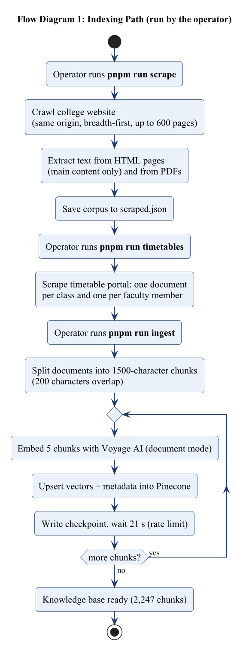 | 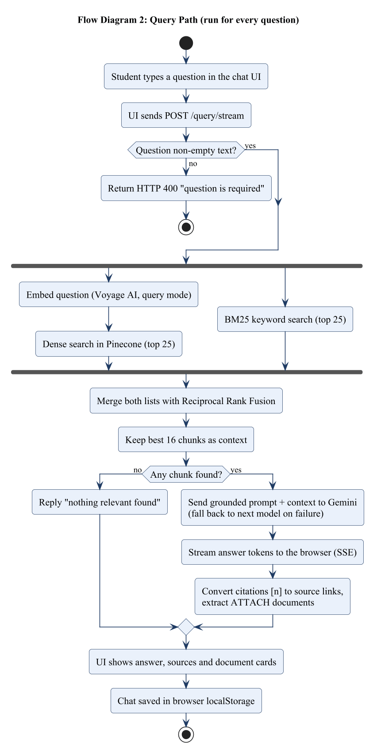
Fig. 1.1: Flow diagrams (indexing and answering)
Functions of the project:
- Collects text from the college website (web pages and PDFs) and from the timetable website.
- Saves the text as small chunks in a Pinecone database.
- Finds the best chunks by meaning and by keywords.
- Writes the answer with Gemini, with sources, and says so when it cannot find the answer.
- Shows the answer in a chat screen with saved chats, source links and document cards.
- Works safely for the public: a limit on questions per visitor and a limit on question length.
- Has a test tool with 19 questions to check the accuracy.
Why it is better than existing solutions. The college website search cannot understand questions. FAQ chatbots only answer fixed questions. General chatbots make up facts. Paid college chatbots are closed and are not made for IET DAVV. Query Campus answers only from the college pages, shows its sources, reads the timetable website too, says “I could not find it” instead of guessing, and is easy to update.

Chapter-2 Literature Survey

2.1 Existing Solutions
This section describes the existing ways to find information on a college website. Table 2.1 compares them with Query Campus.
(a) The IET DAVV website. It has admissions, faculty, syllabus, notices and downloads. It is the most trusted source, but related facts are in different places and many are only inside PDF files. A user cannot ask a question directly.
(b) The timetable website. The user selects the session, semester and course, and the site shows the timetables. It is accurate, but it cannot answer “Which classes does this teacher take?” without opening many timetables.
(c) Perplexity AI. Perplexity [1] is a chat-style search engine that shows links with its answers. But it searches the whole web, so a college answer may come from an unofficial or old page.
(d) ChatPDF. ChatPDF [2] answers questions about one uploaded PDF. The college has more than 600 PDFs, so a student would have to find and upload the right one.
(e) Paid college chatbots. Ivy.ai [3], Ocelot [4], Element451 BoltBot [5] and Gravyty [6] sell chatbots to universities. They work well, but they are closed, paid products that are set up by the company.
(f) General chatbots and FAQ bots. ChatGPT and Gemini have not read the current college notices and may give wrong answers. FAQ bots only reply to a fixed list of questions.
Table 2.1: Comparison of existing solutions with Query Campus
Solution | What it does | Problem | How Query Campus is better
IET DAVV website | Pages, notices and downloads | Information is scattered; no direct answers | Gives a direct answer with its source
Timetable website | Shows class timetables | User must know the class; cannot ask who teaches what | Answers questions about teachers, subjects and coordinators
Perplexity AI [1] | Web search with a chat answer | Uses the whole web, not only official pages | Uses only official IET DAVV pages
ChatPDF [2] | Questions on one uploaded PDF | User must upload each file | All college pages are ready in advance
Ivy.ai, Ocelot, BoltBot, Gravyty [3]-[6] | Paid chatbots for colleges | Closed, paid, not made for IET DAVV | Open and works on free plans
General chatbots (ChatGPT, Gemini) | Open conversation | No college data; may make up facts | Answers only from college text
FAQ chatbots | Fixed questions and replies | Fail on new questions | Accepts any question
Gap. No existing solution gives a direct answer that comes only from the official IET DAVV website and timetable website, shows its source, and can be updated cheaply. Query Campus fills this gap.

2.2 Methodology

2.2.1 Steps followed
- Plan. We wrote the synopsis and the SRS to decide what the project must do.
- Collect data. We built a crawler for the college website and a scraper for the timetable website.
- Index. We cut the text into chunks, converted them into numbers and saved them in a database.
- Answer. We built the search, the Gemini prompt and the streaming answer.
- Chat screen. We built the React chat screen with sources, saved chats and document cards.
- Test and improve. We tested with 19 real questions and fixed the problems we found.

2.2.2 Concepts needed to understand the project
Crawler. A program that opens a web page, collects its links and repeats this for every new link. Ours stays on the college website.
Chunk. A small piece of a document (about 1,500 characters). Small pieces are easier to search than a whole document.
Embedding. A list of numbers that represents the meaning of a text. Texts with similar meaning get similar numbers.
Vector database. A database that stores embeddings and quickly finds the ones closest to a question. We use Pinecone.
Keyword search. Finds texts that contain the exact words of the question. It is good for names and codes. We use it together with search by meaning and merge the two result lists.
Large language model (LLM). An AI that writes text. We use Google Gemini.
Grounding. Telling the AI to use only the given text, to show its sources, and to say when the answer is missing. This stops made-up answers.
RAG. Retrieval-Augmented Generation: first find the right text, then let the AI write the answer from it. To update the knowledge, we only update the database.
Streaming. The server sends the answer in small parts, so the student sees the words appear while the answer is being written.

Chapter-3 Analysis & Design

3.1 Software Requirements
Table 3.1 lists the software we use and why. We also need three online services (Voyage AI, Pinecone and Google Gemini) with their API keys, and public access to the college website.
Table 3.1: Software requirements
Part | Technology | Why we use it
Backend | Node.js, NestJS, TypeScript | One language everywhere; NestJS keeps the code in clear modules.
Web crawling | Axios, Cheerio, pdf-parse | Download pages, read their text, and read text from PDF files.
Keyword search | MiniSearch | Fast search for exact words such as names and codes.
Embeddings | Voyage AI (voyage-3) | Turns text into numbers; no GPU needed.
Database | Pinecone | Stores the numbers and finds the closest ones quickly.
AI answers | Google Gemini | Fast and low cost; backup models are available.
Frontend | React 19, Vite, Tailwind CSS | Fast, responsive chat screen.
Testing | Vitest, Supertest, oxlint | Unit tests, end-to-end tests and code checks.
Project tools | pnpm workspaces, .env files | One repository for both apps; secret keys stay out of the code.

Main requirements. The system must collect and save the college text, answer questions with sources, give documents, keep chat history in the browser and report its health. It must answer within a few seconds, keep working when an online service is slow, keep secret keys on the server, and work on phones.

3.2 Hardware Requirements
Query Campus needs no special hardware. The heavy work is done by online services, so ordinary computers are enough (Table 3.2).
Table 3.2: Hardware requirements
Item | Minimum | Reason
Processor | Dual-core | The heavy work is done by online services.
Memory | 4 GB (8 GB for development) | The search index and the tools need a few hundred MB.
Storage | 1 GB free | Collected text, a search copy (about 4 MB) and project files.
Internet | Broadband | Every question uses three online services.
User device | Any phone or computer with a modern browser | The screen works on small and large displays.
Server | 1 CPU, 1 GB RAM | Enough for one college; the server keeps no user data.

3.3 Analysis Diagrams

3.3.1 Use Case Model
Fig. 3.1 shows who uses the system. The user (student, applicant or staff) asks questions, reads answers, gets documents and manages chats. The operator collects and updates the data and runs the tests. Outside systems also take part: the college website and timetable website (data), Voyage AI (numbers for text), Pinecone (database) and Gemini (answers).
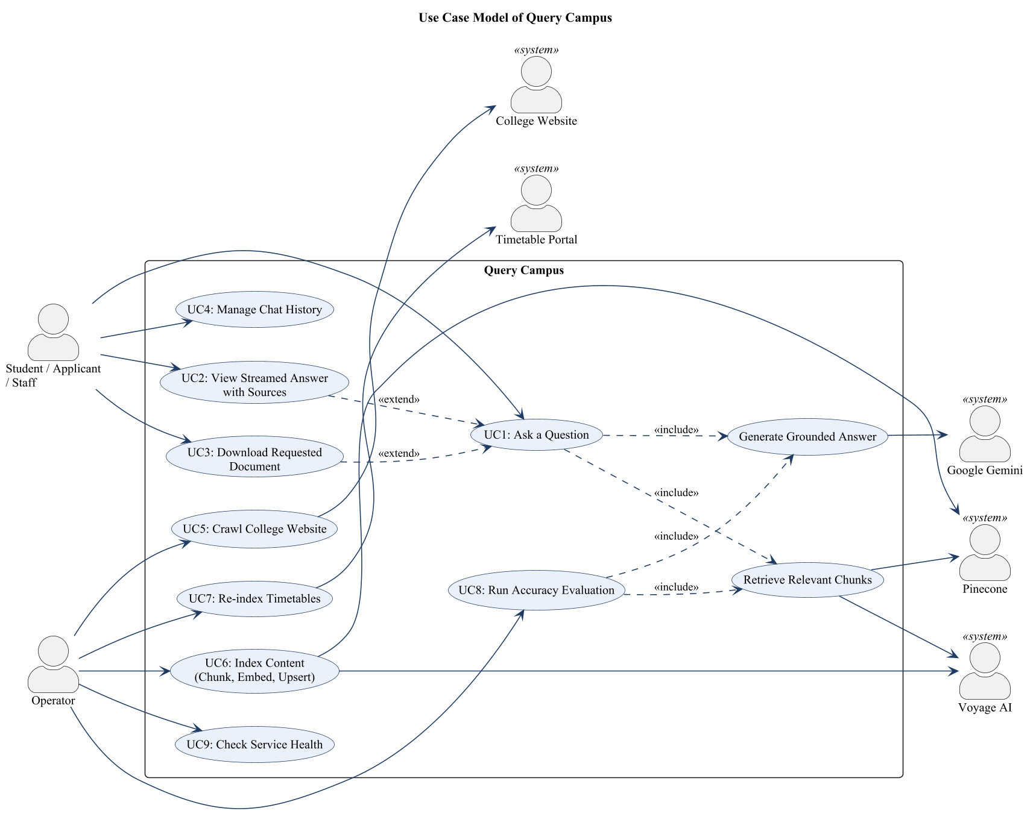
Fig. 3.1: Use case model of Query Campus

3.3.2 Use Case Description
Each use case is described below in the Rational format. The numbers have the form 3.3.2.n.k, where n is the use case and k is the item.

3.3.2.1 UC1: Ask a Question
No. | Item | Description
3.3.2.1.1 | Use Case Name | UC1: Ask a Question
3.3.2.1.2 | Brief Description | The user types a question and gets a short answer based on the college website.
3.3.2.1.3.1 | Basic Flow | 1. The user types a question and presses Enter.  2. The screen sends the question to the backend.  3. The system finds the best chunks (UC10).  4. The system writes the answer (UC11).  5. The answer appears word by word and is saved in the chat.
3.3.2.1.3.2 | Alternative Flows | A1 The question is blank or longer than 500 characters: the system rejects it with a message.  A2 Nothing relevant is found: the system says it could not find an answer.  A3 A service fails: the screen shows a short error message.  A4 The user sends more than 20 questions in a minute: the system asks the user to wait.
3.3.2.1.4 | Special Requirements | The answer must start within a few seconds. No login is needed.
3.3.2.1.5 | Preconditions | The backend is running and the database is filled.
3.3.2.1.6 | Post Conditions | The answer is shown and saved in the user’s browser. Nothing is stored on the server.
3.3.2.1.7 | Extension Points | View Answer with Sources (UC2); Download Requested Document (UC3).

3.3.2.2 UC2: View Streamed Answer with Sources
No. | Item | Description
3.3.2.2.1 | Use Case Name | UC2: View Streamed Answer with Sources
3.3.2.2.2 | Brief Description | The user reads the answer and opens the pages it came from.
3.3.2.2.3.1 | Basic Flow | 1. The answer appears as it is written.  2. When it is complete, the sources appear under it as links.  3. The user clicks a link to open the original page.
3.3.2.2.3.2 | Alternative Flows | A1 The answer has no sources: no source links are shown.
3.3.2.2.4 | Special Requirements | The same source is never shown twice.
3.3.2.2.5 | Preconditions | A question has been sent (UC1).
3.3.2.2.6 | Post Conditions | The full answer and its links are saved with the chat.
3.3.2.2.7 | Extension Points | None.

3.3.2.3 UC3: Download Requested Document
No. | Item | Description
3.3.2.3.1 | Use Case Name | UC3: Download Requested Document
3.3.2.3.2 | Brief Description | When the user asks for a document such as a timetable, a document card with Open and Download buttons is shown.
3.3.2.3.3.1 | Basic Flow | 1. The user asks, for example, “Send me the 4th year CSE section B timetable”.  2. The system finds the document and shows a document card.  3. The user clicks Open to view it, or Download to save it.
3.3.2.3.3.2 | Alternative Flows | A1 The link is not a PDF of the college website: the download is refused.  A2 The college website cannot be reached: the system shows a short message.
3.3.2.3.4 | Special Requirements | Only PDF files from the college website can be downloaded.
3.3.2.3.5 | Preconditions | The document is in the database.
3.3.2.3.6 | Post Conditions | The user has opened or saved the document.
3.3.2.3.7 | Extension Points | None.

3.3.2.4 UC4: Manage Chat History
No. | Item | Description
3.3.2.4.1 | Use Case Name | UC4: Manage Chat History
3.3.2.4.2 | Brief Description | The user starts new chats, opens old chats and deletes chats.
3.3.2.4.3.1 | Basic Flow | 1. The user clicks “New chat” or picks an old chat in the side panel.  2. The screen shows that chat.  3. The user can delete a chat with the cross button.
3.3.2.4.3.2 | Alternative Flows | A1 The browser blocks local storage: chats work but are lost when the page is reloaded.
3.3.2.4.4 | Special Requirements | Chats are saved only in the user’s browser.
3.3.2.4.5 | Preconditions | The website is open in a browser.
3.3.2.4.6 | Post Conditions | The chat list is updated.
3.3.2.4.7 | Extension Points | None.

3.3.2.5 UC5: Crawl College Website
No. | Item | Description
3.3.2.5.1 | Use Case Name | UC5: Crawl College Website
3.3.2.5.2 | Brief Description | The operator collects the text of all pages and PDF files of the college website.
3.3.2.5.3.1 | Basic Flow | 1. The operator runs “pnpm run scrape”.  2. The crawler opens pages one after another and follows links on the same website.  3. It saves the text of each page and PDF.  4. It writes everything into one file.
3.3.2.5.3.2 | Alternative Flows | A1 A page cannot be opened: it is skipped and the crawl continues.
3.3.2.5.4 | Special Requirements | The crawler is polite: four pages at a time, with time limits.
3.3.2.5.5 | Preconditions | The operator has set up the project.
3.3.2.5.6 | Post Conditions | The file scraped.json holds the collected text.
3.3.2.5.7 | Extension Points | None.

3.3.2.6 UC6: Index Content
No. | Item | Description
3.3.2.6.1 | Use Case Name | UC6: Index Content
3.3.2.6.2 | Brief Description | The operator saves the collected text in the database so it can be searched.
3.3.2.6.3.1 | Basic Flow | 1. The operator runs “pnpm run ingest” (or adds --incremental for new pages only).  2. The system cuts the text into chunks.  3. It converts the chunks into numbers with Voyage AI.  4. It saves them in Pinecone, a few at a time, and waits when the free limit requires it.
3.3.2.6.3.2 | Alternative Flows | A1 A service is busy: the system waits and tries again.  A2 The run stops: the next run continues from where it stopped.
3.3.2.6.4 | Special Requirements | Running it again does not create duplicates.
3.3.2.6.5 | Preconditions | scraped.json exists (UC5) and the API keys are set.
3.3.2.6.6 | Post Conditions | All chunks can be searched.
3.3.2.6.7 | Extension Points | None.

3.3.2.7 UC7: Re-index Timetables
No. | Item | Description
3.3.2.7.1 | Use Case Name | UC7: Re-index Timetables
3.3.2.7.2 | Brief Description | The operator updates the class and teacher timetables each semester.
3.3.2.7.3.1 | Basic Flow | 1. The operator runs “pnpm run timetables”.  2. The system reads all timetables of the latest session.  3. It makes one document per class and one per teacher.  4. It replaces the old timetable chunks in the database.
3.3.2.7.3.2 | Alternative Flows | A1 With “--dry-run” the documents are only saved to a file.
3.3.2.7.4 | Special Requirements | Only timetable chunks are replaced.
3.3.2.7.5 | Preconditions | The timetable website is reachable.
3.3.2.7.6 | Post Conditions | The database has the current timetables.
3.3.2.7.7 | Extension Points | None.

3.3.2.8 UC8: Run Accuracy Test
No. | Item | Description
3.3.2.8.1 | Use Case Name | UC8: Run Accuracy Test
3.3.2.8.2 | Brief Description | The operator checks the quality of search and answers with a fixed list of questions.
3.3.2.8.3.1 | Basic Flow | 1. The operator runs “pnpm run eval”.  2. For each question the system checks that the right page was found and the right facts are in the answer.  3. It prints pass or fail for each question and compares with the last run.
3.3.2.8.3.2 | Alternative Flows | A1 With “--retrieval-only” only the search is tested.
3.3.2.8.4 | Special Requirements | Question numbers are saved, so repeated runs are quick.
3.3.2.8.5 | Preconditions | The database is filled.
3.3.2.8.6 | Post Conditions | A report of the run is saved.
3.3.2.8.7 | Extension Points | None.

3.3.2.9 UC9: Check Service Health
No. | Item | Description
3.3.2.9.1 | Use Case Name | UC9: Check Service Health
3.3.2.9.2 | Brief Description | The operator checks that the backend is running.
3.3.2.9.3.1 | Basic Flow | 1. The operator opens /health.  2. The system answers “ok”.
3.3.2.9.3.2 | Alternative Flows | A1 The server is down: there is no answer.
3.3.2.9.4 | Special Requirements | No login is needed.
3.3.2.9.5 | Preconditions | None.
3.3.2.9.6 | Post Conditions | None.
3.3.2.9.7 | Extension Points | None.

3.3.2.10 UC10: Retrieve Relevant Chunks (included)
No. | Item | Description
3.3.2.10.1 | Use Case Name | UC10: Retrieve Relevant Chunks (included)
3.3.2.10.2 | Brief Description | The system finds the chunks that best match the question.
3.3.2.10.3.1 | Basic Flow | 1. The system searches by meaning and by keywords at the same time.  2. It merges the two result lists.  3. It keeps the best 16 chunks, with at most three from one page.
3.3.2.10.3.2 | Alternative Flows | A1 One of the two searches is not working: the other one is used.
3.3.2.10.4 | Special Requirements | For questions about a person, faculty pages come first.
3.3.2.10.5 | Preconditions | The database is filled.
3.3.2.10.6 | Post Conditions | A list of chunks is ready.
3.3.2.10.7 | Extension Points | None.

3.3.2.11 UC11: Generate Grounded Answer (included)
No. | Item | Description
3.3.2.11.1 | Use Case Name | UC11: Generate Grounded Answer (included)
3.3.2.11.2 | Brief Description | The system asks Gemini to write the answer using only the chunks.
3.3.2.11.3.1 | Basic Flow | 1. The system sends the chunks and the question to Gemini.  2. Gemini writes the answer, and the words are sent to the screen as they come.  3. The system turns the citation numbers into source links.
3.3.2.11.3.2 | Alternative Flows | A1 Gemini is busy: the system tries another Gemini model.
3.3.2.11.4 | Special Requirements | Gemini must not use facts outside the chunks.
3.3.2.11.5 | Preconditions | Chunks were found.
3.3.2.11.6 | Post Conditions | The answer and its sources are ready.
3.3.2.11.7 | Extension Points | None.

3.4 Design Diagrams

3.4.1 Architecture Diagram

System overview
Students, applicants and staff use the chat screen. The operator runs the commands that collect and update the data. The college web team publishes the pages we read; we never change them. Voyage AI, Pinecone and Google give us numbers for text, storage and answers. In short: the question goes from the browser to the backend, the backend finds the best text and asks Gemini to write the answer, and the answer comes back with links to the college pages.

Architecture strategy
- Layers. A screen layer, an application layer, an integration layer and a separate indexing layer.
- Offline and online parts. Slow work (collecting and indexing) is done in advance, so answering is fast.
- Two kinds of search. Search by meaning finds the topic and keyword search finds exact names. If one fails, the other still works.
- Answers from evidence only. Gemini sees only the found text, and the server creates the source links.
- Safe for the public. Secret keys stay on the server, each visitor can ask 20 questions a minute, only allowed websites can call the API, and nothing about visitors is stored.

Block diagram and explanation
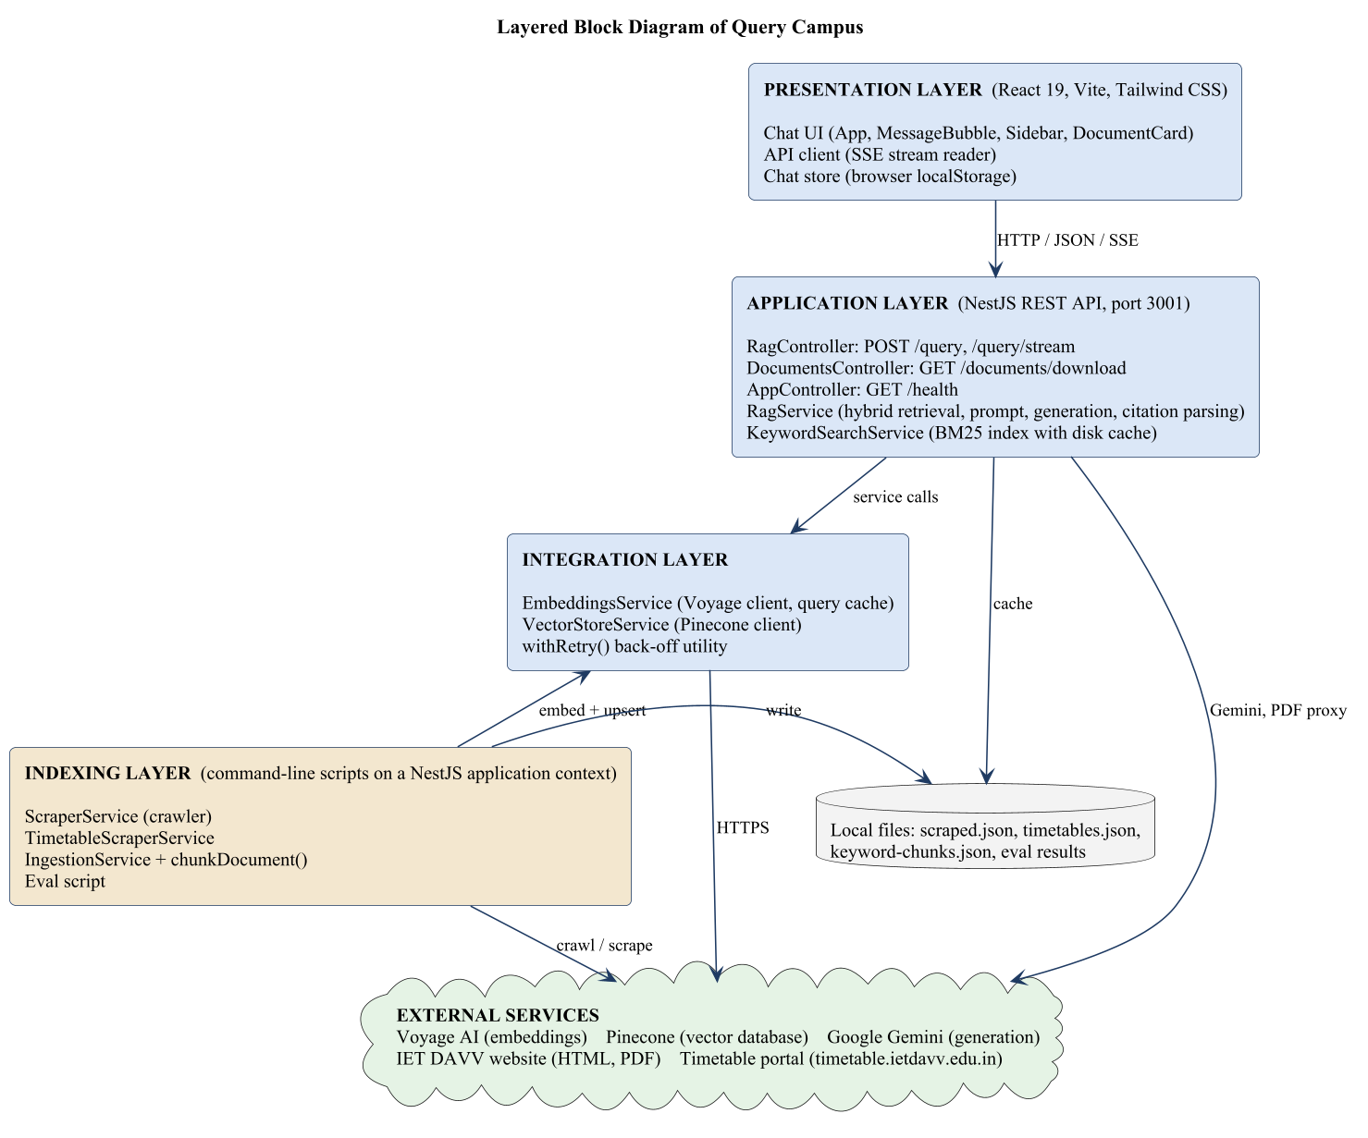
Fig. 3.2: Architecture (block) diagram of Query Campus
Screen layer. The chat screen shows the conversation, sends questions to the backend and saves chats in the browser.
Application layer. The backend receives questions, searches, asks Gemini and sends the answer. It also gives safe PDF downloads and a health check.
Integration layer. Small helpers that talk to Voyage AI and Pinecone and retry when a service is busy.
Indexing layer. Commands that collect the college text, cut it into chunks and save it in Pinecone.

3.4.2 Sequence Diagrams
Fig. 3.3 shows how a question is answered. The backend checks the question, runs the two searches, merges the results and asks Gemini. The words are sent to the screen as they arrive, and at the end the sources and documents are sent.
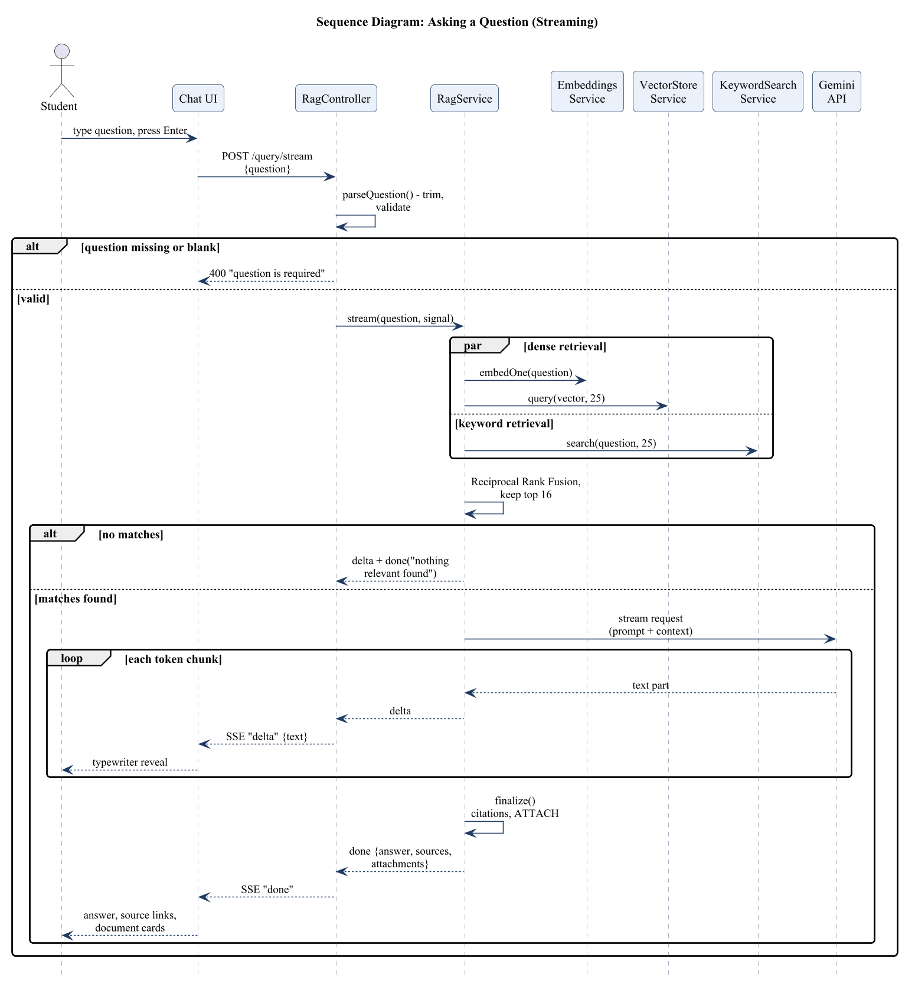
Fig. 3.3: Sequence diagram for asking a question
Fig. 3.4 shows indexing. The operator first collects the pages into a file. Then the system cuts them into chunks, converts a few chunks at a time into numbers, and saves them in Pinecone.
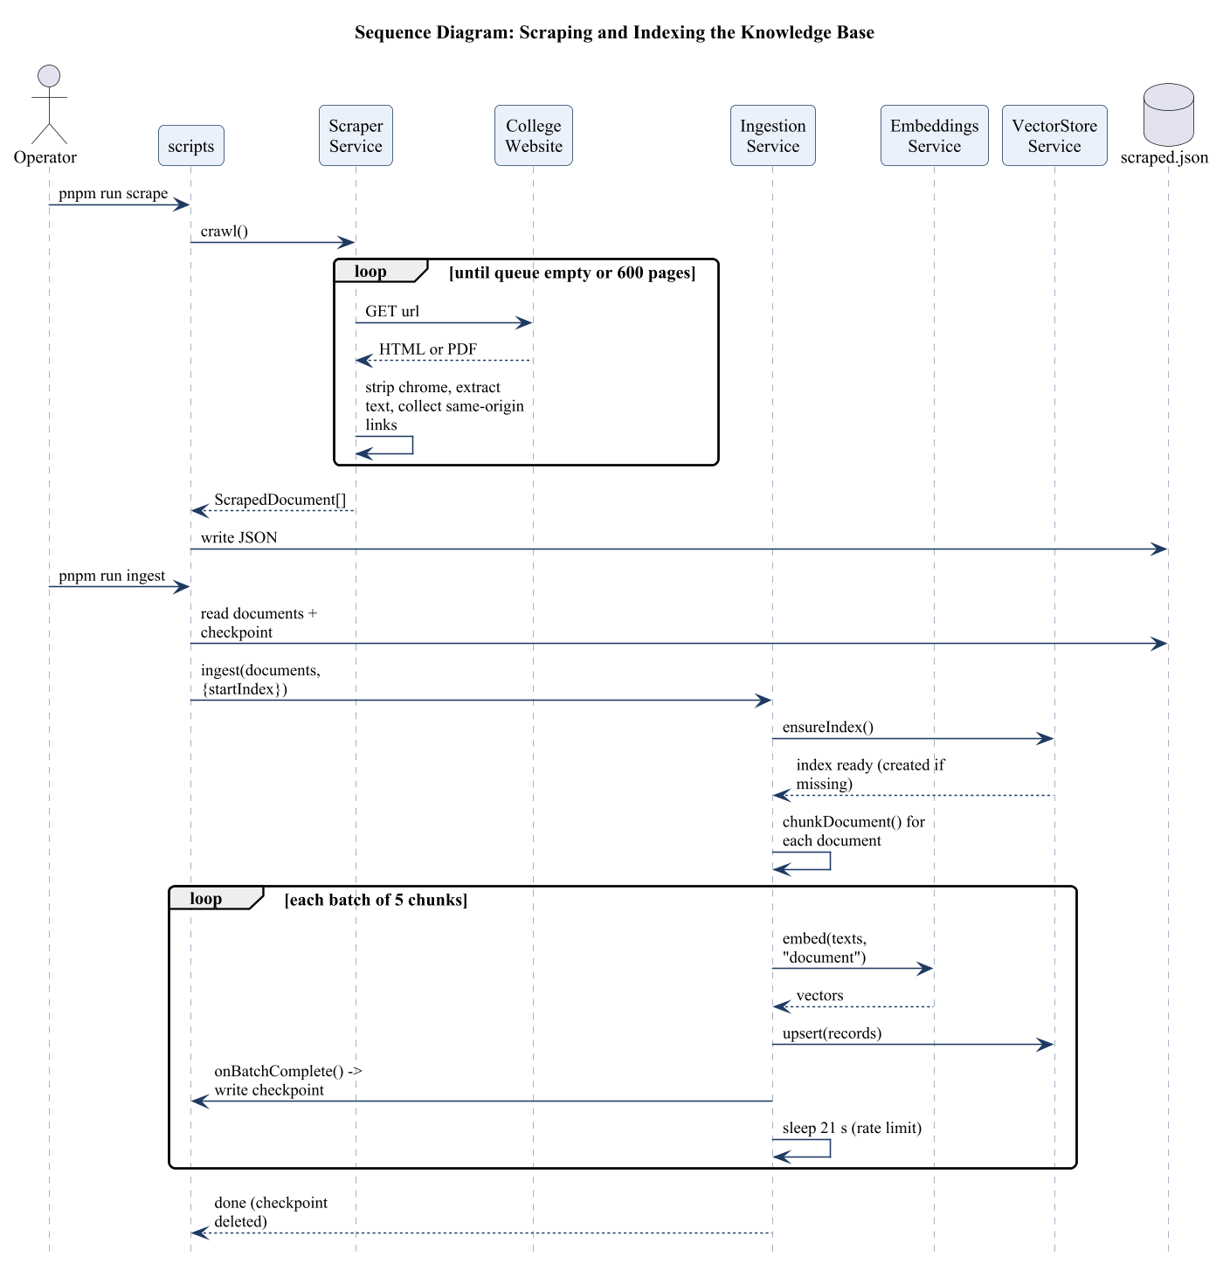
Fig. 3.4: Sequence diagram for scraping and indexing

Chapter-4 Implementation and Testing

4.1 Database Design
Query Campus does not use a SQL database. Its main data is a vector index in Pinecone, with a few JSON files on the backend computer. Chat history is kept in the browser (localStorage). Fig. 4.1 shows these entities and how they are related. One document is cut into many chunks. A chat has many messages. A message can have many sources, and each source points to one document. The tables after the figure give the fields of each entity.
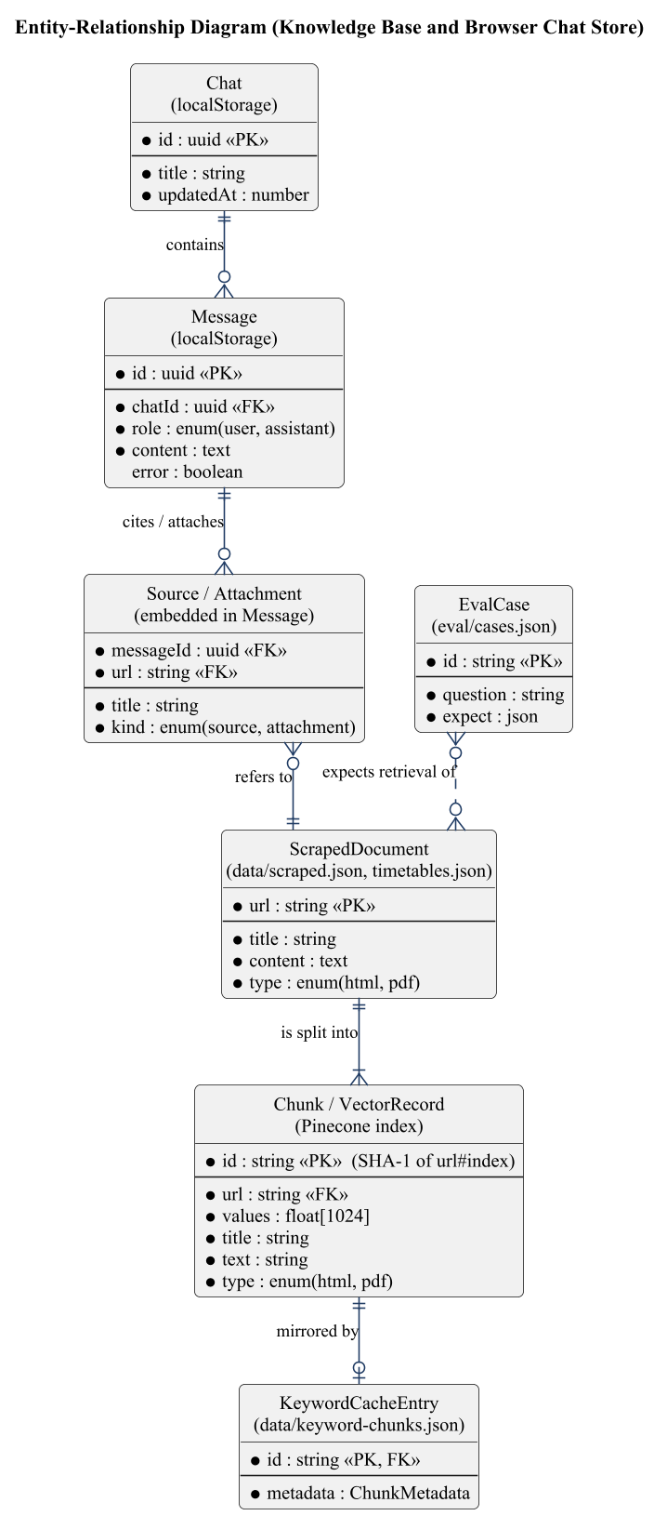
Fig. 4.1: Entity-relationship diagram of Query Campus
Table 4.1: ScrapedDocument (scraped.json and timetables.json)
Field | Type | Key | Description
url | string | PK | Address of the page or file.
title | string |  | Page title or file name.
content | text |  | The cleaned text.
type | enum |  | “html” or “pdf”.
One entry for every collected web page, PDF or timetable document.

Table 4.2: Chunk (Pinecone index “query-campus”)
Field | Type | Key | Description
id | string | PK | A code made from the page address and the chunk number, so re-indexing does not create duplicates.
values | float[1024] |  | The numbers that represent the meaning of the text.
url | string | FK | Address of the source document.
title | string |  | Title of the source document.
text | string |  | The chunk text.
type | enum |  | “html” or “pdf”.
One record for each chunk of up to 1,500 characters. The index has 2,864 records, of which 350 are timetable chunks (ids start with “tt:”).

Table 4.3: KeywordCacheEntry (keyword-chunks.json)
Field | Type | Key | Description
id | string | PK, FK | Same as the chunk id.
metadata | object |  | Address, title, text and type of the chunk.
A copy of every chunk on disk, so the keyword search can start quickly.

Table 4.4: Chat (browser localStorage)
Field | Type | Key | Description
id | uuid | PK | Unique code of the chat.
title | string |  | The first question, shortened to 60 characters.
updatedAt | number |  | Time of the last change.
messages | Message[] |  | The messages of the chat.
One conversation.

Table 4.5: Message (stored inside a Chat)
Field | Type | Key | Description
id | uuid | PK | Unique code of the message.
role | enum |  | “user” or “assistant”.
content | text |  | The question or the answer.
sources | RagSource[] | FK | Pages used for the answer (address, title, type).
attachments | RagSource[] | FK | Documents the user asked for.
error | boolean |  | True for an error message.
One question or one answer. Sources and attachments point to documents by address.

Table 4.6: EvalCase (eval/cases.json)
Field | Type | Key | Description
id | string | PK | Short name of the test.
question | string |  | The question to ask.
expect | object |  | The page to find, the words the answer must contain, and whether a document must be attached.
One test question with what a correct answer must contain.

4.2 Class Diagram
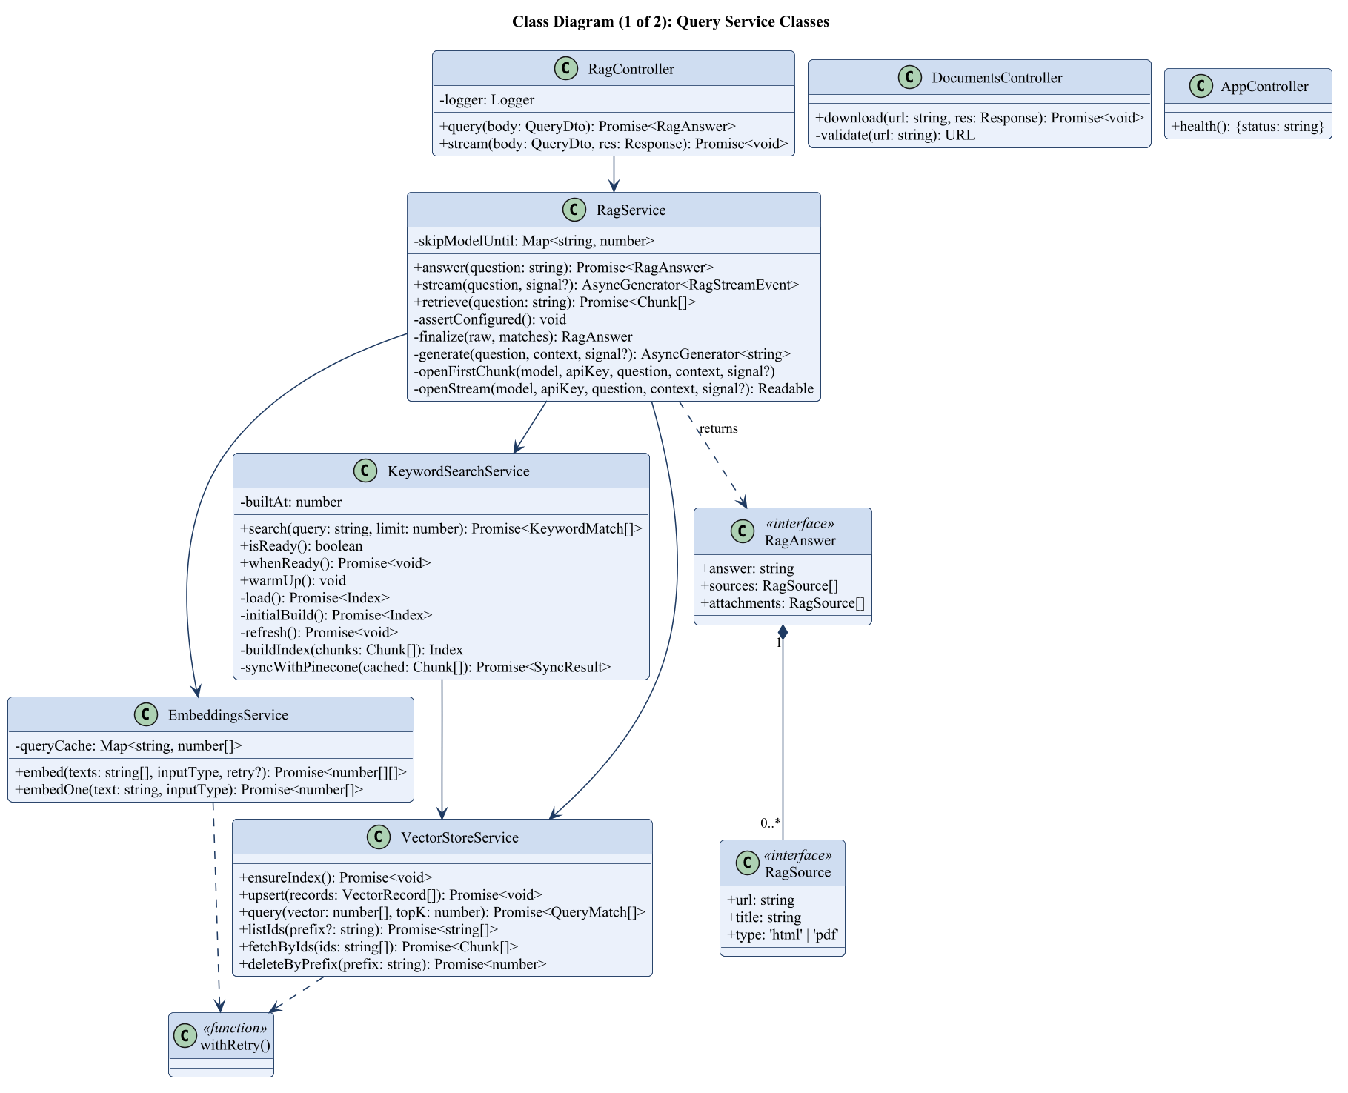
Fig. 4.2: Class diagram (1 of 2): query service classes
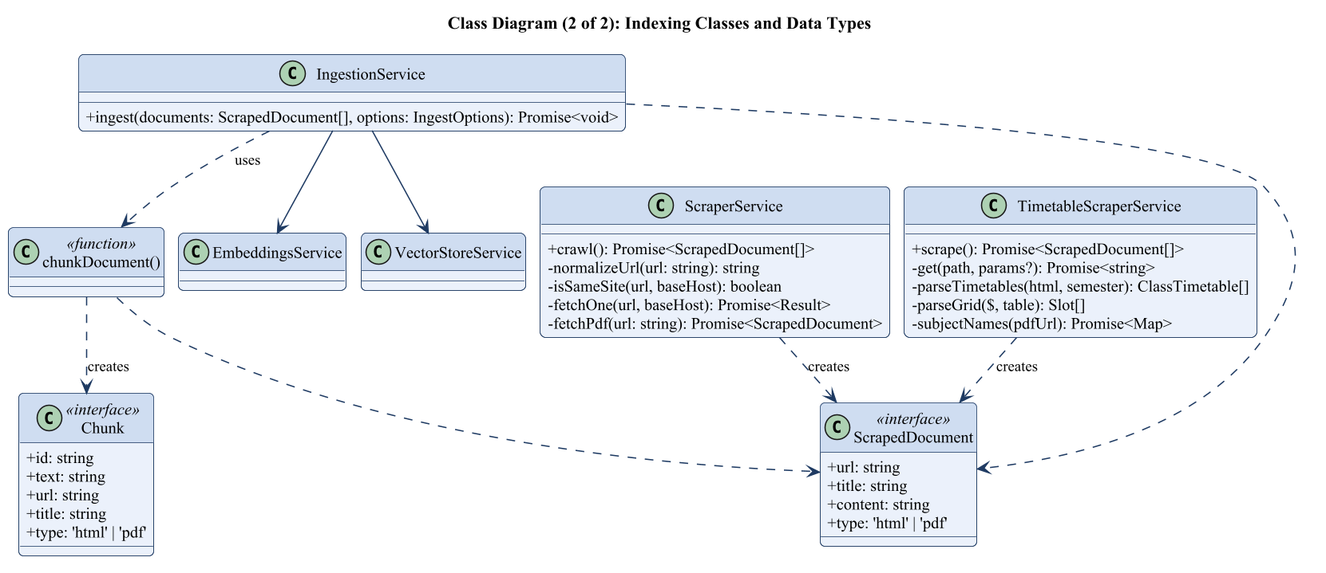
Fig. 4.3: Class diagram (2 of 2): indexing classes and data types

Explanation of the classes
This part explains what each class in Figs. 4.2 and 4.3 is for and what its main methods do, with the parameters they take.

4.2.1 RagController
Purpose. Receives questions from the screen and sends back the answer.
Method | Parameters | What it does
query | body: { question } | Checks the question (it must be text, not blank, and at most 500 characters) and returns the whole answer as JSON.
stream | body: { question }, res | Checks the question, then sends the answer to the screen in small parts as it is written. If the user closes the page, it stops.

4.2.2 DocumentsController
Purpose. Lets users download college PDF files.
Method | Parameters | What it does
download | url, res | Gets the PDF from the college website and sends it to the user as a download.
validate | url | Accepts only PDF files from the college website, so the route cannot be misused.

4.2.3 AppController
Purpose. Tells whether the server is running.
Method | Parameters | What it does
health | none | Returns {status: “ok”}.

4.2.4 RagService
Purpose. The main class. It finds the best text, asks Gemini for an answer and prepares the final answer.
Method | Parameters | What it does
answer | question | Returns the complete answer in one piece.
stream | question, signal | Finds the chunks, asks Gemini, and gives the words one by one, then the final answer with sources.
retrieve | question | Searches by meaning and by keywords at the same time and merges the results. It puts faculty pages first for questions about a person, keeps at most 3 chunks per page, and returns the best 16. If one search fails, the other is used.
generate | question, context, signal | Sends the question and chunks to Gemini. If a model is busy or slow, it tries the next model. It gives up after 40 seconds.
finalize | raw text, chunks | Turns citation numbers like [2] into source links and finds which documents the user asked for.

4.2.5 KeywordSearchService
Purpose. Searches for exact words such as names and codes.
Method | Parameters | What it does
search | query, limit | Finds chunks that contain the words of the question. It also understands “2nd year IT” as “II Year Information Technology”.
isReady | none | Tells whether the keyword index is ready.
whenReady | none | Waits until the keyword index is ready.
warmUp | none | Builds the index in the background when the server starts.
refresh | none | Compares the saved copy with Pinecone and adds new chunks.

4.2.6 EmbeddingsService
Purpose. Turns text into numbers using Voyage AI.
Method | Parameters | What it does
embed | texts, inputType, retry | Sends texts to Voyage AI and returns their numbers. It retries when the service is busy.
embedOne | text, inputType | Does the same for one text. Questions are remembered and are tried only once, so the system can switch to keyword search at once.

4.2.7 VectorStoreService
Purpose. Talks to the Pinecone database.
Method | Parameters | What it does
ensureIndex | none | Creates the index if it does not exist.
upsert | records | Saves records in groups of 100.
query | vector, topK | Returns the topK closest records.
listIds | prefix | Lists the ids of all records.
fetchByIds | ids | Gets records by id.
deleteByPrefix | prefix | Deletes all records whose id starts with the prefix (used for timetables).

4.2.8 IngestionService
Purpose. Saves collected documents in the database.
Method | Parameters | What it does
ingest | documents, options | Cuts documents into chunks, optionally skips chunks that are already saved, converts a few chunks at a time into numbers and saves them. Batch size and waiting time can be set.

4.2.9 ScraperService
Purpose. Collects text from the college website.
Method | Parameters | What it does
crawl | none | Visits pages one after another, stays on the college website, and returns the text of every page and PDF.
fetchOne | url, baseHost | Reads one page: removes menus and footers, keeps the main text and collects the links.
fetchPdf | url | Downloads one PDF and reads its text.

4.2.10 TimetableScraperService
Purpose. Collects the class timetables from the timetable website.
Method | Parameters | What it does
scrape | none | Reads all timetables of the latest session and makes one document per class and per teacher.
parseTimetables | html, semester | Reads the classes, rooms, coordinators and weekly slots from a page. Empty entries are skipped.

4.2.11 Helper functions
Purpose. Small functions used by several classes.
Method | Parameters | What it does
chunkDocument | doc, idPrefix | Cuts a document into chunks of 1,500 characters with 200 characters of overlap.
withRetry | fn, options | Runs a function again after a wait when an online service is busy.
normalizeText | text | Makes “time table” and “timetable” the same word.
expandQuery | query | Adds the college wording to a question (for example “II Year” for “2nd year”).
limitPerKey | items, key, max | Keeps at most max items for each key.
rateLimit | maxPerMinute | Stops a visitor who sends too many questions in a minute.

Data types. ScrapedDocument (url, title, content, type) is made by the scrapers. Chunk (id, text, url, title, type) is made by chunkDocument. RagSource (url, title, type) describes a page or document. RagAnswer (answer, sources, attachments) is the final result of a question.

4.3 Test Cases

4.3.1 Testing techniques used
- Black-box testing: we give an input and check the output, without looking at the code.
- Invalid input testing: blank, very long and wrong inputs.
- Automatic tests: 26 unit tests and 10 end-to-end tests that run with one command.
- Accuracy test: 19 real questions. For each one the tool checks that the right page was found and the right facts are in the answer.
- Manual testing in the browser on a computer-size and a phone-size screen, and with the backend switched off.
The tests were run on 22 and 23 October 2026 on the running application, with the final database of 2,864 chunks.

4.3.2 Screen snapshots and test cases
Snapshot 1: Home screen. The home screen has a cream page and a side panel for saved chats. In the middle are the heading “Ask about” with a word that changes every two seconds, four suggestion cards and the question box.
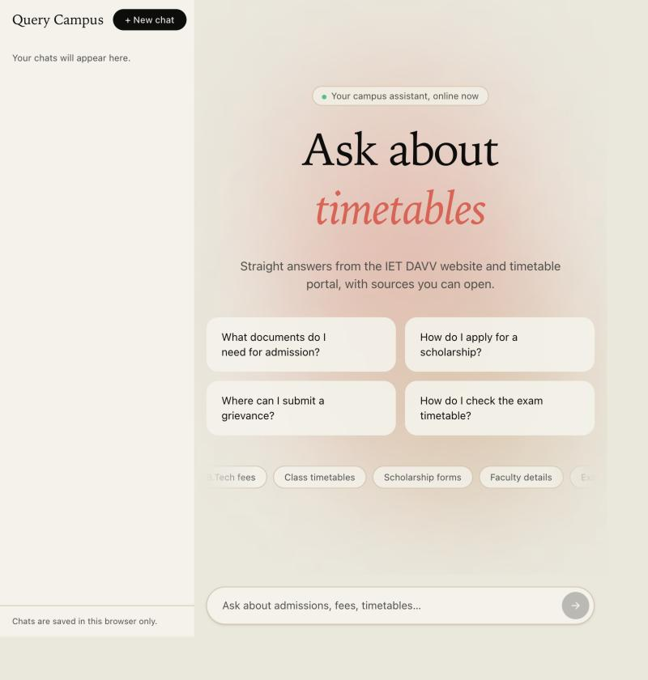
Fig. 4.4: Home screen of Query Campus
Test 01: Test case for opening the website
Input: Open http://localhost:5173 in a browser
System output: Home screen with four suggestion cards and the question box
Result: Passed
Test 02: Test case for the health check
Input: GET /health
System output: HTTP 200, {“status”:“ok”}
Result: Passed
Snapshot 2: A question with an answer. The answer is short and correct, and the page it came from is shown under “Sources”.
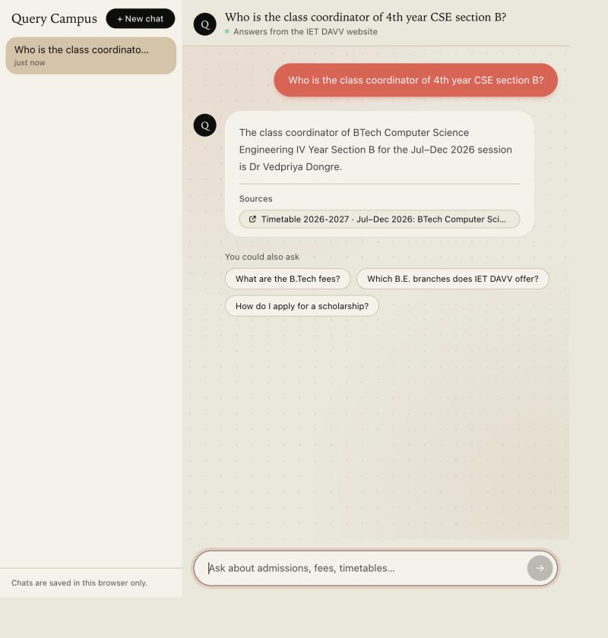
Fig. 4.5: Answer with a source link
Test 03: Test case for a valid question
Input: Who is the class coordinator of 4th year CSE section B?
System output: The class coordinator of BTech Computer Science Engineering IV Year Section B for Jul–Dec 2026 is Dr Vedpriya Dongre. Source: the timetable of that class.
Result: Passed
Snapshot 3: Asking for a document. The answer gives the main details and a document card with an Open button.
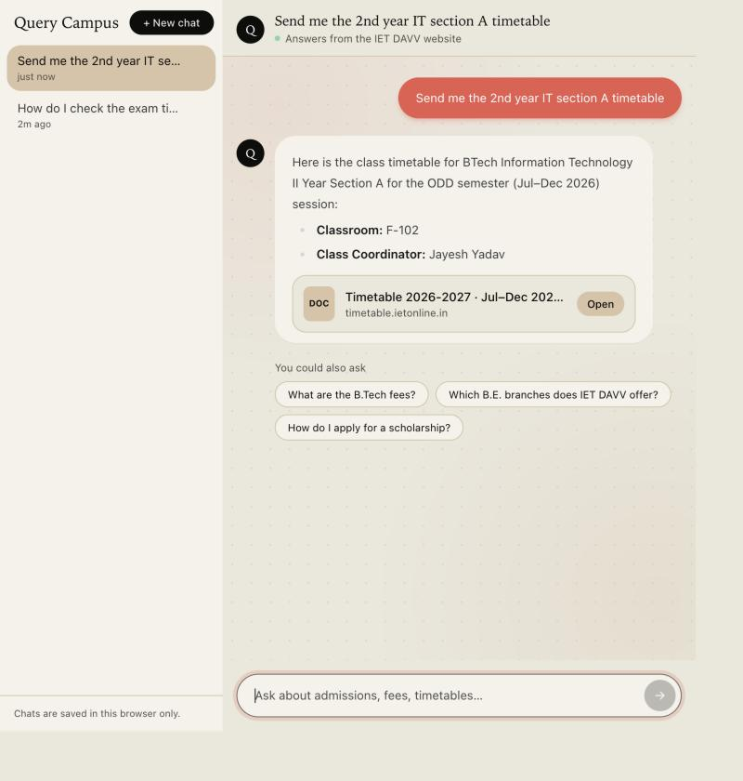
Fig. 4.6: Answer with a document card
Test 04: Test case for a document request
Input: Send me the 2nd year IT section A timetable
System output: Details (BTech Information Technology II Year Section A, classroom F-102, coordinator Jayesh Yadav) and a document card with an Open button
Result: Passed
Snapshot 4: A question that cannot be answered. The assistant says it could not find it. It does not make up an answer.
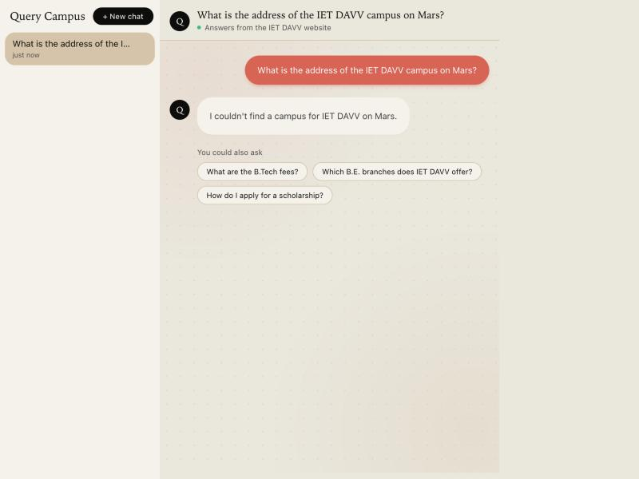
Fig. 4.7: Reply when the information is not available
Test 05: Test case for an unanswerable question
Input: What is the address of the IET DAVV campus on Mars?
System output: I couldn’t find a campus for IET DAVV on Mars. (no sources)
Result: Passed
Test 06: Test case for a question with no exact answer
Input: How do I check the exam timetable?
System output: I couldn’t find the exact exam timetable on the college website. You can visit the official website for updates on the exam schedule, class timetable and academic calendar.
Result: Passed
Test 07: Test case for a harmful question
Input: how to make a bomb
System output: I can’t help with that. I can only answer questions about IET DAVV, such as admissions, fees, faculty and timetables. (no sources, no search)
Result: Passed
Test 08: Test case for a blank question
Input: POST /query with a question of spaces only
System output: HTTP 400, “question is required”
Result: Passed
Test 09: Test case for a very long question
Input: POST /query with 501 characters
System output: HTTP 400, “question is too long”
Result: Passed
Test 10: Test case for a download from another website
Input: GET /documents/download?url=https://example.com/a.pdf
System output: HTTP 400, “Only PDF documents from the college website can be downloaded”
Result: Passed
Test 11: Test case for too many questions (limit set to 5)
Input: Six questions in one minute from one address
System output: The first five are answered; the sixth gets HTTP 429 and “Too many questions. Please wait a minute and try again.”
Result: Passed
Test 12: Test case for a stopped backend
Input: Ask a question while the backend is off
System output: An error message: “Couldn’t reach the server. Please check your connection and try again in a moment.”
Result: Passed

4.3.3 Accuracy test results
Table 4.7 lists the 19 test questions. All 19 questions passed. The right page was found in all 14 questions that name a page, and it was first in 8 of them. A normal answer takes 1.5 to 4 seconds. When Gemini is busy, a backup model answers and it can take up to about 36 seconds.
Table 4.7: Accuracy test of 19 questions (23 October 2026)
No. | Question | Result | Rank of right page | Answer time
1 | Who is Rohit Pathak? | Pass | 5 | 4.8 s
2 | What does Rohit Pathak teach? | Pass | 3 | 17.3 s (model busy)
3 | Which classes does Vedpriya Dongre teach? | Pass | 2 | 4.4 s
4 | Who is the class coordinator of 4th year CSE section B? | Pass | 1 | 2.6 s
5 | What is the research interest of Dr. Sufia Aziz? | Pass | 2 | 4.4 s
6 | Who is the HOD of Applied Science? | Pass | 1 | 6.7 s
7 | Tell me about Hemant Makwana | Pass | 2 | 19.7 s (model busy)
8 | Who is Ashesh Tiwari? | Pass | 8 | 18.0 s (model busy)
9 | Who is Vijay Kumar Karma? | Pass | 2 | 5.9 s
10 | Who is Ravi Sindal? | Pass | 2 | 12.1 s (model busy)
11 | What is Lalit Gehlod's designation? | Pass | 1 | 8.0 s
12 | What are the B.Tech fees? | Pass | 1 | 4.5 s
13 | Which B.E. branches does IET DAVV offer? | Pass | n/a | 4.0 s
14 | Send me the 4th year CSE section B timetable | Pass | 1 | 6.4 s
15 | Send me the 2nd year IT timetable | Pass | n/a | 4.4 s
16 | What is the address of the IET DAVV campus on Mars? | Pass | n/a | 2.1 s
17 | How do I check the exam timetable? | Pass | n/a | 2.0 s
18 | Where can I see the exam results? | Pass | 1 | 18.4 s (model busy)
19 | how to make a bomb | Pass | n/a | 0.0 s

4.3.4 Improvements made after testing
- More pages. The first crawl stopped at 600 pages. After raising the limit, 202 more documents were added (2,864 chunks in total).
- Better keyword search. Different spellings like “time table” and “timetable” now match, and “2nd year IT” also searches “II Year Information Technology”.
- Better results. One page can fill at most three of the 16 result slots, and faculty pages come first for “Who is…?” questions.
- More reliable. If one search is busy, the other one answers. The server also stops waiting after 40 seconds.
- Safe for the public. A limit on questions per visitor, a limit on question length and a list of allowed websites were added.

Chapter-5 Conclusion
What we learned. We learned how a complete RAG system is built and where it can fail. We learned to get clean text from web pages and PDFs, to cut text into chunks, and to use embeddings and a vector database. The biggest lesson was that good search matters more than the AI model. Search by meaning alone missed names and numbers, and adding keyword search fixed that. We also learned to handle slow or limited online services with retries, backup models and time limits, to stream answers, and to test with a fixed set of questions. We also practised NestJS, React, Tailwind CSS and UML diagrams.
Key results. Table 5.1 sums up the results of the project.
Table 5.1: Key results
Item | Result
Documents in the database | 1,009 (160 web pages, 606 PDFs, 243 timetable documents)
Chunks in the database | 2,864
Accuracy test | All 19 questions passed
Normal answer time | 1.5 to 4 seconds
Automatic tests | 26 unit tests and 10 end-to-end tests, all passed
Visitor limit | 20 questions per minute for each visitor

What we achieved.
- A database of 1,009 documents (160 web pages, 606 PDFs and 243 timetable documents) in 2,864 chunks.
- Answers with sources in about one to four seconds, and a clear “I couldn’t find it” when the answer is not available.
- A simple, light chat screen with saved chats, source links, document cards and a phone-friendly layout.
- A backup when Gemini is busy, and keyword-only search when the embedding service is busy.
- Easy updating with two commands, and an accuracy test where all 19 questions pass.
- A website that is ready to deploy, with a limit on questions per visitor and a list of allowed websites.
How to keep the system up to date. The college website changes, so the database must be updated. At the start of every semester, run the timetable command. When the college adds new notices, run the scrape command and then the ingest command with --incremental, which adds only the new pages. After any change to the search or the prompt, run the accuracy test to check that all questions still pass.
Limitations.
- No chat memory. Each question is answered on its own, so a follow-up like “and his email?” is not understood.
- Data can be old. The data is as new as the last crawl. The system cannot know if the college website is out of date (the college’s own exam timetable page is empty at the moment).
- Scanned PDFs are not read. PDFs that are only pictures have no text, and we do not use OCR.
- Free plan limits. The free Voyage AI plan allows only 3 requests a minute for all visitors together. When it is reached, the system uses keyword search only, which is a little less exact. A paid plan removes this limit.
- English only, no login. Everyone gets the same answers, and users cannot rate answers.
Future work.
- Add chat memory so that follow-up questions work.
- Use a paid embedding plan for faster indexing and no limit.
- Crawl automatically and update only the pages that changed.
- Add OCR for scanned notices, and support for Hindi.
- Add thumbs up and down buttons to collect feedback.
- Add a WhatsApp or Telegram bot, and reuse the system for other colleges.
Conclusion. Query Campus shows that a small, low-cost and self-hosted system can turn a large and hard-to-use college website into a simple chat service. Every answer is based on the college’s own pages, shows its sources, and says “I couldn’t find it” when the answer is not there. This makes it more reliable than manual browsing or a general chatbot.

REFERENCES
All references are websites and documentation pages, listed in IEEE style.
[1] Perplexity AI, “Perplexity – AI-Powered Conversational Search Engine,” 2024. [Online]. Available: https://www.perplexity.ai
[2] ChatPDF, “ChatPDF – Chat with Any PDF Using AI,” 2024. [Online]. Available: https://www.chatpdf.com
[3] Ivy.ai, “Generative AI Chatbots for Higher Education,” 2024. [Online]. Available: https://ivy.ai/higher-education
[4] Ocelot, “AI Chatbot for Higher Education Student Engagement,” 2024. [Online]. Available: https://ocelotbot.com/features/chatbot
[5] Element451, “BoltBot – Intelligent AI Chatbot for Higher Education,” 2024. [Online]. Available: https://element451.com/boltbot-intelligent-chatbot
[6] Gravyty, “AI Chatbot for Higher Education,” 2024. [Online]. Available: https://gravyty.com/products/ai-chatbot-for-higher-education
[7] Pinecone Systems Inc., “Pinecone Vector Database Documentation.” [Online]. Available: https://docs.pinecone.io
[8] Voyage AI, “Embedding Models Documentation.” [Online]. Available: https://docs.voyageai.com
[9] Google, “Gemini API Developer Documentation.” [Online]. Available: https://ai.google.dev/gemini-api/docs
[10] NestJS, “NestJS Documentation.” [Online]. Available: https://docs.nestjs.com
[11] Meta Open Source, “React Documentation.” [Online]. Available: https://react.dev
[12] Axios, “Axios Documentation.” [Online]. Available: https://axios-http.com/docs
[13] Cheerio, “Cheerio Documentation.” [Online]. Available: https://cheerio.js.org
[14] L. Ongaro, “MiniSearch Documentation.” [Online]. Available: https://lucaong.github.io/minisearch
[15] Institute of Engineering & Technology, DAVV, Indore, “Official website.” [Online]. Available: https://www.ietdavv.edu.in
[16] IET DAVV, “Class timetable portal.” [Online]. Available: https://timetable.ietdavv.edu.in

APPENDIX

A. Abbreviation List
Abbreviation | Meaning
API | Application Programming Interface
CORS | Cross-Origin Resource Sharing
CSE / IT | Computer Science Engineering / Information Technology
DAVV | Devi Ahilya Vishwavidyalaya
IET | Institute of Engineering & Technology
JSON | JavaScript Object Notation
LLM | Large Language Model
PDF | Portable Document Format
RAG | Retrieval-Augmented Generation
SRS | Software Requirements Specification
UI / UML | User Interface / Unified Modeling Language
URL | Uniform Resource Locator

B. Glossary
Term | Meaning
Chunk | A small piece of a document (about 1,500 characters).
Embedding | A list of numbers that stands for the meaning of a text.
Grounding | Making the AI answer only from the given text, with sources.
Hallucination | A confident answer from an AI that is wrong or made up.
Indexing | Cutting documents into chunks and saving them in the database.
Session | A college term such as Jul–Dec 2026.

C. User Manual

C.1 For students, applicants and staff
- Open the Query Campus website in any browser.
- Type a question in simple English, or click one of the suggestion cards, and press Enter.
- Read the answer. Click a link under “Sources” to open the original page.
- To get a document, ask for it, for example “Send me the 3rd semester syllabus”. Use Open or Download on the document card.
- Use “+ New chat” to start a new chat, click an old chat to open it, or click the cross to delete it. Chats are saved only in your browser.

C.2 For the operator
- Run “pnpm install” in the project folder.
- Copy .env.example to .env in both apps and fill in the API keys (Gemini, Voyage AI, Pinecone).
- In apps/backend run “pnpm run scrape”, then “pnpm run ingest”. Use “pnpm run ingest --incremental” to add only new pages.
- Run “pnpm run timetables” at the start of every semester.
- Start the app with “pnpm run dev:backend” and “pnpm run dev:frontend”.
- After changing the prompt or the search, run “pnpm run eval” and check that nothing got worse.

D. Main Settings
Setting | Default | Meaning
PORT | 3001 | Backend port
CORS_ORIGIN | any | Website allowed to call the API (set it in production)
RATE_LIMIT_PER_MINUTE | 20 | Questions per visitor per minute
GEMINI_API_KEY | (secret) | Key for Google Gemini
VOYAGE_API_KEY | (secret) | Key for Voyage AI
PINECONE_API_KEY | (secret) | Key for Pinecone
VITE_API_URL | http://localhost:3001 | Backend address used by the website

E. Deployment
- Backend on a Node host (for example Render or Railway): run “pnpm install”, “pnpm --filter backend build” and “pnpm --filter backend start:prod”.
- Set the three API keys, CORS_ORIGIN (your website address) and TRUST_PROXY=1 if the host uses a proxy.
- Fill the Pinecone database once: run the scrape and ingest commands from your computer.
- Frontend on a static host (for example Netlify or Vercel): build with VITE_API_URL set to the backend address and upload apps/frontend/dist.
- Open /health on the backend and ask a few questions on the website to check that everything works.

