INSTITUTE OF ENGINEERING AND TECHNOLOGY, DAVV

QUERY CAMPUS: A RETRIEVAL-AUGMENTED GENERATION BASED CONVERSATIONAL ASSISTANT FOR COLLEGE WEBSITE INFORMATION ACCESS
(Project Synopsis)

Submitted By: -
Name of Student | Email-id | Mobile No. | Department
Akshat Sharma | 23bit005@ietdavv.edu.in | 8817985894 | Information Technology
Tanmay Choudhary | 23bcs072@ietdavv.edu.in | 6260145664 | Computer Engineering
Riya Rawat | 23bit060@ietdavv.edu.in | 8962755988 | Information Technology

Submitted To: -
Name of the Supervisor | Email-id | Mobile No. | Department
Vedpriya Dongre | [supervisor.email@iet.dauniv.ac.in] | 9753754889 | [Department]

_______________________
(Signature of Supervisor)
Keywords: Retrieval-Augmented Generation (RAG), Large Language Models, Vector Embeddings, Semantic Search, Conversational AI
[Supervisor's email and department are placeholders — please fill in before submission, and add the supervisor's signature above.]
1. INTRODUCTION
College websites are typically large, loosely organized repositories of notices, circulars, admission rules, fee structures, and academic schedules spread across dozens of pages and PDF documents. Students and prospective applicants routinely struggle to locate specific, time-sensitive information buried within this unstructured content, leading to repeated queries to administrative staff and delays in decision-making. The recent maturity of Large Language Models (LLMs) such as Google Gemini [9] has made natural-language question answering practical, but LLMs used in isolation are prone to hallucination — generating plausible but factually incorrect answers when asked about institution-specific data they were never trained on. Retrieval-Augmented Generation (RAG), as used in conversational search products such as Perplexity AI [1], addresses this limitation by grounding the model's responses in content retrieved from a verified external knowledge source at query time, rather than relying purely on the model's parametric memory. This project, Query Campus, applies the RAG paradigm to the IET DAVV college website: it crawls and indexes the site's own published content into a semantic vector store and answers student questions in plain English strictly on the basis of that indexed content, citing the source pages used. The system combines web scraping, text embedding, vector similarity search, and LLM-based generation into a single conversational pipeline, offering a faster and more reliable alternative to manual browsing of the college website.
2. LITERATURE SURVEY
Existing approaches to helping users find information on institutional websites fall into a few broad categories, summarized and compared in Table 1. Native keyword search bars cannot interpret natural-language questions or synthesize an answer from multiple pages; rule-based FAQ chatbots only answer a fixed script and need constant manual upkeep; generic LLM assistants used without grounding frequently hallucinate institution-specific facts with high confidence, which is actively dangerous for admission- or exam-related queries; and enterprise site-search platforms improve ranking but still return a list of links rather than a direct answer. Commercial RAG-based products such as Perplexity AI [1] and document-focused assistants such as ChatPDF [2] demonstrate that combining a retriever with a generator substantially reduces hallucination on knowledge-intensive tasks, while purpose-built higher-education chatbot platforms such as Ivy.ai [3], Ocelot [4], Element451's BoltBot [5], and Gravyty [6] show that grounded conversational assistants can be deployed at institutional scale; however, these are largely closed, subscription-based platforms layered over generic content management systems, and published accounts rarely cover an open, end-to-end, self-hosted RAG pipeline tailored to a single institution's own live website. The gap this project addresses is the absence of an accessible, self-updating, citation-backed conversational interface specific to IET DAVV: Query Campus fills this gap by combining automated scraping, chunked embedding-based indexing, and grounded LLM generation into one continuously re-indexable system.
Approach | Examples | Advantages | Drawbacks
Native keyword search | IET DAVV site search bar | Simple, fast, no extra infrastructure | No natural-language understanding; cannot synthesize answers across pages
Rule-based FAQ chatbot | Menu-driven university chatbots | Predictable, controlled answers | Fails outside scripted questions; high manual maintenance
Generic LLM assistant | Asking ChatGPT/Gemini directly | Fluent, flexible natural-language replies | Hallucinates institution-specific facts with no source data
Enterprise site search | Algolia-style search widgets | Better relevance ranking than keyword match | Returns links, not a direct synthesized answer
Commercial RAG-based chatbot platforms | Perplexity AI [1], ChatPDF [2], Ivy.ai [3], Ocelot [4], Element451 BoltBot [5], Gravyty [6] | Grounded, low-hallucination answers with citations; several purpose-built for higher education | Closed, subscription-based products; not self-hostable or tailored to a single institution's own website
Query Campus (this project) | RAG over IET DAVV website | Natural-language Q&A grounded in live site content, with citations and self-updating index | Answer quality bounded by scrape coverage and chunking granularity
Table 1: Comparison of existing approaches to institutional information access.
3. PROBLEM DOMAIN
The core problem is that essential information on the IET DAVV website — admission procedures, exam schedules, fee structures, scholarship forms, notices — is spread across many HTML pages and PDF circulars with no unified way to ask a direct question and get an accurate answer. Students waste time manually searching or repeatedly contacting administrative staff, while generic AI chatbots cannot be trusted for institution-specific facts since they hallucinate when unsure. The objectives of this project are to: (i) automatically crawl and extract text content from the college website, including PDFs; (ii) index this content in a form that supports semantic, meaning-based search rather than brittle keyword matching; (iii) allow users to ask questions in plain English and receive answers grounded strictly in the indexed content, with source citations; and (iv) have the system explicitly decline to answer rather than guess when the requested information is not present in the indexed data.
4. SOLUTION DOMAIN
Query Campus is architected as a three-stage pipeline sitting behind a chat-style web interface, illustrated in Fig. 1. Stage 1 — Scraping: a same-origin crawler (built with Axios for HTTP requests and Cheerio for HTML parsing) traverses the target website, extracting clean text from HTML pages and using pdf-parse to extract text from linked PDF documents such as notices and forms; the crawled corpus is persisted as a structured JSON dataset. Stage 2 — Ingestion: each scraped document is split into overlapping text chunks by a custom chunker to preserve local context across chunk boundaries; each chunk is passed through the Voyage AI embedding model to obtain a dense vector representation, and the resulting vectors are upserted into a Pinecone vector index together with metadata (source URL, page title) that enables citation later. Stage 3 — Retrieval-Augmented Generation: when a user submits a question, the same embedding model encodes the query, Pinecone performs an approximate nearest-neighbour similarity search [7] to retrieve the top-k most relevant chunks, and these chunks are assembled into a context window passed to Google Gemini with an instruction to answer using only the supplied context, cite the originating source, and explicitly state when the answer cannot be found. The scrape-and-ingest pipeline is designed to be re-run periodically so the index stays current whenever the source website changes, without requiring any change to the retrieval or generation logic.
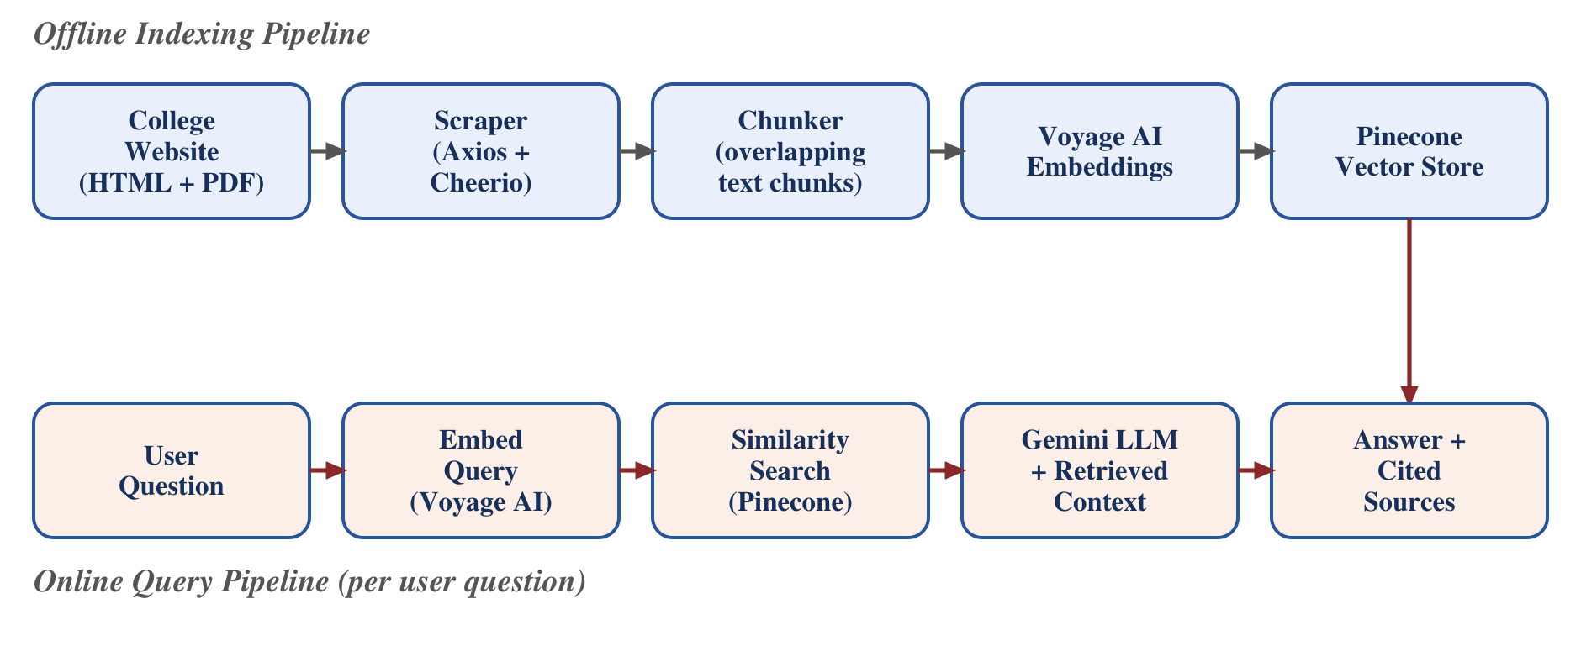
Fig. 1: Data flow of the Query Campus RAG pipeline — offline indexing (top) builds the vector store once; the online query pipeline (bottom) runs per user question.
The backend exposing this pipeline is built with NestJS as a modular REST API (separate modules for scraper, ingestion, embeddings, vector store, and RAG), while the frontend is a React + Vite single-page application styled with Tailwind CSS that renders the conversation, including Markdown-formatted answers and citations, in a chat interface, as summarized in Fig. 2.
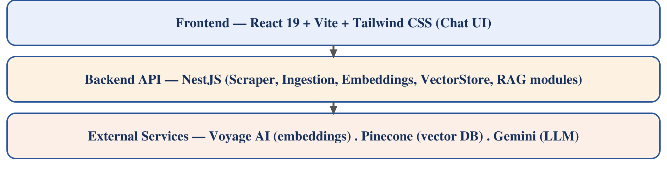
Fig. 2: Layered view of the Query Campus technology stack.
5. SYSTEM DOMAIN
The system is implemented as a TypeScript monorepo managed with pnpm workspaces. Table 2 lists the primary tools/technologies used and the justification for each choice. No specialized hardware is required — the application runs on any standard machine with Node.js installed and internet access to the three cloud APIs (Voyage, Pinecone, Gemini), making deployment lightweight and inexpensive.
Component | Technology | Justification
Backend runtime / framework | Node.js + NestJS (TypeScript) | Modular, testable service architecture; strong typing reduces runtime errors
Web scraping | Axios + Cheerio | Lightweight HTTP client and HTML parser sufficient for same-origin crawling
PDF text extraction | pdf-parse | Extracts text from notices/forms published only as PDF
Embeddings | Voyage AI | High retrieval quality on domain-specific text via a managed API
Vector database | Pinecone | Fully managed, scalable similarity search without self-hosting overhead
Generation (LLM) | Google Gemini | Large context window and low cost/latency, suited to context-heavy RAG prompts
Frontend | React 19 + Vite + Tailwind CSS | Fast dev/build pipeline and utility-first styling for a responsive chat UI
Testing | Vitest | Unit and e2e coverage integrated with the TypeScript/Vite toolchain
Package management | pnpm workspaces | Efficient monorepo dependency management across frontend and backend
Table 2: Technology stack used in Query Campus and justification for each choice.
6. APPLICATION DOMAIN
Query Campus is directly applicable to prospective applicants researching admission criteria, current students checking exam schedules, fee deadlines, or scholarship procedures, and administrative staff fielding repetitive informational queries. Because the scraper and ingestion pipeline are website-agnostic, the same architecture can be re-pointed at any other college or university website with minimal change, making the solution reusable beyond IET DAVV. For end users, the practical impact is a reduction in time spent searching for information and fewer incorrect assumptions caused by outdated or misread notices.
7. EXPECTED OUTCOME
- A working full-stack web application where users can chat in natural language and receive accurate, source-cited answers about IET DAVV.
- An automated scrape-and-ingest pipeline that keeps the underlying knowledge base synchronized with the live college website.
- Noticeably reduced time-to-answer compared to manually browsing the website for the same information.
- A hallucination-resistant response policy, where the system explicitly declines to answer rather than fabricate information absent from the indexed content.
- A reusable RAG architecture that can be redeployed for other institutional websites with minimal reconfiguration.

REFERENCES
[1] Perplexity AI, "Perplexity – AI-Powered Conversational Search Engine," Perplexity AI, Inc., 2024. [Online]. Available: https://www.perplexity.ai. [Accessed: Sep. 2026].
[2] ChatPDF, "ChatPDF – Chat with Any PDF Using AI," ChatPDF, 2024. [Online]. Available: https://www.chatpdf.com. [Accessed: Sep. 2026].
[3] Ivy.ai, "Ivy.ai – Generative AI Chatbots for Higher Education," Ivy.ai Inc., 2024. [Online]. Available: https://ivy.ai/higher-education. [Accessed: Sep. 2026].
[4] Ocelot, "Chatbot – AI Chatbot for Higher Education Student Engagement," Ocelot, 2024. [Online]. Available: https://ocelotbot.com/features/chatbot. [Accessed: Sep. 2026].
[5] Element451, "BoltBot – Intelligent AI Chatbot for Higher Education," Element451 Inc., 2024. [Online]. Available: https://element451.com/boltbot-intelligent-chatbot. [Accessed: Sep. 2026].
[6] Gravyty, "AI Chatbot for Higher Education – Ivy & Ocelot," Gravyty, 2024. [Online]. Available: https://gravyty.com/products/ai-chatbot-for-higher-education. [Accessed: Sep. 2026].
[7] Pinecone Systems Inc., "Pinecone Vector Database – Documentation," Pinecone, 2024. [Online]. Available: https://docs.pinecone.io. [Accessed: Sep. 2026].
[8] Voyage AI, "Voyage AI – Embedding Models Documentation," Voyage AI, 2024. [Online]. Available: https://docs.voyageai.com. [Accessed: Sep. 2026].
[9] Google, "Gemini API – Developer Documentation," Google AI for Developers, 2024. [Online]. Available: https://ai.google.dev/gemini-api/docs. [Accessed: Sep. 2026].
[10] NestJS, "NestJS – A Progressive Node.js Framework – Documentation," OpenJS Foundation, 2024. [Online]. Available: https://docs.nestjs.com. [Accessed: Sep. 2026].
[11] React, "React – The Library for Web and Native User Interfaces – Documentation," Meta Open Source, 2024. [Online]. Available: https://react.dev. [Accessed: Sep. 2026].
[12] Axios, "Axios – Promise Based HTTP Client for the Browser and Node.js – Documentation," Axios, 2024. [Online]. Available: https://axios-http.com/docs. [Accessed: Sep. 2026].
APPENDIX
Appendix – A: Scraped dataset (apps/backend/data/scraped.json) containing the raw crawled corpus from the IET DAVV website used for chunking, embedding, and indexing during development.
[Signatures of all group members and endorsement by the respective supervisor to be added before submission, per department requirements.]

