WEEK 1 | PRACTICAL ACTIVITY
CareNavigatorPH
Navigate to the right care, at the right time.
A mobile healthcare navigation app for Filipino communities
SDG 3 | Good Health and Well-Being

Student Name | Laza, Neil Ardrey
Course / Section | Advanced Mobile Programming / ITE 231
Instructor | John Paul Cabance
Date | 7/20/26
PROJECT SNAPSHOT
CareNavigatorPH helps people describe symptoms safely, understand the appropriate level of care, find verified hospitals with relevant services and availability, and begin a consultation without presenting AI guidance as a medical diagnosis.
1. Community Problem & SDG Alignment
PROBLEM STATEMENT
People in many Philippine communities struggle to decide where to seek care because hospital information is fragmented, service availability is unclear, and symptoms can be difficult to interpret. This can cause delayed treatment, unnecessary travel, crowded facilities, and confusion during urgent situations.
Why this matters in the community
- Patients may not know which nearby facility has the right department, specialist, emergency capability, beds, or rooms.
- Rural residents, older adults, caregivers, and first-time patients may spend extra time calling or visiting multiple facilities.
- Online health information can be misleading when it lacks local context, safety warnings, and a clear path to professional care.
Selected UN Sustainable Development Goal
SDG
3
GOOD HEALTH AND WELL-BEING
Ensure healthy lives and promote well-being for all at all ages.
Direct alignment: Target 3.8 focuses on access to quality essential healthcare services. CareNavigatorPH improves access by connecting users to appropriate, verified, and locally available care.
Intended impact
The app aims to shorten the path from uncertainty to appropriate professional care. It supports informed decisions and timely referrals while keeping emergency escalation, privacy, and clinician review central to the experience.

2. Project Proposal
Core concept
CareNavigatorPH is a mobile healthcare navigation platform designed for Philippine communities. A user can describe symptoms, receive preliminary guidance about urgency and the type of care to seek, compare verified hospitals, and start a consultation. The app does not diagnose or replace a licensed healthcare professional.
Target audience
PRIMARY USERS
- Patients and caregivers
- Residents searching for nearby care
- People unsure which department or hospital level they need
SECONDARY USERS
- Doctors and hospital staff
- Hospital administrators
- Community health workers and referral partners
Primary functionality
01 | AI symptom navigator | Collects symptoms and context, then suggests urgency and an appropriate care type with safety warnings.
02 | Hospital directory | Searches verified facilities by location, level, service, specialist, and availability.
03 | Care matching | Connects assessment needs to suitable hospitals and departments.
04 | Consultation request | Lets a first-time user submit care needs and receive a trackable reference.
05 | My Care | Keeps appointments, messages, records, notifications, and consent in one place.
Scope and safety boundaries
The first version focuses on discovery, preliminary guidance, referrals, and consultation intake. It directs emergencies to 911 or the nearest emergency room, labels AI output as non-diagnostic, protects health data, and requires professional review for clinical decisions.

3. Mockup / Wireframe
User flow: Sign in > describe symptoms > review guidance > find matching care
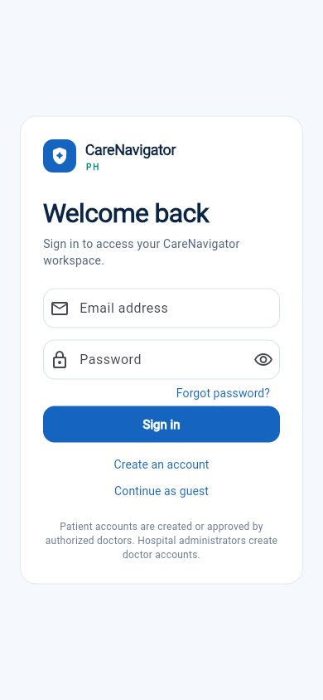 | 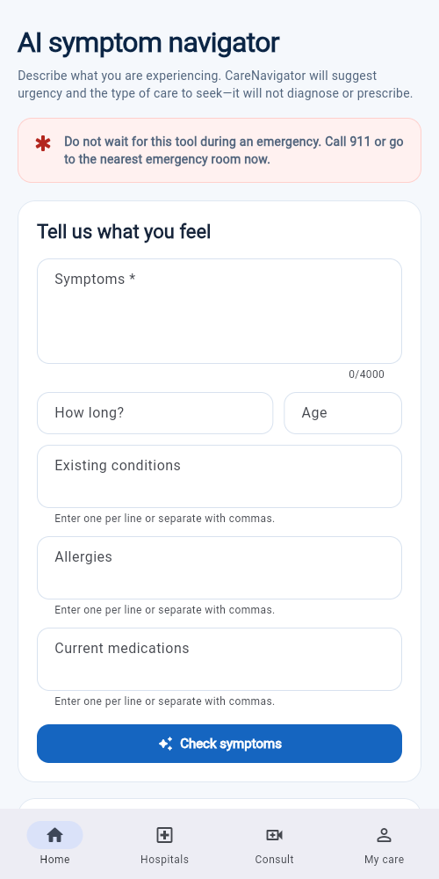
SCREEN 1 - SIGN IN  Purpose: Provides secure entry for patients and care providers.  Key elements: Email, password, recovery, and sign-in action.  Next action: Sign in and proceed to the symptom navigator. | SCREEN 2 - SYMPTOM ASSESSMENT  Purpose: Collects information for preliminary care guidance.  Key elements: Symptoms, duration, age, conditions, allergies, medicines, and emergency warning.  Next action: Tap Check symptoms.
Design notes
The interface uses a calm blue-and-teal palette, plain-language instructions, high-contrast actions, and persistent mobile navigation. Emergency messaging appears before the assessment to prevent unsafe reliance on the tool.

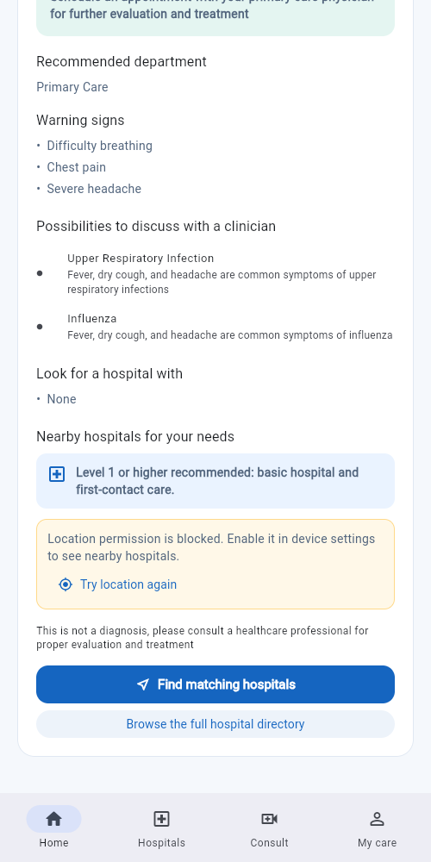 | 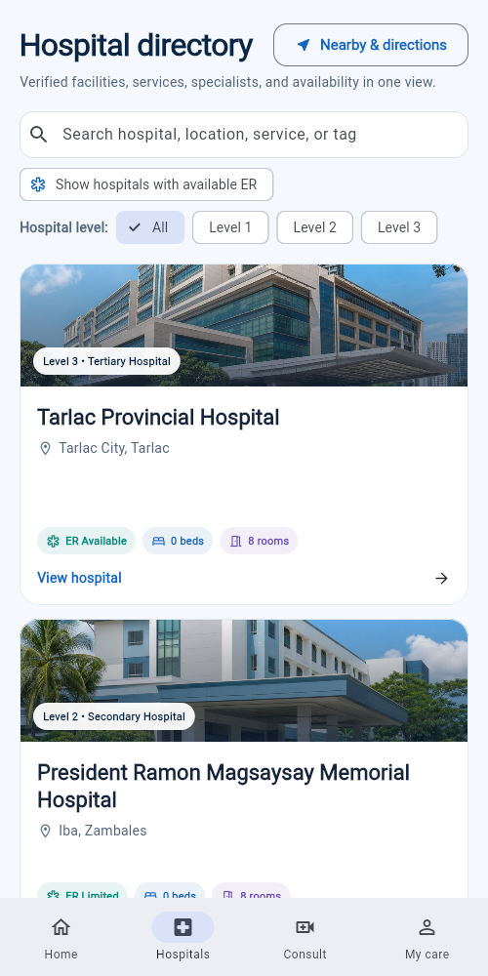
SCREEN 3 - CARE GUIDANCE  Purpose: Turns the assessment into a clear next step without diagnosing.  Key elements: Department, warning signs, possible conditions, hospital-level guidance, and disclaimer.  Next action: Tap Find matching hospitals. | SCREEN 4 - HOSPITAL DIRECTORY  Purpose: Compares verified facilities for the identified need.  Key elements: Search, level and ER filters, location, beds, rooms, and details.  Next action: Open a hospital or proceed to consultation.
Flow logic
1
SIGN IN
>
2
ASSESS
>
3
GUIDANCE
>
4
FIND CARE
Expected result
At the end of the flow, the user understands the suggested level of care and has a practical next step: view a suitable hospital, get directions, or begin a consultation. The design reduces uncertainty without removing professional judgment.

Final step: begin a first-time online consultation
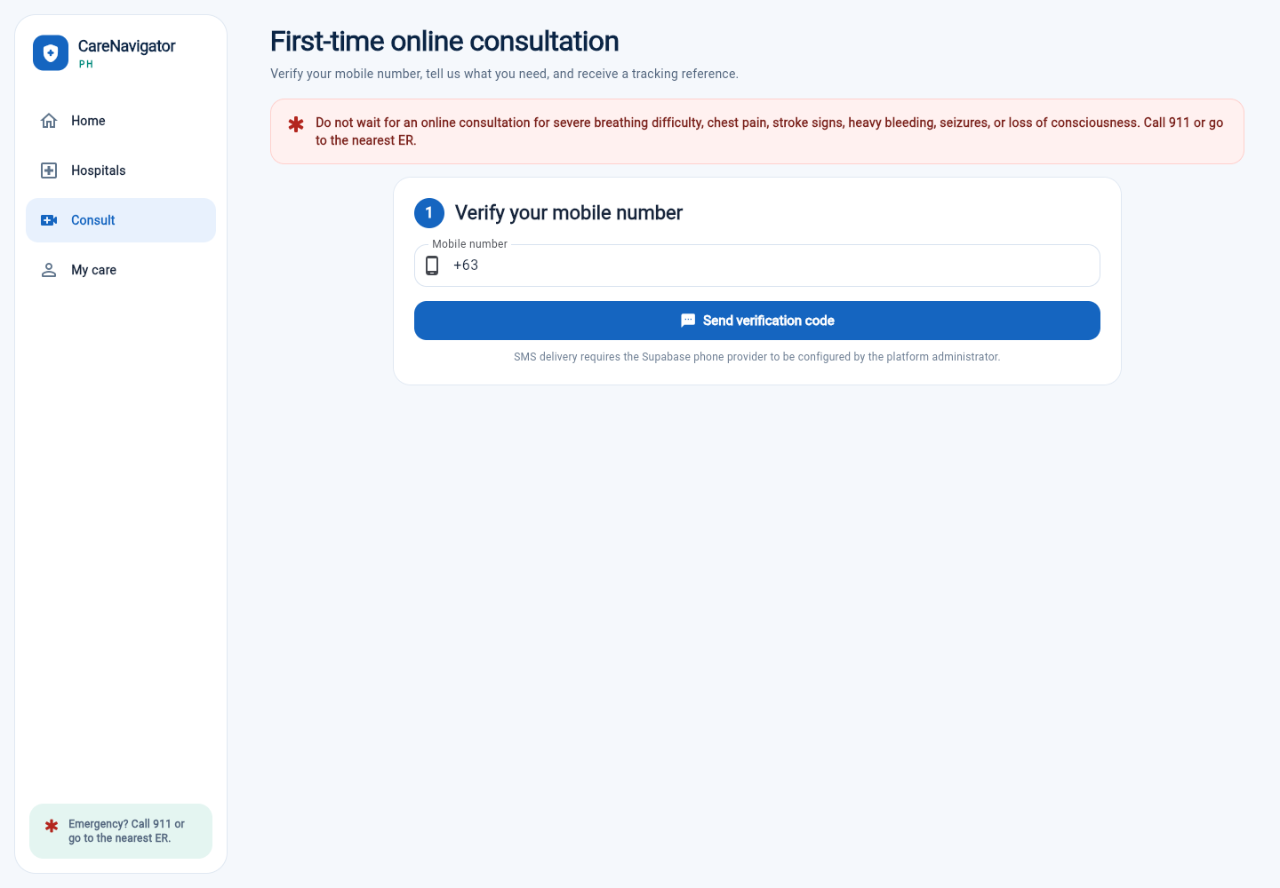
SCREEN 5 - CONSULTATION REQUEST
Purpose: Gives the user a direct way to request professional care after finding an appropriate facility or department.
Key elements: Emergency warning, identity or contact verification, care-needs intake, schedule details, and a trackable reference.
Next action: Verify the contact method, complete the intake form, and submit the request.
Design rationale: This screen closes the navigation loop by connecting information and hospital discovery to a professional care workflow.
Complete five-screen user flow
1 SIGN IN > 2 ASSESS > 3 GUIDANCE > 4 HOSPITAL > 5 CONSULT

Appendix A. Complete Application Page Inventory
The five wireframes above satisfy the required proposal flow. This appendix documents the remaining distinct mobile and web pages represented in the CareNavigatorPH routes and finalized screenshots.
PUBLIC ACCESS | Login, registration, home, assessment, hospital directory, hospital detail, nearby map, and first-time consultation.
PATIENT ACCESS | Dashboard/My Care, care workspace, profile, secure messages, and notifications.
DOCTOR ACCESS | Clinical workspace, consultations, patients, result review, records, clinical actions, messages, and professional profile.
HOSPITAL ADMIN | Hospital profile, operations, consultations, hospital patients, doctors, schedules, availability, analytics, and alerts.
SUPER ADMIN | Hospitals, administrators, service categories, doctors, reports, settings, permissions, audits, and security review.
Application routes reviewed
/login, /register, /home, /hospitals, /hospitals/map, /hospitals/:hospitalId, /assessment, /consult, /dashboard, /care, /profile, /messages/:conversationId, /notifications, /admin, and /admin/operations.
Repeated test captures and duplicate screenshots are omitted. Each following page represents a distinct finalized interface or role-specific responsive view.

A1. Web Login
Audience: All registered users
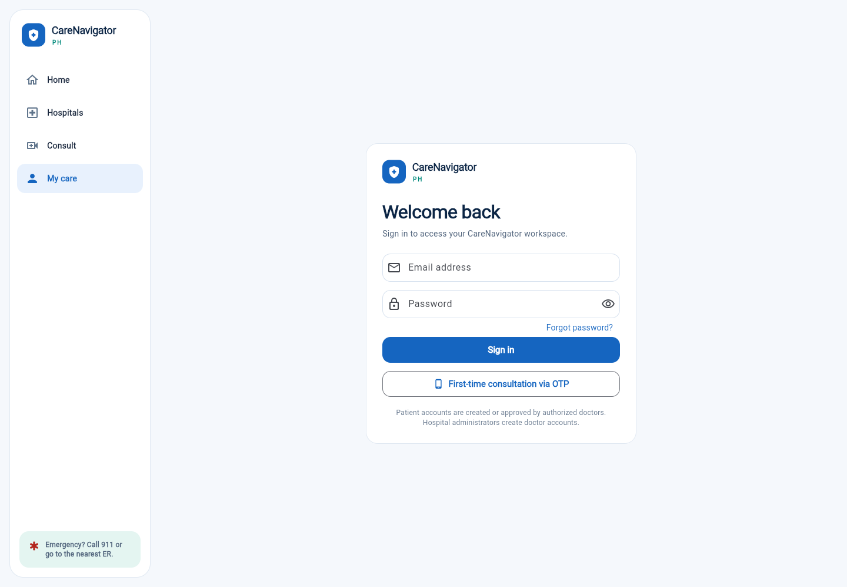
PURPOSE
Authenticates patients, doctors, hospital administrators, and super administrators before protected pages are opened.
MAIN FUNCTIONS
Email/password entry, password recovery, account registration, and role-aware redirection.

A2. Web Home
Audience: Guests and signed-in users
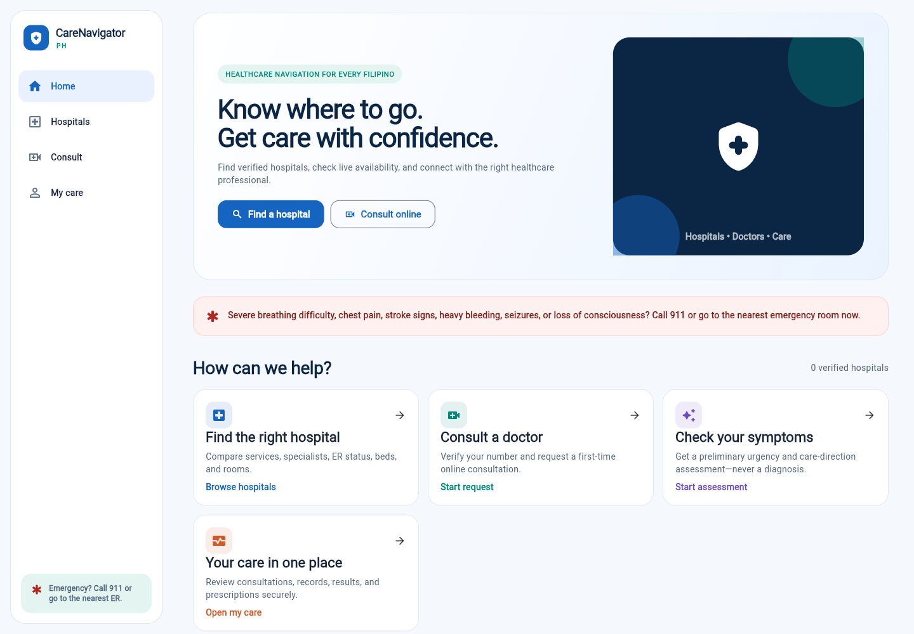
PURPOSE
Serves as the main navigation hub for the application.
MAIN FUNCTIONS
Hospital search, online consultation, symptom assessment, My Care, and visible emergency instructions.

A3. Web Symptom Assessment
Audience: Guests and patients
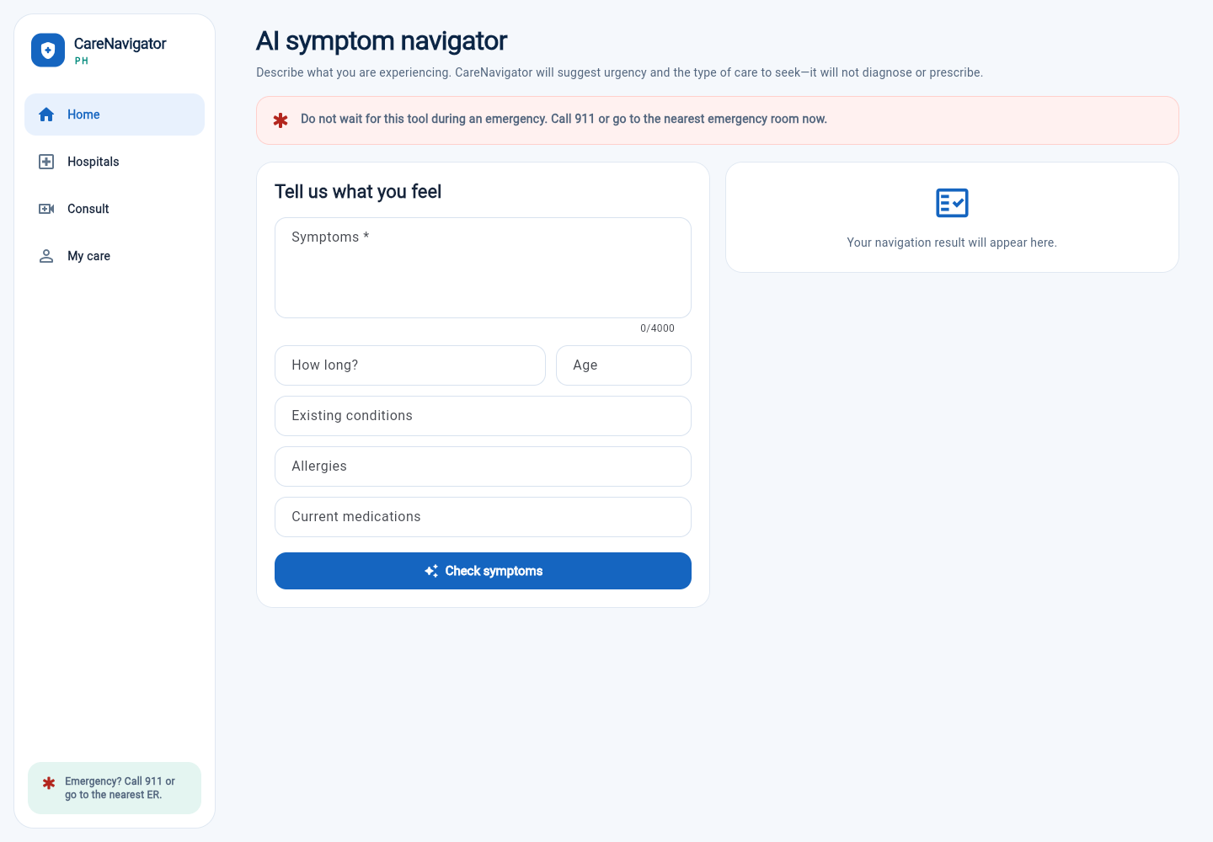
PURPOSE
Collects symptoms and relevant health context in a structured form.
MAIN FUNCTIONS
Symptoms, duration, age, conditions, allergies, medicines, emergency escalation, and assessment submission.

A4. Web Assessment Result
Audience: Assessment users
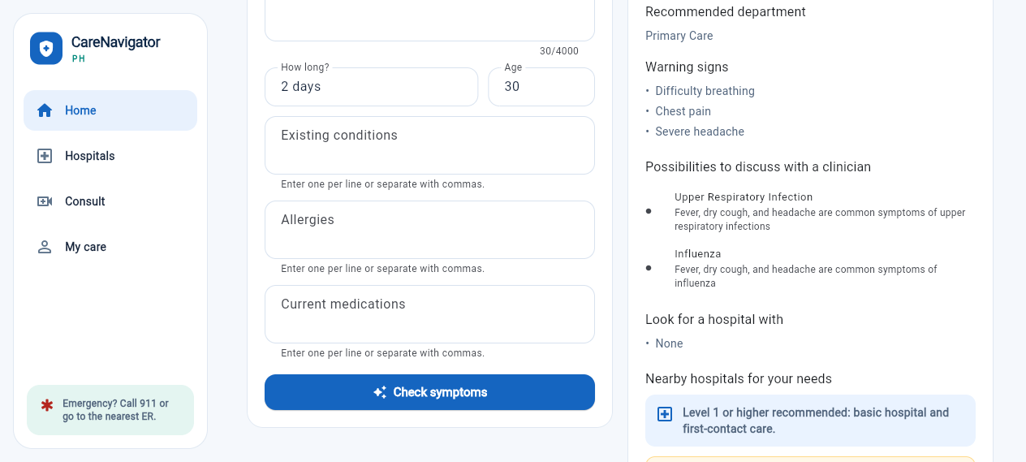
PURPOSE
Summarizes preliminary urgency and care-direction guidance without diagnosing.
MAIN FUNCTIONS
Suggested department, warning signs, possible conditions to discuss, safety disclaimer, and hospital matching.

A5. Web Hospital Directory
Audience: Public care seekers
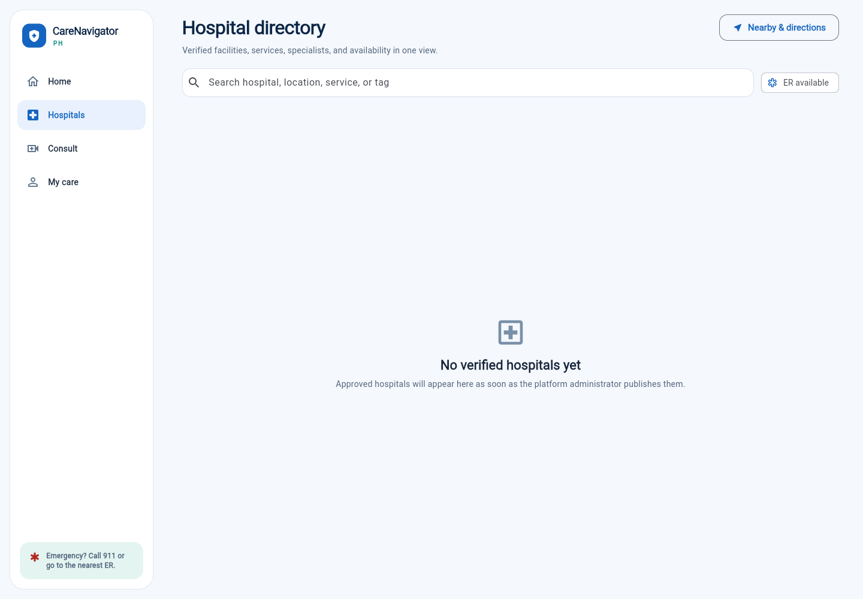
PURPOSE
Compares verified hospitals in one searchable directory.
MAIN FUNCTIONS
Search, hospital-level filters, ER availability, locations, beds, rooms, services, and facility details.

A6. Web Hospital Detail
Audience: Patients and caregivers
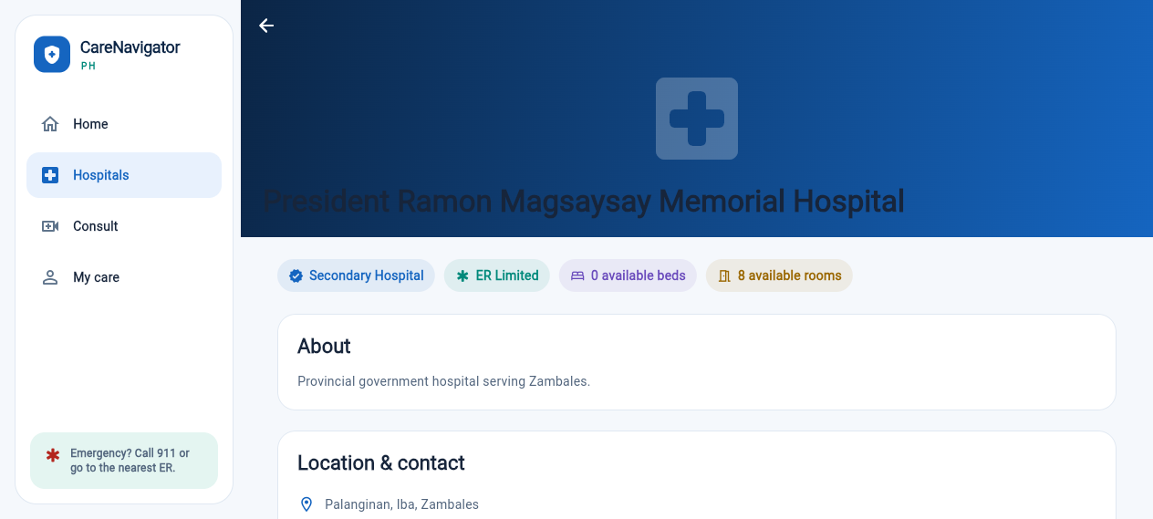
PURPOSE
Presents detailed information about one selected hospital.
MAIN FUNCTIONS
Classification, ER/beds/rooms status, overview, location, contacts, departments, services, doctors, and schedules.

A7. Web Nearby-Care Map
Audience: Location-based care seekers
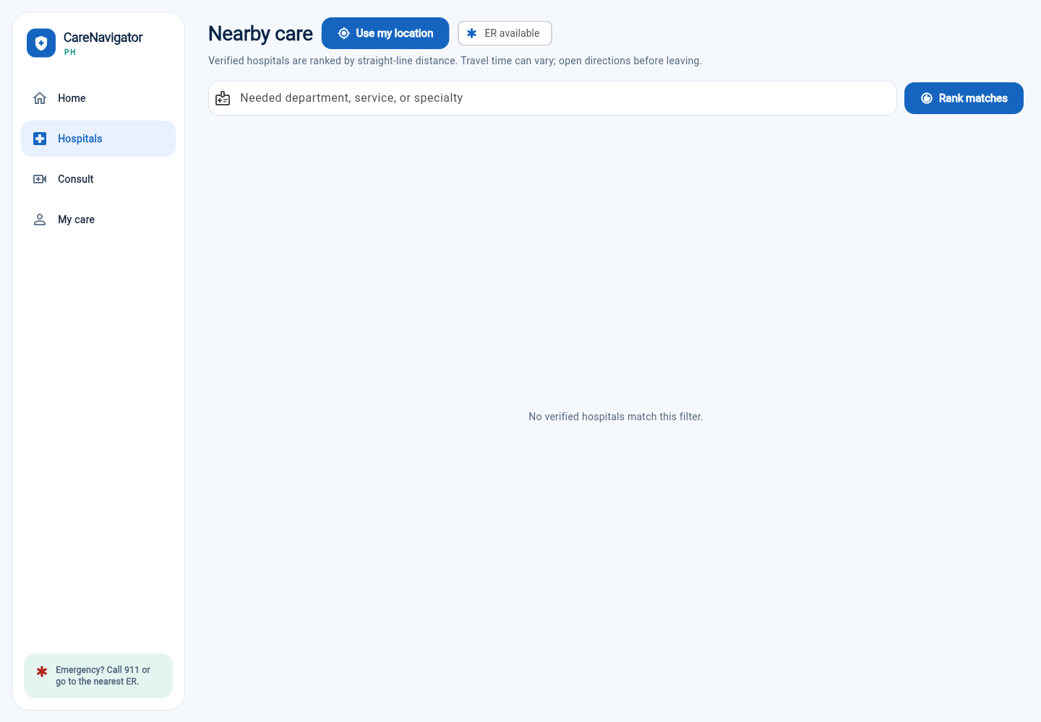
PURPOSE
Ranks suitable hospitals using the user location and care requirement.
MAIN FUNCTIONS
Location permission, ER filter, required service entry, matching, ranking, and directions.

A8. Web Notifications
Audience: Signed-in users
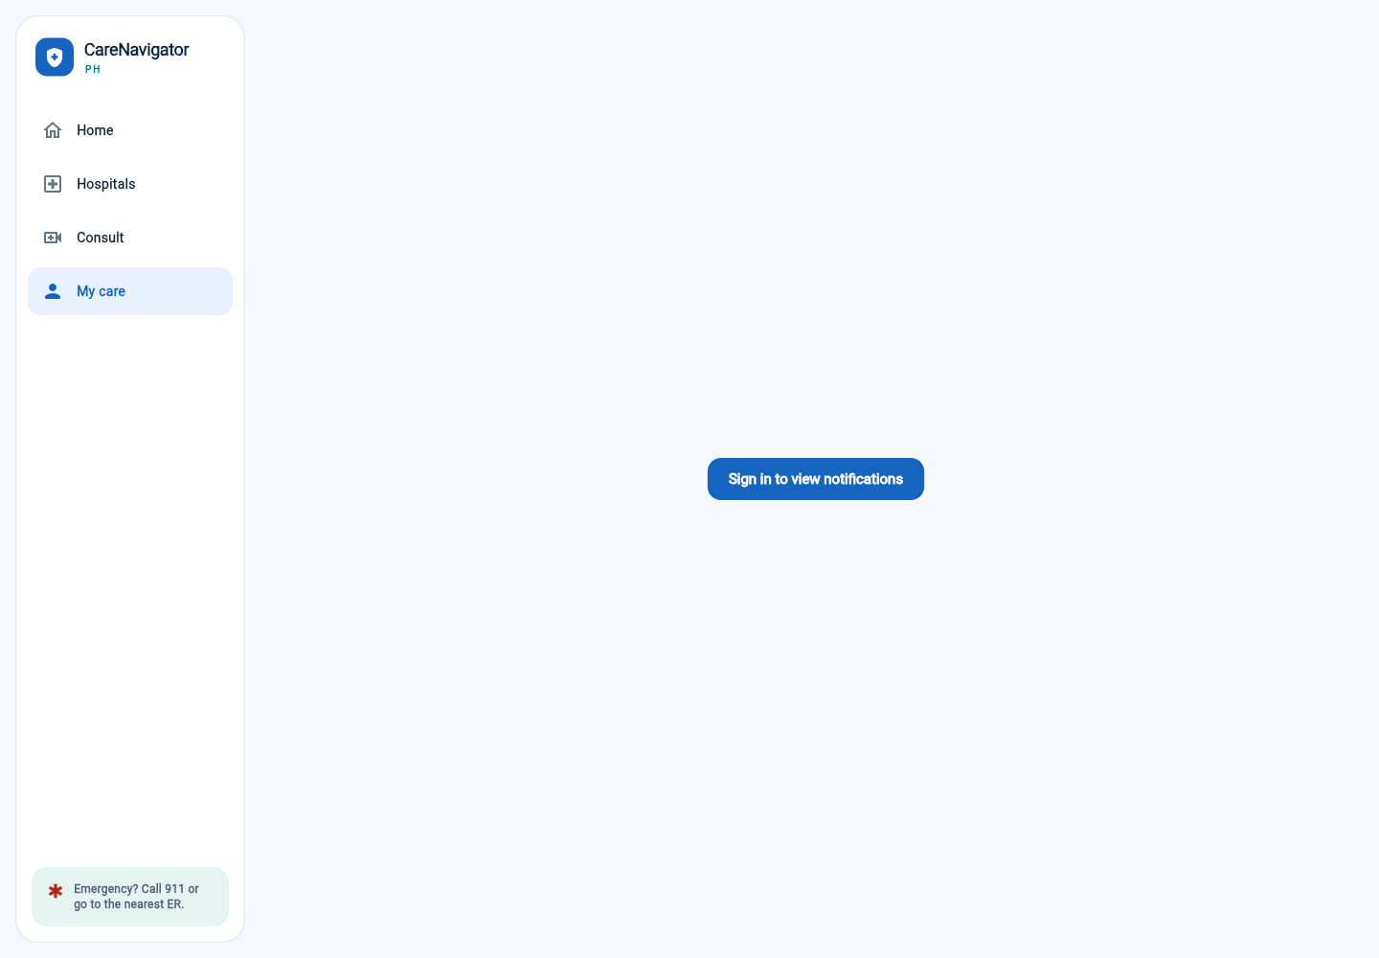
PURPOSE
Centralizes appointment, consultation, clinical, and operational alerts.
MAIN FUNCTIONS
Protected access, notification review, read status, and navigation to the related workflow.

A9. Doctor Patient Workspace
Audience: Authorized doctors
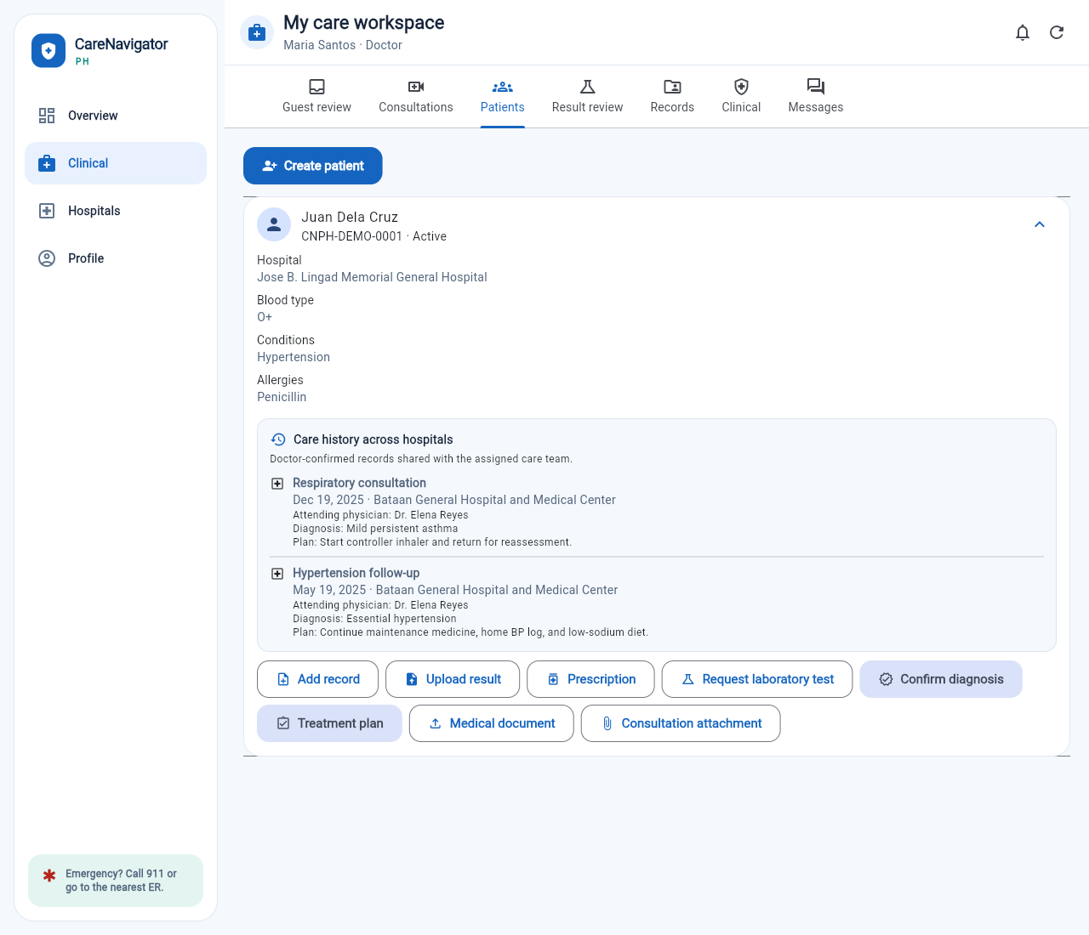
PURPOSE
Provides a consolidated view of assigned patients and cross-hospital care history.
MAIN FUNCTIONS
Consultations, diagnoses, plans, prescriptions, laboratory requests, results, documents, and attachments.

A10. Doctor Profile
Audience: Doctors
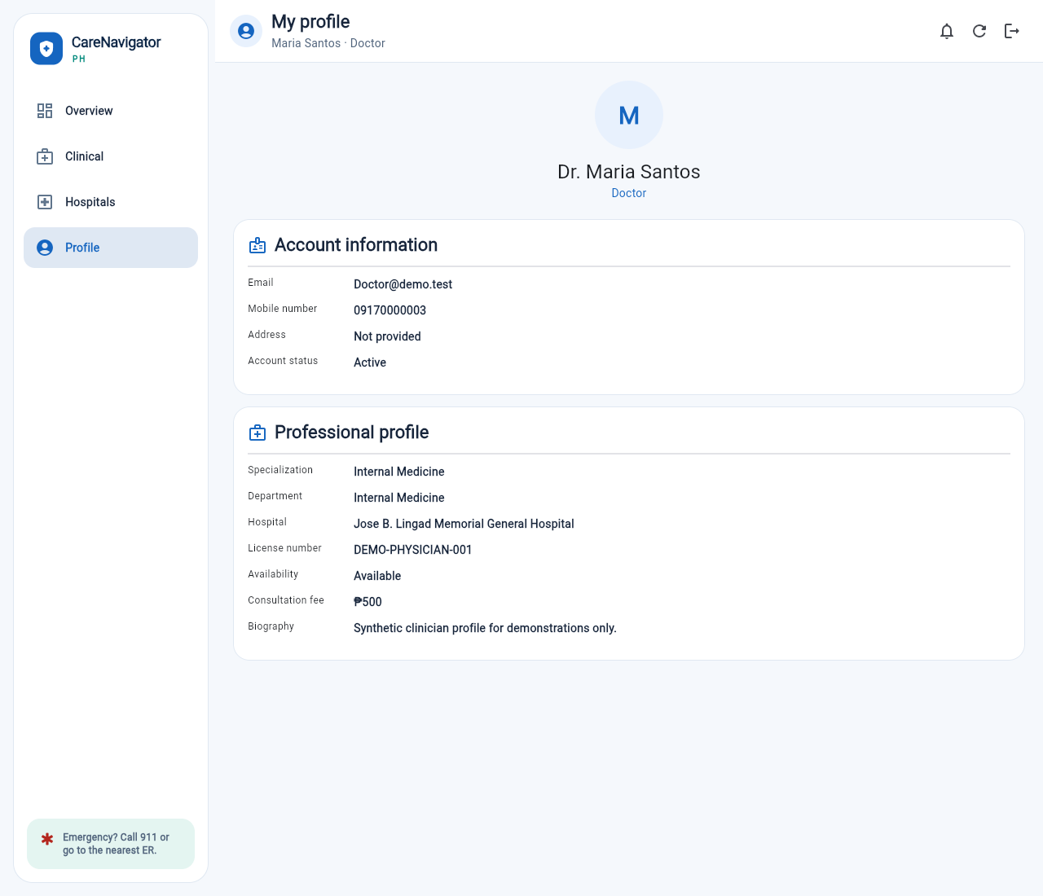
PURPOSE
Displays account and verified professional information.
MAIN FUNCTIONS
Contact details, specialization, department, hospital, license, availability, fee, and biography.

A11. Hospital-Admin Care Console
Audience: Hospital administrators
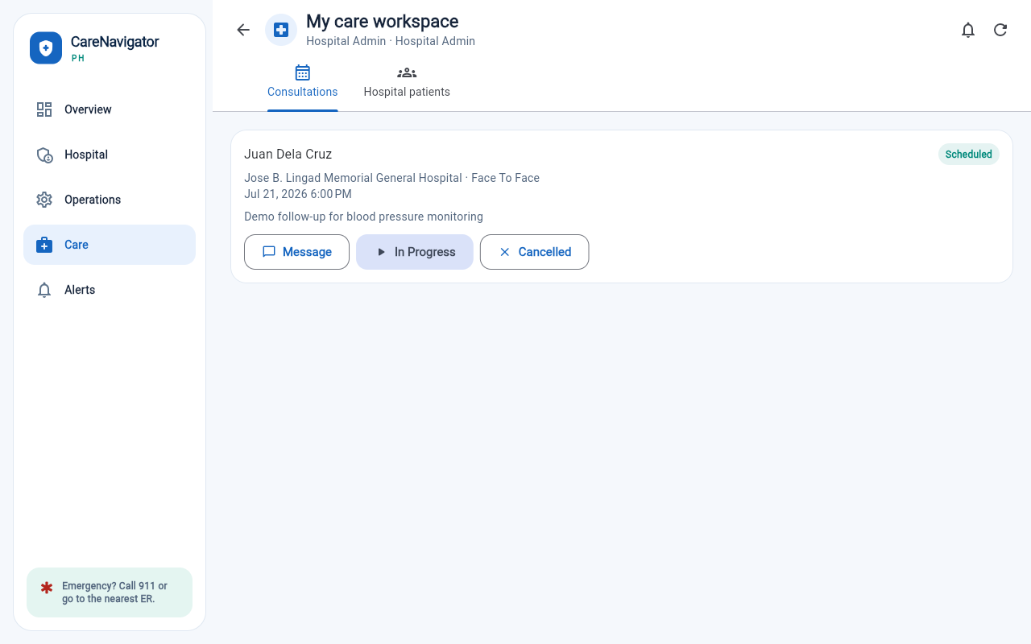
PURPOSE
Coordinates hospital-level consultations and operational care workflows.
MAIN FUNCTIONS
Consultation monitoring, hospital patients, messages, status changes, operations, availability, and alerts.

A12. Super-Admin Platform Console
Audience: Platform super administrators
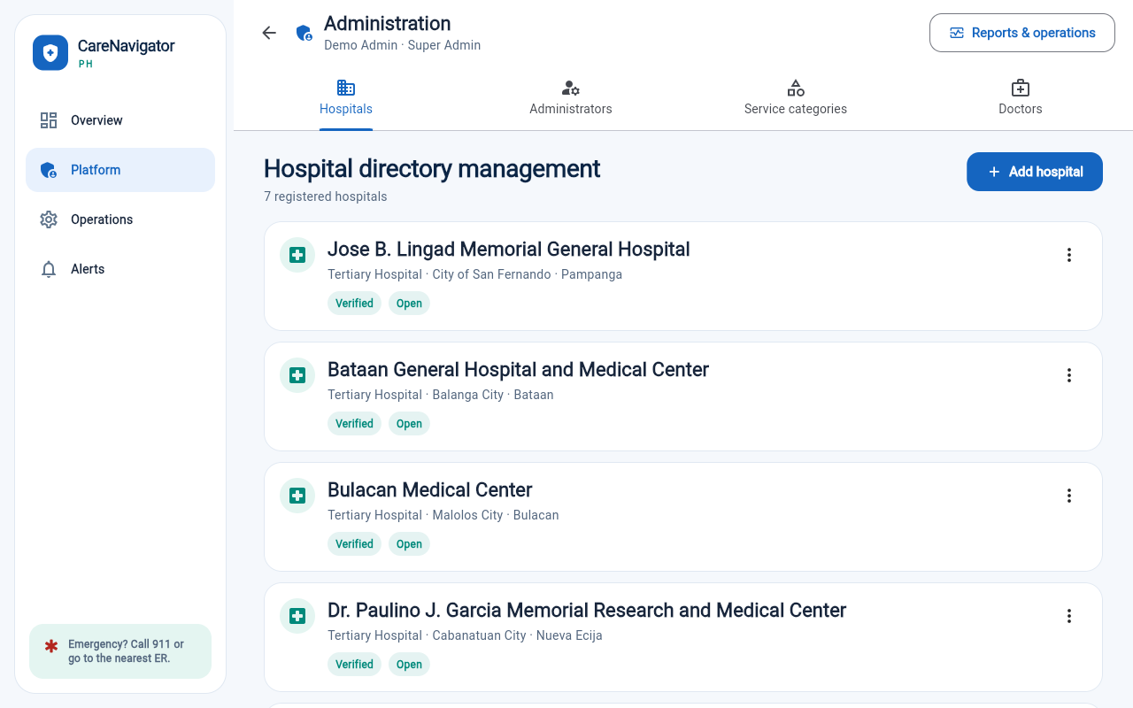
PURPOSE
Governs the CareNavigatorPH hospital network.
MAIN FUNCTIONS
Hospitals, administrator accounts, services, doctors, reports, permissions, settings, audit, and security review.

B1. Doctor Mobile Care
Audience: Doctors on mobile
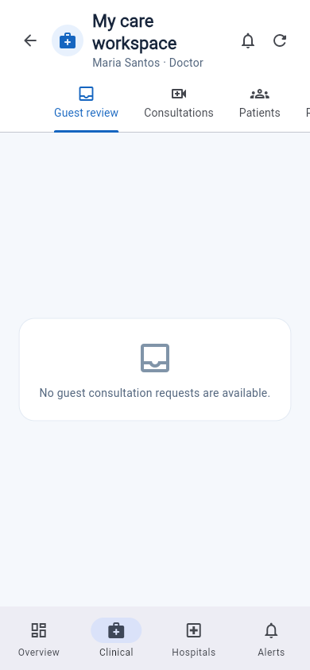
PURPOSE
Presents the clinical workspace in a compact mobile layout.
MAIN FUNCTIONS
Mobile clinical navigation, patient access, care actions, and role-safe responsive behavior.

B2. Hospital-Admin Mobile
Audience: Hospital administrators on mobile
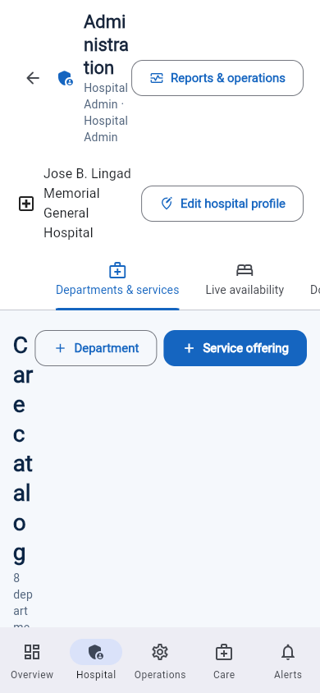
PURPOSE
Shows hospital operations and care coordination on a small screen.
MAIN FUNCTIONS
Responsive administrative navigation, hospital workflows, and access controls.

B3. Super-Admin Mobile
Audience: Super administrators on mobile
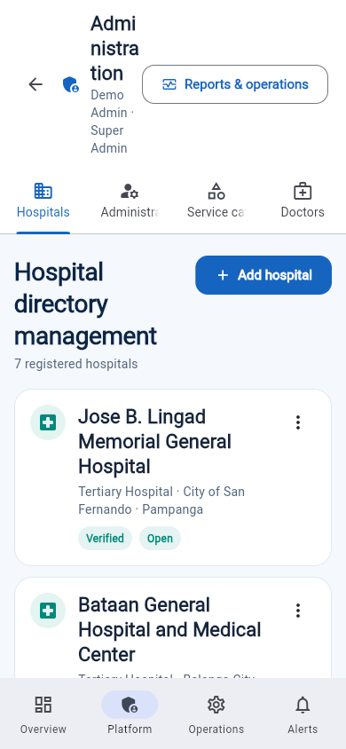
PURPOSE
Demonstrates responsive presentation of platform-management information.
MAIN FUNCTIONS
Compact management navigation and mobile-safe administrative layout.

B4. Desktop-Portal Safeguard
Audience: Administrative mobile users
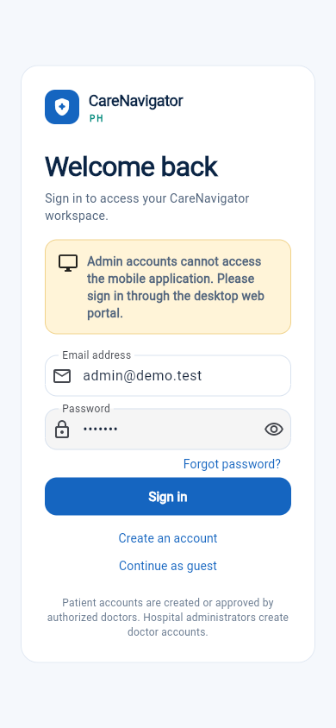
PURPOSE
Prevents selected high-risk administrative work from being performed in an unsafe mobile layout.
MAIN FUNCTIONS
Clear desktop requirement, access explanation, and return-to-sign-in action.

4. Presentation Guide
Suggested 2-3 minute presentation script
OPENING | Our project is CareNavigatorPH, a mobile app that helps Filipino patients navigate from symptoms to suitable local care.
THE PROBLEM | People often do not know which hospital has the right service, specialist, or current capacity. This causes confusion, delays, and unnecessary travel.
SDG | The project supports SDG 3: Good Health and Well-Being, particularly Target 3.8 on access to quality essential healthcare services.
THE SOLUTION | Users enter symptoms, receive safety-focused guidance, see the recommended type of care, and find verified matching hospitals.
USER FLOW | The five wireframes show the complete journey: sign in, symptom assessment, care guidance, hospital selection, and consultation request.
SAFETY | CareNavigatorPH does not diagnose. Emergency cases are directed to 911 or the nearest ER, and clinical decisions remain with licensed professionals.
CLOSING | Our goal is simple: reduce the time and uncertainty between needing help and reaching the right care.
Success measures for a future prototype test
- Users can identify the next care step without assistance.
- Users can find a suitable facility in three minutes or less.
- Users understand that AI guidance is preliminary and non-diagnostic.
- Users notice emergency instructions before starting an assessment.
SUBMISSION CHECKLIST
[ ] Replace the student, section, instructor, and date placeholders.
[ ] Rename the file using your real LastName_FirstName.
[ ] Review the wireframes and rehearse the presentation script.
[ ] Upload the Word file or exported PDF as instructed.

