ADVANCED MOBILE APPLICATION DEVELOPMENT
FINAL PROJECT DOCUMENTATION

PROJECT TITLE

CareNavigator PH
Healthcare Navigation and Care Coordination

Prepared by:
Neil Ardrey Laza
ITE 231

Subject:
Mobile Application Development
Submitted to:
Prof. Paul John D. Cabance
Date Submitted:

TABLE OF CONTENTS
Chapter 1 Project Overview 3
Introduction 3
Objectives and significance 4
Scope and limitations 5
Chapter 2 System Analysis and Design 6
System description and architecture 6
System flow and lifecycle 8
Use case diagram 10
Database design and tables 11
User interface design 14
Chapter 3 System Development 15
Tools and technologies 15
Development process 16
Deployment and reproducibility 17
Chapter 4 Results and Testing 18
System features 18
Functional testing 19
Detailed test cases 20
Evaluation and verification 25
Chapter 5 Conclusion and Recommendations 26
Appendix A Screenshots of the Application 27
Appendix B Source Code Snippets 31
Appendix C User Manual 33
Appendix D Main Feature ERD 36
Research References 37
Project References 38

CHAPTER 1

PROJECT OVERVIEW

Introduction
Access to healthcare involves more than identifying a nearby facility. Patients must also determine whether the facility offers an appropriate service, whether a clinician is available, and how to continue care after a consultation. In the Philippines, the 2018 health system review describes regional and socioeconomic differences in access to resources and identifies fragmentation of service delivery as a continuing challenge (Dayrit et al., 2018). These concerns provide a context for examining how information systems can support healthcare navigation and coordination.
When facility information, appointment requests, medical documents, and follow-up communication are handled through separate channels, patients and healthcare personnel must reconcile information across several steps. A request for consultation must be reviewed, a schedule must be confirmed, and supporting documents must reach an authorized clinician. Without a coordinated workflow, users may have difficulty identifying the current status of a request or the next action required. This project addresses that workflow problem within the scope of a mobile and web application.
Digital health offers an opportunity to connect these activities through a shared information system. However, technology alone does not establish an effective service. The World Health Organization’s Global Strategy on Digital Health 2020–2027 emphasizes the need to integrate organizational, human, financial, and technological resources into digital health initiatives (World Health Organization, 2025). For this project, that perspective supports a design that considers the responsibilities of patients, doctors, hospital administrators, and platform administrators, together with the protection of patient information.
This project presents CareNavigator PH, a healthcare navigation and care coordination application for guest and registered users. It seeks to answer the following development question: How can a mobile and web system connect facility discovery, hospital-reviewed booking, consultation tracking, and clinical documentation while preserving clear responsibilities and controlled access? The project evaluates the implemented workflows through software verification. It does not claim to measure changes in health outcomes or population-wide access to care.

Project Objectives and Significance

Project Objectives

General Objective
To develop a mobile and web application that helps users discover appropriate healthcare facilities and coordinate consultations, clinical records, and care communications through authorized, role-specific workflows.

Specific Objectives
• Provide a searchable hospital and clinician directory with service availability, emergency-room capacity, and map-based navigation.
• Support verified guest intake and registered-patient booking with hospital confirmation for online requests and a 24-hour reservation lead time.
• Give assigned doctors structured checkup, document review, prescription, laboratory, and communication tools.
• Protect patient information through ownership checks, care relationships, scoped sharing, private storage, and hospital access boundaries.
• Provide hospital and platform administrators with operational controls, audit history, and accurate notification delivery states.
• Validate behavior with Flutter tests, database acceptance checks, browser journeys, and integration evidence.

Significance of the Project
The project provides a practical model for coordinating healthcare information across user roles. Patients can follow consultation requests and manage supporting documents; doctors can review authorized information and produce structured clinical records; hospital staff can manage appointments and facility operations. For student developers, the system demonstrates how interface design, transactional workflows, and access controls can be combined in a healthcare application. These are intended contributions of the design rather than measured clinical benefits.
Sources S1 S2 S3 S4

Scope of the Project

Supported Users and Functions
User | Project scope
Guest | Browse facilities and clinicians, receive preliminary symptom guidance, verify email, submit intake, and track an approved request.
Patient | Book and track consultations, answer hospital questions, respond to schedule proposals, upload supporting files, view official records, and manage sharing and notification preferences.
Doctor | Review authorized patient information, conduct assigned consultations, complete structured checkups, issue signed prescription orders, and manage clinical follow-up.
Hospital administrator | Manage the assigned hospital, clinicians, departments, services, schedules, ER capacity, guest requests, and online review decisions.
Super administrator | Manage platform accounts and hospital verification, inspect audits and security events, and supervise maintenance and delivery operations.

Limitations
The application depends on internet access and backend availability. Maps, routes, AI responses, video conferencing, and email each depend on separate services. A successful database action does not establish that an external message arrived or that both video participants received media.
AI symptom guidance and document extraction are preliminary aids. Official diagnoses, treatment plans, medication instructions, and clinical completion require authorized clinician actions. Emergency guidance does not itself reserve an emergency bed or provide emergency medical treatment.
Android and web release builds are recorded. iOS and physical-device behavior require separate verification. The system has no documented payment, insurance-claims, or complete hospital billing workflow in this project scope.
Live notification email is blocked until the dispatcher receives a replacement SMTP_PASSWORD server secret. Its handler passed seven local SMTP checks. Real inbox delivery, Google Meet media, physical-device behavior, and full cloud installation and upgrade remain verification gates. [S24]
Sources S1 S3 S4 S13 S14

CHAPTER 2

SYSTEM ANALYSIS AND DESIGN

System Description
CareNavigator PH uses a layered client and managed-backend design. Feature screens present public and authenticated workflows, Riverpod providers coordinate identity and asynchronous state, and typed Dart repositories perform Supabase operations. Server-side rules determine whether a caller may act on a patient record, care relationship, consultation, hospital, or notification. Client route guards improve navigation, while database authorization remains the enforcement boundary. [S2, S5]

Core Business Rules
Area | Required behavior
Online booking | Every new online request requires hospital review and confirmation before reserving a slot. A published online workflow requires an active hospital reviewer.
Appointment time | Reservations preserve the existing 24-hour lead time. Comparisons use Asia/Manila; persisted appointment timestamps represent an absolute instant.
Clinical authority | Only the assigned doctor may start and complete the clinical consultation. Completion requires the existing structured checkup information.
Patient uploads | Patient-owned files retain immutable patient_supplied provenance. AI extraction and uploaded prescriptions do not independently create official medication orders.
Guest activation | The verified account that submitted an approved request activates its own patient profile. Existing credentials remain patient-controlled.
Missed visits | After 30 minutes, authorized staff may record a missed visit only when a contact attempt is recorded and no clinical start has occurred.
Daily summaries | Automatic medication summaries become eligible after 8 AM Asia/Manila, once per patient and local date, with medication-reminder and email preferences enabled.
Hospital boundaries | ER capacity is separate from outpatient and online eligibility. Clinical access requires the correct ownership, role, and active care relationship.

Sources S3 S5 S6 S7

System Architecture
The following architecture separates presentation, data access, authorization, storage, and external integrations. Secrets for privileged services remain outside the Flutter client.
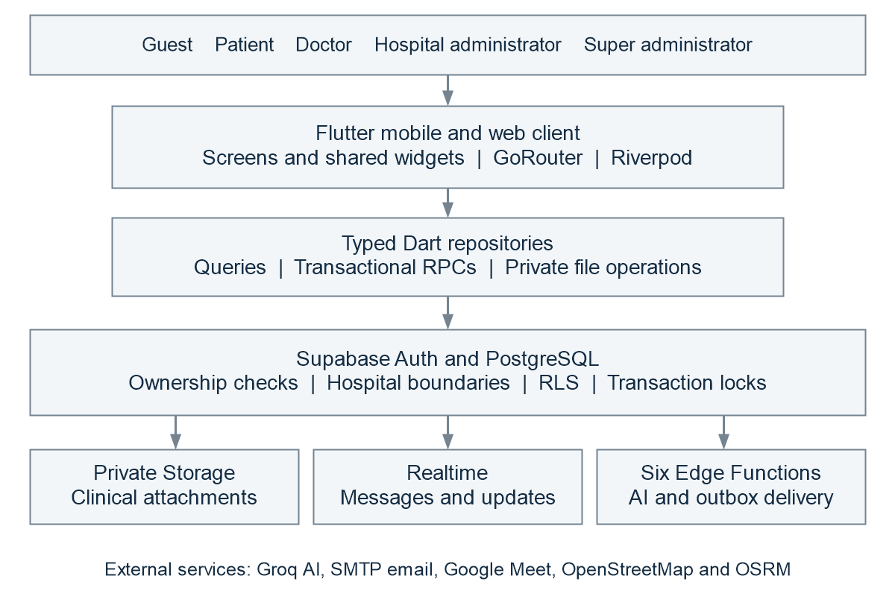
Figure 1 Layered architecture of CareNavigator PH

Authorization and Data Flow
Supabase Auth establishes the user session. PostgreSQL row-level security, function authorization, ownership predicates, and relationship grants constrain data operations. Private clinical files are accessed through authorized storage operations rather than public file URLs. Realtime subscriptions refresh allowed messages and notifications.
Transactional RPCs coordinate actions that update several records together. Booking, confirmation, rescheduling, and schedule changes use common locking rules so availability checks and reservation changes belong to the same operation. Edge Functions perform AI and notification work using server configuration.
Public client configuration contains the project URL, publishable key, and optional application URL. Privileged credentials, AI keys, SMTP passwords, and dispatcher tokens remain server-side.
Sources S2 S3 S5 S8

System Flow
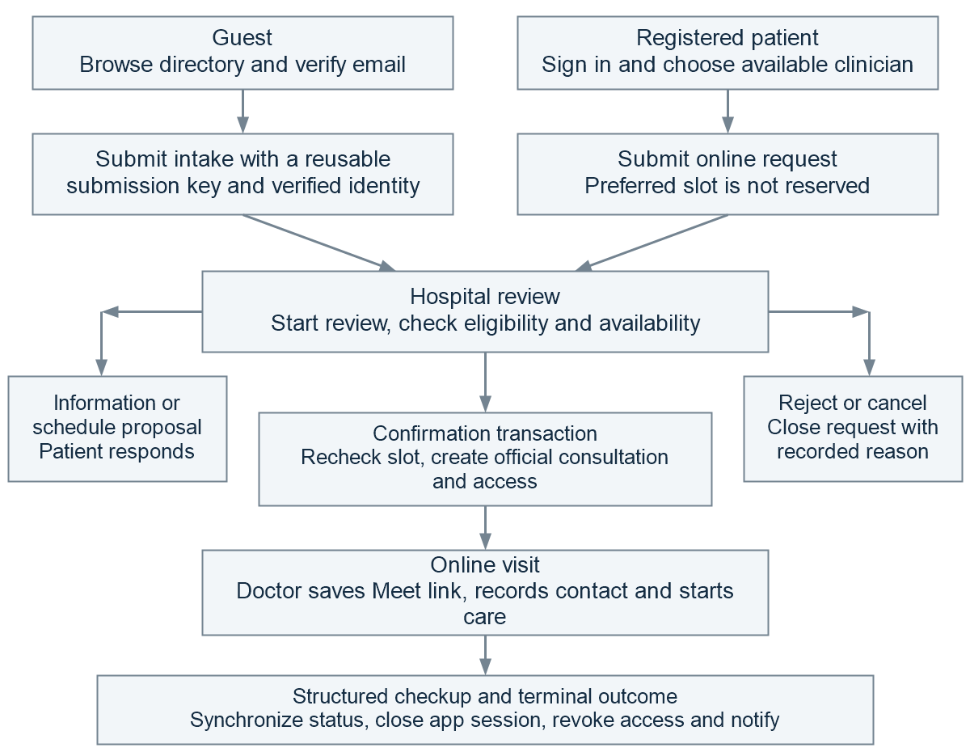
Figure 2 Online care journey with hospital review
The guest path verifies email before submitting intake and retains a reusable submission key. Approved guests activate their patient identity in place and continue tracking the authorized consultation. Registered patients submit online requests through the typed booking interface. Both paths require hospital confirmation before a new online reservation.
Information requests and schedule proposals give the patient a visible response action. Accepting an approved proposal rechecks availability and confirms atomically. Declining a proposal returns the request to hospital review. Face-to-face recommendations offer a new-booking action and do not create another reservation automatically.
Sources S3 S6 S7 S9

Online Consultation Lifecycle
Request status tracks review and contact; consultation status tracks the clinical appointment. Terminal actions synchronize app sessions, access, history, and notifications. Google Meet controls hosting and admission. [S5, S7, S10]
Request state | Authorized actor | Visible next action or outcome
submitted | Hospital reviewer | Start review, request information, propose a schedule, confirm, or reject.
under review | Hospital reviewer | Continue assessment and select a reviewed decision.
more information required | Submitting patient | Provide the requested response; return to hospital review.
schedule proposed | Submitting patient | Accept after an availability recheck or decline and return to review.
confirmed | Hospital care team and patient | Track the appointment, record contact, or let the assigned doctor save the Meet link.
awaiting contact | Hospital care team | Record an attempted contact and proceed to the appropriate visit action.
video ready | Assigned doctor and patient | Join within the permitted time window; the assigned doctor starts clinical care.
in progress | Assigned doctor | Complete the structured checkup and submit the clinical outcome.
completed | Assigned doctor | Finalize records; close app session records and consultation-specific access, and notify.
rejected or cancelled | Authorized reviewer or participant | Record the reason and close the workflow and related active access.
no show or scheduled patient unreachable | Authorized hospital care team | After the missed-visit conditions are met, cancel the official consultation and retain the specific outcome reason.
face to face recommended | Assigned doctor | Close the online episode and present a separate new-booking action.

Timing and Terminal Rules
Missed visits require at least 30 elapsed minutes, a recorded contact attempt, and no consultation start. Video joining is allowed from 15 minutes before the appointment until strictly before four hours after it, with participant authorization.
Terminal actions close app sessions and related access, retaining outcome reasons. They cannot end Google Meet calls or invalidate copied links.
Sources S5 S7 S10

Use Case Diagram
The five actors use a shared application, but receive distinct operations and data scopes. The diagram groups related use cases for readability.
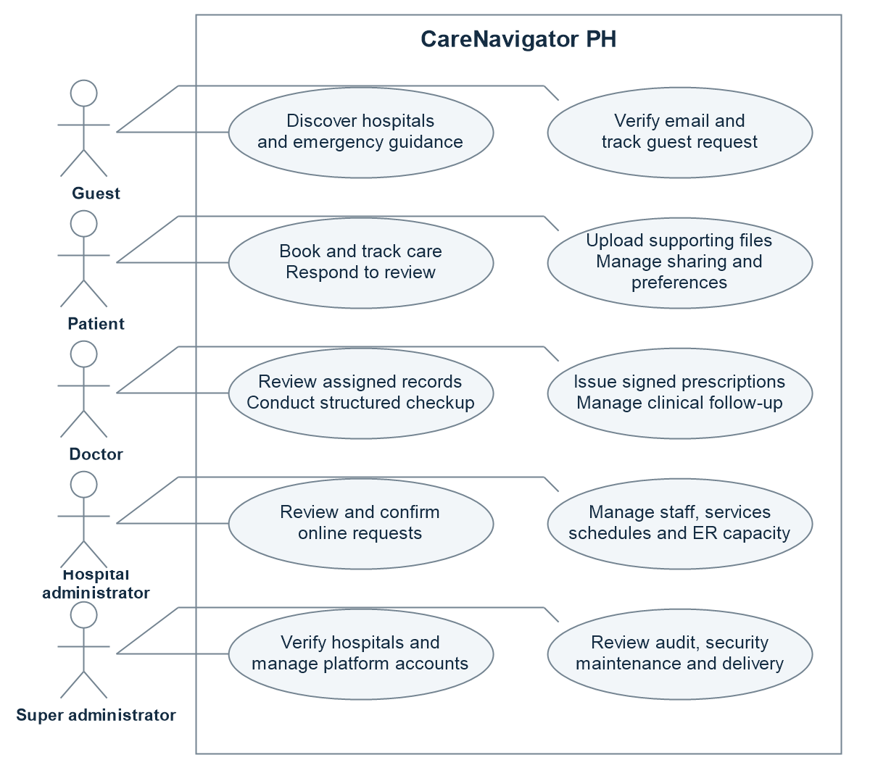
Figure 3 Role-based use case diagram
Verified identity is required for patient-facing email and activation actions. A patient's file access follows ownership and explicit sharing. Doctor access follows an active authorized relationship. Hospital administrators operate within their assigned hospital; platform administration uses separate privileged actions.
Sources S2 S5 S6 S8

Database Design
CareNavigator PH uses PostgreSQL for account profiles, hospital discovery, appointments, and clinical records. The main feature ERD in Appendix D selects nine central tables and their principal relationships. The baseline catalog remains the source for the complete schema. [S3, S11]

Main Feature ERD
Appendix D shows the main account-to-care path: users have patient or doctor profiles; hospitals have doctors; doctors publish schedules; patients reserve consultations; consultations link to medical records and prescription orders; orders group medication entries. Only selected fields and foreign keys are shown.
See Appendix D for the main feature diagram.

Reading the Model
PK identifies a primary key, FK a displayed foreign key, and UK a unique key. A circle means optional, a bar means one, and a crow foot means many. Diagram labels name the child foreign-key column. Selected fields keep the model readable; additional database constraints remain in the catalog.
Supabase Auth handles credentials separately from the application users table. Patient and doctor profiles refer to users.id. The diagram shows schema nullability and uniqueness; application workflows may impose stricter rules.
Type labels are shortened: timestamptz means timestamp with time zone, int2 means smallint, int4 means integer, and enum represents the field-specific enumerated type. Row Level Security and workflow authorization are defined in SQL, outside the diagram.
Sources S3 S5 S11

Database Tables for Identity and Appointments

Users
Field | Type | Purpose
id | uuid | Application user primary key.
auth_user_id | uuid | Unique reference to the Supabase Auth identity.
role_id | smallint | Role reference; role labels use roles.role_name.
hospital_id | uuid | Associated hospital where applicable.
email | text | Application email information.
account_status | enum | Account state enforced by server workflows.

Consultations
Field | Type | Purpose
id | uuid | Official consultation primary key.
patient_id and doctor_id | uuid | Patient profile and assigned doctor references.
hospital_id | uuid | Hospital responsible for the appointment.
guest_request_id | uuid | Originating guest request when applicable.
appointment_date | timestamptz | Scheduled instant displayed and compared using Manila rules.
consultation_type | enum | Face-to-face, online, guest online, or emergency type.
status | enum | Official clinical appointment status.
outcome_reason | text | Specific terminal outcome such as a missed visit.

online_consultation_requests connects hospital review to the official consultation through official_consultation_id. It retains the preferred, proposed, and confirmed scheduling information and patient responses. Its history uses from_status and to_status. Rescheduling must also update access validity, room validity, and reminder jobs.
Sources S5 S6 S11

Database Tables for Clinical Documents and Orders

Medical Documents
Field | Type | Purpose
id and patient_id | uuid | Document identity and owning patient.
uploaded_by | uuid | Original uploader reference.
origin_type | text | Preserves patient_supplied or hospital-generated provenance.
storage_path | text | Private storage object reference.
review_state | text | Separates an unreviewed upload from doctor review.
reviewed_by and reviewed_at | uuid and timestamptz | Auditable reviewer and review time.
review_rejection_reason | text | Recorded explanation for rejection.

Prescription Orders
Field | Type | Purpose
id | uuid | Order primary key; groups medications and attachments.
patient_id and doctor_id | uuid | Patient and authorized prescriber.
hospital_id | uuid | Originating hospital.
consultation_id or assignment_id | uuid | Applicable clinical relationship.
idempotency_key | text | Reuses the original issuance on a valid retry.
issued_at and status | timestamptz and text | Issuance time and order state.
legacy_import | boolean | Marks conservative migration of legacy rows.

Each medication row references prescriptions.order_id and stores structured dose, route, frequency, dates, PRN information, and prescriber-signature details. Issuance validates the complete medication list in one transaction. Attachments use explicit order references and can be retried against the same order. Official entries can reference medical_records.source_document_id without changing original document authorship.
Sources S5 S7 S11 S12

User Interface Design
The interface adapts one Flutter codebase to mobile and wider web layouts. Shared cards, tables, dialogs, loading indicators, and error messages give the roles a consistent visual structure. GoRouter maps public pages, authentication screens, recovery screens, and protected workspaces. Riverpod refreshes session and asynchronous data state. [S1, S2]
Screen group | Purpose and primary interaction
Public home and directories | Search published hospitals and clinicians, inspect services and ER capacity, and open navigation or consultation intake.
Authentication | Sign in, register, verify email, request recovery, change a recovered password, or restart an expired recovery flow.
Guest verification and tracking | Retain intake after failure, show review status, activate an approved account, and prepare to join authorized video.
Patient workspace | Show appointments, online requests, prescriptions, files, messages, notifications, and profile preferences.
Doctor workspace | Show assigned care, structured checkups, prescriptions, result review, documents, schedules, and communications.
Hospital workspace | Provide request review controls, clinician and service management, appointment operations, and hospital availability.
Platform workspace | Provide hospital verification, user administration, audit and security inspection, maintenance, and system operations.

Interaction and Feedback
Booking feedback uses BookingOutcome.status and slotReserved to explain whether an appointment exists and whether its slot is actually reserved. Prescription feedback separates issuance success from attachment failure and from notification queue state. Missing record details display an unavailable-record state.
Sharing management groups access by care relationship. Revocation covers every active grant, category, and selected record in that relationship. Video joining requires an assigned-doctor Google Meet link and an open join window; missing links offer a refresh-and-retry state.
Sources S2 S6 S9 S12

CHAPTER 3

SYSTEM DEVELOPMENT

Tools and Technologies Used
Technology | Recorded version | Project use
Flutter and Dart | Dart SDK constraint ^3.12.2 | Shared mobile and web presentation and application logic.
flutter_riverpod | 3.4.2 | Providers, identity state, asynchronous data, and refresh behavior.
go_router | 17.4.0 | Routing, role redirects, deep links, and recovery navigation.
supabase_flutter | 2.17.1 | Flutter integration with Auth, database, files, and subscriptions.
supabase | 2.16.0 | Typed client operations used by repositories.
PostgreSQL and Supabase | Managed backend | Relational data, RLS, RPC transactions, Auth, Storage, Realtime, and scheduling.
Deno and TypeScript | Versioned function source | Serverless workflow, analysis, account, and notification handlers.
Groq, SMTP, and Google Meet | Configured services | Preliminary AI assistance, opt-in email, and doctor-supplied meeting links.
flutter_map | 8.3.1 | Hospital map using OpenStreetMap and OSRM integration.
Flutter Test and Playwright | Project test tooling | Behavioral and visual Flutter checks and browser journeys.

Development Environment
The repository is maintained in a Windows development workspace and edited through an IDE. Android release packaging uses the Flutter and Gradle toolchains. Web release packaging produces build/web. These artifacts require public runtime configuration and operational backend services before deployment.
Dependency versions above are taken from the project lockfile. They identify the examined build inputs; they are not claims about the latest available package releases.
Sources S1 S3 S15

Development Process

Requirements and Design
The 11 October 2026 workflow audit identified 15 defects involving authorization, scheduling, clinical lifecycle, uploads, activation, prescriptions, notifications, reproducibility, and verification. The repair plan defines the expected transitions and acceptance conditions for the five roles. [S4]
The design retains Flutter, Riverpod, Supabase, hospital access boundaries, and the 24-hour lead time. Typed outcomes report actual server results. Transactions protect actions that update several records.

Implementation Sequence
Step | Work area | Implementation focus
1 | Email authorization | Remove embedded secrets, require verified identity, resolve recipients from records, restrict test delivery, and use the outbox.
2 | Booking consistency | Repair table-specific lead-time checks; lock bookings and schedule mutations; return actual reservation state and synchronize rescheduling.
3 | Online lifecycle | Connect hospital and patient review actions, assigned-doctor clinical actions, missed visits, terminal synchronization, and relationship sharing controls.
4 | Guest and recovery | Activate approved verified guests in place; retain OTP verification and intake on retries; use submission keys; route password-recovery events.
5 | Uploads and prescriptions | Preserve patient provenance, add scoped review, issue a complete order atomically, and retry attachments without repeating clinical issuance.
6 | Notifications and release | Persist history and preferences, enqueue eligible daily summaries, align deployed functions, maintain the physical ERD, and verify installation.

Testing During Development
Flutter regressions cover verified guest retries and explicit order grouping. SQL suites define authorization and clinical acceptance checks. Browser tests exercise role routing, preferences, sharing, issuance, recovery, uploads, and video. Chapter 4 separates results from outstanding verification.
Sources S3 S4 S5 S16 S17

Deployment and Reproducibility

Backend Package
The repository includes a sanitized application-schema baseline, reference seeds, storage definitions, active migrations, deployment configuration, and an archive of historical migrations. The historical chain depends on a missing base schema and contains three duplicated migration versions; it is retained for investigation rather than blind replay.
Versioned Edge Function | Responsibility
care-navigator-chat | Care-assistant interaction and authorized patient-facing workflow actions.
analyze-symptoms | Preliminary symptom analysis.
analyze-medical-result | Authorized medical-document extraction and analysis.
care-workflows | Privileged care workflow operations.
admin-users | Authorized account administration.
dispatch-notifications | Private-token dispatcher for appointment reminders, daily summaries, and outbox delivery.

Installation and Upgrade Process
• For an empty Supabase project, establish managed Auth and Storage, then apply active migrations in unique version order and the separate reference and storage seeds.
• Configure the actual application Site URL and recovery redirects; deploy all six function folders with their recorded JWT settings and server secrets.
• Configure the five-minute dispatcher with its private token. Eligible daily summaries are enqueued after 8 AM Manila time and deduplicated by patient and local date.
• For an existing deployment, compare the actual catalog and correction history before applying an upgrade or reconciling migration metadata.
• Deploy security corrections first, followed by compatible database and API changes, the Flutter client, and unified hospital review.
• Verify a complete empty-project installation and a staging-copy upgrade, then monitor authorization failures, lifecycle mismatches, failed delivery, duplicates, and activation errors.
Local clean-schema and reconstructed-upgrade checks are limited evidence. They do not substitute for the full cloud tests. SMTP must remain server-configured, and the owner must revoke the exposed credential before a replacement is enabled.
Sources S3 S8 S18

CHAPTER 4

RESULTS AND TESTING

System Features
Feature | Implemented application behavior
Discovery and navigation | Published hospital and clinician directories, service details, separate ER capacity, and map-based routing.
Authentication and recovery | Role-aware sign-in, guest email verification, approved guest self-activation, and explicit password-recovery routing.
Appointment coordination | Availability queries, typed booking outcomes, online hospital review, information responses, proposals, confirmation, rescheduling, and cancellation.
Clinical workspace | Assigned-doctor checkups, diagnoses and plans, document review, laboratory workflows, and signed prescription orders.
Files and provenance | Private supporting uploads, review attribution, explicit source-document references, and order attachment retry.
Communication and notifications | Care messaging, conversation history, in-app notifications, preference persistence, and outbox queue and delivery states.
Sharing management | Relationship-grouped access visibility and a relationship-wide revoke action with a stated scope.
Administration | Hospital staff, services, schedules, ER operations, platform verification, account controls, maintenance, and audit inspection.

Clinical and Notification Outputs
The clinical output is the doctor's finalized structured checkup and its associated official records. A prescription issuance creates one order with its medication records, prescriber information, and signature validation. A patient-uploaded prescription remains a supporting document until reviewed and does not become a reminder instruction automatically.
The notification output reports queued, sent, or failed according to the outbox state. Automatic summaries include only official prescriptions active on the summary date. Future and expired prescriptions are excluded. PRN directions remain directions and do not acquire invented administration times. Manual summary requests authorize that individual delivery.
Sources S5 S7 S8 S12

Functional Testing
Five scenarios cover the presentation: sign-in, directory search, successful in-person booking, no available slots, and appointment viewing/cancellation. The four detailed Activity 1 case identifiers are retained and mapped below. Existing verification results remain dated and qualified. [S23, S24]
Before the demonstration, prepare an active verified test patient, a published unoccupied in-person slot more than 24 hours after the demo, and a separate test doctor with no qualifying slots in the next 30 days. Use synthetic data. Record the actual result and screenshots for each scenario.

Five Demonstration Scenarios
ID | Demonstration | Expected result
TS-01 | Patient sign-in: try an incorrect password, then sign in with valid credentials. | Wrong credentials show an error; valid credentials open the correct patient workspace.
TS-02 | Hospital and doctor search: search the public directory and open a matching result. | Relevant verified, operating hospitals and their doctor details are displayed.
TS-03 | Successful booking: reserve a published in-person slot more than 24 hours ahead. | Confirmation appears; the appointment has the selected doctor/date/time; the occupied slot is unavailable.
TS-04 | No available slots: select the prepared test doctor with no qualifying slots. | The empty-availability notice appears; Reserve consultation is disabled; no appointment is created.
TS-05 | View and cancel: open the test appointment, check its details, then cancel it. | Details match the booking; cancellation succeeds and the appointment is no longer active, with history retained.

Detailed Case Coverage
TS-01 is covered by TC_AUTH_001 and TC_AUTH_002. TS-03 is covered by TC_BOOKING_001; TS-04 by TC_BOOKING_002. TS-02 and TS-05 are demonstrated through the scenario checklist. There are exactly four detailed test cases.
The booking cases use in-person appointments and the 24-hour minimum lead time. The previous no-slot result used a controlled empty response; prepare a real no-slot test doctor for the live demonstration. Broader automated evidence below remains separate from the five presentation scenarios.
Source S23 supplies the four original detailed cases. The five demonstration scenarios are adapted for this presentation; S24 records prior execution evidence.

Test Case TC_AUTH_001

Successful Sign-In and Role-Based Redirect
Related scenario: TS-01. Case type: Positive / happy path.

Preconditions
1. The test Supabase project is available.
2. An active patient account exists.
3. The tester is signed out.

Test Data
Use the owned synthetic patient configured for the test run and its correct test password. Keep credentials in local test configuration and outside this document.

Test Steps
1. Open CareNavigator PH and select Sign in.
2. Enter the active patient's email and correct password.
3. Select Sign in.
4. Verify the destination workspace.

Expected Results
1. Authentication succeeds and a session is created.
2. The user is redirected to the Patient workspace.
3. Patient navigation and the user's scoped data appear.
4. Doctor and administrator access is not granted.
Execution on 16 October 2026: PASS with the owned synthetic patient. Real Auth sign-in and the protected patient appointments page passed. S24. Activity 1 supplied no execution record.

Test Case TC_AUTH_002

Sign-In Rejected for an Incorrect Password
Related scenario: TS-01. Case type: Negative / error path.

Preconditions
1. The test Supabase project is available.
2. The active patient email exists.
3. The tester is signed out.

Test Data
Use the owned synthetic patient configured for the test run and a deliberately incorrect password. Keep the real test password outside this document.

Test Steps
1. Open CareNavigator PH and select Sign in.
2. Enter the patient email and an incorrect password.
3. Select Sign in.
4. Attempt to open /patient/appointments.

Expected Results
1. Authentication fails and a safe error message appears.
2. The user remains on the sign-in screen.
3. No authenticated session is created.
4. The protected route returns to sign-in and exposes no patient data.
Execution on 16 October 2026: PASS with the owned synthetic patient. Incorrect credentials returned HTTP 400 and the protected route redirected to sign-in. S24.

Test Case TC_BOOKING_001

Reserve an In-Person Consultation from a Published Slot
Related scenario: TS-03. Case type: Positive / happy path.

Preconditions
1. An active patient is signed in with a complete profile.
2. A verified, operating hospital has an eligible doctor.
3. An unoccupied in-person slot is at least 24 hours away.

Test Data
Use the owned synthetic patient and doctor at a verified, operating hospital. Select the next published, unoccupied in-person slot at least 24 hours ahead; a fixed 48-hour offset may not match a published schedule.

Test Steps
1. Open Patient > Appointments.
2. Select Reserve consultation.
3. Choose the hospital, clinician, and In person care mode.
4. Enter the primary care concern.
5. Choose a published date and time, then select Reserve consultation.

Expected Results
1. One reservation is created for the signed-in patient.
2. It appears with the selected hospital, doctor, mode, and time.
3. Its status and time match the server record.
4. The occupied slot is no longer offered.
Execution on 16 October 2026: PASS with a published synthetic slot at least 24 hours ahead. The row appeared in the patient list and the occupied slot disappeared. The test reservation was cancelled. S24.

Test Case TC_BOOKING_002

Reservation Blocked When No Qualifying Slot Is Available
Related scenario: TS-04. Case type: Negative / error path.

Preconditions
1. An active patient is signed in.
2. The doctor has no qualifying unoccupied slot in the next 30 days.
3. No reservation exists for this attempt.

Test Data
Expected fixture: no qualifying slots in the next 30 days, with a 24-hour minimum lead time. The recorded UI check supplies an empty availability response; it does not provision a separate no-slot clinician.

Test Steps
1. Open Patient > Appointments and select Reserve consultation.
2. Select the clinician fixture with no qualifying slots.
3. Select In person care mode.
4. Review the availability area and the submission control.

Expected Results
1. No date or time can be selected.
2. The no-slot message states the 24-hour notice rule.
3. Reserve consultation is disabled.
4. No consultation or duplicate record is created.
Execution on 16 October 2026: UI PASS with a controlled empty response. The 24-hour notice appeared, submission stayed disabled, and no booking request was sent. A real no-slot backend fixture was not used. S24.

Supplementary Workflow Verification
The 16 October checks distinguish live actions, database assertions, and controlled responses. External email delivery and real provider media remain separate gates. [S24]
Verification area | Expected behavior | Recorded evidence or outstanding check
Role sign-in and account routing | Five roles follow permitted routes during sign-in, reload, and sign-out. | Five role browser journeys passed.
OTP verified then insertion fails | Keep intake and the same key; retry without reusing the verified OTP. | Verified retry regression passed.
New online booking | Review before reservation; show actual slot_reserved. | Live review and confirmation passed.
Information and proposal response | Return answers to review; accepting a proposal rechecks and confirms. | SQL response/proposal checks passed.
Guest activation retry | Reuse the submitting verified account and patient profile; preserve credentials. | SQL activation and retry passed.
Reschedule and schedule races | Synchronize time, grants, room, and reminders; protect reserved schedules. | SQL reschedule and local races passed.
Competing confirmations | Only one competing request may reserve a slot. | Concurrent confirmation race passed.
Video time boundaries | Authorize participants and enforce minus 15 minutes to before plus four hours. | SQL/UI passed; real media open.
Missed visit around 30 minutes | Reject early, uncontacted, or started visits; preserve valid missed outcomes. | SQL checks before/at 30 minutes passed.
Patient upload and doctor review | Enforce ownership and scope; retain provenance and record review. | Live upload and scoped review passed.
Invalid medication in a full order | Invalid medication commits neither order nor medication. | Full-order rollback assertion passed.
Attachment retry and grouping | Retry the existing order; use order_id and explicit attachment references. | Grouping/attachment checks passed.
Unauthorized email action | Deny public or unrelated callers; resolve authorized recipients from records. | Local SMTP passed; live blocked.
Preferences and sharing | Persist preferences and revoke every active relationship grant. | Preference reload and revocation passed.
Daily medication eligibility | Check both preferences, active dates, and patient/date deduplication. | Date guards present; dispatch timing open.
Password recovery | Handle expired links and complete valid-link password change. | Recovery passed; email delivery open.

Sources S5 S10 S13 S16 S17 S19.

Evaluation and Recorded Verification
Verification on 16 October 2026 passed 281 Flutter checks, 28 browser checks and 11 deployed SQL suites. Four follow-ups and the local SMTP and concurrency tests add qualified evidence. External delivery and media remain open. [S24]
Check | Result | Recorded evidence and limit
Flutter static analysis | Passed | 16 October: no issues found.
Flutter test coverage | 281 passed | 270 ordinary checks plus 11 separate live checks; none of those live checks remained skipped.
Web release build | Passed | Fresh release build on 16 October.
Android release build | Recorded | 12 October APK retained; not rebuilt or tested on a physical device in this review.
Browser verification | Passed with limits | 28 broader checks plus four follow-ups. Meet display/join responses were controlled; no provider media claim.
Schema and SQL acceptance | Passed with limits | 11 deployed suites rolled back; clean local schema passed with 178 functions. Full cloud install/upgrade remain open.
SMTP notification delivery | Local pass; live blocked | Seven local SMTP checks passed. The deployed dispatcher has no SMTP_PASSWORD secret; real inbox delivery is open.
Two-party Google Meet media | Open | Controlled external navigation does not establish admission or received audio/video.
Concurrent scheduling | Local pass | Three checks used independent PostgreSQL sessions, observed advisory waits, and verified both schedule-race orders.
Valid password recovery | Passed with limit | Real Auth recovery token, redirect and password change passed; token obtained by admin API, without sending email.

Strengths and Remaining Work
Fresh results support scoped care, transactional orders, and review controls. Earlier AI extraction remains historical evidence and does not establish clinical accuracy.
Local races, generated-link recovery and controlled Meet navigation passed. External inbox delivery, real provider media, device checks, and full cloud installation and staging upgrade remain open. [S24]
Sources S3 S13 S14 S19 S20

CHAPTER 5

CONCLUSION AND RECOMMENDATIONS

Conclusion
CareNavigator PH connects discovery, verified intake, hospital-reviewed booking, clinician records, communication, and administration in one Flutter application. Riverpod and Supabase support shared data flows; role and care-relationship checks control access.
The workflows include typed booking outcomes, guest activation, reviewed uploads, atomic prescription orders, and delivery states. Passing tests support these features. Notification email still requires a dispatcher SMTP password; external integration and deployment gates remain open.

Recommendations
• Configure the dispatcher SMTP_PASSWORD server secret, verify a controlled inbox, and revoke previously exposed credentials.
• Retain upload-review and browser CRUD regressions; extend document rejection and failure-recovery coverage while preserving provenance.
• Verify real Google Meet admission and received media on both sides. App revocation does not replace provider host controls.
• Retain generated-link recovery coverage and test actual recovery-email delivery through deployed routes.
• Retain isolated concurrency checks; test staging load, attachment retry, and daily-dispatch timing without weakening booking rules.
• Prove empty-cloud installation and staging upgrades. Maintain migration reconciliation, the baseline catalog, the main feature ERD, and all six function versions.
• Monitor lifecycle, access, outbox, duplicate-summary, and activation errors after rollout. Test real Android devices and verify iOS separately.
Completion requires every audited defect to be closed, required integration tests to run without skips, and each exposed state to provide an authorized and usable next action.
Sources S3 S4 S13 S14 S18

APPENDICES

Appendix A Screenshots of the Application
These application images come from the Flutter visual catalog with controlled fixture data. They illustrate the rendered interface and do not constitute live clinical or integration evidence.
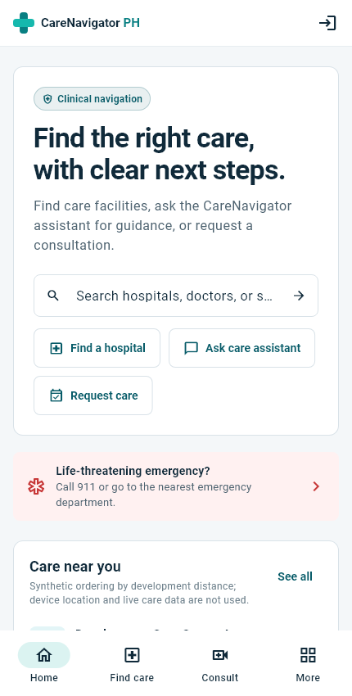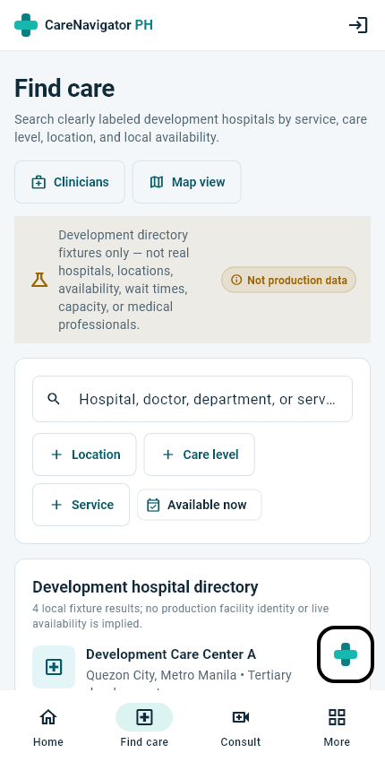
Figure 5 Public home and discovery | Figure 6 Hospital directory
The public home introduces care discovery and consultation entry. The hospital directory presents facility information and filters. Role-specific patient, doctor, and administration views are illustrated on the following pages.
Source S21

Screenshots of Patient and Doctor Workspaces
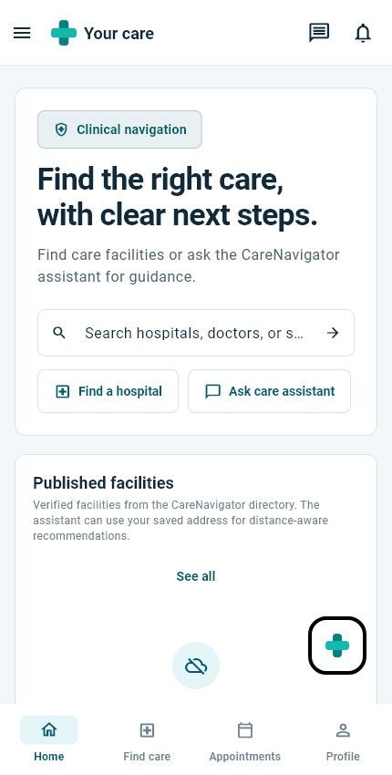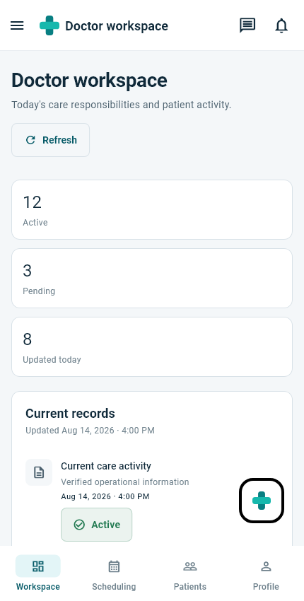
Figure 7 Patient home | Figure 8 Doctor workspace
The patient home provides navigation to discovery, appointments, and profile settings. The doctor dashboard summarizes care activity and provides access to scheduling and patients. These views illustrate the role-specific navigation and fixture-based dashboard layout.
The figures show fixture content from automated visual checks. They demonstrate layout, navigation, and information hierarchy; test execution and live integration outcomes are reported separately in Chapter 4.
Source S21

Screenshots of Administration Workspaces
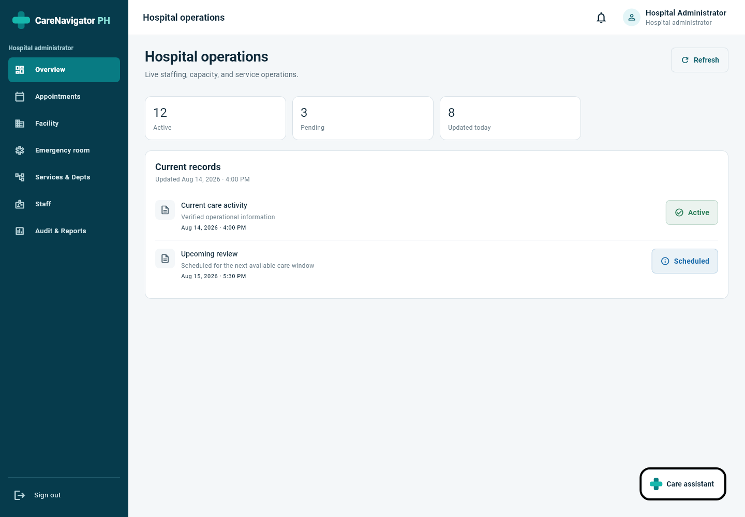
Figure 9 Hospital administrator — desktop web layout on Windows (1440 × 1000)
The desktop workspace displays the hospital sidebar and operational overview. The image uses controlled visual-catalog data; it illustrates the interface rather than a live hospital dataset.
Sources S2 S21

Screenshot of Platform Administration
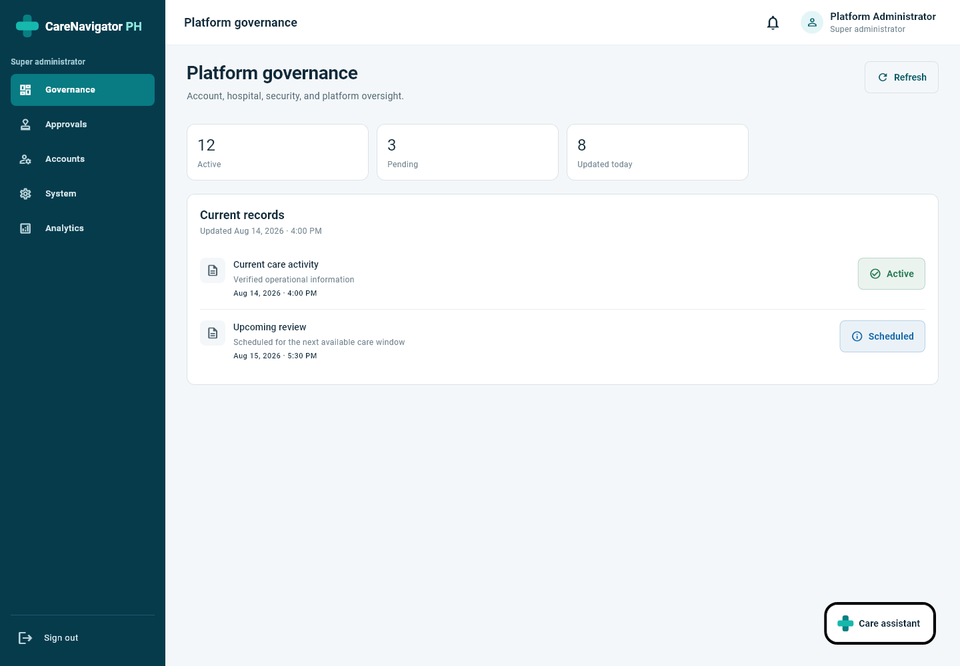
Figure 10 Super administrator — desktop web layout on Windows (1440 × 1000)
The platform workspace provides governance, approvals, account management, system settings, and analytics through a desktop sidebar. The image uses controlled visual-catalog data.
Sources S2 S21

Appendix B Source Code Snippets

Typed Booking Outcome
BookingOutcome reports the server reservation state. Source: lib/src/models/booking_outcome.dart.
class BookingOutcome {
const BookingOutcome({
this.requestId,
this.consultationId,
required this.status,
required this.slotReserved,
});

final String? requestId;
final String? consultationId;
final String status;
final bool slotReserved;

factory BookingOutcome.fromJson(Map<String, dynamic> json) => BookingOutcome(
requestId: json['request_id'] as String?,
consultationId: json['consultation_id'] as String?,
status: json['status'] as String,
slotReserved: json['slot_reserved'] as bool,
);

String get message => slotReserved
? 'Appointment reserved. Current status: ${status.replaceAll('_', ' ')}.'
: 'Request submitted for hospital review. The preferred slot is not reserved until confirmation.';
}

Preference Serialization
The serializer persists medication_reminders and email settings. Source: lib/src/repositories/profile_repository.dart.
Map<String, Object?> toJson(String authUserId) => {
'user_id': authUserId,
'consultation_updates': consultationUpdates,
'appointment_reminders': appointmentReminders,
'medical_results': medicalResults,
'prescriptions': prescriptions,
'medication_reminders': medicationReminders,
'messages': messages,
'hospital_alerts': hospitalAlerts,
'email_enabled': emailEnabled,
'in_app_enabled': inAppEnabled,
};

Sources S6 S22

Source Code for Transactional Prescription Issuance
The complete medication list and one idempotency key are sent to the transactional RPC. Source: lib/src/repositories/care_repository.dart.
@override
Future<PrescriptionOrderOutcome> issuePrescriptionOrder({
required ClinicalRelationship relationship,
required String diagnosisReason,
required List<Map<String, Object?>> medications,
required String idempotencyKey,
}) async {
final response = await _client.rpc<Map<String, dynamic>>(
'issue_prescription_order',
params: {
'idempotency_key': idempotencyKey,
'order_payload': {
'patient_id': relationship.patientId,
'consultation_id': relationship.hasConsultation
? relationship.consultationId
: null,
'assignment_id': relationship.assignmentId,
'diagnosis_reason': diagnosisReason,
'medications': medications,
},
},
);
return PrescriptionOrderOutcome.fromJson(response);
}

Missed Visit Guard
The guard requires 30 elapsed minutes, recorded contact, and no clinical start. Source: the workflow boundary upgrade.
if now()<c.appointment_date+interval '30 minutes' or c.started_at is not null or c.status='in_progress'
or old.contact_attempted_at is null or nullif(btrim(old.contact_attempt_notes),'') is null then
raise exception 'A missed visit requires 30 elapsed minutes, a recorded contact attempt and no clinical start'; end if;

Attachment upload follows successful order creation. If it fails, the interface reports that failure separately and directs the user to Attach document on the existing order. Retrying an attachment or delivery must not repeat clinical issuance.
Sources S7 S12

Appendix C User Manual

Getting Started
Open the configured CareNavigator PH web application or install the approved Android package supplied for the project. Use a working internet connection. Permit location, camera, and microphone only when needed for navigation or an authorized consultation.

Guest Journey
1. Browse hospital and clinician directories. Review services, availability, and hospital navigation.
2. Open consultation intake. Enter personal and care information, choose the facility and preferred schedule, and review privacy and sharing choices.
3. Request an email verification code, open the code sent to the chosen address, and verify it. Submit the intake and retain the request reference.
4. Track the request while the hospital reviews it. A submitted online request does not yet reserve the preferred slot.
5. After approval, activate while signed in with the verified submitting email. Use patient-controlled password setup if required. Existing accounts keep their credentials.
6. Use Join Google Meet / retry during the permitted window after the doctor saves the link. Follow any identity-resolution action while continuing authorized tracking.

Patient Journey
1. Sign in to the patient workspace and choose an available published clinician and appointment type. Select a time at least 24 hours ahead.
2. Submit the care concern and sharing choices. Read the returned reservation message; online requests await hospital confirmation.
3. Open online requests to answer requested information. Accept a hospital-approved schedule proposal or decline it to return the request to review.
4. Track, reschedule, or cancel where permitted. Select Join Google Meet after the doctor saves the link and the scheduled join window opens.
5. Upload supporting files through the patient files area and track their review state. View official records and prescriptions after clinician issuance.
6. Use profile preferences for email and medication summaries. Inspect Sharing by care relationship before revoking all access under that relationship.
Sources S6 S9 S10 S12 S22

User Manual for Clinical and Hospital Staff

Doctor Journey
1. Sign in using the verified doctor account. Open the assigned consultation or authorized active care relationship.
2. Review the patient's permitted information and the supporting documents selected or shared for that relationship. Approve or reject an upload with the appropriate review note; preserve its uploader and provenance.
3. After hospital confirmation, create a Google Meet meeting and select Set Google Meet link. Paste its HTTPS meeting URL. Select Join Google Meet during the join window and use Google Meet host controls to admit the patient.
4. Start the clinical consultation as its assigned doctor. Enter the required structured checkup findings, diagnosis, treatment, and consultation summary before completing it.
5. Use prescription preview and issuance to submit the complete medication list. Check dose, route, frequency, dates, PRN directions, and prescriber signature information.
6. Read the issuance result and email queue state. If an attachment fails, reopen the issued order and choose Attach document to retry against the same order.
7. Complete the consultation or record an authorized clinical follow-up recommendation. A face-to-face recommendation requires a separate booking action.

Hospital Administrator Journey
1. Sign in to the hospital workspace and confirm the assigned facility. Review departments, services, active staff, and published clinician schedules.
2. Open the online-request queue and choose Start review. Check intake, doctor eligibility, sharing, and availability before making a decision.
3. Use Request information for missing intake details or Propose schedule for a reviewed alternative. Continue the workflow when the patient responds.
4. Confirm only after the server rechecks availability. Use Reject with a recorded explanation when the request cannot be approved.
5. Record contact attempts and manage the scheduled visit. Use Mark missed visit only after 30 elapsed minutes, with recorded contact and no consultation start.
6. Update ER capacity independently of outpatient and online publication. Respect reserved-appointment protection when modifying or deleting schedules.
Sources S7 S9 S10 S12

User Manual for Platform Operations and Recovery

Super Administrator Journey
1. Sign in to the super-administrator workspace. Review hospital verification and platform account information through the authorized administration controls.
2. Inspect audit and security events and review maintenance settings. Preserve audit notes when correcting an inconsistent workflow record.
3. Inspect failed notification jobs before retrying them. Recheck preferences and retry the existing delivery job rather than issuing another prescription.
4. Use test-email actions only with the configured controlled recipient and operational replacement SMTP credentials. Monitor activation failures and duplicate daily-summary attempts after rollout.

Password Recovery and Session Expiry
Request recovery and open the emailed link. For an expired link, request a new one. Enter and confirm a new password on reset-password. Generated-link recovery through real Auth passed on 16 October; delivery of an actual recovery email remains a separate check. [S24]
After session expiry, sign in again before protected work. When switching accounts, sign out and verify the newly loaded identity before opening records. Keep passwords and verification codes private.

Failure Recovery
Situation | User action
Verified intake submission fails | Retry the retained intake; do not create a second request intentionally.
Preferred slot becomes unavailable | Choose another published time or respond to the hospital's revised proposal.
Google Meet link is not ready | Refresh and retry after the doctor saves the link; contact the hospital if it remains unavailable.
Attachment upload fails | Retry Attach document on the existing prescription order.
Email shows queued or failed | Check the delivery state and preferences; an issued prescription remains issued.
Requested record is unavailable | Return to the list or contact the care team; another record must not be substituted.
Sharing is revoked | Review the relationship-wide scope; contact the care team about any needed future sharing.

Sources S3 S9 S12 S18 S22

Appendix D Main Feature ERD
Nine central tables show account profiles, directory doctors, schedules, consultations, medical records, and prescription orders/items. Selected columns and foreign keys are shown; supporting operational and platform tables are omitted. [S5, S11]
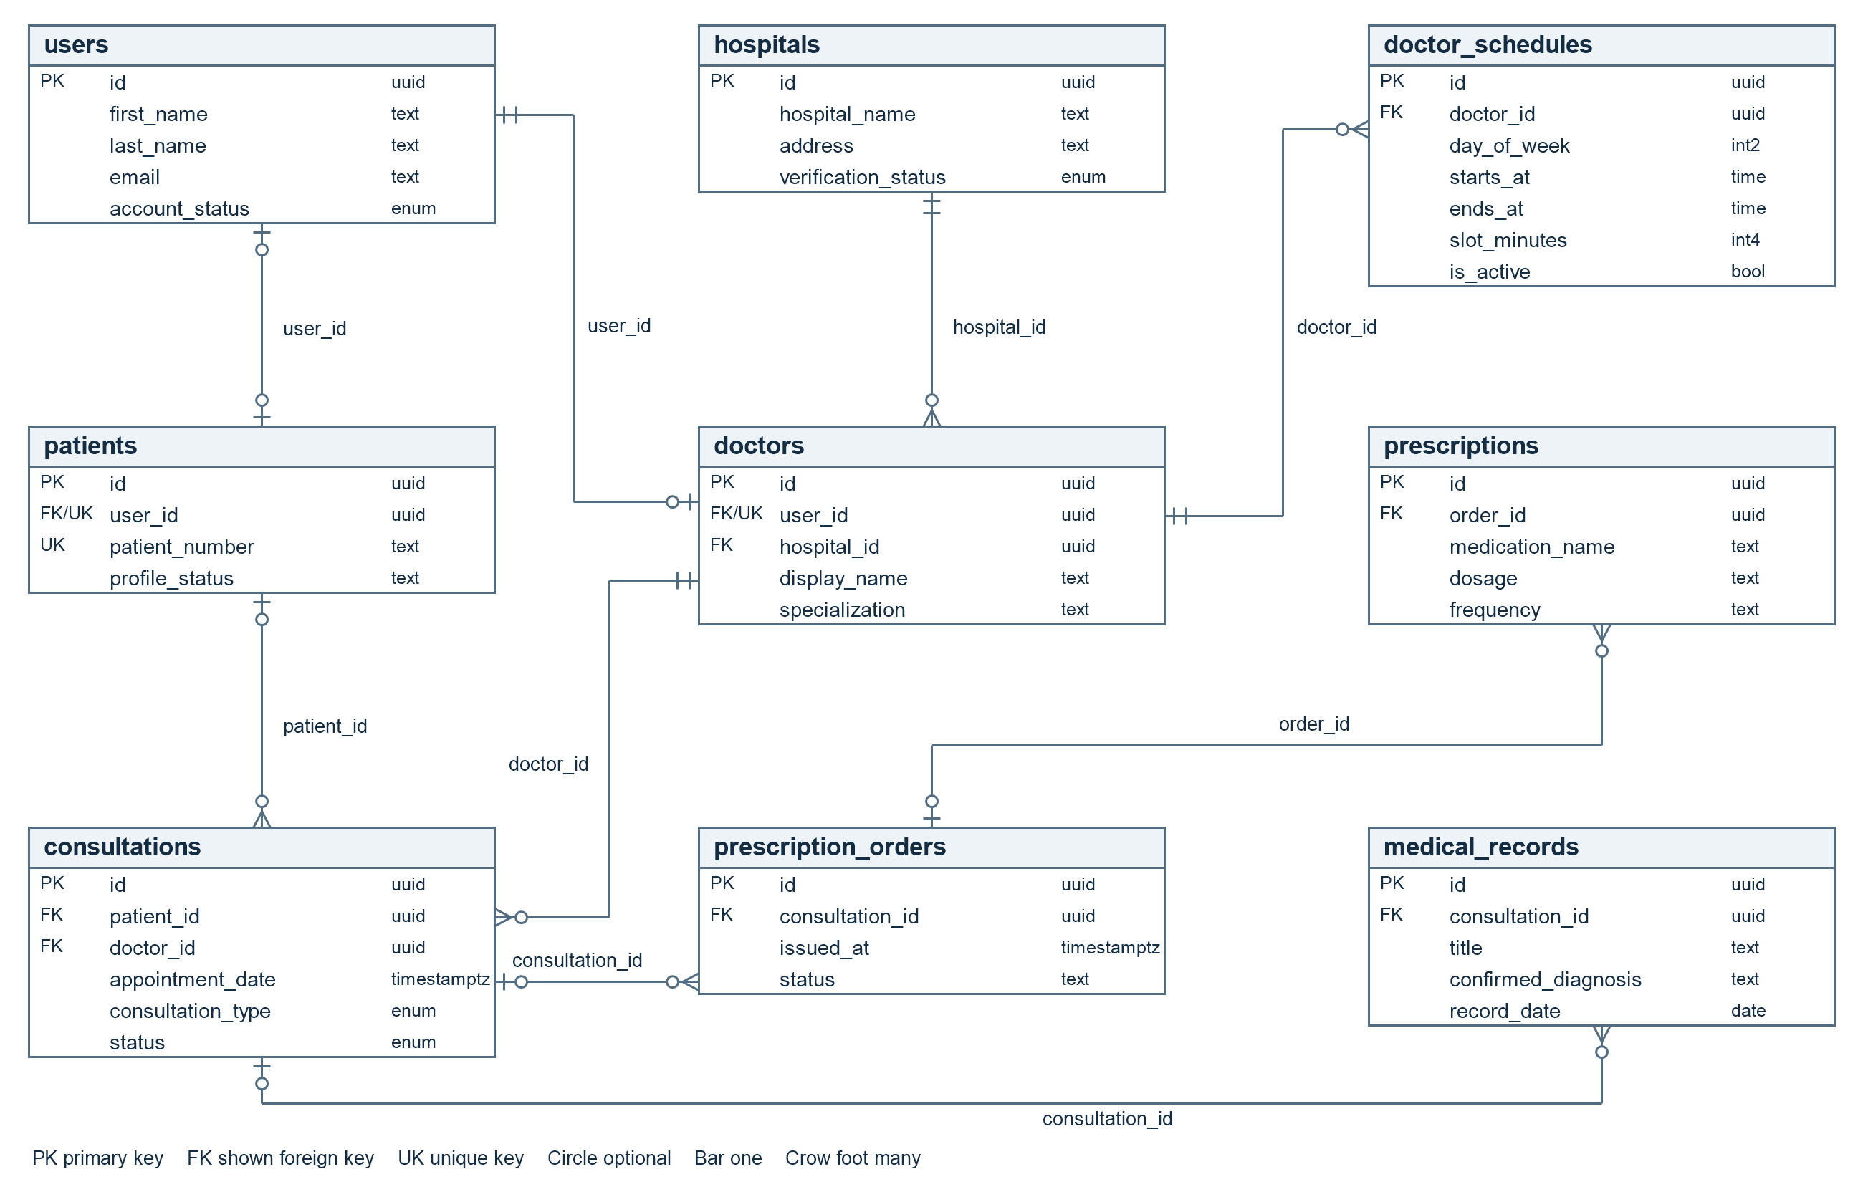
Figure D1 Main feature ERD with selected keys and relationships

Research References
Dayrit, M. M., Lagrada, L. P., Picazo, O. F., Pons, M. C., & Villaverde, M. C. (2018). The Philippines health system review (Vol. 8, No. 2). World Health Organization, Regional Office for South-East Asia.
WHO Philippines health system review
World Health Organization. (2025). Global strategy on digital health 2020–2027.
WHO Global strategy on digital health

Project References
The following repository sources and verification artifacts support the system descriptions and results. Historical evidence is dated 11 and 12 October 2026. Current results and qualified follow-up checks are dated 16 October 2026.
[S1] README.md and pubspec.yaml. Project overview and package configuration.
[S2] SYSTEM_ARCHITECTURE.md. Layered architecture and role workflows.
[S3] supabase/README.md. Baseline, installation, server configuration, and release gates.
[S4] docs/SYSTEM_WORKFLOW_AUDIT_2026-10-11.md and supplied repair plan. 15 findings and agreed repair requirements.
[S5] supabase/migrations/20261011100000_application_baseline.sql. Physical schema, authorization, and transactional workflow definitions.
[S6] lib/src/models/booking_outcome.dart and lib/src/repositories/consultation_repository.dart. Typed booking, verified intake, and patient responses.
[S7] supabase/upgrades/audit-2026-10/20261011091000_review_and_order_boundaries.sql. Clinical transition and missed-visit guards.
[S8] supabase/config.toml and supabase/functions/dispatch-notifications/index.ts. Six function configurations and dispatcher behavior.
[S9] Guest providers, guest verification, and sharing_management_dialog.dart. Retained verification, activation controls, and relationship-wide revocation.
[S10] Active Google Meet migrations 20261011231128 and 20261011232923. Doctor-supplied links, assignment guards, participant authorization, and join-window enforcement.
[S11] Appendix D main feature ERD. Nine tables and selected keys/relationships validated against supabase/baseline/catalog.json.
[S12] care_repository.dart, workspace_repository.dart, and live_workspace_view.dart. Issuance, document review, explicit grouping, and visible role actions.
[S13] Historical Playwright evidence from 12 October 2026, retained in tmp/final_project_doc/verification_evidence.json. Current browser results are recorded under S24.
[S14] .codex-runtime/repair-web-build.log and repair-apk-build.log. Web and Android release build results.
[S15] pubspec.lock. Resolved dependency versions.
[S16] test/unit/repair_regression_test.dart. Guest retry and prescription grouping regression definitions.
[S17] supabase/tests/*_acceptance.sql. Database acceptance suites; definitions alone do not certify execution.
[S18] supabase/operations/README.md. Rollout monitoring and audited corrections.
[S19] .codex-runtime/repair-analyze.log, repair-all-tests.log, and repair-final-regressions.log. Analysis and recorded Flutter test results.
[S20] .codex-runtime/repair-ai-fixture-result.json. Controlled synthetic prescription extraction output.
[S21] test/visual_catalog/. Application screenshots rendered with controlled fixture data.
[S22] lib/src/repositories/profile_repository.dart and auth_repository.dart. Preference serialization and password-recovery behavior.
[S23] Activity1_CareNavigator_PH_Test_Scenarios_and_Test_Cases.docx. Four original detailed cases; this revision selects five demonstration scenarios.
[S24] 16 October 2026 verification report in output/final_project; evidence in tmp/documentation_accuracy_20261016 and tmp/documentation_update_20261016.

