COURSE SUBMISSION • DUE AUGUST 17, 2026
CareNavigator PH
Implement CRUD Functionality (Week 4)
Submission scope: This file contains only the Week 4 Create, Read, Update, and Delete submission requirements and evidence.
Project type: Flutter web/mobile healthcare navigation application
Backend: Supabase Data API, PostgreSQL, Auth, Realtime, Storage, and Edge Functions
Prepared: August 15, 2026
Student: Neil Ardrey Laza
Course / Section: ITE 231

- Persistent Supabase PostgreSQL storage with Row Level Security
- Client validation and protected destructive actions
- Database-backed Create, Read, Update, and Delete for doctor schedule slots
- Create, Read, Update, and Delete user-interface screenshots

WEEK 4 SUBMISSION
Implement CRUD Functionality
Complete Create, Read, Update, and Delete operations using persistent Supabase PostgreSQL storage.
Main data entity: Doctor schedule slots (doctor_schedules). Each record stores the doctor, weekday, start/end time, consultation type, appointment duration, and active state.

CRUD implementation summary
Operation | Repository method | Action | Safeguard
Create | createScheduleSlot | INSERT / POST | Validates day, time order, duration, and care mode.
Read | WorkspaceRepository.load | SELECT / GET | Filters rows to the authenticated doctor.
Update | setScheduleActive | UPDATE / PATCH | Requires a non-empty schedule ID.
Delete | deleteScheduleSlot | DELETE | Blocks removal when an appointment depends on the slot.

Persistence and user experience
- Records are persisted in Supabase PostgreSQL and protected by authentication and Row Level Security.
- The UI provides labeled forms, status chips, publish/unpublish actions, confirmation dialogs, and retry states.
- Destructive deletion is guarded by a booked-appointment dependency check.

WEEK 4 EVIDENCE 1
Create operation
Figure 1. Add Slot form for creating a doctor schedule record.
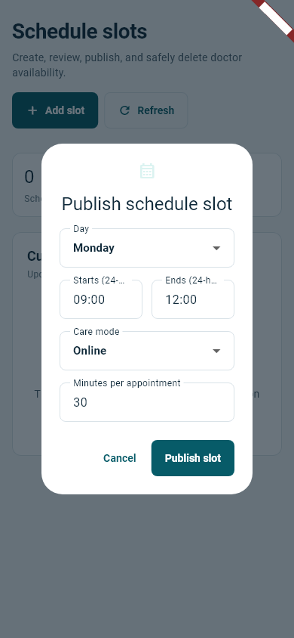
The Create form collects a weekday, 24-hour start/end times, care mode, and minutes per appointment. Submitting calls the repository insert and refreshes the persisted schedule list.
CareRepository.createScheduleSlot(...) → doctor_schedules.insert({...})
Validation: Day must be 0-6, times must use HH:mm, end must be later than start, duration must be 10-240 minutes, and consultation type is normalized.

WEEK 4 EVIDENCE 2
Read operation
Figure 2. Persisted schedule record displayed in the doctor workspace.
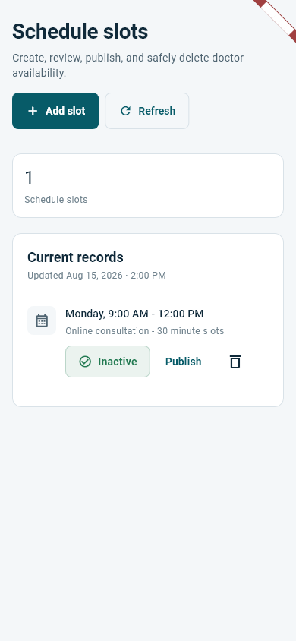
The Read flow selects doctor_schedules through WorkspaceRepository, limits records to the authenticated doctor, orders them, maps JSON rows to WorkspaceItem models, and annotates booking dependencies.
WorkspaceRepository.load(...) → from('doctor_schedules').select(...)
Meaningful display: The UI shows the weekday, time range, care mode, slot duration, active state, and available row actions instead of raw JSON.

WEEK 4 EVIDENCE 3
Update operation
Figure 3. Confirmation before publishing an inactive schedule slot.
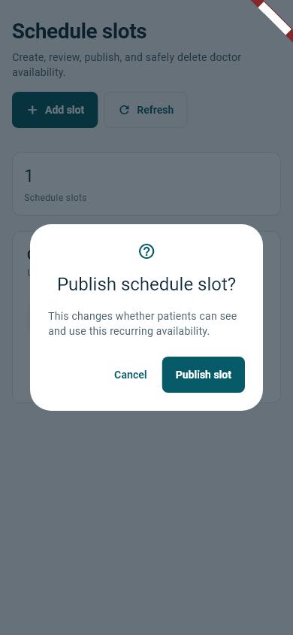
The Update flow toggles is_active for the selected schedule ID. A confirmation dialog explains that publishing changes whether patients can see and use the recurring availability.
CareRepository.setScheduleActive(...) → update({'is_active': active})
Safety: The repository rejects an empty schedule ID, updates only the matching row, and requests the updated ID so a missing/invalid record does not silently succeed.

WEEK 4 EVIDENCE 4
Delete operation
Figure 4. Destructive-action confirmation for deleting availability.
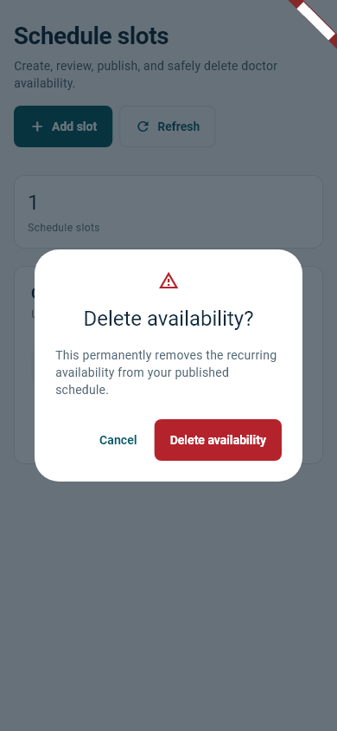
The Delete flow first confirms ownership, compares the recurring slot with non-cancelled appointments, and removes the record only when no booking depends on it.
CareRepository.deleteScheduleSlot(...) → delete().eq('id', scheduleId)
Protected deletion: If a booked consultation matches the slot, deletion is blocked with a clear message. The final confirmation uses explicit destructive wording.

WEEK 4 DOCUMENTATION
Validation, persistence, and verification

How CRUD was implemented
The Flutter UI delegates all database work to typed repository classes. Supabase translates select, insert, update, and delete calls into HTTP requests to PostgreSQL through PostgREST. Riverpod reloads the workspace snapshot after successful mutations, so users immediately see persisted state.

Data validation
- Client validation prevents malformed day, time, duration, care-mode, and identifier values before a network request.
- Database constraints and RLS provide server-side persistence and access control.
- Delete checks protect appointments that depend on a recurring slot.
- Repository failures are converted into concise messages suitable for the UI.

Verification results
Static analysis: flutter analyze: No issues found (August 15, 2026).
Focused tests: 30 repository-validation, primary-action, row-action, and CRUD-evidence tests passed. The four screenshots in this section were generated by a reproducible Flutter widget test without modifying live medical data.

Submission checklist
- Updated project source code: present in the CareNavigator PH workspace.
- Create operation screenshot: Figure 1.
- Read operation screenshot: Figure 2.
- Update operation screenshot: Figure 3.
- Delete operation screenshot: Figure 4.
- Brief CRUD implementation, validation, persistence, and verification documentation is included.
End of Week 4 submission document.

