COURSE SUBMISSION • DUE AUGUST 17, 2026
CareNavigator PH
API Integration & HTTP Requests (Week 5)
Submission scope: This file contains only the Week 5 API Integration and HTTP Requests submission requirements and evidence.
Project type: Flutter web/mobile healthcare navigation application
Backend: Supabase Data API, PostgreSQL, Auth, Realtime, Storage, and Edge Functions
Prepared: August 15, 2026
Student: Neil Ardrey P. Laza
Course / Section: ITE 231

- Live GET evidence from the configured Supabase project
- HTTP POST implementation with validation and JSON processing
- Retrieved API data displayed in the Flutter user interface
- Loading, invalid-response, empty-state, and success-state handling

WEEK 5 SUBMISSION
API Integration & HTTP Requests
External/custom backend API integration for dynamic care-directory data and consultation workflows.
API name: Supabase Data API (PostgREST) with the CareNavigator Edge Function API. The integration retrieves verified hospital data, creates consultation requests, and supplies the care assistant with structured JSON.

API endpoints and methods
Method | Endpoint | Purpose
GET | /rest/v1/hospitals | Retrieves verified, open or limited hospitals for the public directory.
POST | /rest/v1/guest_consultation_requests | Creates a validated consultation request and returns the new record ID.
POST | /functions/v1/care-navigator-chat | Sends message/facility JSON to the care-assistant Edge Function.

Features added through the integration
- A live public directory of verified Philippine hospitals, including operating state and availability information.
- Dynamic display of API data in Flutter rather than hard-coded records.
- Validated consultation-request creation through a POST request.
- Care-assistant JSON exchange through a protected Supabase Edge Function.
- Explicit loading, empty, unavailable, retry, and malformed-response handling.

WEEK 5 EVIDENCE 1
HTTP GET request implementation
Figure 1. Supabase query used to retrieve verified, operating hospitals.
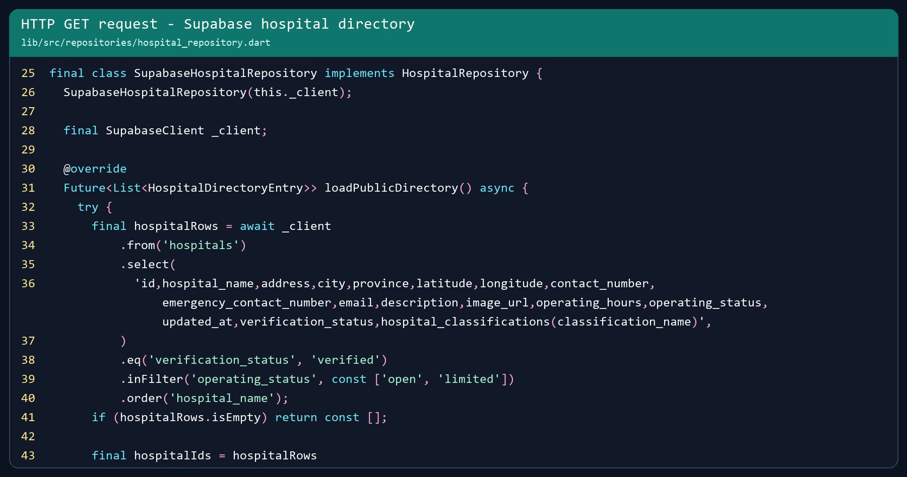
The Supabase Dart client composes an HTTP GET request to the hospitals REST endpoint. The query selects required JSON fields, filters verification_status to verified, restricts operating_status to open or limited, and orders results by hospital_name.
Meaningful processing: The repository immediately returns an empty list for an empty response, then joins related departments, services, emergency-room records, bed capacity, doctors, and schedules before creating typed UI models.

WEEK 5 EVIDENCE 2
HTTP POST request implementation
Figure 2. POST-style insert for a validated guest consultation request.
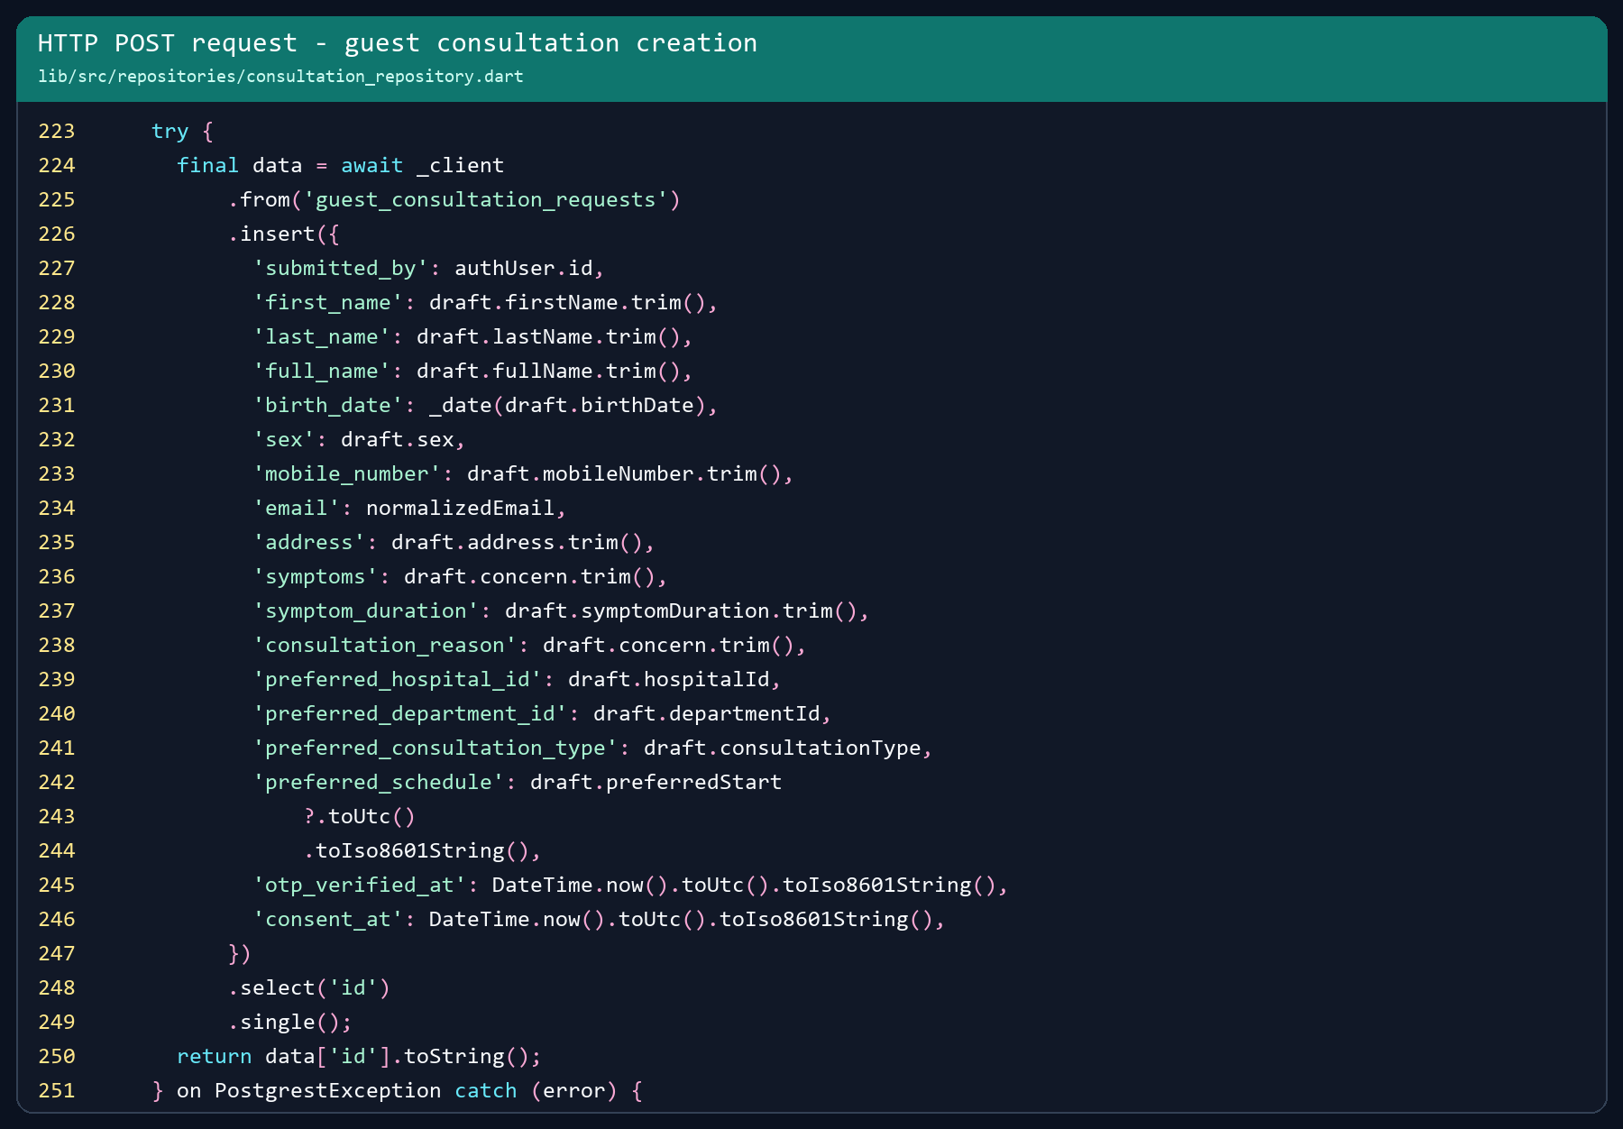
The repository sends a JSON request body to guest_consultation_requests, requests the inserted id, parses the returned object, and exposes the ID to the calling UI. Authentication and field validation run before the request.
Validation: Required fields, email format, concern length, hospital/department selection, supported consultation type, future schedule time, and verified-email ownership are checked before data is sent.

WEEK 5 EVIDENCE 3
JSON parsing and processing
Figure 3. JSON rows converted into typed HospitalDirectoryEntry models.
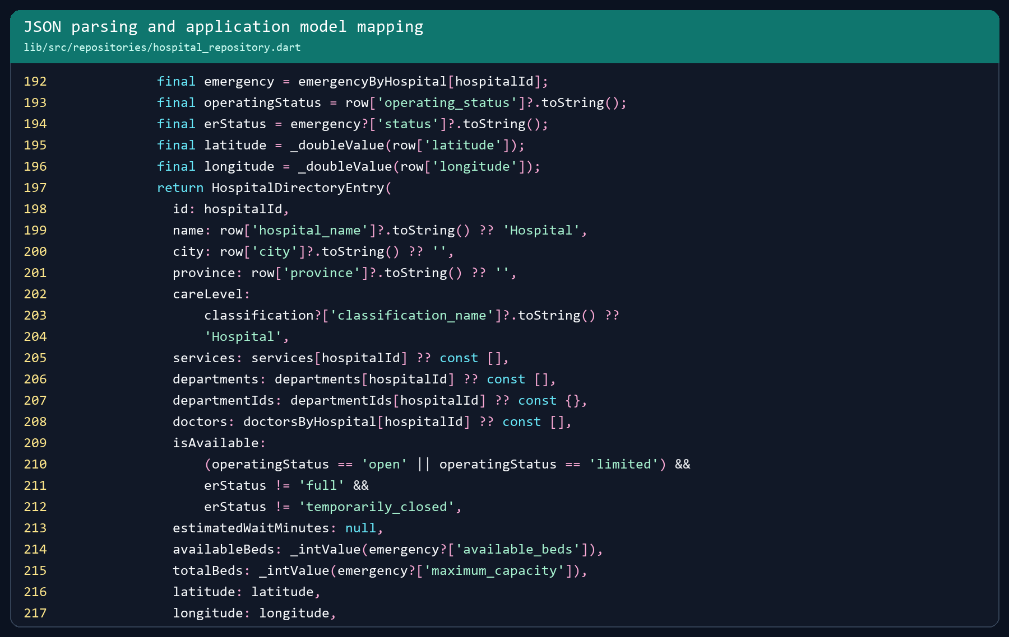
Fields are read defensively with null-safe conversions. Operating and emergency states are combined into a meaningful isAvailable value, while geographic coordinates and capacity fields are normalized before the UI receives them.
Invalid responses: PostgREST, Edge Function, authentication, repository, and unexpected exceptions are converted into user-safe messages. Raw errors and credentials are not displayed to end users.

WEEK 5 EVIDENCE 4
Live JSON response sample
Figure 4. Live GET response captured from the configured Supabase hospitals endpoint on August 15, 2026.
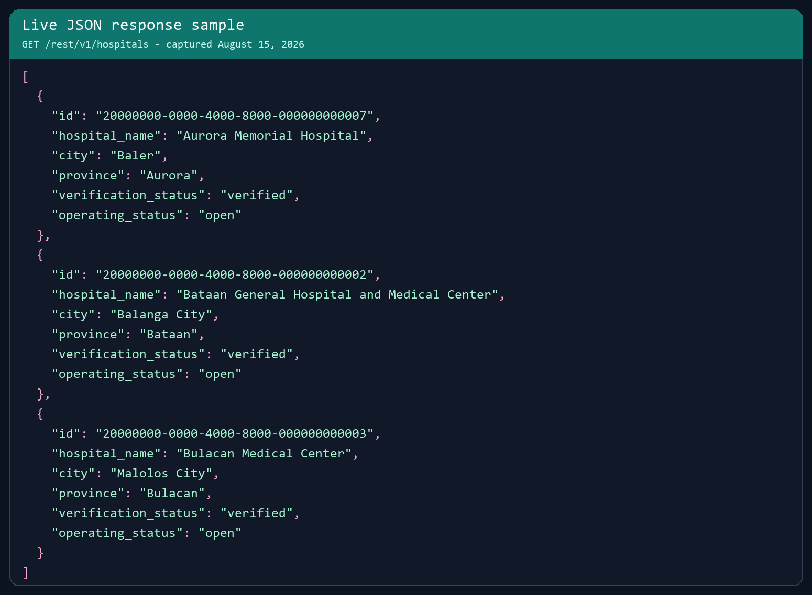
Result: The response returned verified, open facilities. The first two records correspond to the facilities rendered in the application screenshot on the next page.
Security note: the response sample intentionally excludes authentication headers and publishable-key values. Row Level Security remains the authorization boundary for Supabase data access.

WEEK 5 EVIDENCE 5
Retrieved API data displayed in the UI
Figure 5. Mobile Flutter interface displaying hospitals retrieved from the live Supabase API.
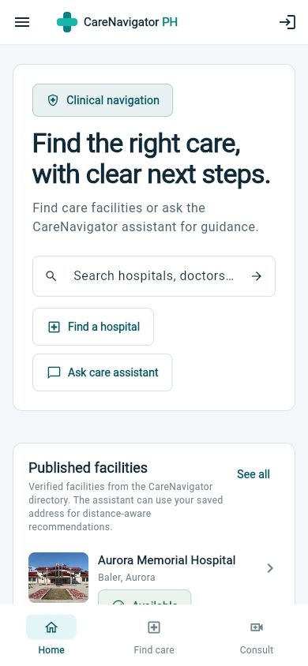

Loading and response-state handling
- Loading: the panel shows “Loading verified facilities” while the repository request is active.
- Error: a “Hospital directory unavailable” state displays a safe message and Retry button.
- Empty: “No facilities published” appears when the API returns no matching records.
- Success: verified facilities are rendered with name, location, operating state, directions, bed availability, and clinician count.
Verification: The live GET response and the rendered UI were captured on August 15, 2026. flutter analyze completed with no issues.

WEEK 5 DOCUMENTATION
Submission checklist
- Updated project source code: present in the CareNavigator PH workspace.
- API request implementation screenshots: Figures 1 and 2.
- JSON parsing implementation screenshot: Figure 3.
- Live JSON response sample: Figure 4.
- Retrieved API data displayed in the application: Figure 5.
- API name, endpoints, request methods, features, loading states, and invalid-response handling are documented.
End of Week 5 submission document.

