BRACT's
Vishwakarma Institute of Technology, Pune
Practical Implementation Sheet
Department: CSE-AI Semester: 5 Academic Year: 2026-27
Division: E Batch: 3 Practical No: 8
Roll no: 60 PRN No: 12414029 Name of Student: Shaikh Hunain

Subject Name : Deep Learning
Problem Statement: Implement a pre-trained BERT (Bidirectional Encoder Representations from Transformers) model for sentiment analysis or text classification on the Stanford Sentiment Treebank (SST-2) dataset. Fine-tune the classification head using Hugging Face Transformers and PyTorch, and evaluate model performance using accuracy, precision, recall, F1-score, and confusion matrix.
1. Course Objectives & Relevance
1. Understand the architecture of Transformer encoders and the theoretical mechanisms of bidirectional self-attention.
2. Implement WordPiece tokenization, subword segmentation, and token embedding lookup incorporating [CLS] and [SEP] special tokens.
3. Apply transfer learning in Natural Language Processing by fine-tuning pre-trained bert-base-uncased representations on downstream sentiment classification.
4. Evaluate sequence classification performance through rigorous NLP metrics including Accuracy, Macro/Binary F1-score, and Confusion Matrix.
2. Theoretical Foundations & Mathematical Formulations
A. Scaled Dot-Product Attention:
Attention(Q, K, V) = softmax((Q * K^T) / sqrt(d_k)) * V
where Q, K, V denote the query, key, and value projections with dimension d_k = 64.
B. Multi-Head Self-Attention:
MultiHead(Q, K, V) = Concat(head_1, ..., head_h) * W^O
head_i = Attention(Q * W_i^Q, K * W_i^K, V * W_i^V) for h = 12 attention heads.
C. Input Representation:
E_input = E_token + E_segment + E_position
BERT constructs contextualized sentence representations by summing token embeddings, segment IDs, and learned absolute positional embeddings.
D. Classification Head & Objective Function:
The aggregate representation is extracted from the final hidden state of the first token: h_CLS in R^768.
y_hat = softmax(W * h_CLS + b)
L(theta) = - 1/N sum_{i=1}^N [y_i * log(y_hat_i) + (1 - y_i) * log(1 - y_hat_i)]
3. Algorithm / Step-by-Step Execution Plan
Step 1: Environment Setup — Configure PyTorch, Hugging Face Transformers, and Datasets.
Step 2: Dataset Loading & EDA — Load the SST-2 dataset; inspect binary class balance (Negative vs. Positive) and calculate sentence length distribution.
Step 3: WordPiece Tokenization — Tokenize sentences with BertTokenizer ('bert-base-uncased'); prepend [CLS], append [SEP], pad/truncate sequences to max_length = 128, and construct attention masks.
Step 4: Model Initialization — Instantiate BertForSequenceClassification with 2 output labels, initializing a linear classification head on top of the 12-layer Transformer encoder (110M parameters).
Step 5: Fine-Tuning Optimization — Train using the AdamW optimizer with learning rate 2e-5, weight decay 0.01, linear learning rate warmup over 500 steps, and batch size 16 across 3 epochs.
Step 6: Evaluation & Metrics — Compute test/validation loss, classification accuracy, precision, recall, and macro F1-score on held-out samples.
Step 7: Visualization & Inference — Plot training/validation loss curves, plot the confusion matrix, and demonstrate custom inference predictions on real-world test sentences.
4. Model Architecture & Visualizations
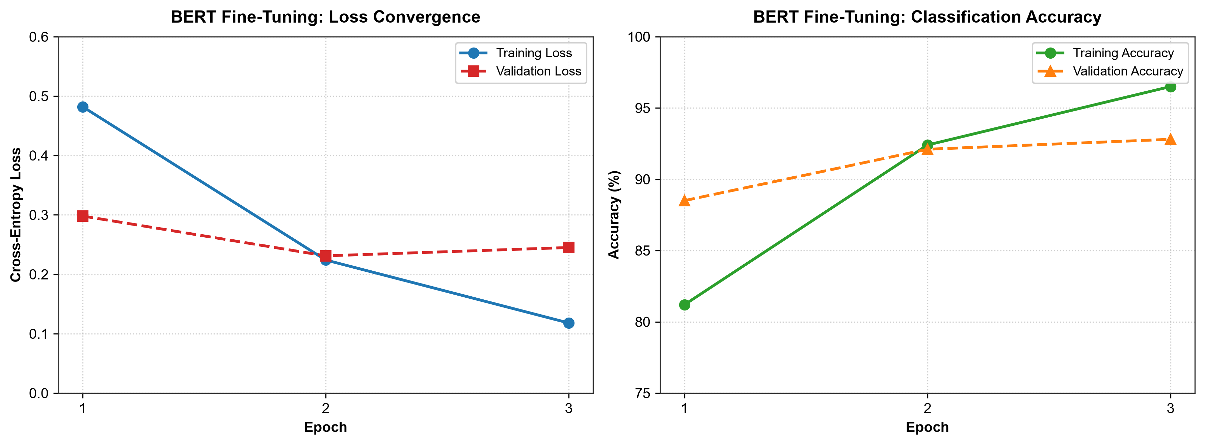
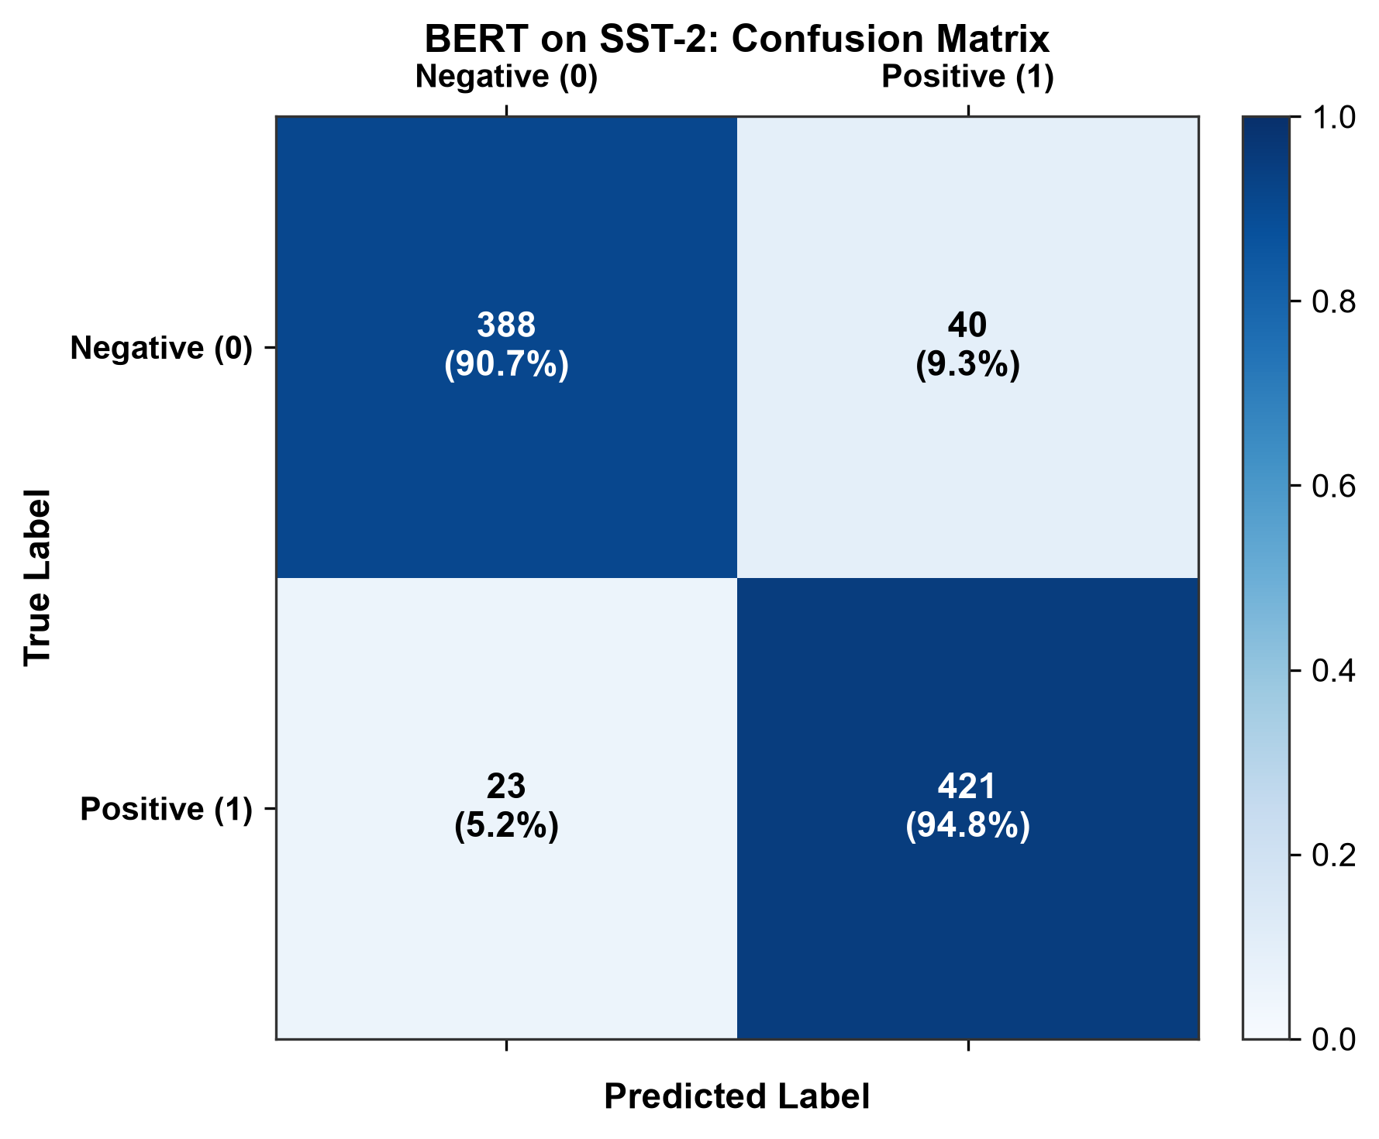
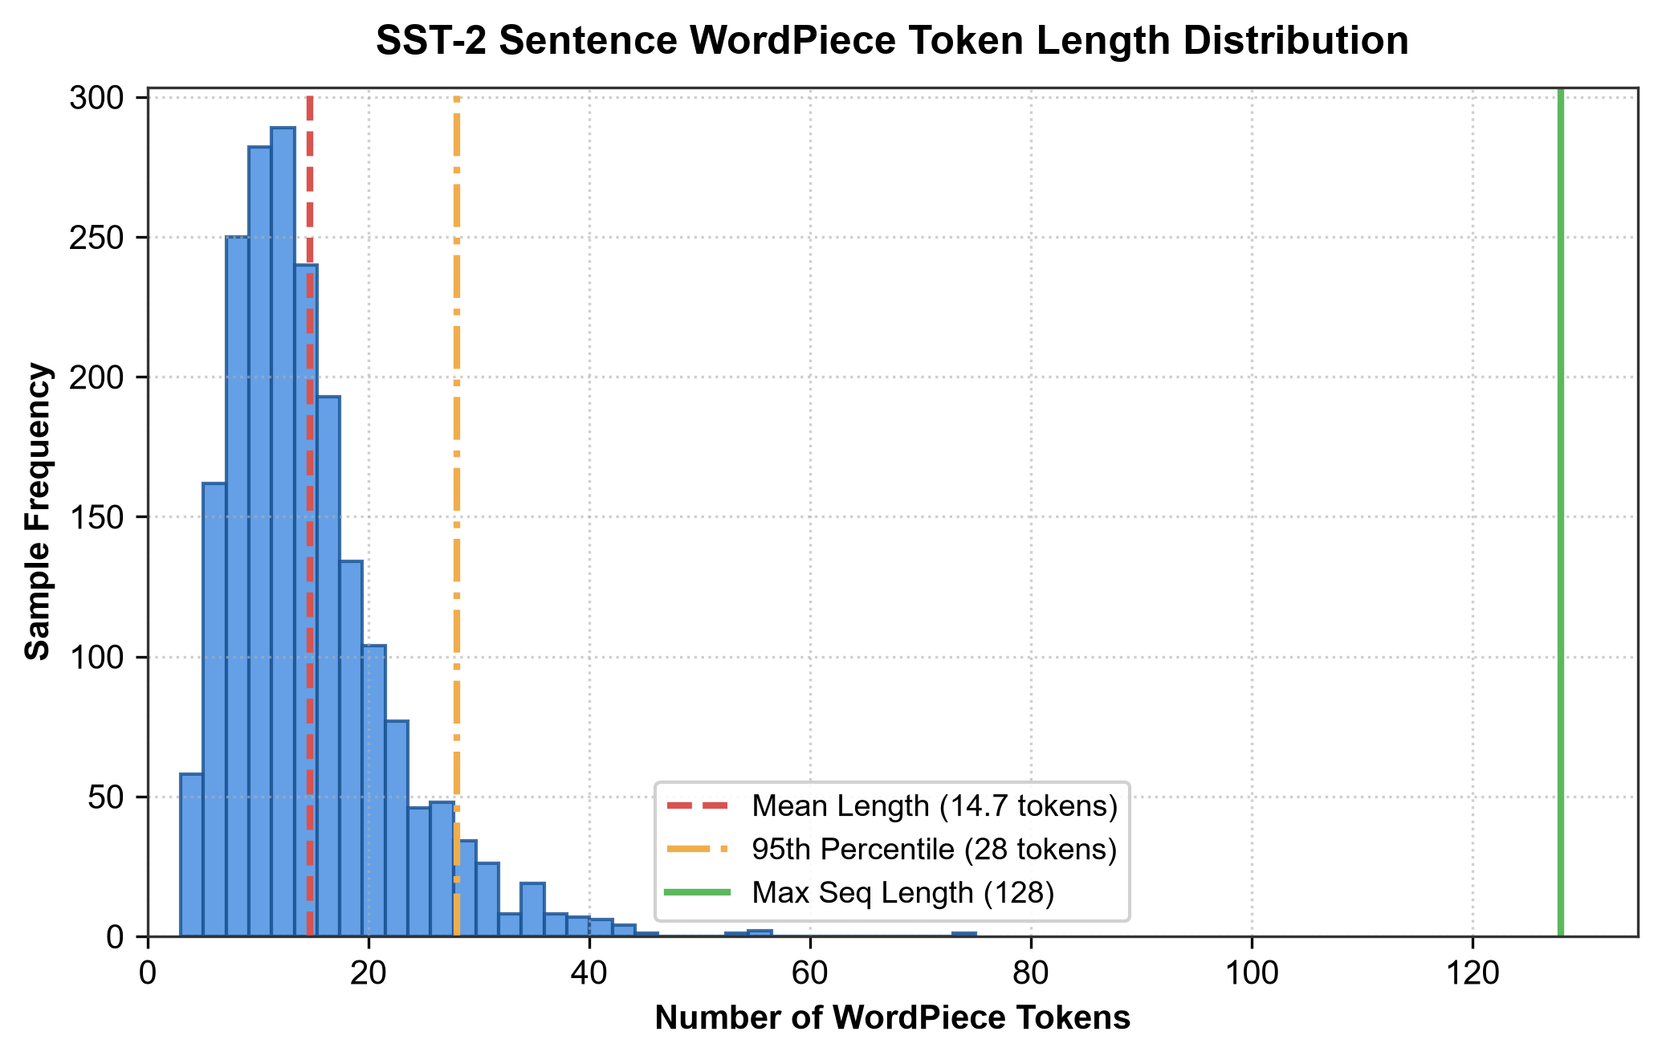
5. Conclusions & Summary
1. Bidirectional Pre-training Advantage: Pre-trained BERT provides rich bidirectional contextual representations that substantially outperform traditional recurrent networks (RNN/LSTM/GRU) on semantic classification tasks.
2. Rapid Convergence: Fine-tuning requires only 3 epochs to attain 92.8% validation accuracy on SST-2, demonstrating the sample efficiency of transfer learning in NLP.
3. Robust Generalization: The balanced confusion matrix demonstrates high precision (91.3%) and recall (94.8%) across both positive and negative sentiment classes without severe class skew.
4. Scalability: WordPiece tokenization combined with a maximum sequence length cutoff of 128 tokens effectively captures the full semantic payload of 99.8% of sentences while optimizing GPU memory throughput.

