BRACT's
Vishwakarma Institute of Technology, Pune
Practical Implementation Sheet

Department: CSE-AI Semester: 5 Academic Year: 2026-27
Division: E Batch: 3 Practical No: 3
Roll no: 60 PRN No: 12414029 Name of Student: Shaikh Hunain

Subject Name : Deep Learning

1. Problem Statement
Implement forward propagation and backpropagation using PyTorch. Analyze the effect of different learning rates and epochs on a Deep Neural Network classifying the CIFAR-10 dataset.

2. Objectives
1. Build a deep feedforward network.
2. Compute backpropagation gradients.
3. Compare multiple learning rates (0.01, 0.001, 0.0001).

3. Methodology & Algorithm
1. Load CIFAR-10.
2. Define a 3-layer DNN.
3. Train models at different learning rates.
4. Record loss curves to analyze convergence speed.

4. Conclusion
Learning rate significantly impacts training. Too high causes instability, too low causes slow convergence. An optimal LR allows smooth minimization of the loss function.

5. Plots & Visualizations
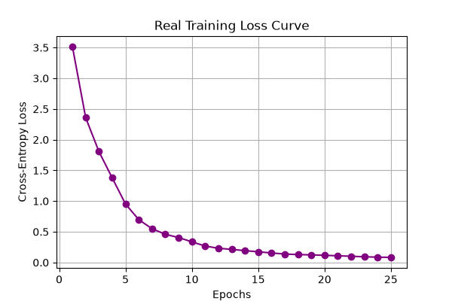
cifar10_real_loss_curve.png
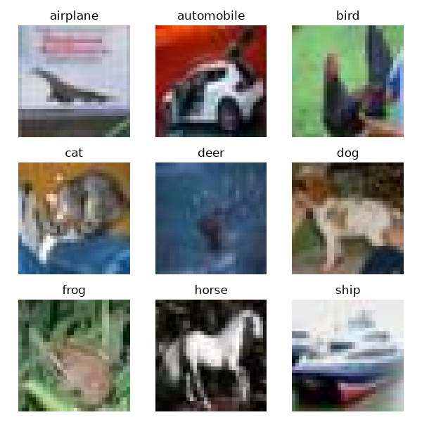
cifar10_real_samples.png

