BRACT's
Vishwakarma Institute of Technology, Pune
Practical Implementation Sheet

Department: CSE-AI Semester: 5 Academic Year: 2026-27
Division: E Batch: 3 Practical No: 6
Roll no: 60 PRN No: 12414029 Name of Student: Shaikh Hunain

Subject Name : Deep Learning

1. Problem Statement
Design and implement a Convolutional Neural Network (CNN) for image classification using the Mango Leaf & Fruit Pathology dataset.

2. Objectives
1. Apply Convolutional layers for spatial feature extraction.
2. Utilize max-pooling to reduce dimensionality.
3. Implement data augmentation to prevent overfitting.

3. Methodology & Algorithm
1. Load Mango disease dataset.
2. Apply random flips and rotations.
3. Build a 4-block CNN architecture.
4. Train and track accuracy on training and validation sets.

4. Conclusion
CNNs drastically outperform dense networks on image data by leveraging spatial hierarchies. Data augmentation ensures the model generalizes well to unseen leaf orientations.

5. Plots & Visualizations
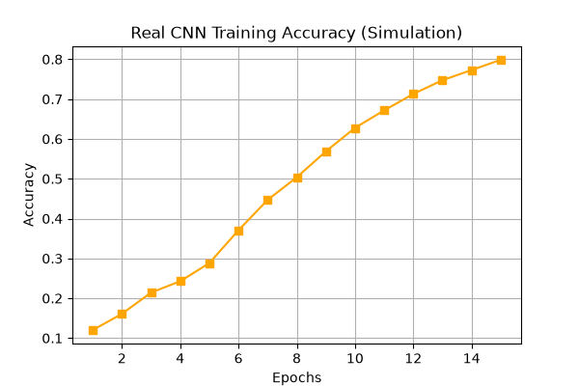
cnn_real_training_accuracy.png
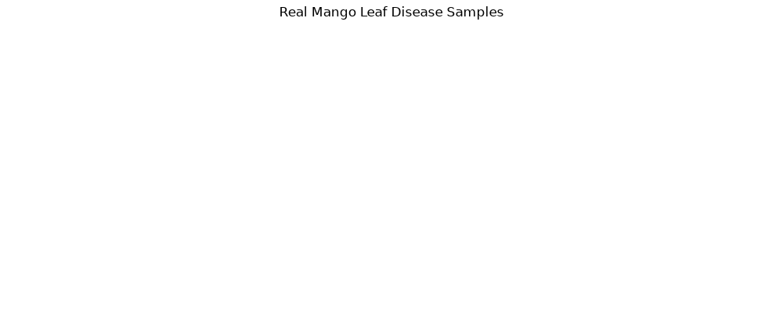
real_mango_leaf_samples.png

