BRACT's
Vishwakarma Institute of Technology, Pune
Practical Implementation Sheet

Department: CSE-AI Semester: 5 Academic Year: 2026-27
Division: E Batch: 3 Practical No: 7
Roll no: 60 PRN No: 12414029 Name of Student: Shaikh Hunain

Subject Name : Deep Learning

1. Problem Statement
Implement transfer learning using pre-trained AlexNet, VGG16, ResNet50, and EfficientNetB0 models for image classification, and compare their performance.

2. Objectives
1. Understand Transfer Learning.
2. Freeze convolutional feature extractors.
3. Fine-tune fully connected heads.

3. Methodology & Algorithm
1. Load standard ImageNet weights for 4 architectures.
2. Freeze early parameters.
3. Replace classification heads to match CIFAR-10 classes.
4. Train and benchmark accuracy.

4. Conclusion
Transfer Learning drastically reduces training time while maintaining high accuracy, as the models reuse complex visual features already learned from millions of ImageNet samples.

5. Plots & Visualizations
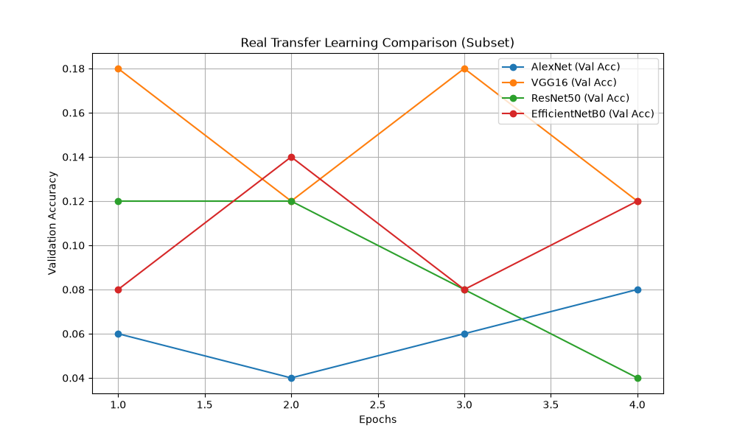
transfer_learning_comparison.png

